Cisco Network Sizer

Release 2.0

Getting Started Guide

Table of Contents

Table of Contents

Introduction 4

Prerequisites 4

User credentials 4

Sizer hosted on Cisco LAE infrastructure 4

Sizer deployed using OVA 5

Getting started with Network Sizer 5

Create First Project 5

Physical Sizer 6

Construct Data centre. 6

Termination Workflow 9

Placement Algorithms: 9

Leaf to Spine termination 10

Logical Sizer 10

Making changes to Logical requirements 11

Configure contracts to use repository objects 12

Save configuration to APIC 14

Network Sizer GUI 17

Project List page 17

Physical Sizer 17

Build Datacenter 17

Add devices to rack 18

How to interpret inventory 21

Port termination and revert 21

How to interpret result 24

Logical diagram view 25

Results 27

Placement of logical topology on Physical infrastructure 27

Repository 27

Plugins 28

User management 29

Application Templates 29

Blank Application. 29

Flat application. 29

2-tier application. 29

3-tier application. 30

Tenant, Application Properties and Sizing. 31

# Introduction

Cisco® Network Sizer is a Web based application which helps in sizing ACI or Nexus 9000 based Network infrastructure for a data centre.

Network Sizer consists of three high level modules,

* Logical Sizer: For a given workload/application, it calculates the optimum number of leaf switches required. It also gives information about the utilization of these switches with respect to various switch attributes.
* Physical Sizer: Calculates number of leafs, spine switches, and port termination statistics for a datacentre having servers and other devices on racks.
* Profiler: For importing the application specific constraints from third party devices which can be used in constructing application rules

There is no particular order in which these modules have to be used. User can start with any of these.

## Prerequisites

Make sure you have latest version of one of the supported Browsers.

* Chrome version 35 (at minimum)
* Firefox version 26 (at minimum)
* Safari
* Internet Explorer version 11 (at minimum)

## User credentials

### Sizer hosted on Cisco LAE infrastructure

Network Sizer is hosted on Cisco LAE infrastructure. To access this server, use your Cisco user id and password.

Use any of the below URLs are access Network Sizer.

* Outside Cisco corporate network

<https://nwsizer.cloudapps.cisco.com/networksizer>

* Within Cisco corporate Network

<https://t459jj4xprd-nwsserver.cloudapps.cisco.com/networksizer>

Open your Internet browser such as Chrome or Firefox and visit any of the above URLs. You will be prompted for login.

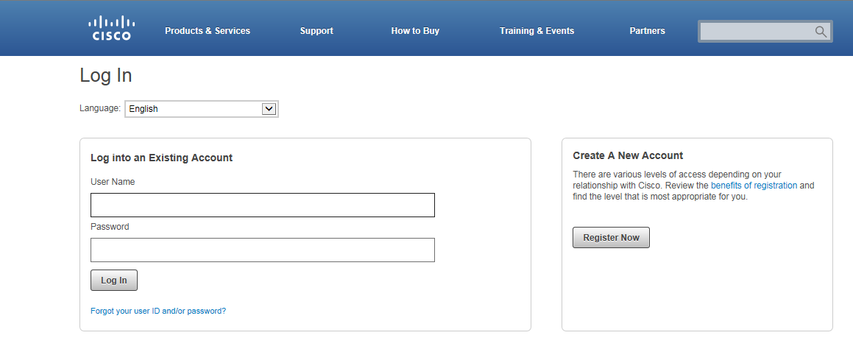

* Enter your Cisco user credentials. You will be redirected to Network Sizer page.

### Sizer deployed using OVA

Use credentials, admin/admin or user/user to login to application.

# Getting started with Network Sizer

Once you login, the first page displays a list of all the projects previously created by the user as displayed below

* Start a new project either by creating a new project by clicking C:\build\cisco\dev-branches\ACISizer\src\main\webapp\images\plus-icon.png button or clone (copy) an existing project.

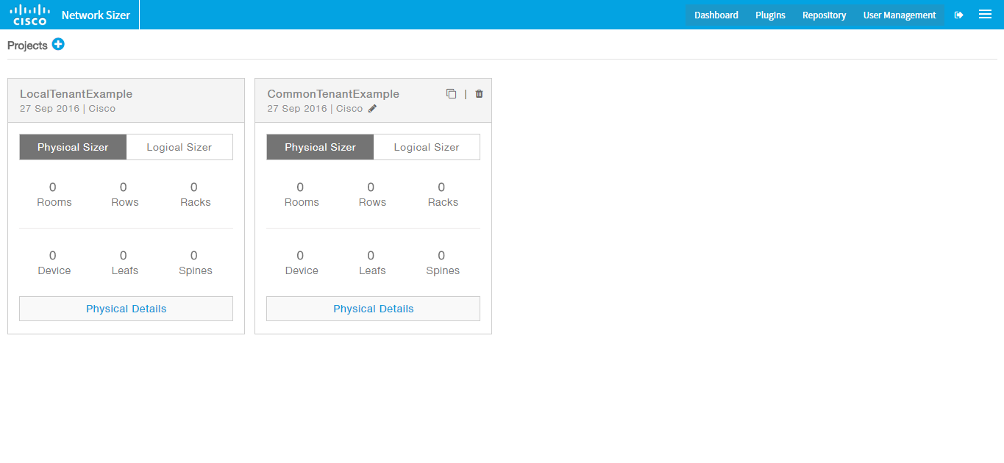

## Create First Project

* Click C:\build\cisco\dev-branches\ACISizer\src\main\webapp\images\plus-icon.png icon, next to the title "Projects". Enter project attributes, name, description, and customer name. For project type select ACI or Nexus 9000 project.
  + For ACI projects, both Logical and Physical Sizer components are created.
  + For Nexus 9000 projects, only Physical Sizer component is created.

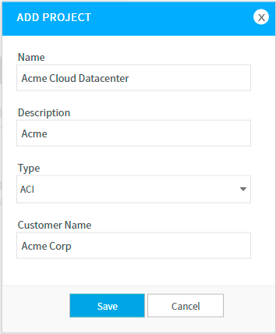

* A project is created and UI is redirected to project details page.
* For ACI projects, by default, a common tenant is automatically created in logical Sizer. This common tenant has a VRF, a BD, an L3out and a shared service.

## Physical Sizer

Physical Sizer is similar to a datacentre infrastructure management tool. Below is typical usage steps of physical sizer.

* Build data centre by creating rooms, rows and racks.
* Place servers on the rack
* Optionally place Leaf switches on the rack or allow the application to decide and place the Leaf on rack
* Terminate the server ports to Leaf. Provide port termination statistics.
* Application calculates the number of spines required and terminate Leaf ports to spine ports. Provides leaf to spine port termination statistics.
* Tool also provides other information, such as inventory details.

Access physical Sizer by clicking Physical sizer tab and Physical Sizer details as displayed below.

### Construct Data centre.

Access physical Sizer by clicking Physical sizer tab and Physical Sizer details as displayed below.

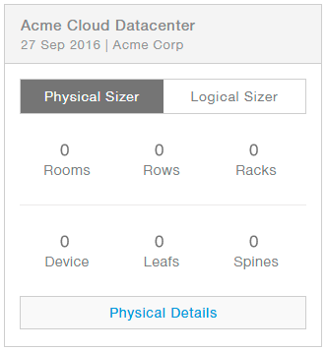

Add room by entering number of Rows, Racks per Row, Rack type and room level policy

When a room is added, all the rows are created and racks are placed.

#### Add devices

Select a row, Select a Rack and add server by clicking + mark on top of rack.



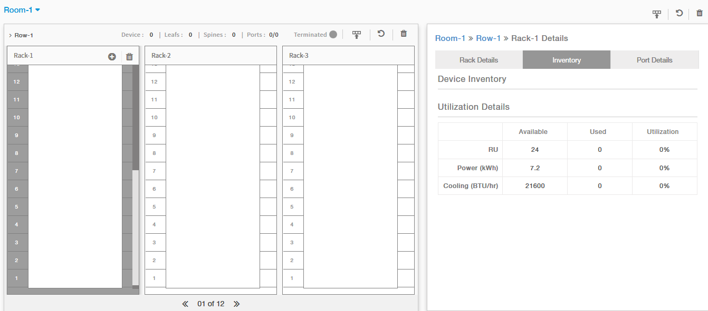

As you add servers, inventory details are updated on the right side.

There are standard templates for UCS servers, Fabric interconnect, Firewalls and switches.

There is an option to change the Network port details, if the networking port details are different for a server model.

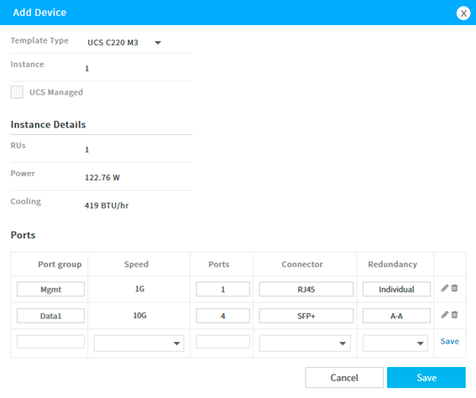

#### Add Switches

Add switches to a rack by selecting + icon top of rack. This is an optional step. In most of the cases, the Row termination places a switch and does termination of ports.

#### Automatically Place Switches and Terminate Device ports

Click Terminate port icon on Row header.

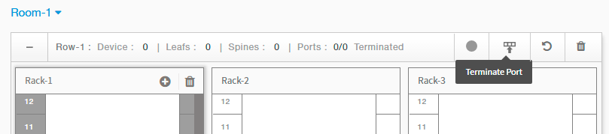

Selected preferred leaf and type of algorithm to use for calculation of leaf and placement.

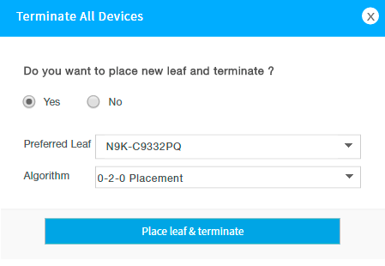

This adds switches to all the racks and calculates the port termination and updates inventory and port usage statistics. If there are unused switches after terminating ports, these are removed.

If some of the ports can’t be terminated, then termination status turns Red and hovering on this displays list of racks where there are not enough leaf ports for termination.

#### Revert

Automatically placed Leaf switches can be reverted by clicking revert button.

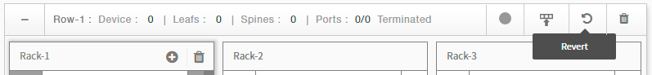

### Termination Workflow

Placement algorithms 1-1-1, 2-0-2, 0-2-2, and 2-2-2 may not be optimum algorithms for some of the deployments, but these are common patterns. Below are the steps while using these algorithms.

* Select Leaf, preferred algorithm and terminate.
* Go to racks which have termination errors, either manually add a new switch or modify devices.
* Click on terminate row again. This time, terminate without adding any new Leaf.
* Repeat the steps if there are still unterminated devices on racks.

### Placement Algorithms:

1-1-1: Places one switch on every rack

2-0-2: Places two switches on alternate racks.

0-2-0: Places two switches on alternate racks. Starts with no switch on first rack.

2-2-2: Places two switches on every rack.

### Leaf to Spine termination

Spine calculation is done at room level. Click the terminate button at room level. Select spine model and terminate. Spine switches are placed on racks designated as Network Racks and spine termination statistics is updated.

## Logical Sizer

Logical Sizer is a planning tool to calculate the number of leaf/spines required for an ACI based deployments. It can also use the Leaf and Spine switches from Physical sizer to place the logical topology on already existing physical infrastructure.

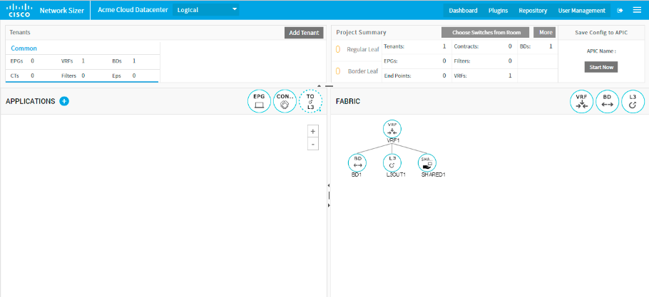

* Add a new tenant by clicking C:\build\cisco\dev-branches\ACISizer\src\main\webapp\images\plus-icon.png icon next to the title “Tenants”.
* Make sure newly created tenant is selected if not select it by clicking on the Tenant box.
* Add an application, by clicking C:\build\cisco\dev-branches\ACISizer\src\main\webapp\images\plus-icon.png icon next to the title “Applications”.
* In application creation wizard, select one of the pre-defined templates, for example, select 3-tier Application template.
* Select default options in subsequent steps and complete the wizard.
* An application is created with 3-EPGs, Contracts, L3out, and BDs of a typical 3-tier Web application.

Once you create a project, detailed view of the project similar to below this picture, is displayed.

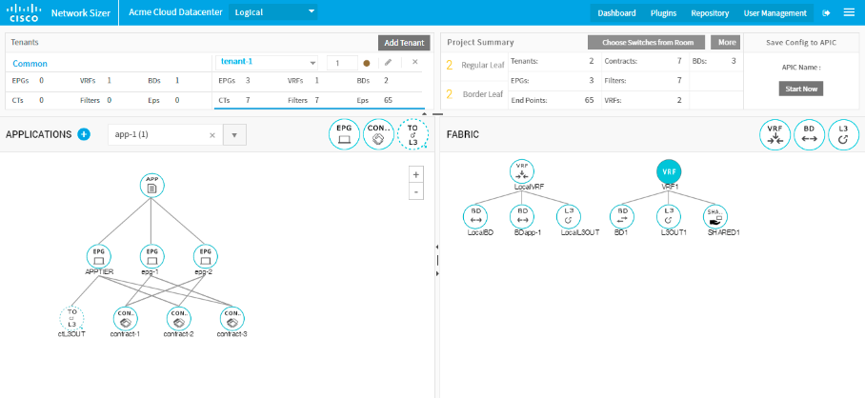

## Making changes to Logical requirements

The diagram editor (Application and Fabric pane) allows you to add new components or modify attributes of a component.

#### Add EPG

* Drag an EPG icon from the palette and drop it into application canvas area.
* A popup appears. Fill the attributes of EPG object and click update button.
* An EPG is created and is rendered below the application object.

#### Edit EPG

* Click an EPG object and select the object.
* Click the Edit icon/link in popup menu.
* Modify values and save.

#### Delete EPG

* Click an EPG icon.
* Click Delete icon.
* Confirm deletion.

These basic operations are similar for all objects, EPGs, Contracts, BDs, VRF and L3out. Below picture demonstrates these options for an L3out object.

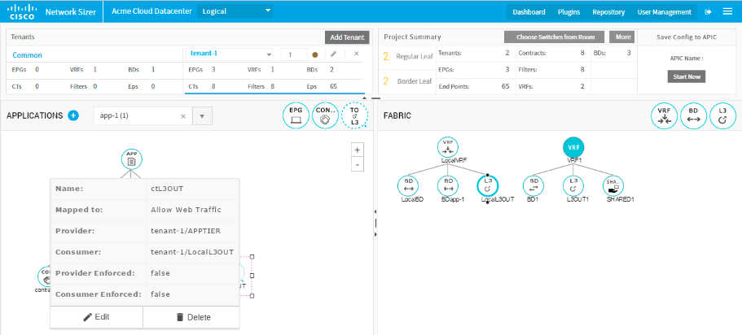

As you keep making changes to the objects, Sizing result is calculated and updated in Result box on top right corner of the application.

Logical sizer has two components, a planning tool for size estimation and making configuration changes on the APIC devices. Contracts can be mapped to the repository object which contains specific contract, filter and filter entry criteria. When a tenant is applied to an APIC, these changes are reflected on APIC.

## Configure contracts to use repository objects

Click contract object, select edit.

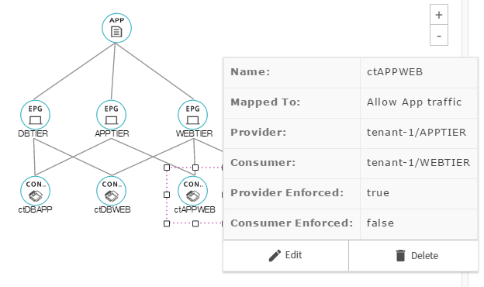

Select map button. This brings up a table with list of contracts from repository objects. Search required contract.

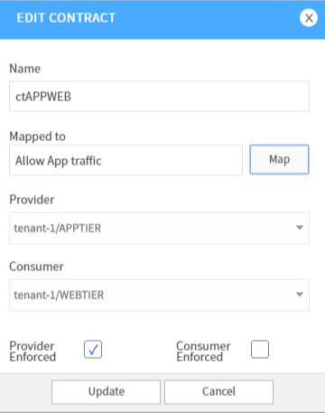

Select a contract and save.

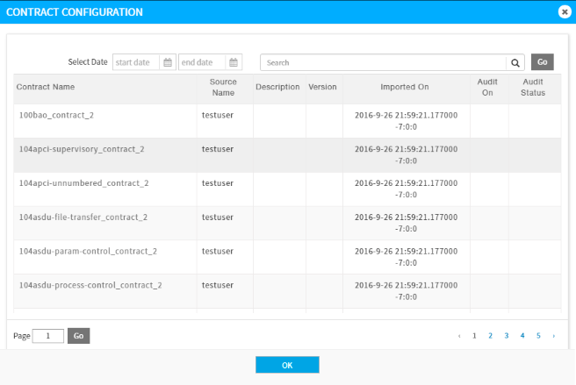

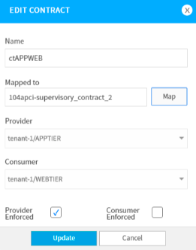

## Save configuration to APIC

Make sure APIC device is added to list of Devices under Repository page.

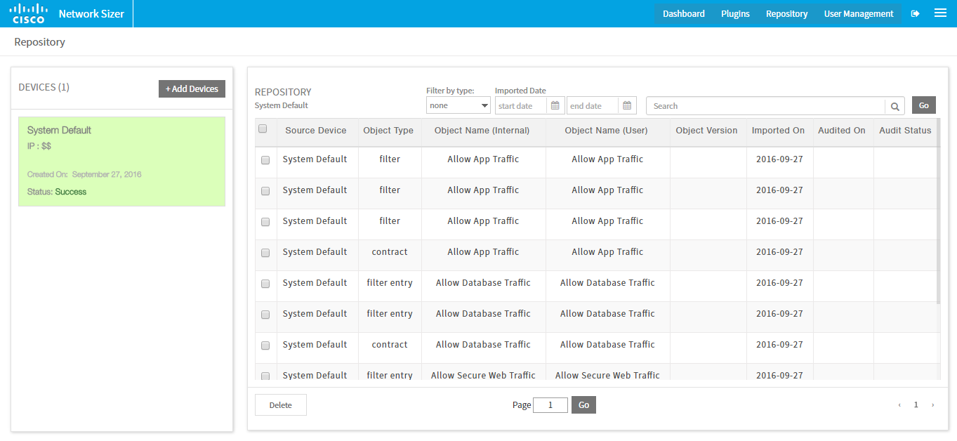

**Add APIC device**: Go to Repository section. Add APIC IP address, username and password under repository devices

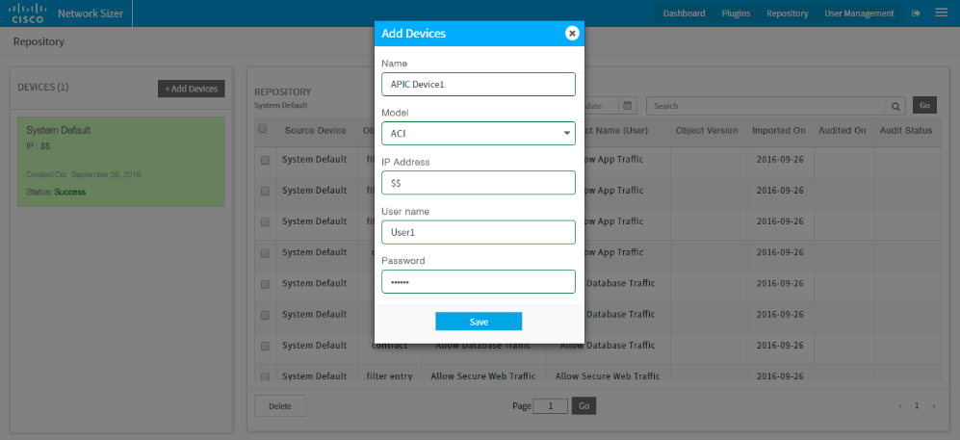

From project page, select the APIC device, select the tenants to be pushed and click on apply.

Tenant configuration is applied to APIC

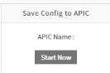

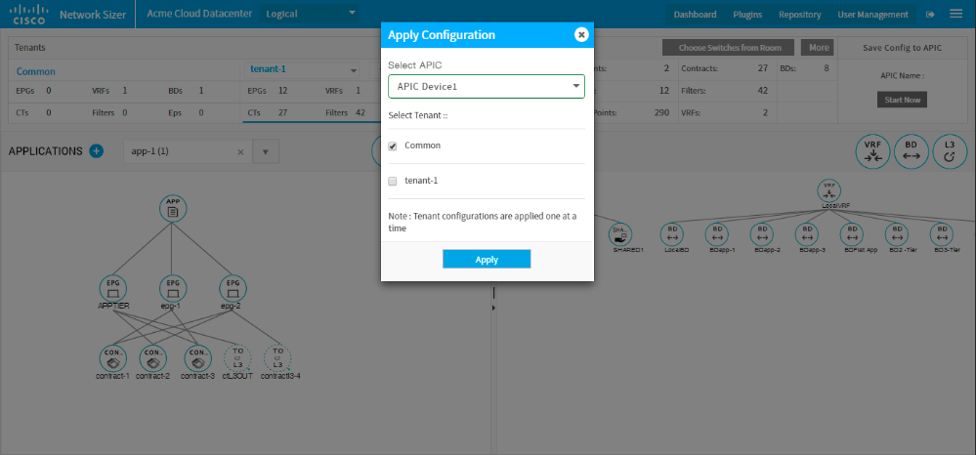

The tenant box has a status symbol which indicates whether configuration is successfully applied to APIC or not. If configuration of the tenant has changed since previous apply of configuration, same icon is used to indicate the tenant modification. This can be used to decide which tenant configurations have to be applied again.

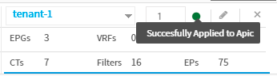

# Network Sizer GUI

Network Sizer UI consists of two main pages and several dialog boxes within each page. Below is the project list page. The titles are self-explanatory.

## Project List page

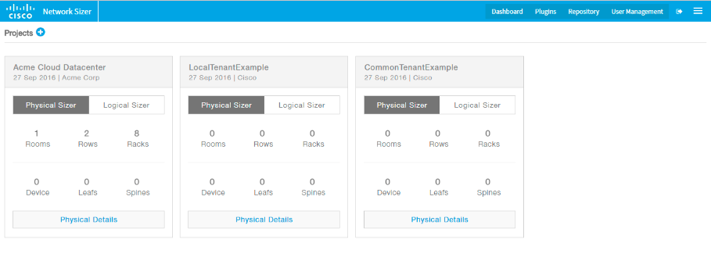

## Physical Sizer

### Build Datacenter

Add a new room.

Click “Add Room” icon to add a new Room for the Datacenter

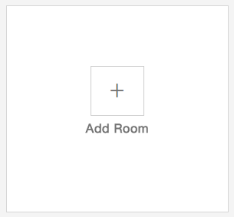

Fill in Rows, Racks per row, rack type and Policy details to create a room.

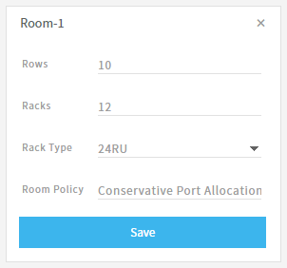 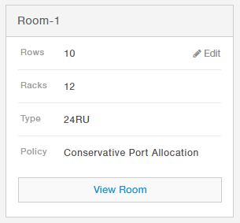

Click “View Room” to enter room level view. Room will showcase the no. of rows and racks created under each row with Room details on the right side pane.

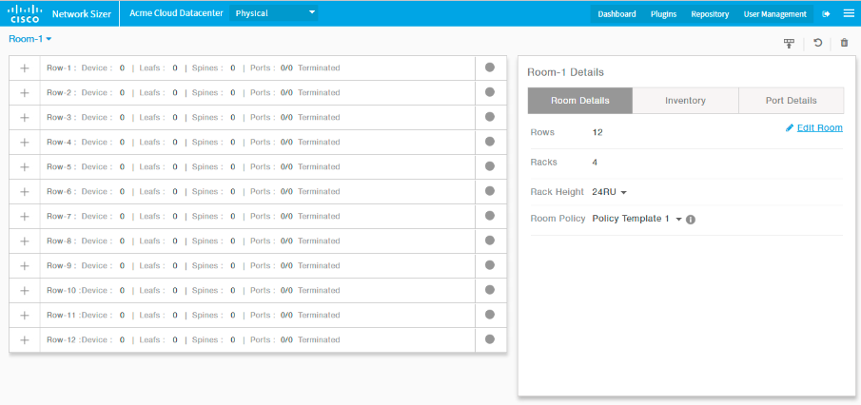

Click Row name to view “Row details” on the right side pane.

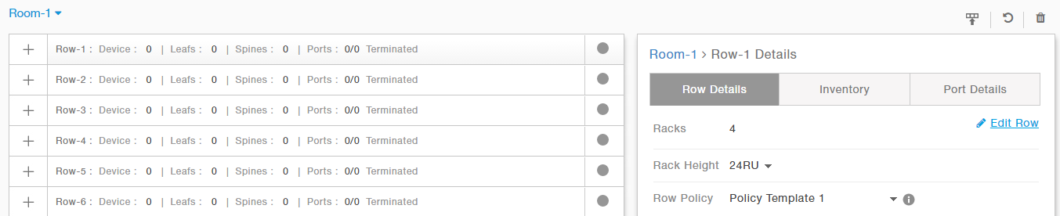

Click “+” icon on each row list to expand the row view. Click on a rack to select and view rack details on the right side pane.

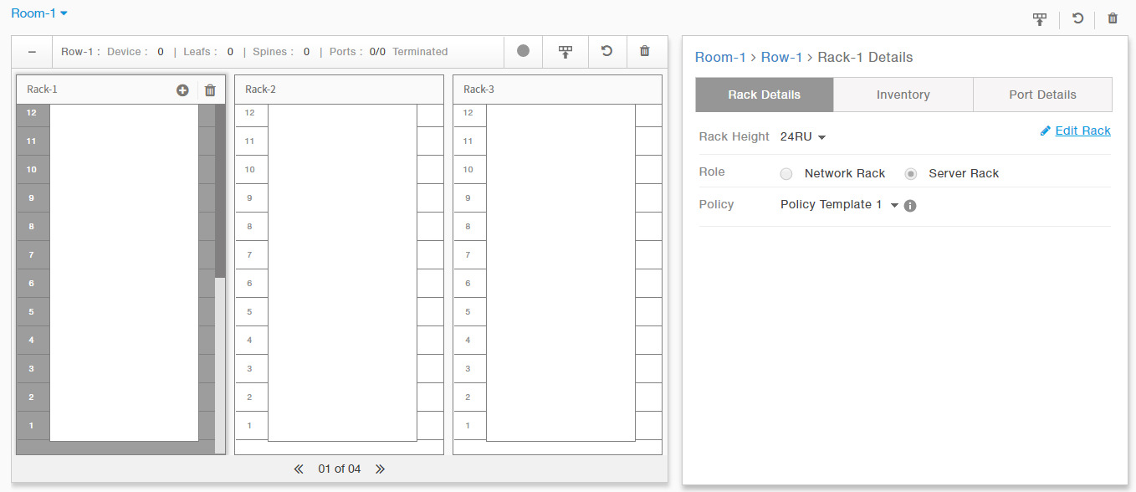

### Add devices to rack

Click “+” icon on top of each selected Rack to view list of devices popup dialog.

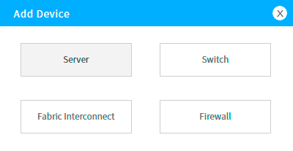

In this dialog choose Server or Fabric interconnect or Firewall or switch to add to rack.

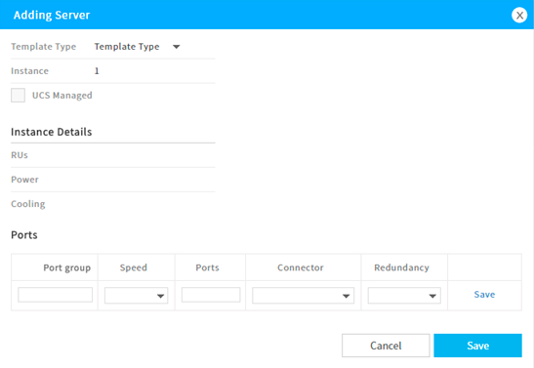

Fill in server details and click “Save” and. For most of the cases, you have to select only number of instances. The server descriptions are standard. If the network ports are customized for your server, you may have to add/delete/edit the port details.

Newly added servers are added from the bottom of the rack. Servers and Leaf can’t be added to a network rack.

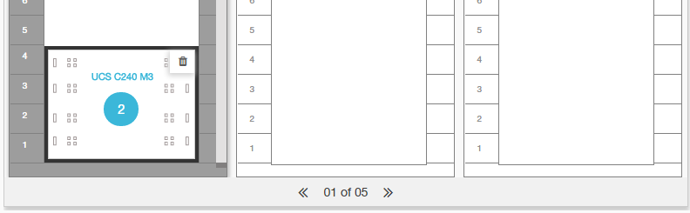Add switches to rack

Click “Switch” in the dialog.

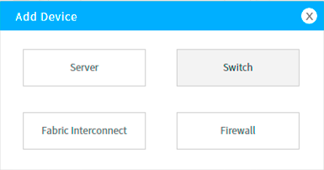

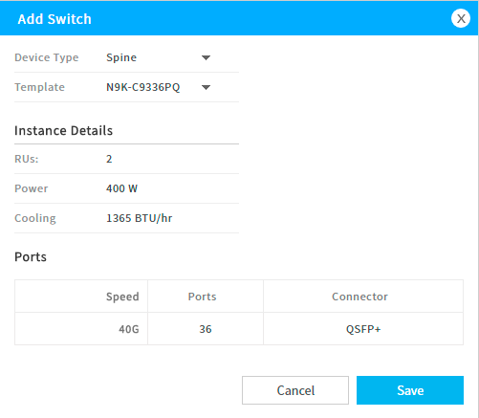

Choose Leaf or Spine from the Switch Type and fill in instance count to add a switch. Newly added switches are placed from top of the rack.

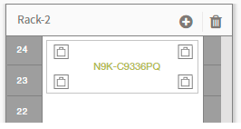

### How to interpret inventory

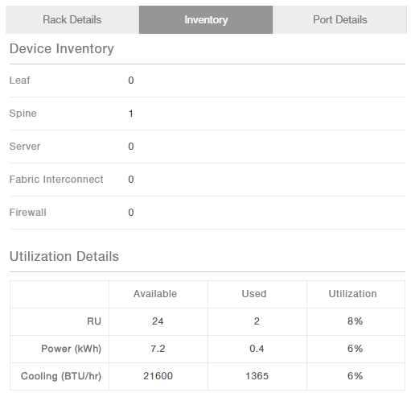

Inventory information at each level shows the sum of all devices in that hierarchy.

### Port termination and revert

**Row level Termination**

Click on Termination icon on the top right of row to terminate Ports.

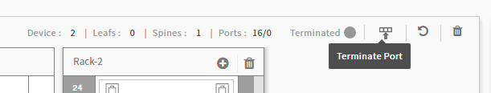

There are two options. Either to place new leaf and terminate or terminate without adding any new leaf.

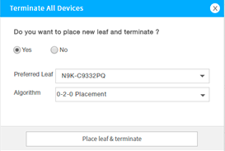 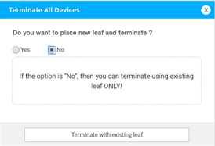

If some of the device ports are not terminated, then problematic racks are displayed when clicked on Red circle.

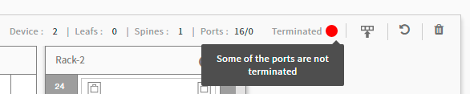

**Room level Termination**

Room level termination provides option to terminate all rows in one go, or selected rows and also spine placement and leaf to spine termination.

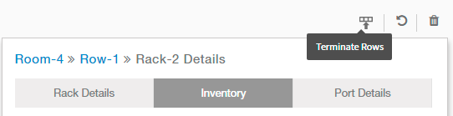

**Leaf Termination**

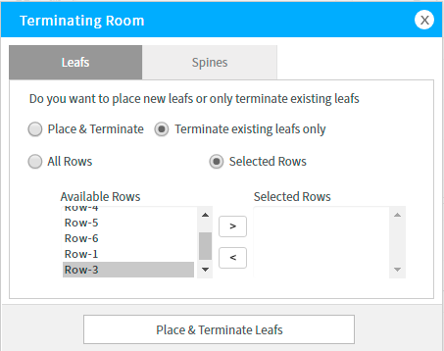

**Spine Termination**

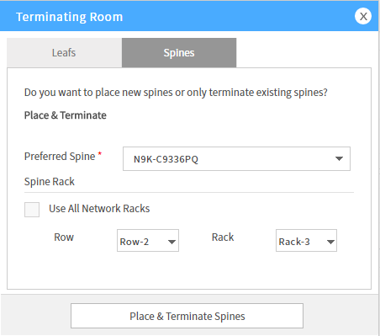

**Revert**

Click “Revert” icon on the right top of Row to remove automatically placed leafs.

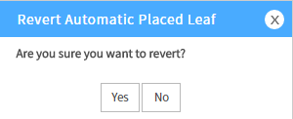

**Room Level Revert**

Click “Revert” icon on the right top of room to revert automatically placed leafs.

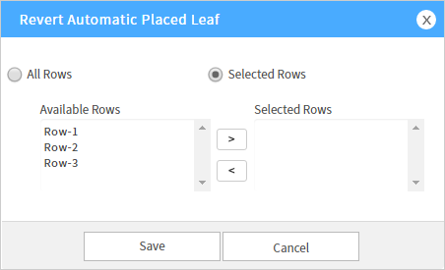

### How to interpret result

The goal is to have all the ports terminated for complete working network infrastructure.

Once termination is complete, view the port details. 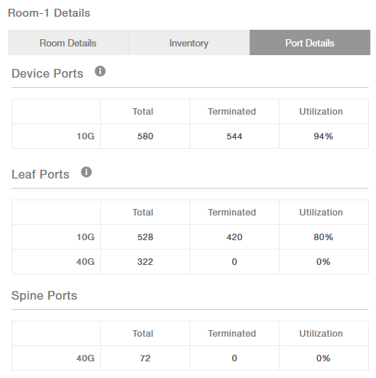

If there are devices having unterminated ports,

* Go to these racks. Either add server or delete server to different rack, or manually add a leaf and do row lever termination again (with existing leaf only)

Verify port utilization statistics. You make adjustments to bring down the utilization depending on the future growth requirement.

Similarly analyse the table containing spine port usage details.

## Logical diagram view

Logical diagram view consists of four area.

* Tenants
* Application Pane
* Fabric Pane
* Sizer Result box

Below image is a detailed view of Logical Diagram Editor and Result.

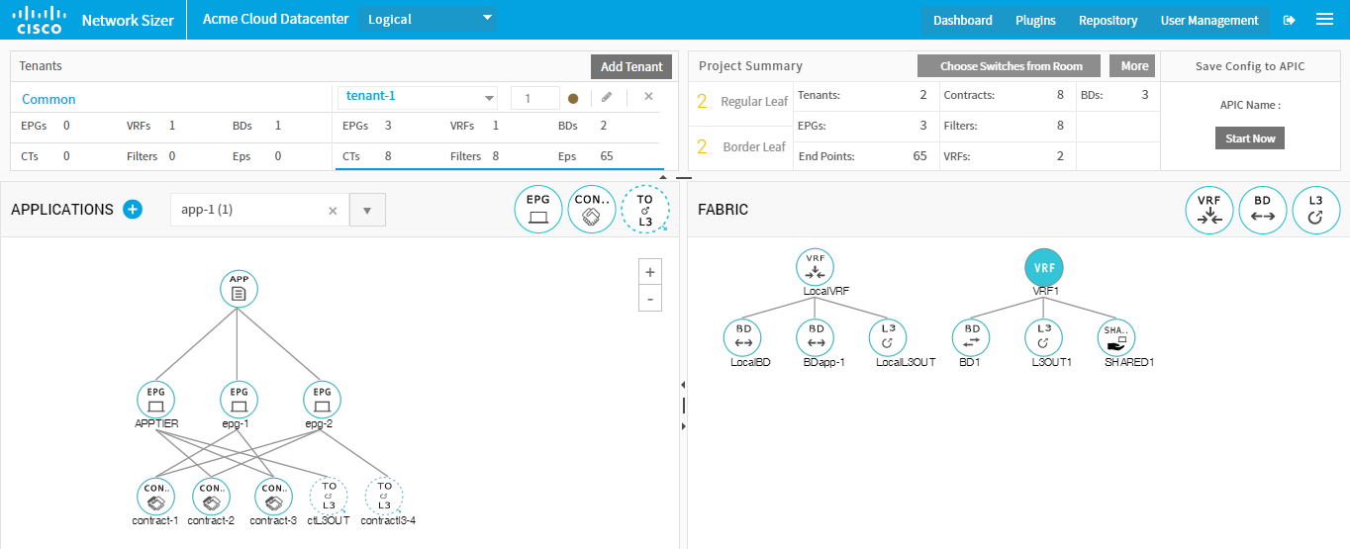

**Icons and the ACI objects**

Below are the icons and the ACI object which they represent.

|  |  |  |  |
| --- | --- | --- | --- |
| Icon | ACI Object | Icon | ACI Object |
|  | End Point Group |  | VRF of user tenant |
|  | Inter EPG Contracts |  | BD of user tenant |
|  | Contract to L3out |  | L3out of user tenant |
|  |  |  | Shared services |
|  | | VRF, BD and L3 out of common tenant | |

**Addition of new objects to application or fabric diagram:**

To add a new object to the diagram, drag the icon from palette and drop within diagram view. A dialog pops up, enter values for attributes of this object and save. This creates object. The dialog title and tooltips make it easy to enter values for these fields.

**Modification:**

To modify an object, click the object and then select Edit link in in popup.

**Move an Object:**

Click an object, hold the icon and move to new location.

### Results

Quick Result View: This displays leaf count and the workload summary in terms of count of different types of objects.

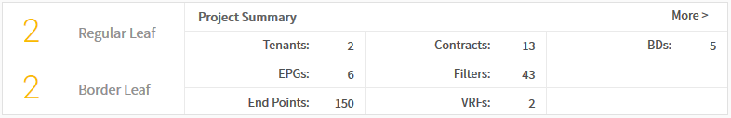

Detailed Result View: This view gives details about every switch. It also provides contents of quick result view.

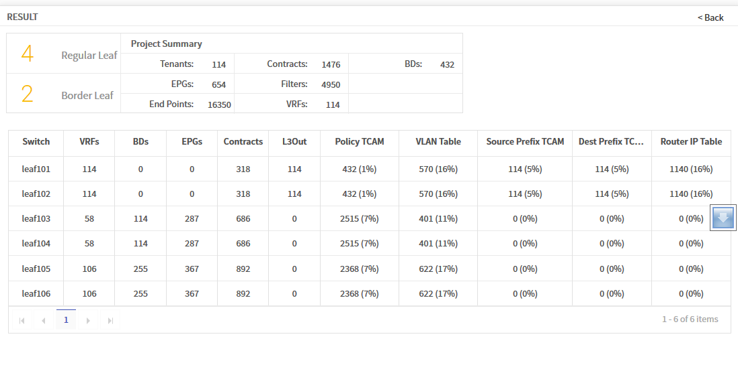

### Placement of logical topology on Physical infrastructure

This feature is not supported in this release. This feature allows selection of switches from Physical sizer to use in logical sizer result.



# Repository

Repository is collection of application configuration. Repository objects can be created by importing application configuration items from third party devices such as firewalls. These can be used in application configuration of ACI tenants.



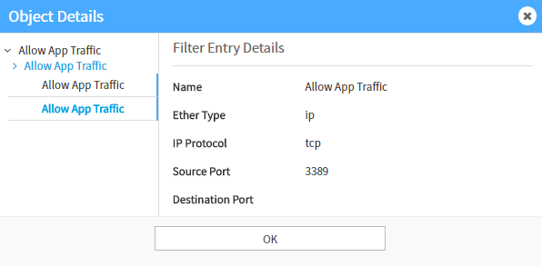

# Plugins

Plugins are components of Sizer application which retrieve data from specific type of device. Once a plugin is installed, it displays list of devices/models it supports. Devices of these types can be added to Repository and configuration can be imported from these devices.

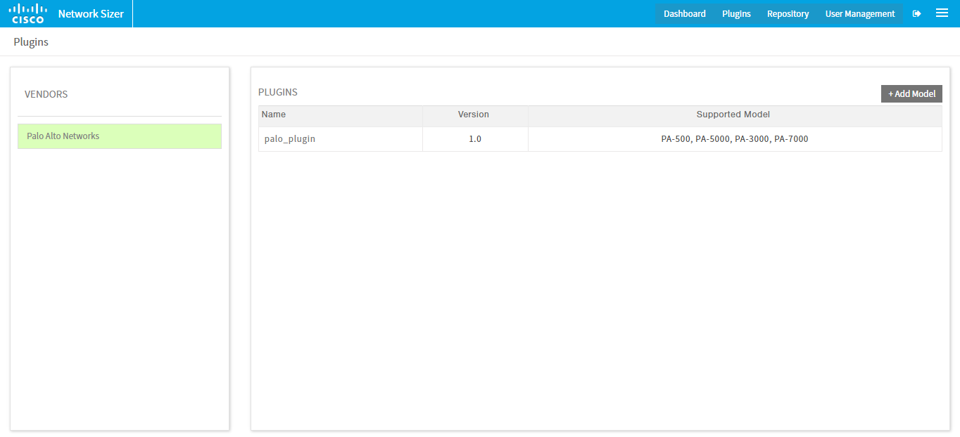

# User management

User management module is for administration of the users of the Sizer application. User management component is enabled only for those users having ROLE_ADMIN.

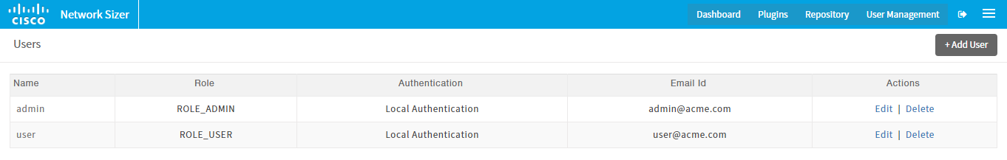

# Application Templates

Network sizer comes with predefined templates for some of the well-known application types. This helps in adding an application quickly and then it can be further customized based on specific requirement. An application created from a template can be edited and can be further customized.

Below are the details of predefined templates.

### Blank Application.

This is an empty application. Add EPGs, Contracts, L3outs based on your application requirement.

### Flat application.

This consists of, one EPG.

A BD under tenants common VRF.

An L3out contract from EPG to L3out under common VRF.

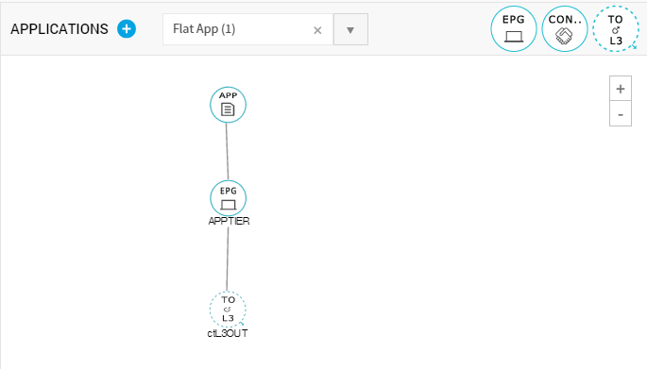

### 2-tier application.

This consists of, 2 EPGs representing database tier and application tier.

Application specific BD under common VRF.

Both the EPGs are placed under this BD.

There is a contract between these two EPGs and a contract from app tier to L3out for external connectivity

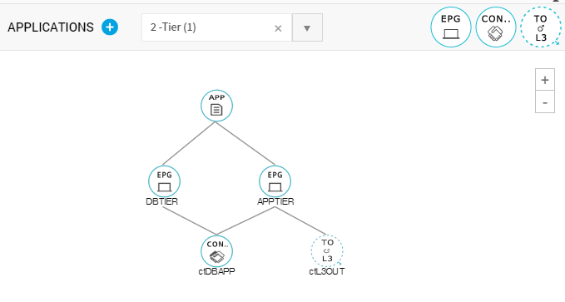

### 3-tier application.

This consists of 3 EPGs, representing Web tier, Application tier and Database tier.

Application specific BDs are created under common VRF.

Contracts between, these three EPGs.

An L3out, connecting Web tier EPG to external network is also created.

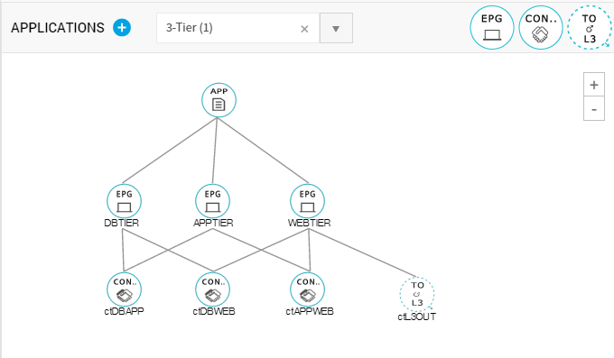

Application and Fabric view for a project having all types of applications.

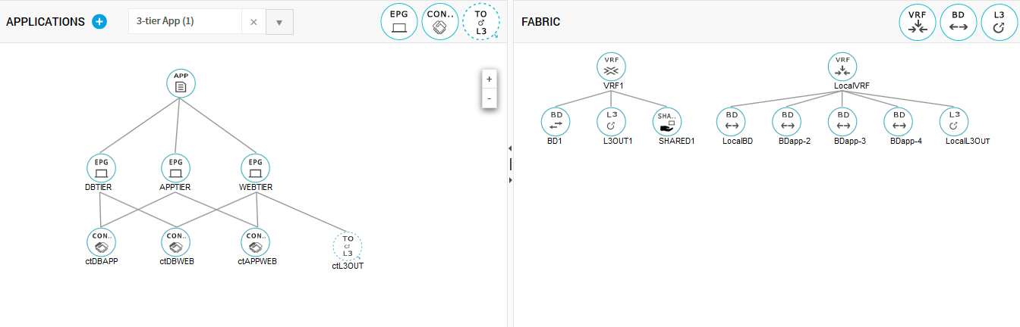

# Tenant, Application Properties and Sizing.

Below are the details of the attributes used in Tenant and application objects.

**Tenant Properties**

|  |  |
| --- | --- |
| **Attribute** | **Meaning** |
| Name | Tenant Name |
| Instance | This decides how many copies of the same Tenant has to be used for sizing. |
| VRF | * Local VRF: Creates a local VRF under user tenant. Application templates use this VRF. * Use common tenant VRF: A local VRF is not created. Instead applications use common VRF which is part of common tenant. |
| External Connectivity | This attribute defines how to use L3out.   * Create dedicated L3out: An L3out is created within Tenant Fabric. * Use Common L3out: L3out object of common tenant is used. |
| L3out complexity | Defines the number of interfaces in an L3out object |

**Application object:**

|  |  |
| --- | --- |
| **Property** | **Meaning** |
| Name | Application Name |
| Application instance | This decides how many copies of the same application has to be used for sizing. In diagram view, only one copy is rendered. Instance count is indicated next to application name. |
| BD Policy | * Unique BD: For each application instance, one BD is created under the tenant's VRF. The diagram view shows only one BD. Instance count is displayed in a bubble on top of BD. * Default BD: All instances use same BD. Specific BD (local or common tenant) depends on the BD policy selected while creating tenant. |
| BD Subnet policy | * Unique BD subnet per EPG: Every EPG of the application is placed under unique subnet with in BD. * Default subnet: All EPGs use the default subnet of the BD |
| EPG complexity | Defines the number of end points within EPG. |
| Inter EPG contract complexity | Defines the number of filters |
| Shared services contract | If this is selected, an internal contract is created (this is not shown in UI) between each EPG of the application and the shared service object of common tenant |