Cisco Network Sizer

OVA Deployment Guide

Release 2.0

Contents

Introduction 3

Deploy OVA 3

Configure Virtual Machine 6

User credentials 6

Access Sizer Application 6

# Introduction

This document describes steps in setting up of a VM and Sizer application from an OVA.

Please download CiscoNetworkSizer.ova and follow below steps to deploy in a VMWare ESXI/vCenter.

# Deploy OVA

Step 1: Open vSphere client. Go to File->Deploy OVF Template

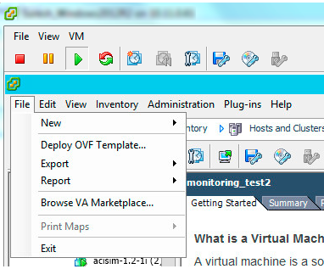

Step 2: Select the OVA file you want to deploy from the disk and click next

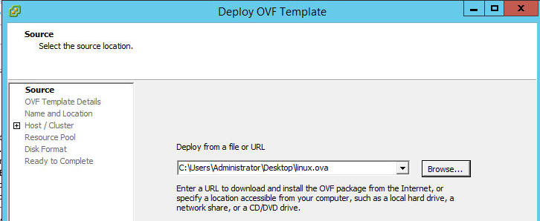

Click next after reading summary in OVF templates details

Step 3: Give a name for the VM and click next

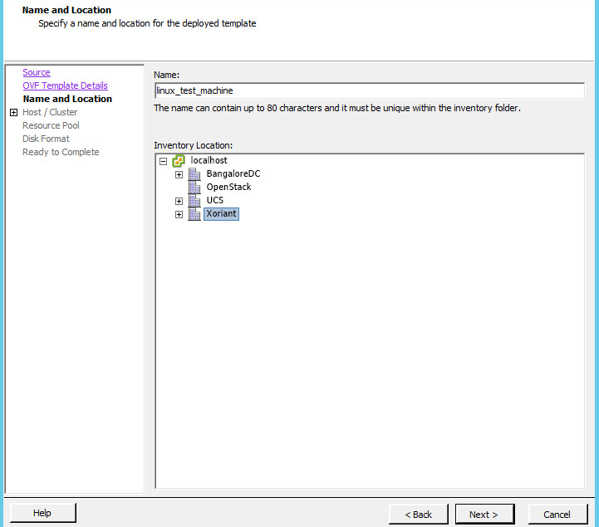

Step 4: Select resource pool and click next

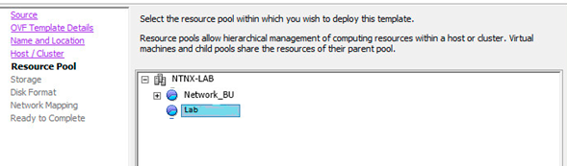

Step 5: Select datastore where you want to deploy the VM and click next.

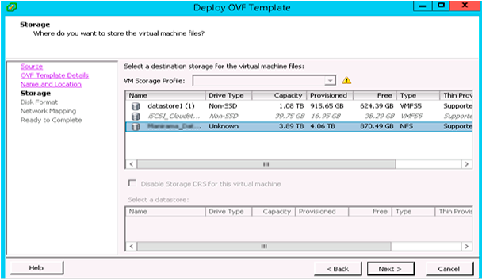

Step 6: Select power on VM after deploy and select finish

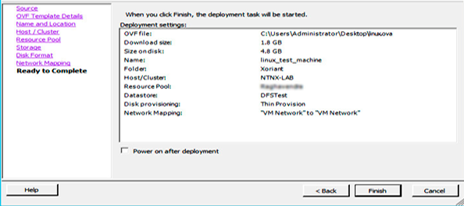

Wait for the deployment task to complete.

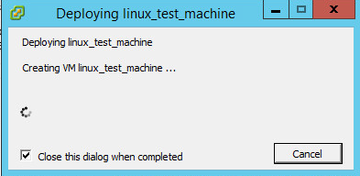

After Completion, success message is displayed.



# Configure Virtual Machine

## User credentials

Virtual appliance is configured with below user.

Username: appadmin

Password: password

Virtual machine is configures with DHCP IP address. Power on the VM, login to VM and note down the IP address.

If your environment requires static IP address for VMs, please configure static IP address by editing configuration file, /etc/network/interfaces.

The ACI sizing result calculation binary is not bundled with the appliance. If you have access to this binary, please copy this to /home/appadmin/sizer/acitool. Without this, logical sizer results are not calculated.

# Access Sizer Application

Access application using URL https://<<IP address>>/

Use below credentials to login to application.

User name: admin

Password: admin

Refer application user guide for more information on application features.