Stress Trained Stacking Model Improves Flood Report Probability Scoring under Incomplete Rainfall Observations
Masrizal^{1*}, Ibnu Rasyid Munthe², Bhakti Helvi Rambe³, Shabrina Rasyid Munthe⁴, Sudi Suryadi⁵
^{1,2,5}Information Systems, Faculty of Science and Technology, Universitas Labuhanbatu, Rantauprapat, Indonesia
³Accounting, Faculty of Economics and Business, Universitas Labuhanbatu, Rantauprapat, Indonesia
⁴Informatics Engineering, Faculty of Computer Science, Universitas Al Washliyah Labuhanbatu, Rantauprapat, Indonesia
*Corresponding author: Masrizal, masrizal120405@ulb.ac.id

Abstract
Incomplete rainfall observations challenge both probability estimation and event prioritization. This study evaluates stress trained stacking with uncertainty and observation quality features for flood report prediction in West Java, Indonesia. The analysis covers 59,184 region days from 2020 to 2025 and compares nine calibrated models. On the exploratory 2025 evaluation of 9,855 region days with 296 positive reports, Stress achieves the highest average precision point estimate of 0.106197 and the lowest Brier score of 0.028106. Relative to standard stacking, these values represent a 6.30% AP increase and a 0.55% Brier reduction. Paired station masking provides the strongest evidence of its probability scoring advantage. Across twelve missingness conditions with 100 replicates each, Stress improves mean Brier score in every condition and wins 98.75% of paired comparisons against standard stacking. Against HistGB, it wins all 1,200 AP comparisons and 99.58% of Brier comparisons. Standard stacking retains higher mean AP under additional missingness, identifying a distinction between probability scoring and ranking objectives. Stress also achieves onset AP of 0.064948 and captures 31.42% of recorded positive region days at three daily flags. These results support stress training as a promising approach for probability scoring under the evaluated observation losses. Repeated use of 2025 during development makes the findings exploratory. Independent forward evaluation remains necessary for operational claims.
Keywords: flood report prediction, stress training, stacking, rainfall missingness, Brier score

I. INTRODUCTION

A. Prediction problem and practical relevance
Machine learning supports riverine forecasting in ungauged watersheds [1], but administrative flood reports represent a different target. Report prediction combines physical event occurrence with recording practices. Evaluating this target requires explicit labels, information horizons, and probability measures.
Flood prediction reviews emphasize input selection, forecast horizon, and study setting [2], [3]. Hybrid process and data driven forecasting extends evaluation to probabilistic outputs [4]. These developments motivate testing probability quality under observation loss.

B. Literature synthesis and unresolved questions
Unresolved flood modelling issues include calibration and spatial and temporal uncertainty [5]. Useful rankings need not provide calibrated probabilities [6]. Structured observation gaps can also change predictor distributions [7]. Their interaction motivates a direct comparison of probability scoring and ranking under station loss.
We ask whether stress trained stacking improves flood report probability scoring under incomplete rainfall observations. Nine models compare individual learners, a seasonal baseline, and stacking variants with uncertainty proxies, observation quality features, and stress augmentation.

C. Study objective and contribution
Identical station masks and labels support paired comparisons across missingness mechanisms and severity levels. Onset ranking and daily screening capacity assess whether probability gains extend to alternative objectives.
Repeated development use of 2025 makes the evaluation exploratory. Chronological fitting limits direct future dated training leakage but does not remove this selection history [8].

II. LITERATURE REVIEW

A. Flood prediction targets and model combination
Flood report prediction estimates a documented regional event under the dataset’s recording process. Comparisons require compatible outcomes and evaluation populations.
Global ungauged riverine forecasting [1] addresses observation scarcity, but its physical target prevents direct score comparisons with administrative reports.
Reviews motivate individual learners, ensembles, and data strategies [2], [3]. A seasonal baseline tests whether these models add predictive value.
Hybrid probabilistic forecasting [4] motivates evaluating probability quality alongside ranking when station observations disappear.
Stacked generalization combines base predictions [9]. Chronological out of fold prediction supplies meta training examples from dates later than each base model’s fitting window.
Random forests [10] and gradient boosting [11] capture nonlinear relationships. Logistic regression adds a linear log odds model. Their diversity motivates, but does not guarantee, stacking gains.

B. Probability quality and discrimination
Ranking prioritizes cases; probability scoring evaluates assigned probabilities. A monotonic transformation can preserve ranking while changing probability error. Both objectives therefore require separate evaluation.
Calibration measures agreement with observed frequencies [6]. Disagreement and entropy do not independently identify aleatoric or epistemic uncertainty [12]; we treat them as predictive features.
Precision recall analysis evaluates positive retrieval under class imbalance [13]. AP depends on ranking and prevalence, so different eligibility sets define different comparisons.
Brier score is a proper scoring rule [14]. Lower squared probability error alone does not establish better calibration or operational utility.
Reliability diagrams describe probability agreement [15]. Calibration estimation depends on the assessment procedure [16]; evaluating frozen scores differs from replacing them with newly calibrated scores.
T-Cal provides finite sample calibration testing [17]. We use descriptive calibration and scoring, without claiming a formal calibration guarantee.

C. Missing observations and temporal evaluation
Structured missingness includes station outages, temporal gaps, and quality dependent losses [7]. Equal nominal removal rates can produce different regional predictors.
Coverage features describe observation support but may also encode regional recording practices. Their value requires evaluation under changing station availability.
Paired masks and recomputed regional features isolate relative performance under specified disturbances. Replicate variation describes simulation spread conditional on this dataset.
Date ordered fitting does not reverse repeated development use of 2025 [8]. Independent outcomes remain necessary for confirmation.
Date block resampling retains temporal sequences [18] and all regions within each sampled date. Block lengths of 7, 14, and 30 days assess dependence sensitivity.

D. Research gap and analytical framework
The research gap concerns how stress training changes probability scoring and ranking for regional reports under matched station losses. Standard stacking and HistGB provide ensemble and individual learner benchmarks.
Table 1. Relationship between prior research and the present study
Research stream | Verified contribution | Present comparison
Flood forecasting [1], [2], [3] | Learning across locations and reviewing model combinations | Report occurrence as a distinct administrative target
Hybrid forecasting [4] | Combination of process and data driven forecasts | Matched quality and uncertainty stacking variants
Calibration [6], [15], [16], [17] | Probability assessment, diagrams, and testing concepts | Brier, descriptive calibration, and explicit inference limits
Structured missingness [7] | Learning with patterned observation gaps | Paired station perturbations and recomputed predictors
Evaluation integrity [8], [18] | Leakage awareness and dependent resampling | Exploratory reused year with date block sensitivity

III. METHOD

A. Data provenance and outcome construction
We use Mendeley Data version 1, DOI 10.17632/d7j3s64vvr.1 [19], covering 460 rainfall stations, 4,231 source flood records, and 2020 to 2025. The full rainfall matrix, flood catalogue, and station metadata define all dates, including dates without reports.
Station and administrative name normalization preserves cities and regencies. The manifest confirms identifiers for 458 of 460 headers. Regional aggregation retains only station columns with resolved administrative mappings. Checks cover duplicate dates, numeric and negative rainfall, and geographic consistency. The panel contains 27 regions across 2,192 days, or 59,184 region days. Collapsing same region and date reports yields 1,358 positives.
The outcome equals one for at least one catalogue report and zero otherwise. Zero indicates no recorded report, not verified flood absence. The estimand concerns recorded reports under the represented observation and reporting processes.
Figure 1 summarizes the workflow. Regional rainfall means use available mapped stations; pipeline imputers handle missing values within their fitting boundaries.
$c_{r,t}=\frac{N_{r,t}}{S_{r}}$ (1)
In Equation (1), Nᵣ,ₜ counts observed mapped stations and Sᵣ counts retained mapped stations in region r. Coverage is undefined when Sᵣ = 0. Predictors use earlier dates.
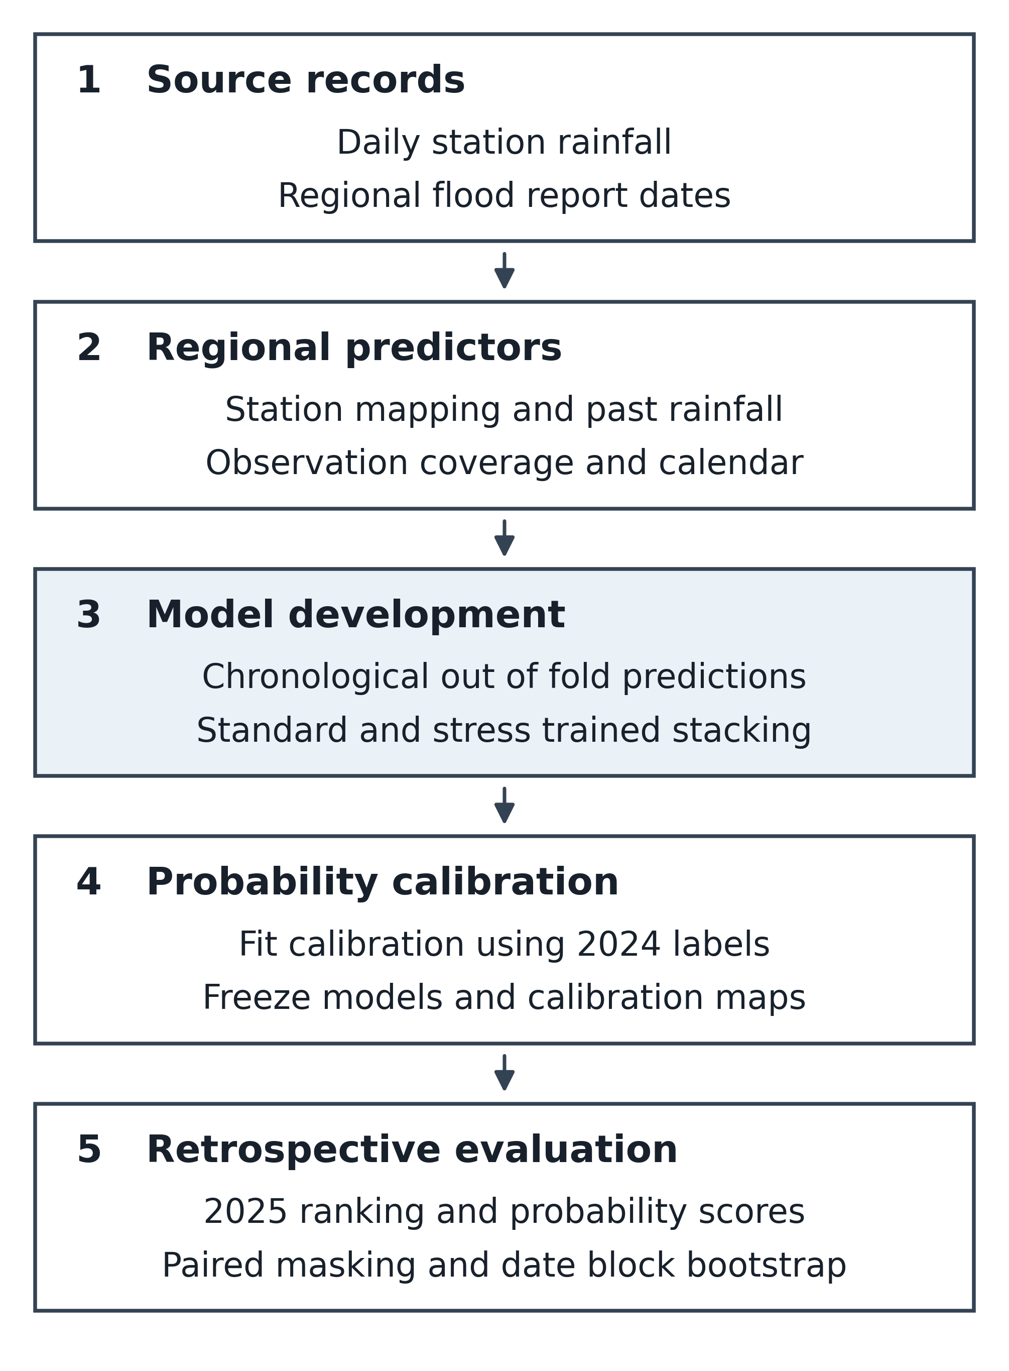
Figure 1. Computational workflow for regional feature construction, chronological stacking, calibration, and retrospective evaluation.

B. Predictors and chronological estimation
Predictors comprise regional mean and maximum rainfall at lags of 1, 2, 3, and 7 days, preceding 3 and 7 day sums of regional mean rainfall, observed day counts, wet day counts and fractions, and lagged observation coverage. A wet day uses regional mean rainfall above 1 mm. Missing observations do not count as dry days. Additional predictors include the lagged number of observed stations, mapped station count, sine and cosine terms for calendar month, and indicators for administrative unit.
Rainfall and coverage predictors precede the labelled date. Missing observations remain missing when rolling windows lack sufficient data. Date alignment does not verify operational availability, so the analysis does not establish a 24 hour warning horizon.
Table 2 defines fitting in 2020 to 2023, calibration in 2024, and exploratory evaluation in 2025. Four expanding folds predict January to June and July to December in 2022 and 2023. Each fold fits preprocessing and base learners on strictly earlier dates. Final base estimators refit on all 2020 to 2023 records (Figure 2).
Table 2. Temporal partitions and recorded outcomes
Role | Years | Region days | Positive
Training | 2020-2023 | 39,447 | 802
Calibration | 2024 | 9,882 | 260
Exploratory evaluation | 2025 | 9,855 | 296
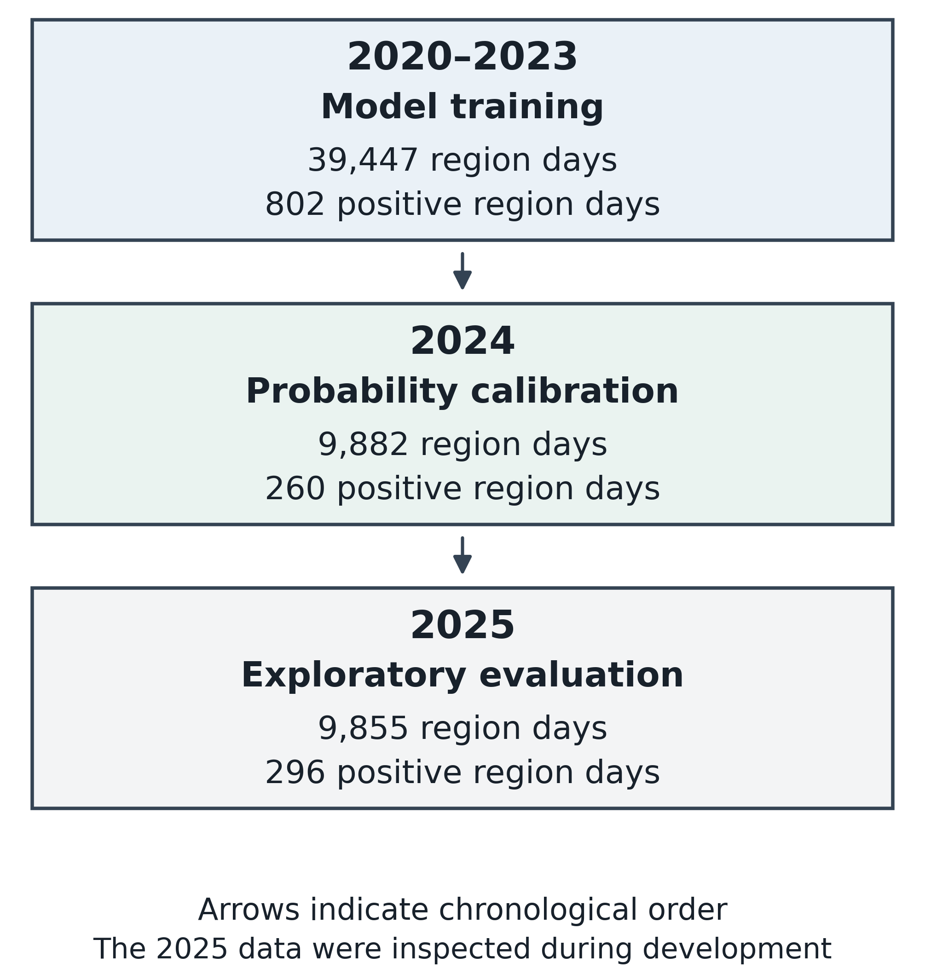
Figure 2. Chronological data partitions and region day counts. The 2025 evaluation remains exploratory because development repeatedly used these data.
Stacking [9] combines logistic regression, random forest [10], and histogram gradient boosting [11] probabilities. A seasonal regional baseline uses month and administrative indicators. All models share labelled partitions.
Table 3. Frozen experiment identity and resampling settings
Record | Value
Audit version | v18 reporting notebook; embedded audit version v15.0
Model pipeline | v8.0.0 locked temporal missingness prospective audit 20261018
Model signature | fe8bc39e393c2c1d
Feature version | lagged region rainfall v3
Random seed | 42
Missingness replicates | 100 per mechanism and severity
Main bootstrap | 1,000 replicates with seven day date blocks
Calibration bootstrap | 600 replicates with seven day date blocks

C. Uncertainty proxies and stress training
Standard uses three base probabilities. Uncertainty only adds their standard deviation and mean binary entropy. Quality only adds lag 1 coverage, prior 3 and 7 day mean coverage, and mapped station count. Full combines both additions. These proxies do not establish an aleatoric and epistemic decomposition [12].
$u_{i}=\sqrt{\frac{1}{M}\sum_{m=1}^{M}{{(p_{im}−\bar{p_{i}})}^{2}}}$ (2)
$h_{i}=−\frac{1}{M}\sum_{m=1}^{M}{[p_{im} ln p_{im}+q_{im} ln q_{im}]}$ (3)
Equations (2) and (3) define population standard deviation and mean binary entropy across M = 3 base learners. Here pᵢₘ denotes an uncalibrated probability, p̄ᵢ its learner mean, and qᵢₘ = 1 − pᵢₘ. Entropy uses natural logarithms after clipping probabilities to [0.000001, 0.999999].
Equation (4) maps meta inputs zᵢ to score sᵢ. Median imputation and standard scaling precede logistic regression with C = 0.2 and max_iter = 1500. Chronological out of fold examples fit β and β₀; variants differ in inputs and augmentation.
$s_{i}=σ(β_{0}+β^{T}z_{i})$ (4)
The logistic function σ(v) equals 1 divided by 1 + exp(−v). Equation (4) defines the implemented meta model. The logistic base learner uses C = 0.5, max_iter = 1200, balanced class weights, median imputation, and standard scaling. Random forest uses 125 trees, maximum depth 13, minimum leaf size 9, square root feature sampling, and balanced subsample class weights. Histogram gradient boosting uses 135 iterations, learning rate 0.06, at most 15 leaf nodes, minimum leaf size 35, and L2 regularization 3.0. Both tree pipelines use median imputation. Stochastic estimators use random seed 42.
Stress training augments the chronological out of fold meta features after masking station readings and recomputing regional predictors. Each of the four folds contributes one augmented set per mechanism. Training masking levels are 10% for independent cell removal, 20% for whole station outages, 30% for seven day temporal blocks, and 20% for quality dependent removal. Quality dependent removal weights use missingness histories preceding the relevant feature window. A 14 day prefix supplies lag and rolling feature context. The clean and augmented example groups each receive half of the total fitting weight, with uniform weights within each group. This training schedule differs from the evaluation grid of 10%, 20%, and 30% loss for each mechanism with 100 paired replicates per condition.
Each learner receives a separate logistic calibrator fitted on its clipped raw score logits and the 2024 labels, using C = 1.0 and max_iter = 1200. Scores are clipped between 0.000001 and 0.999999 before logit calculation. Calibrators remain fixed during 2025 evaluation. The descriptive calibration fit on 2025 assesses the frozen probabilities and never replaces them. The implementation also selects F1 maximizing thresholds on 2024. Those thresholds do not determine AP, Brier, or the daily top k ranking reported here. Median imputation and scaling fit within the relevant estimator training boundary.
$π_{i}=σ(a+b logit(s_{i}))$ (5)
Equation (5) maps score sᵢ to probability πᵢ using coefficients a and b fitted on 2024. The logit equals ln(s/(1 − s)). Shared calibration and threshold selection make apparent 2024 performance non-independent.
Table 3 identifies the frozen experiment. Notebook settings and manifest workbook hashes reproduce signature fe8bc39e393c2c1d. This confirms configuration consistency without rerunning training or independently verifying upstream transformations. Complete reproduction still requires the saved model bundle, package versions, and hardware record.

D. Evaluation and paired sensitivity analysis
Brier score evaluates probability error [14]; AP evaluates positive ranking [13]. AUROC supplements discrimination. These priorities interpret exploratory results and do not imply preregistration or calibration superiority.
$AP=\sum_{k=1}^{K}{(R_{k}−R_{k−1})P_{k}}$ (6)
Equation (6) sums precision Pₖ weighted by recall increments across K descending score thresholds, with R₀ = 0. Equal scores enter together; the calculation uses no trapezoidal interpolation.
$BS=\frac{1}{n}\sum_{i=1}^{n}{{(π_{i}−y_{i})}^{2}}$ (7)
$ΔAP={AP}_{stress}−{AP}_{benchmark}$ (8)
$ΔBS={BS}_{benchmark}−{BS}_{stress}$ (9)
Equation (7) averages squared errors over n binary outcomes yᵢ and frozen probabilities πᵢ. Equations (8) and (9) define Stress minus benchmark AP and benchmark minus Stress Brier. Positive values favor Stress. Reliability diagrams [15] and descriptive logistic intercept and slope assess frozen predictions without replacing them [16]. Ideal values are zero and one.
Formal testing such as T-Cal [17] addresses a separate calibration hypothesis. We report descriptive agreement and score uncertainty.
Four masking mechanisms use 10%, 20%, and 30% target additional loss, with 100 paired replicates per condition. Models share masks and labels. We rebuild rainfall and quality features and apply frozen estimators and calibrators. Quantiles describe disturbance variability rather than future generalization confidence intervals.
Non-circular moving date blocks retain all regions per date [18]. We use 1,000 seven day resamples and 300 each for 14 and 30 day sensitivity analyses. Percentile intervals and Bonferroni sensitivity cover four contrasts across three block lengths. Small adjusted tails have limited Monte Carlo precision. Resampling cannot correct repeated use of 2025.
Onset eligibility requires seven preceding complete days without a report. We rank eligible examples using original report day scores, without treating them as calibrated onset probabilities. Daily screening flags the highest ranked one, two, or three regions and counts captured positive region days. Unmatched flags do not establish physical false alarms.

IV. RESULTS AND DISCUSSION
The nine model comparison separates probability scoring, ranking, perturbation sensitivity, and screening capacity. All 2025 findings remain exploratory.

A. Evaluation population and temporal change
Tables 2 and 4 summarize the 59,184 region days. Evaluation contains 9,855 examples and 296 positives, with prevalence 3.0036%. The common observation frame comes from the source dataset [19].
Table 4. Temporal population, report prevalence, and mean lag 1 station coverage
Role | Years | Region days | Cases | Rate (%) | Cover (%)
Training | 2020–2023 | 39,447 | 802 | 2.03 | 93.92
Calibration | 2024 | 9,882 | 260 | 2.63 | 97.72
Exploratory evaluation | 2025 | 9,855 | 296 | 3.00 | 99.73
Report prevalence rises from 2.03% in training to 3.00% in 2025, while mean lag 1 coverage rises from 93.92% to 99.73% (Table 4; Figure 3). These changes do not identify contributions from physical hazard, reporting, or station operations. High observed coverage motivates separate perturbation tests.
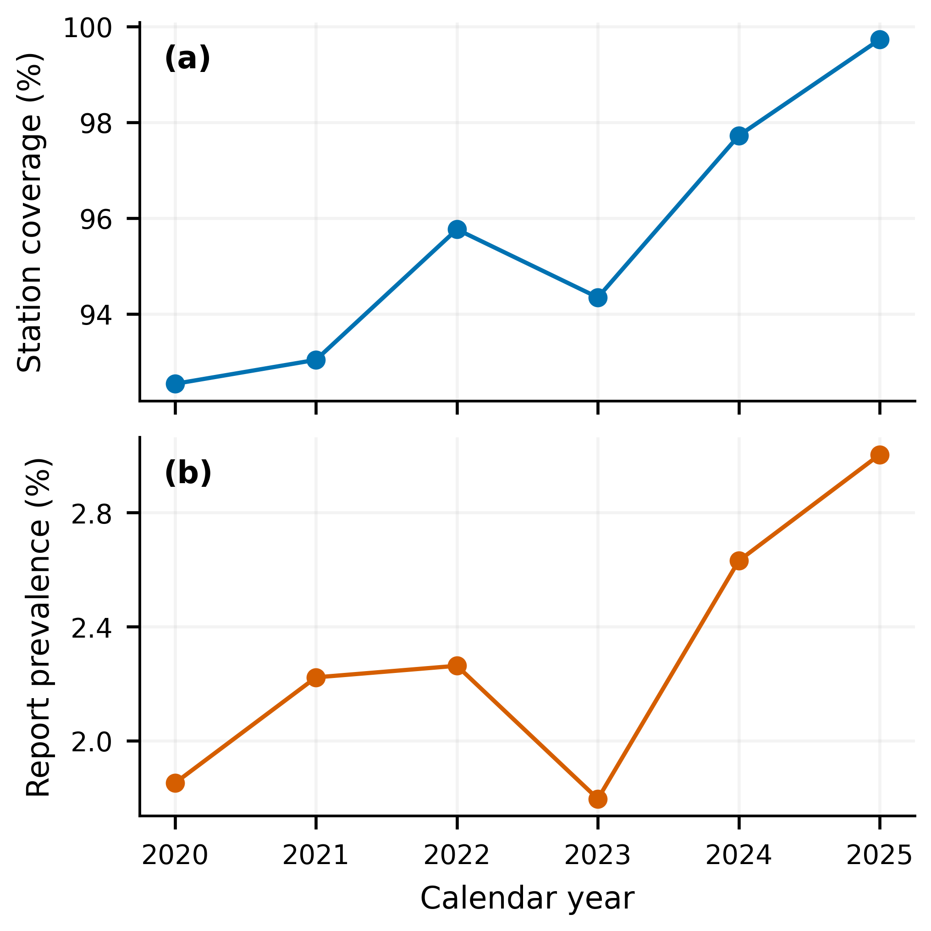
Figure 3. Annual lag 1 station coverage and recorded report prevalence. Coverage averages use region day counts as weights.
Only 11 of 27 evaluation regions contain at least ten positives; regional counts range from one to 44. Mean coverage ranges from 95.65% to 100%. Sparse positives restrict regional inference, and aggregate coverage does not resolve unmatched source identifiers.
Caravan demonstrates standardized hydrological records [20], while forcing comparisons show that dataset choices affect performance [21]. Observation uncertainty also affects interpretation [22]. Station denominators and report ascertainment therefore matter when assessing small score differences.
Flooding digital twins require reliable data arrival [23], and missing input models address inference time gaps [24]. High recorded coverage alone establishes neither timely availability nor robustness to actual outages.

B. Ranking and probability quality
Table 5 compares nine models. Stress adds augmentation to Full’s uncertainty and quality inputs. Brier skill measures relative error reduction against the seasonal baseline.
Table 5. Exploratory 2025 performance on the common report day target
Model | AP | AUROC | Brier | Skill (%)
Seasonal | 0.069268 | 0.7248 | 0.028603 | 0.000
Logistic | 0.087002 | 0.7384 | 0.028381 | 0.774
Random forest | 0.075546 | 0.7279 | 0.028506 | 0.340
HistGB | 0.101648 | 0.7474 | 0.028212 | 1.364
Standard | 0.099900 | 0.7467 | 0.028262 | 1.191
Uncertainty | 0.102817 | 0.7497 | 0.028195 | 1.426
Quality | 0.099332 | 0.7521 | 0.028239 | 1.270
Full | 0.105341 | 0.7548 | 0.028174 | 1.499
Stress | 0.106197 | 0.7575 | 0.028106 | 1.737
Table 5 and Figure 4 show that Stress reaches AP 0.106197, AUROC 0.757466, and Brier 0.028106. Against Standard, AP increases by 0.006297 (6.30%) and Brier falls by 0.000156 (0.55%). Against HistGB, gains are 0.004549 AP and 0.000107 Brier. These favorable point estimates combine ranking and probability benefits, but the absolute Brier gain remains small.
Quality only, uncertainty only, and Full achieve AP 0.099332, 0.102817, and 0.105341. Stress adds 0.000856 AP to Full. Shared base specifications support comparison of the meta configurations, subject to the reused evaluation year.
Hybrid forecasting [4] and heterogeneous rainfall stacking [25] motivate combined and individual benchmarks. Their different targets prevent direct numerical comparison with report AP.
Stress AP equals 3.54 times prevalence, not an accuracy percentage. Positive class precision recall evaluation [13] complements probability scoring in this imbalanced panel.
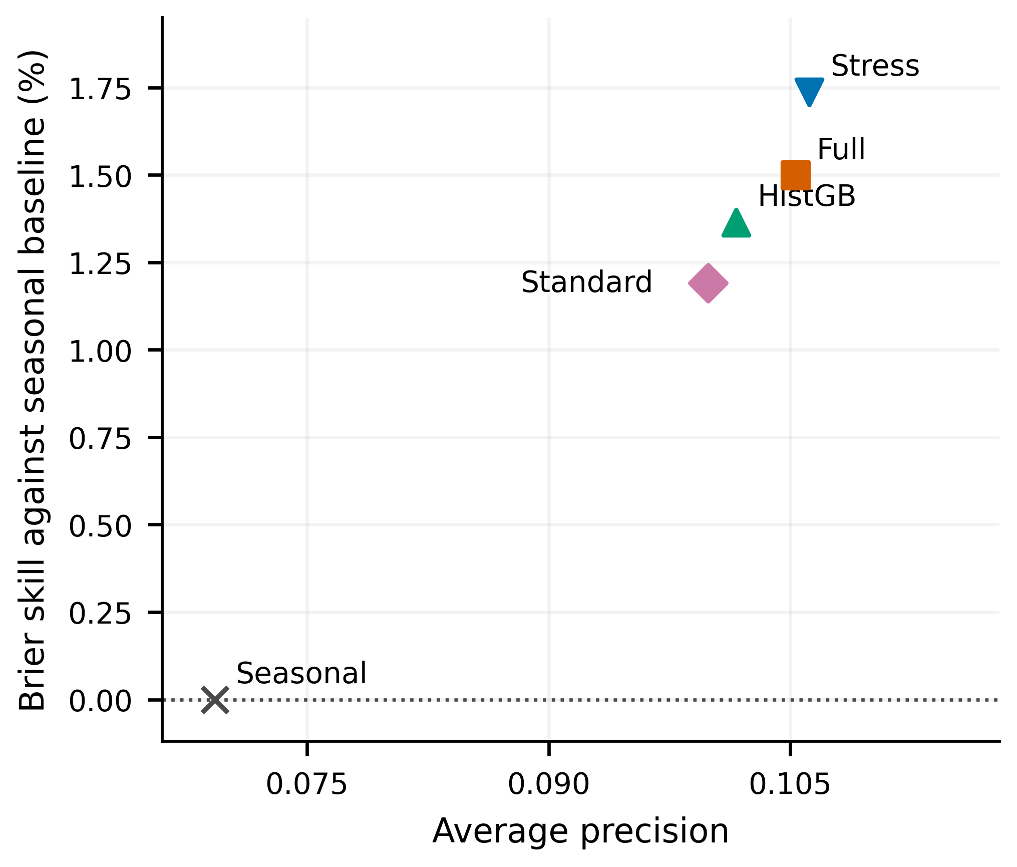
Figure 4. Joint AP and Brier skill point estimates for the principal comparators. The seasonal baseline defines zero Brier skill. Table 5 reports all nine models.
Stress predicts a mean probability of 2.9207% against prevalence 3.0036%, reducing Standard’s absolute mean gap from 0.1793 to 0.0828 percentage points. This 53.8% reduction concerns population mean agreement. Figure 5 evaluates agreement across probability bins using 600 seven day resamples.
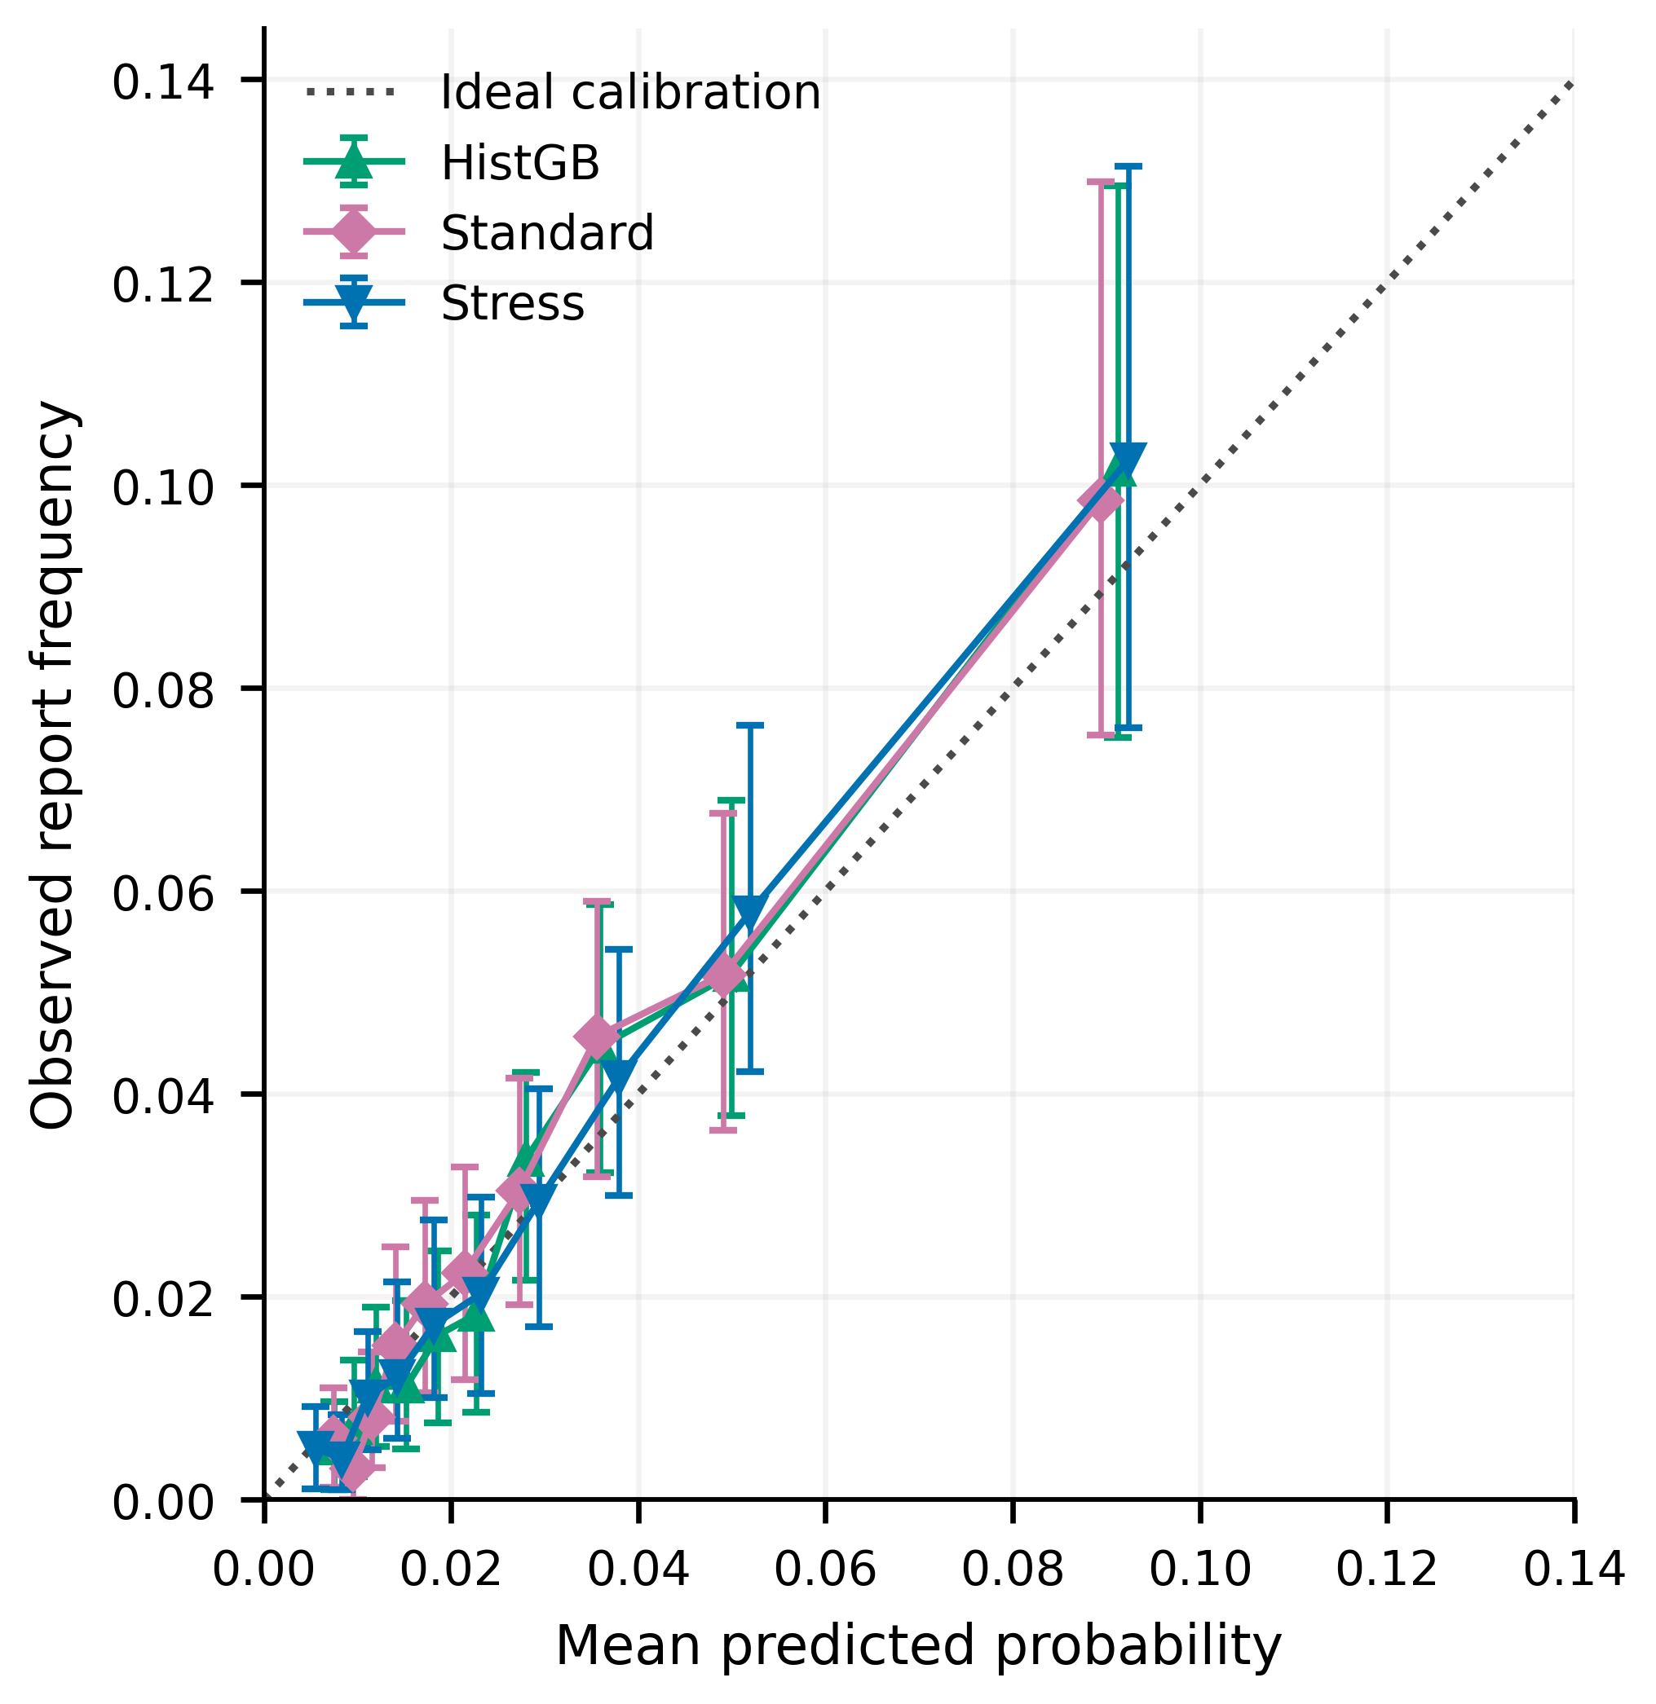
Figure 5. Reliability estimates with nominal 95% date block bootstrap intervals. Each model uses its own fixed bins. The diagonal represents ideal calibration.
The upper Stress bin contains 985 examples and 101 positives. Mean prediction is 0.09237, observed frequency 0.10254, and its date block interval 0.07607 to 0.13140. Descriptive calibration intercept 0.47554 and slope 1.14210 depart from ideal values and do not recalibrate predictions.
Brier scoring [14], reliability diagrams [15], and fit on test assessment [16] address different properties. Improved mean agreement alone does not establish distribution wide calibration [6].
The triptych framework separates calibration, discrimination, and utility [26]. We make no formal calibration guarantee [17].
Probabilistic streamflow studies assess residual distributions [27], [28]. Binary report Brier scores measure neither streamflow interval coverage nor flood depth accuracy.

C. Dependence and incomplete rainfall observations
Table 6 reports matched date block intervals for Stress against Standard and HistGB, using the sign conventions in Equations (8) and (9).
Table 6. Stress comparison with two benchmarks and nominal 95% date block intervals. AP values use units of 10⁻³ and Brier values use units of 10⁻⁴
Model | Days | ΔAP | AP interval | ΔBrier | Brier interval
Standard | 7 | 6.297 | [-3.774, 16.380] | 1.563 | [0.415, 2.742]
HistGB | 7 | 4.549 | [0.146, 9.793] | 1.065 | [0.326, 1.787]
Standard | 14 | 6.297 | [-5.216, 15.529] | 1.563 | [0.393, 2.645]
HistGB | 14 | 4.549 | [-0.748, 9.583] | 1.065 | [0.342, 1.853]
Standard | 30 | 6.297 | [-4.413, 12.934] | 1.563 | [0.558, 2.270]
HistGB | 30 | 4.549 | [-1.866, 9.963] | 1.065 | [0.377, 1.765]
Stress minus Standard AP has a seven day interval of −0.003774 to 0.016380; longer block intervals also cross zero. Against HistGB, the seven day interval is positive, but longer block lower limits and the Bonferroni lower limit are negative. Ranking separation therefore remains uncertain.
Figure 6 shows that nominal Brier improvement intervals against Standard remain positive across block lengths: 0.000042 to 0.000274 at seven days and 0.000056 to 0.000227 at 30 days. The adjusted 14 day interval includes zero. Dependence resampling [18] supports a more consistent scoring signal without overcoming development reuse.
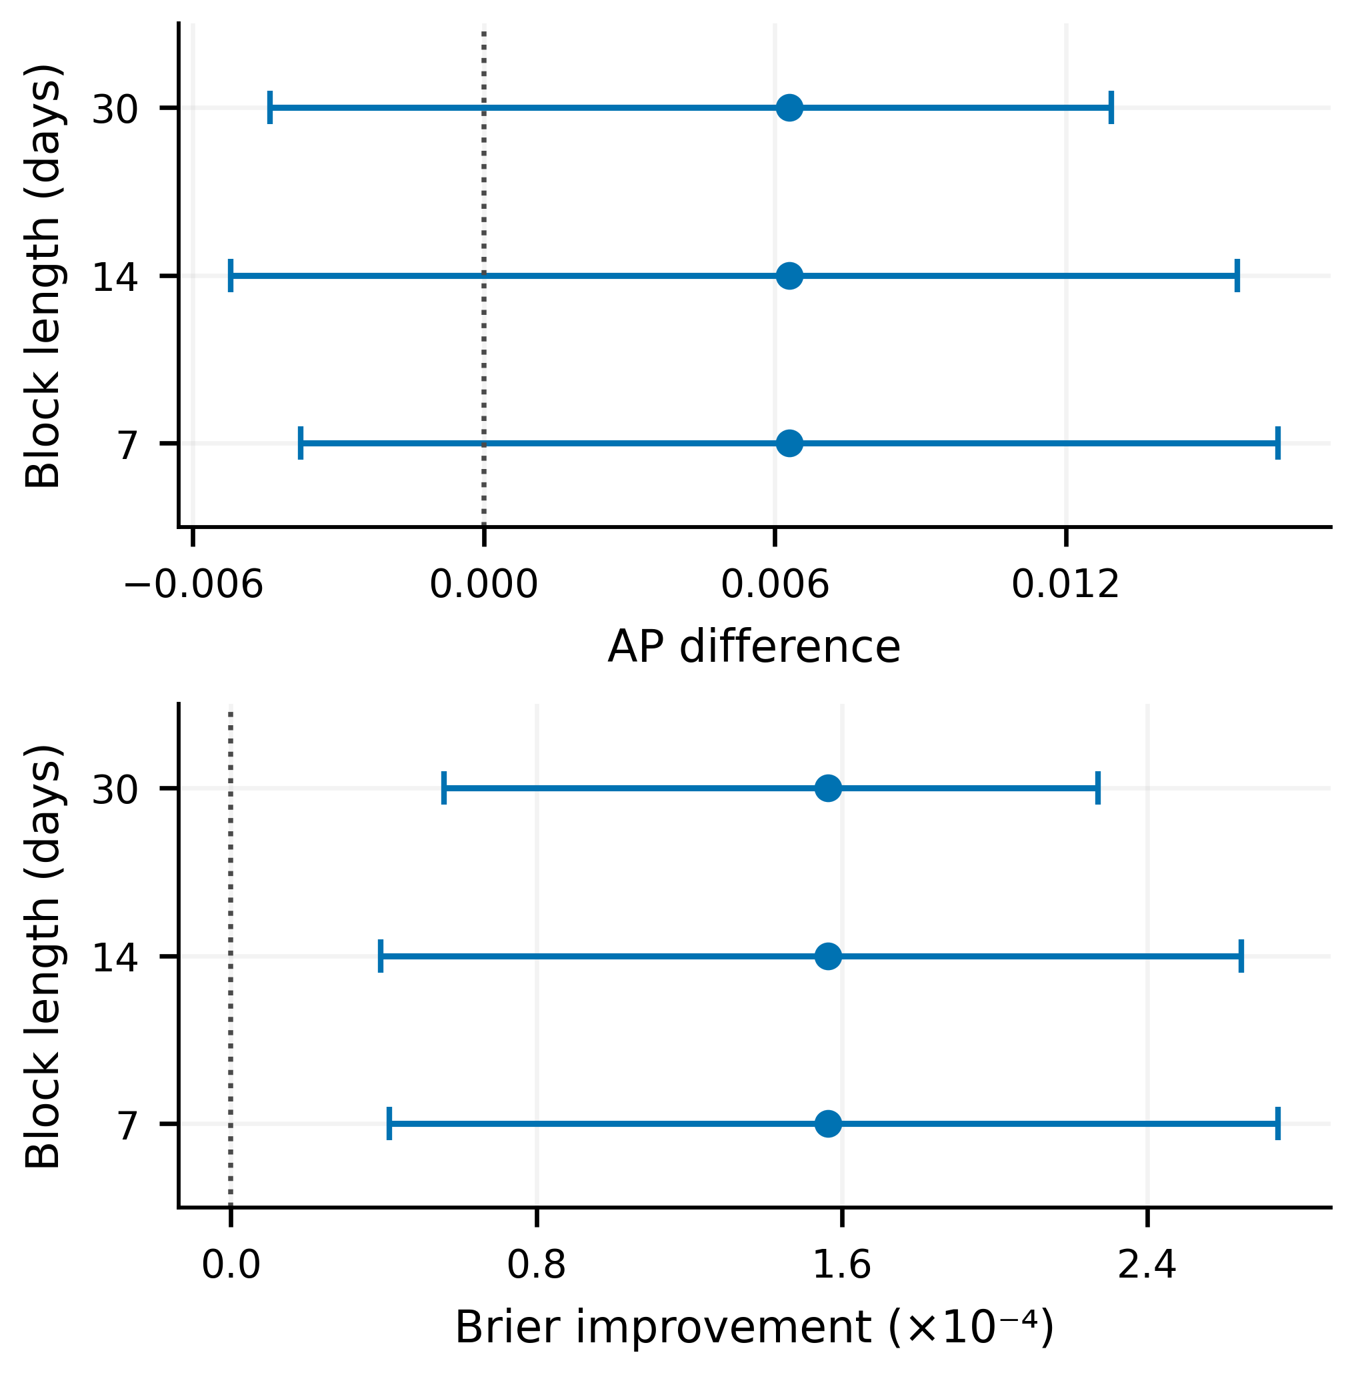
Figure 6. Stress versus Standard score differences with nominal 95% intervals across date block lengths. Positive differences favor Stress on both panels.
Table 7 reports twelve paired conditions with 100 replicates each. Win proportions describe the specified disturbances, not probabilities of future operational superiority.
Table 7. Stress versus Standard under additional station missingness. Brier improvement uses units of 10⁻⁴ and win proportions use percent
Mechanism | Loss (%) | Mean ΔAP | Mean ΔBrier | AP win | Brier win
MCAR | 10 | -0.00421 | 0.268 | 0 | 98
MCAR | 20 | -0.00526 | 0.813 | 1 | 100
MCAR | 30 | -0.00592 | 1.254 | 0 | 100
Station outage | 10 | -0.00353 | 0.306 | 3 | 91
Station outage | 20 | -0.00461 | 0.832 | 3 | 100
Station outage | 30 | -0.00415 | 1.274 | 3 | 100
Temporal block | 10 | -0.00336 | 0.350 | 3 | 96
Temporal block | 20 | -0.00437 | 0.823 | 0 | 100
Temporal block | 30 | -0.00461 | 1.261 | 0 | 100
Quality | 10 | -0.00362 | 0.410 | 0 | 100
Quality | 20 | -0.00376 | 0.905 | 0 | 100
Quality | 30 | -0.00397 | 1.232 | 0 | 100
Stress reduces mean Brier in all twelve conditions by 0.0000268 to 0.0001274 and wins 1,185/1,200 comparisons (98.75%). Mean AP differences instead range from −0.003363 to −0.005925, with only 13/1,200 wins (1.08%). The evidence supports probability scoring over Standard, not universal ranking robustness.
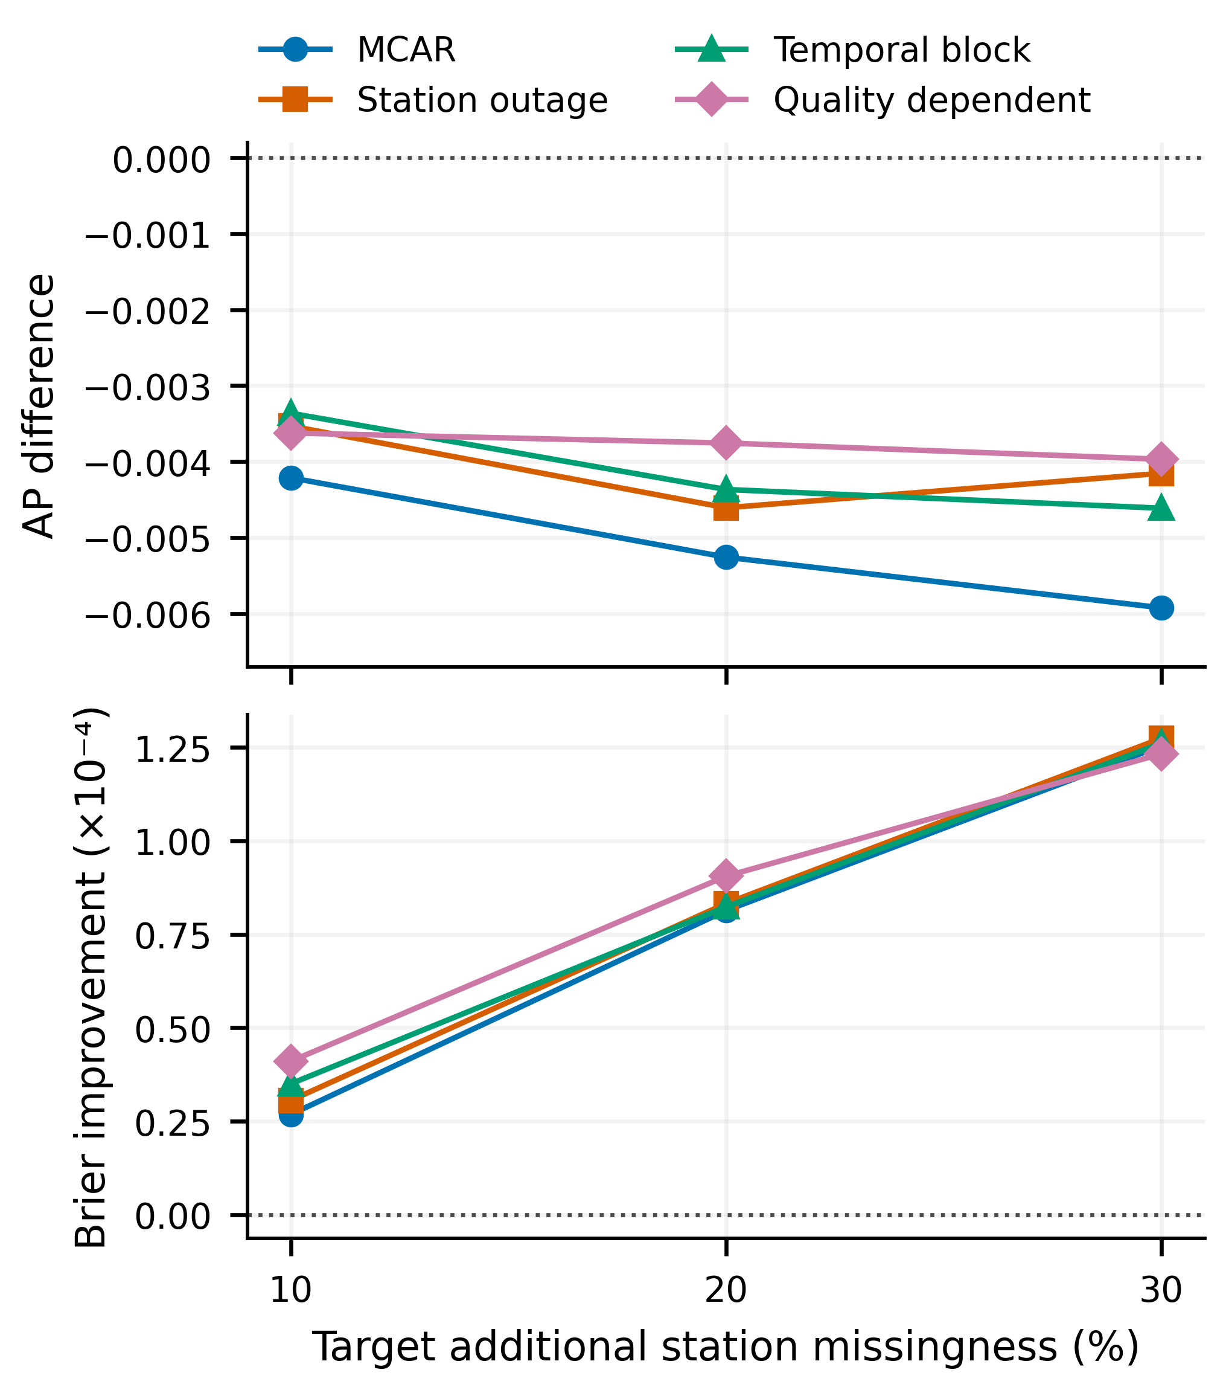
Figure 7. Paired mean score differences between Stress and Standard across four missingness mechanisms. Each point summarizes 100 perturbation replicates.
Under MCAR, the mean AP difference changes from −0.004213 at 10% loss to −0.005925 at 30%, while Brier improvement grows from about 0.000027 to 0.000125 (Figure 7). Structured missingness motivates mechanism comparisons [7], but actual outage records would be needed to validate realism.
Rainfall imputation [29] and probabilistic streamflow reconstruction [30] offer alternative missing input treatments. A fair comparison should retain the report target and paired masks.
Hydrological uncertainty also includes model, parameter, and boundary contributions [31], [5], with cascading effects in linked models [32]. Three classifier outputs cannot identify these components.
Data centric uncertainty prediction [33] and CHUP-BMA [34] motivate alternative uncertainty representations without validating the present bootstrap coverage or feature interpretation.
Against HistGB, Stress improves mean AP in every condition by 0.004193 to 0.005433 and wins all 1,200 AP comparisons. It improves Brier in 1,195 comparisons (99.58%). Thus it provides paired ranking and scoring gains over HistGB, while Standard remains the stronger missingness ranking benchmark.

D. Report onset and daily review capacity
The onset risk set contains 8,286 eligible region days and 179 positives (2.1603%). Excluding preceding seven day reports removes 1,569 examples, including 117 continuation positives. This population differs from the report day task.
Table 8. Onset ranking and daily report capture. Recall columns refer to the original 296 positive report days, while onset AP uses the 179 positive eligible examples
Model | Report AP | Onset AP | Onset lift | k=2 recall (%) | k=3 recall (%)
Seasonal | 0.06927 | 0.04835 | 2.24 | 18.24 | 33.11
HistGB | 0.10165 | 0.06142 | 2.84 | 23.99 | 31.08
Standard | 0.09990 | 0.05978 | 2.77 | 21.62 | 28.38
Full | 0.10534 | 0.06277 | 2.91 | 23.65 | 31.08
Stress | 0.10620 | 0.06495 | 3.01 | 26.01 | 31.42
Stress onset AP is 0.064948, against Standard 0.059783 and HistGB 0.061417. Seven day difference intervals cross zero: −0.004975 to 0.016416 and −0.002122 to 0.011130, respectively. Longer intervals also cross zero. These are exploratory ranking gains, not calibrated physical onset probabilities.
Seasonal UK flood risk [35] and subseasonal Yangtze forecasts [36] use different horizons. Neither validates the present reporting clock.
With one, two, and three daily flags, Stress captures 45, 77, and 93 of 296 positive region days (Table 8; Figure 8). Three flags yield recall 31.42%, precision 8.49%, and 1,002 unmatched catalogue flags among 1,095 reviews.
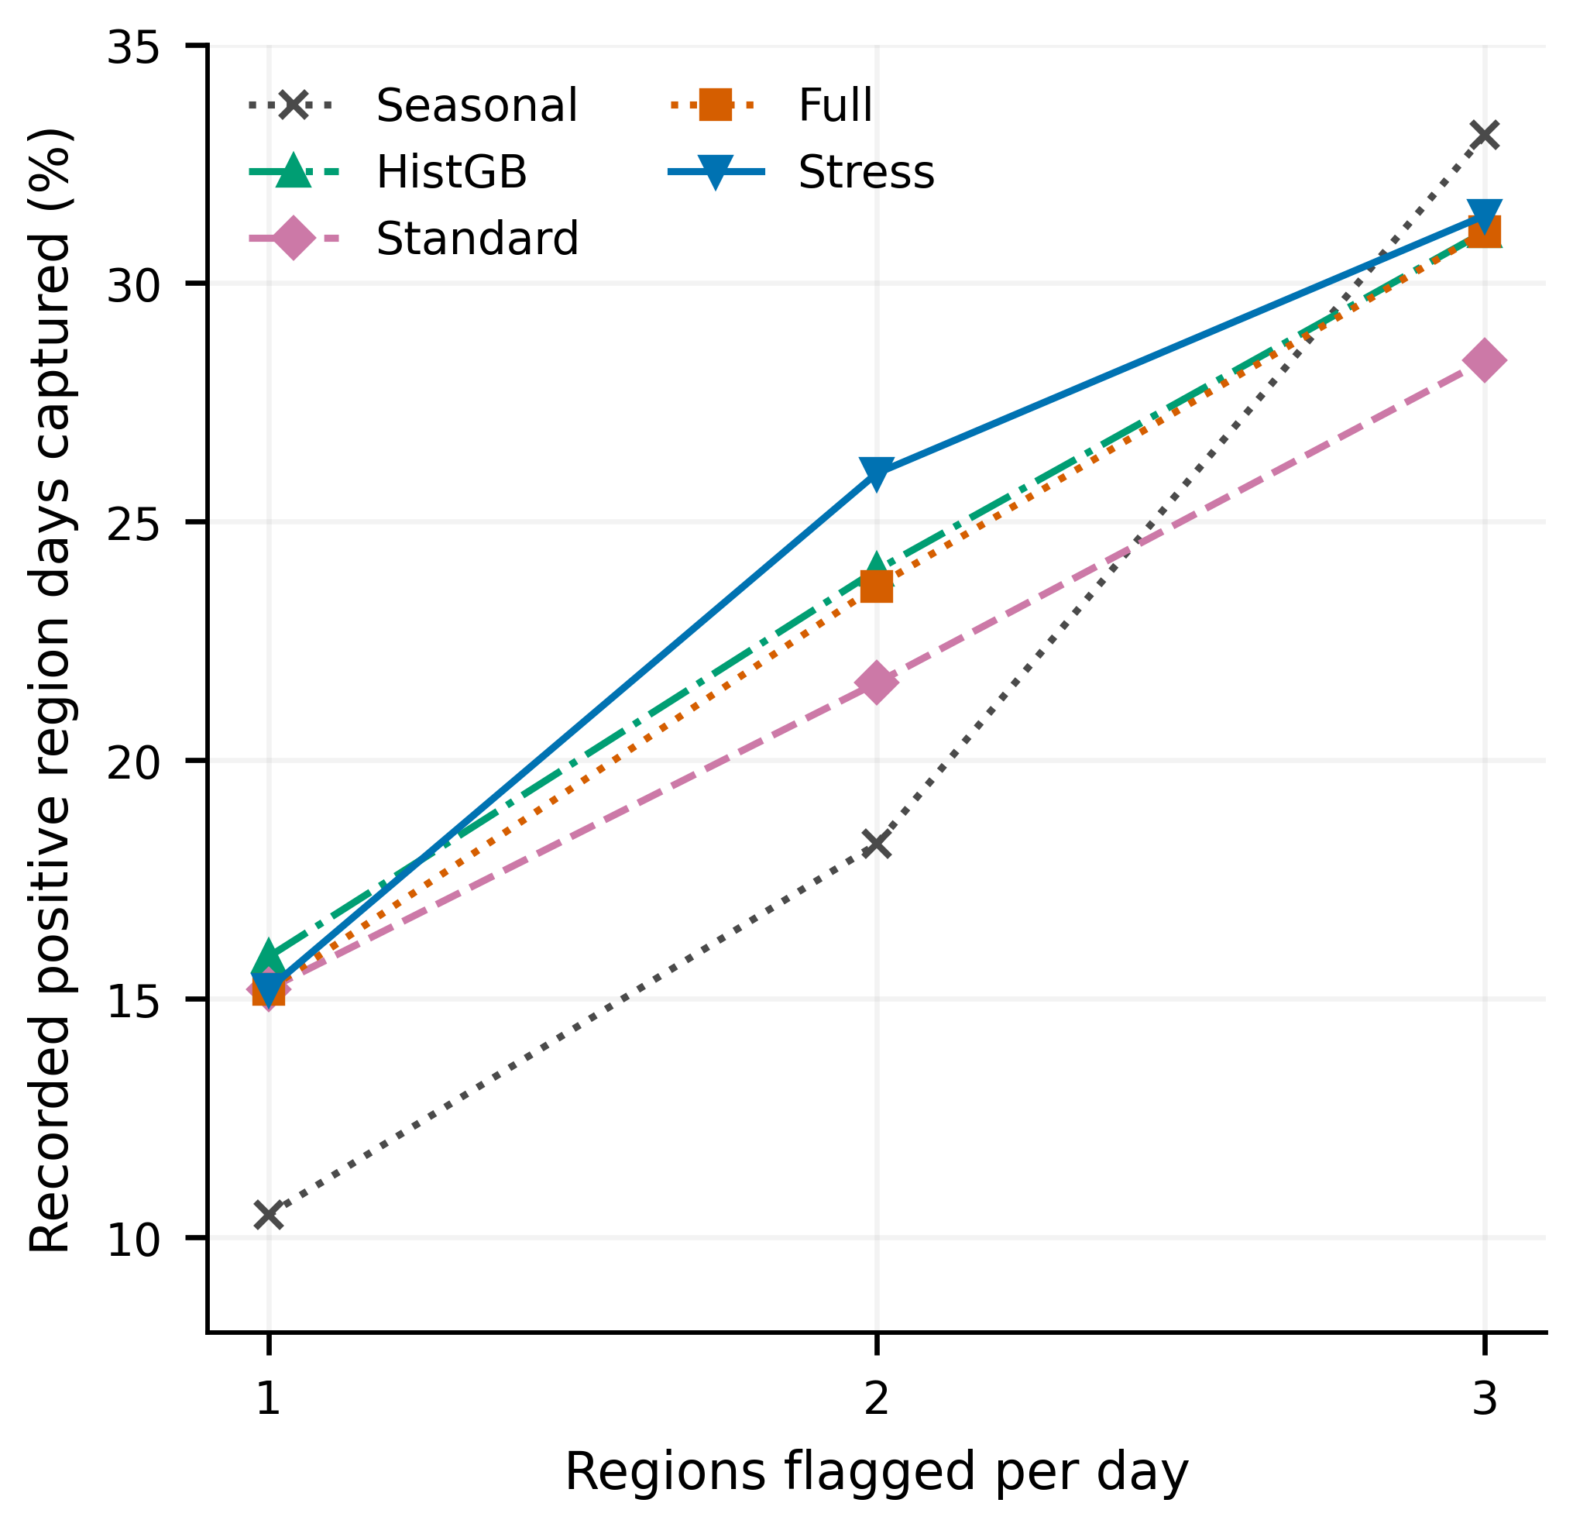
Figure 8. Retrospective capture of recorded positive region days under one, two, or three regional flags per date. Each model uses its own daily ranking.
HistGB captures 47 positives at one flag; the seasonal baseline captures 98 at three. Stress therefore does not dominate every capacity. Unmatched catalogue flags cannot establish physical false alarms.
Adding a second daily flag captures 32 extra positives across 365 additional reviews; a third captures 16. Marginal match rates fall from 8.77% to 4.38%. Choosing capacity requires review costs and missed event costs.
Decision focused pooling [37] and reservoir optimization [38] show why forecast scores and decision outcomes require separate evaluation. Capacity and costs should precede operational model selection.
Impact based warning [39], FOREWARNS verification [40], and integrated risk systems [41] examine lead time, consequences, and exposure. Catalogue capture alone does not validate a warning service.

E. Principal contribution and scope of inference
The principal contribution is a probability scoring advantage over Standard across prescribed station losses, together with paired scoring and ranking gains over HistGB. Benchmark choice changes the ranking conclusion.
Global riverine forecasting [1] predicts a physical target. This study adds within dataset evidence for administrative reports, without claiming superiority over physical forecasting systems.
Ungauged basin LSTM evaluation [42] and differentiable hydrology [43] test geographic extrapolation. Our temporal split retains the same regions and does not establish spatial transfer.
The 9,559 examples without reports constitute 97.00% of evaluation data. Lower error among this majority could coexist with weaker positive ranking, but aggregate scores do not establish that mechanism. Class specific Brier components and paired probability changes would be needed.
Repeated inspection of 2025 could influence feature, model, and comparison selection [8]. Freezing the final configuration does not restore an unseen test year.
Independent reproduction requires the transformations, model bundle, environment, and evaluation probabilities. EvalHyd [44], FROSTBYTE [45], and REFORMS [46] provide relevant reproducibility precedents.
Forward evaluation should freeze the pipeline and primary metrics before new outcomes arrive. Independent regions, verified event inventories, actual station outage records, and issue time information should test transfer, reporting completeness, and operational utility.

V. CONCLUSION
Stress trained stacking achieves exploratory AP 0.106197 and Brier 0.028106, improving Standard’s point estimates by 6.30% and 0.55%, respectively. Its strongest finding is lower mean Brier in all twelve missingness conditions and a 98.75% paired win rate against Standard.
Against HistGB, Stress wins 100% of paired AP comparisons and 99.58% of Brier comparisons. Standard retains higher mean AP under additional missingness. Model selection therefore depends on whether probability scoring or ranking has priority.
Onset AP 0.064948 and three flag recall 31.42% extend the evaluation to screening objectives. Reused evaluation data, report based labels, unresolved source identifiers, and unverified issue times restrict inference. Independent forward evaluation should precede operational adoption.

Data and code availability
Mendeley Data version 1 provides the source data under CC BY 4.0 [19]. The computational record includes the notebook, workbook hashes, configuration, and aggregate outputs. Authors still need to provide a persistent archive for the code, runtime environment, fitted bundle, and evaluation probabilities.

Funding
[AUTHOR CONFIRMATION REQUIRED: funding agencies and grant numbers, or confirmation of no specific funding.]

Competing interests
[AUTHOR CONFIRMATION REQUIRED: financial and nonfinancial competing interests, or confirmation of none.]

Author contributions
[AUTHOR CONFIRMATION REQUIRED: verified CRediT roles and final approval for all five authors.]

Ethics and consent
The study uses regional aggregate reports and rainfall observations without recruiting participants. [AUTHOR CONFIRMATION REQUIRED: institutional ethics determination or exemption, any approval identifier, and compliance with data terms.]

Declaration of AI assisted writing
ChatGPT (OpenAI, Codex based on GPT-6) assisted with drafting, editing, output summaries, figure preparation, reference metadata checks, and formatting. Authors retain responsibility for calculations, citations, interpretations, and final review. Section III documents the predictive models separately.

REFERENCES
[1] G. Nearing et al., “Global prediction of extreme floods in ungauged watersheds,” Nature, vol. 627, no. 8004, pp. 559-563, 2024. doi: 10.1038/s41586-024-07145-1
[2] M. Asif, M. M. Kuglitsch, I. Pelivan, and R. Albano, “Review and Intercomparison of Machine Learning Applications for Short-term Flood Forecasting,” Water Resources Management, vol. 39, no. 5, pp. 1971-1991, 2025. doi: 10.1007/s11269-025-04093-x
[3] A. H. Akinsoji, B. Adelodun, Q. Adeyi, R. A. Salau, G. Odey, and K. S. Choi, “Integrating Machine Learning Models with Comprehensive Data Strategies and Optimization Techniques to Enhance Flood Prediction Accuracy: A Review,” Water Resources Management, vol. 38, no. 12, pp. 4735-4761, 2024. doi: 10.1007/s11269-024-03885-x
[4] C. Xu et al., “A hybrid model coupling process-driven and data-driven models for improved real-time flood forecasting,” Journal of Hydrology, vol. 638, pp. 131494, 2024. doi: 10.1016/j.jhydrol.2024.131494
[5] J. A. Idowu, and A. Alfahid, “Open problems in uncertainty quantification for flood modelling: A systematic review,” Environmental Modelling & Software, vol. 196, pp. 106799, 2026. doi: 10.1016/j.envsoft.2025.106799
[6] T. Silva Filho, H. Song, M. Perello-Nieto, R. Santos-Rodriguez, M. Kull, and P. Flach, “Classifier calibration: a survey on how to assess and improve predicted class probabilities,” Machine Learning, vol. 112, no. 9, pp. 3211-3260, 2023. doi: 10.1007/s10994-023-06336-7
[7] R. Mitra et al., “Learning from data with structured missingness,” Nature Machine Intelligence, vol. 5, no. 1, pp. 13-23, 2023. doi: 10.1038/s42256-022-00596-z
[8] S. Kapoor, and A. Narayanan, “Leakage and the reproducibility crisis in machine-learning-based science,” Patterns, vol. 4, no. 9, pp. 100804, 2023. doi: 10.1016/j.patter.2023.100804
[9] D. H. Wolpert, “Stacked generalization,” Neural Networks, vol. 5, no. 2, pp. 241-259, 1992. doi: 10.1016/S0893-6080(05)80023-1
[10] L. Breiman, “Random Forests,” Machine Learning, vol. 45, no. 1, pp. 5-32, 2001. doi: 10.1023/A:1010933404324
[11] J. H. Friedman, “Greedy function approximation: A gradient boosting machine,” The Annals of Statistics, vol. 29, no. 5, pp. 1189-1232, 2001. doi: 10.1214/aos/1013203451
[12] E. Hullermeier and W. Waegeman, “Aleatoric and epistemic uncertainty in machine learning: an introduction to concepts and methods,” Machine Learning, vol. 110, pp. 457-506, 2021. doi: 10.1007/s10994-021-05946-3
[13] T. Saito and M. Rehmsmeier, “The Precision-Recall Plot Is More Informative than the ROC Plot When Evaluating Binary Classifiers on Imbalanced Datasets,” PLOS ONE, vol. 10, no. 3, Art. no. e0118432, 2015. doi: 10.1371/journal.pone.0118432
[14] T. Gneiting and A. E. Raftery, “Strictly Proper Scoring Rules, Prediction, and Estimation,” Journal of the American Statistical Association, vol. 102, no. 477, pp. 359-378, 2007. doi: 10.1198/016214506000001437
[15] T. Dimitriadis, T. Gneiting, and A. I. Jordan, “Stable reliability diagrams for probabilistic classifiers,” Proceedings of the National Academy of Sciences, vol. 118, no. 8, Art. no. e2016191118, 2021. doi: 10.1073/pnas.2016191118
[16] M. Kängsepp, K. Valk, and M. Kull, “On the usefulness of the fit-on-test view on evaluating calibration of classifiers,” Machine Learning, vol. 114, no. 4, Art. no. 105, 2025. doi: 10.1007/s10994-024-06652-6
[17] D. Lee, X. Huang, H. Hassani, and E. Dobriban, “T-Cal: An Optimal Test for the Calibration of Predictive Models,” Journal of Machine Learning Research, vol. 24, no. 335, pp. 1-72, 2023. Available: https://jmlr.org/papers/v24/22-0320.html
[18] H. R. Kunsch, “The Jackknife and the Bootstrap for General Stationary Observations,” The Annals of Statistics, vol. 17, no. 3, pp. 1217-1241, 1989. doi: 10.1214/aos/1176347265
[19] H. Saputra, B. D. Dasanto, S. D. Tarigan, I P. Santikayasa, and Y. Darmawan, “Daily Rainfall Observations from 460 Stations and Flood Event Records across West Java, Indonesia (2020-2025),” Mendeley Data, version 1, 2026. doi: 10.17632/d7j3s64vvr.1
[20] F. Kratzert et al., “Caravan - A global community dataset for large-sample hydrology,” Scientific Data, vol. 10, no. 1, Art. no. 61, 2023. doi: 10.1038/s41597-023-01975-w
[21] F. Clerc-Schwarzenbach, G. Selleri, M. Neri, E. Toth, I. van Meerveld, and J. Seibert, “Large-sample hydrology – a few camels or a whole caravan?,” Hydrology and Earth System Sciences, vol. 28, no. 17, pp. 4219-4237, 2024. doi: 10.5194/hess-28-4219-2024
[22] J. P. M. Aerts, J. M. Hoch, G. Coxon, N. C. van de Giesen, and R. W. Hut, “On the importance of discharge observation uncertainty when interpreting hydrological model performance,” Hydrology and Earth System Sciences, vol. 28, no. 22, pp. 5011-5030, 2024. doi: 10.5194/hess-28-5011-2024
[23] A. C. Green, E. Lewis, X. Tong, and R. Wardle, “A framework for incorporating rainfall data into a flooding digital twin,” Journal of Hydrology, vol. 656, pp. 132893, 2025. doi: 10.1016/j.jhydrol.2025.132893
[24] M. Gauch, F. Kratzert, D. Klotz, G. Nearing, D. Cohen, and O. Gilon, “How to deal w___ missing input data,” Hydrology and Earth System Sciences, vol. 29, no. 21, pp. 6221-6235, 2025. doi: 10.5194/hess-29-6221-2025
[25] P. Umamaheswari, and V. Ramaswamy, “An integrated framework for rainfall prediction and analysis using a Stacked Heterogeneous Ensemble Model (SHEM),” Expert Systems with Applications, vol. 256, pp. 124831, 2024. doi: 10.1016/j.eswa.2024.124831
[26] T. Dimitriadis, T. Gneiting, A. I. Jordan, and P. Vogel, “Evaluating probabilistic classifiers: The triptych,” International Journal of Forecasting, vol. 40, no. 3, pp. 1101-1122, 2024. doi: 10.1016/j.ijforecast.2023.09.007
[27] J. Romero-Cuellar, R. Arabzadeh, J. R. Craig, B. A. Tolson, and J. Mai, “A multi-model evaluation of probabilistic streamflow predictions via residual error modelling,” Journal of Hydrology, vol. 635, pp. 131152, 2024. doi: 10.1016/j.jhydrol.2024.131152
[28] J. Liang, S. Liu, Z. Zhou, G. Zhong, and Y. Zhen, “Improving probabilistic streamflow predictions through a nonparametric residual error model,” Environmental Modelling & Software, vol. 175, pp. 105981, 2024. doi: 10.1016/j.envsoft.2024.105981
[29] F. Piadeh, V. Bakhtiari, and F. Piadeh, “Automated novel real-time framework for rainfall data imputation in flood early warning systems,” Engineering Applications of Artificial Intelligence, vol. 164, pp. 113348, 2026. doi: 10.1016/j.engappai.2025.113348
[30] G. R. Arathy Nair, S. Adarsh, A. El-Shafie, and A. N. Ahmed, “Enhancing hydrological data completeness: A performance evaluation of various machine learning techniques using probabilistic fusion imputer with neural networks for streamflow data reconstruction,” Journal of Hydrology, vol. 639, pp. 131583, 2024. doi: 10.1016/j.jhydrol.2024.131583
[31] A. Panchanathan et al., “An overview of approaches for reducing uncertainties in hydrological forecasting: Progress and challenges,” Earth-Science Reviews, vol. 258, pp. 104956, 2024. doi: 10.1016/j.earscirev.2024.104956
[32] D. F. Muñoz, H. Moftakhari, and H. Moradkhani, “Quantifying cascading uncertainty in compound flood modeling with linked process-based and machine learning models,” Hydrology and Earth System Sciences, vol. 28, no. 11, pp. 2531-2553, 2024. doi: 10.5194/hess-28-2531-2024
[33] A. Auer, M. Gauch, F. Kratzert, G. Nearing, S. Hochreiter, and D. Klotz, “A data-centric perspective on the information needed for hydrological uncertainty predictions,” Hydrology and Earth System Sciences, vol. 28, no. 17, pp. 4099-4126, 2024. doi: 10.5194/hess-28-4099-2024
[34] Z. Cui, S. Guo, H. Chen, D. Liu, Y. Zhou, and C. Y. Xu, “Quantifying and reducing flood forecast uncertainty by the CHUP-BMA method,” Hydrology and Earth System Sciences, vol. 28, no. 13, pp. 2809-2829, 2024. doi: 10.5194/hess-28-2809-2024
[35] S. Moulds, L. Slater, L. Arnal, and A. W. Wood, “Skilful probabilistic predictions of UK flood risk months ahead using a large-sample machine learning model trained on multimodel ensemble climate forecasts,” Hydrology and Earth System Sciences, vol. 29, no. 11, pp. 2393-2406, 2025. doi: 10.5194/hess-29-2393-2025
[36] N. Dong, H. Hao, M. Yang, J. Wei, S. Xu, and H. Kunstmann, “Deep-learning-based sub-seasonal precipitation and streamflow ensemble forecasting over the source region of the Yangtze River,” Hydrology and Earth System Sciences, vol. 29, no. 8, pp. 2023-2042, 2025. doi: 10.5194/hess-29-2023-2025
[37] A. Stratigakos, S. Pineda, and J. M. Morales, “Decision-focused linear pooling for probabilistic forecast combination,” International Journal of Forecasting, vol. 41, no. 3, pp. 1112-1125, 2025. doi: 10.1016/j.ijforecast.2024.11.006
[38] Y. Guo, Y. P. Xu, X. Yu, L. Liu, and H. Gu, “AI‐Based Ensemble Flood Forecasts and Its Implementation in Multi‐Objective Robust Optimization Operation for Reservoir Flood Control,” Water Resources Research, vol. 60, no. 5, Art. no. e2023WR035693, 2024. doi: 10.1029/2023wr035693
[39] H. Najafi et al., “High-resolution impact-based early warning system for riverine flooding,” Nature Communications, vol. 15, no. 1, Art. no. 3726, 2024. doi: 10.1038/s41467-024-48065-y
[40] B. Maybee et al., “FOREWARNS: development and multifaceted verification of enhanced regional-scale surface water flood forecasts,” Natural Hazards and Earth System Sciences, vol. 24, no. 4, pp. 1415-1436, 2024. doi: 10.5194/nhess-24-1415-2024
[41] M. Reichstein et al., “Early warning of complex climate risk with integrated artificial intelligence,” Nature Communications, vol. 16, no. 1, Art. no. 2564, 2025. doi: 10.1038/s41467-025-57640-w
[42] R. Arsenault, J. L. Martel, F. Brunet, F. Brissette, and J. Mai, “Continuous streamflow prediction in ungauged basins: long short-term memory neural networks clearly outperform traditional hydrological models,” Hydrology and Earth System Sciences, vol. 27, no. 1, pp. 139-157, 2023. doi: 10.5194/hess-27-139-2023
[43] D. Feng, H. Beck, K. Lawson, and C. Shen, “The suitability of differentiable, physics-informed machine learning hydrologic models for ungauged regions and climate change impact assessment,” Hydrology and Earth System Sciences, vol. 27, no. 12, pp. 2357-2373, 2023. doi: 10.5194/hess-27-2357-2023
[44] T. Hallouin, F. Bourgin, C. Perrin, M. H. Ramos, and V. Andréassian, “EvalHyd v0.1.2: a polyglot tool for the evaluation of deterministic and probabilistic streamflow predictions,” Geoscientific Model Development, vol. 17, no. 11, pp. 4561-4578, 2024. doi: 10.5194/gmd-17-4561-2024
[45] L. Arnal et al., “FROSTBYTE: a reproducible data-driven workflow for probabilistic seasonal streamflow forecasting in snow-fed river basins across North America,” Hydrology and Earth System Sciences, vol. 28, no. 17, pp. 4127-4155, 2024. doi: 10.5194/hess-28-4127-2024
[46] S. Kapoor et al., “REFORMS: Consensus-based Recommendations for Machine-learning-based Science,” Science Advances, vol. 10, no. 18, Art. no. eadk3452, 2024. doi: 10.1126/sciadv.adk3452

