# Instructions on Setup an LIC Dev VM

# Prerequisites

**MSDN**

Login to your MSDN Subscription and Get a product Key for Windows Server 2012 R2 Standard,

Note**:** If you don’t have a MSDN Subscription (Premium or Ultimate) then you are legally not allowed to use a copy of this VM.

**Windows 8.1 on the host machine.**

Windows 8.1 enterprise installed (Note the Hyper V Manager version), please install this from:

\\fedfs.dsldev.local\Operating Systems\Windows8.1\Datacom Corp image\SW_DVD5_SA_Win_Ent_8.1_64BIT_English_MLF_X18-96759.ISO

Once installed, start the Hyper V Manager.

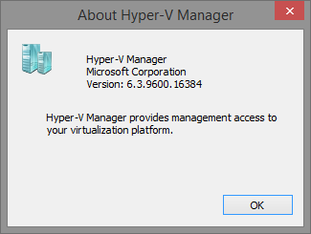

# Hyper-V

Copy the virtual machine hard disk and settings xml file to an appropriate location (These can be obtained from Pawan G or David Y), e.g.

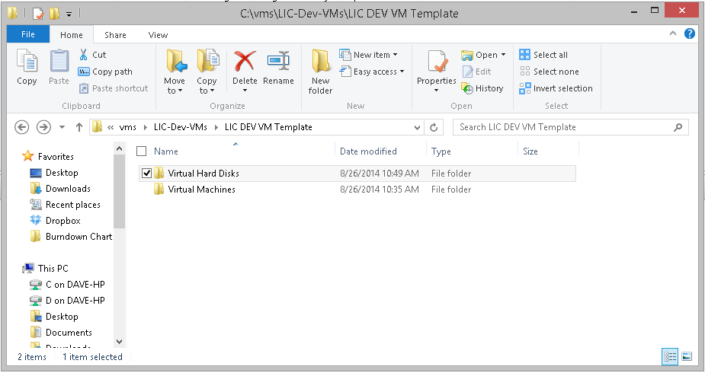

Go to the Hyper V Manager, select the Import Virtual Machine option inside the Action panel.

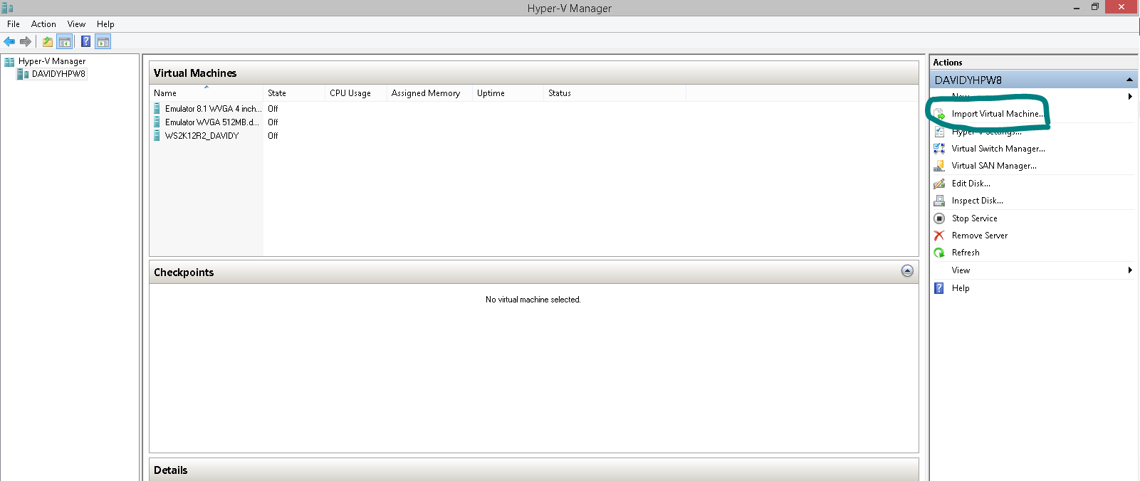

When prompted enter the location of the folder containing the virtual hard disks and virtual machines folders (in this case LIC Dev VM Template, click Next.

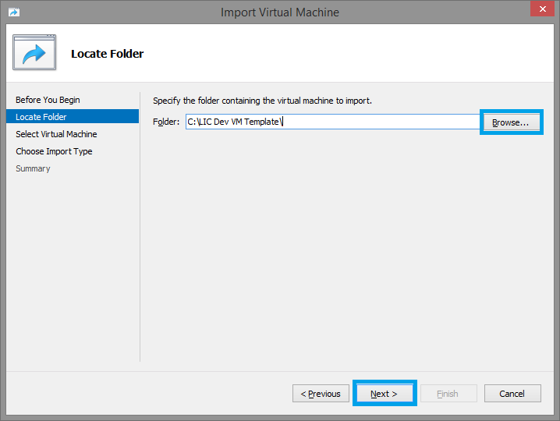

There should be only one virtual machine to select, click Next.

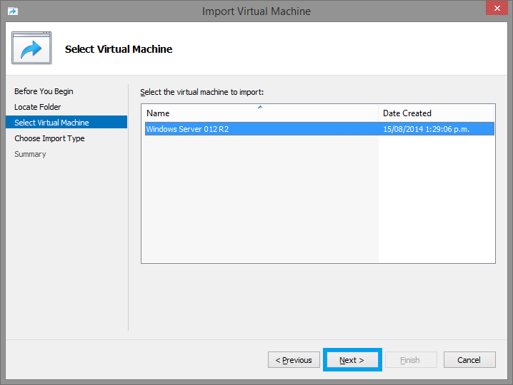

From the options select the “Copy the virtual machine, create a new unique ID” and click Next.

**Note:** this is an important step otherwise the VM being set up may end up sharing the same unique ID with another instance on your machine.

This may necessitate a repeat of the setup process.

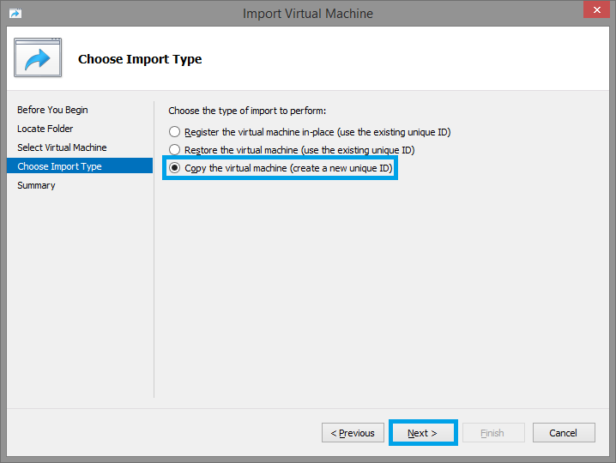

Click Next.

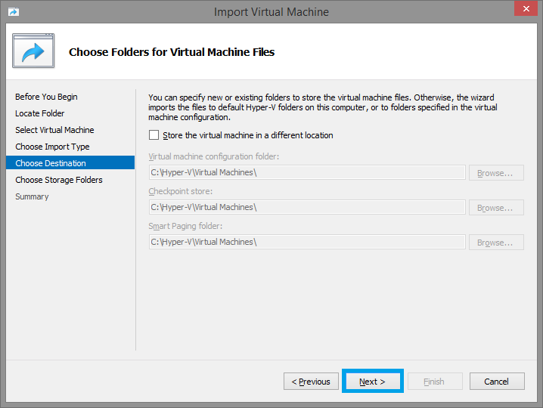

Create a VM storage folder in Explorer and enter the location in the next prompt, click Next

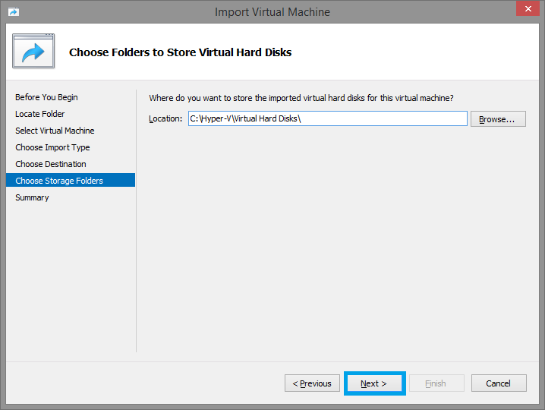

Wait for the process to complete. This may take 10 to 30 minutes depending on the type and speed of your hard disk.

# VM settings.

**Network settings:**

Create a virtual network switch so the newly created VM can access the LAN, Actions > Virtual Switch Manger > External > Create Virtual Switch.

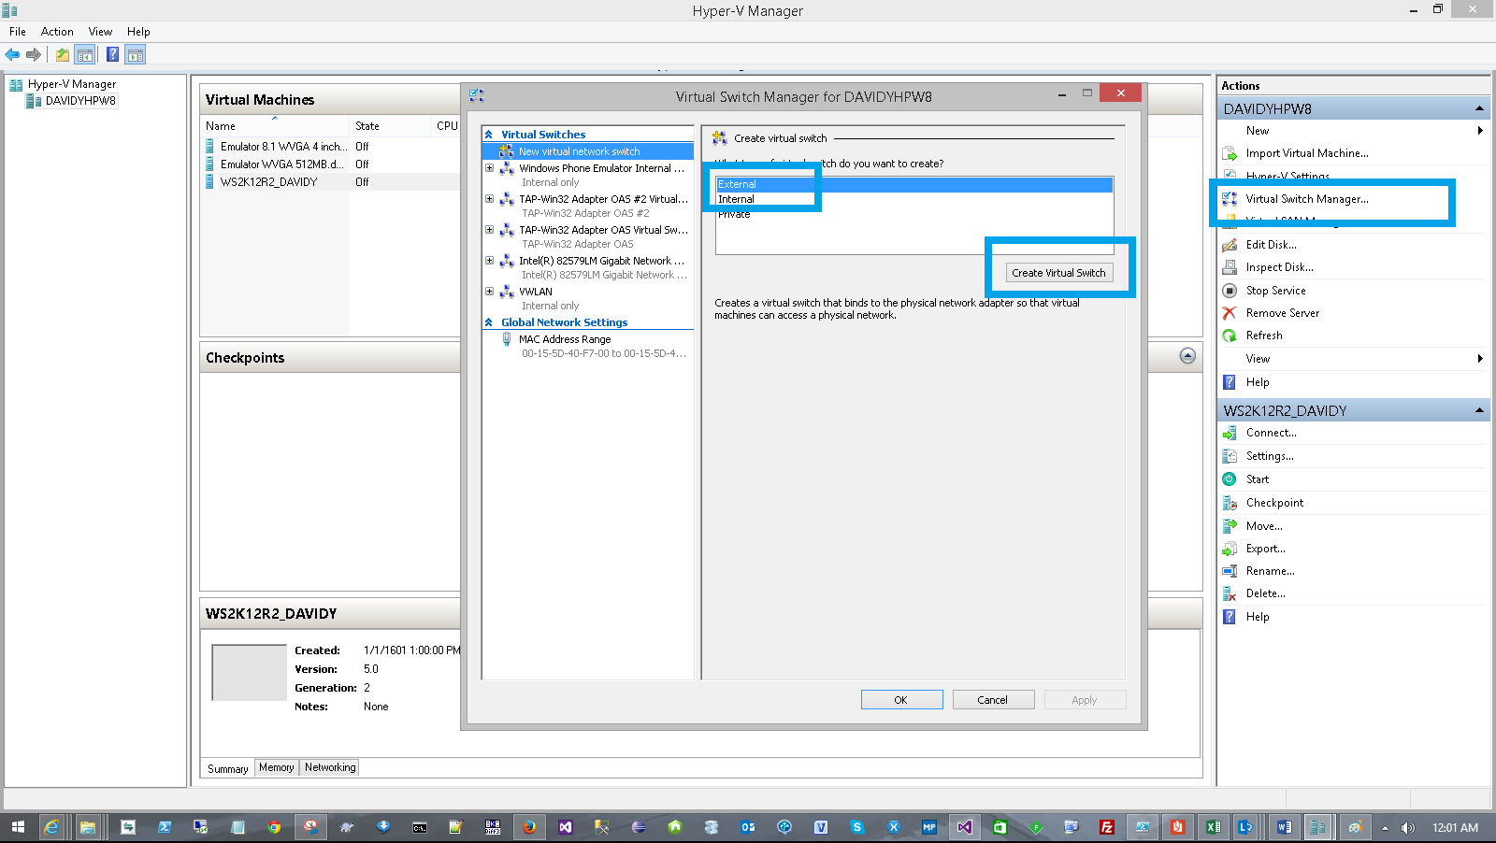

Give the connection an appropriate name and select External network, select an appropriate network adapter from the drop down list (wireless or LAN connection).

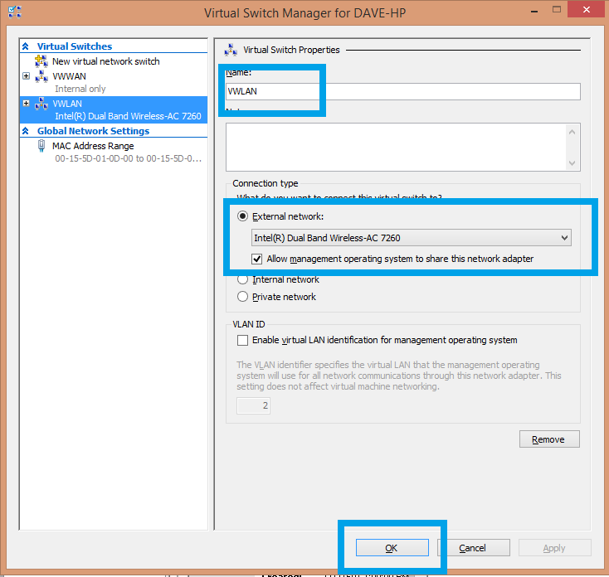

**Configuring the new VM:**

Change the Name of the VM to your preference e.g. LICDEV01, please note that this does not necessarily reflect the actual FQDN (fully qualified domain name) of the VM.

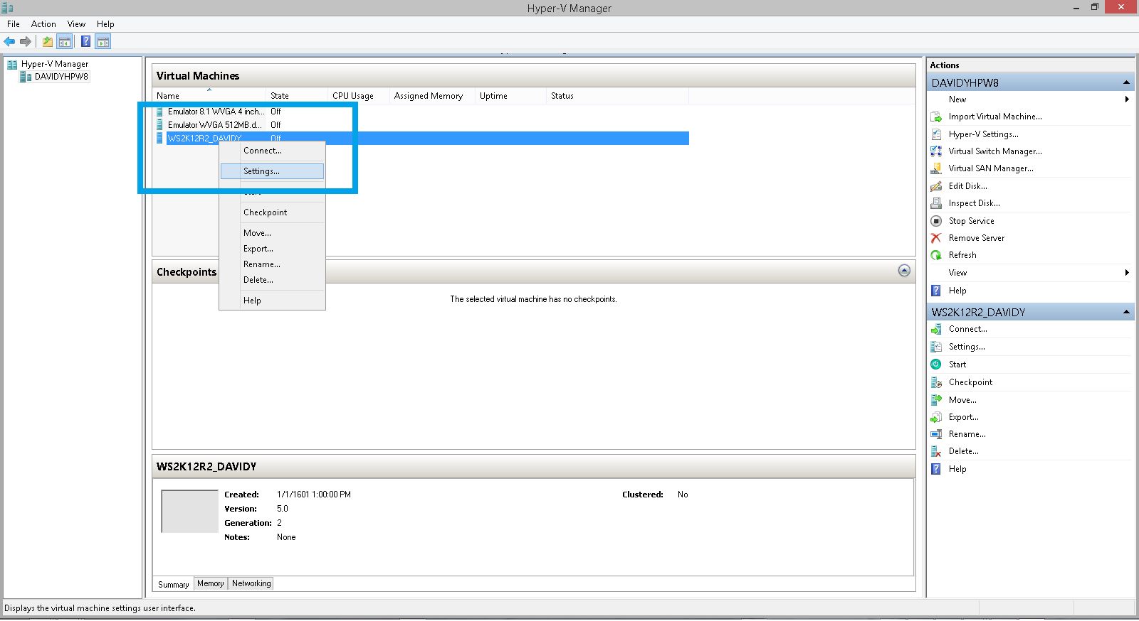

Go to Hardware - > SCSI Controller -> Hard Drive, click Browse and browse to the location of the vhdx file.

e.g. C:\vms\LIC-Dev-VMs\LIC DEV VM Template\Virtual Hard Disks

You may wish to rename the XXX.vhdx to have the same name as the VM instance for easy identification.

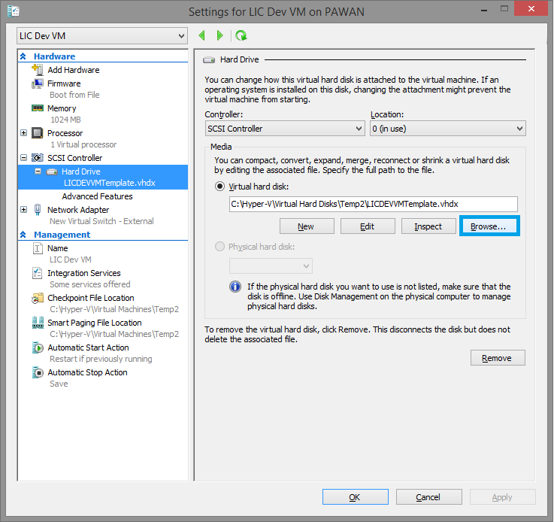

Select the network switch created ealier.

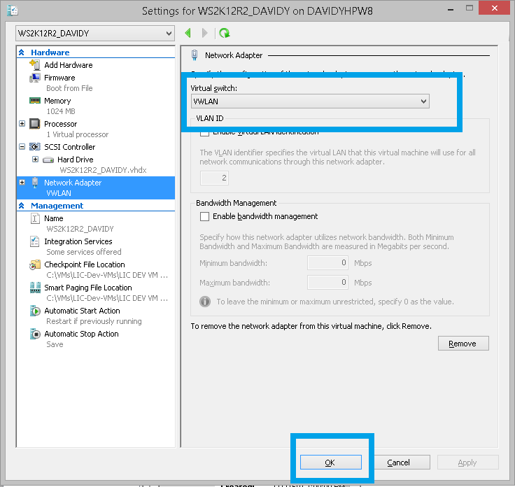

# Start the VM

Go back to the Hyper V Manager main window, select the newly created VM, right click and select Start.

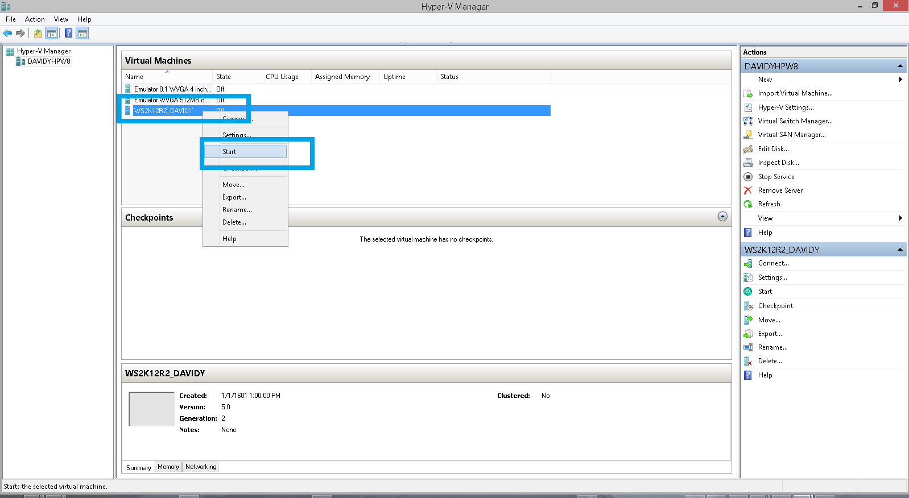

Start the VM and you will see the below screen, Click next

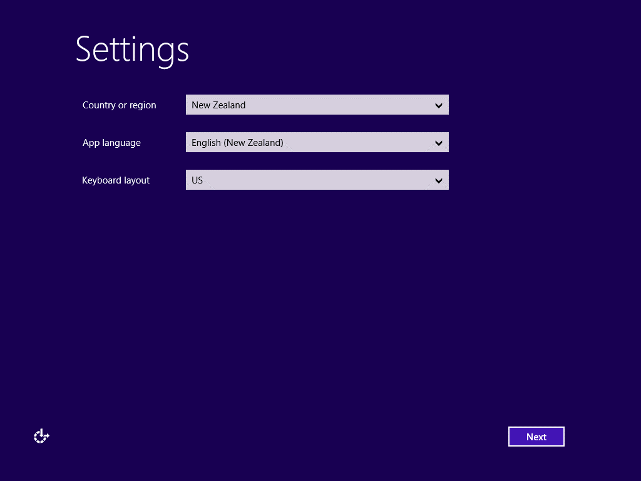

(Repeat of a prerequisite)

Login to your MSDN Subscription and Get a product Key for Windows Server 2012 R2 Standard,

Note**:** If you don’t have a MSDN Subscription (Premium or Ultimate) then you are legally not allowed to use a copy of this VM.

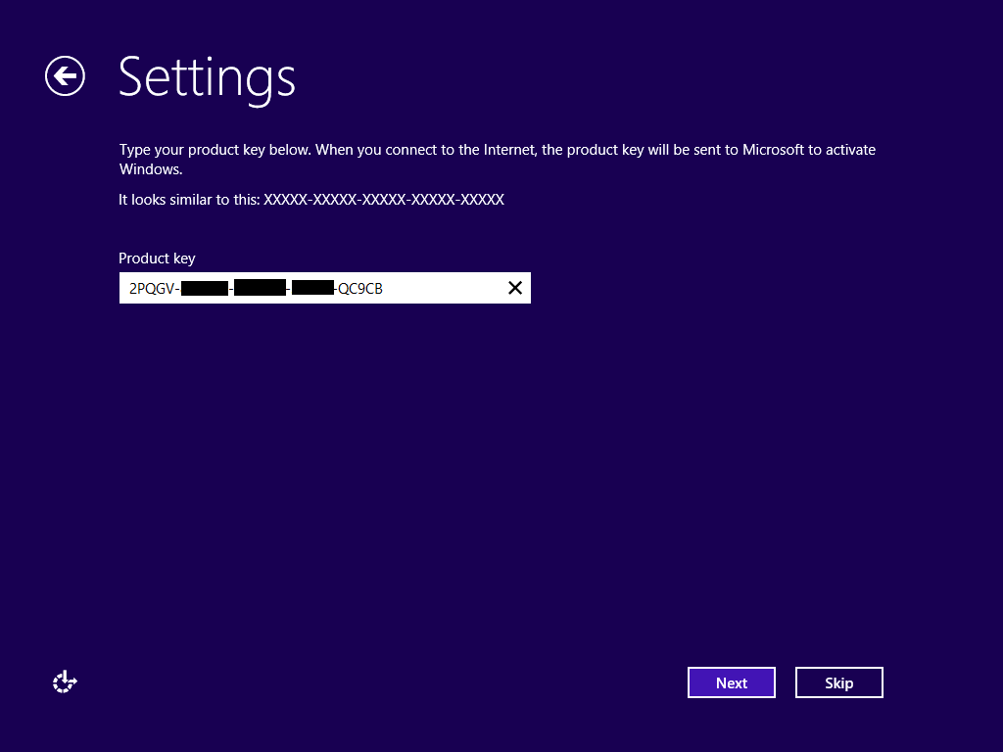

Enter your key from MSDN and click next

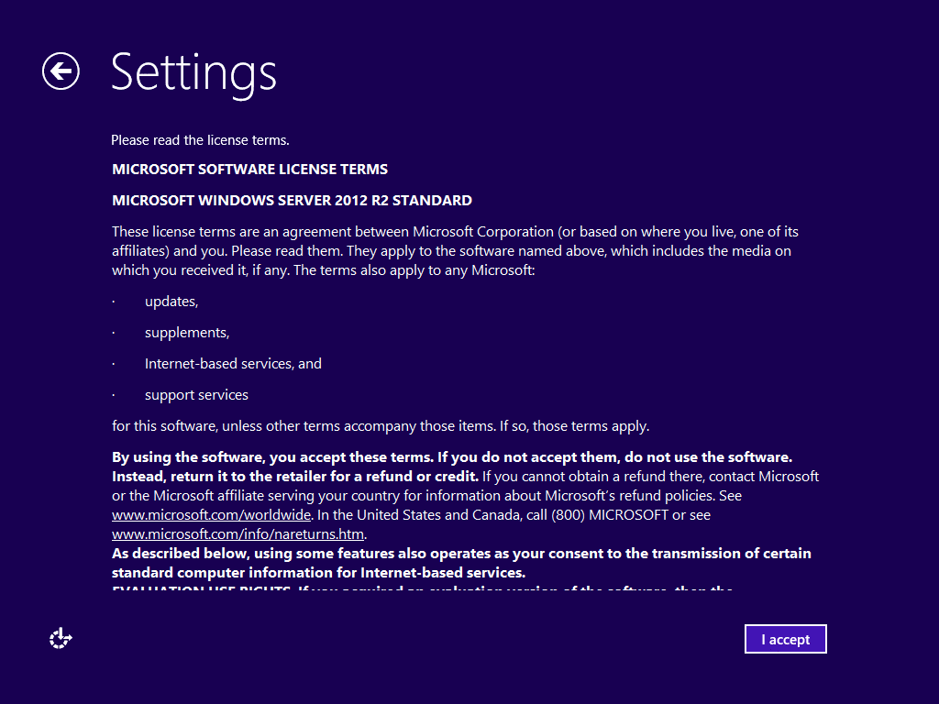

READ THE AGREEMENT and if you agree click I accept ☺

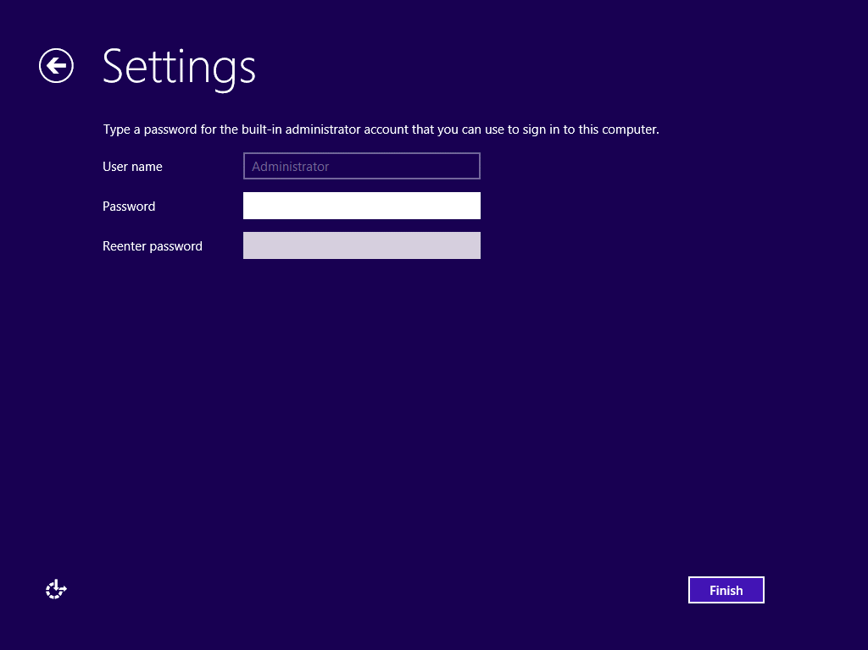

Provide Admin Password and click Finish, This will be the password for you localadmin

Login to the VM with your admin password

# Inside the VM

**Join the Datacom domain**

Connect/Add the VM to Datacom or LIC AD (Active Directory).

Change the computer came and connect it to the appropriate domain (LICDomain / Datacom.co.nz / Datacom)

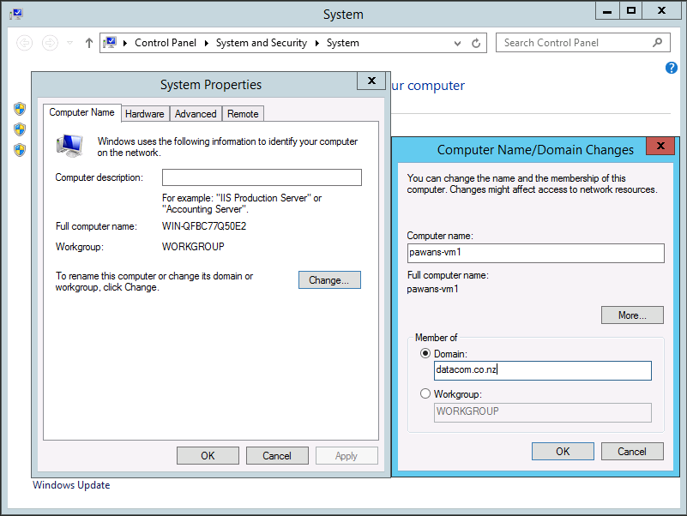

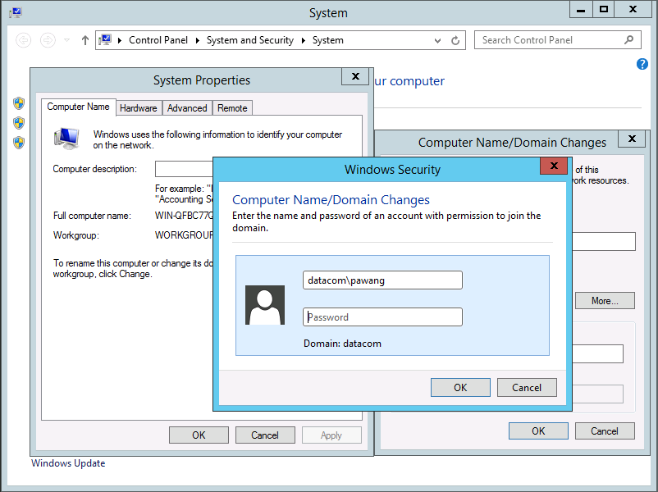

Provide your domain credentials when asked.

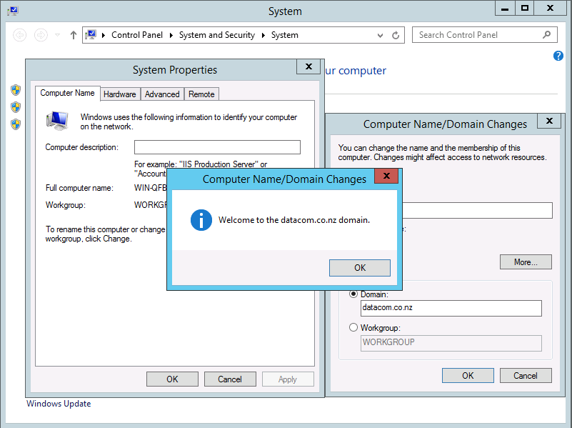

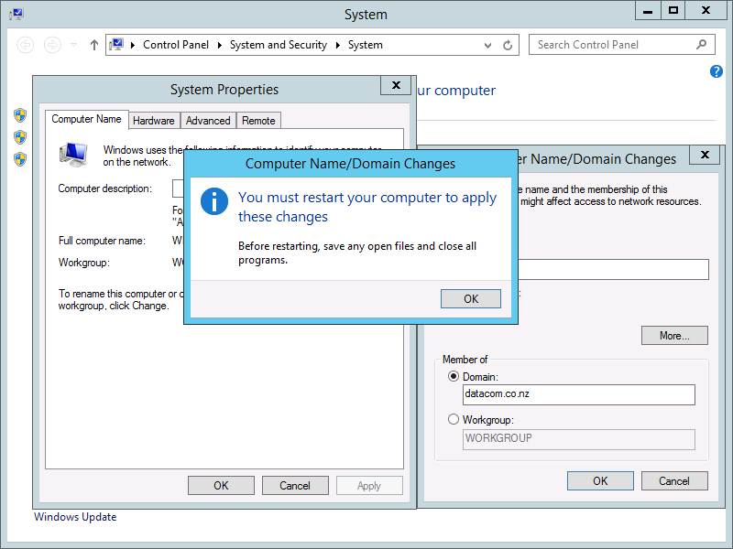

Restart the VM.

# Screen resolution

This restart should set the VM resolution a bit higher and allowing you to select. So, select the resolution that is appropriate to your screen.

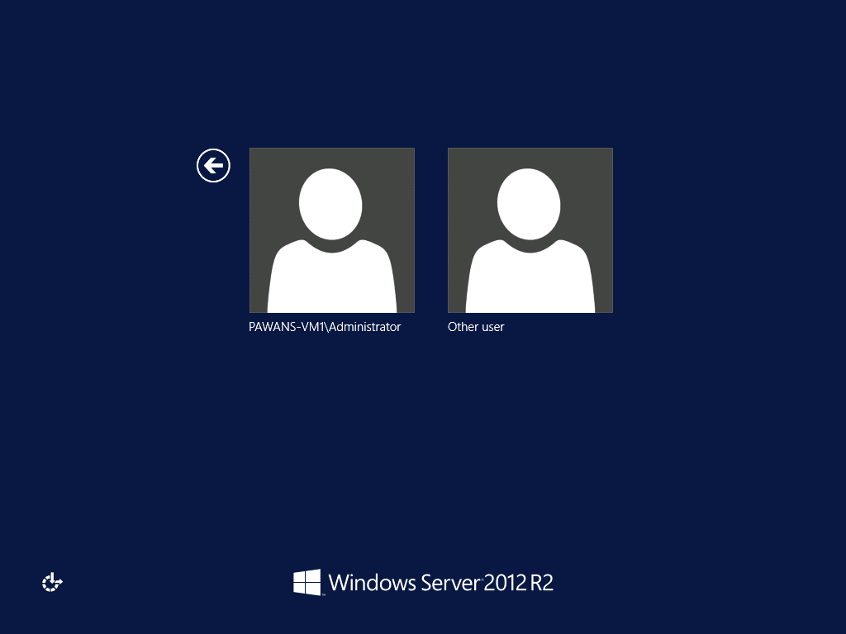

## Step 12

Log back in as the local administrator, invoke the following command from windows search:

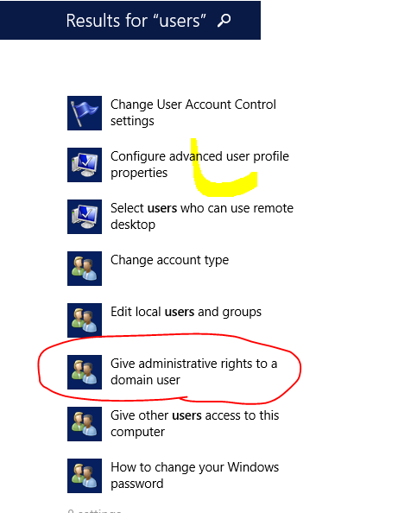

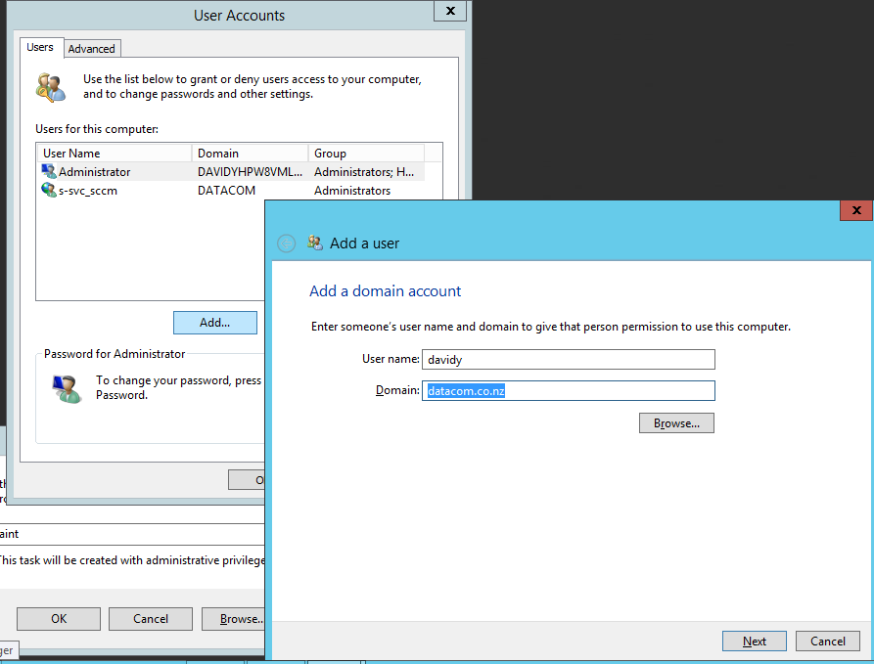

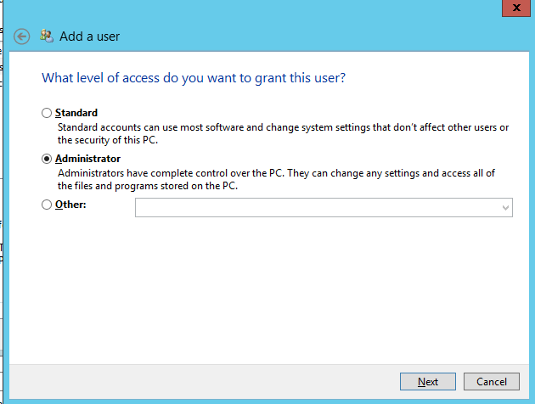

Sign out and select the other user, this should select Datacom/LICDomain as your domain to sign in

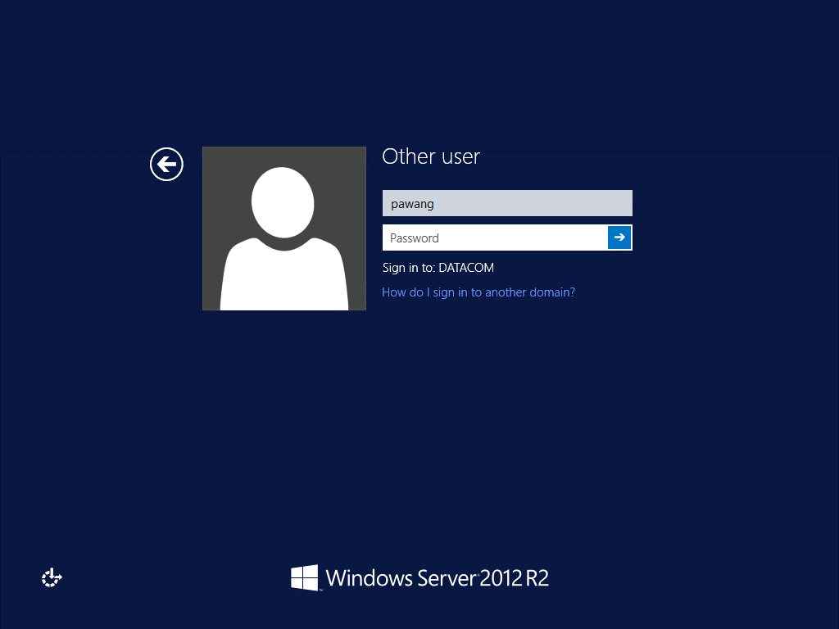

**Hard disk volume expansion**

Expand disk volume (c: drive on the virtual machine, not the host machine) to accommodate new program installations.

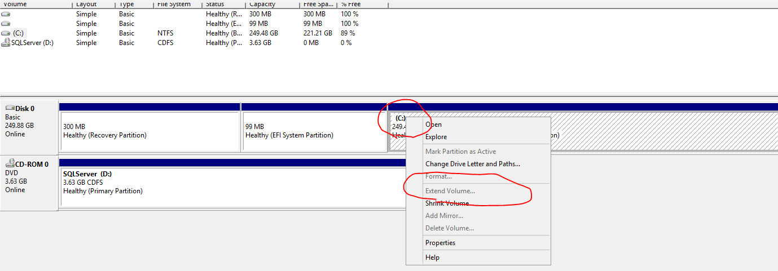

**Additional software**

Here’s a list of the base software required for LIC development work.

|  |  |  |
| --- | --- | --- |
| **Product** | **Version** | **Details** |
|  |  |  |
| Microsoft Firewall Client | 4.0.3442 | Datacom to provide, not part of VM image |
| Cisco IP Communicator | 8.6.3.0 | Datacom to provide, not part of VM image |
| OpenVPN Client | 1.5.6 | Datacom to provide, not part of VM image |
| SourceTree (GIT) | 1.5.2 |  |
| Microsoft SQL Server 2012 Native Client + full instance | 11.0.2218.0 | \\fedfs.dsldev.local\Database\SQL Server\SQL Server 2012\ en_sql_server_2012_developer_edition_with_sp1_x64_dvd_1228540.iso |
|  |  |  |
| Xsd2Code 3.6.0.0 | 3.6 |  |
| NServiceBus | 4.4.2 | http://www.jetbrains.com/resharper/download/ |
| SQL Server | 2012 (Full) | Full install  Default Instance |
| Resharper |  | http://www.jetbrains.com/resharper/download/ |
| NServiceBus | 4.4.2 |  |