**Game Manual**

Jurassic Mistake

COMP 4981

**Abstract**

System requirements, source code build instructions, client and server operation and how to play.

Table of Contents

System Requirements 3

Source Code Build Instructions 3

How to run the Game Server 3

How to run the Game Client 4

How to Play 6

Commander 7

Player Specifications 7

Shop 7

Item Costs 7

Game Interface 8

# System Requirements

* x86 Linux-based Operating System with X11 (Ubuntu, Fedora, etc)
* SFML 2.0RC runtimes
* LAN/Internet connection

# Source Code Build Instructions

Ensure you have an active Internet connection before executing the bootstrap.

1. Download the latest source code from the Git repository <https://github.com/rbellido/Project/archive/master.zip>
2. Extract the zip file
3. Change directories into the newly extracted folder
4. Execute *./sfml-setup.sh*
5. Change directories into the /redesigned/ folder
6. Execute *make*

# How to run the Game Server

To play, clients must join a game server. Once the server is started, other players on your LAN or on the Internet can join your game. Ensure that you know your IP address and port (default: 4545) so that client players can join your server!

|  |  |
| --- | --- |
| 1) Execute *./run-server* |  |

# How to run the Game Client

To join the server, get the IP address and port (default: 4545) of the server then follow the instructions below.

|  |  |
| --- | --- |
| 1) Execute *./run-client* |  |
| 2) Once you start the game client, you should be able to see a game menu. There are three buttons:   * Join Game - Wait for other clients to join the game before starting. * Quit - Exit the game. | C:\Users\Luke\Desktop\manual_doc\Screenshot from 2013-04-11 06_29_03.png |
| 3) Once you join the game, a form will pop up, prompting you to enter the following:   * User Name: A unique user name that will identify you in-game. Other clients will see this user name. * Server: The IP Address of the server to connect to. * Port: The port number of the server to connect to. (Default is 4545)   Click “join” to continue. | C:\Users\Luke\Desktop\manual_doc\Screenshot from 2013-04-11 06_29_11.png |
| 4) Afterwards, you’re user name will be listed in the unassigned players list. Select an “Empty” slot with the corresponding character in either Team One or Team Two and click “Ready”. You can chat with other people in the lobby.  You can exit the lobby to return to the main game menu. | C:\Users\Luke\Desktop\manual_doc\Screenshot from 2013-04-11 06_29_47.png |
| 5) Once you’re ready, the game will start until everyone in the lobby is ready. Note that you cannot enter in a middle of a game after it has started. | C:\Users\Luke\Desktop\manual_doc\Screenshot from 2013-04-11 06_30_10.png |
| 6) Once you start the game after selecting a team, you’ll be brought to this game interface where you can compete to win. | C:\Users\Luke\Desktop\manual_doc\Screenshot from 2013-04-11 06_30_47.png |
| 7) If you need to know what each tower and creep’s health points and damage does, click the “*i”* on the bottom right corner. | C:\Users\Luke\Desktop\manual_doc\Screenshot from 2013-04-11 06_30_29.png |

# How to Play

The objective of the game is to destroy the opposing team’s base, located in the opposite corner of the screen from your own base. Your base and the enemy base are connected by three lanes. Your team will have a constant flow of neutral attacking units called “creeps” that will make their way, on each of the three lanes, to enemy tower in order to destroy it. As you destroy enemy creeps, you will gain gold that can be used to purchase more powerful creeps for attacking or defensive “towers” to guard against the enemy creeps. In addition, you control a player-controlled creep called a “commander” to take part of the action as well.



## Commander

The commander is controlled with a WASD-scheme (W key moves up, D key moves right, etc). When the commander/player runs into the opposing team’s commander/player or creep, the character will automatically attack based on the direction the player is attacking by holding down the direction of the key.



## Player Specifications

|  |  |
| --- | --- |
| Mario – the builder of the team. This is the only character who can build towers or spawn creeps. | F:\manual_doc\m1.png |
| Flash – Runs extremely fast, but not as strong when it comes to attack. | F:\manual_doc\m3.png |
| Samus – Balanced speed and attack. | F:\manual_doc\m4.png |
| Gordon Freeman – Attack is stronger than Samus but slightly slower than her. | F:\manual_doc\m2.png |
| Hulk – Extremely slow but extremely powerful. | F:\manual_doc\m5.png |

## Shop

To buy towers or special creeps, select a lane with the “lane selector”, ensure you have enough gold for the item then click on the creep or tower icon to purchase.

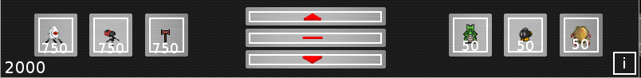

## Item Costs

Special creeps - 50 gold

Tower - 750 gold

# Game Interface

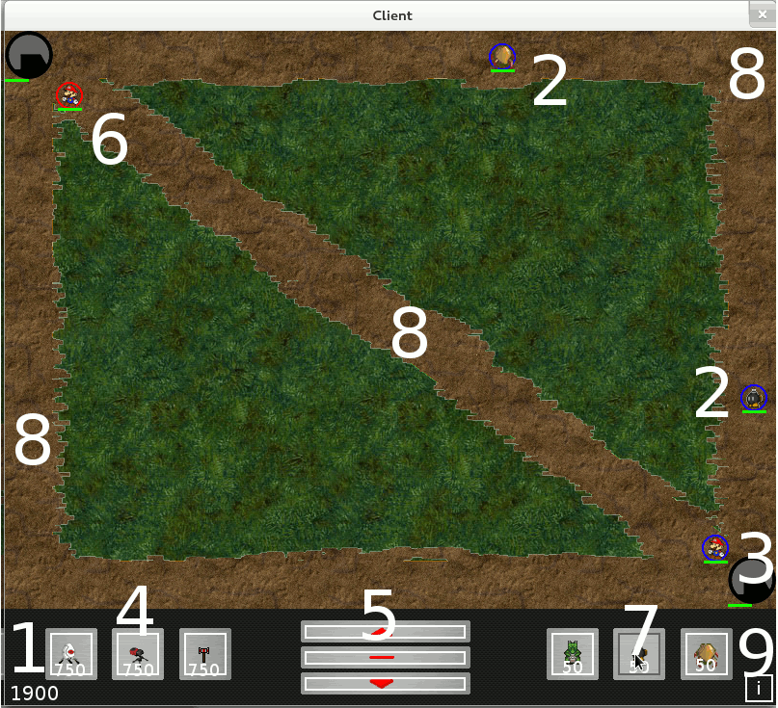

1. your team’s current gold
2. neutral creep
3. base
4. purchasable towers
5. lane selector (select top, mid, or bottom lane)
6. player-controlled commander
7. purchasable special creeps
8. lanes (top, mid, bottom)
9. Tower and creep information