Lab 8 — Trace a Blocked Network Flow to the Exact Policy (Cilium & Hubble)
DataCouch — Advanced Kubernetes (Nutanix)
Table of Contents

Day 2 · Extending and Operating the Platform Under Pressure
YES — Tested end-to-end on a real 3-node kind cluster running Cilium 1.20.1 as its CNI (kube-proxy fully replaced) with Hubble enabled. Every screenshot is a real capture. The insight you'll reach: the fix for a blocked flow isn't editing the policy — it's changing the client's labels, which gives it a new Cilium identity (you'll watch it flip from ID:1609 to ID:18439), and the verdict changes the instant that identity propagates.

What you'll learn
- Why Cilium's network policy is identity-based, not IP-based: every Pod gets a numeric security identity from its labels, and policy is evaluated on identities — so rules keep working as Pods churn and IPs change.
- How to install Cilium as the CNI (replacing kube-proxy) and turn on Hubble for flow-level observability.
- How to read a DROPPED flow in Hubble and trace it to the exact verdict (Policy denied).
- The non-obvious fix — change the client's identity (labels) to match the policy — and the propagation delay to expect.
- Why ndots:5 and the search list turn one hostname into eight DNS queries, and what that costs CoreDNS.
- How to diagnose the most misread failure in Kubernetes networking: the name fails, the IP works — an egress policy that forgot DNS.
- Where the five-second DNS stall comes from, measured off the resolver's own retry timer.

What you'll do
You'll build a Cilium cluster, deploy a client and a backend, and watch normal traffic flow in Hubble. Then you'll apply a policy that blocks the client, trace the drop in Hubble, and fix it by changing the client's identity — watching the verdict flip from DROPPED back to FORWARDED.
Then you'll turn the same lens on DNS: read the resolver every Pod is handed, count the eight queries one hostname really produces, break name resolution with a realistic egress policy, and diagnose it from Hubble's denied flows before fixing it.

Time & cost
- Time: ~50 minutes.
- Cost: $0 — runs on a local kind cluster.

Before you start
- Where you'll work: in a terminal on your own machine. One step needs a second terminal tab (for Hubble's live feed).
- Tools you need: docker, kind, kubectl, the cilium CLI, and the hubble CLI — install the last two with brew install cilium-cli hubble.
- ⚠️ This lab uses its own dedicated kind cluster (Cilium needs to be the CNI), separate from the Day-2 GKE cluster.
Nutanix note — and why this one is kind, not GKE. Installing upstream Cilium and opening Hubble requires control of the cluster's CNI, which managed GKE doesn't give you (its CNI is fixed; GKE Dataplane V2 is Google's own locked-down Cilium with no upstream Hubble CLI/UI). So this lab runs on kind, where you own the datapath. On Nutanix, NKE lets you run Cilium as the CNI (or install it yourself), so everything here — identity-based policy, hubble observe, the drop/forward verdicts — transfers directly to NKE; only the cluster-creation step differs.

The idea in 60 seconds
Cilium is an eBPF-based CNI that programs the Linux datapath directly and can fully replace kube-proxy. Its key idea for this lab is identity: Cilium doesn't write policy in terms of Pod IPs (which are ephemeral) — it gives every Pod a numeric security identity derived from its labels, and evaluates policy identity-to-identity. Change a Pod's labels and it gets a new identity.
Hubble is Cilium's observability layer: because Cilium already sees every packet, Hubble exports a live flow log — source identity, destination identity, port, and the verdict (FORWARDED / DROPPED) with a reason. That's what turns "my connection hangs" into "identity 1609 was denied by policy reaching backend:80."
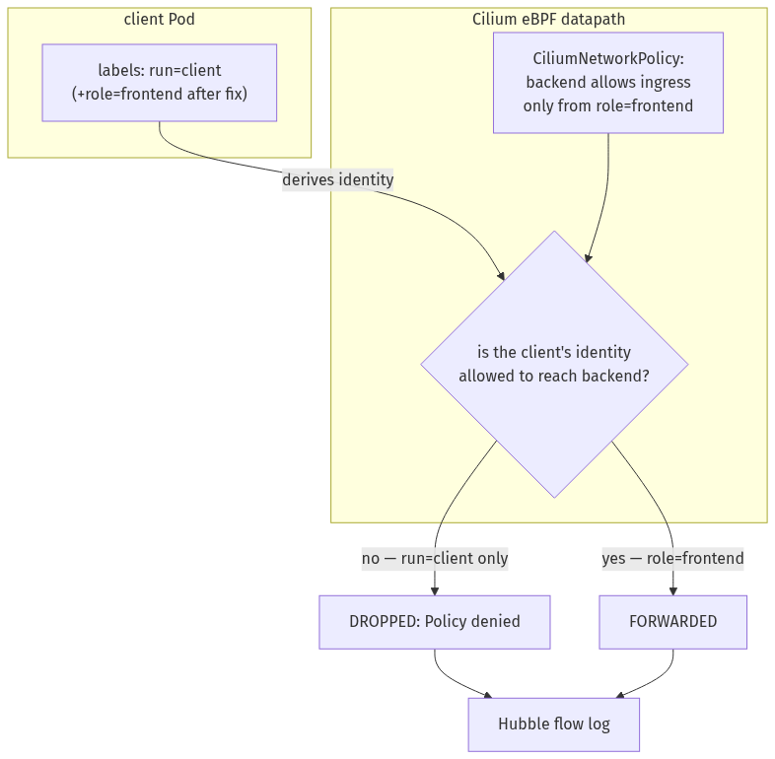

Step 1 — Build a Cilium cluster and enable Hubble
Goal: create a kind cluster with no CNI, install Cilium (which becomes the CNI and replaces kube-proxy), and turn on Hubble.
1. Create a cluster with the default CNI and kube-proxy disabled:
cat > cilium-kind.yaml <<'EOF'
kind: Cluster
apiVersion: kind.x-k8s.io/v1alpha4
name: cilium-lab
networking:
disableDefaultCNI: true
kubeProxyMode: none
nodes:
- role: control-plane
- role: worker
- role: worker
EOF
kind create cluster --config cilium-kind.yaml
# the nodes will be NotReady until a CNI exists — that's expected
2. Install Cilium with Hubble, and wait for it to come up:
cilium install --set hubble.relay.enabled=true
cilium status --wait
What you should see: Cilium's image is large, so its Pods sit in Init for a minute or two while it downloads. Then cilium status reports Cilium: OK, Operator: OK, Hubble Relay: OK, all Pods "managed by Cilium," and the nodes flip from NotReady to Ready.
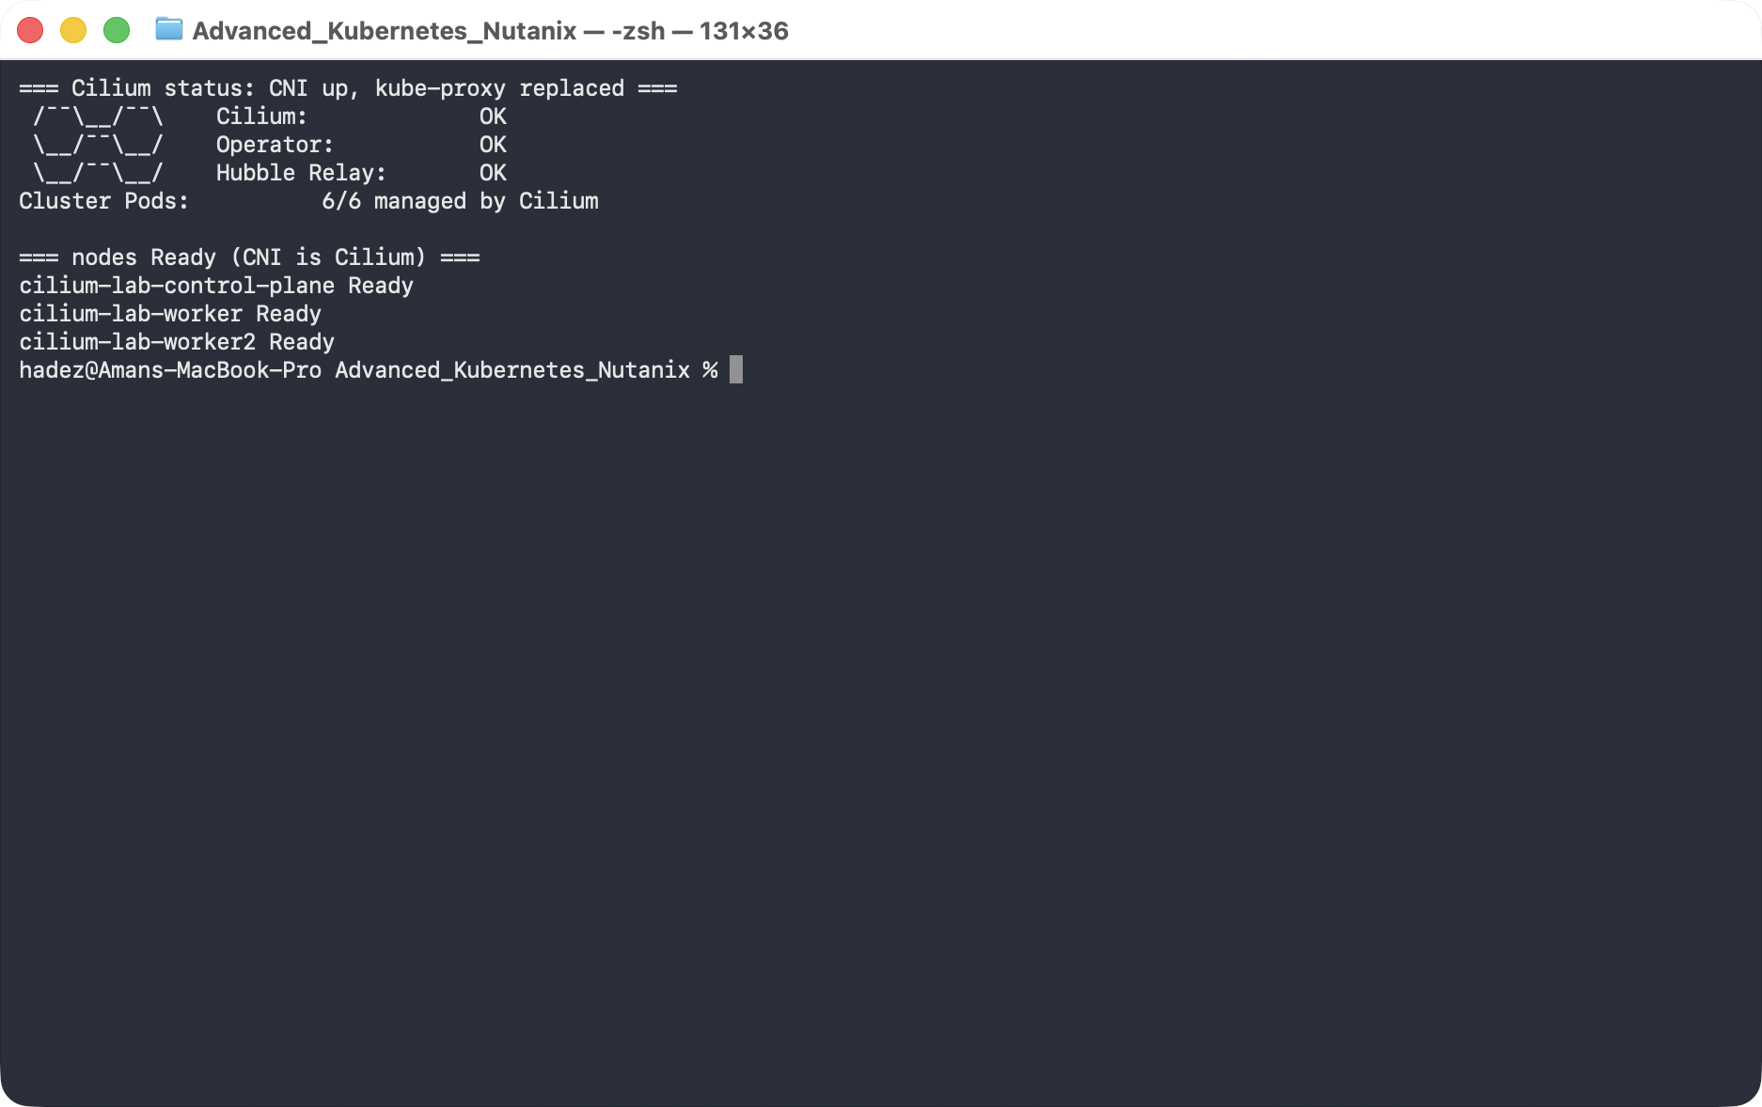
What this means: Cilium is now the cluster's datapath — it provides Pod networking and service routing (it detected kube-proxy was absent and took over). Hubble is ready to show you flows.

Step 2 — See what a healthy request looks like
Goal: before blocking anything, watch normal traffic so you know what "good" looks like in Hubble.
1. Deploy a backend and a client:
kubectl create deployment backend --image=nginx:1.27
kubectl expose deployment backend --port=80
kubectl run client --image=curlimages/curl --restart=Never -- sleep 3600
kubectl wait --for=condition=Ready pod/client --timeout=90s
2. Open Hubble's live flow feed — leave this running in a second terminal tab:
cilium hubble port-forward
3. Back in your first terminal, send one request and look at the flow:
kubectl exec client -- curl -s -o /dev/null -w "HTTP %{http_code}\n" http://backend
hubble observe --pod client --to-label app=backend --last 3
What you should see: curl prints HTTP 200, and Hubble prints three lines ending in FORWARDED, e.g. default/client (ID:1609) -> default/backend:80 (ID:41353).
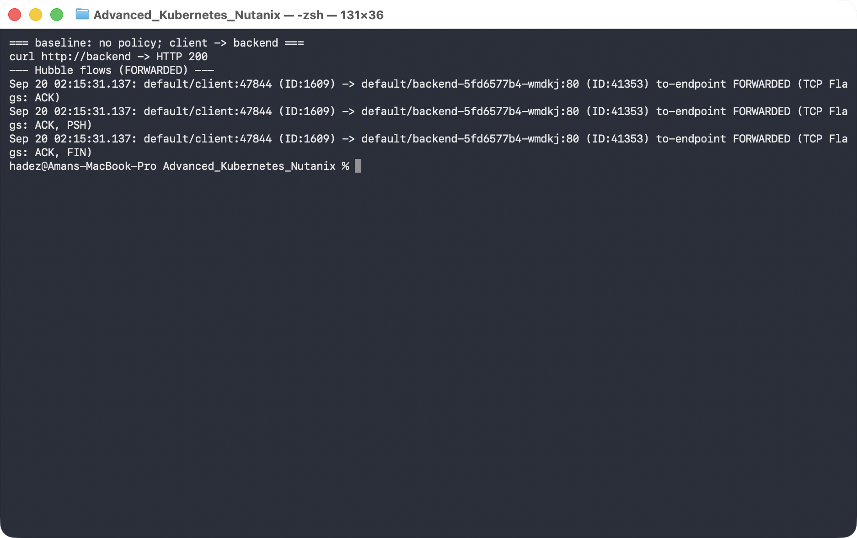
What this means: with no policy in place, Cilium forwards the client's packets. Note the identity numbers — client ID:1609, backend ID:41353. Remember the client's number; it's about to change.

Step 3 — Apply a policy and trace the drop
Goal: apply a policy that only lets role=frontend reach the backend, and watch Hubble name the drop.
1. Apply the policy, then try the request again:
kubectl apply -f - <<'EOF'
apiVersion: cilium.io/v2
kind: CiliumNetworkPolicy
metadata:
name: backend-allow-frontend
spec:
endpointSelector:
matchLabels: {app: backend}
ingress:
- fromEndpoints:
- matchLabels: {role: frontend}
EOF
kubectl exec client -- curl -s -o /dev/null -w "HTTP %{http_code}\n" --max-time 5 http://backend
hubble observe --pod client --verdict DROPPED --last 4
What you should see: curl now times out (exit 28) — the connection never establishes — and Hubble shows exactly why: default/client (ID:1609) <> default/backend:80 (ID:41353) Policy denied DROPPED (TCP Flags: SYN).
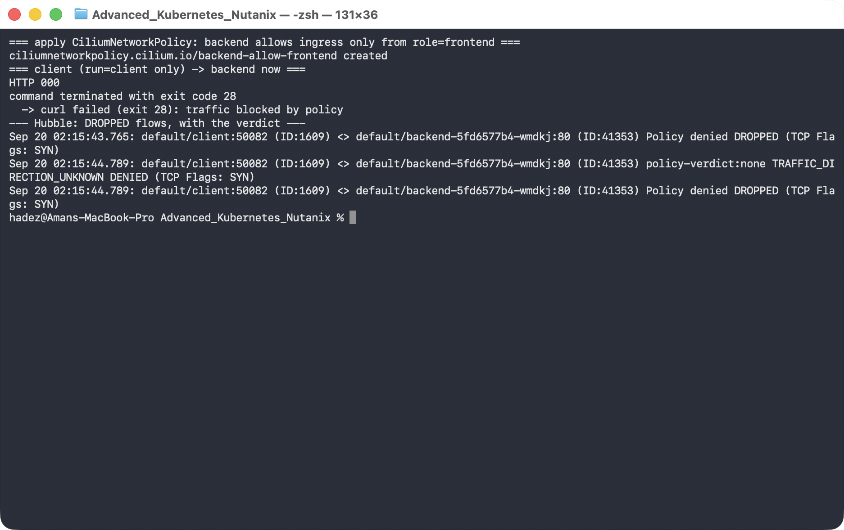
What this means: the client's SYN packets are dropped by the datapath before they reach the backend. This is the diagnosis Hubble gives you that plain kubectl never will — not "it's slow," but "identity 1609 is denied by policy."
The key mental model: once any CiliumNetworkPolicy selects an endpoint (here backend), that endpoint switches to default-deny for the direction the policy covers. So this one rule didn't just "allow frontend" — it simultaneously denied everything else, which is why the previously-working client is now dropped.

Step 4 — Fix it by changing the client's identity
Goal: give the client the identity the policy already trusts (role=frontend), and watch the verdict flip.
1. Label the client, wait for the new identity to propagate, then retry:
kubectl label pod client role=frontend --overwrite
sleep 12 # let the new identity propagate
kubectl exec client -- curl -s -o /dev/null -w "HTTP %{http_code}\n" --max-time 5 http://backend
hubble observe --pod client --to-label app=backend --last 3
What you should see: curl returns HTTP 200 again, Hubble shows FORWARDED — and the client's identity has changed from ID:1609 to ID:18439.
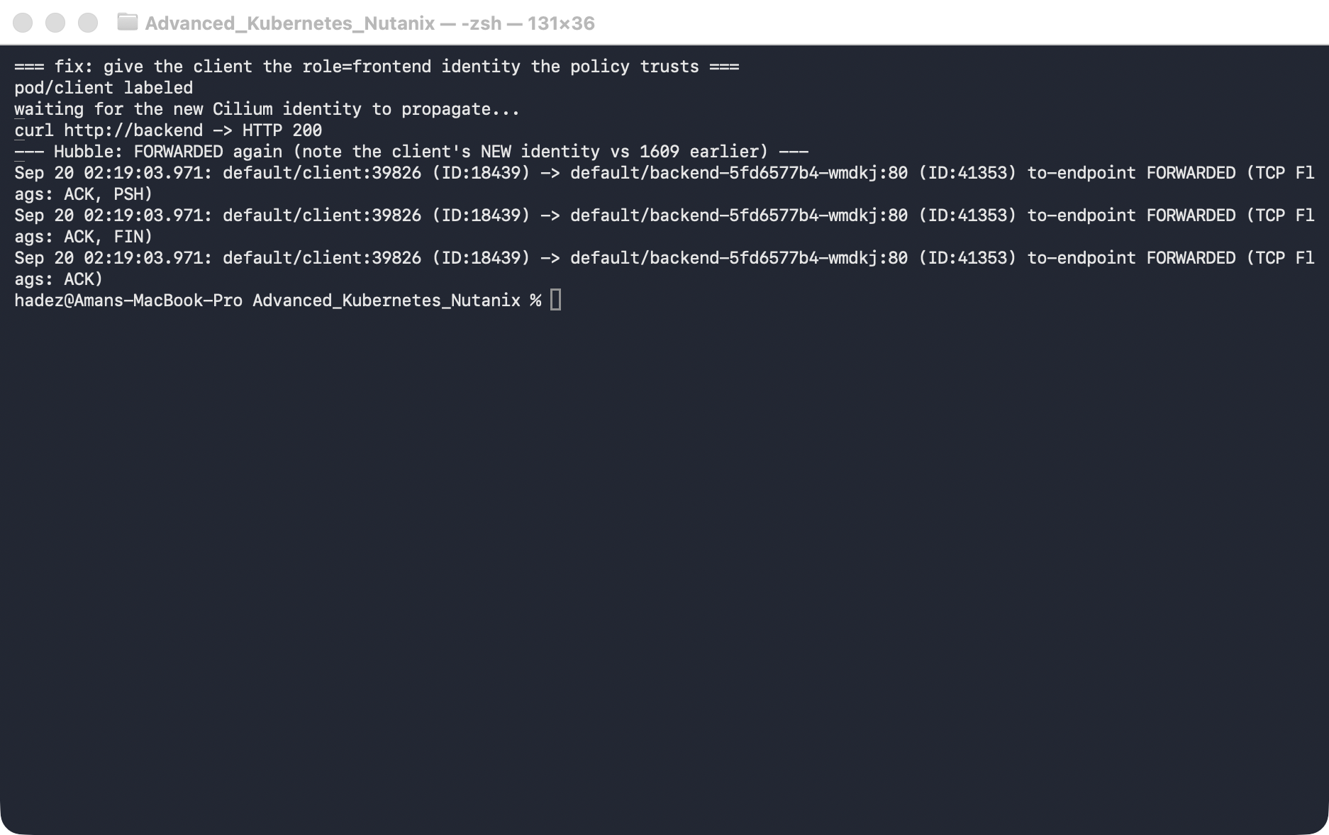
What this means: adding the role=frontend label gave the client a new Cilium identity, and that new identity matches the policy's fromEndpoints. The verdict flipped because the identity changed, not because the policy did. That's identity-based networking in one screenshot.
⚠️ Gotcha — identity propagation isn't instant. Immediately after kubectl label, the very next curl can still be DROPPED for a few seconds: the Pod's new identity has to be computed and pushed to every node's datapath. In our run it took ~10 seconds. If you test too quickly you'll wrongly conclude the fix failed — wait a moment, or watch hubble observe until you see the identity number change.

Step 5 — The resolver every Pod is handed
Goal: understand why one hostname becomes eight DNS queries, before anything breaks.
Cilium and Hubble are the lens; DNS is what you will spend most of your incident time looking through it at. Start by reading the resolver config the kubelet writes into every Pod.
kubectl exec client -- cat /etc/resolv.conf
What you should see:
search default.svc.cluster.local svc.cluster.local cluster.local
nameserver 10.96.0.10
options ndots:5
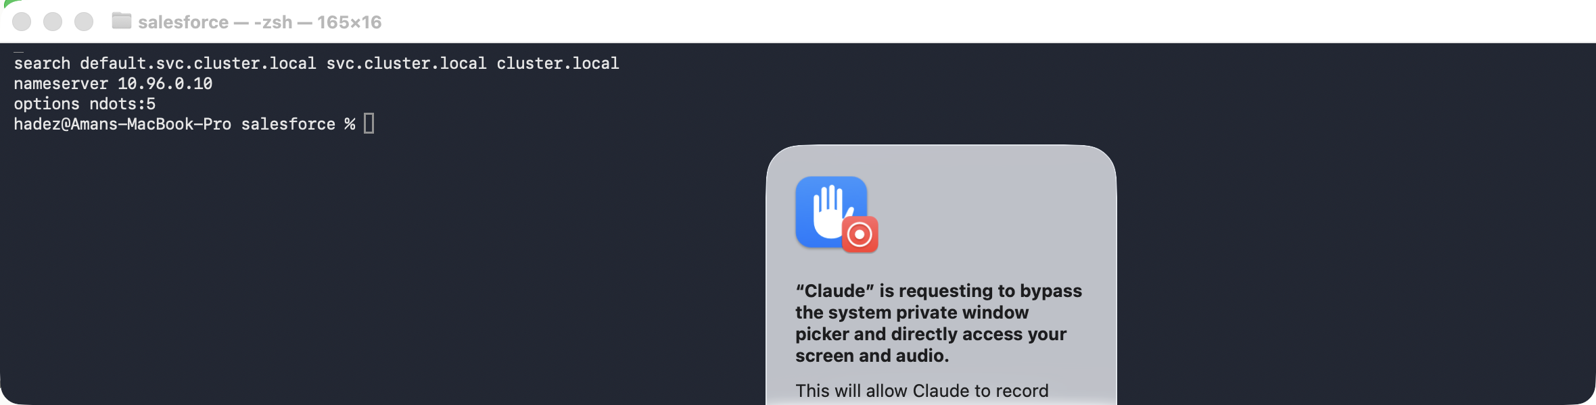
What this means. Three things, and the third is the one that bites:
- nameserver 10.96.0.10 — the kube-dns Service. Every lookup leaves the Pod as UDP to that ClusterIP.
- search … — three suffixes the resolver will append before giving up.
- options ndots:5 — "if the name has fewer than 5 dots, try the search list first."
backend has 0 dots. example.com has 1. Both are below the threshold, so both get the search list applied before the name is tried as written.

Step 6 — Watch one hostname become eight queries
Goal: measure the amplification instead of taking it on trust.
By default Hubble shows DNS as opaque UDP:53 flows — you see that a Pod talked to CoreDNS, not what it asked. Query names are L7 data, and Cilium only parses them when a DNS-aware policy says to. Apply one:
cat <<'EOF' | kubectl apply -f -
apiVersion: cilium.io/v2
kind: CiliumNetworkPolicy
metadata:
name: dns-visibility
spec:
endpointSelector:
matchLabels:
run: client
egress:
- toEndpoints:
- matchLabels:
io.kubernetes.pod.namespace: kube-system
k8s-app: kube-dns
toPorts:
- ports:
- port: "53"
protocol: UDP
rules:
dns:
- matchPattern: "*"
- toEntities: [world, cluster]
EOF
Now make one request to an external name and count what CoreDNS was asked:
kubectl exec client -- curl -s -o /dev/null http://example.com
hubble observe --pod client --protocol dns --last 40 | grep 'DNS Query'
What you should see — eight queries for one hostname:
example.com.default.svc.cluster.local. AAAA
example.com.default.svc.cluster.local. A
example.com.svc.cluster.local. AAAA
example.com.svc.cluster.local. A
example.com.cluster.local. A
example.com.cluster.local. AAAA
example.com. AAAA
example.com. A
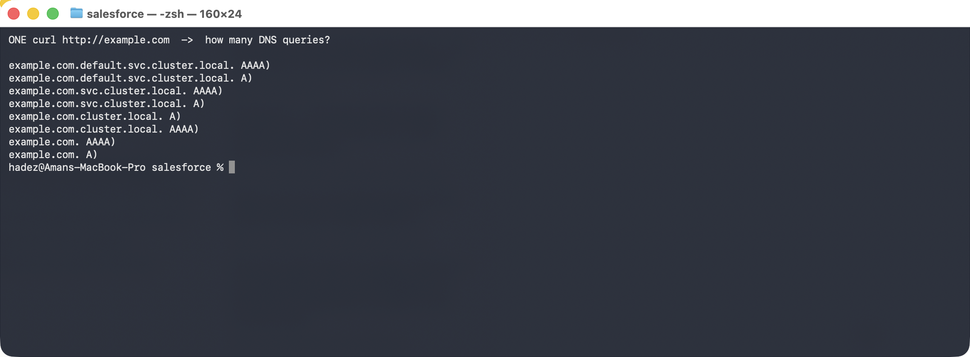
What this means. Four name variants (three search suffixes plus the name as written) × two address families (A and AAAA) = eight queries, six of which are guaranteed NXDOMAIN. Multiply by every Pod, every external call, no caching — this is why CoreDNS is so often the first thing to fall over in a busy cluster, and why ndots:2 in a Pod's dnsConfig is such a common tuning fix for workloads that mostly call out to the internet.
⚠️ Gotcha — nslookup will not show you this. nslookup example.com sends the name absolute (with a trailing dot), skipping the search list entirely. You will see two queries and conclude everything is fine. Use a client that goes through the normal resolver path — curl, or the application itself.

Step 7 — Break DNS the way a real policy does
Goal: produce the most misread symptom in Kubernetes networking.
Replace the visibility policy with the egress rule almost everyone writes first — "the client is allowed to reach the backend":
kubectl delete ciliumnetworkpolicy dns-visibility
cat <<'EOF' | kubectl apply -f -
apiVersion: cilium.io/v2
kind: CiliumNetworkPolicy
metadata:
name: client-egress
spec:
endpointSelector:
matchLabels:
run: client
egress:
- toEndpoints:
- matchLabels:
app: backend
toPorts:
- ports:
- port: "80"
protocol: TCP
EOF
Wait ~8 seconds, then try the Service by name, and the Pod by IP:
kubectl exec client -- curl -s --max-time 8 -o /dev/null -w "exit=%{exitcode}\n" http://backend
BIP=$(kubectl get pod -l app=backend -o jsonpath='{.items[0].status.podIP}')
kubectl exec client -- curl -s --max-time 8 -o /dev/null -w "http=%{http_code}\n" http://$BIP
What you should see:
--- by NAME ---
exit=6
--- by IP ---
http=200
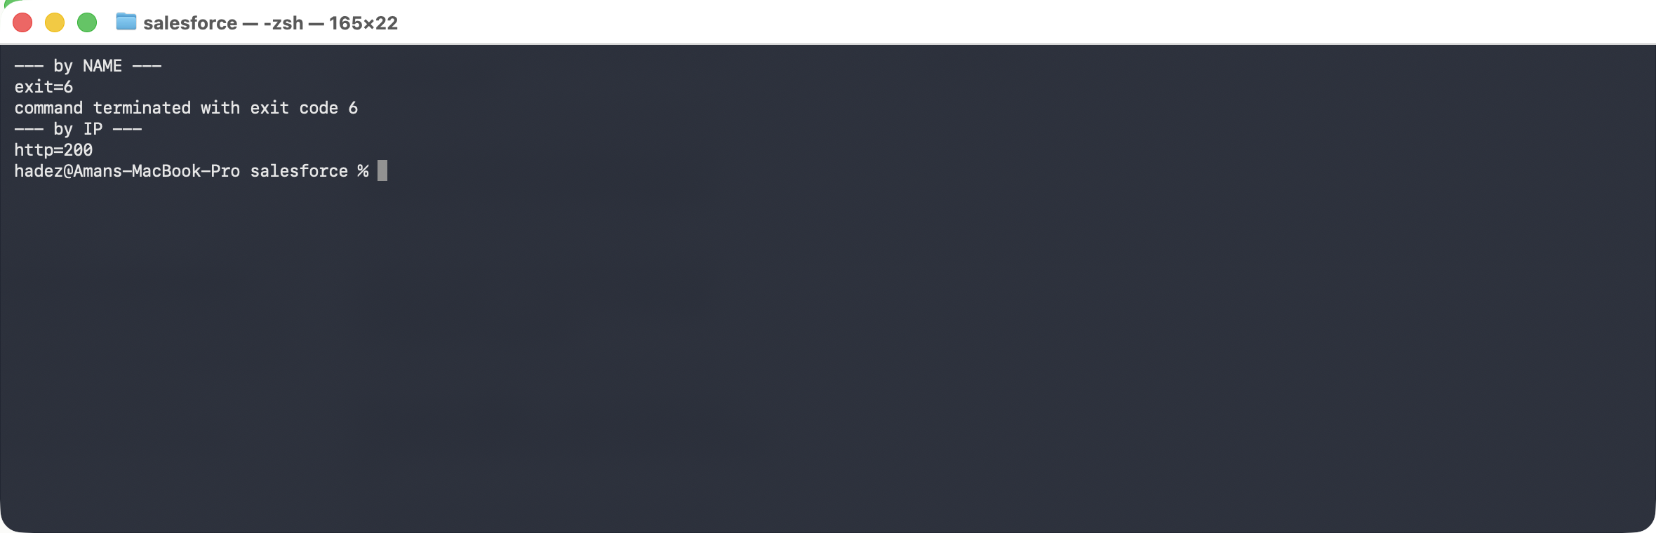
What this means. exit=6 is curl's "couldn't resolve host." The policy did exactly what it said — the client can reach the backend — and the application still cannot, because resolving the name was never allowed. The connection was never attempted; it died one layer earlier.
This is the shape of the real incident: "I allowed the traffic and it still doesn't work." The IP working while the name fails is the tell.

Step 8 — Let Hubble name the cause
Goal: go from symptom to the exact denied flow in one command.
hubble observe --pod client --verdict DROPPED --to-label k8s-app=kube-dns --last 6
What you should see:
default/client:56241 <> kube-system/coredns-559f6c778d-rq5c4:53 Policy denied DROPPED (UDP)
default/client:56241 <> kube-system/coredns-559f6c778d-rq5c4:53 Policy denied DROPPED (UDP)
default/client:45744 <> kube-system/coredns-559f6c778d-sg8b9:53 Policy denied DROPPED (UDP)
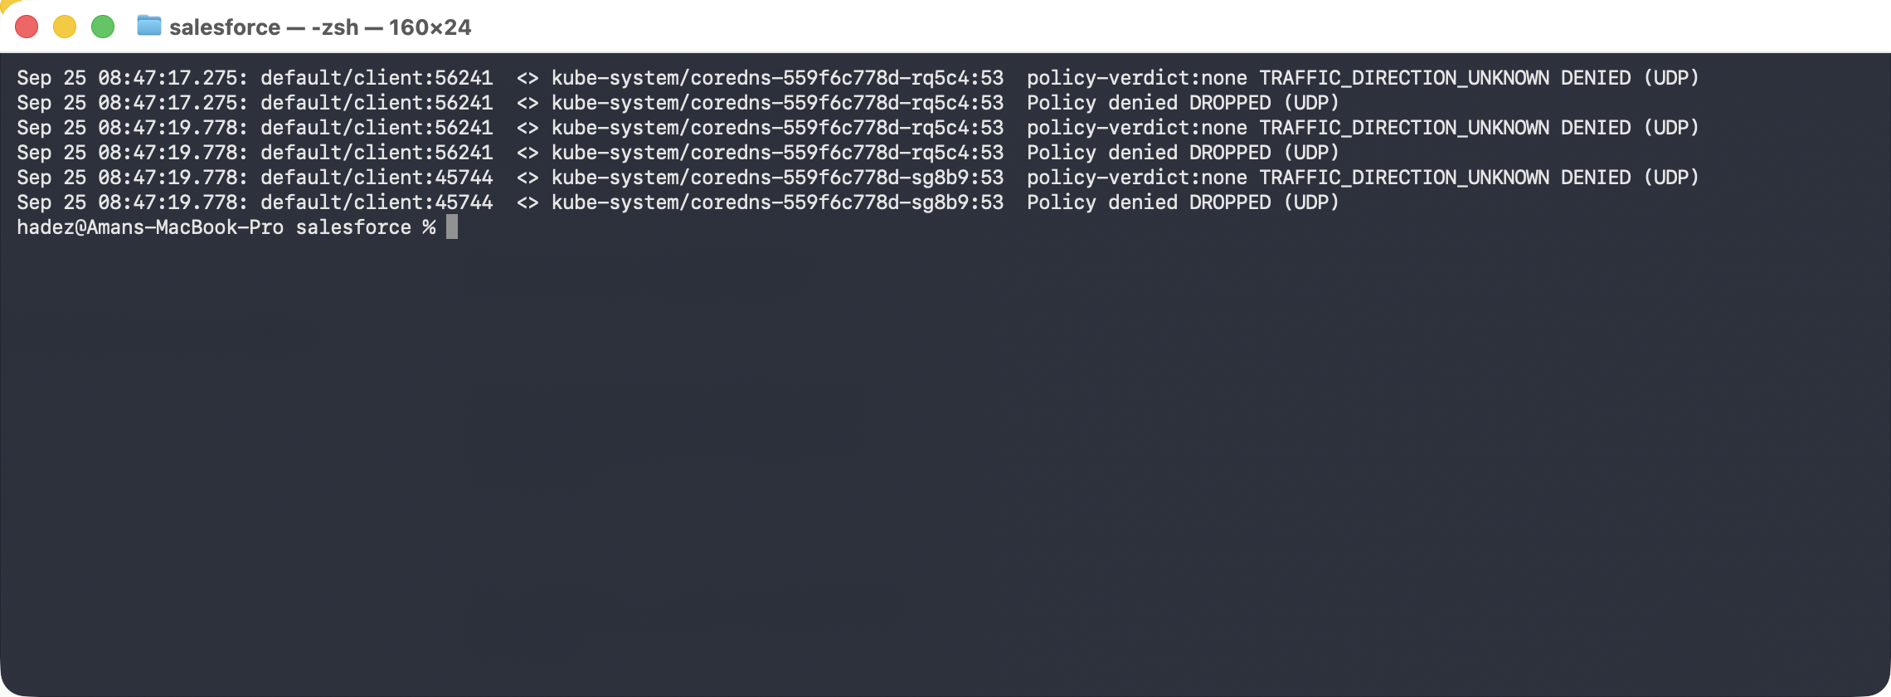
What this means. No guessing: the client's UDP traffic to CoreDNS on :53 was Policy denied. That points straight at the missing egress rule.
⚠️ Gotcha — --port 53 returns nothing here. These drops are recorded with unknown traffic direction (<>), and the port filter does not match them. Filter on the destination workload instead: --to-label k8s-app=kube-dns. Learners who try the obvious flag conclude Hubble has no record of the drop.
Look at the timestamps. In the captured run the retry bursts are at 08:47:17.275 and 08:47:19.778 — 2.503 seconds apart. That is the resolver's retry timer, and two of those is the notorious five-second DNS stall. When users report "the app hangs for about five seconds then works," this timer is usually why: something is dropping or losing a fraction of DNS packets and the resolver is waiting out its retry before falling through to the next search suffix.

Step 9 — Add the rule everyone forgets
Goal: fix it, and see the query succeed.
cat <<'EOF' | kubectl apply -f -
apiVersion: cilium.io/v2
kind: CiliumNetworkPolicy
metadata:
name: client-egress
spec:
endpointSelector:
matchLabels:
run: client
egress:
# the rule everyone writes
- toEndpoints:
- matchLabels:
app: backend
toPorts:
- ports: [{ port: "80", protocol: TCP }]
# the rule everyone forgets
- toEndpoints:
- matchLabels:
io.kubernetes.pod.namespace: kube-system
k8s-app: kube-dns
toPorts:
- ports: [{ port: "53", protocol: UDP }]
rules:
dns:
- matchPattern: "*"
EOF
kubectl exec client -- curl -s --max-time 8 -o /dev/null -w "http=%{http_code}\n" http://backend
hubble observe --pod client --protocol dns --last 4
What you should see: http=200, and the lookup now FORWARDED:
default/client -> kube-system/coredns:53 dns-request proxy FORWARDED (DNS Query backend.default.svc.cluster.local. A)
default/client <- kube-system/coredns:53 dns-response proxy FORWARDED (DNS Answer "10.96.201.151" ...)
What this means. Egress policy is default-deny once it selects an endpoint — the moment you write any egress rule for a Pod, everything you did not list is denied, including DNS. Every egress policy needs a DNS allowance, and adding it as an L7 rules.dns block buys you the query names in Hubble at the same time.
Nutanix note. The ndots:5 amplification and the default-deny DNS trap are upstream Kubernetes and Cilium behaviour — neither depends on the cloud. They reproduce identically on NKE. What does differ on-prem is the blast radius: with no managed DNS tier absorbing the extra queries, CoreDNS replica count and its cache plugin settings become a capacity decision you own.

Step 10 — Clean up
kind delete cluster --name cilium-lab

What you learned
You saw… | in Step | proof
Cilium can be the CNI and replace kube-proxy | 1 | cilium status: OK, nodes Ready, kube-proxy absent
Hubble shows per-flow verdicts with identities | 2 | FORWARDED flows, client ID:1609
One policy flips the selected endpoint to default-deny | 3 | previously-working client now DROPPED
A drop is traceable to Policy denied in Hubble | 3 | Policy denied DROPPED (TCP Flags: SYN)
Policy is identity-based; labels drive identity | 4 | client ID:1609 → ID:18439 on relabel, verdict flips
Identity propagation has a short delay | 4 gotcha
ndots:5 + 3 search domains = 8 queries per hostname | 6 | all eight listed in hubble observe --protocol dns
Query names need an L7 DNS-aware policy to appear | 6 | opaque UDP:53 before, named queries after
An egress policy is default-deny — and silently kills DNS | 7 | name exit=6, same backend by IP http=200
A DNS drop is traceable to Policy denied on :53 | 8 | client <> coredns:53 Policy denied DROPPED (UDP)
The 5-second DNS stall is two 2.5s resolver retries | 8 | retry bursts 2.503s apart in the captured flows

Evidence
Real screenshots for this lab are in artifacts/lab-08/screenshots/, and full command transcripts are in artifacts/lab-08/evidence/:
- lab-07-cilium-hubble.txt — Steps 1–4, the identity/policy arc.
- lab-08-dns-diagnosis.txt — Steps 5–9, captured 2026-09-25 on Cilium 1.20.1: the resolver config, all eight queries, the exit=6 / http=200 split, the denied flows with their 2.503s retry gap, and the fix.

Next: Lab 9 — Make Two Clusters Behave Like One (Multi-Cluster Service Mesh with Istio)

