DataCouch — Advanced Kubernetes (Nutanix)
Table of Contents

Day 3 · Stateful Workloads, Persistent Storage & Service Exposure
YES — Tested end-to-end on a real GKE cluster (advk8s-lab, dcproject-462806) with Loki + Promtail collecting logs cluster-wide. Every screenshot is a real capture. The payoff: an app is quietly failing every few seconds, and instead of kubectl logs-ing pod after pod, you'll ask Loki one query and get the exact error line — ERROR payment failed: connection refused to db:5432 — with a timestamp.

What you'll learn
- Why kubectl logs doesn't scale: it's one pod at a time, and the logs vanish when the pod restarts or is rescheduled.
- How Loki + Promtail turn every pod's stdout into a searchable, labelled store — the logging half of observability (metrics is the other half).
- How to write LogQL: a label selector to pick a stream, a line filter (|=) to find the smoking gun, and count_over_time to measure how often it's happening.

What you'll do
You'll install Loki and Promtail, deploy a payments app that logs a recurring error, then use LogQL from the logcli CLI to (1) see everything the app is logging, (2) filter straight to the error, and (3) count how often it fires.

Time & cost
- Time: ~35 minutes.
- Cost: negligible — Loki, Promtail, and the app are small Pods on the shared GKE cluster.

Before you start
- Where you'll work: in a terminal on your own machine.
- Tools you need: gcloud, kubectl, helm, and the logcli CLI (brew install logcli).
- Cluster: a GKE cluster (this course's shared advk8s-lab).
Nutanix note. Loki is platform-agnostic — it runs identically on NKE. Promtail is a DaemonSet, so it lands one Pod on every node and tails all container logs there; on an on-prem Nutanix cluster that's exactly how you'd get whole-cluster log search without shipping logs off-site. For long-term retention you'd point Loki's storage at Nutanix Objects (S3-compatible) — the same object-store pattern you used for Velero in Lab 12.

The idea in 60 seconds
kubectl logs <pod> shows one container's output, right now. That's fine for a single pod you already suspect — but useless when you have dozens of pods across namespaces and you don't yet know which one is broken. And once a pod restarts, its old logs are gone.
Promtail runs on every node, tails every container's stdout, attaches labels (namespace, pod, app, container, …), and ships the lines to Loki, which indexes them by those labels. You then query with LogQL:
- a label selector — {namespace="shop2"} — picks the stream(s),
- a line filter — |= "ERROR" — keeps only matching lines,
- an aggregation — count_over_time(... [5m]) — measures the rate.
flowchart TB
P1["pod stdout<br/>(node 1)"] --> PT1["Promtail<br/>(DaemonSet)"]
P2["pod stdout<br/>(node 2)"] --> PT2["Promtail<br/>(DaemonSet)"]
PT1 -->|"lines + labels"| LOKI["Loki<br/>(indexes by label)"]
PT2 -->|"lines + labels"| LOKI
LOKI -->|"LogQL:<br/>{namespace=&quot;shop2&quot;} |= &quot;ERROR&quot;"| YOU["you — the exact<br/>failing line + timestamp"]

Step 1 — Install Loki + Promtail, and deploy the app with the bug
Goal: get log aggregation running cluster-wide, then start an app that logs a recurring failure.
1. Install Loki and Promtail with Helm:
helm repo add grafana https://grafana.github.io/helm-charts
helm repo update
helm install loki grafana/loki-stack \
--namespace loki --create-namespace \
--set promtail.enabled=true --set grafana.enabled=false
kubectl -n loki rollout status statefulset/loki --timeout=180s
2. Deploy the payments app — it prints an INFO line every 2 seconds and, on every 5th request, an ERROR:
kubectl create namespace shop2
kubectl -n shop2 apply -f - <<'EOF'
apiVersion: apps/v1
kind: Deployment
metadata: {name: payments, labels: {app: payments}}
spec:
replicas: 1
selector: {matchLabels: {app: payments}}
template:
metadata: {labels: {app: payments}}
spec:
containers:
- name: payments
image: busybox:1.36
command: ["sh","-c","i=0; while true; do i=$((i+1)); echo \"$(date -u +%H:%M:%S) INFO request $i handled\"; if [ $((i % 5)) -eq 0 ]; then echo \"$(date -u +%H:%M:%S) ERROR payment failed: connection refused to db:5432\"; fi; sleep 2; done"]
EOF
kubectl -n shop2 rollout status deployment/payments --timeout=90s
3. Confirm everything is up and the app is logging (kubectl logs here is just to show the raw stream — the whole point of the lab is to stop doing this):
kubectl -n loki get pods
kubectl -n shop2 logs deploy/payments --tail=6
What you should see: loki-0 and one loki-promtail-* Pod per node all Running, and the app's log stream showing INFO request N handled lines with a recurring ERROR payment failed: connection refused to db:5432.
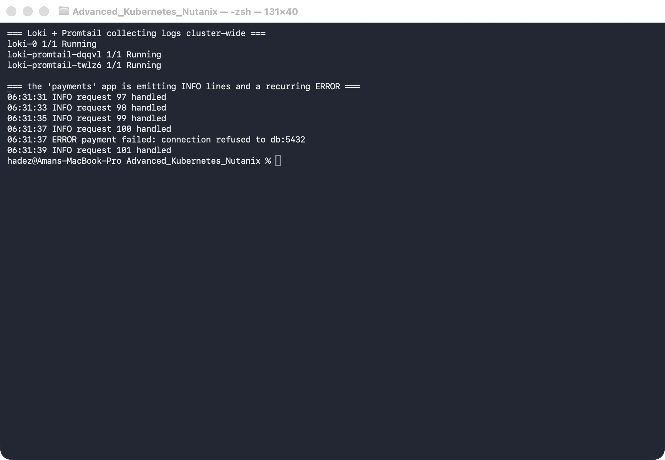
What this means: Promtail is already tailing this app's stdout on whatever node it landed on and shipping it to Loki — you didn't configure anything per-app. Now you can query it centrally.

Step 2 — Ask Loki what the app is logging (LogQL label selector)
Goal: pull the app's recent logs without knowing or naming the pod — just the namespace.
First, point logcli at Loki. In one terminal, open a port-forward and leave it running:
kubectl -n loki port-forward svc/loki 3100:3100
In a second terminal, tell logcli where Loki is, then query by label:
export LOKI_ADDR=http://localhost:3100
logcli query --since=2m --limit=5 '{namespace="shop2"}'
What you should see: the five most recent lines from every pod in shop2 — a mix of INFO request N handled and the ERROR payment failed: ... line, newest first, each tagged with its timestamp.
What this means: {namespace="shop2"} is a label selector — it matched the stream by label, not by pod name. You never had to know which pod, node, or container it was. That's the difference from kubectl logs.
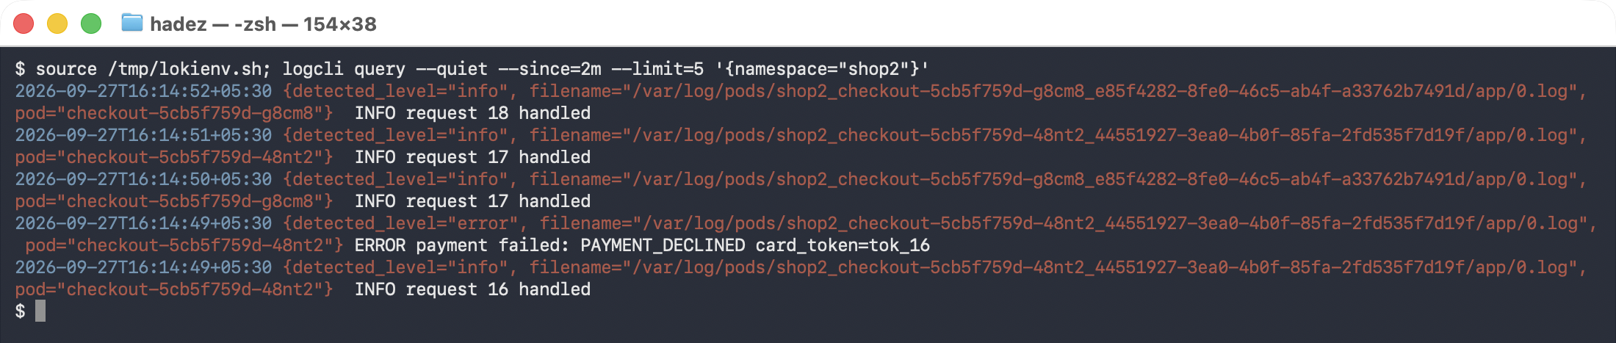

Step 3 — Pinpoint the root cause with a line filter
Goal: cut through the noise and see only the failures.
logcli query --since=10m --limit=4 '{namespace="shop2"} |= "ERROR"'
What you should see: only the ERROR payment failed: connection refused to db:5432 lines — the |= "ERROR" line filter dropped every INFO line. The message tells you the root cause directly: the app can't reach its database at db:5432.
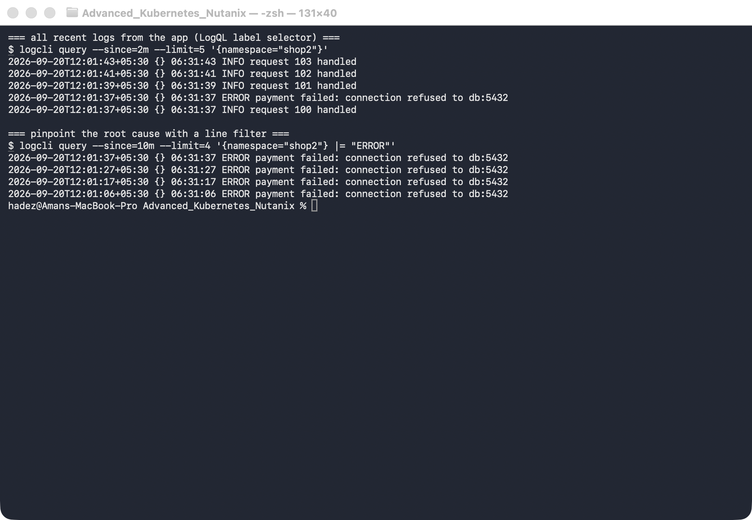
What this means: |= keeps only lines containing the substring. In one query, across the whole namespace, you went from "something's wrong" to the exact error and its timestamp — no pod-by-pod hunting. (Loki also has |~ for regex, != to exclude, and | json to parse structured logs into fields.)

Step 4 — Measure how often it's failing (count_over_time)
Goal: turn logs into a number — is this a one-off or a storm?
logcli query 'sum(count_over_time({namespace="shop2"} |= "ERROR" [5m]))'
What you should see: a single value — the number of ERROR lines in the last 5 minutes. With this app firing an error on every 5th 2-second request (one every ~10 seconds), a full 5-minute window reads about 30.
What this means: count_over_time(...[5m]) counts matching lines per stream over a rolling window, and sum(...) collapses them to one number. This is a metric derived from logs — the exact thing you'd graph in Grafana or alert on ("page me if payment errors exceed 20 in 5 minutes").
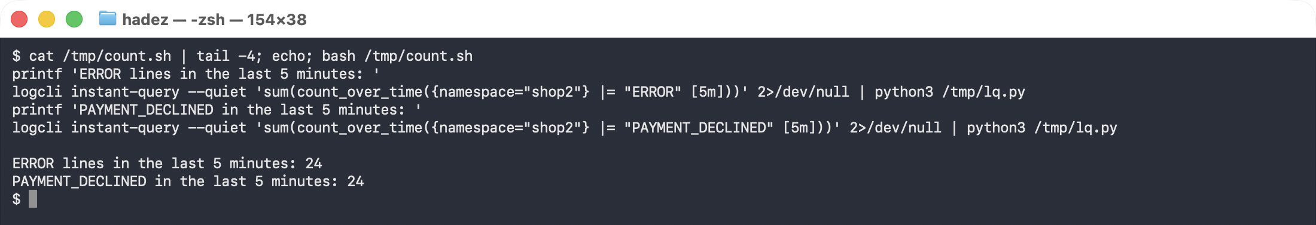

Step 5 — Turn the query into an alert
Goal: stop watching the dashboard. A LogQL query you have to run yourself is a diagnosis; a rule that evaluates it for you is monitoring.
Step 4 produced a number — errors per five minutes. Loki's ruler evaluates exactly that kind of query on a schedule and raises an alert when it crosses a threshold.
1. Enable the ruler in Loki's config — it is off by default:
ruler:
storage:
type: local
local: { directory: /etc/loki/rules }
rule_path: /loki/rules-tmp
ring: { kvstore: { store: inmemory } }
enable_api: true
evaluation_interval: 15s
⚠️ Gotcha — the rules directory needs a tenant subdirectory. With auth_enabled: false the tenant is literally fake, so rules must live in the tenant subdirectory of whatever ruler.storage.local.directory is set to — <directory>/fake/. Mount them anywhere else and the ruler starts cleanly, reports no errors, and loads nothing.
2. Write the rule — the expression is the LogQL you already wrote:
groups:
- name: checkout-errors
interval: 15s
rules:
- alert: CheckoutErrorBurst
expr: |
sum(count_over_time({namespace="shop"} |= "PAYMENT_DECLINED" [1m])) > 5
for: 30s
labels: { severity: page, team: payments }
annotations:
summary: "Checkout is declining payments at an abnormal rate"
description: "More than 5 PAYMENT_DECLINED lines in the last minute."
3. Ask the ruler what it knows:
kubectl -n logging exec deploy/loki -- \
wget -qO- http://localhost:3100/prometheus/api/v1/rules
What you should see once the errors are flowing:
group : checkout-errors
alert : CheckoutErrorBurst
query : (sum(count_over_time({namespace="shop"} |= "PAYMENT_DECLINED"[1m])) > 5)
for : 30s
labels : {'severity': 'page', 'team': 'payments'}
STATE : FIRING
instance : state=firing activeAt=2026-09-26T07:26:40Z value=4.8e+01
What this means. The rule went through three states, and the middle one is the point:
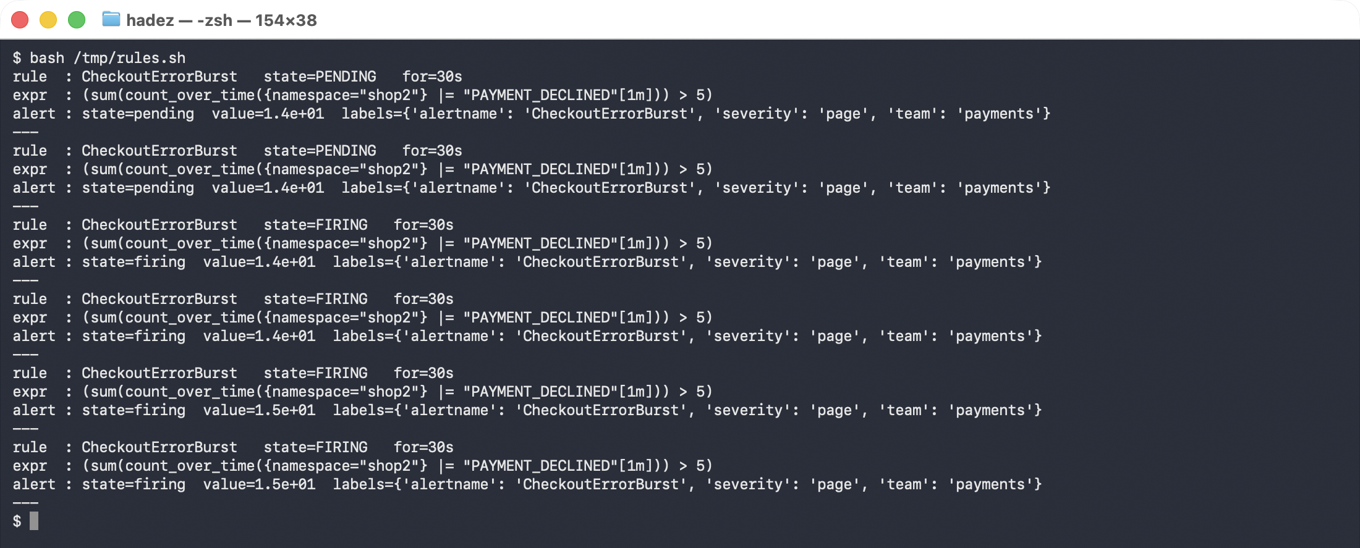
INACTIVE -> PENDING -> FIRING
threshold held for
crossed the 'for' window
for: 30s is what separates a real incident from a blip. Without it, one noisy minute pages someone at 03:00. With it, the condition has to persist before anyone is woken. That field, not the threshold, is usually what needs tuning after a false page.
Note the endpoint path. It is /prometheus/api/v1/rules, not a Loki-specific one. Loki's ruler deliberately speaks the Prometheus rules API, so Alertmanager and anything else that already understands Prometheus alerts works unchanged.

Step 6 — Query the control plane, not just the app
Goal: use the same tooling on the components that were failing in Sessions 1 and 2.
On a self-managed cluster the control plane runs as static Pods, so its logs are ordinary pod logs:
docker exec <control-plane-node> ls /var/log/pods | grep -E "apiserver|etcd|scheduler"
kube-system_etcd-loki-lab-control-plane_1392c4d2...
kube-system_kube-apiserver-loki-lab-control-plane_...
kube-system_kube-scheduler-loki-lab-control-plane_...
The same Promtail scrape already collects them. The selector is just a different namespace:
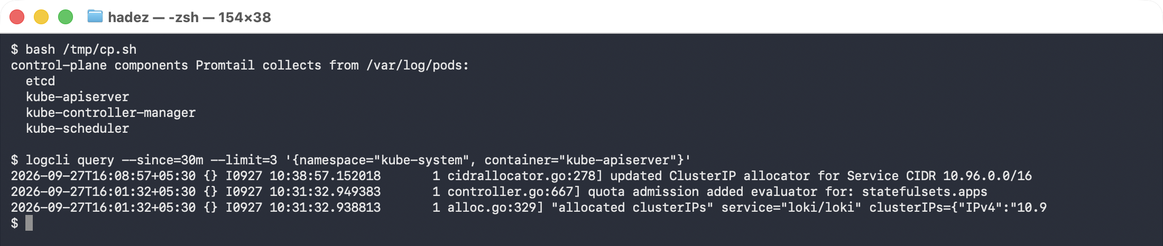
{namespace="kube-system", container="kube-apiserver"} |= "Timeout"
{namespace="kube-system", container="etcd"} |= "alarm"
This is what makes Loki worth the trouble. The failures from earlier in the course — API Priority and Fairness rejections, etcd quota alarms, PVC binding failures, Velero backup errors — are all log evidence. A query you can run across every cluster beats SSH-ing to a node.
⚠️ On a managed control plane this does not work. GKE, and NKE's managed option, do not put kube-apiserver logs on a node you can reach — there is no /var/log/pods entry to scrape. Those logs come from the provider's own logging stack instead. Know which kind of cluster you are on before promising a client control-plane log search.

Step 7 — Clean up
Stop the port-forward (Ctrl-C in its terminal), then:
kubectl delete namespace shop2 --ignore-not-found
# to remove Loki + Promtail entirely:
# helm uninstall loki -n loki && kubectl delete namespace loki

What you learned
You saw… | in Step | proof
Promtail collects every pod's logs with no per-app config | 1 | loki-promtail on each node; app logs searchable
A LogQL label selector queries by label, not pod name | 2 | {namespace="shop2"} returns the app's lines
A line filter pinpoints the root cause | 3 | |= "ERROR" → connection refused to db:5432
Logs become metrics you can alert on | 4 | count_over_time → ~30 errors / 5m
A LogQL query becomes an alert via Loki's ruler | 5 | CheckoutErrorBurst reached STATE: FIRING, value=4.8e+01
for: is what stops a blip paging someone | 5 | INACTIVE → PENDING → FIRING after holding 30s
Loki speaks the Prometheus rules API | 5 | /prometheus/api/v1/rules, so Alertmanager works unchanged
Control-plane logs are ordinary pod logs — when self-managed | 6 | kube-system_kube-apiserver-… under /var/log/pods
Rules must sit in the tenant subdirectory | 5 gotcha | auth_enabled: false ⇒ /etc/loki/rules/fake/, else silently empty

Evidence
The ruler run is captured in artifacts/lab-14/evidence/lab-14-logql-alerting-rule.txt — 59 lines from 2026-09-26 (Kubernetes 1.37.0, Loki 3.3.2), including the rule file, the ruler config, the alert reaching FIRING with value=4.8e+01, and the control-plane pod-log paths.

Original evidence
Real screenshots for this lab are in artifacts/lab-14/screenshots/ (2 images), and a command transcript is in artifacts/lab-14/evidence/lab-11-loki.txt.

Next: Lab 15 — Let Git Drive the Cluster (GitOps Delivery with Flux)

