DataCouch — Advanced Kubernetes (Nutanix)
Table of Contents

Day 2 · Extending and Operating the Platform Under Pressure
YES — Tested end-to-end on a real GKE cluster (dcproject-462806, the shared Day-2 cluster). Screenshots for Steps 1–3 are real captures from that GKE cluster; Step 4's two captures were taken on a local kind cluster on 2026-09-28 — see the note in that step about how kind's metrics pipeline changes one HPA condition. The eye-opener: kubectl delete prints … deleted, yet the object is still there with a deletionTimestamp set — because a finalizer is holding it open. Deletion in Kubernetes is a two-phase handshake, not an instant remove.

What you'll learn
- What a finalizer is — a key in .metadata.finalizers that turns deletion into a two-phase operation — and why kubectl delete succeeding does not mean the object is gone.
- How the deletion lifecycle really works: deletionTimestamp is set, the object goes Terminating, and it's removed only once every finalizer is cleared.
- Why operators add finalizers (to guarantee cleanup runs first), and what happens when the operator is down: their resources wedge in Terminating forever.
- How to diagnose a stuck object and a stuck namespace, the manual override to force deletion — and why that override is dangerous.

What you'll do
You'll wedge three different things into Terminating on purpose — a ConfigMap, a custom resource, and a whole namespace — diagnose each, and recover it. Along the way you'll see exactly why "it won't delete" is almost always a finalizer.

Time & cost
- Time: ~35 minutes.
- Cost: negligible — everything here is control-plane-only (no extra nodes or storage). Reuses the Day-2 GKE cluster.

Before you start
- Where you'll work: in a terminal on your own machine.
- Tools you need: gcloud, kubectl.
- Cluster: this lab creates a shared Day-2 GKE cluster (reused by Labs 6 and C):
gcloud container clusters create advk8s-day2 \
--zone us-central1-a --num-nodes 2 --machine-type e2-medium \
--disk-size 30 --release-channel regular
gcloud container clusters get-credentials advk8s-day2 --zone us-central1-a
Nutanix note. Finalizers, deletionTimestamp, the Terminating state, and namespace status.conditions are pure Kubernetes API machinery — identical on NKE, GKE, and kind. Nothing here is cloud-specific; we run it on GKE only because Day 2 is cloud-first. It behaves exactly the same on a Nutanix NKE cluster.

The idea in 60 seconds
Deleting a Kubernetes object is a two-phase operation:
- You call delete. The API server sets .metadata.deletionTimestamp; the object enters Terminating. It is not removed yet.
- Any controller that registered a finalizer (a string in .metadata.finalizers) runs its cleanup, then removes its own finalizer key.
- Only when .metadata.finalizers is empty does the object actually get deleted.
This is how operators guarantee cleanup — an operator managing a cloud load balancer adds a finalizer so deleting its custom resource first deprovisions the real load balancer, then lets the resource vanish. The failure mode is the mirror image: if a finalizer is present but nothing ever removes it (the operator crashed, was uninstalled, or never existed), the object is stuck in Terminating forever. That's the most common "why won't this delete?" incident in Kubernetes, and you'll reproduce it three ways.
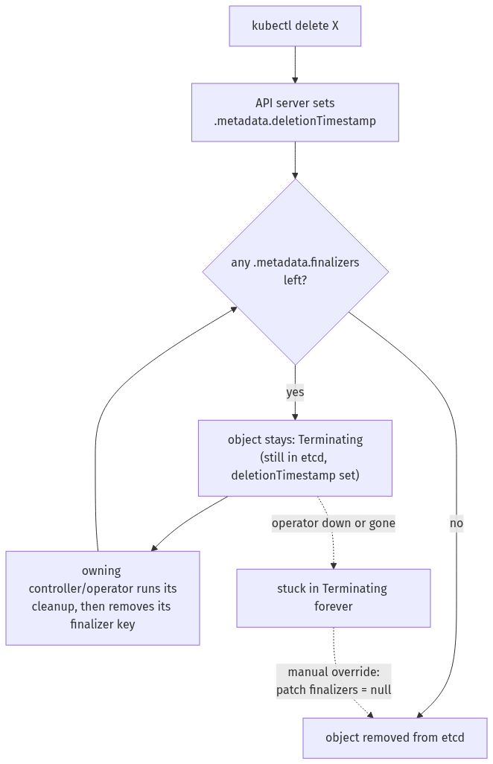

Step 1 — Warm-up: watch delete lie to you
Goal: put a finalizer on a plain ConfigMap and see that "deleted" doesn't mean gone.
1. Create a ConfigMap, add a finalizer, then delete it:
kubectl create configmap protected --from-literal=k=v
kubectl patch configmap protected --type=merge \
-p '{"metadata":{"finalizers":["demo.example.com/protect"]}}'
kubectl delete configmap protected --wait=false # prints "deleted" ...
kubectl get configmap protected \
-o jsonpath='name={.metadata.name} deletionTimestamp={.metadata.deletionTimestamp} finalizers={.metadata.finalizers}{"\n"}'
What you should see: kubectl delete prints configmap "protected" deleted, but the get still returns it — with deletionTimestamp set and finalizers=["demo.example.com/protect"].
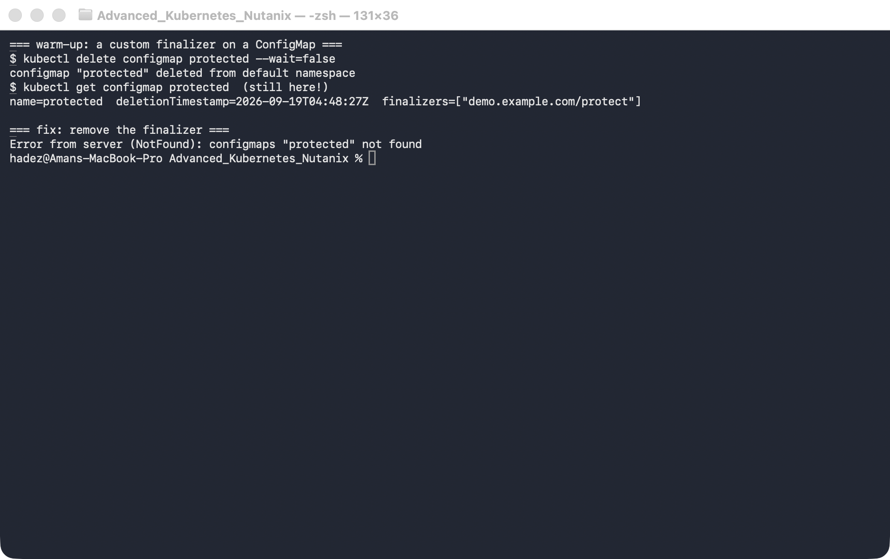
What this means: it's in Terminating, waiting for a finalizer that nobody will ever remove. Clear it by hand and it vanishes instantly:
kubectl patch configmap protected --type=merge -p '{"metadata":{"finalizers":null}}'
kubectl get configmap protected # Error ... NotFound

Step 2 — The operator pattern: a custom resource that won't delete
Goal: define a custom resource (as an operator would), create one with a finalizer, then delete it while no operator is running to process it.
1. Create the CRD and one custom resource carrying a finalizer:
kubectl apply -f - <<'EOF'
apiVersion: apiextensions.k8s.io/v1
kind: CustomResourceDefinition
metadata:
name: widgets.example.com
spec:
group: example.com
scope: Namespaced
names: {plural: widgets, singular: widget, kind: Widget}
versions:
- name: v1
served: true
storage: true
schema:
openAPIV3Schema:
type: object
properties:
spec:
type: object
properties: {size: {type: string}}
EOF
kubectl wait --for=condition=Established crd/widgets.example.com --timeout=30s
kubectl apply -f - <<'EOF'
apiVersion: example.com/v1
kind: Widget
metadata:
name: gadget
finalizers: ["widgets.example.com/cleanup"]
spec: {size: large}
EOF
2. Delete it and check:
kubectl delete widget gadget --wait=false
kubectl get widget gadget \
-o jsonpath='name={.metadata.name} deletionTimestamp={.metadata.deletionTimestamp} finalizers={.metadata.finalizers}{"\n"}'
What you should see: the Widget is stuck exactly like the ConfigMap — deletionTimestamp set, finalizers=["widgets.example.com/cleanup"], still present.
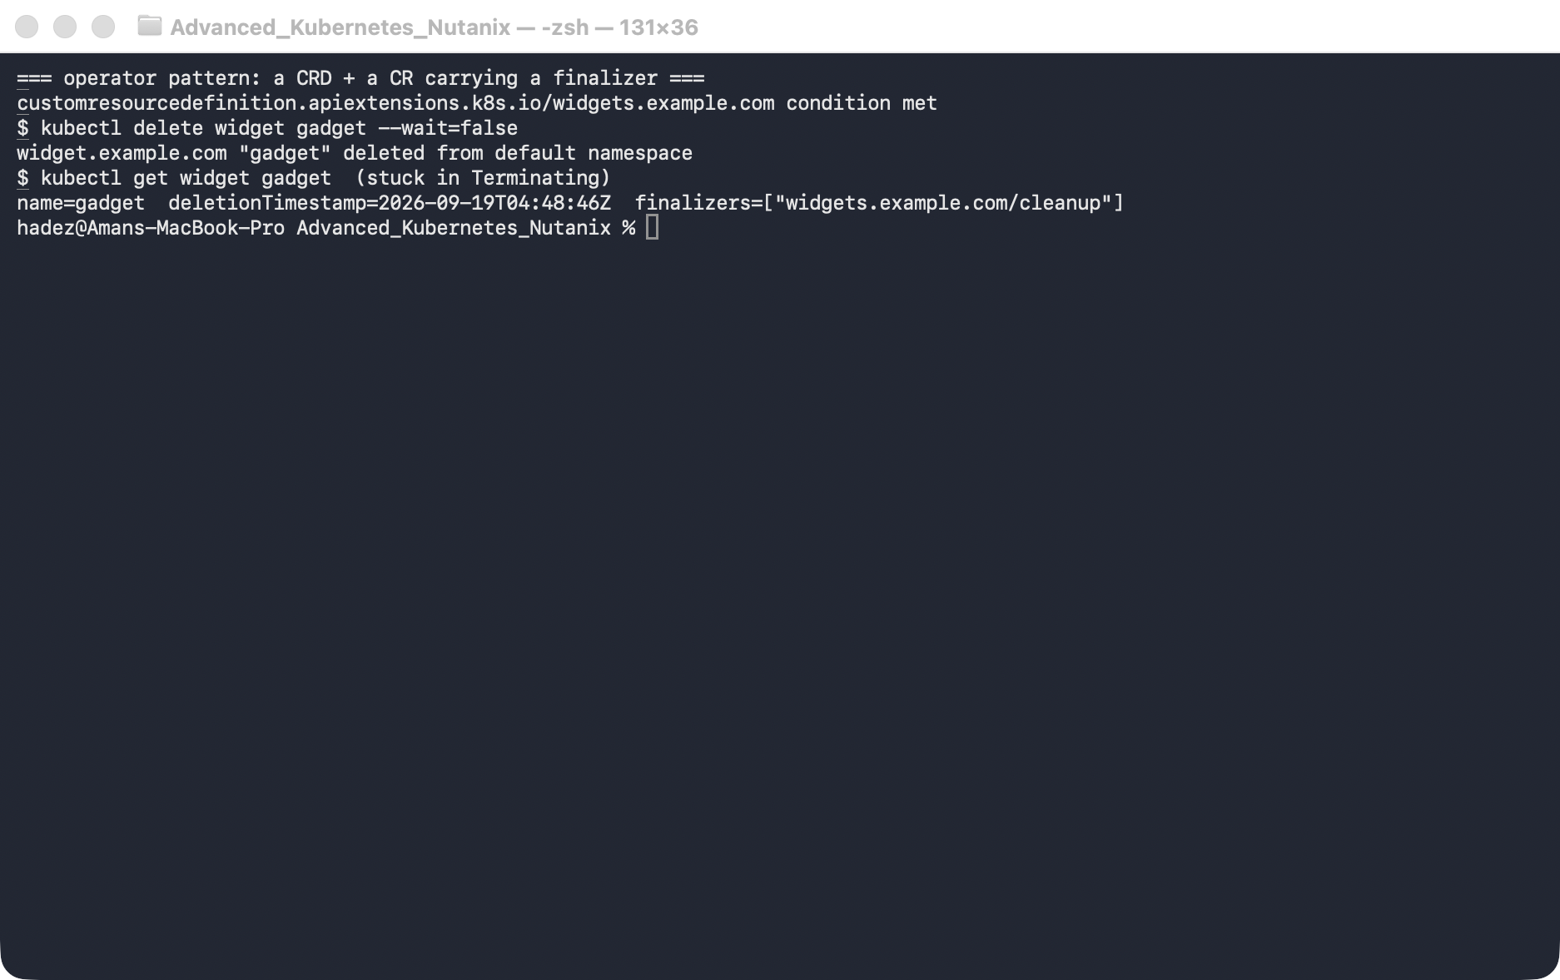
What this means: in production this is a resource whose operator was going to run some external cleanup before letting it go. With the operator down, deletion can never complete.
3. Force it out with the same finalizer patch:
kubectl patch widget gadget --type=merge -p '{"metadata":{"finalizers":null}}'
kubectl get widget gadget # NotFound
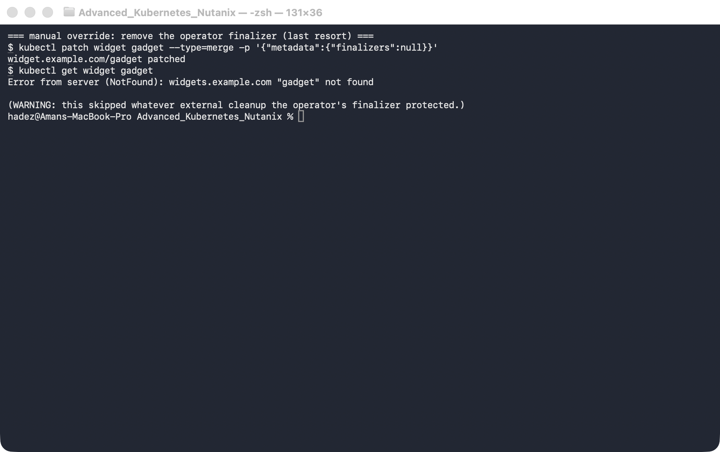
⚠️ Gotcha — force-removing a finalizer skips the cleanup it was protecting. Patching finalizers: null makes the object disappear, but it bypasses whatever the operator was going to do — deprovisioning a cloud disk, deregistering a load balancer, deleting a DNS record. You may have orphaned the real resource it represented, which will keep costing money and won't be tracked. The correct fix is almost always to get the operator healthy again so it removes its own finalizer after real cleanup; the manual patch is a last resort for when the operator is gone for good and you've verified the external cleanup by hand.

Step 3 — The classic incident: a namespace stuck in Terminating
Goal: wedge a whole namespace by leaving one finalizer-blocked object inside it, then diagnose it from the namespace's own conditions.
1. Create a namespace with a blocked ConfigMap inside, then delete the namespace:
kubectl create namespace stuck-demo
kubectl -n stuck-demo create configmap blocker --from-literal=k=v
kubectl -n stuck-demo patch configmap blocker --type=merge \
-p '{"metadata":{"finalizers":["demo.example.com/hold"]}}'
kubectl delete namespace stuck-demo --wait=false
kubectl get namespace stuck-demo -o jsonpath='phase={.status.phase}{"\n"}'
kubectl get namespace stuck-demo -o jsonpath='{range .status.conditions[*]}{.type}={.status} ({.reason}){"\n"}{end}'
(The conditions take ~10 seconds to populate after the delete — if the second command prints nothing, wait a moment and re-run it.)
What you should see: phase=Terminating, and the conditions name the blockage — NamespaceContentRemaining=True (SomeResourcesRemain) and NamespaceFinalizersRemaining=True (SomeFinalizersRemain).
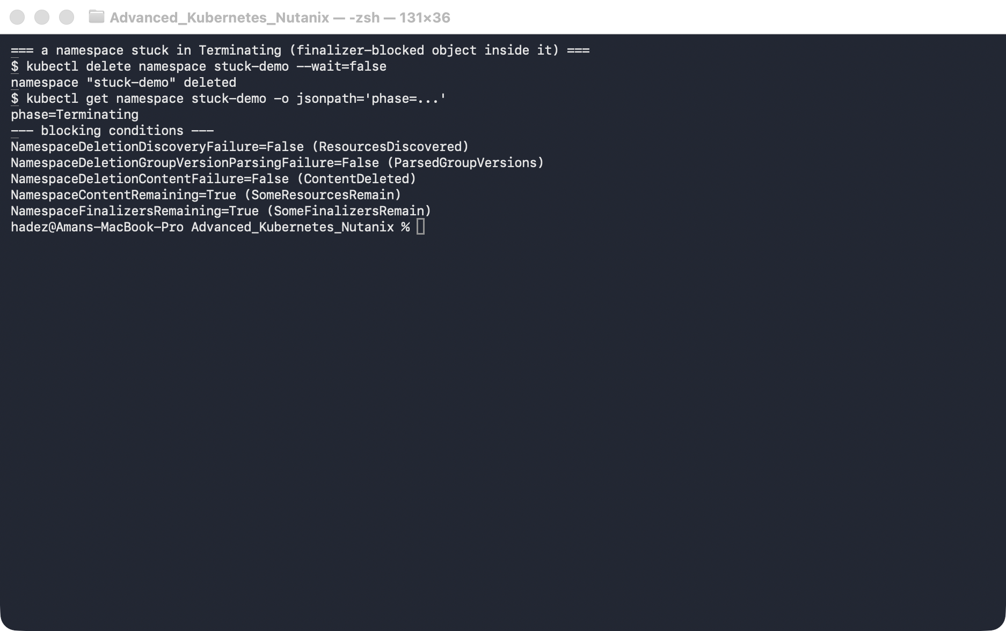
What this means: deleting a namespace deletes everything in it — so a single finalizer-blocked object wedges the whole namespace. The namespace's status.conditions are the right place to look first: they tell you what it's waiting on, so you don't have to guess.
2. Fix the root cause — clear the finalizer on the object inside the namespace:
kubectl -n stuck-demo patch configmap blocker --type=merge -p '{"metadata":{"finalizers":null}}'
kubectl get namespace stuck-demo # after ~25s: NotFound
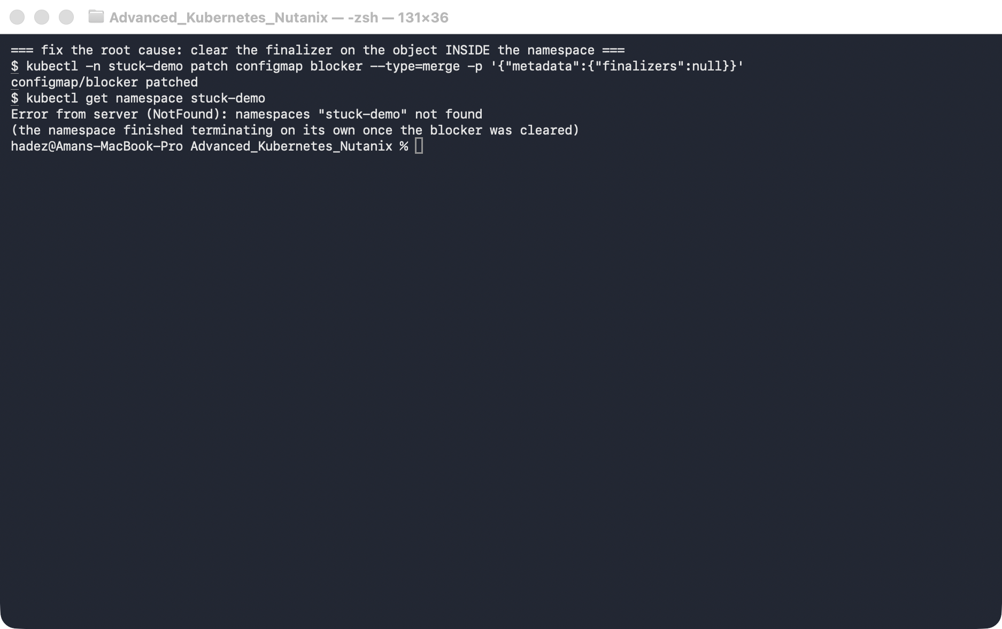
What this means: within about half a minute (the namespace controller re-checks on an interval) the namespace finishes and disappears. Note that you fixed the cause (the blocked object), not the symptom — editing the namespace's own spec.finalizers (the other "fix" you'll see online) is a sledgehammer that can strand the very content it was still trying to clean up.

Step 4 — The other operator failure: a reconcile hot loop
Goal: meet the failure where every controller reports success and the cluster still thrashes.
A stuck deletion is loud — something sits in Terminating and stays there. A hot loop is the opposite: two controllers each doing their job correctly, forever, against each other. Nothing errors.
The textbook version is an operator that requeues itself without backoff. The version you will actually meet is this one:
Git declares spec.replicas: 2. A HorizontalPodAutoscaler declares minReplicas: 5. Neither is wrong. Neither yields.
Set it up — a Flux Kustomization applying a Deployment pinned at 2 replicas, then:
kubectl -n shop autoscale deploy/api --min=5 --max=10 --cpu=80%
Sample the replica count every five seconds:
t+5 deploy=2 hpa=5
t+15 deploy=5 hpa=5 <- HPA wins
t+20 deploy=2 hpa=5 <- Flux wins
t+30 deploy=5 hpa=5
t+65 deploy=2 hpa=5
t+85 deploy=2 hpa=5
t+90 deploy=5 hpa=5
Pods are being created and destroyed continuously. Now try to find that in the usual places.
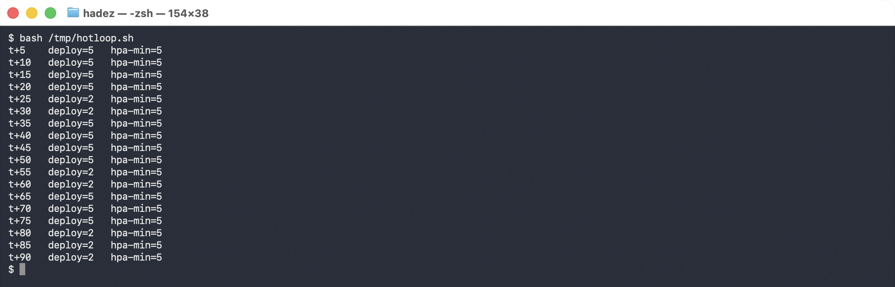

Why this is hard to see
kubectl -n flux-system get kustomization app -o jsonpath='{.status.conditions}'
kubectl -n shop get hpa api -o jsonpath='{.status.conditions}'
ready = True msg = Applied revision: main@sha1:5e998bf4...
hpa = AbleToScale True, ScaledToZero False, ScalingActive False
⚠️ ScalingActive False is not the bug, and it does not stop the loop. On kind, the metrics pipeline often serves node metrics but not Pod metrics, so the HPA reports failed to get cpu utilization: no metrics returned from resource metrics API and TARGETS shows cpu: <unknown>. It still enforces minReplicas: 5 — which is all this fight needs. If your cluster has working Pod metrics you will see ScalingActive True instead; the oscillation is identical either way.
Both controllers report success. Flux says it applied the revision — true. The HPA says it is scaling normally — also true. Neither can see the other, and nothing in either status will ever tell you there is a fight.

Where it does show: the event count field
kubectl -n shop get events \
-o custom-columns='COUNT:.count,REASON:.reason,MSG:.message' | grep -i scaling
COUNT REASON MSG
1 ScalingReplicaSet Scaled up replica set api-97fd78bc6 from 0 to 2
9 ScalingReplicaSet Scaled up replica set api-97fd78bc6 from 2 to 5
9 ScalingReplicaSet Scaled down replica set api-97fd78bc6 from 5 to 2
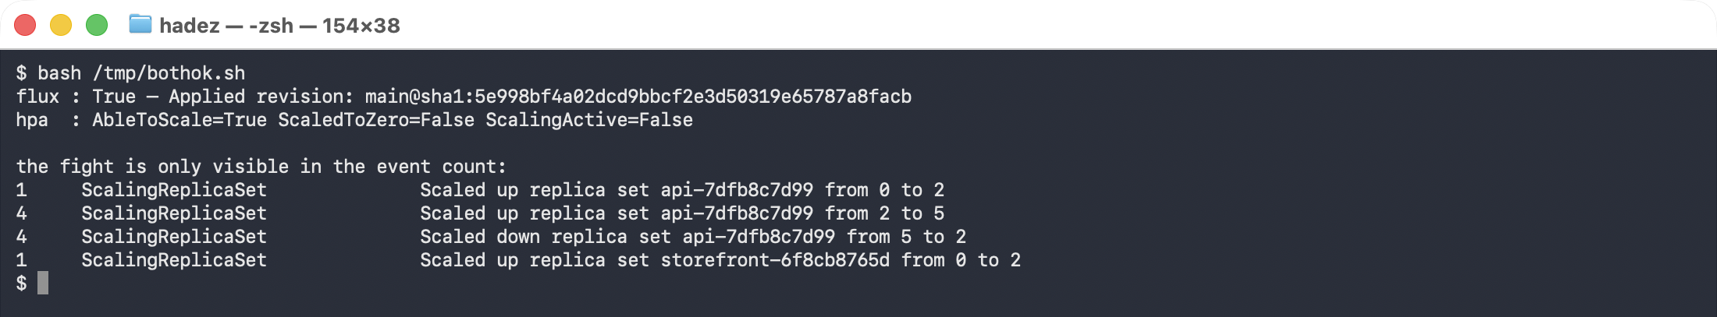
Nine up, nine down. Kubernetes aggregates repeated events into one record with a count, so the default kubectl get events output shows this as two unremarkable lines. Ask for the count column and the loop is obvious.
The diagnostic habit worth taking away: when something is thrashing and every controller claims success, stop reading statuses and start counting events. .count is the field that reveals repetition, and it is not in the default output.

The fix — decide which controller owns the field
Remove spec.replicas from the Git manifest entirely and let the HPA own it:
spec:
# replicas deliberately ABSENT — the HorizontalPodAutoscaler owns this field.
selector:
matchLabels: { app: api }
deploy=5 hpa=5
deploy=5 hpa=5 ... stable for 75s, counts stopped advancing
⚠️ Gotcha — deleting replicas is not "leave it alone". The field defaults to 1, so the Deployment scaled 2 → 1 before the HPA pulled it back to 5. On a busy service that is a real capacity dip in the middle of your fix. Do it in a maintenance window, or keep the field in Git and tell the reconciler to ignore it rather than removing it.
The general rule: for any field, exactly one controller may own it. Two owners is not a misconfiguration you can tune your way out of — it is a design error, and the only fix is to decide.

Step 5 — Clean up
kubectl delete crd widgets.example.com --ignore-not-found
Leave the advk8s-day2 cluster running for Labs 6 and C.

What you learned
You saw… | in Step | proof
kubectl delete returning "deleted" ≠ object gone | 1 | ConfigMap present with deletionTimestamp after "deleted"
A finalizer holds an object in Terminating until removed | 1 / 2 | object persists with finalizers set
Operator resources wedge when the operator can't clear its finalizer | 2 | Widget stuck on widgets.example.com/cleanup
Force-removing a finalizer skips protected cleanup | 2 gotcha
A finalizer-blocked object wedges its whole namespace | 3 | stuck-demo in Terminating
Namespace status.conditions name the blockage | 3 | NamespaceContentRemaining / NamespaceFinalizersRemaining
A hot loop is two controllers each succeeding, forever | 4 | replicas oscillating 2↔5 while both report Ready
Controller status never reveals a fight | 4 | Flux Applied revision while the replica count oscillates
Event .count is where repetition shows | 4 | one line, count=9 — invisible in default output
One field, one owner — two owners is a design error | 4 | removing replicas from Git settled it at 5/5
Deleting replicas momentarily scales to 1 | 4 gotcha | Scaled down from 2 to 1 before the HPA recovered it

Evidence
The hot-loop run is captured in artifacts/lab-06/evidence/lab-06-reconcile-hot-loop.txt — 58 lines from 2026-09-25 (Kubernetes 1.37.0, Flux 2.9.5), including the oscillation samples, the aggregated event counts, both controllers reporting success, and the momentary drop to 1 during the fix.

Original evidence
Real screenshots for this lab are in artifacts/lab-06/screenshots/ (5 images), and a full command transcript is in artifacts/lab-06/evidence/lab-05-operators-finalizers.txt.

Next: Lab 7 — Find the Cluster's Breaking Point (Cluster Scale Knee-Point)

