DataCouch — Advanced Kubernetes (Nutanix)
Table of Contents

Day 1 · How Kubernetes Really Works
YES — Tested end-to-end on a real GKE cluster (dcproject-462806, us-central1-a, 2× e2-medium, Kubernetes v1.35.7-gke). Screenshots for Steps 1–5 are real captures from that GKE cluster; Step 6's two KWOK captures were taken on a local kind cluster on 2026-09-28, because KWOK's simulated nodes are the point of that step and cost nothing to run locally. You'll seed the four Pending reasons that cause the vast majority of real incidents, read the exact FailedScheduling message for each, and fix each until the Pod runs.

What you'll learn
- The four reasons a Pod sits in Pending — insufficient resources, an untolerated taint, a node-affinity/selector mismatch, and an unbound PVC — and the exact scheduler message each one produces.
- How to read a scheduling failure the fast way (kubectl describe pod → the FailedScheduling event).
- Why the scheduler's message tells you precisely which check rejected the Pod and on how many nodes — and how to turn that into a one-line fix.
- A cloud-specific twist: on GKE, an "insufficient resources" Pod can be fixed by the cluster autoscaler adding a node, not just by editing the Pod.

What you'll do
You'll create a GKE cluster, then deliberately create four Pods that each can't schedule for a different reason. For each, you'll read the scheduler's own explanation, apply the fix, and watch the Pod go Running. Finally you'll confirm all four are healthy and tear the cluster down.

Time & cost
- Time: ~45 minutes.
- Cost: ~$0.30–0.60 of GKE if you create the cluster just for this lab and delete it at the end. A 2-node e2-medium zonal cluster is roughly $0.20/hr plus the GKE management fee.

Before you start
- Where you'll work: in a terminal on your own machine.
- Tools you need: gcloud, kubectl, and the gke-gcloud-auth-plugin.
- Account: a GCP project with billing enabled and the Kubernetes Engine API turned on. (See the Setup Environment Guide.)
Nutanix note. Every failure here — Insufficient cpu, untolerated taint, affinity mismatch, unbound PVC — is core kube-scheduler behaviour, byte-for-byte identical on NKE, kind, and every conformant cluster; the diagnosis commands don't change at all. The only platform-specific bit is the resolution for the resource case: GKE's autoscaler adds a node, whereas on NKE you'd scale the node pool through Prism/NKE. We run this on GKE to show that cloud twist.

The idea in 60 seconds
A Pending Pod is one the scheduler looked at and couldn't place. The scheduler runs two phases: Filter (which nodes are even feasible?) and Score (of those, which is best?). A Pod goes Pending when Filter eliminates every node — and, crucially, the scheduler records why, as a FailedScheduling event you can read. Four filters reject almost everything:
- Fit — the Pod's CPU/memory requests must fit in a node's allocatable capacity (which is less than its raw size).
- Taints — a node can carry a taint that repels Pods unless they tolerate it.
- Node affinity / nodeSelector — the Pod can demand labels a node must have.
- Volume binding — a Pod whose PVC can't be bound can't schedule.
flowchart TB
POD["new Pod: Pending<br/>PodScheduled=False"] --> SCHED["kube-scheduler, Filter phase"]
SCHED --> F1{"fits cpu/memory?"}
F1 -->|"no"| R1["Insufficient cpu/memory"]
F1 -->|"yes"| F2{"tolerates node taints?"}
F2 -->|"no"| R2["untolerated taint"]
F2 -->|"yes"| F3{"matches nodeSelector/affinity?"}
F3 -->|"no"| R3["node affinity/selector mismatch"]
F3 -->|"yes"| F4{"PVCs bound?"}
F4 -->|"no"| R4["unbound PersistentVolumeClaims"]
F4 -->|"yes"| BIND["Score, then bind to best node"]
BIND --> RUN["Pod Running"]
R1 -.->|"FailedScheduling"| STUCK["stays Pending"]
R2 -.-> STUCK
R3 -.-> STUCK
R4 -.-> STUCK

Step 1 — Create the cluster and see what "allocatable" really is
Goal: stand up a 2-node GKE cluster and notice how little CPU is actually schedulable.
1. In your terminal, create the cluster and connect to it:
gcloud container clusters create advk8s-gke \
--zone us-central1-a --num-nodes 2 --machine-type e2-medium \
--disk-size 30 --release-channel regular
gcloud container clusters get-credentials advk8s-gke --zone us-central1-a
kubectl get nodes -o custom-columns='NODE:.metadata.name,CPU_ALLOC:.status.allocatable.cpu,MEM_ALLOC:.status.allocatable.memory'
What you should see: two Ready nodes, each reporting 940m allocatable CPU — even though an e2-medium nominally has 2 vCPUs.
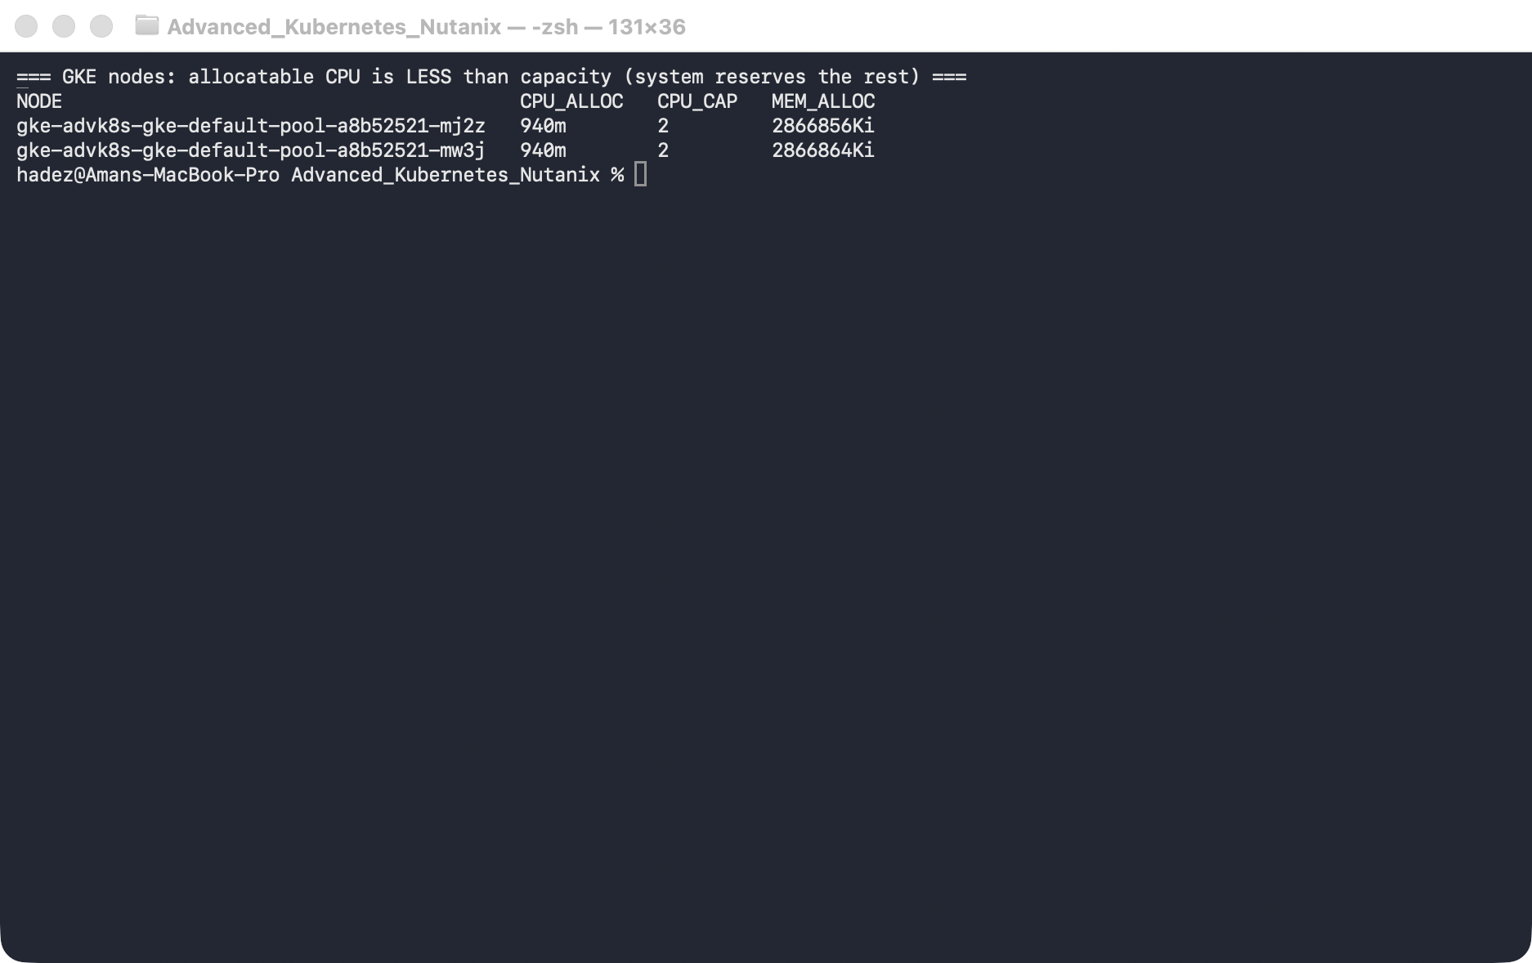
What this means: GKE reserves over half of each node's CPU for the system and kubelet. The scheduler fits Pods into allocatable, not raw capacity — and that gap is what makes the next scenario trivial to trigger.

Step 2 — Pending #1: not enough CPU
Goal: create a Pod that asks for more CPU than any node can offer, and read the message.
1. Create a Deployment whose Pod requests 5 CPUs (baked into the manifest, so there's exactly one clean Pending Pod — using create then set resources would leave the first, unconstrained Pod Running alongside the new Pending one):
kubectl apply -f - <<'EOF'
apiVersion: apps/v1
kind: Deployment
metadata: {name: hog, labels: {app: hog}}
spec:
replicas: 1
selector: {matchLabels: {app: hog}}
template:
metadata: {labels: {app: hog}}
spec:
containers:
- name: nginx
image: nginx:1.27
resources: {requests: {cpu: "5"}}
EOF
kubectl get pods -l app=hog
kubectl describe pod -l app=hog | sed -n '/Events:/,$p'
What you should see: the Pod is Pending, and the event reads FailedScheduling → 0/2 nodes are available: 2 Insufficient cpu. There's often a second event from cluster-autoscaler: NotTriggerScaleUp.
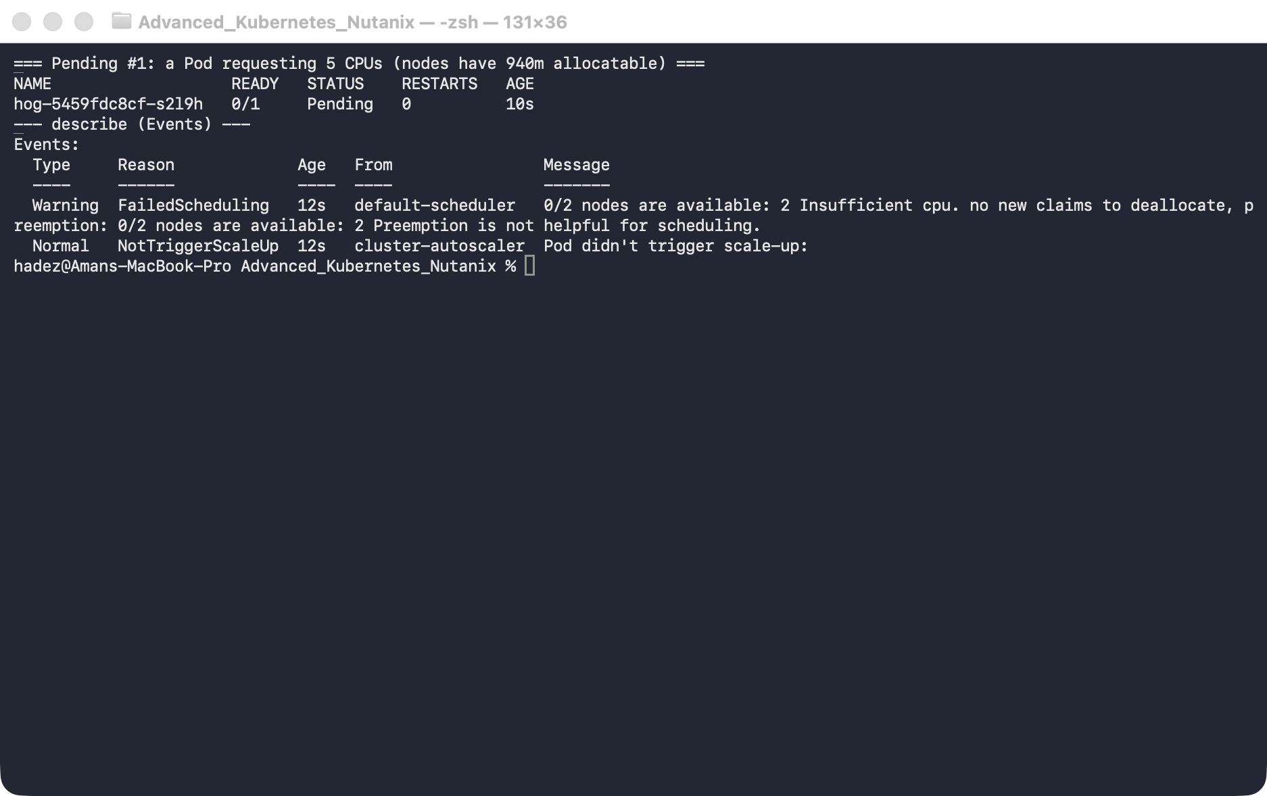
What this means: neither node has 5 cores of allocatable CPU free (each has only 940m), so both are filtered out. The NotTriggerScaleUp line means the autoscaler looked at this Pod but this cluster has no autoscaling enabled — so it stays Pending.
2. Fix it — ask for a realistic amount:
kubectl set resources deployment hog --requests=cpu=100m
kubectl get pods -l app=hog -w # watch it go Pending -> Running
☁️ Cloud twist (GKE). The other fix is to add capacity. Had you created the cluster with --enable-autoscaling --min-nodes=2 --max-nodes=4, that 5-core Pod would have triggered the cluster autoscaler to provision a third node, and the Pod would schedule onto it a couple of minutes later — no edit required. On NKE you'd scale the node pool for the same effect; on plain kind there's no autoscaler, so it would stay Pending forever. Same scheduler decision, three platform-specific resolutions.

Step 3 — Pending #2: no node matches the selector
Goal: demand a node label that doesn't exist, and read the message.
1. Create a Deployment that requires disktype=ssd:
kubectl apply -f - <<'EOF'
apiVersion: apps/v1
kind: Deployment
metadata: {name: picky, labels: {app: picky}}
spec:
replicas: 1
selector: {matchLabels: {app: picky}}
template:
metadata: {labels: {app: picky}}
spec:
nodeSelector: {disktype: ssd}
containers: [{name: nginx, image: nginx:1.27}]
EOF
kubectl describe pod -l app=picky | sed -n '/Events:/,$p'
What you should see: FailedScheduling → 0/2 nodes are available: 2 node(s) didn't match Pod's node affinity/selector.
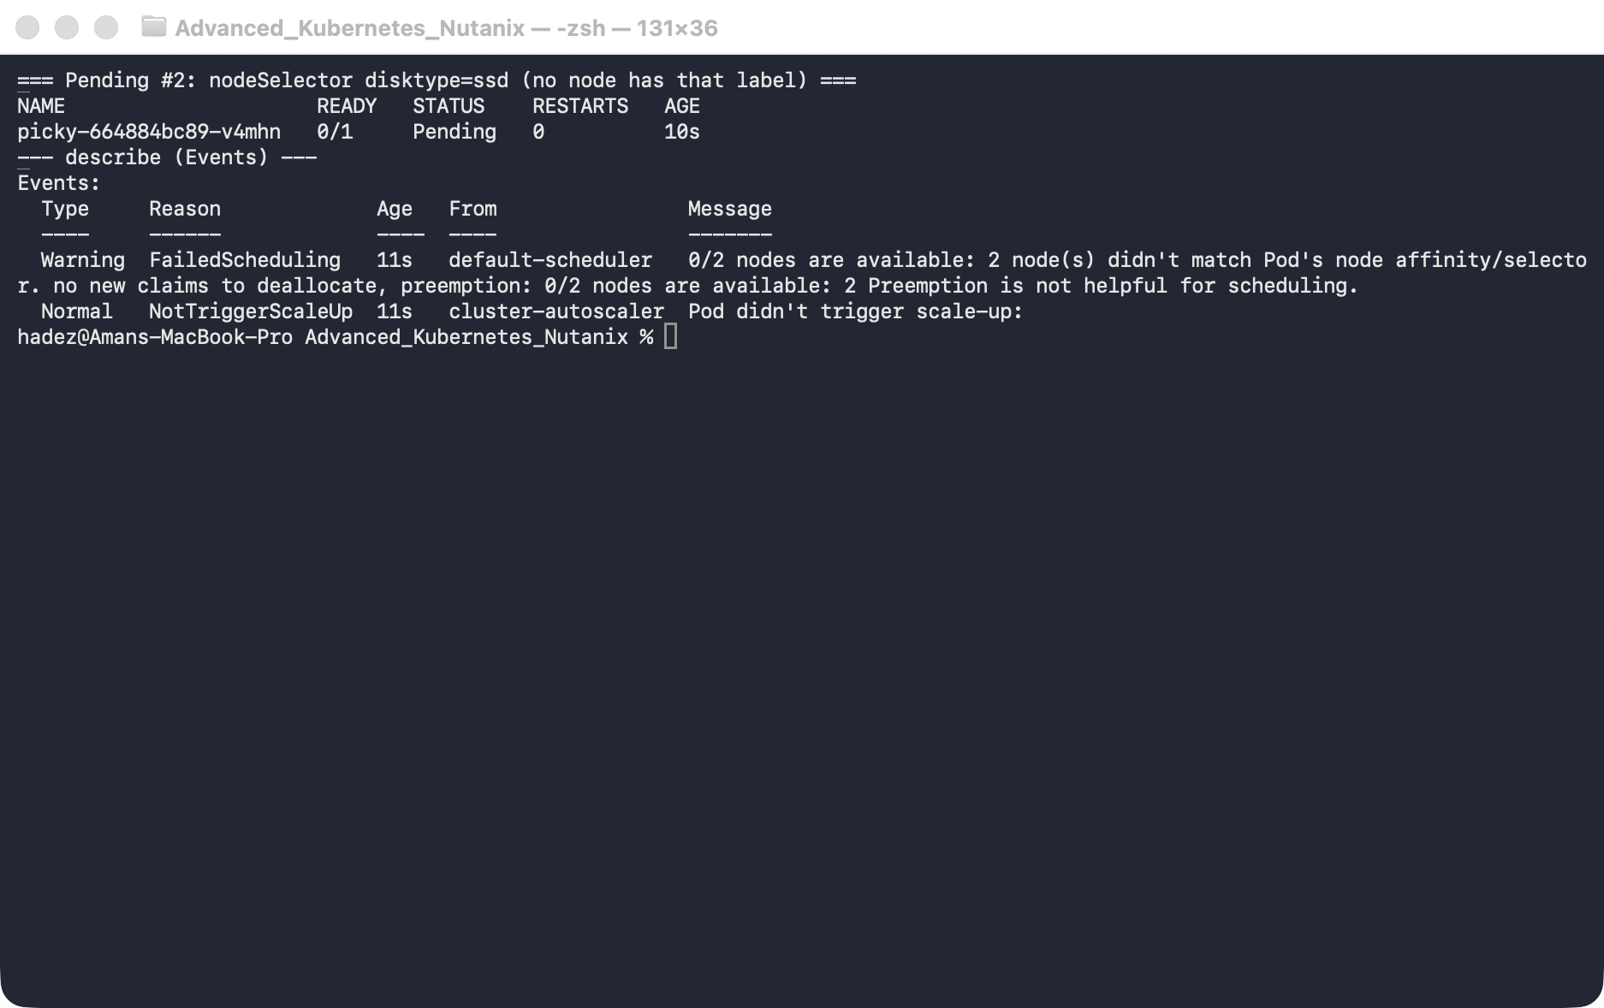
What this means: no node carries the disktype=ssd label, so both are filtered out.
2. Fix it — label a node so the selector matches (the existing Pending Pod then schedules onto it):
NODE=$(kubectl get nodes -o jsonpath='{.items[0].metadata.name}')
kubectl label node "$NODE" disktype=ssd
kubectl get pods -l app=picky -w

Step 4 — Pending #3: an untolerated taint
Goal: taint both nodes so they repel Pods, then run one without a toleration.
1. Taint the nodes and create a plain Deployment:
kubectl taint nodes --all dedicated=analytics:NoSchedule
kubectl create deployment worker --image=nginx:1.27
kubectl describe pod -l app=worker | sed -n '/Events:/,$p'
What you should see: FailedScheduling → 0/2 nodes are available: 2 node(s) had untolerated taint(s).
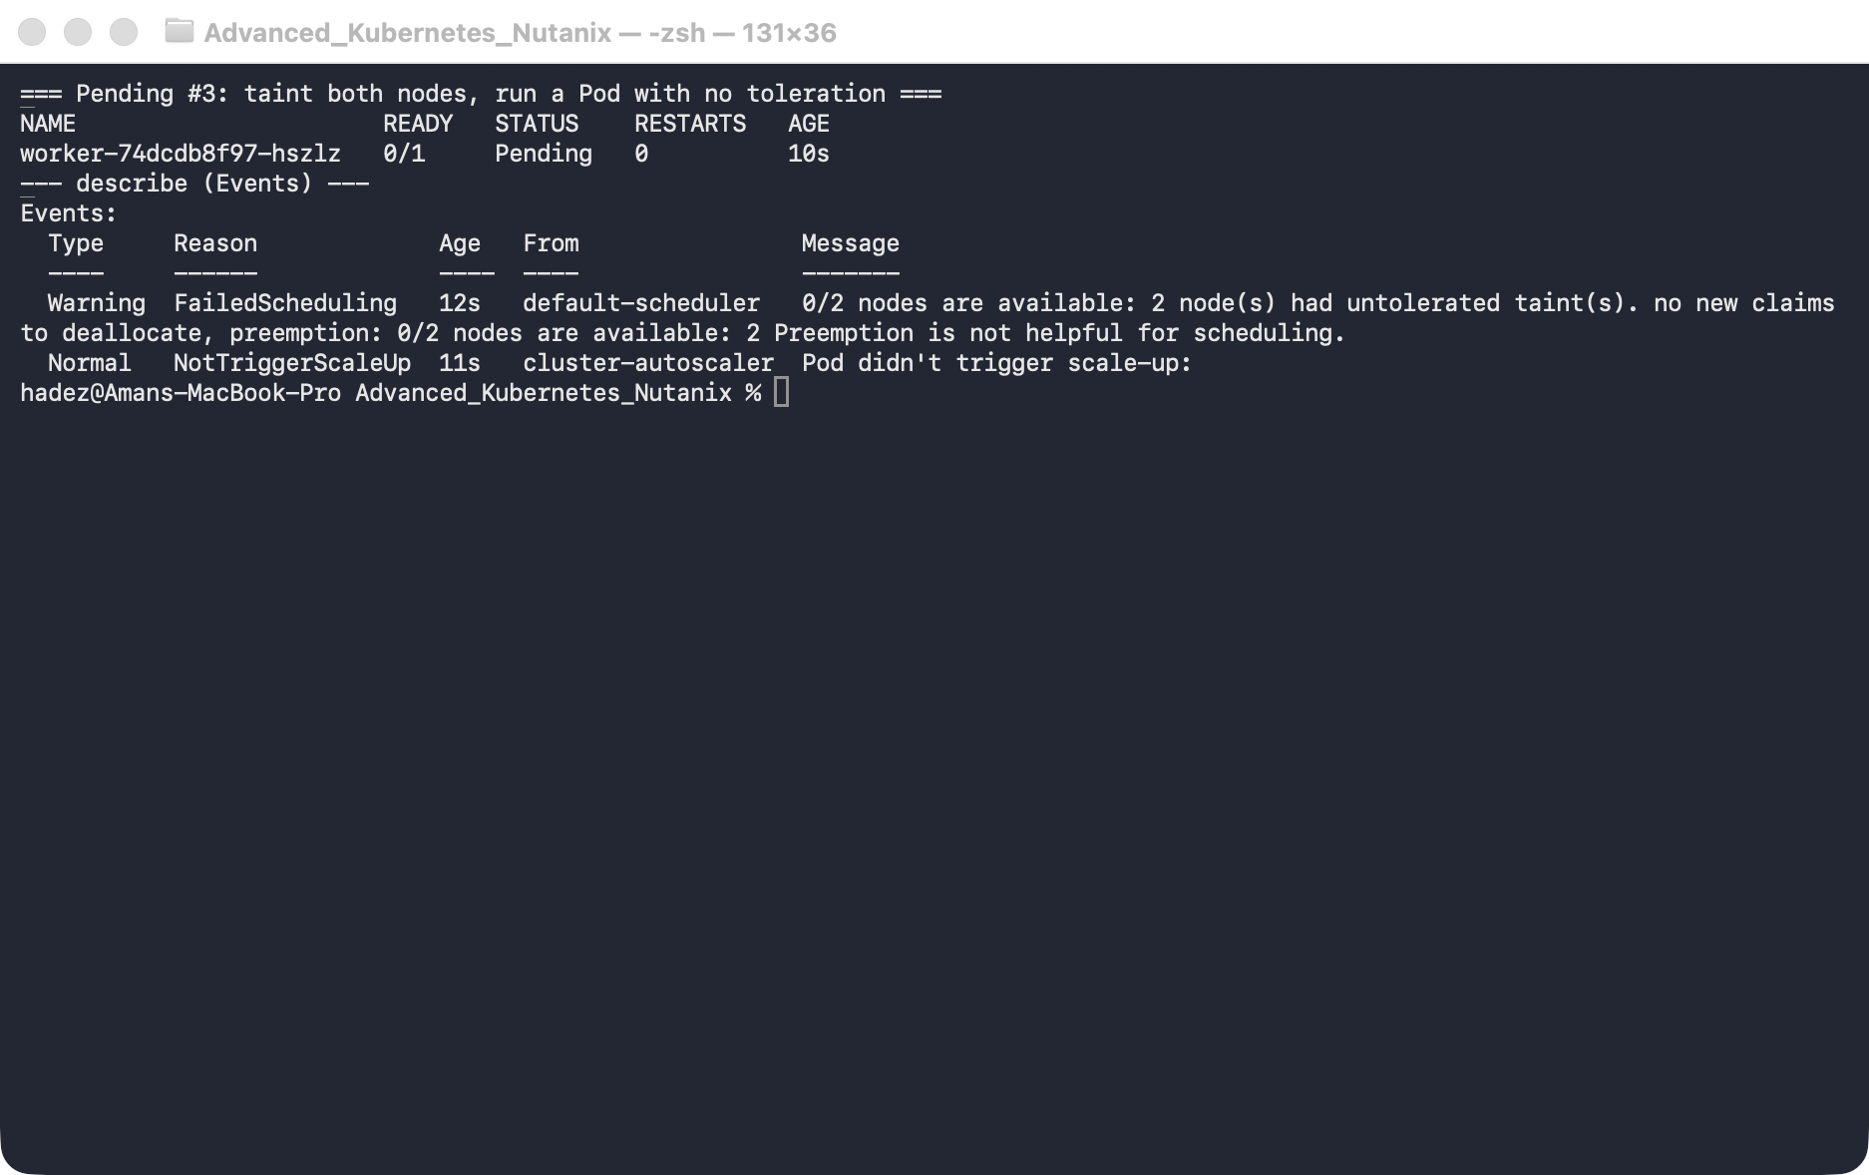
What this means: the nodes have capacity and match everything else — but the dedicated=analytics:NoSchedule taint actively repels any Pod that doesn't carry a matching toleration.
2. Fix it — give the Pod the toleration:
kubectl patch deployment worker --type=merge -p '{"spec":{"template":{"spec":{"tolerations":[{"key":"dedicated","operator":"Equal","value":"analytics","effect":"NoSchedule"}]}}}}'
kubectl get pods -l app=worker -w
# remove the taint again so it doesn't affect the other steps:
kubectl taint nodes --all dedicated=analytics:NoSchedule-

Step 5 — Pending #4: an unbound PVC
Goal: point a Pod at a PVC whose StorageClass doesn't exist.
1. Create the PVC (bad class) and a Pod that mounts it:
kubectl apply -f - <<'EOF'
apiVersion: v1
kind: PersistentVolumeClaim
metadata: {name: data}
spec:
accessModes: ["ReadWriteOnce"]
storageClassName: does-not-exist
resources: {requests: {storage: 1Gi}}
---
apiVersion: v1
kind: Pod
metadata: {name: needs-storage, labels: {app: needs-storage}}
spec:
containers:
- name: app
image: nginx:1.27
volumeMounts: [{name: d, mountPath: /data}]
volumes:
- name: d
persistentVolumeClaim: {claimName: data}
EOF
kubectl get pvc data
kubectl describe pod needs-storage | sed -n '/Events:/,$p'
What you should see: the PVC stays Pending, and the Pod's event reads FailedScheduling → 0/2 nodes are available: pod has unbound immediate PersistentVolumeClaims.
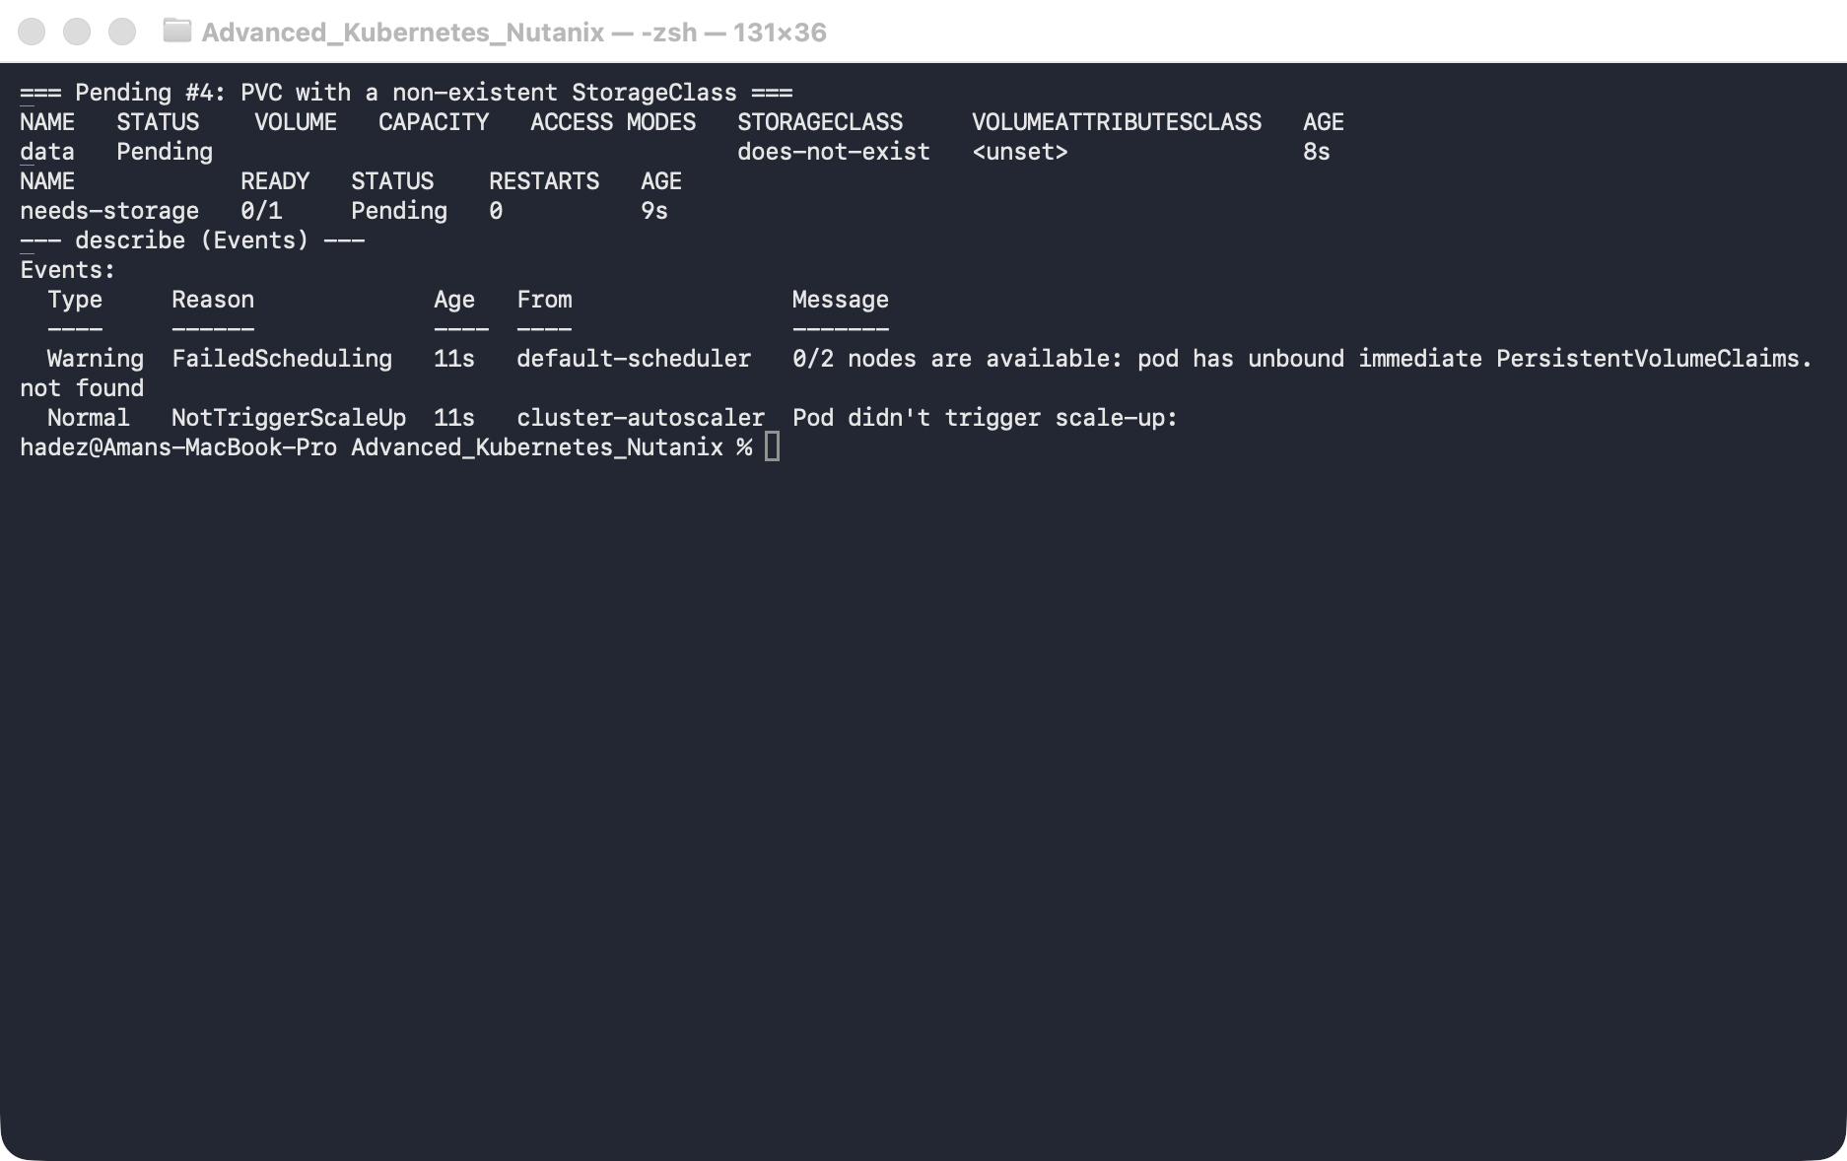
What this means: nothing can provision a volume for the does-not-exist class, so the PVC never binds — and the scheduler won't place a Pod whose volume can't be bound.
2. Fix it — recreate the PVC with a real StorageClass (GKE's default is standard-rwo):
kubectl get storageclass
kubectl delete pod needs-storage; kubectl delete pvc data
kubectl apply -f - <<'EOF'
apiVersion: v1
kind: PersistentVolumeClaim
metadata: {name: data}
spec:
accessModes: ["ReadWriteOnce"]
storageClassName: standard-rwo
resources: {requests: {storage: 1Gi}}
---
apiVersion: v1
kind: Pod
metadata: {name: needs-storage, labels: {app: needs-storage}}
spec:
containers:
- name: app
image: nginx:1.27
volumeMounts: [{name: d, mountPath: /data}]
volumes:
- name: d
persistentVolumeClaim: {claimName: data}
EOF
kubectl get pvc data -w # Bound; the Pod schedules and runs

Step 6 — Simulate a twenty-node fleet with KWOK
Goal: test scheduler and node-controller behaviour at a size you cannot build on a laptop.
The four Pending causes above each needed one real node. Some questions need twenty — does my topology spread actually spread? what happens to placement when I cordon a rack? KWOK answers them by creating nodes that the API server and scheduler treat as real, with no kubelet and no containers behind them.
KWOK_VER=v0.8.0
kubectl apply -f https://github.com/kubernetes-sigs/kwok/releases/download/${KWOK_VER}/kwok.yaml
kubectl apply -f https://github.com/kubernetes-sigs/kwok/releases/download/${KWOK_VER}/stage-fast.yaml
Then create nodes as plain objects — annotate them kwok.x-k8s.io/node: fake, label type: kwok, and declare whatever capacity you want to test against (8 vCPU / 16Gi each here). Create twenty.
What you should see:
NAME STATUS ROLES VERSION CONTAINER-RUNTIME
kwok-lab-control-plane Ready control-plane v1.37.0 containerd://2.3.4
kwok-node-0 Ready agent fake kwok-v0.8.0
kwok-node-1 Ready agent fake kwok-v0.8.0
...
fake nodes : 20
real nodes : 1
kubeletVersion: fake and CONTAINER-RUNTIME: kwok-v0.8.0 are the tell.
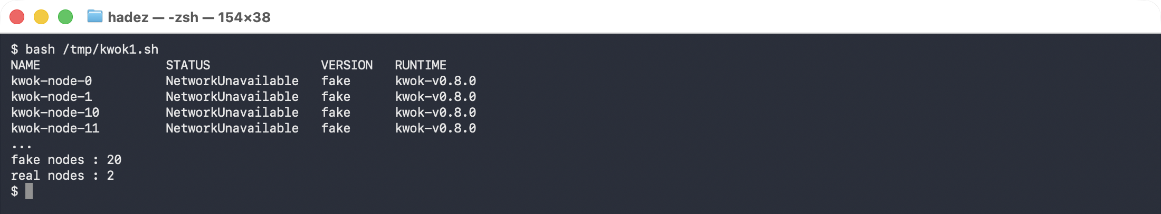
Now schedule against them — Pods need a toleration for kwok.x-k8s.io/node and a nodeSelector: {type: kwok}:
kubectl scale deploy/fleet-web --replicas=100
kubectl get pods -o wide | awk '{print $7}' | sort | uniq -c
5 kwok-node-0
5 kwok-node-1
5 kwok-node-10
...
total Running : 100 across 20 nodes
What this means. One hundred Pods, spread evenly over twenty nodes, while the only real containers on the laptop are the two kind nodes themselves. Every scheduling decision here is the genuine scheduler making genuine choices — only the kubelet is fictional.
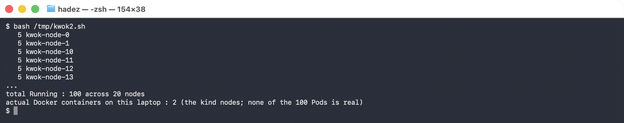
Cordon one and watch the node-controller respond:
kubectl cordon kwok-node-5
kubectl get node kwok-node-5 -o jsonpath='{.spec.unschedulable} {.spec.taints}'
unschedulable = true
taint added = node.kubernetes.io/unschedulable:NoSchedule
pods already there, untouched = 5
Cordoning adds a taint and sets unschedulable; it stops new placement and evicts nothing. That distinction is the one people get wrong under pressure.

Why a failed node takes five minutes to fail over
Ask any Pod what tolerations it has — including ones you never wrote:
kubectl get pod <any-pod> -o jsonpath='{.spec.tolerations}'
node.kubernetes.io/not-ready op=Exists effect=NoExecute tolerationSeconds=300
node.kubernetes.io/unreachable op=Exists effect=NoExecute tolerationSeconds=300
Kubernetes injects these into every Pod. When a node goes unreachable, workloads sit there for 300 seconds before eviction — and that delay is neither the scheduler being slow nor a controller backoff, which is what most people assume. It is a default toleration, and it is editable:
tolerations:
- { key: node.kubernetes.io/unreachable, operator: Exists, effect: NoExecute, tolerationSeconds: 10 }
Shorten it and failover happens in seconds. Shorten it too far and a node with a brief network blip sheds its whole workload for nothing. That trade-off is the discussion worth having.

⚠️ Gotcha — KWOK will not let you fail a node, and this costs people an afternoon
Measured on KWOK v0.8.0:
- kubectl patch node ... --subresource=status to set Ready=False is reverted within seconds — the node reports Ready=True again. Adding kwok.x-k8s.io/status: custom did not change this, and neither did recreating the node with Ready=False in its manifest.
- A NoExecute taint applied with kubectl taint is removed by the kwok-controller. It is present at t+0 and gone shortly after. Pods never evict.
The kwok-controller owns the node object and continuously reconciles it. KWOK simulates a fleet of healthy nodes extremely well; it is not a node-failure injector. To exercise eviction, drive it with a KWOK Stage resource, or take a real kind worker down with docker stop.

Step 7 — Confirm all four are Running, then clean up
Goal: verify every seeded Pending Pod is now Running.
kubectl get pods -o wide
What you should see: hog, picky, worker, and needs-storage all Running, and kubectl get pvc data shows Bound.
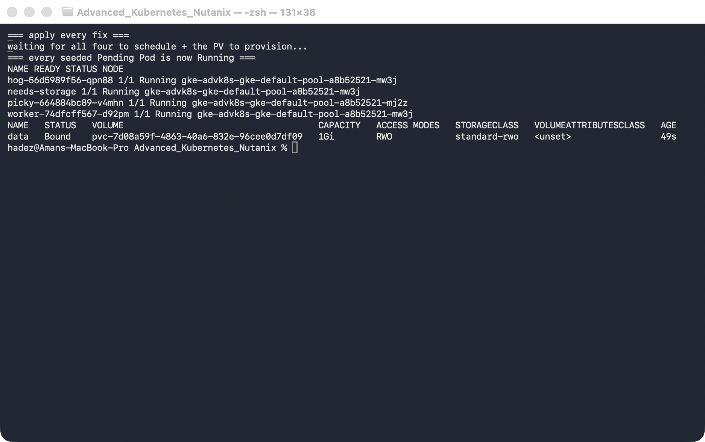
Delete the cluster (this is the only real cost in the lab):
gcloud container clusters delete advk8s-gke --zone us-central1-a --quiet
gcloud container clusters list # verify it's gone

What you learned
You saw… | in Step | proof
Allocatable is far less than raw vCPU | 1 | 940m allocatable vs 2 capacity
Over-request → Insufficient cpu on all nodes | 2 | 0/2 nodes are available: 2 Insufficient cpu
A selector with no matching node → affinity failure | 3 | didn't match Pod's node affinity/selector
An untolerated taint repels an otherwise-fine Pod | 4 | 2 node(s) had untolerated taint(s)
An unbound PVC blocks scheduling | 5 | unbound immediate PersistentVolumeClaims
Each fix moves the Pod Pending → Running | 2–5 watches + 6 all Running
Cloud autoscaler is an alternate fix for the resource case | 2 cloud twist
KWOK simulates a fleet the scheduler treats as real | 6 | 20 fake nodes, 100 Pods spread, 1 real container
Cordon stops new placement and evicts nothing | 6 | unschedulable=true + NoSchedule taint, 5 Pods stayed
The 5-minute failover delay is an injected toleration | 6 | not-ready/unreachable tolerationSeconds=300 on every Pod
KWOK owns the node object and reverts failure injection | 6 gotcha | Ready=False patch reverted; NoExecute taint removed

Evidence
The KWOK simulated-fleet run is captured in artifacts/lab-04/evidence/lab-04-kwok-simulated-fleet.txt — 64 lines from 2026-09-25 (Kubernetes 1.37.0, KWOK v0.8.0), including the 20-node fleet, the 100-Pod spread, the cordon response, the injected 300s tolerations, and both things KWOK refused to do.

Original evidence
Real screenshots for this lab are in artifacts/lab-04/screenshots/ (6 images), and a full command transcript is in artifacts/lab-04/evidence/lab-04-pending-pod-diagnostics.txt.

Next: Lab 5 — Autopilot vs Standard, Private Clusters & Release Channels

