DataCouch — Advanced Kubernetes (Nutanix)
Table of Contents

Day 3 · Stateful Workloads, Persistent Storage & Service Exposure
YES — Tested end-to-end on a real GKE cluster (advk8s-lab, dcproject-462806) using real Persistent Disks and CSI volume snapshots, and Steps 5–7 on a 3-node kind cluster running csi-driver-host-path v1.18.0. Every screenshot is a real capture. The payoff you'll see: you write data, snapshot it, delete the StatefulSet and its disk entirely, then bring the data back from the snapshot onto a brand-new volume — important-data-v1, intact.

What you'll learn
- How a StatefulSet gives each Pod its own stable PVC via a volumeClaimTemplate, backed by a real cloud disk.
- How to take a VolumeSnapshot of a live PVC through the CSI driver, and confirm it's readyToUse.
- How to restore a snapshot onto a new PVC using dataSource, and verify the data survived a full destroy/restore cycle.
- Why a snapshot in the same storage system is a fast recovery tool — and where its limits are (that's what Lab 12's Velero backup covers).
- How volume expansion actually lands: two CSI RPCs, why the PVC sits at FileSystemResizePending, and why volumes only ever grow.
- How to diagnose a multi-attach conflict on a ReadWriteOnce volume — and the node-affinity-pinned volume failure waiting behind it.
- Why a deleted PVC stays Terminating, what kubernetes.io/pvc-protection is protecting you from, and how reclaimPolicy decides whether "delete the PVC" means "delete the data".
- How volume cloning (dataSource → a PVC) differs from restoring a snapshot, and when to reach for each.

What you'll do
You'll run a StatefulSet with a persistent volume, write a known value into it, snapshot the volume, then delete the whole StatefulSet and its PVC to simulate a disaster. Then you'll restore the snapshot onto a fresh PVC and prove the original data is still there. After that you'll move to a local kind cluster running the CSI hostpath driver to expand a volume in use, reproduce a multi-attach conflict and a node-affinity mount failure on purpose, watch a PVC finalizer hold a deletion, and clone a volume straight from another PVC.

Time & cost
- Time: ~40 minutes for Steps 1–4 on GKE (much of it waiting for real disks to provision), plus ~45 minutes for Steps 5–7 on kind.
- Cost: a few cents of Persistent Disk on the shared GKE cluster; Steps 5–7 are $0 on kind.

Before you start
- Where you'll work: in a terminal on your own machine.
- Tools you need: gcloud, kubectl for Steps 1–4; docker, kind, kubectl for Steps 5–7.
- Cluster: a GKE cluster (this course's shared advk8s-lab). GKE ships the CSI snapshot CRDs but no VolumeSnapshotClass by default — you'll create one in Step 2.
Nutanix note. StatefulSets, PVCs, VolumeSnapshot, and the dataSource-restore mechanism are all standard Kubernetes/CSI — identical on NKE. The only platform-specific piece is the CSI driver name: here it's pd.csi.storage.gke.io (Google Persistent Disk); on Nutanix it's the Nutanix CSI driver (csi.nutanix.com), which likewise supports VolumeSnapshot. Swap the driver name in the VolumeSnapshotClass and everything else in this lab is unchanged.

The idea in 60 seconds
A StatefulSet is how you run stateful apps: each replica gets a stable identity (db-0, db-1, …) and its own PVC from a volumeClaimTemplate, so a Pod that restarts reattaches to the same disk. A PVC is bound to a real volume provisioned by a CSI driver (here Google Persistent Disk).
A VolumeSnapshot asks that CSI driver to take a point-in-time copy of the volume. It's fast and space-efficient, and — crucially — you can create a new PVC from a snapshot (spec.dataSource), which is how you recover. That's the cycle you'll run: snapshot → destroy → restore.
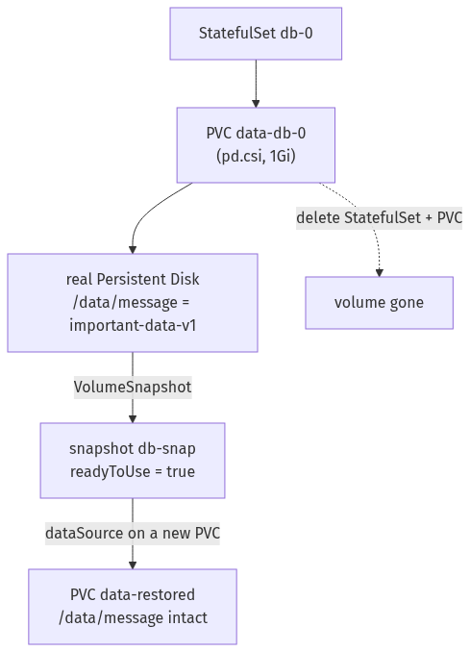

Step 1 — Run a StatefulSet and write data to its volume
Goal: create a StatefulSet whose Pod has its own persistent disk, and put a known value on it.
1. Create the StatefulSet (it declares a volumeClaimTemplate), wait for it, then write a file:
kubectl apply -f - <<'EOF'
apiVersion: apps/v1
kind: StatefulSet
metadata: {name: db}
spec:
serviceName: db
replicas: 1
selector: {matchLabels: {app: db}}
template:
metadata: {labels: {app: db}}
spec:
containers:
- name: app
image: busybox:1.36
command: ["sh","-c","sleep 3600"]
volumeMounts: [{name: data, mountPath: /data}]
volumeClaimTemplates:
- metadata: {name: data}
spec:
accessModes: ["ReadWriteOnce"]
storageClassName: standard-rwo
resources: {requests: {storage: 1Gi}}
EOF
kubectl rollout status statefulset/db --timeout=120s
kubectl exec db-0 -- sh -c 'echo "important-data-v1" > /data/message; cat /data/message'
kubectl get pvc data-db-0
What you should see: the rollout completes, cat /data/message prints important-data-v1, and kubectl get pvc data-db-0 shows a Bound 1Gi PVC.
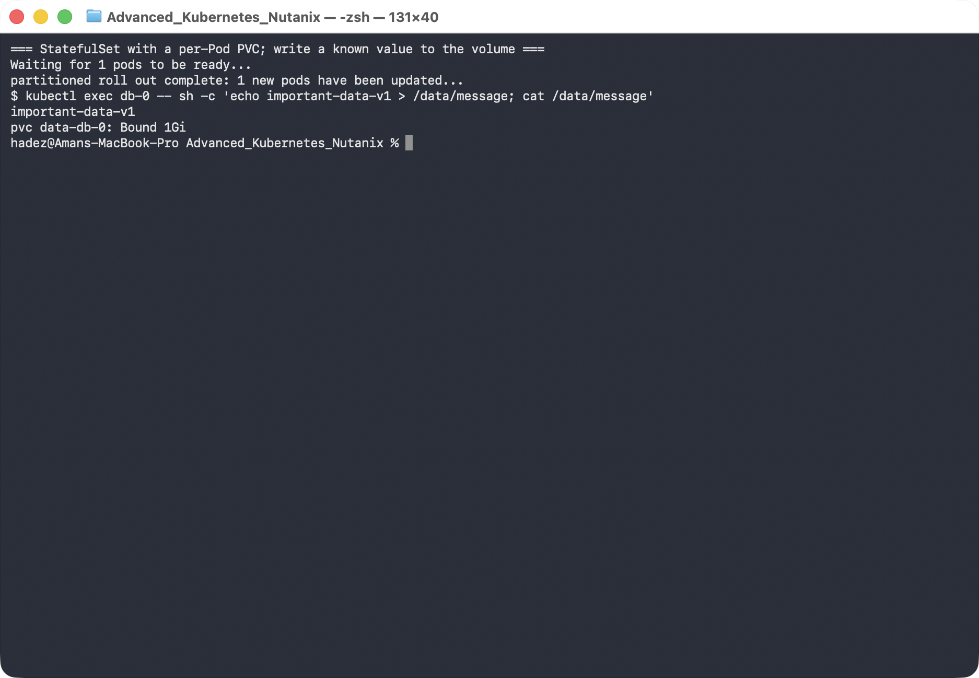
What this means: the StatefulSet created a PVC named data-db-0 (template name + Pod name), CSI provisioned a real Persistent Disk for it, and your file lives on that disk — not in the Pod.

Step 2 — Snapshot the volume
Goal: create a VolumeSnapshot of the PVC and confirm it's usable.
1. Create a VolumeSnapshotClass (GKE doesn't ship one), then snapshot the PVC:
kubectl apply -f - <<'EOF'
apiVersion: snapshot.storage.k8s.io/v1
kind: VolumeSnapshotClass
metadata: {name: pd-snapclass}
driver: pd.csi.storage.gke.io
deletionPolicy: Delete
EOF
kubectl apply -f - <<'EOF'
apiVersion: snapshot.storage.k8s.io/v1
kind: VolumeSnapshot
metadata: {name: db-snap}
spec:
volumeSnapshotClassName: pd-snapclass
source: {persistentVolumeClaimName: data-db-0}
EOF
kubectl wait --for=jsonpath='{.status.readyToUse}'=true volumesnapshot/db-snap --timeout=120s
kubectl get volumesnapshot db-snap
What you should see: db-snap with READYTOUSE: true and RESTORESIZE: 1Gi.
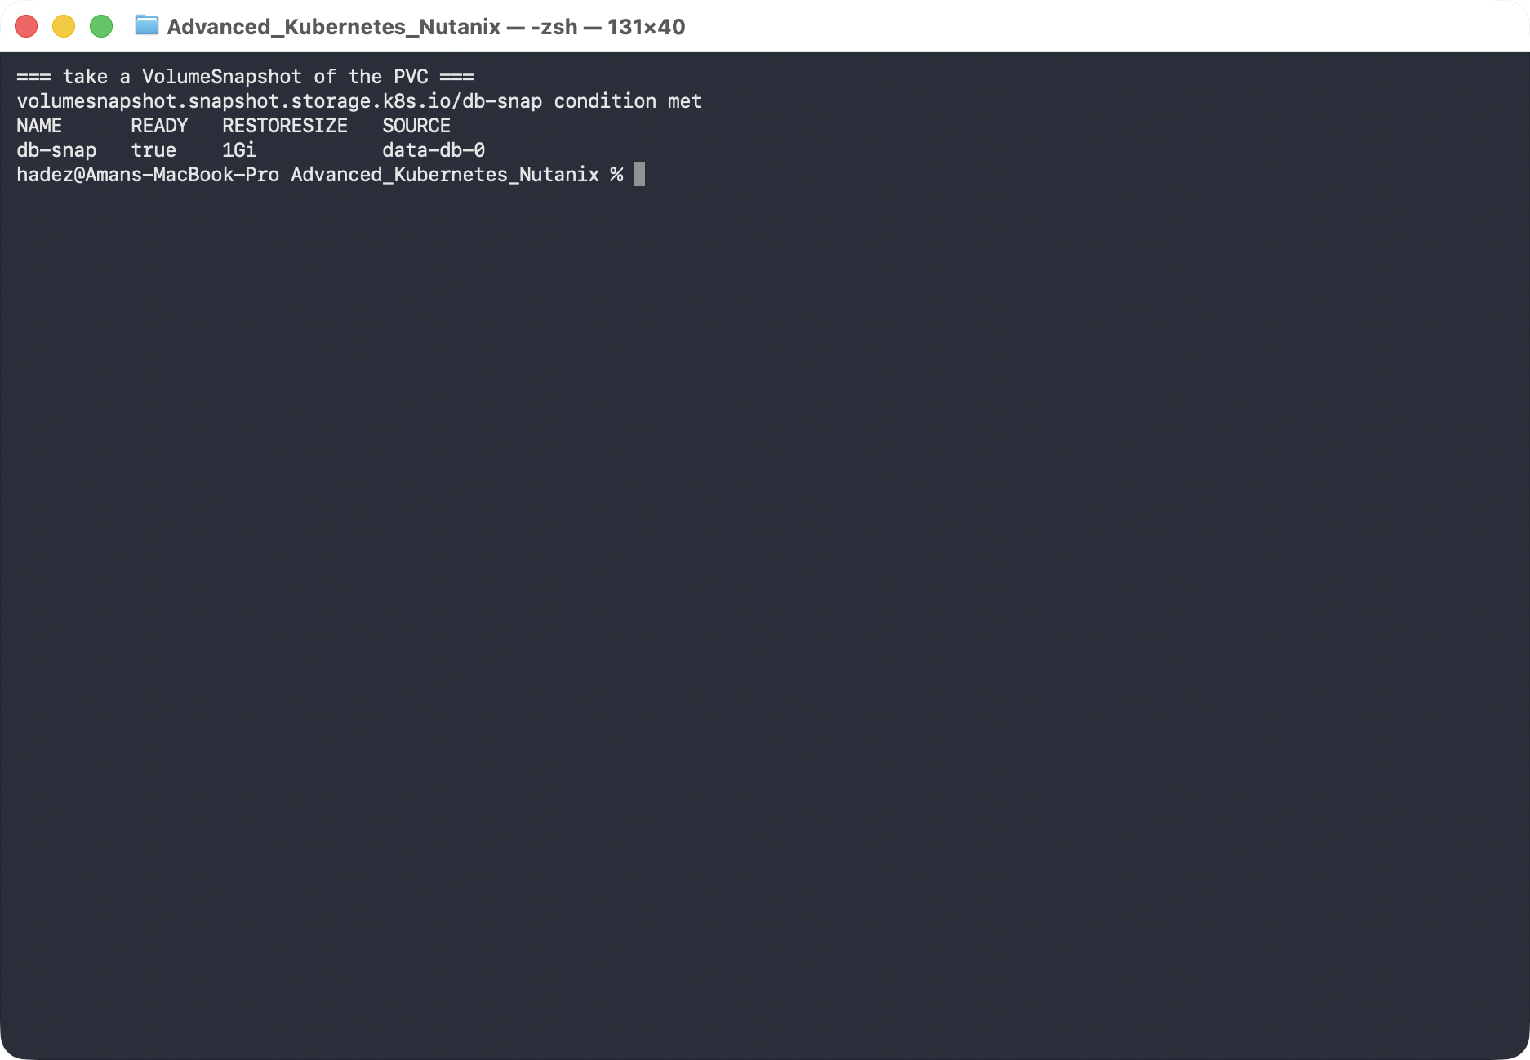
What this means: the CSI driver captured a point-in-time copy of the disk. It exists independently of the PVC now — you could delete the original and still restore from this.

Step 3 — Simulate a disaster
Goal: destroy the StatefulSet and its volume, so recovery has to come from the snapshot.
kubectl delete statefulset db
kubectl delete pvc data-db-0
kubectl get pvc data-db-0 --ignore-not-found
kubectl get volumesnapshot db-snap
What you should see: data-db-0 is gone (no output), but db-snap is still present and ready.
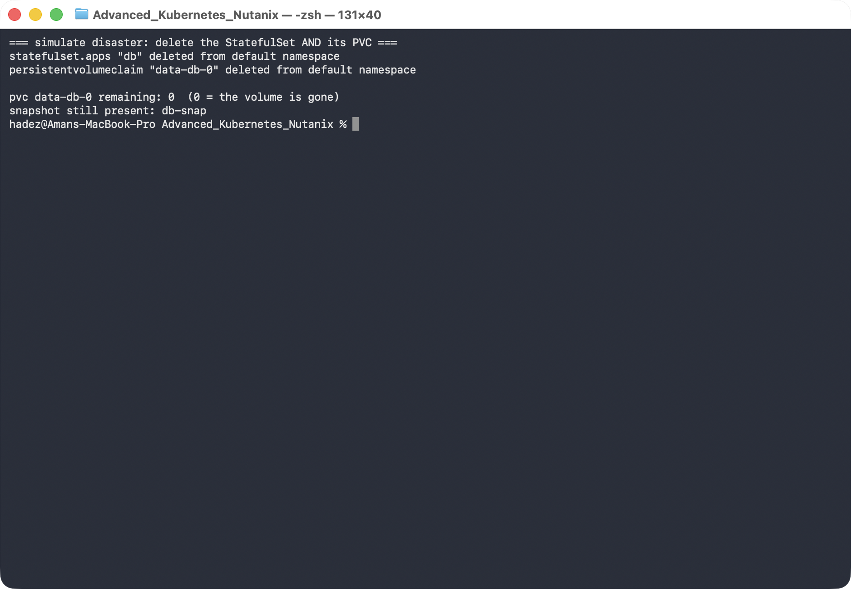
What this means: the live volume no longer exists — this is the "someone deleted the wrong thing" or "the disk is gone" scenario. The only copy of your data is the snapshot.

Step 4 — Restore from the snapshot and verify
Goal: create a new PVC from the snapshot and prove the data survived.
kubectl apply -f - <<'EOF'
apiVersion: v1
kind: PersistentVolumeClaim
metadata: {name: data-restored}
spec:
storageClassName: standard-rwo
dataSource: {name: db-snap, kind: VolumeSnapshot, apiGroup: snapshot.storage.k8s.io}
accessModes: ["ReadWriteOnce"]
resources: {requests: {storage: 1Gi}}
---
apiVersion: v1
kind: Pod
metadata: {name: restore-check}
spec:
containers:
- name: app
image: busybox:1.36
command: ["sh","-c","sleep 3600"]
volumeMounts: [{name: data, mountPath: /data}]
volumes:
- name: data
persistentVolumeClaim: {claimName: data-restored}
EOF
kubectl wait --for=condition=Ready pod/restore-check --timeout=120s
kubectl exec restore-check -- cat /data/message
What you should see: cat /data/message prints important-data-v1 — the exact value from before the disaster.
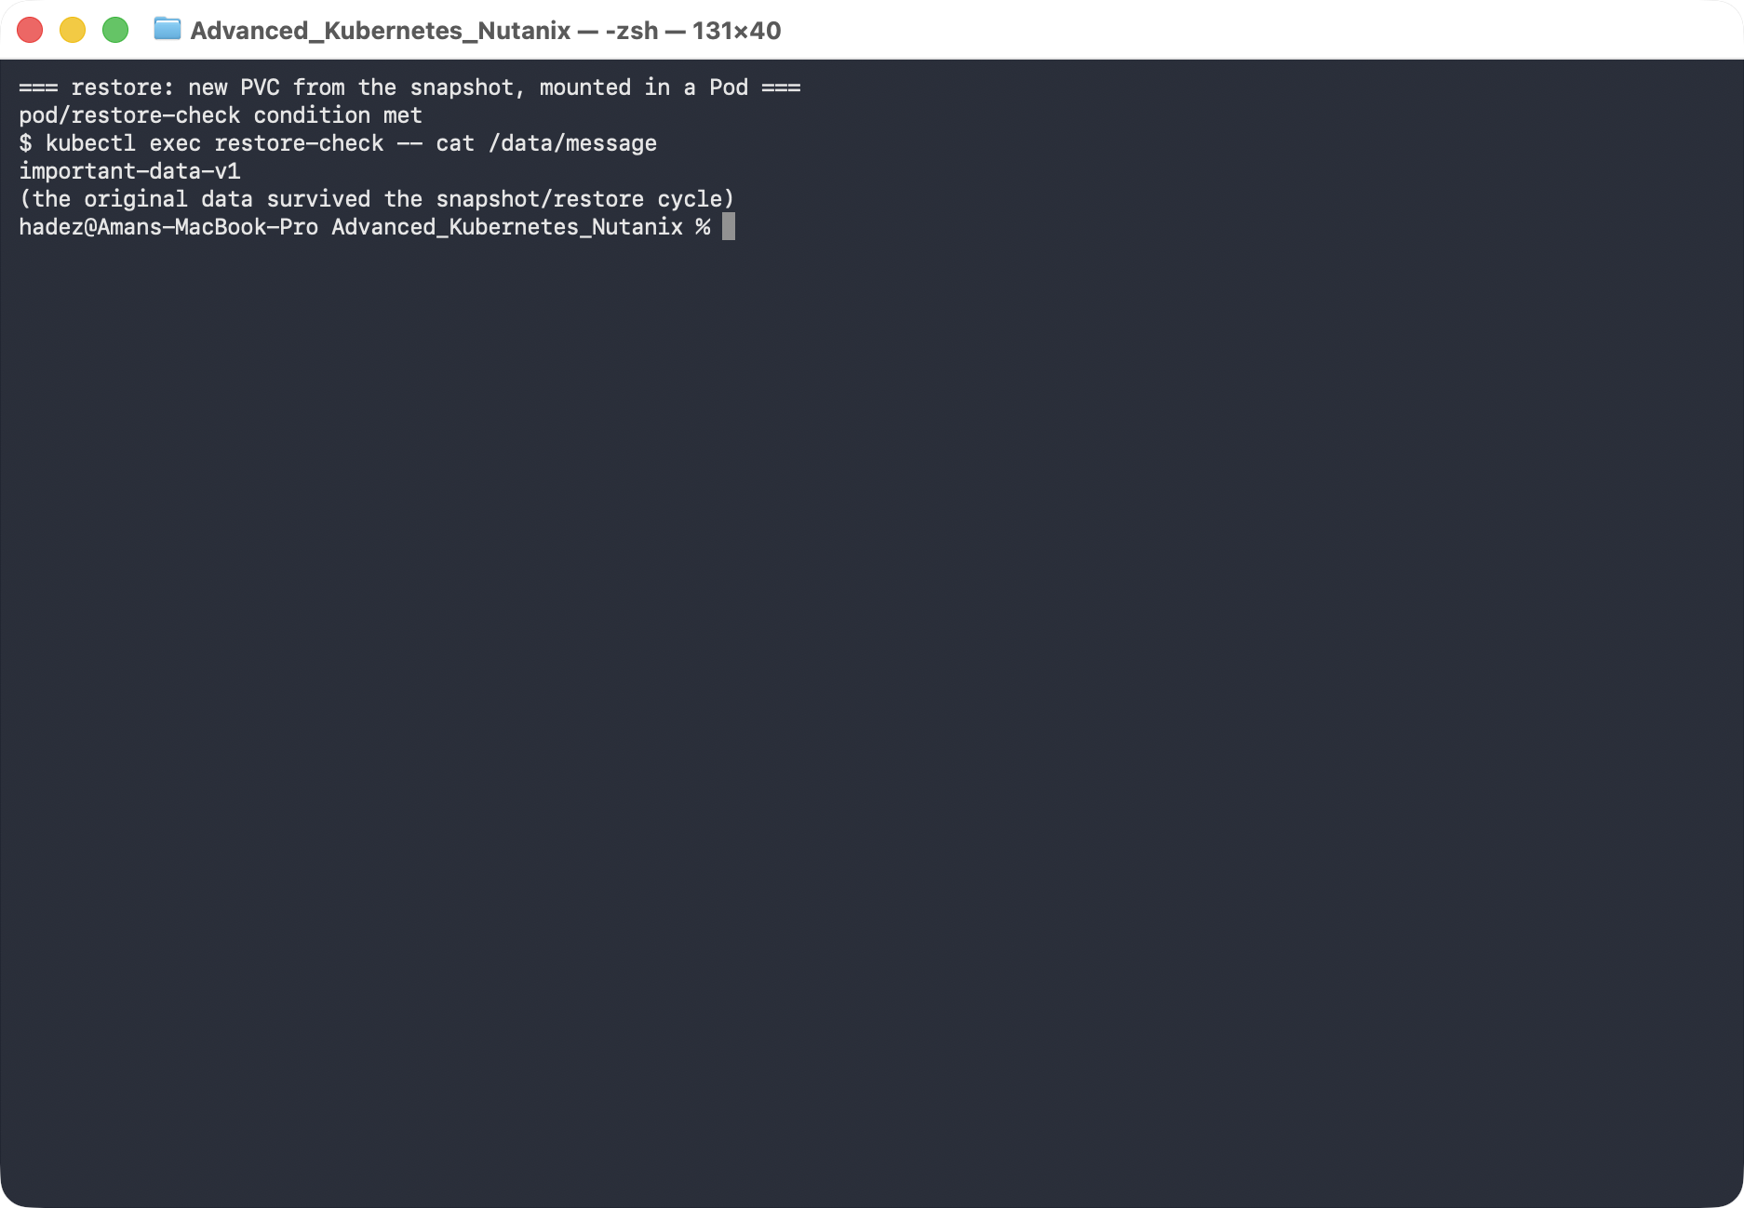
What this means: the snapshot's dataSource pre-populated a brand-new disk with the snapshot's contents, so the data survived a complete destroy/restore cycle. This is the fast path for recovering a single volume.
Where snapshots stop. A VolumeSnapshot lives in the same storage system and doesn't capture your Kubernetes objects (the StatefulSet, Services, ConfigMaps). For "restore a whole namespace, objects and data, possibly to another cluster," you need a backup tool that captures both — that's Lab 12 (Velero).

Steps 5–7 — a second cluster, with a CSI driver that can resize and attach
Steps 1–4 ran on GKE because Persistent Disk snapshots are the realistic thing to demonstrate there. The remaining three outline topics — volume expansion, the multi-attach conflict and the PVC lifecycle — are behaviours of the Kubernetes controllers, not of any particular cloud, so they are done here on a local kind cluster at zero cost.
They need a driver that kind's built-in provisioner cannot provide:
$ kubectl get sc -o custom-columns=NAME:.metadata.name,PROVISIONER:.provisioner,EXPANSION:.allowVolumeExpansion,BINDING:.volumeBindingMode,RECLAIM:.reclaimPolicy
NAME PROVISIONER EXPANSION BINDING RECLAIM
csi-hostpath-noexpand hostpath.csi.k8s.io false Immediate Delete
csi-hostpath-sc hostpath.csi.k8s.io true Immediate Delete
standard rancher.io/local-path <none> WaitForFirstConsumer Delete
kind's default standard class has no allowVolumeExpansion field at all, so it can never resize. Set up the CSI hostpath driver instead:
kind create cluster --name csistate --config - <<'EOF'
kind: Cluster
apiVersion: kind.x-k8s.io/v1alpha4
nodes: [{ role: control-plane }, { role: worker }, { role: worker }]
EOF
# snapshot CRDs + controller
S=https://raw.githubusercontent.com/kubernetes-csi/external-snapshotter/v8.2.0
kubectl apply -f $S/client/config/crd/snapshot.storage.k8s.io_volumesnapshotclasses.yaml
kubectl apply -f $S/client/config/crd/snapshot.storage.k8s.io_volumesnapshotcontents.yaml
kubectl apply -f $S/client/config/crd/snapshot.storage.k8s.io_volumesnapshots.yaml
kubectl apply -f $S/deploy/kubernetes/snapshot-controller/rbac-snapshot-controller.yaml
kubectl apply -f $S/deploy/kubernetes/snapshot-controller/setup-snapshot-controller.yaml
# RBAC for the CSI sidecars
kubectl apply -f https://raw.githubusercontent.com/kubernetes-csi/external-attacher/v4.12.0/deploy/kubernetes/rbac.yaml
kubectl apply -f https://raw.githubusercontent.com/kubernetes-csi/external-provisioner/v6.3.0/deploy/kubernetes/rbac.yaml
kubectl apply -f https://raw.githubusercontent.com/kubernetes-csi/external-resizer/v2.2.1/deploy/kubernetes/rbac.yaml
kubectl apply -f https://raw.githubusercontent.com/kubernetes-csi/external-snapshotter/v8.6.0/deploy/kubernetes/csi-snapshotter/rbac-csi-snapshotter.yaml
kubectl apply -f https://raw.githubusercontent.com/kubernetes-csi/external-health-monitor/v0.18.0/deploy/kubernetes/external-health-monitor-controller/rbac.yaml
# the driver itself
H=https://raw.githubusercontent.com/kubernetes-csi/csi-driver-host-path/v1.18.0/deploy/kubernetes-1.34/hostpath
kubectl apply -f $H/csi-hostpath-driverinfo.yaml
kubectl apply -f $H/csi-hostpath-plugin.yaml
kubectl apply -f $H/csi-hostpath-snapshotclass.yaml
# a StorageClass that permits expansion
kubectl apply -f - <<'EOF'
apiVersion: storage.k8s.io/v1
kind: StorageClass
metadata: { name: csi-hostpath-sc }
provisioner: hostpath.csi.k8s.io
reclaimPolicy: Delete
volumeBindingMode: Immediate
allowVolumeExpansion: true
EOF
kubectl rollout status statefulset/csi-hostpathplugin --timeout=300s
YES — Tested end-to-end on kind v1.37.0 (3 nodes) with csi-driver-host-path v1.18.0, external-resizer v2.2.1 and external-attacher v4.12.0. Full transcript: artifacts/lab-11/evidence/lab-11-expansion-and-multiattach.txt.
Re-create the StatefulSet from Step 1, but pointed at csi-hostpath-sc:
kubectl apply -f - <<'EOF'
apiVersion: apps/v1
kind: StatefulSet
metadata: { name: shop-db }
spec:
serviceName: shop-db
replicas: 1
selector: { matchLabels: { app: shop-db } }
template:
metadata: { labels: { app: shop-db } }
spec:
containers:
- name: app
image: busybox:1.36
command: ["sh","-c","echo important-data-v1 > /data/message; sleep 100000"]
volumeMounts: [{ name: data, mountPath: /data }]
volumeClaimTemplates:
- metadata: { name: data }
spec:
accessModes: ["ReadWriteOnce"]
storageClassName: csi-hostpath-sc
resources: { requests: { storage: 1Gi } }
EOF
Unlike the GKE Persistent Disk class, this driver requires an attach step, so there is a real VolumeAttachment object to look at — which is what makes Step 6 possible:
$ kubectl get volumeattachment -o custom-columns=NAME:.metadata.name,ATTACHER:.spec.attacher,NODE:.spec.nodeName,ATTACHED:.status.attached
NAME ATTACHER NODE ATTACHED
csi-762d7c3ab1a1e8c5f370b4742ce4f947... hostpath.csi.k8s.io csistate-worker2 true

Step 5 — Expand a volume while the application is running
Goal: grow a bound PVC and understand why the change lands in two phases, one in the control plane and one on the node.
1. Ask for more space by editing the PVC — never the PV:
kubectl patch pvc data-shop-db-0 --type merge \
-p '{"spec":{"resources":{"requests":{"storage":"3Gi"}}}}'
2. Watch spec, status and the conditions separately:
watch -n2 'kubectl get pvc data-shop-db-0 \
-o jsonpath="spec={.spec.resources.requests.storage} status={.status.capacity.storage} {range .status.conditions[*]}{.type}={.status} {end}"; echo'
What you should see — and it does not finish on its own:
spec=3Gi status=1Gi conditions=[Unused=False Resizing=True FileSystemResizePending=True ]
spec=3Gi status=1Gi conditions=[Unused=False Resizing=True FileSystemResizePending=True ]
spec=3Gi status=1Gi conditions=[Unused=False Resizing=True FileSystemResizePending=True ]
The PV is already the new size, though:
$ kubectl get pv -o custom-columns=NAME:.metadata.name,CAPACITY:.spec.capacity.storage
NAME CAPACITY
pvc-f833ee26-a0ef-4f3f-bea3-077146df7c56 3Gi
3. Read the event trail — it names every actor in order:
$ kubectl describe pvc data-shop-db-0 | sed -n '/Events/,$p'
Normal ExternalExpanding 18s volume_expand waiting for an external controller to expand this PVC
Normal Resizing 18s external-resizer hostpath.csi.k8s.io External resizer is resizing volume pvc-f833ee26-…
Normal FileSystemResizeRequired 18s external-resizer hostpath.csi.k8s.io Require file system resize of volume on node
The driver told the resizer it is only half done:
"Method":"/csi.v1.Controller/ControllerExpandVolume",
"Response":{"capacity_bytes":3221225472,"node_expansion_required":true}
What this means. Expansion is a two-RPC operation. ControllerExpandVolume grows the backing volume — that is the external-resizer sidecar, and it is what updated the PV. Then NodeExpandVolume grows the filesystem on the node, and only kubelet can do that, only while the volume is mounted. FileSystemResizePending is the handoff between the two.
4. Restart the consumer so kubelet performs the node-side resize:
kubectl delete pod shop-db-0
kubectl rollout status statefulset/shop-db --timeout=240s
spec=3Gi status=3Gi conditions=[Unused=False ]
$ kubectl get pvc data-shop-db-0
data-shop-db-0 Bound pvc-f833ee26-… 3Gi RWO csi-hostpath-sc 76s
$ kubectl exec shop-db-0 -- cat /data/message
important-data-v1
status.capacity now matches spec, the conditions are gone, and the data survived.
⚠️ Gotcha — status.capacity, not spec, is the size you actually have. spec.resources.requests.storage is a request. Monitoring or automation that reads spec will believe the volume grew the moment you patched it, which is wrong for as long as FileSystemResizePending is set — potentially indefinitely, if nothing ever restarts the Pod. Alert on the condition, not on the request.
⚠️ Gotcha — whether you need the restart depends on the driver. Drivers that support online expansion complete NodeExpandVolume on the mounted volume with no restart, and you never see FileSystemResizePending for more than a moment. The hostpath driver here, like many block drivers, needs the remount. Check your driver's docs before promising a zero-downtime resize.
⚠️ Gotcha — df inside the Pod will not confirm this on the hostpath driver. Because the hostpath driver bind-mounts a directory from the node's filesystem rather than formatting a device, df -h /data reports the node's disk (here 452.1G) both before and after. The Kubernetes-level resize is real — the PV, the PVC status and both CSI RPCs all prove it — but the filesystem is not a separate device. On GKE PD or Nutanix CSI, df does change, and that is the check to use there.
5. Two refusals worth seeing once. The second needs a claim on a class that forbids expansion:
kubectl apply -f - <<'EOF'
apiVersion: storage.k8s.io/v1
kind: StorageClass
metadata: { name: csi-hostpath-noexpand }
provisioner: hostpath.csi.k8s.io
allowVolumeExpansion: false
---
apiVersion: v1
kind: PersistentVolumeClaim
metadata: { name: locked-pvc }
spec:
accessModes: ["ReadWriteOnce"]
storageClassName: csi-hostpath-noexpand
resources: { requests: { storage: 1Gi } }
EOF
$ kubectl patch pvc data-shop-db-0 --type merge -p '{"spec":{"resources":{"requests":{"storage":"1Gi"}}}}'
The PersistentVolumeClaim "data-shop-db-0" is invalid: spec.resources.requests.storage:
Forbidden: field can not be less than status.capacity
$ kubectl patch pvc locked-pvc --type merge -p '{"spec":{"resources":{"requests":{"storage":"2Gi"}}}}'
Error from server (Forbidden): persistentvolumeclaims "locked-pvc" is forbidden:
only dynamically provisioned pvc can be resized and the storageclass that provisions
the pvc must support resize
Volumes only grow. There is no shrink in Kubernetes — the API server rejects it outright — and expansion is gated on allowVolumeExpansion in the StorageClass, decided at provisioning time. Pick the class correctly up front; retrofitting means migrating data.

Step 6 — Diagnose a multi-attach failure
Goal: produce the classic ReadWriteOnce conflict on purpose, read the message correctly, and fix it — then meet the second failure hiding behind it.
1. Find where the volume is attached, then deliberately put a second Pod somewhere else:
kubectl get pod shop-db-0 -o custom-columns=POD:.metadata.name,NODE:.spec.nodeName
POD NODE
shop-db-0 csistate-worker2
kubectl apply -f - <<'EOF'
apiVersion: v1
kind: Pod
metadata: { name: report-runner }
spec:
nodeName: csistate-worker # <- the OTHER worker, on purpose
containers:
- name: app
image: busybox:1.36
command: ["sh","-c","cat /data/message; sleep 100000"]
volumeMounts: [{ name: data, mountPath: /data }]
volumes:
- name: data
persistentVolumeClaim: { claimName: data-shop-db-0 }
EOF
2. It hangs in ContainerCreating. Get the reason from the events:
$ kubectl get pod report-runner
NAME READY STATUS RESTARTS AGE
report-runner 0/1 ContainerCreating 0 45s
$ kubectl describe pod report-runner | sed -n '/Events/,$p'
Warning FailedAttachVolume 46s attachdetach-controller Waiting for detach for volume
"pvc-f833ee26-…" Volume is already used by pod(s) shop-db-0
$ kubectl get volumeattachment -o custom-columns=NODE:.spec.nodeName,ATTACHED:.status.attached
NODE ATTACHED
csistate-worker2 true
What this means. A ReadWriteOnce volume can be attached to one node at a time. The attachdetach-controller in kube-controller-manager sees an existing VolumeAttachment for csistate-worker2 and refuses to create a second one for csistate-worker. Notice there is still exactly one VolumeAttachment — the conflict is resolved by not acting, which is why the Pod waits forever rather than failing.
⚠️ Gotcha — the wording changed, the condition did not. On Kubernetes v1.37 the message is Waiting for detach for volume "…" Volume is already used by pod(s) <name>. Older clusters print Multi-Attach error for volume "…" Volume is already exclusively attached to one node and can't be attached to another. Search runbooks for FailedAttachVolume, which is stable, rather than for the phrase "Multi-Attach".
⚠️ Gotcha — RWO is per node, not per Pod. Two Pods sharing one RWO volume is fine as long as the scheduler puts them on the same node — which is exactly why this bug hides in development and appears in production, where replicas spread out. The real-world trigger is almost never a hand-written nodeName: it is a Deployment with an RWO PVC scaled past one replica, or a rolling update where the new Pod lands elsewhere before the old one is gone. If a workload genuinely needs shared access, it needs ReadWriteMany and a driver that supports it — not a retry loop.
3. Free the volume and watch the attachment move:
kubectl scale statefulset shop-db --replicas=0
$ kubectl get volumeattachment -o custom-columns=NODE:.spec.nodeName,ATTACHED:.status.attached
NODE ATTACHED
csistate-worker true
The attach succeeded on the new node — proving the earlier refusal really was only about the prior attachment. But the Pod still will not start, and the reason is now different:
$ kubectl describe pod report-runner | sed -n '/Events/,$p'
Warning FailedAttachVolume 106s attachdetach-controller Waiting for detach for volume …
Normal SuccessfulAttachVolume 22s attachdetach-controller AttachVolume.Attach succeeded …
Warning FailedMount 6s (x6 over 22s) kubelet MountVolume.NodeAffinity check
failed for volume "pvc-f833ee26-…" : no matching NodeSelectorTerms
4. This is the fourth failure pattern — a node-affinity-pinned volume:
$ kubectl get pv -o jsonpath='{.items[0].spec.nodeAffinity}'
{"required":{"nodeSelectorTerms":[{"matchExpressions":[{"key":"topology.hostpath.csi/node",
"operator":"In","values":["csistate-worker2"]}]}]}}
$ kubectl get csinode -o custom-columns=NODE:.metadata.name,DRIVERS:.spec.drivers[*].name,TOPOLOGY:.spec.drivers[*].topologyKeys
NODE DRIVERS TOPOLOGY
csistate-control-plane <none> <none>
csistate-worker <none> <none>
csistate-worker2 hostpath.csi.k8s.io [topology.hostpath.csi/node]
The volume is physically on csistate-worker2, so the provisioner wrote nodeAffinity into the PV. kubectl let the attach happen, then kubelet refused the mount. Fix it by scheduling the consumer where the data is:
kubectl delete pod report-runner
# re-create with nodeName: csistate-worker2
kubectl exec report-runner -- cat /data/message
important-data-v1
What this means. Two distinct controls stopped you, in order: the attach-detach controller (one node per RWO volume) and then kubelet's node-affinity check (this volume only exists on one node). Read the From column — attachdetach-controller versus kubelet — to know which one you are fighting. A FailedMount with NodeAffinity is never fixed by waiting; the Pod must move.
Nutanix note. On a Nutanix cluster, Nutanix Volumes are reachable from any node, so a PV normally carries no nodeAffinity and this second failure does not occur — a detached RWO volume will attach and mount anywhere. The multi-attach conflict in part 2 is identical, because it is enforced by kube-controller-manager and not by the driver. Where topology does bite on Nutanix is across availability domains or rack-aware storage containers; the diagnostic is the same pair of commands — the PV's nodeAffinity and the CSINode topology keys.

Step 7 — PVC lifecycle: a finalizer that holds a deletion, and cloning
Goal: see why a PVC you deleted is still there, and copy a volume without going through a snapshot.
1. Delete a PVC that a running Pod still uses:
kubectl delete pvc data-shop-db-0 --wait=false
kubectl get pvc data-shop-db-0
persistentvolumeclaim "data-shop-db-0" deleted from default namespace
NAME STATUS VOLUME CAPACITY ACCESS MODES STORAGECLASS AGE
data-shop-db-0 Terminating pvc-f833ee26-… 3Gi RWO csi-hostpath-sc 3m31s
2. The object is marked for deletion but held by a finalizer:
$ kubectl get pvc data-shop-db-0 -o jsonpath='{.metadata.finalizers}'
["kubernetes.io/pvc-protection"]
$ kubectl get pvc data-shop-db-0 -o jsonpath='{.metadata.deletionTimestamp}'
2026-09-27T05:44:02Z
A minute later nothing has changed, and the volume is still serving reads:
data-shop-db-0 Terminating pvc-f833ee26-… 3Gi RWO csi-hostpath-sc 4m26s
$ kubectl exec report-runner -- cat /data/message
important-data-v1
3. Remove the consumer and the deletion completes by itself:
kubectl delete pod report-runner
kubectl get pvc data-shop-db-0
kubectl get pv
Error from server (NotFound): persistentvolumeclaims "data-shop-db-0" not found
NAME STATUS CLAIM
pvc-f17b29aa-b1e9-471f-b9d3-079f2294f2b7 Bound locked-pvc
The PVC went, and because the StorageClass used reclaimPolicy: Delete, the PV and the data went with it.
What this means. kubernetes.io/pvc-protection is deliberate protection, not a bug: it stops you destroying storage that something is still mounting. Terminating plus a deletionTimestamp plus a finalizer means "waiting for a precondition" — find the holder, don't force it.
🚨 Gotcha — never kubectl patch a pvc-protection finalizer away to "unstick" it. Stripping the finalizer deletes the PVC while a Pod still has the volume mounted; with reclaimPolicy: Delete the PV is then removed under a running application, which is data loss, not a cleanup. The supported fix is always to remove the consumer. kubectl describe pvc names it, and so does:
kubectl get pods -o json | jq -r '.items[] | select(.spec.volumes[]?.persistentVolumeClaim.claimName=="data-shop-db-0") | .metadata.name'
⚠️ Gotcha — reclaimPolicy is what decides whether "delete the PVC" means "delete the data". Delete (the default for most dynamic classes, including this one and GKE's standard-rwo) destroys the volume. Retain keeps the PV in Released state so you can recover it — but a Released PV will not rebind to a new PVC until you clear spec.claimRef by hand. Choose per class, and know which one your production class uses before you test a deletion.
4. Clone a volume directly from another PVC — no snapshot in between. First make a source with something in it:
kubectl apply -f - <<'EOF'
apiVersion: v1
kind: PersistentVolumeClaim
metadata: { name: src-pvc }
spec:
accessModes: ["ReadWriteOnce"]
storageClassName: csi-hostpath-sc
resources: { requests: { storage: 1Gi } }
---
apiVersion: v1
kind: Pod
metadata: { name: writer }
spec:
containers:
- name: app
image: busybox:1.36
command: ["sh","-c","echo orders-2026-Q3 > /data/ledger; sleep 100000"]
volumeMounts: [{ name: d, mountPath: /data }]
volumes: [{ name: d, persistentVolumeClaim: { claimName: src-pvc } }]
EOF
kubectl wait --for=condition=Ready pod/writer --timeout=180s
Then clone it:
kubectl apply -f - <<'EOF'
apiVersion: v1
kind: PersistentVolumeClaim
metadata: { name: clone-pvc }
spec:
accessModes: ["ReadWriteOnce"]
storageClassName: csi-hostpath-sc
resources: { requests: { storage: 1Gi } }
dataSource:
kind: PersistentVolumeClaim # <- a PVC, not a VolumeSnapshot
name: src-pvc
EOF
NAME STATUS VOLUME CAPACITY ACCESS MODES STORAGECLASS AGE
src-pvc Bound pvc-10da5199-… 1Gi RWO csi-hostpath-sc 22s
clone-pvc Bound pvc-95e46fdc-… 1Gi RWO csi-hostpath-sc 12s
Mount the clone to read it:
kubectl apply -f - <<'EOF'
apiVersion: v1
kind: Pod
metadata: { name: clone-reader }
spec:
containers:
- name: app
image: busybox:1.36
command: ["sh","-c","sleep 100000"]
volumeMounts: [{ name: d, mountPath: /data }]
volumes: [{ name: d, persistentVolumeClaim: { claimName: clone-pvc } }]
EOF
kubectl wait --for=condition=Ready pod/clone-reader --timeout=180s
The clone carries the source's contents and is then fully independent:
$ kubectl exec clone-reader -- cat /data/ledger
orders-2026-Q3
$ kubectl exec clone-reader -- sh -c 'echo clone-only-line >> /data/ledger; cat /data/ledger'
orders-2026-Q3
clone-only-line
$ kubectl exec writer -- cat /data/ledger # source untouched
orders-2026-Q3
What this means. dataSource takes either a VolumeSnapshot (Step 4) or a PersistentVolumeClaim. Cloning is the right tool for "give me a copy of production data to test against" — it is one object and no snapshot to manage. A snapshot is the right tool for point-in-time recovery, because it keeps existing after the source volume is gone. Both require driver support and both are constrained to the same StorageClass.

Step 8 — Clean up
# GKE part (Steps 1-4)
kubectl delete pod restore-check --ignore-not-found
kubectl delete pvc data-restored --ignore-not-found
kubectl delete volumesnapshot db-snap --ignore-not-found
kubectl delete volumesnapshotclass pd-snapclass --ignore-not-found
# kind part (Steps 5-7) — one command removes everything
kind delete cluster --name csistate

What you learned
You saw… | in Step | proof
A StatefulSet gives each Pod its own PVC/disk | 1 | data-db-0 Bound, file on the disk
You can snapshot a live PVC via CSI | 2 | db-snap readyToUse=true, 1Gi
A snapshot outlives its source volume | 3 | PVC deleted, snapshot remains
A snapshot restores onto a new PVC via dataSource | 4 | data-restored Bound, data intact
Data survives a full destroy/restore cycle | 4 | important-data-v1 after restore
Expansion takes two CSI calls, controller then node | 5 | node_expansion_required:true, PV 3Gi while PVC status 1Gi
FileSystemResizePending does not clear on its own | 5 | unchanged over 18s; cleared only after the Pod restarted
Volumes only grow, and only if the class allows it | 5 | field can not be less than status.capacity; …must support resize
An RWO volume attaches to one node, not one Pod | 6 | FailedAttachVolume … already used by pod(s) shop-db-0, one VolumeAttachment
Freeing the volume reveals a second failure | 6 | MountVolume.NodeAffinity check failed: no matching NodeSelectorTerms
The PV is pinned by CSI topology | 6 | PV nodeAffinity on topology.hostpath.csi/node, CSINode shows one node
A PVC finalizer holds a deletion open indefinitely | 7 | Terminating + ["kubernetes.io/pvc-protection"] for 60s+
reclaimPolicy: Delete destroys the data with the PVC | 7 | PV gone once the consumer was removed
dataSource also clones from a PVC, independently | 7 | clone reads orders-2026-Q3, diverges, source unchanged

Evidence
Real screenshots for this lab are in artifacts/lab-11/screenshots/ (4 images), and command transcripts are in artifacts/lab-11/evidence/lab-08-statefulsets-snapshots.txt (Steps 1–4, GKE) and artifacts/lab-11/evidence/lab-11-expansion-and-multiattach.txt (Steps 5–7, kind + CSI hostpath).

Next: Lab 12 — Bring a Deleted Namespace Back from Backup (Velero)

