DataCouch — Advanced Kubernetes (Nutanix)
Table of Contents

Day 3 · Stateful Workloads, Persistent Storage & Service Exposure
YES — Tested end-to-end, in three parts. Steps 2–4 were first verified on a real GKE cluster (advk8s-lab, dcproject-462806) against an in-cluster MinIO bucket; every screenshot is a real capture from that run. MinIO's public images have since been withdrawn, so Step 1 was rewritten and re-verified on kind with SeaweedFS 3.80 on 2026-09-27 (backup location Available, volume data backed up and restored). Steps 5–6 were verified on kind on 2026-09-25. The payoff is unchanged: you kubectl delete namespace an entire application, then bring it all back — Deployment, Service, and its data — with catalog: widget-9000=42.00 intact.

What you'll learn
- The difference between a volume snapshot (Lab 11 — one disk, same storage system) and a backup (this lab — whole namespaces of objects and data, in external object storage you can restore anywhere).
- How to run Velero against S3-compatible object storage — here in-cluster SeaweedFS, exactly the pattern you'd use with Nutanix Objects.
- Why a backup that reports Completed with zero errors can restore nothing usable, and the one test that catches it.
- How Schedules, TTL and expiry behave — including what expiry actually deletes.
- How to back up a namespace, prove it's stored, delete the namespace completely, and restore it.

What you'll do
You'll stand up an S3-compatible object store as a backup target and install Velero pointing at it. Then you'll create an app with data, back up its namespace, delete the whole namespace, and restore it from the backup — verifying every object and its data returns.

Time & cost
- Time: ~45 minutes.
- Cost: negligible — the object store and Velero run as small Pods; no cloud object storage needed.

Before you start
- Where you'll work: in a terminal on your own machine.
- Tools you need: gcloud, kubectl, and the velero CLI (brew install velero).
- Cluster: a GKE cluster (this course's shared advk8s-lab).
Nutanix note. Velero is the standard Kubernetes backup tool and is platform-agnostic. We back up to an in-cluster S3 store here so the lab is self-contained and needs no cloud credentials — but the object-store config is identical for Nutanix Objects (also S3-compatible): you'd just point s3Url at your Nutanix Objects endpoint and use its access keys. Everything else in this lab is unchanged on NKE.

The idea in 60 seconds
A snapshot (Lab 11) copies one volume within the same storage system — great for fast single-disk recovery, useless if the whole cluster or namespace is gone. A backup captures your Kubernetes objects (Deployments, Services, ConfigMaps, …) and volume data, and writes them to external object storage. Because the backup lives outside the cluster, you can restore a deleted namespace — or rebuild onto a brand-new cluster entirely.
Velero is the tool: it watches for Backup/Restore custom resources, serialises the selected objects, and stores them in an S3 bucket. Here that bucket is served by SeaweedFS running in the cluster.
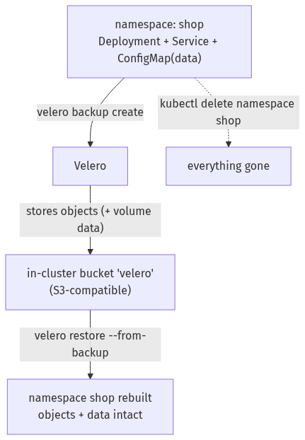

Step 1 — Stand up the backup target (SeaweedFS) and install Velero

🚨 This lab used MinIO until 2026-09-25. MinIO's public images are gone.
Re-verified 2026-09-27 — every MinIO image this lab used now fails to pull:
$ docker pull minio/minio:latest
Error response from daemon: pull access denied for minio/minio, repository does not exist
or may require 'docker login'
$ docker pull quay.io/minio/minio:RELEASE.2025-09-07T16-13-09Z-cpuv1
... unexpected status from HEAD request to https://quay.io/v2/minio/minio/manifests/...: 401 Unauthorized
$ docker pull quay.io/minio/mc:RELEASE.2025-08-13T08-35-41Z-cpuv1
... unexpected status from HEAD request to https://quay.io/v2/minio/mc/manifests/...: 401 UNAUTHORIZED
Both the server and the mc client are unavailable, on Docker Hub and on quay.io, while other registries work normally. MinIO restricted their public images; there is nothing to configure around it. This step is therefore written for SeaweedFS, which is verified working below. zenko/cloudserver and adobe/s3mock also pull if you prefer them.
Everything downstream keeps the Service name minio, so Steps 2–7, all the s3Url values and every command in the rest of the lab are unchanged.
Goal: deploy an S3-compatible object store, create a bucket, and install Velero pointing at it.
YES — Verified end-to-end 2026-09-27 on kind v1.37.0 with Velero v1.18.2, velero-plugin-for-aws v1.13.0, SeaweedFS 3.80 and the kopia uploader: backup location Available, PodVolumeBackup and PodVolumeRestore both Completed, and widget-9000=42.00 recovered after the namespace was destroyed. Transcript: artifacts/lab-12/evidence/lab-12-seaweedfs-s3-target.txt.
1. Give SeaweedFS real S3 credentials. Unlike MinIO, SeaweedFS serves S3 anonymously unless you define identities, and Velero signs every request — so without this file the object store answers "Signed request requires setting up SeaweedFS S3 authentication" and the backup location never validates:
kubectl create namespace velero
cat > /tmp/s3config.json <<'EOF'
{
"identities": [
{
"name": "velero",
"credentials": [ { "accessKey": "veleroaccess", "secretKey": "verosecret123" } ],
"actions": ["Admin","Read","Write","List","Tagging"]
}
]
}
EOF
kubectl -n velero create secret generic seaweedfs-s3-config --from-file=s3config.json=/tmp/s3config.json
2. Deploy it as minio so nothing else in the lab has to change:
kubectl apply -n velero -f - <<'EOF'
apiVersion: apps/v1
kind: Deployment
metadata: {name: minio, labels: {app: minio}}
spec:
replicas: 1
selector: {matchLabels: {app: minio}}
template:
metadata: {labels: {app: minio}}
spec:
containers:
- name: seaweedfs
image: chrislusf/seaweedfs:3.80
args:
- "server"
- "-dir=/data"
- "-s3"
- "-s3.port=9000"
- "-s3.config=/etc/seaweedfs/s3config.json"
- "-master.volumeSizeLimitMB=128"
ports: [{containerPort: 9000}]
volumeMounts:
- {name: cfg, mountPath: /etc/seaweedfs}
- {name: data, mountPath: /data}
volumes:
- name: cfg
secret: {secretName: seaweedfs-s3-config}
- name: data
emptyDir: {}
---
apiVersion: v1
kind: Service
metadata: {name: minio}
spec:
selector: {app: minio}
ports: [{port: 9000, targetPort: 9000}]
EOF
kubectl -n velero rollout status deployment/minio --timeout=300s
3. Create the velero bucket with the AWS CLI. The old mc Job cannot be used — mc is a MinIO image and is equally unavailable — but amazon/aws-cli pulls fine and speaks to any S3 endpoint:
kubectl -n velero run mkbucket --rm -i --restart=Never --image=amazon/aws-cli:latest \
--env=AWS_ACCESS_KEY_ID=veleroaccess \
--env=AWS_SECRET_ACCESS_KEY=verosecret123 \
--env=AWS_DEFAULT_REGION=us-east-1 \
--command -- sh -c 'aws --endpoint-url http://minio.velero.svc:9000 s3 mb s3://velero &&
aws --endpoint-url http://minio.velero.svc:9000 s3 ls'
make_bucket: velero
2026-09-27 05:59:12 velero
4. Install Velero pointing at it. The credentials must match the identity in s3config.json:
cat > /tmp/velero-creds <<'EOF'
[default]
aws_access_key_id=veleroaccess
aws_secret_access_key=verosecret123
EOF
velero install \
--provider aws \
--plugins velero/velero-plugin-for-aws:v1.13.0 \
--bucket velero \
--secret-file /tmp/velero-creds \
--use-volume-snapshots=false \
--use-node-agent \
--uploader-type kopia \
--backup-location-config region=minio,s3ForcePathStyle=true,s3Url=http://minio.velero.svc:9000 \
--namespace velero \
--wait
velero backup-location get
What you should see:
NAME PROVIDER BUCKET/PREFIX PHASE LAST VALIDATED ACCESS MODE DEFAULT
default aws velero Available ... ReadWrite true
$ kubectl -n velero get pods
NAME READY STATUS RESTARTS AGE
minio-7856f76d85-gn6hc 1/1 Running 0 11m
node-agent-wdg6m 1/1 Running 0 10m
velero-566f786554-2n8pc 1/1 Running 0 10m
What this means: Velero is installed and its S3 target is validated. PHASE: Available is the check that matters — it proves Velero authenticated to the bucket and can write to it. On NKE you'd point s3Url at Nutanix Objects and use its access keys instead; nothing else changes.
⚠️ Gotcha — --use-node-agent is what backs up data; without it you get objects only. The node-agent DaemonSet is the component that reads volume contents (via kopia). If it is missing or not Running, backups still complete and still say Completed, but no PodVolumeBackup object is created and a restore gives you an empty volume. Confirm all three Pods above are up before you trust a backup.
🚨 Gotcha — on a kind cluster the default StorageClass silently defeats file-system backup. kind's standard class (rancher.io/local-path) provisions hostPath PVs, and Velero refuses to file-system-backup those. The only signal is one warning in the server log:
$ kubectl -n velero logs deploy/velero | grep "hostPath volume which is not supported"
level=warning msg="Volume d in pod shop/catalog-… is a hostPath volume which is not supported
for pod volume backup, skipping" logSource="pkg/podvolume/backupper.go:347"
The backup reports Completed, velero backup get shows WARNINGS 1, and kubectl -n velero get podvolumebackup returns nothing at all. Diagnosing this as an object-store problem is the natural mistake and it is wrong — the bucket is fine. Check the PV type first:
kubectl get pv -o custom-columns=NAME:.metadata.name,CSI:.spec.csi.driver,SC:.spec.storageClassName
A CSI driver in the CSI column means fs-backup will work; an empty column means it will not. On GKE (pd.csi.storage.gke.io) and on Nutanix CSI this does not arise. On kind, install a real CSI driver — the setup at the top of Lab 11's Steps 5–7 is exactly what's needed — and point the PVC's storageClassName at it.
With a CSI-backed volume the same backup behaves properly:
$ kubectl -n velero get podvolumebackup -o custom-columns=NAME:.metadata.name,STATUS:.status.phase,UPLOADER:.spec.uploaderType,VOLUME:.spec.volume,BYTES:.status.progress.totalBytes
NAME STATUS UPLOADER VOLUME BYTES
shop-csi-fw7xz Completed kopia d 18
and after kubectl delete ns shop, the restore brings the data back:
$ velero restore create shop-back-2 --from-backup shop-verify --wait
Restore completed with status: Completed.
$ kubectl -n shop exec $POD -c app -- cat /data/catalog.txt
widget-9000=42.00
$ kubectl -n velero get podvolumerestore -o custom-columns=NAME:.metadata.name,STATUS:.status.phase,UPLOADER:.spec.uploaderType,BYTES:.status.progress.totalBytes
NAME STATUS UPLOADER BYTES
shop-back-2-2cmx6 Completed kopia 18
⚠️ Gotcha — velero backup describe --details fails from your laptop, and it is not a broken backup. The CLI tries to fetch the result files from the object store directly, using the in-cluster address:
Warnings: <error getting warnings: Get "http://minio.velero.svc:9000/velero/backups/…":
dial tcp: lookup minio.velero.svc: no such host>
Your machine cannot resolve a cluster DNS name. The backup itself is fine. Read the server log instead — kubectl -n velero logs deploy/velero — or port-forward the Service. This affects any in-cluster object store, MinIO included.

Step 2 — Create an app with data, and back it up
Goal: back up a whole namespace to MinIO.
kubectl create namespace shop
kubectl -n shop create deployment web --image=nginx:1.27-alpine
kubectl -n shop create configmap catalog --from-literal=featured="widget-9000" --from-literal=price="42.00"
kubectl -n shop expose deployment web --port=80
velero backup create shop-backup --include-namespaces shop --wait
velero backup describe shop-backup
What you should see: the backup reaches Phase: Completed, with something like 16 items backed up (the namespace and everything in it), and the catalog data is widget-9000=42.00.
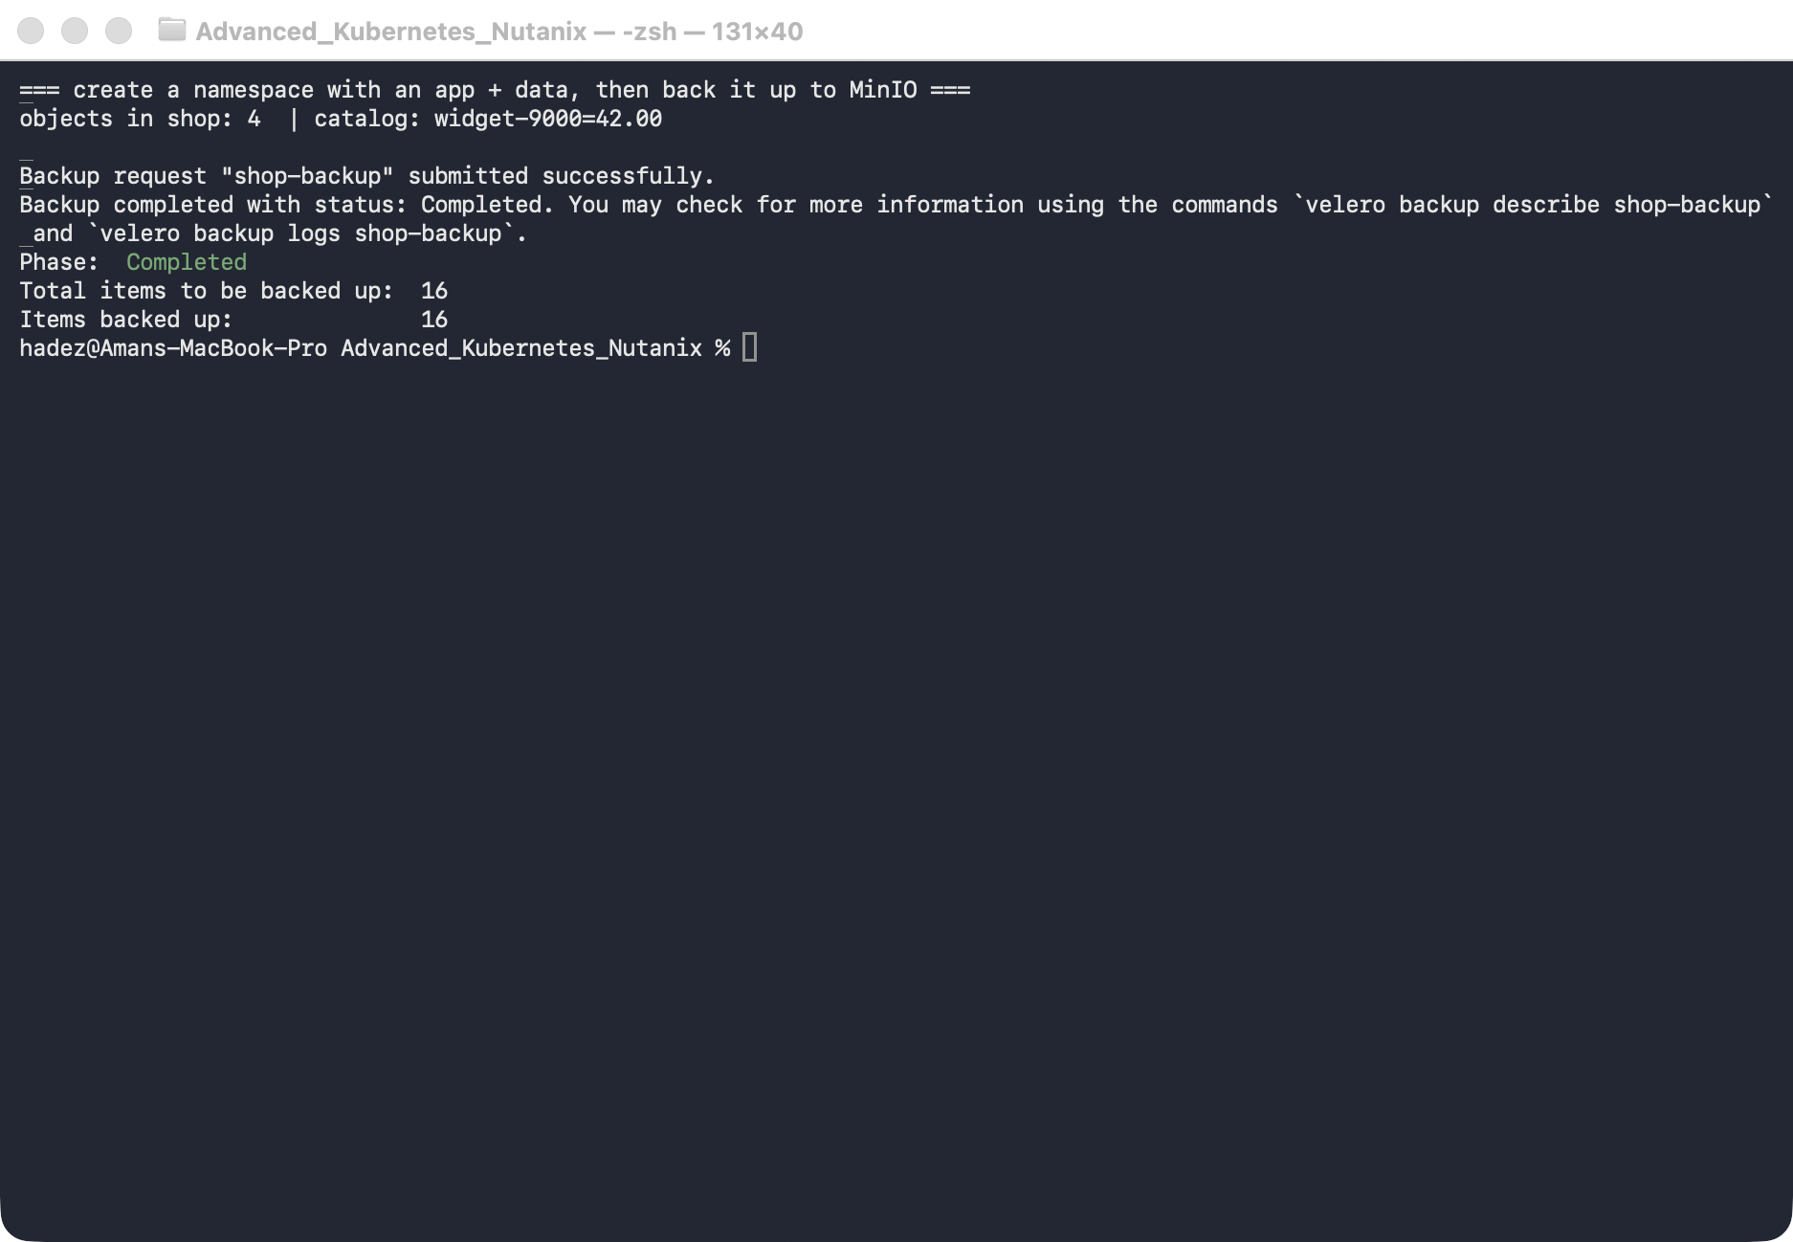
What this means: Velero serialised every object in shop and wrote them to the MinIO bucket. That backup now exists independently of the cluster.

Step 3 — Delete the entire namespace
Goal: simulate a real disaster — the whole namespace is gone.
kubectl delete namespace shop
kubectl get ns shop --ignore-not-found
velero backup get
What you should see: shop is gone (no output), but shop-backup is still listed as Completed.
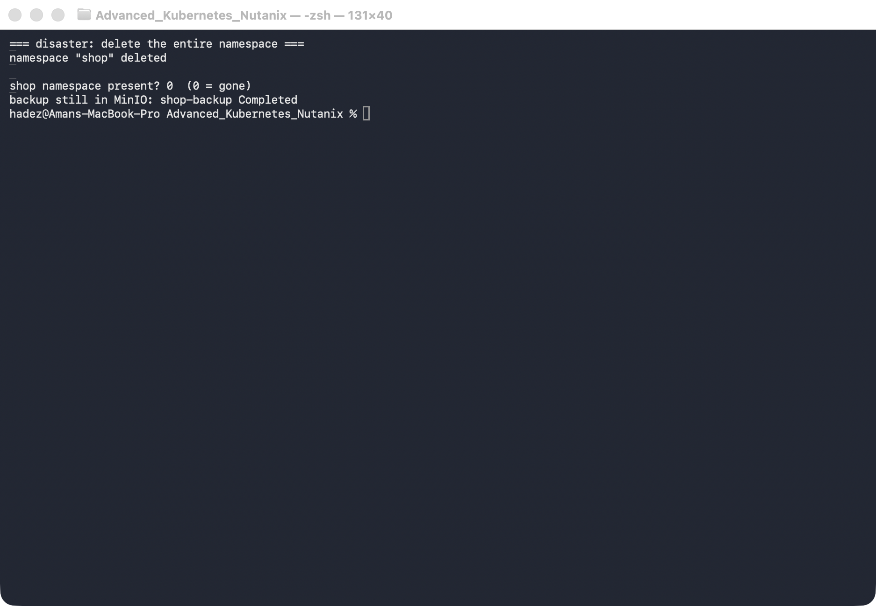
What this means: the live application is completely gone — Deployment, Service, ConfigMap, all of it. The only copy is the backup in MinIO.

Step 4 — Restore, and verify the data came back
Goal: restore the namespace from the backup and prove everything returned.
velero restore create shop-restore --from-backup shop-backup --wait
kubectl get ns shop
kubectl -n shop get deploy,svc,cm
kubectl -n shop get cm catalog -o jsonpath='{.data.featured}={.data.price}{"\n"}'
What you should see: the restore completes, shop is Active again, web (Deployment + Service) and catalog are back, and the ConfigMap data reads widget-9000=42.00 — exactly as before.
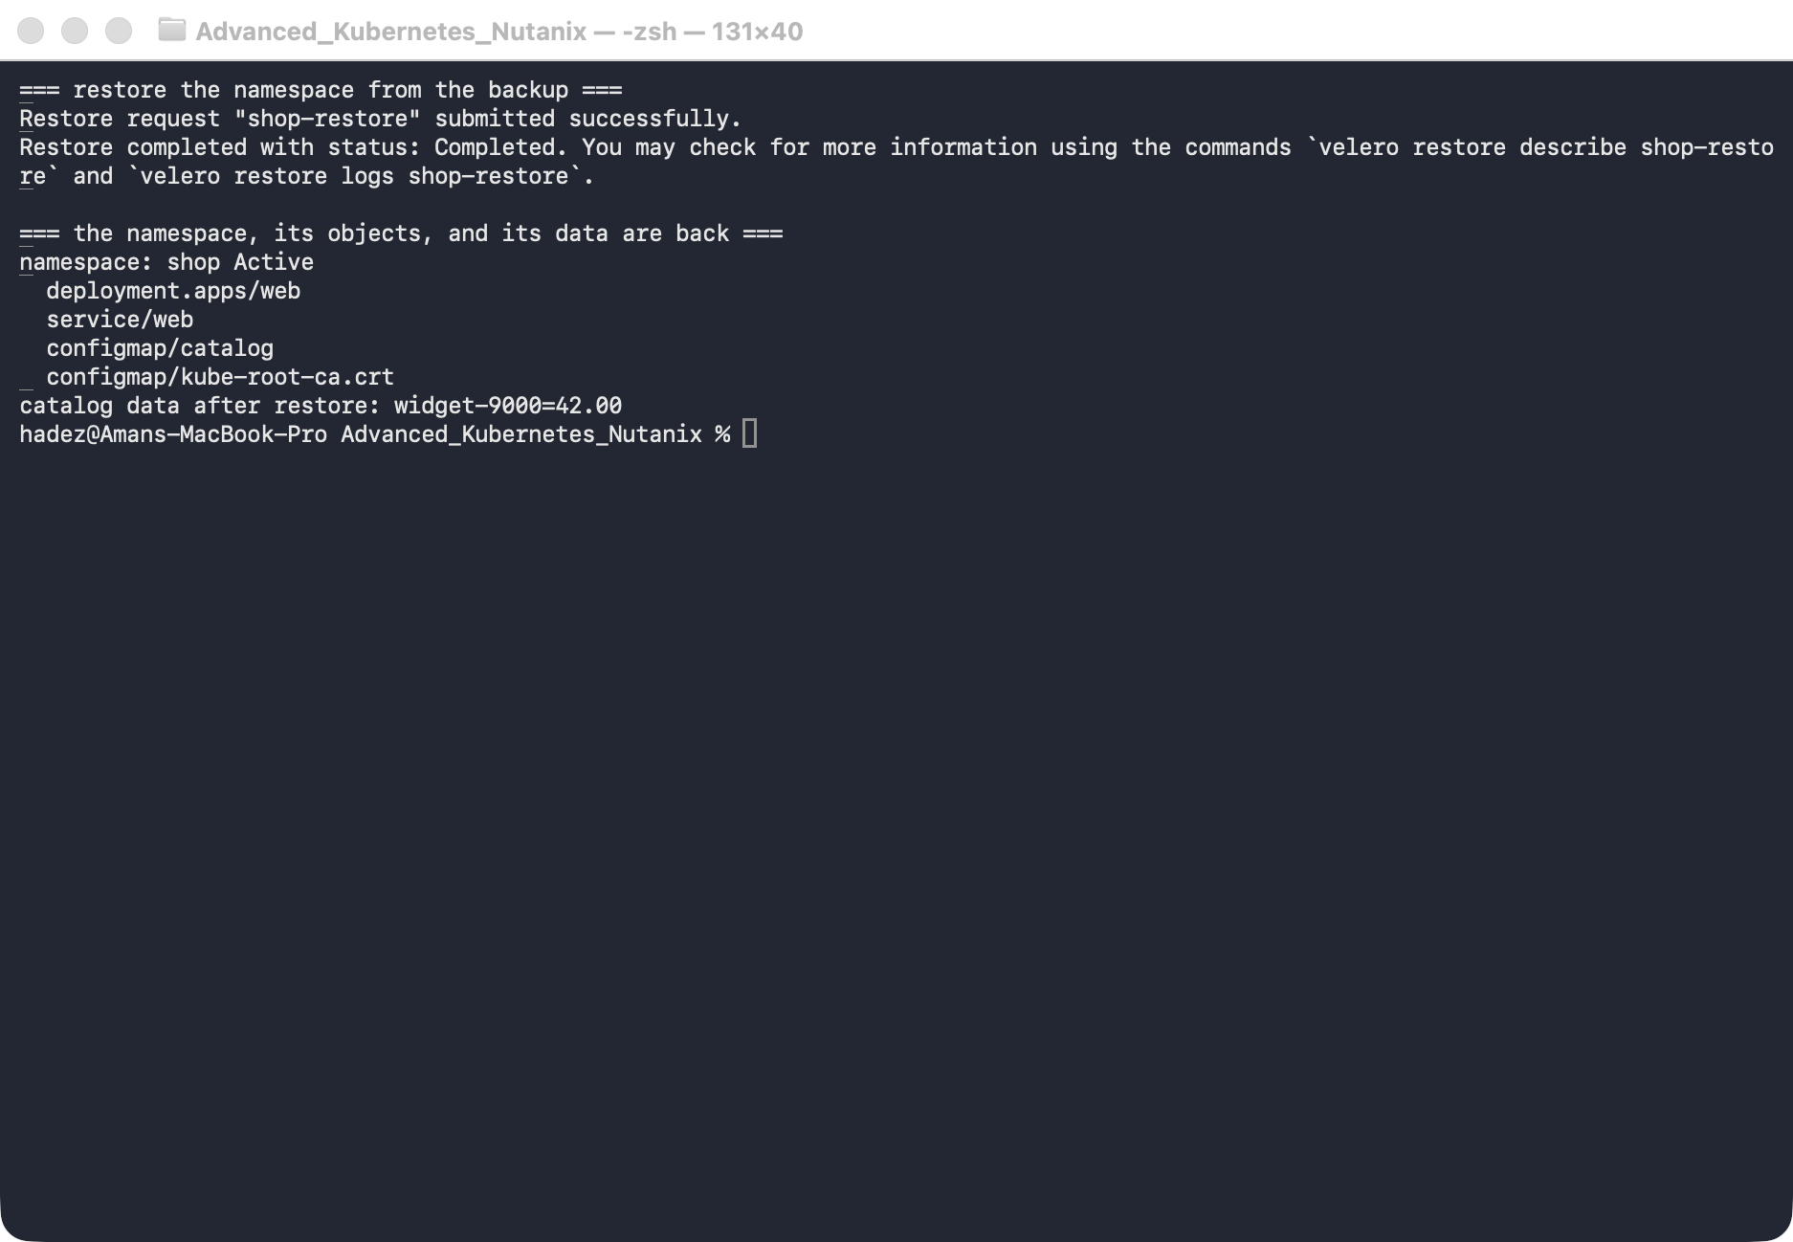
What this means: a fully deleted namespace came back, objects and data intact, from external storage. Because the backup lives in object storage, the very same command could restore this app onto a different cluster — which is the real power of a backup over a snapshot.

Step 5 — The backup that says Completed and restores nothing
Goal: meet the failure mode that makes people trust backups they should not.
Everything so far worked. Now configure Velero the way most teams first do — and watch it lie to you.
Back the same namespace up without file-system backup of the volume:
velero backup create orders-nightly --include-namespaces orders \
--default-volumes-to-fs-backup=false --wait
velero backup get orders-nightly
What you should see — a completely clean result:
phase = Completed
itemsBackedUp = 19 of 19
errors = 0
warnings = 0
Destroy the namespace and restore it:
kubectl delete ns orders
velero restore create --from-backup orders-nightly --wait
Restore completed with status: Completed.
ERRORS: 0
Check the cluster — everything is healthy:
kubectl -n orders get pvc,deploy
persistentvolumeclaim/pgdata Bound pvc-5e49edac... 1Gi RWO standard
deployment.apps/orders-db 1/1 1 1
Now ask the database:
kubectl -n orders exec $POD -- psql -U postgres -c "SELECT * FROM orders;"
ERROR: relation "orders" does not exist
What this means. Backup Completed. Restore Completed, zero errors. PVC Bound. Pod 1/1 Running. The data is gone.
Velero backed up the Kubernetes objects — the PVC, the Deployment, the Service — and never touched the bytes inside the volume. On restore it recreated an empty PVC. Postgres found an empty data directory, ran initdb, and started cleanly. Nothing anywhere reports a problem.
⚠️ This is worse than a failed restore. A restore that errors gets investigated. This one reports success, so it gets ticked off — and the gap is discovered months later by someone who actually needed the data. The outline calls this "restores that report success without usable data", and it is the single most important thing in this module.
The fix is to tell Velero to back up volume contents, not just the objects that describe them:
velero install ... --use-node-agent --default-volumes-to-fs-backup
velero backup create orders-nightly --include-namespaces orders --default-volumes-to-fs-backup
Then verify by the only test that counts:
kubectl -n velero get podvolumebackups # a row per volume, with bytesDone
The rule this lab exists to teach: a backup is not verified by its phase. It is verified by a restore into a scratch namespace and a query against the restored data. Put that in the runbook.

Step 6 — Schedules, TTL and what expiry actually deletes
Goal: make the backup recurring, and know when it disappears.
velero schedule create orders-daily \
--schedule="0 2 * * *" \
--include-namespaces orders \
--ttl 72h
velero schedule get
NAME STATUS SCHEDULE BACKUP TTL LAST BACKUP PAUSED
orders-daily Enabled 0 2 * * * 72h0m0s n/a false
Every backup the schedule creates inherits that TTL. Look at what that becomes on the object:
kubectl -n velero get backup <name> \
-o jsonpath='ttl={.spec.ttl}{"\n"}completed={.status.completionTimestamp}{"\n"}expiration={.status.expiration}'
ttl = 720h0m0s
completed = 2026-09-25T13:40:02Z
expiration = 2026-10-25T13:40:01Z
What this means. TTL is resolved to an absolute expiration timestamp at creation, not evaluated later. Velero's gc-controller removes the Backup object and its data in object storage once that moment passes.
Two consequences worth stating plainly:
- Changing a Schedule's --ttl does not re-date backups already taken. The old ones still expire on their original schedule. If you extend retention after an incident, the backups you care about may already be counting down.
- Expiry deletes the data, not just the record. This is not an index tidy-up. A backup that ages out is gone from the bucket.
⚠️ Gotcha — velero backup describe --details fails against an in-cluster object store. The CLI runs on your laptop and tries to fetch details directly from S3, so it cannot resolve minio.velero.svc. You get dial tcp: lookup minio.velero.svc: no such host even though the backup itself is fine. Read kubectl -n velero logs deploy/velero instead, or port-forward the object store.

Step 7 — Clean up
kubectl delete namespace shop --ignore-not-found
velero backup delete shop-backup --confirm
# to remove Velero and the object store entirely:
# kubectl delete namespace velero
# on kind, one command removes the lot:
# kind delete cluster --name veleros3

What you learned
You saw… | in Step | proof
Velero backs up to S3-compatible storage (SeaweedFS / Nutanix Objects) | 1 | backup location Available
SeaweedFS needs S3 identities before Velero can sign requests | 1 | -s3.config identity; without it the location never validates
--use-node-agent is what captures volume data | 1 | PodVolumeBackup … Completed kopia 18
A hostPath PV silently defeats file-system backup | 1 gotcha | Completed + WARNINGS 1, zero PodVolumeBackup objects
A namespace backup captures all its objects | 2 | Completed, 16 items
The backup survives the cluster's objects | 3 | namespace deleted, backup remains
A deleted namespace restores with data intact | 4 | shop Active, catalog=widget-9000=42.00
Backups (unlike snapshots) can restore to another cluster | 4
A backup can report Completed and restore nothing usable | 5 | 19/19 items, 0 errors — then relation "orders" does not exist
Velero backs up objects, not volume bytes, unless told | 5 | PVC Bound and empty; Postgres ran initdb and started clean
Only a restore-and-query verifies a backup | 5 | every status field was green while the data was gone
TTL becomes an absolute expiry stamped at creation | 6 | ttl=720h → expiration=2026-10-25T13:40:01Z
Expiry deletes the backup and its data | 6 | gc-controller removes the object and the bucket contents

Evidence
The object-store rewrite — the MinIO pull failures, the SeaweedFS setup, the hostPath trap and a full destroy/restore cycle with volume data — is captured in artifacts/lab-12/evidence/lab-12-seaweedfs-s3-target.txt — 109 lines from a run on 2026-09-27 (Kubernetes 1.37.0, Velero 1.18.2, SeaweedFS 3.80).
The "backup said Completed" scenario and the schedule/TTL behaviour are captured in artifacts/lab-12/evidence/lab-12-backup-completed-no-data.txt — 78 lines from a run on 2026-09-25 (Kubernetes 1.37.0, Velero 1.18.2), including the clean Completed phases, the healthy PVC and Pod, and the relation "orders" does not exist that follows.

Original GKE evidence
Real screenshots for this lab are in artifacts/lab-12/screenshots/ (3 images), and a command transcript is in artifacts/lab-12/evidence/lab-09-velero-backup-restore.txt.

Next: Lab 13 — Give On-Prem Services a Real IP (Bare-Metal LoadBalancer with MetalLB)

