DataCouch — Advanced Kubernetes (Nutanix)
Table of Contents

Day 3 · Stateful Workloads, Persistent Storage & Service Exposure
YES — Tested end-to-end on a real 4-node kind cluster with MetalLB v0.14.9, and the Step 4 comparison on a second, 2-node kind cluster with Cilium 1.20.1. Every screenshot is a real capture. You'll watch a Service type=LoadBalancer sit at <pending> forever, then get a real, reachable IP from MetalLB — and keep that IP working after you kill the node that was announcing it.

What you'll learn
- Why Service type=LoadBalancer gives an EXTERNAL-IP on a cloud (GKE) but stays <pending> on bare metal / on-prem — there's no cloud load-balancer controller.
- How MetalLB fills that gap: an IPAddressPool plus Layer-2 advertisement that assigns an address and announces it from a node.
- How MetalLB survives a node failure — the address is re-announced from another node.
- Why this is one of the most Nutanix-relevant labs: on-prem NKE clusters need exactly this.
- How the same job looks with Cilium LB-IPAM instead of MetalLB — what it removes from your stack, what it doesn't change, and the two ways it can bite you.
- When to prefer the Cilium BGP control plane over MetalLB BGP mode, and why the answer is usually about ownership rather than features.

What you'll do
You'll expose a Deployment as a LoadBalancer and see it stuck <pending>. Then you'll install MetalLB, give it an address pool, and watch the Service get a reachable IP. Then you'll docker stop the node announcing that IP and prove the Service stays up. Finally you'll build a second cluster running Cilium and do the same job with LB-IPAM, so you can compare the two approaches side by side on evidence rather than on marketing.

Time & cost
- Time: ~40 minutes for Steps 1–3, plus ~30 minutes for the Cilium comparison in Step 4.
- Cost: $0 — runs on a local kind cluster.

Before you start
- Where you'll work: in a terminal on your own machine.
- Tools you need: docker, kind, kubectl.
- Cluster: a multi-node kind cluster (this course's advk8s-day1, 1 control-plane + 3 workers — you need multiple nodes for the failover step).
Nutanix note — and why this one is kind, not GKE. On GKE a LoadBalancer Service is handled for you by a Google Cloud load balancer, so MetalLB would be redundant. MetalLB is for bare-metal and on-prem clusters that have no cloud LB — which is exactly the situation on a Nutanix on-prem cluster. So this lab runs on kind to simulate bare metal. On real NKE you'd install MetalLB the same way (or use Nutanix's own load-balancing), point the IPAddressPool at a range on your Nutanix network, and everything else here is identical.

The idea in 60 seconds
Service type=LoadBalancer asks the cluster for an external IP. On a cloud, a controller calls the cloud API and provisions a real load balancer, filling in EXTERNAL-IP. On bare metal there's no such controller, so the field stays <pending> — the Service works inside the cluster but has no external address.
MetalLB is that missing controller for bare metal. You give it a pool of IPs (IPAddressPool) from your network, and in Layer-2 mode one node answers ARP for each assigned IP and forwards traffic to the Service. If that node dies, MetalLB re-elects another node to announce the IP — so the address survives node failure.
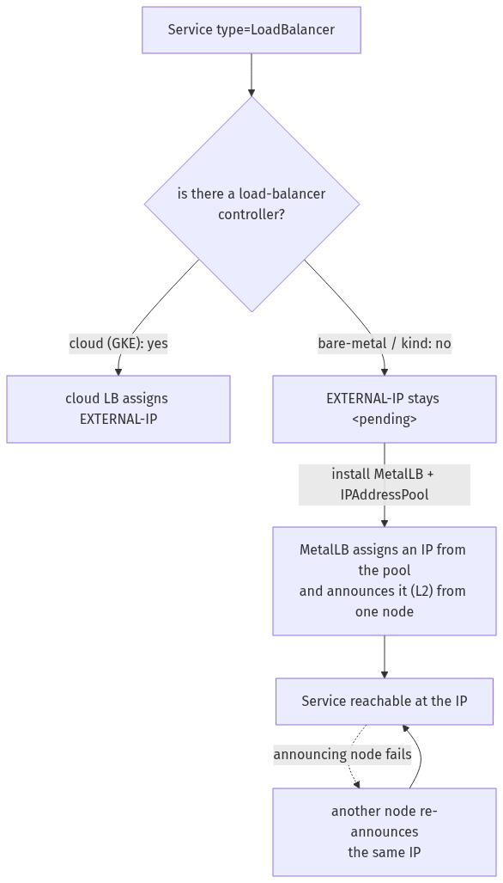

Step 1 — Watch a LoadBalancer Service hang at <pending>
Goal: see that, without a cloud LB, an external IP never appears.
1. Expose a Deployment as a LoadBalancer:
kubectl create deployment web --image=nginx:1.27-alpine
kubectl expose deployment web --port=80 --type=LoadBalancer --name=web-lb
kubectl get svc web-lb
What you should see: web-lb of type LoadBalancer with EXTERNAL-IP: <pending> — and it will stay that way indefinitely.
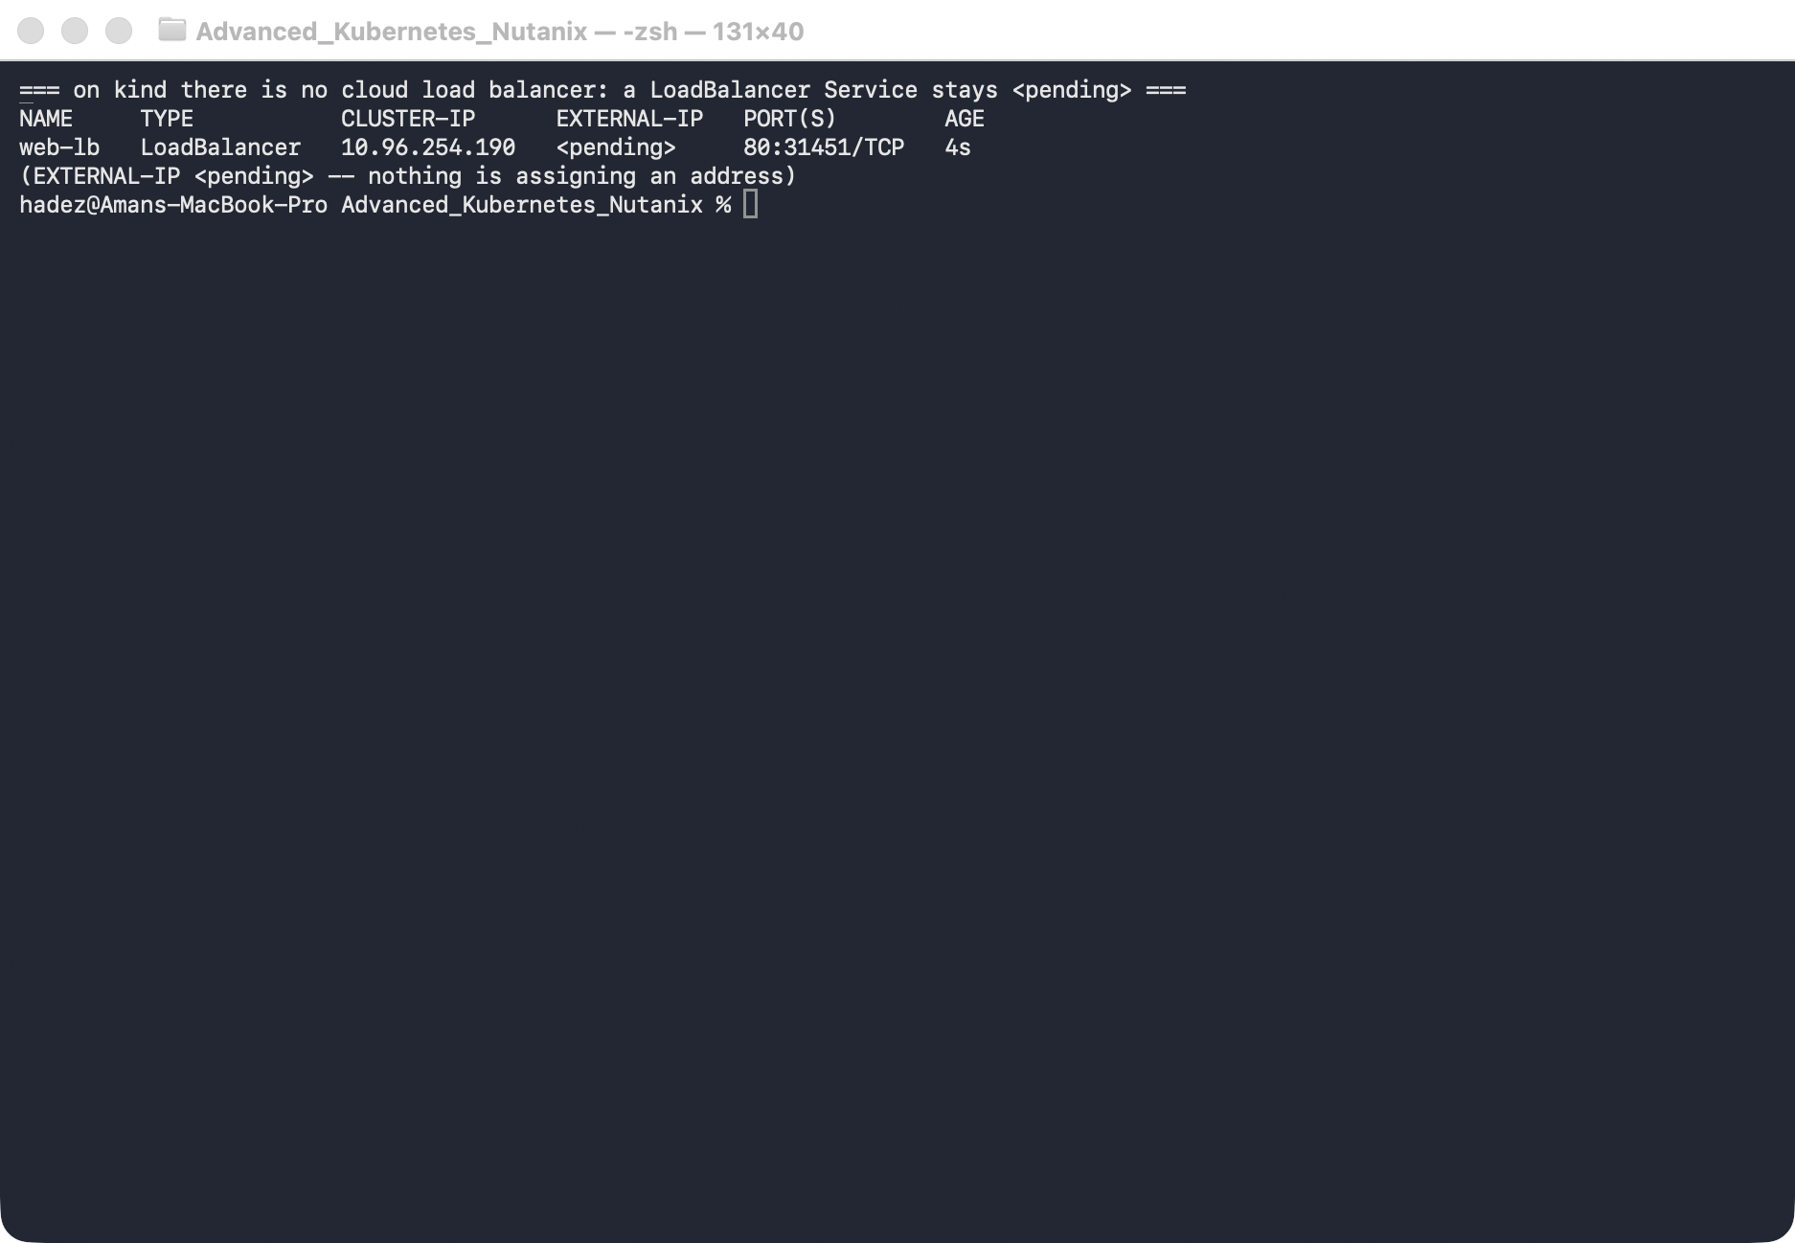
What this means: nothing in a bare-metal cluster is watching for LoadBalancer Services to assign them an address. The Service has a ClusterIP and works inside the cluster, but there's no external IP. On Nutanix on-prem you'd hit exactly this.

Step 2 — Install MetalLB and give it an address pool
Goal: install MetalLB, hand it a range of IPs from the cluster's network, and watch the Service get a reachable address.
1. Install MetalLB and wait for it:
kubectl apply -f https://raw.githubusercontent.com/metallb/metallb/v0.14.9/config/manifests/metallb-native.yaml
kubectl -n metallb-system rollout status deployment/controller --timeout=150s
kubectl -n metallb-system rollout status daemonset/speaker --timeout=120s
2. Give it an IPAddressPool from the kind docker subnet (find yours with docker network inspect kind; here it's 172.19.0.0/16, so we use a high, unused range):
kubectl apply -f - <<'EOF'
apiVersion: metallb.io/v1beta1
kind: IPAddressPool
metadata: {name: kind-pool, namespace: metallb-system}
spec:
addresses: ["172.19.255.200-172.19.255.250"]
---
apiVersion: metallb.io/v1beta1
kind: L2Advertisement
metadata: {name: l2, namespace: metallb-system}
spec:
ipAddressPools: [kind-pool]
EOF
kubectl get svc web-lb
3. Reach the IP from inside the cluster network (on Docker-Desktop-for-Mac the docker subnet isn't routable from your Mac, so curl from a node):
IP=$(kubectl get svc web-lb -o jsonpath='{.status.loadBalancer.ingress[0].ip}')
docker exec advk8s-day1-worker3 curl -s -o /dev/null -w "HTTP %{http_code}\n" http://$IP
What you should see: web-lb now has a real EXTERNAL-IP (e.g. 172.19.255.200), and the curl returns HTTP 200.
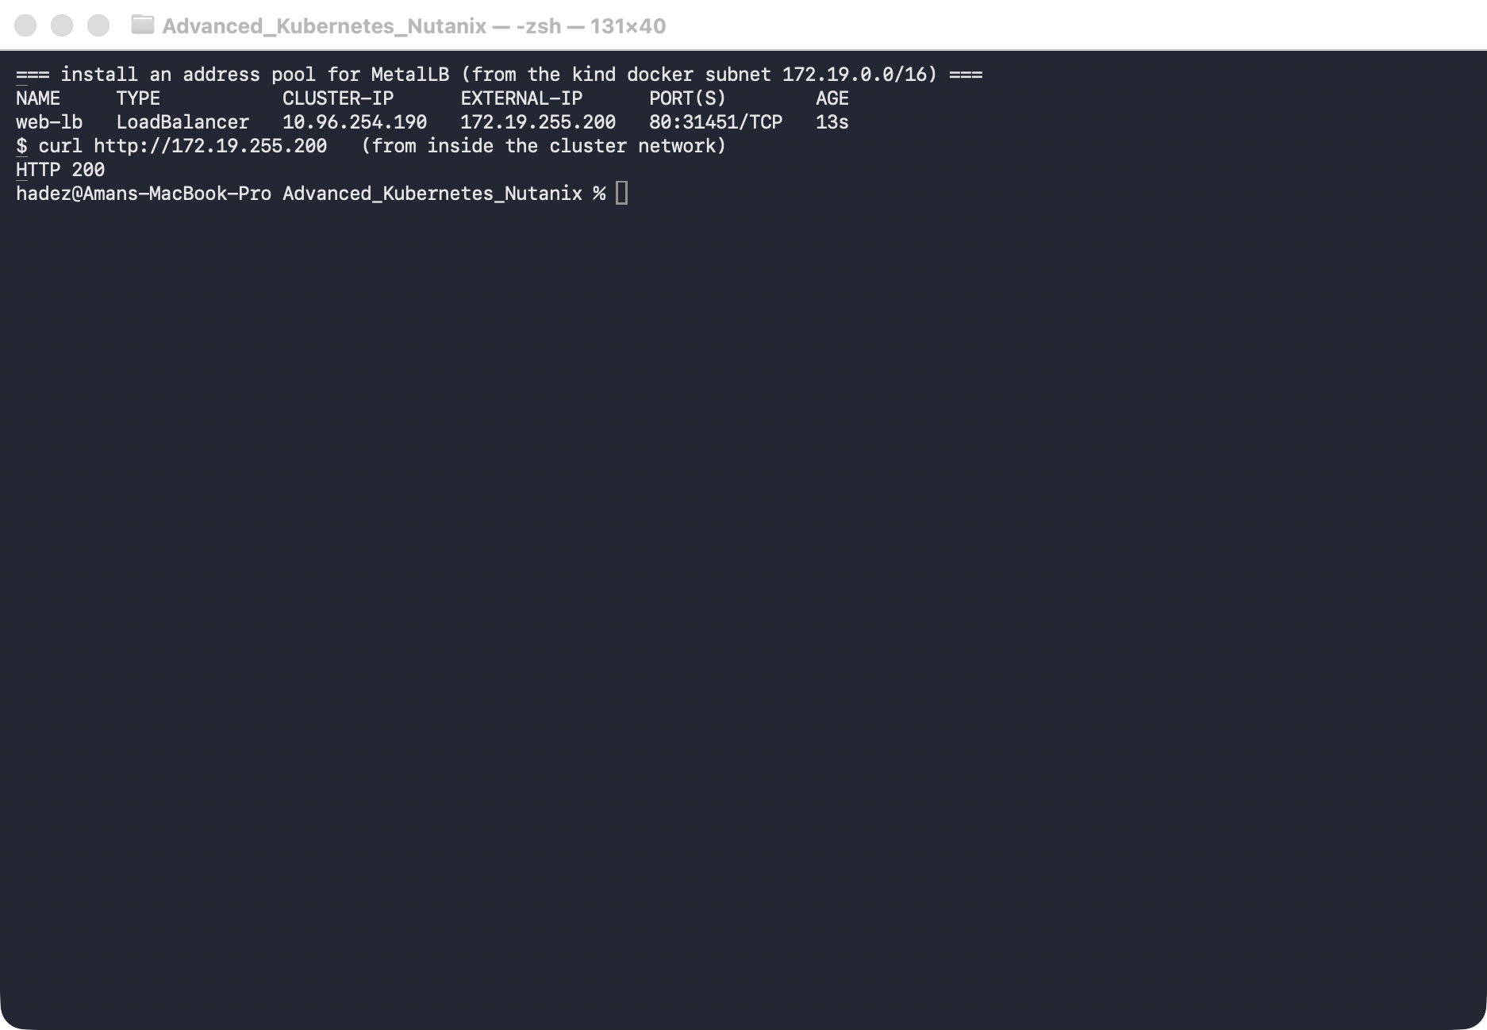
What this means: MetalLB is the load-balancer controller the cluster was missing. It picked an address from your pool and is announcing it (Layer-2) from one node, so the Service is now reachable at a stable IP.

Step 3 — Survive a node failure
Goal: kill the node that's announcing the IP and prove the Service stays reachable.
1. Find the announcing node, then stop it:
IP=$(kubectl get svc web-lb -o jsonpath='{.status.loadBalancer.ingress[0].ip}')
kubectl describe svc web-lb | grep 'announcing from node' # e.g. advk8s-day1-worker
# simulate a node failure:
docker stop advk8s-day1-worker
2. Wait for Kubernetes to mark the node NotReady, then curl the same IP from a surviving node:
kubectl get node advk8s-day1-worker # NotReady after a few seconds
kubectl describe svc web-lb | grep 'announcing from node' # now a DIFFERENT node
docker exec advk8s-day1-worker3 curl -s -o /dev/null -w "HTTP %{http_code}\n" http://$IP
What you should see: after the node goes NotReady, MetalLB shows the IP announcing from node "advk8s-day1-worker2" (a different node), and curling the same IP returns HTTP 200.
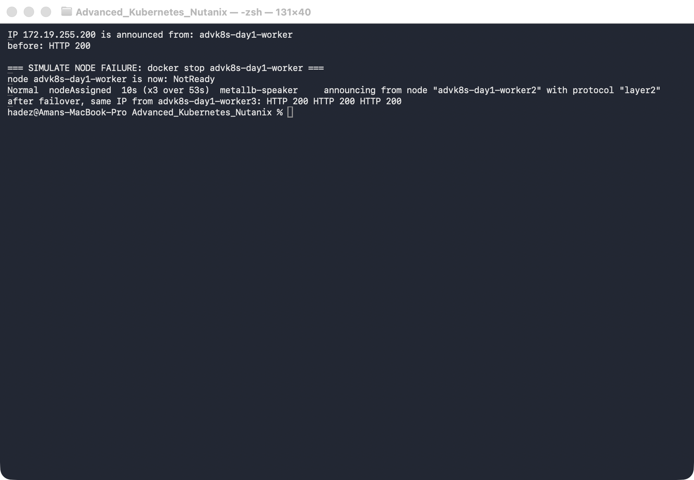
⚠️ Gotcha — there's a brief failover window. For the first few seconds after the node stops, curl may fail (HTTP 000): Kubernetes hasn't yet marked the node NotReady, so it still routes some traffic to the dead Pod, and the L2 announcement hasn't moved. Once the node is NotReady (endpoints pruned) and MetalLB re-announces from a healthy node, it recovers. This is normal L2 failover behaviour — L2 mode fails over, it doesn't load-balance across nodes.
3. Restore the node:
docker start advk8s-day1-worker

Step 4 — Compare the result against Cilium LB-IPAM
MetalLB is not the only way to answer this question. If you already run Cilium as your CNI — common on NKE — Cilium can allocate and announce LoadBalancer addresses itself, with no extra components at all. This step builds a second cluster and does the same job with Cilium, so you can see exactly what differs.
YES — Tested end-to-end on a 2-node kind cluster named lbipam with Cilium 1.20.1 (kube-proxy replacement, disableDefaultCNI: true) and MetalLB not installed. Every command output quoted below is from artifacts/lab-13/evidence/lab-13-cilium-lb-ipam.txt.

4.1 — Build the Cilium cluster
cat > /tmp/lbipam-kind.yaml <<'EOF'
kind: Cluster
apiVersion: kind.x-k8s.io/v1alpha4
networking:
disableDefaultCNI: true
kubeProxyMode: none
nodes:
- role: control-plane
- role: worker
EOF
kind create cluster --name lbipam --config /tmp/lbipam-kind.yaml
Install Cilium with L2 announcements switched on from the start. Read the gotcha below before you skip that flag.
helm repo add cilium https://helm.cilium.io/ && helm repo update cilium
helm install cilium cilium/cilium --version 1.20.1 -n kube-system \
--set kubeProxyReplacement=true \
--set k8sServiceHost=lbipam-control-plane --set k8sServicePort=6443 \
--set l2announcements.enabled=true \
--set k8sClientRateLimit.qps=50 --set k8sClientRateLimit.burst=200
cilium status --wait
cilium status should show Cilium: OK and Operator: OK. Now note what is not there:
$ kubectl -n kube-system get ds,deploy -o name | grep -iE "metallb|speaker"
(no output — allocation is done by the cilium-operator, announcement by the cilium agents)
MetalLB needed a controller Deployment plus a speaker DaemonSet on every node. Cilium needs neither — the operator you already run does the allocation, and the agent you already run does the announcing. That is the single biggest practical difference.
⚠️ Gotcha — l2announcements.enabled=true must be set through Helm, not by patching the ConfigMap. Setting enable-l2-announcements: "true" in cilium-config and restarting the DaemonSet does turn the feature on — the agent logs --enable-l2-announcements='true' — but the Helm chart is also what renders the RBAC rule for leases. Without it every announcement attempt fails in a tight loop:
level=error msg="Error retrieving lease lock" error="leases.coordination.k8s.io
\"cilium-l2announce-default-shopfront\" is forbidden: User
\"system:serviceaccount:kube-system:cilium\" cannot get resource \"leases\"
in API group \"coordination.k8s.io\" in the namespace \"kube-system\""
The address stays allocated, nothing answers ARP, and kubectl get svc looks completely healthy. Running helm upgrade --reuse-values --set l2announcements.enabled=true fixes it by adding the rule — verify with:
kubectl get clusterrole cilium -o yaml | grep -A4 coordination.k8s.io
# apiGroups: ['coordination.k8s.io'] resources: ['leases'] verbs: ['create','get','update','list','delete']

4.2 — Allocation: CiliumLoadBalancerIPPool
Create a Service and watch it hang exactly as it did in Step 1:
kubectl create deployment shopfront --image=nginx:1.27-alpine
kubectl expose deployment shopfront --type=LoadBalancer --port=80
kubectl get svc shopfront
shopfront LoadBalancer 10.96.59.24 <pending> 80:31166/TCP 12s
Now give Cilium a pool. Use the cilium.io/v2 API — v2alpha1 still works but warns:
Warning: cilium.io/v2alpha1 CiliumLoadBalancerIPPool is deprecated; use cilium.io/v2 CiliumLoadBalancerIPPool
kubectl apply -f - <<'EOF'
apiVersion: cilium.io/v2
kind: CiliumLoadBalancerIPPool
metadata:
name: shop-pool
spec:
blocks:
- { start: "172.19.255.200", stop: "172.19.255.250" }
EOF
kubectl get svc shopfront
kubectl get ciliumloadbalancerippool
shopfront LoadBalancer 10.96.59.24 172.19.255.200 80:31166/TCP 27s
NAME DISABLED CONFLICTING IPS AVAILABLE AGE
shop-pool false False 50 15s
The pool reports its own remaining capacity — IPS AVAILABLE — which MetalLB's IPAddressPool does not. To pin a specific address, annotate the Service (the equivalent of MetalLB's metallb.universe.tf/loadBalancerIPs):
kubectl apply -f - <<'EOF'
apiVersion: v1
kind: Service
metadata:
name: shopfront-fixed
annotations:
lbipam.cilium.io/ips: "172.19.255.240"
spec:
type: LoadBalancer
selector: { app: shopfront }
ports: [{ port: 80, targetPort: 80 }]
EOF
$ kubectl get svc shopfront-fixed
shopfront-fixed LoadBalancer 10.96.172.101 172.19.255.240 80:32296/TCP 8s
$ kubectl get svc shopfront -o jsonpath="{.status.loadBalancer.ingress[0]}"
{"ip":"172.19.255.200","ipMode":"VIP"}
⚠️ Gotcha — a CIDR block hands out the network address too. A pool written as blocks: [{ cidr: "172.19.254.0/29" }] allocated 172.19.254.0 — the network address itself — and it served traffic normally (http_code=200). Cilium treats the block as a flat range, not as a subnet with reserved first and last addresses. If anything upstream of your cluster dislikes .0 or the broadcast address, use explicit start/stop bounds instead of cidr.

4.3 — Announcement is a separate feature
This is the part that surprises people. Allocation and announcement are two different things in Cilium, and LB-IPAM only does the first:
$ kubectl get svc shopfront
shopfront LoadBalancer 10.96.59.24 172.19.255.200 80:31166/TCP 27s
$ curl -o /dev/null -w '%{http_code}' http://172.19.255.200
000
The Service looks perfect and the address is dead. LoadBalancer IPs must be claimed by a CiliumL2AnnouncementPolicy before any node answers ARP for them:
kubectl apply -f - <<'EOF'
apiVersion: cilium.io/v2alpha1
kind: CiliumL2AnnouncementPolicy
metadata:
name: announce-lb
spec:
loadBalancerIPs: true
interfaces:
- eth0
EOF
Within a few seconds the addresses start working, and you can prove which node is answering:
$ curl -o /dev/null -w '%{http_code}' http://172.19.255.200 -> 200
$ curl -o /dev/null -w '%{http_code}' http://172.19.255.240 -> 200
$ kubectl -n kube-system get lease -o custom-columns=LEASE:.metadata.name,HOLDER:.spec.holderIdentity | grep l2announce
cilium-l2announce-default-shopfront lbipam-control-plane
cilium-l2announce-default-shopfront-fixed lbipam-control-plane
cilium-l2announce-default-tenant-b lbipam-control-plane
$ docker exec lbipam-control-plane cat /sys/class/net/eth0/address
96:28:36:56:3b:56
$ docker exec lbipam-worker cat /sys/class/net/eth0/address
2a:9c:8d:4b:af:61
$ arping -c2 172.19.255.200
Unicast reply from 172.19.255.200 [96:28:36:56:3B:56] 0.538ms
Unicast reply from 172.19.255.200 [96:28:36:56:3B:56] 0.610ms
The replying MAC is the lease holder's eth0. Cilium keeps one Kubernetes Lease per Service and the holder is the only node that answers — architecturally identical to MetalLB L2 mode, including the same single-node failure domain and the same failover window you measured in Step 3. Switching from MetalLB to LB-IPAM does not buy you multi-node ingress.
The agent exposes what it is announcing:
$ kubectl -n kube-system exec $CILIUM_POD -c cilium-agent -- cilium-dbg shell -- db/show l2-announce
IP NetworkInterface
172.19.254.0 eth0
172.19.255.200 eth0
172.19.255.240 eth0

4.4 — Per-tenant pools, and the two traps in them
Cilium scopes a pool to Services by label selector, which is more expressive than MetalLB's namespace/annotation-based IPAddressPool sharing:
kubectl apply -f - <<'EOF'
apiVersion: cilium.io/v2
kind: CiliumLoadBalancerIPPool
metadata:
name: tenant-b-pool
spec:
blocks:
- { cidr: "172.19.254.0/29" }
serviceSelector:
matchLabels:
tenant: b
EOF
kubectl expose deploy tenant-b --type=LoadBalancer --port=80 --labels=tenant=b
Expect tenant-b to land in 172.19.254.x. It did not. It got 172.19.255.241 — out of shop-pool:
NAME LABELS EXTERNAL-IP
tenant-b b 172.19.255.241
⚠️ Gotcha 1 — a pool with no serviceSelector is a catch-all and will win. shop-pool had no selector, so it matched every Service, including the correctly-labelled tenant=b one. Having the right label on the Service is not enough; a more specific pool does not take priority. The fix is to give every pool a serviceSelector — once shop-pool was scoped to tenant: a, the same Service was re-created and landed on 172.19.254.0 as intended. In a multi-tenant cluster, treat an unscoped pool as a misconfiguration.
Scoping shop-pool after the fact revealed the second, more dangerous behaviour:
$ kubectl get svc shopfront shopfront-fixed # before
shopfront LoadBalancer 10.96.59.24 172.19.255.200 80:31166/TCP 12m
shopfront-fixed LoadBalancer 10.96.172.101 172.19.255.240 80:32296/TCP 9m11s
$ kubectl patch ciliumloadbalancerippool shop-pool --type merge \
-p '{"spec":{"serviceSelector":{"matchLabels":{"tenant":"qa"}}}}'
ciliumloadbalancerippool.cilium.io/shop-pool patched
$ kubectl get svc shopfront shopfront-fixed # 12s later
shopfront LoadBalancer 10.96.59.24 <pending> 80:31166/TCP 12m
shopfront-fixed LoadBalancer 10.96.172.101 <pending> 80:32296/TCP 9m23s
🚨 Gotcha 2 — narrowing a pool's serviceSelector revokes addresses from live Services. Two working, traffic-serving Services lost their external IPs 12 seconds after an edit to a pool, with no warning and no admission rejection. Re-labelling the Services tenant=a restored the same two addresses and traffic resumed (http_code=200), but during the gap they were unreachable from outside the cluster. Editing a CiliumLoadBalancerIPPool selector in production is an outage-class change — treat it like editing a firewall rule, not like adding a label.

4.5 — Overlapping pools are refused, not silently merged
$ kubectl get ciliumloadbalancerippool
NAME DISABLED CONFLICTING IPS AVAILABLE AGE
overlap-pool false True 11 8s
shop-pool false False 49 11m
$ kubectl get ciliumloadbalancerippool overlap-pool \
-o jsonpath='{.status.conditions[?(@.type=="cilium.io/PoolConflict")].message}'
Pool conflicts since range '172.19.255.240 - 172.19.255.250' overlaps range
'172.19.255.200 - 172.19.255.250' from IP Pool 'shop-pool'
The conflicting pool is marked CONFLICTING=True and stops allocating; the existing pool keeps working. This is genuinely better than MetalLB, where overlapping IPAddressPool ranges are not flagged for you.
⚠️ Gotcha — when a Service matches no pool, kubectl describe tells you nothing. There is no Event at all:
$ kubectl describe svc orphan | sed -n '/Events/,$p'
Events: <none>
The explanation is on the Service's conditions, which describe does not print:
$ kubectl get svc orphan -o jsonpath='{.status.conditions}'
[{"type":"cilium.io/IPAMRequestSatisfied","status":"False","reason":"no_pool",
"message":"There are no enabled CiliumLoadBalancerIPPools that match this service"}]
Make kubectl get svc <name> -o jsonpath='{.status.conditions}' the first thing you run when an LB-IPAM address does not appear.

4.6 — When to prefer the Cilium BGP control plane over MetalLB BGP mode
Everything above was L2. Both projects also speak BGP, and in Cilium that is a third feature, off by default — the CRDs are not even registered until you enable it:
$ kubectl -n kube-system get cm cilium-config -o jsonpath="{.data.enable-bgp-control-plane}"
(empty — disabled)
$ kubectl api-resources --api-group=cilium.io | grep -i bgp
(no output — the BGP CRDs are not even registered until bgpControlPlane.enabled=true)
Enable it with --set bgpControlPlane.enabled=true, then configure CiliumBGPClusterConfig / CiliumBGPPeerConfig.
Guidance for choosing — architectural judgement, not something this lab measured:
Prefer Cilium BGP when… | Prefer MetalLB BGP when…
Cilium is already your CNI — no new DaemonSet, no second thing to patch, upgrade, or get paged about | Your CNI is not Cilium (Calico, Flannel, an NKE default you don't control)
You want to advertise PodCIDRs and Service ranges from one peering session — MetalLB only advertises Service addresses | You only need Service addresses and want the smaller blast radius of a separate component
You need per-node or per-peer policy tied to Cilium identities, or BGP alongside egress gateway / ClusterMesh | Your network team already has a reviewed MetalLB BGP configuration and peering template
You want announcement state observable through cilium-dbg and Hubble alongside everything else | You want load-balancing to be upgradeable independently of the CNI
The decisive question is usually ownership, not features: if the platform team owns Cilium, one control plane is less to operate; if the network team owns peering and the CNI is chosen elsewhere, MetalLB keeps the boundary clean.

4.7 — Side-by-side summary
 | MetalLB (Steps 1–3) | Cilium LB-IPAM (Step 5)
Extra components | controller Deployment + speaker DaemonSet | none — reuses cilium-operator + agents
Works with any CNI | yes | no — requires Cilium
Allocation object | IPAddressPool | CiliumLoadBalancerIPPool
Remaining capacity visible | no | yes — IPS AVAILABLE
Request a specific IP | metallb.universe.tf/loadBalancerIPs annotation | lbipam.cilium.io/ips annotation
Scope a pool to workloads | namespace / pool-sharing annotations | serviceSelector label selector
Overlapping ranges | not flagged | CONFLICTING=True + explicit message
Announcement | built into the speaker | separate — CiliumL2AnnouncementPolicy or BGP
L2 failure domain | one node per address | one node per address (identical)
Failover mechanism | leader election, re-announce | Kubernetes Lease per Service, re-announce
BGP | L2 or BGP mode in the same component | separate bgpControlPlane, off by default
Can advertise PodCIDRs | no | yes
The practical read: if you already run Cilium, LB-IPAM removes a component from your stack for free and gives you better pool diagnostics — but it is not a networking upgrade. You get the same single-node L2 announcement and the same failover behaviour, plus two new sharp edges (announcement must be enabled separately; pool selectors can revoke live addresses).

4.8 — Tear down the comparison cluster
kind delete cluster --name lbipam

Step 5 — Clean up
kubectl delete svc web-lb --ignore-not-found
kubectl delete deployment web --ignore-not-found
# to remove MetalLB: kubectl delete -f https://raw.githubusercontent.com/metallb/metallb/v0.14.9/config/manifests/metallb-native.yaml

What you learned
You saw… | in Step | proof
A LoadBalancer Service stays <pending> on bare metal | 1 | EXTERNAL-IP <pending> on kind
MetalLB assigns a real IP from a pool | 2 | web-lb gets 172.19.255.200, curl 200
The IP is reachable via L2 announcement from a node | 2 | curl 200 from another node
The IP survives the announcing node failing | 3 | re-announced from a different node, curl 200
L2 mode fails over (brief window), it doesn't balance | 3 gotcha | curl 000 during the window
Cilium LB-IPAM does the same job with no extra components | 4.1 | no speaker/controller; operator + agent only
LB-IPAM allocates but does not announce | 4.3 | EXTERNAL-IP set, curl → 000 until CiliumL2AnnouncementPolicy exists
Cilium L2 has the same single-node failure domain as MetalLB | 4.3 | arping MAC 96:28:36:56:3B:56 == the Lease holder's eth0
An unscoped pool is a catch-all that overrides per-tenant pools | 4.4 | labelled tenant=b Service still got 172.19.255.241 from shop-pool
Narrowing a pool selector revokes live addresses | 4.4 | two serving Services → <pending> in 12s, reason: no_pool
Overlapping pools are flagged, not merged | 4.5 | CONFLICTING=True + explicit overlap message
An unmatched Service explains itself only in .status.conditions | 4.5 gotcha | Events: <none>, condition cilium.io/IPAMRequestSatisfied=False
Cilium BGP is a third, separate feature | 4.6 | enable-bgp-control-plane empty, no BGP CRDs registered

Evidence
Real screenshots for this lab are in artifacts/lab-13/screenshots/ (3 images), and command transcripts are in artifacts/lab-13/evidence/lab-10-metallb.txt (Steps 1–3) and artifacts/lab-13/evidence/lab-13-cilium-lb-ipam.txt (Step 5, the Cilium comparison).

Next: Lab 14 — Find the Failing Pod from Its Logs (Log-Based Diagnosis with Loki)

