Lab 5 — Autopilot vs Standard, Private Clusters & Release Channels
DataCouch — Advanced Kubernetes (Nutanix)
Table of Contents

Day 1 · How Kubernetes Really Works
YES — Tested end-to-end against two real GKE clusters. Every screenshot is a real capture — including a deliberate lockout-and-recovery of the control plane, and a privileged container that Standard runs happily but Autopilot rejects by name.

What you'll learn
- The real difference between GKE's two modes — Standard (you manage node pools and machine shapes) and Autopilot (Google manages nodes; you only think in Pods) — and how to choose.
- What a private cluster actually restricts, and how master authorized networks gates who can reach the control plane — including how to lock yourself out and recover.
- Release channels as GKE's managed-upgrade mechanism.
- Concretely, what Autopilot's built-in Pod security blocks that Standard allows — as a real admission-time rejection you trigger yourself.

What you'll do
You'll create a private Standard cluster on a release channel, deliberately lock yourself out of its API server and recover, then create an Autopilot cluster and prove — by deploying the same privileged Pod to both — that Autopilot's built-in guardrails reject what Standard permits. Finally you'll inspect a Standard node pool and tear both clusters down.

Time & cost
- Time: ~60 minutes.
- Cost: real but small — two small GKE clusters up for under 20 minutes total, then deleted (a few dollars if you tear down promptly, per Step 6).

Before you start
- Where you'll work: in a terminal on your own machine.
- Tools you need: gcloud authenticated against a real GCP project with billing enabled and the Kubernetes Engine API on; kubectl with the gke-gcloud-auth-plugin.
- Note: Lab 5 closes Day 1 (after the local Labs 1–4). It creates its own two clusters and deletes them at the end — independent of every other lab.
Nutanix note. Autopilot is GKE-specific, so this lab is deliberately a GKE lab. The transferable ideas — private control-plane endpoints and authorized-network allow-lists, managed upgrade channels, and a hardened Pod-admission baseline — all have NKE equivalents (NKE cluster tiers, Prism-managed networking, and Pod Security Admission / Kyverno for the guardrails). Lab 10 covers the platform-agnostic way to enforce Autopilot-style Pod rules with Kyverno.

The idea in 60 seconds
Standard mode is "a GKE cluster" in the classic sense: you choose machine types, node counts, and autoscaling for one or more node pools, and you're billed for those VMs. You can run privileged/host-networked Pods and treat the nodes as yours.
Autopilot inverts this: there are no node pools to configure. You submit Pod specs; GKE provisions and bills for exactly the compute they need, per-Pod. In exchange, Autopilot enforces a hardened Pod baseline by default via GKE Warden — no privileged containers, among other rules — because Google operates the nodes.
Private clusters are a networking property (both modes support them): nodes get no public IP, and the control plane's public endpoint is gated by master authorized networks — an allow-list of CIDRs. Get that list wrong and you lock yourself out (you'll do exactly that, on purpose, in Step 2). Release channels (rapid/regular/stable) opt you into a managed upgrade cadence instead of pinning versions yourself.
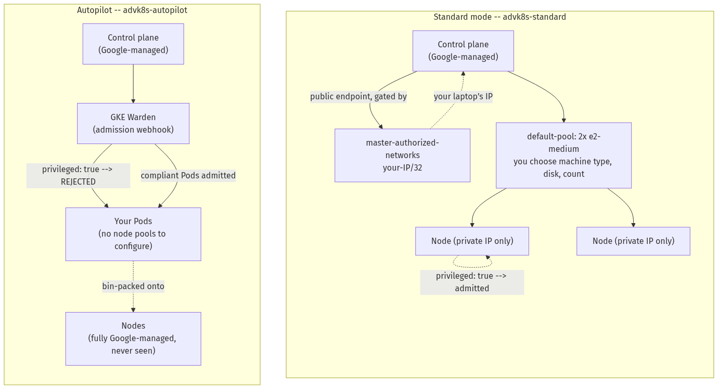

Step 1 — Create a private Standard cluster on a release channel
Goal: stand up a Standard cluster with private nodes, gated to your IP, on the regular release channel.
1. Set your project and find your public IP (use -4 — on a dual-stack network a plain lookup can hand back an IPv6 address, which silently breaks --master-authorized-networks):
export PROJECT_ID=YOUR_GCP_PROJECT_ID
gcloud services enable container.googleapis.com --project=$PROJECT_ID
MY_IP=$(curl -4 -s ifconfig.me)
echo "Your current public IPv4: $MY_IP"
2. Create the cluster:
gcloud container clusters create advk8s-standard \
--project=$PROJECT_ID \
--zone=us-central1-a \
--release-channel=regular \
--enable-private-nodes \
--enable-master-authorized-networks \
--master-authorized-networks="${MY_IP}/32" \
--enable-ip-alias \
--num-nodes=2 \
--machine-type=e2-medium \
--disk-size=30
⚠️ Gotcha — two flags, always together. --master-authorized-networks is rejected outright (Cannot use --master-authorized-networks if --enable-master-authorized-networks is not specified) unless you also pass --enable-master-authorized-networks. Many older docs show only the CIDR flag; both are required, on create and on any later update.
3. Connect and look at the nodes:
gcloud container clusters get-credentials advk8s-standard --zone us-central1-a --project=$PROJECT_ID
kubectl config rename-context gke_${PROJECT_ID}_us-central1-a_advk8s-standard advk8s-standard
kubectl --context advk8s-standard get nodes -o wide
What you should see: two Ready nodes with no EXTERNAL-IP — confirming they're private.
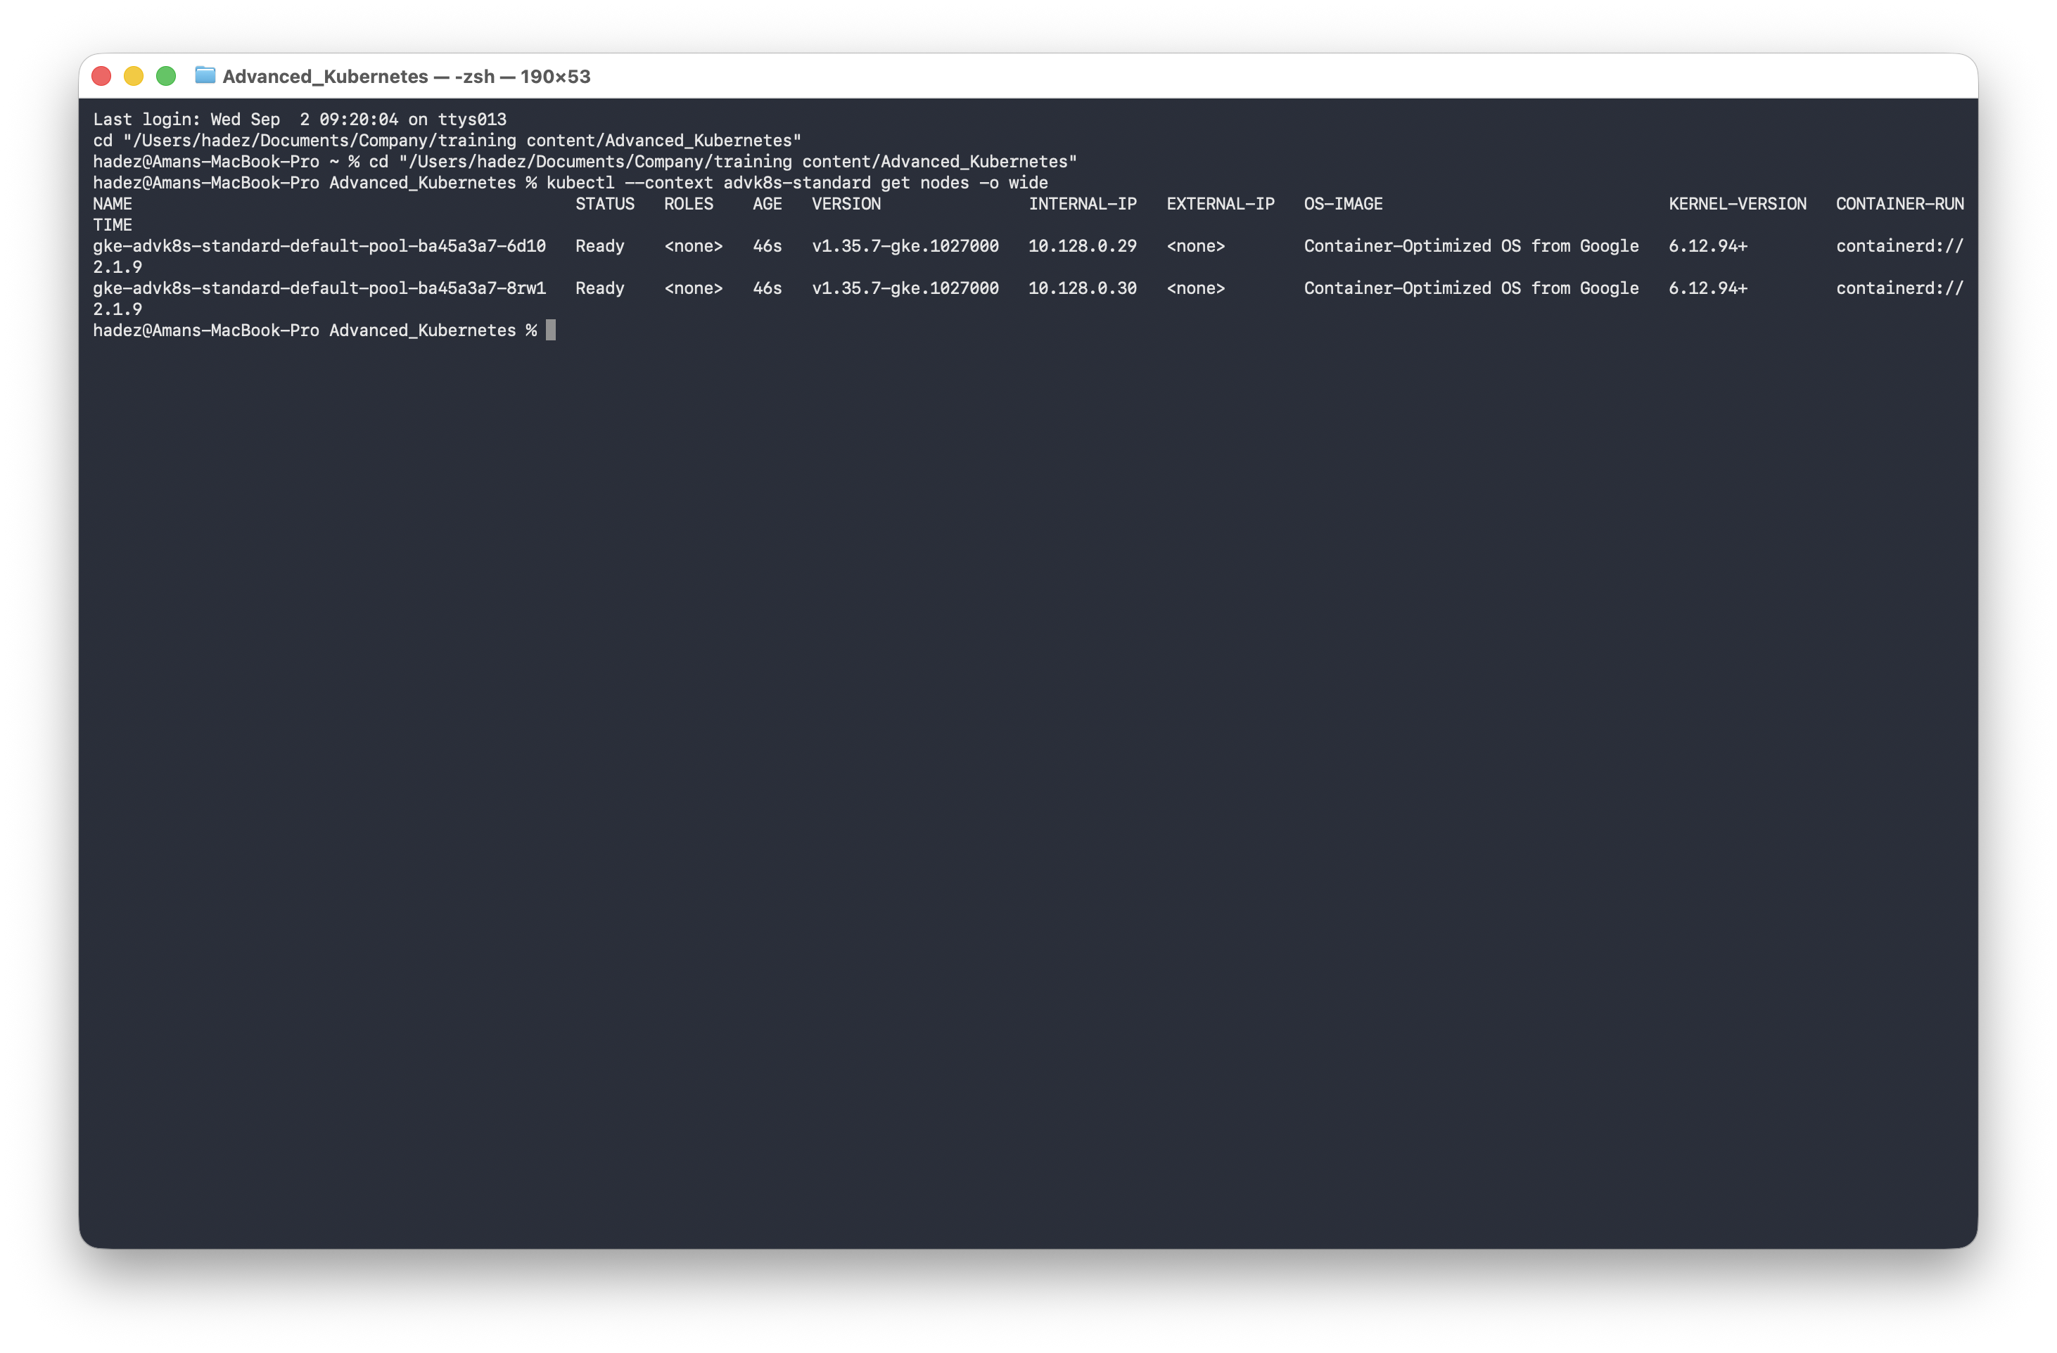
4. Confirm the config — release channel, private nodes, authorized network:
gcloud container clusters describe advk8s-standard --zone us-central1-a --project=$PROJECT_ID \
--format="yaml(releaseChannel, privateClusterConfig, masterAuthorizedNetworksConfig)"
What you should see: releaseChannel: channel: REGULAR, privateClusterConfig: enablePrivateNodes: true, and your IP in masterAuthorizedNetworksConfig.cidrBlocks.
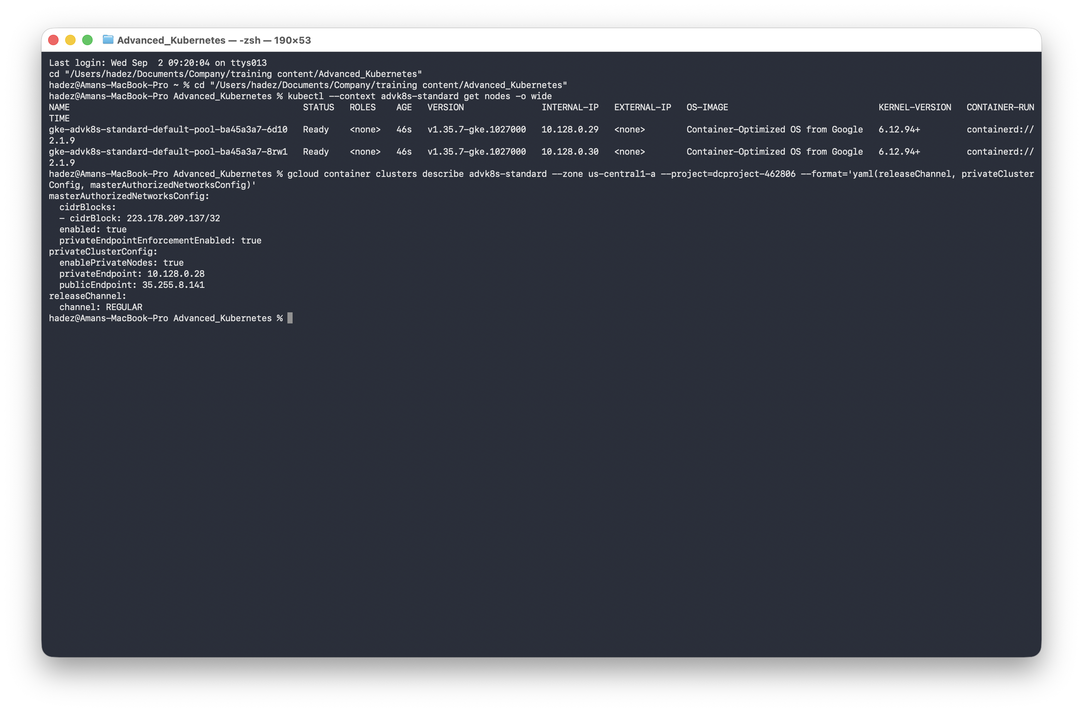
What this means: the nodes have no public IP, the control plane keeps a public endpoint gated to your IP only, and GKE will manage version upgrades on the regular cadence.

Step 2 — Lock yourself out (on purpose) and recover
Goal: reproduce the most common private-cluster mistake — an authorized-networks list that excludes you — so you recognise it instantly.
1. Change the allow-list to a CIDR that is not your IP, then try to use the cluster:
gcloud container clusters update advk8s-standard \
--zone us-central1-a --project=$PROJECT_ID \
--enable-master-authorized-networks \
--master-authorized-networks="203.0.113.0/32"
kubectl --context advk8s-standard --request-timeout=15s get nodes
What you should see: Unable to connect to the server: context deadline exceeded.
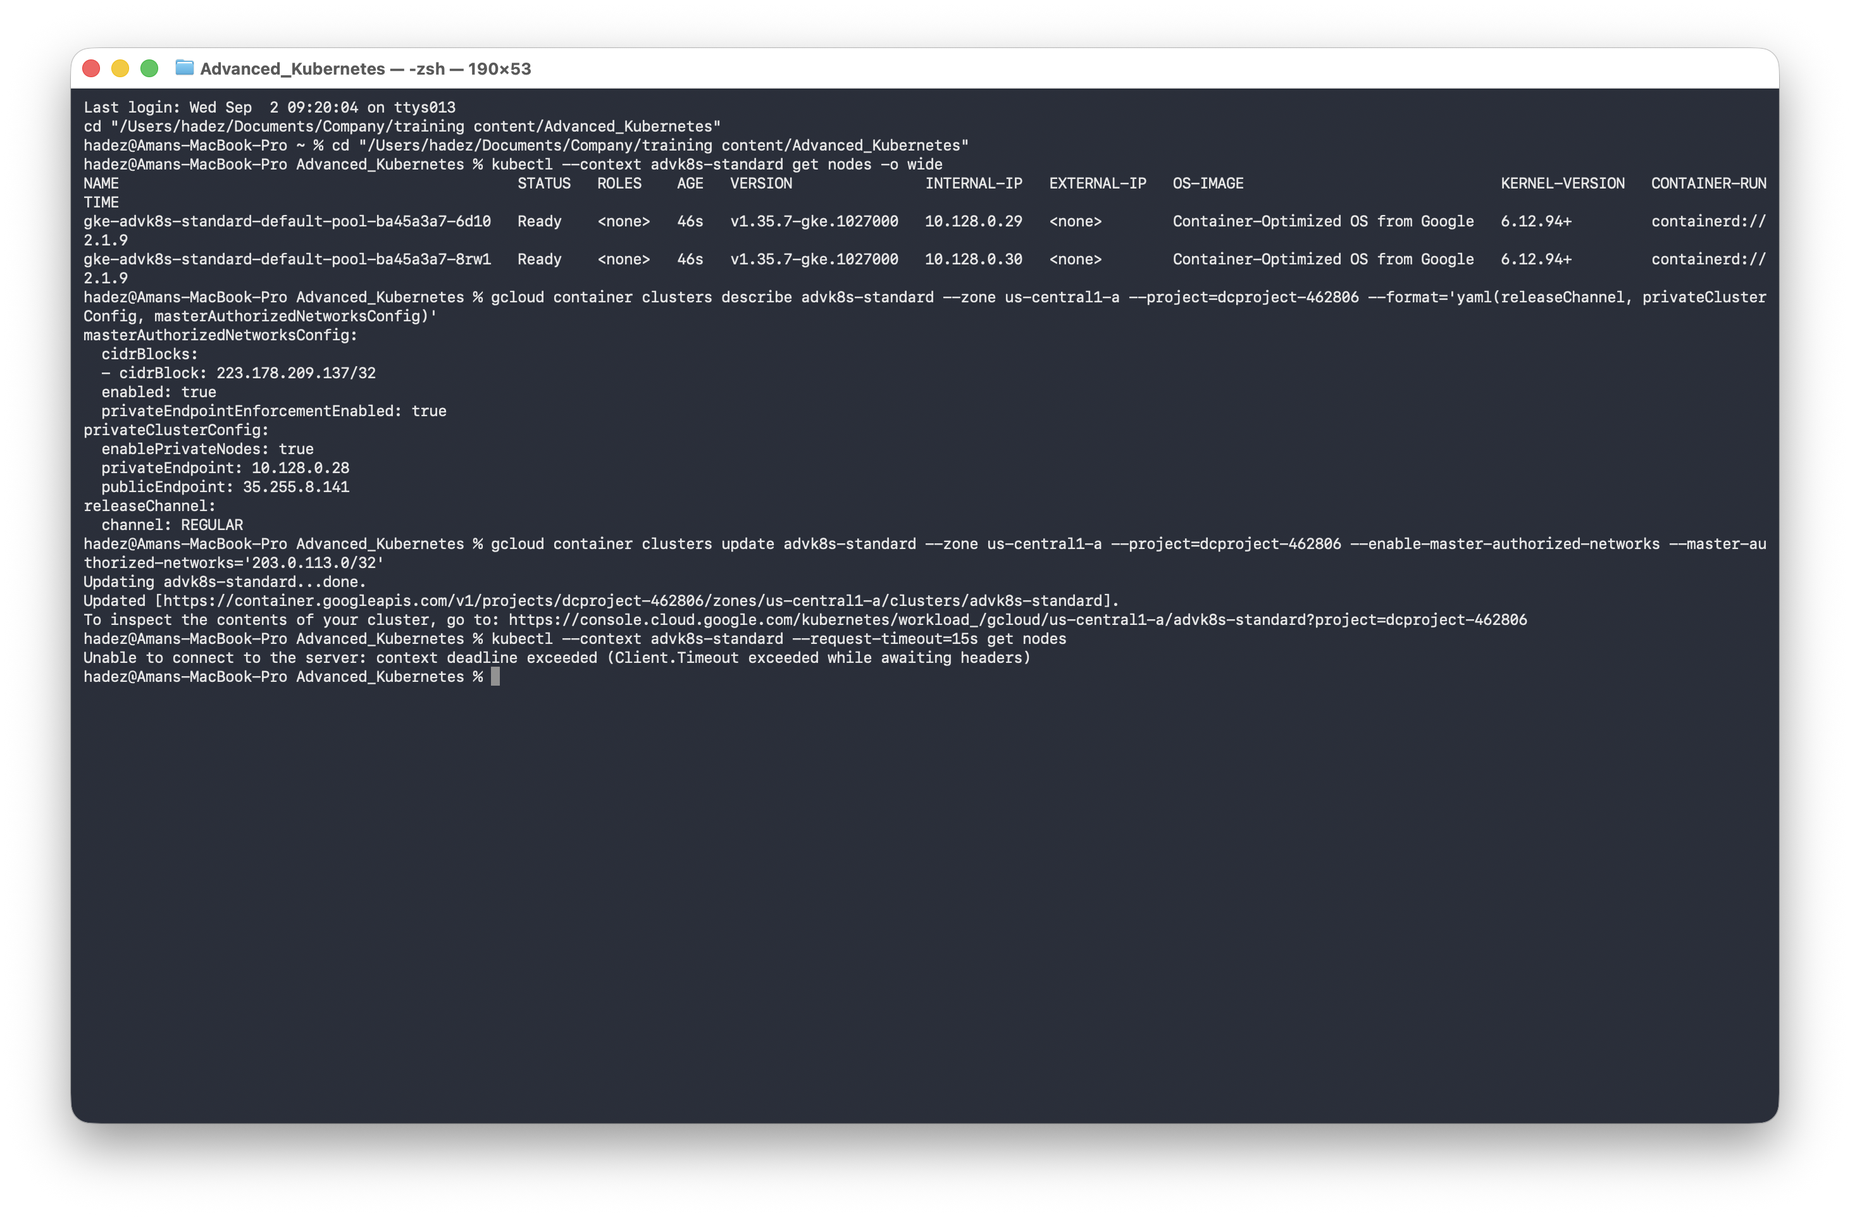
What this means: this is a connection timeout, not an RBAC Forbidden — the control plane's load balancer drops your connection before authentication even happens, because your IP isn't on the list. That's the detail that trips people up: they go looking for an RBAC fix to what is actually a networking block.
2. Put your IP back and confirm recovery:
gcloud container clusters update advk8s-standard \
--zone us-central1-a --project=$PROJECT_ID \
--enable-master-authorized-networks \
--master-authorized-networks="${MY_IP}/32"
kubectl --context advk8s-standard get nodes
What you should see: both nodes Ready again, within about a minute.
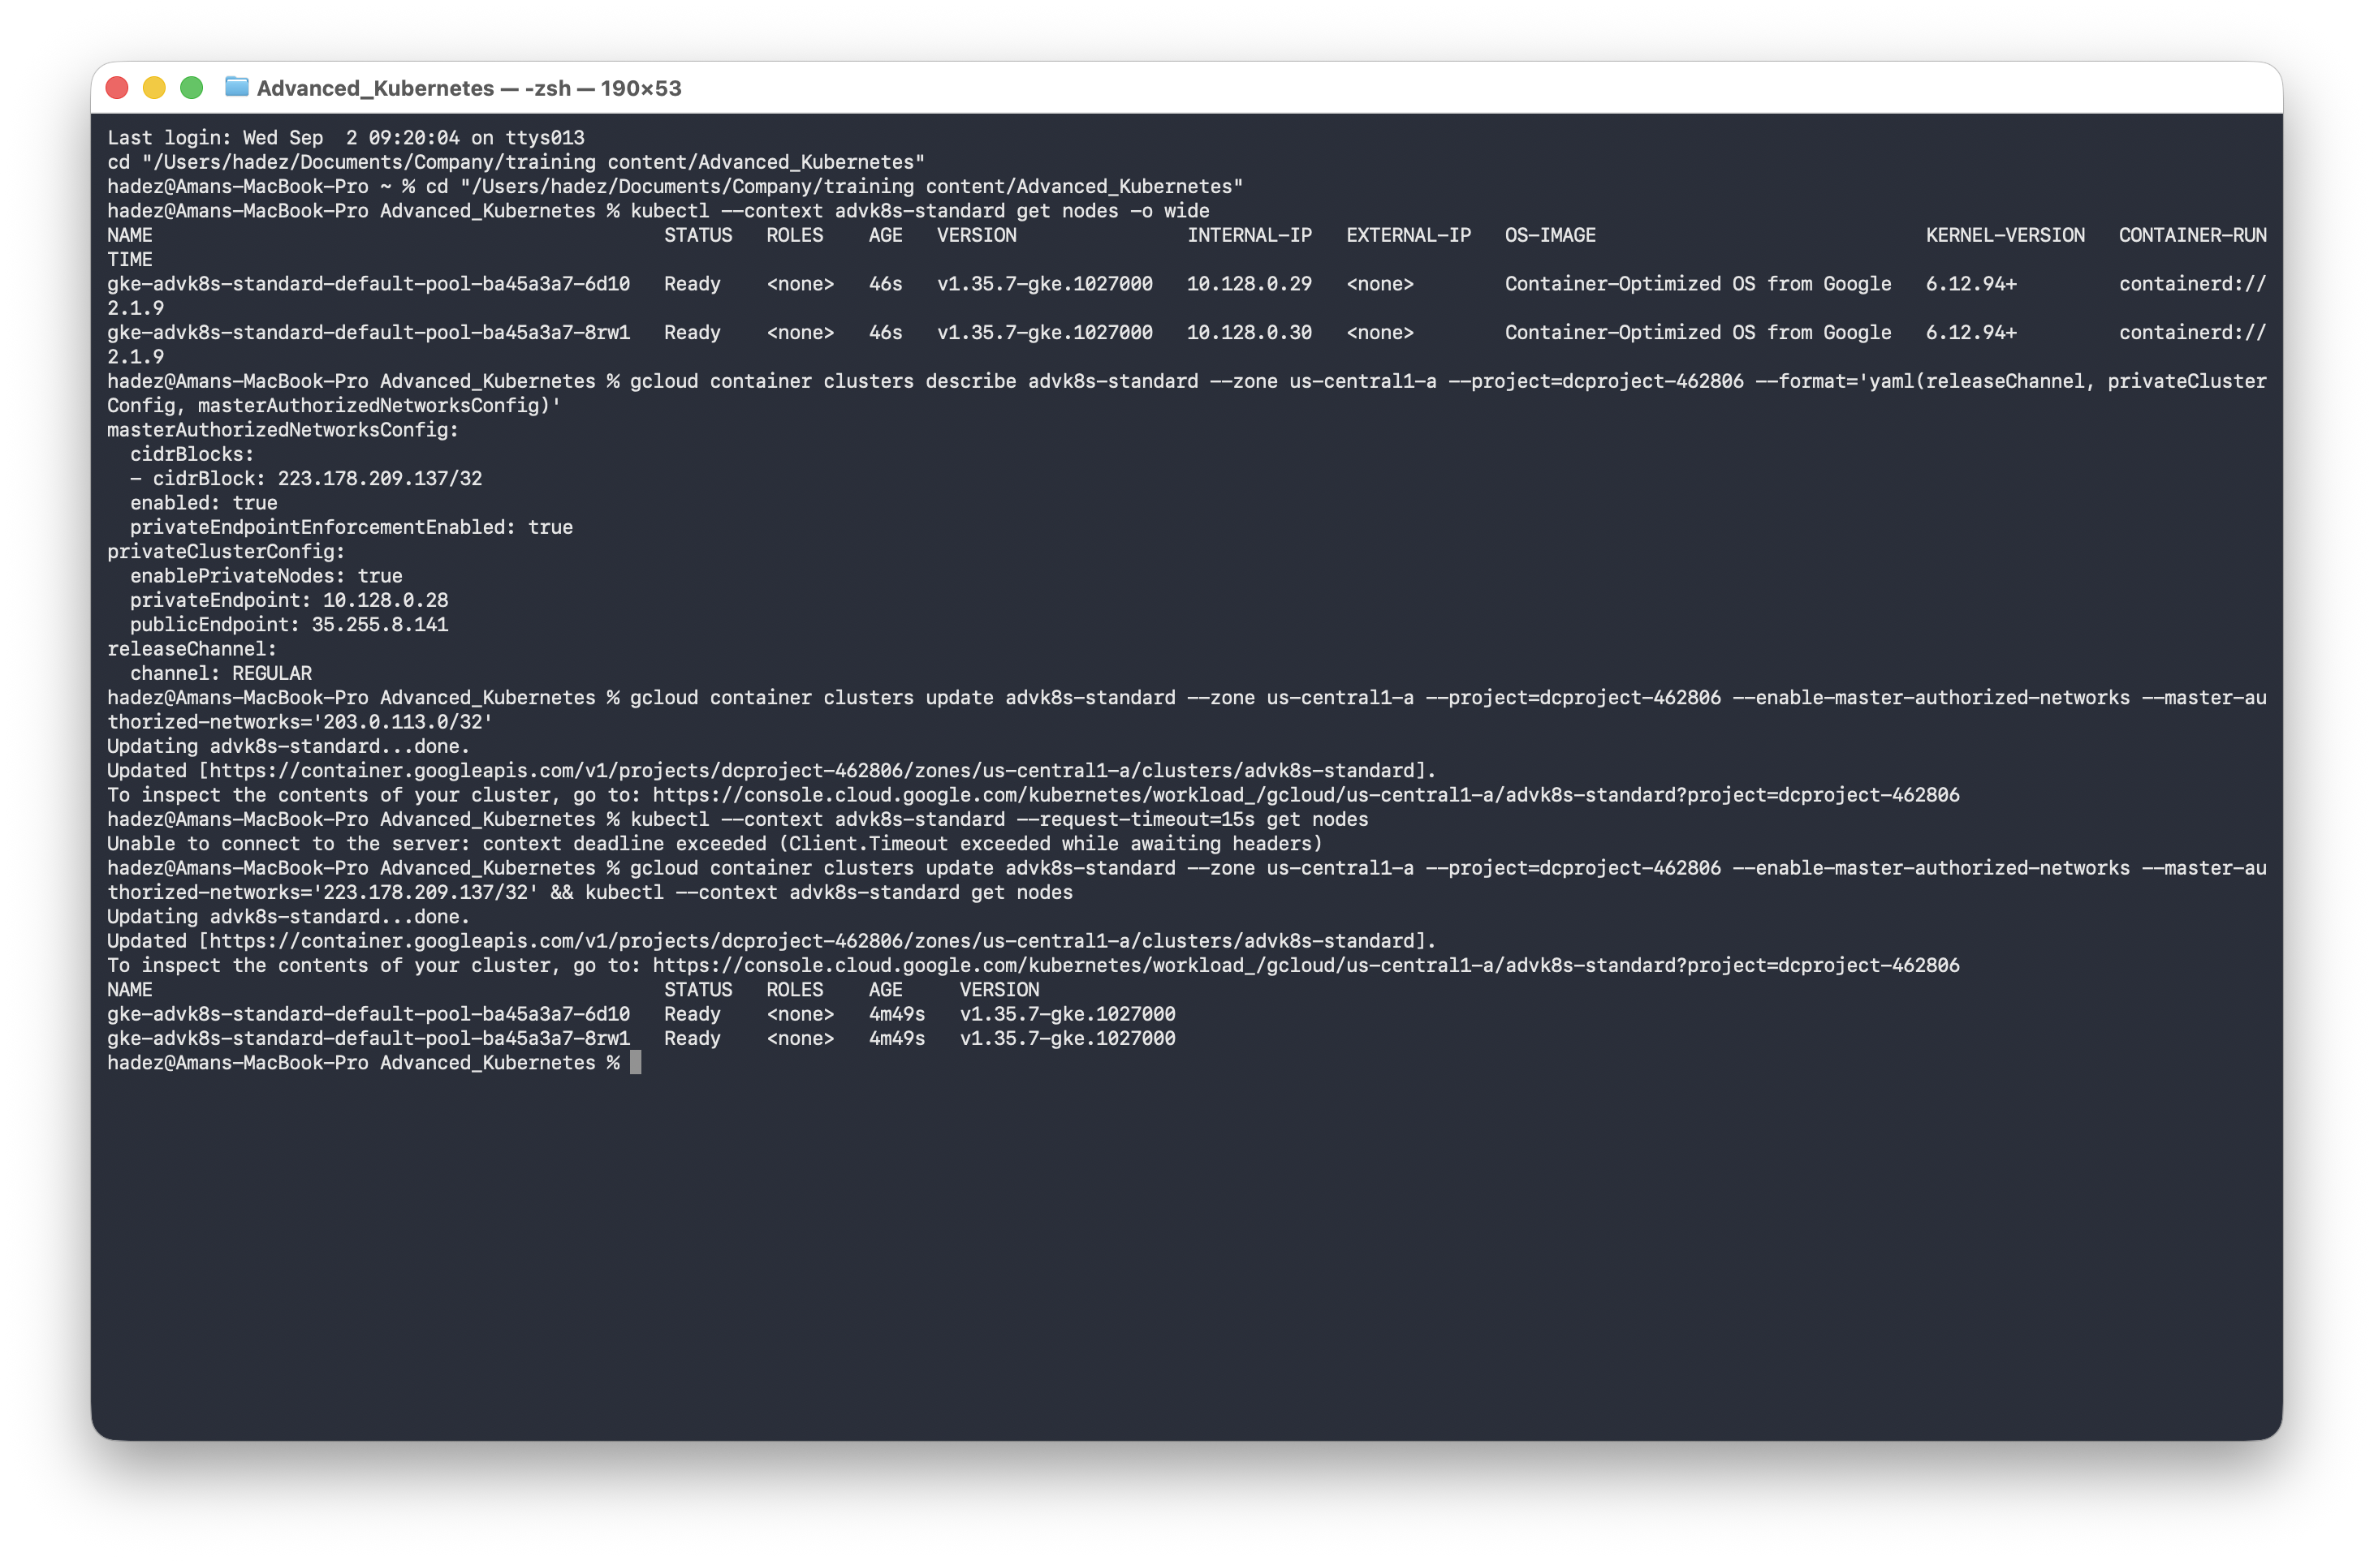

Step 3 — Create an Autopilot cluster
Goal: create an Autopilot cluster and notice how different it is from the moment it exists.
gcloud container clusters create-auto advk8s-autopilot \
--project=$PROJECT_ID \
--region=us-central1 \
--release-channel=regular
gcloud container clusters get-credentials advk8s-autopilot --region us-central1 --project=$PROJECT_ID
kubectl config rename-context gke_${PROJECT_ID}_us-central1_advk8s-autopilot advk8s-autopilot
kubectl --context advk8s-autopilot get nodes
What you should see: at least one node already Ready before you've deployed anything.
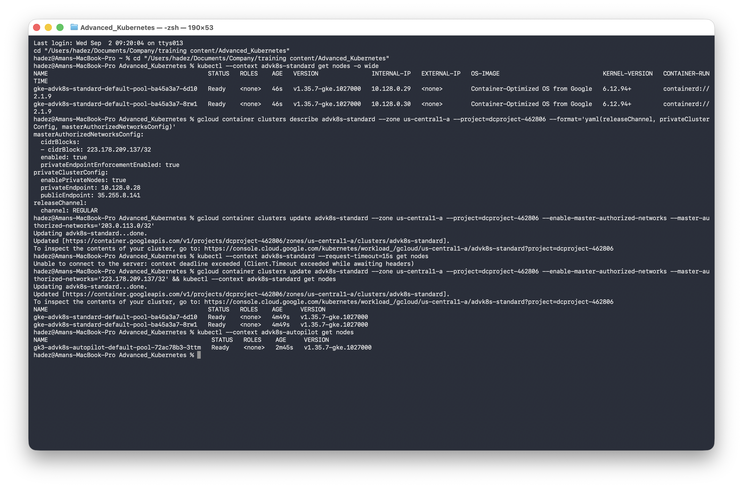
What this means: this is create-auto (Autopilot), which is regional by default (not zonal), and it pre-provisions a little system capacity for its own managed components. You never chose a machine type — that's Autopilot's whole premise.

Step 4 — The real difference: a privileged container
Goal: deploy the identical privileged Pod to both clusters and watch only Autopilot reject it.
1. Write the manifest and apply it to both clusters:
cat > /tmp/privileged-test.yaml <<'EOF'
apiVersion: v1
kind: Pod
metadata:
name: privileged-test
spec:
containers:
- name: test
image: busybox
command: ["sleep", "3600"]
securityContext:
privileged: true
EOF
echo "--- Standard ---"
kubectl --context advk8s-standard apply -f /tmp/privileged-test.yaml
kubectl --context advk8s-standard get pod privileged-test
echo "--- Autopilot ---"
kubectl --context advk8s-autopilot apply -f /tmp/privileged-test.yaml
What you should see: on Standard the Pod is created and reaches Running. On Autopilot the apply is rejected at admission by GKE Warden:
Error from server (GKE Warden constraints violations): ... admission webhook
"warden-validating.common-webhooks.networking.gke.io" denied the request:
Violations details: {"[denied by autogke-disallow-privilege]":["container test is privileged; not allowed in Autopilot"]}
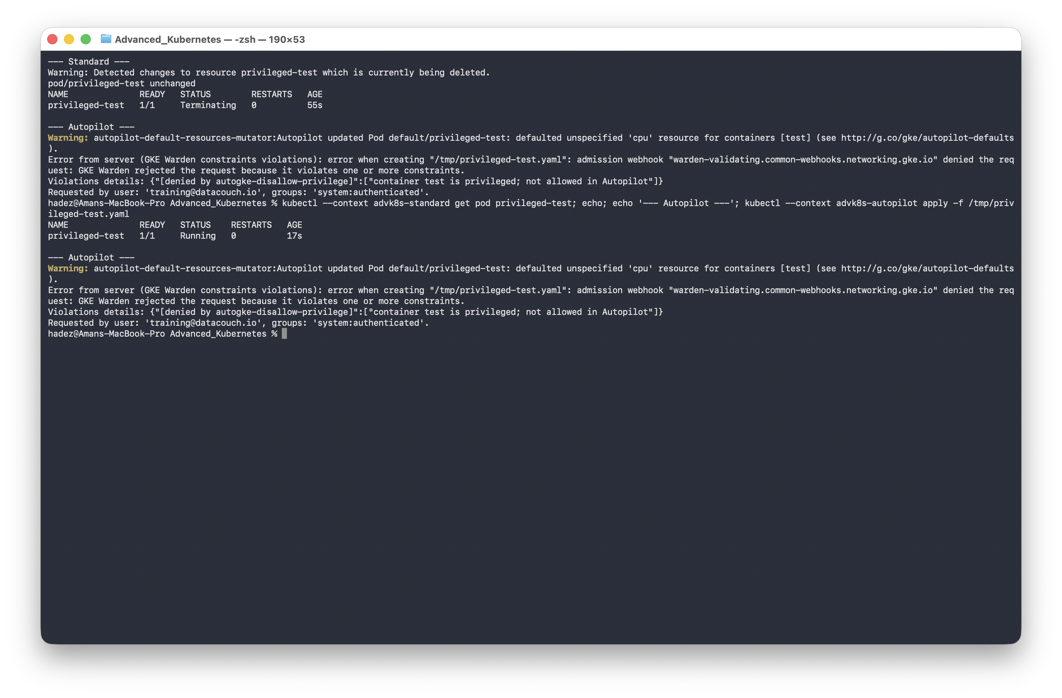
What this means: Standard treats a privileged container as a normal request. Autopilot's built-in admission control rejects it by name (autogke-disallow-privilege) — a hard constraint you didn't opt into. Google can guarantee this precisely because you never had node-level access. Clean up the Standard Pod:
kubectl --context advk8s-standard delete pod privileged-test

Step 5 — Inspect a node pool (Standard only)
Goal: see where machine type, disk, spot pricing, and auto-repair/upgrade live — the decisions Autopilot makes for you.
gcloud container node-pools list --cluster advk8s-standard --zone us-central1-a --project=$PROJECT_ID
gcloud container node-pools describe default-pool --cluster advk8s-standard --zone us-central1-a --project=$PROJECT_ID \
--format="yaml(config.machineType, config.diskSizeGb, config.spot, management)"
What you should see: config.machineType: e2-medium, config.diskSizeGb: 30, and management: autoRepair: true, autoUpgrade: true. (config.spot is simply absent when it's false — normal YAML omission, not a missing field.)
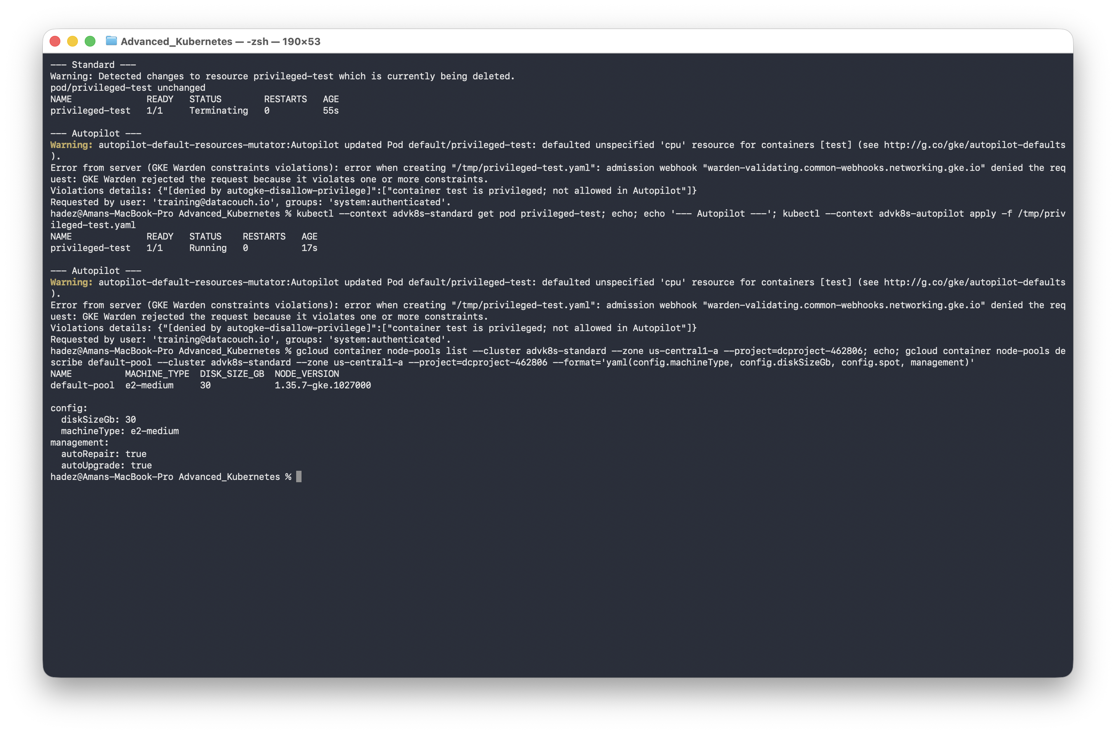
What this means: every one of these is a knob you own in Standard and Autopilot decides for you. This is also the object the later cluster-scaling and autoscaling labs operate on.

Step 6 — Clean up both clusters
Goal: delete both clusters and verify nothing is left billing.
kubectl --context advk8s-standard delete pod privileged-test --ignore-not-found
kubectl --context advk8s-autopilot delete pod privileged-test --ignore-not-found
gcloud container clusters delete advk8s-standard --zone us-central1-a --project=$PROJECT_ID --quiet
gcloud container clusters delete advk8s-autopilot --region us-central1 --project=$PROJECT_ID --quiet
gcloud container clusters list --project=$PROJECT_ID
What you should see: an empty cluster list.
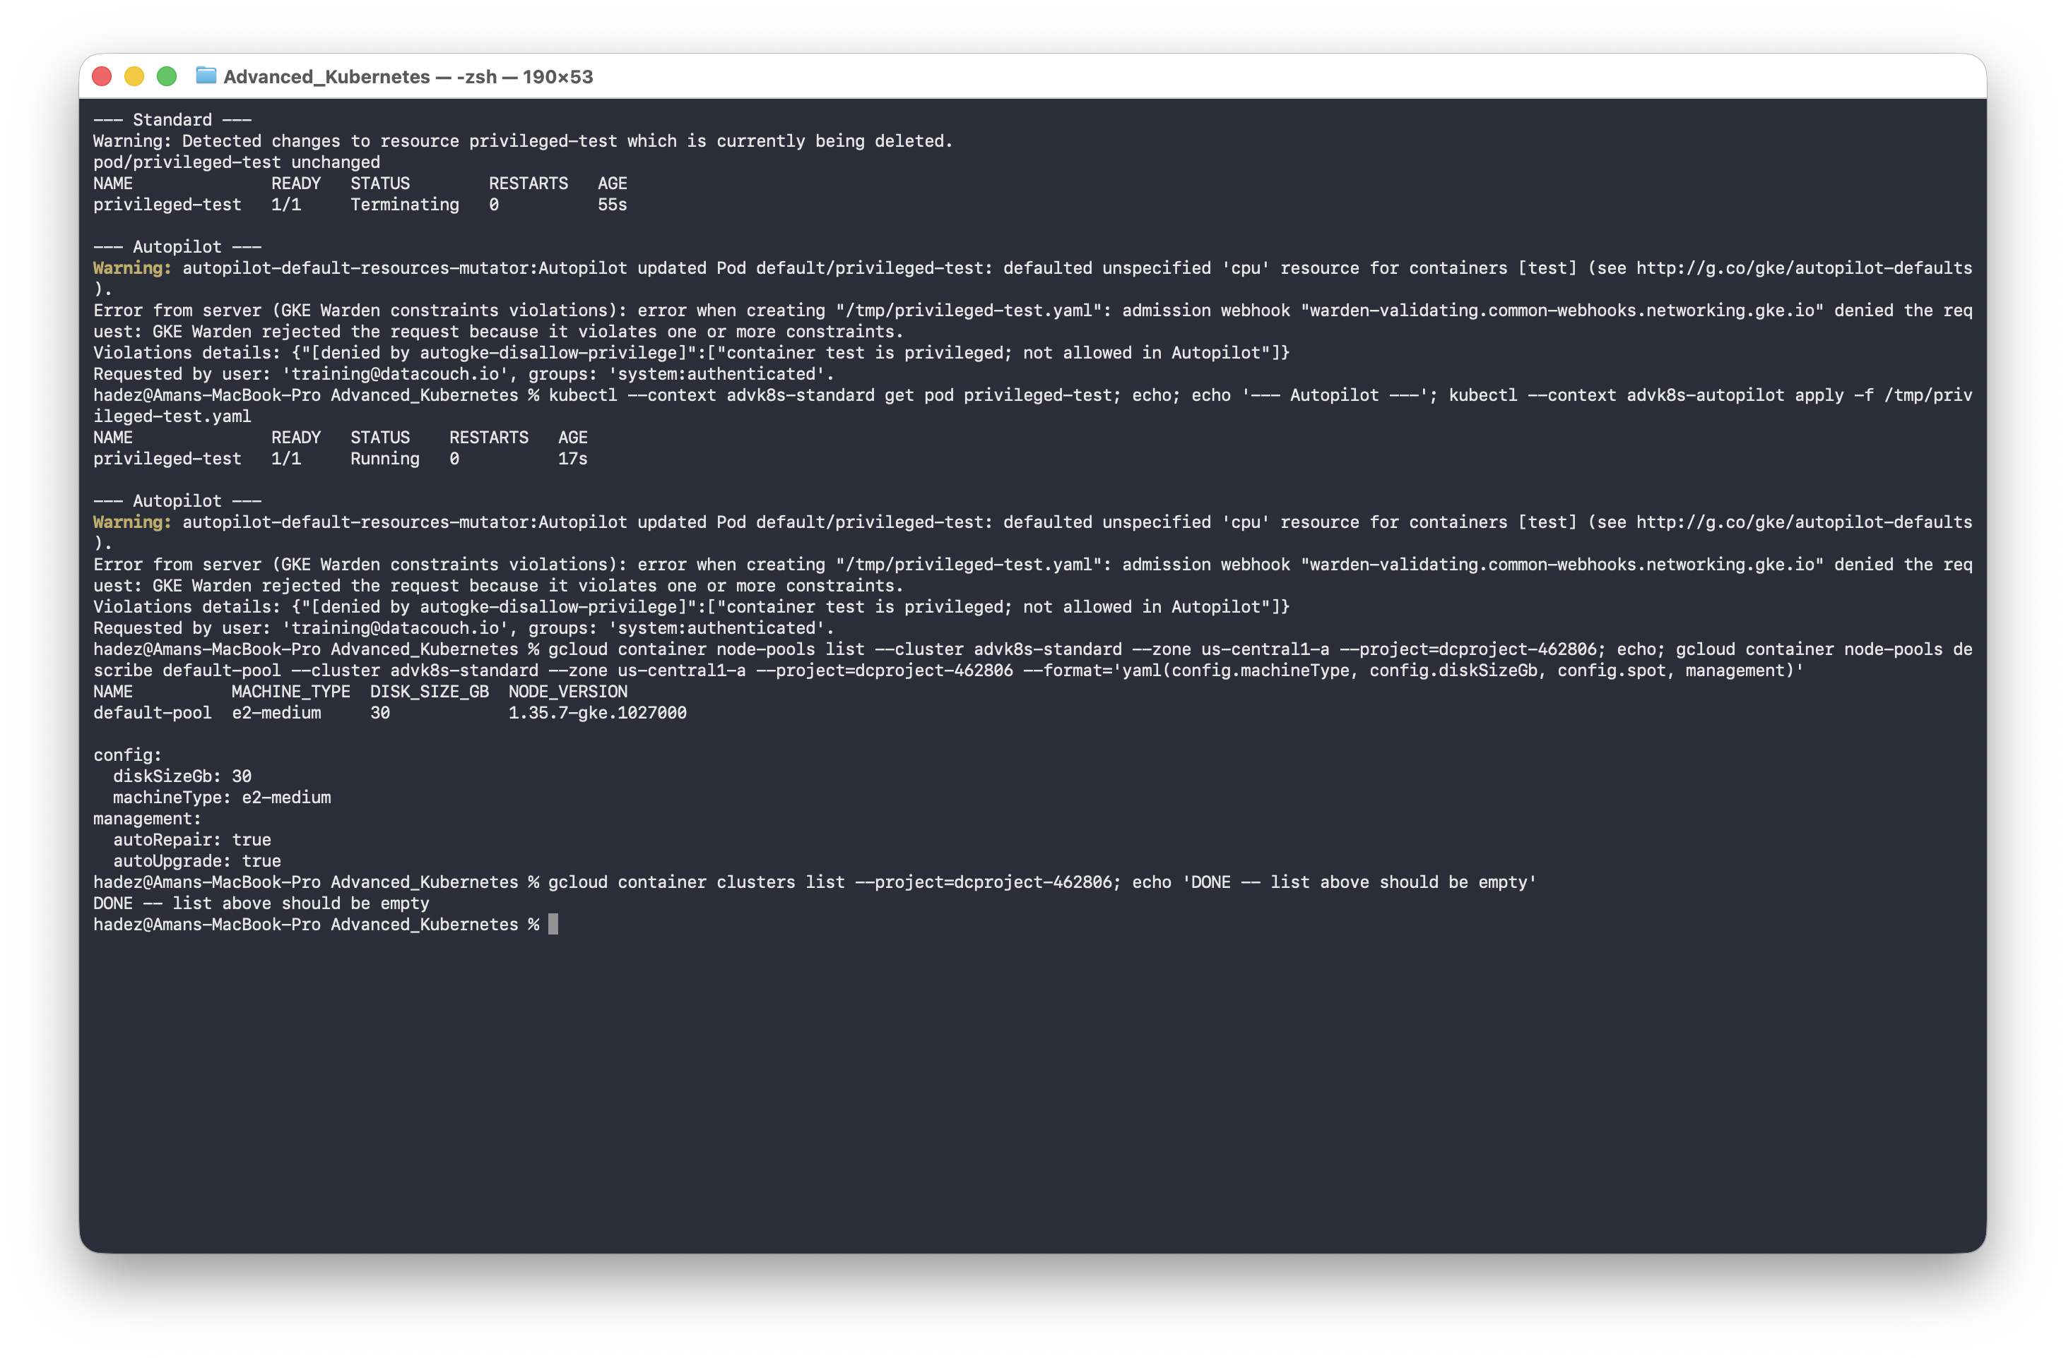
What this means: both clusters are gone. (Notice Autopilot has no separate node pools to clean up first — one delete is the whole teardown, itself a small illustration of the trade-off this lab is about.)

What you learned
 | Standard | Autopilot
Node pools you manage | YES — | None — fully managed
Privileged containers | YES — Allowed | NO — Blocked by GKE Warden (autogke-disallow-privilege)
Billing granularity | Per-node | Per-Pod resource request
Cluster scope | Zonal (as created here) | Regional by default
Private nodes + authorized networks | YES — tested, incl. a real lockout/recovery | Same mechanism, not exercised here
Release channel | YES — regular | YES — regular

Evidence
Real screenshots for this lab are in artifacts/lab-05/screenshots/ (8 images).

Next: Lab 6 — Why Won't This Delete? (Operators, Finalizers & Stuck Deletions)

