Lab 8 — Trace a Blocked Network Flow to the Exact Policy (Cilium & Hubble)
DataCouch — Advanced Kubernetes (Nutanix)
Table of Contents

Day 2 · Extending and Operating the Platform Under Pressure
YES — Tested end-to-end on a real 3-node kind cluster running Cilium 1.20.1 as its CNI (kube-proxy fully replaced) with Hubble enabled. Every screenshot is a real capture. The insight you'll reach: the fix for a blocked flow isn't editing the policy — it's changing the client's labels, which gives it a new Cilium identity (you'll watch it flip from ID:1609 to ID:18439), and the verdict changes the instant that identity propagates.

What you'll learn
- Why Cilium's network policy is identity-based, not IP-based: every Pod gets a numeric security identity from its labels, and policy is evaluated on identities — so rules keep working as Pods churn and IPs change.
- How to install Cilium as the CNI (replacing kube-proxy) and turn on Hubble for flow-level observability.
- How to read a DROPPED flow in Hubble and trace it to the exact verdict (Policy denied).
- The non-obvious fix — change the client's identity (labels) to match the policy — and the propagation delay to expect.

What you'll do
You'll build a Cilium cluster, deploy a client and a backend, and watch normal traffic flow in Hubble. Then you'll apply a policy that blocks the client, trace the drop in Hubble, and fix it by changing the client's identity — watching the verdict flip from DROPPED back to FORWARDED.

Time & cost
- Time: ~50 minutes.
- Cost: $0 — runs on a local kind cluster.

Before you start
- Where you'll work: in a terminal on your own machine. One step needs a second terminal tab (for Hubble's live feed).
- Tools you need: docker, kind, kubectl, the cilium CLI, and the hubble CLI — install the last two with brew install cilium-cli hubble.
- ⚠️ This lab uses its own dedicated kind cluster (Cilium needs to be the CNI), separate from the Day-2 GKE cluster.
Nutanix note — and why this one is kind, not GKE. Installing upstream Cilium and opening Hubble requires control of the cluster's CNI, which managed GKE doesn't give you (its CNI is fixed; GKE Dataplane V2 is Google's own locked-down Cilium with no upstream Hubble CLI/UI). So this lab runs on kind, where you own the datapath. On Nutanix, NKE lets you run Cilium as the CNI (or install it yourself), so everything here — identity-based policy, hubble observe, the drop/forward verdicts — transfers directly to NKE; only the cluster-creation step differs.

The idea in 60 seconds
Cilium is an eBPF-based CNI that programs the Linux datapath directly and can fully replace kube-proxy. Its key idea for this lab is identity: Cilium doesn't write policy in terms of Pod IPs (which are ephemeral) — it gives every Pod a numeric security identity derived from its labels, and evaluates policy identity-to-identity. Change a Pod's labels and it gets a new identity.
Hubble is Cilium's observability layer: because Cilium already sees every packet, Hubble exports a live flow log — source identity, destination identity, port, and the verdict (FORWARDED / DROPPED) with a reason. That's what turns "my connection hangs" into "identity 1609 was denied by policy reaching backend:80."
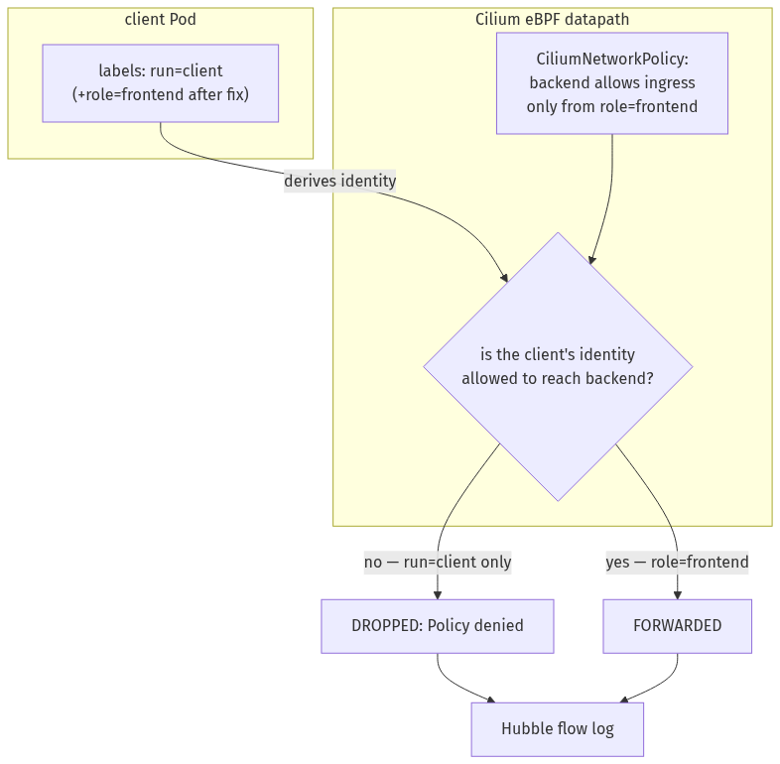

Step 1 — Build a Cilium cluster and enable Hubble
Goal: create a kind cluster with no CNI, install Cilium (which becomes the CNI and replaces kube-proxy), and turn on Hubble.
1. Create a cluster with the default CNI and kube-proxy disabled:
cat > cilium-kind.yaml <<'EOF'
kind: Cluster
apiVersion: kind.x-k8s.io/v1alpha4
name: cilium-lab
networking:
disableDefaultCNI: true
kubeProxyMode: none
nodes:
- role: control-plane
- role: worker
- role: worker
EOF
kind create cluster --config cilium-kind.yaml
# the nodes will be NotReady until a CNI exists — that's expected
2. Install Cilium with Hubble, and wait for it to come up:
cilium install --set hubble.relay.enabled=true
cilium status --wait
What you should see: Cilium's image is large, so its Pods sit in Init for a minute or two while it downloads. Then cilium status reports Cilium: OK, Operator: OK, Hubble Relay: OK, all Pods "managed by Cilium," and the nodes flip from NotReady to Ready.
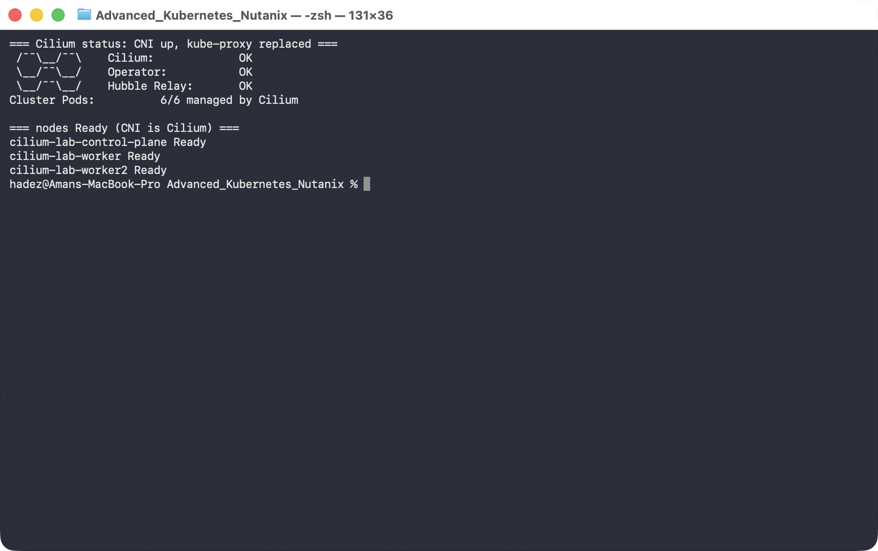
What this means: Cilium is now the cluster's datapath — it provides Pod networking and service routing (it detected kube-proxy was absent and took over). Hubble is ready to show you flows.

Step 2 — See what a healthy request looks like
Goal: before blocking anything, watch normal traffic so you know what "good" looks like in Hubble.
1. Deploy a backend and a client:
kubectl create deployment backend --image=nginx:1.27
kubectl expose deployment backend --port=80
kubectl run client --image=curlimages/curl --restart=Never -- sleep 3600
kubectl wait --for=condition=Ready pod/client --timeout=90s
2. Open Hubble's live flow feed — leave this running in a second terminal tab:
cilium hubble port-forward
3. Back in your first terminal, send one request and look at the flow:
kubectl exec client -- curl -s -o /dev/null -w "HTTP %{http_code}\n" http://backend
hubble observe --pod client --to-label app=backend --last 3
What you should see: curl prints HTTP 200, and Hubble prints three lines ending in FORWARDED, e.g. default/client (ID:1609) -> default/backend:80 (ID:41353).
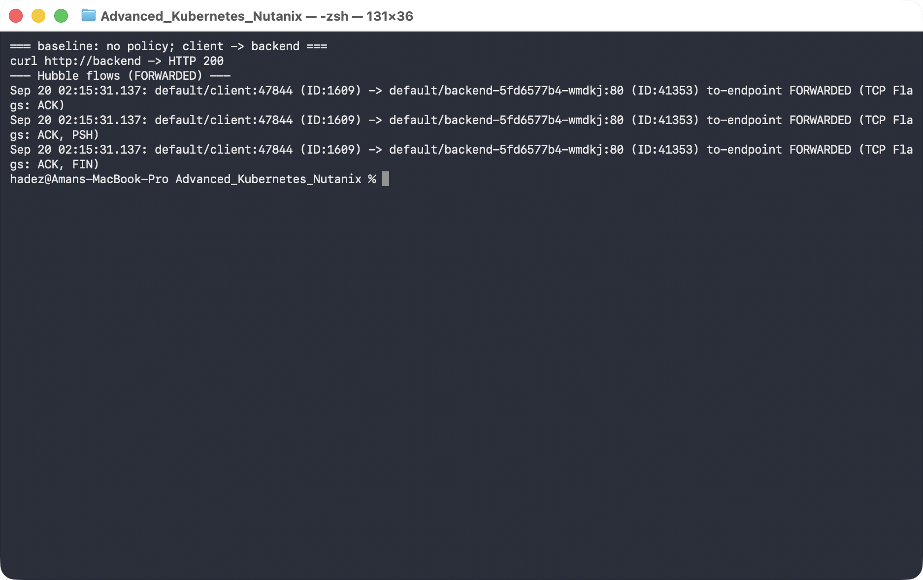
What this means: with no policy in place, Cilium forwards the client's packets. Note the identity numbers — client ID:1609, backend ID:41353. Remember the client's number; it's about to change.

Step 3 — Apply a policy and trace the drop
Goal: apply a policy that only lets role=frontend reach the backend, and watch Hubble name the drop.
1. Apply the policy, then try the request again:
kubectl apply -f - <<'EOF'
apiVersion: cilium.io/v2
kind: CiliumNetworkPolicy
metadata:
name: backend-allow-frontend
spec:
endpointSelector:
matchLabels: {app: backend}
ingress:
- fromEndpoints:
- matchLabels: {role: frontend}
EOF
kubectl exec client -- curl -s -o /dev/null -w "HTTP %{http_code}\n" --max-time 5 http://backend
hubble observe --pod client --verdict DROPPED --last 4
What you should see: curl now times out (exit 28) — the connection never establishes — and Hubble shows exactly why: default/client (ID:1609) <> default/backend:80 (ID:41353) Policy denied DROPPED (TCP Flags: SYN).
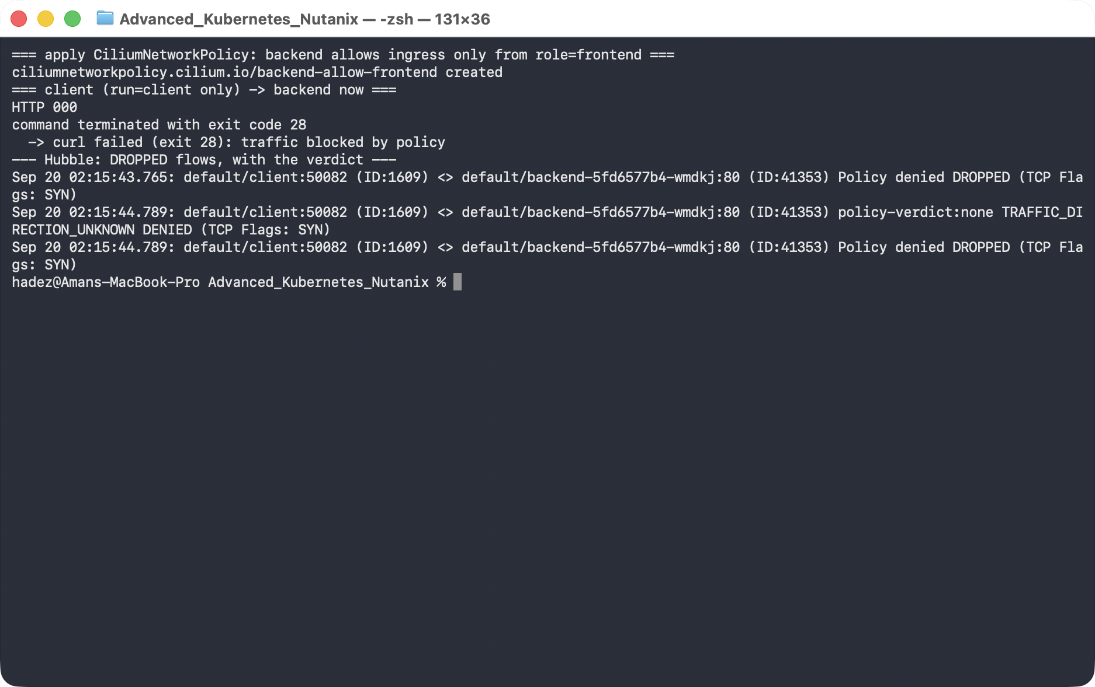
What this means: the client's SYN packets are dropped by the datapath before they reach the backend. This is the diagnosis Hubble gives you that plain kubectl never will — not "it's slow," but "identity 1609 is denied by policy."
The key mental model: once any CiliumNetworkPolicy selects an endpoint (here backend), that endpoint switches to default-deny for the direction the policy covers. So this one rule didn't just "allow frontend" — it simultaneously denied everything else, which is why the previously-working client is now dropped.

Step 4 — Fix it by changing the client's identity
Goal: give the client the identity the policy already trusts (role=frontend), and watch the verdict flip.
1. Label the client, wait for the new identity to propagate, then retry:
kubectl label pod client role=frontend --overwrite
sleep 12 # let the new identity propagate
kubectl exec client -- curl -s -o /dev/null -w "HTTP %{http_code}\n" --max-time 5 http://backend
hubble observe --pod client --to-label app=backend --last 3
What you should see: curl returns HTTP 200 again, Hubble shows FORWARDED — and the client's identity has changed from ID:1609 to ID:18439.
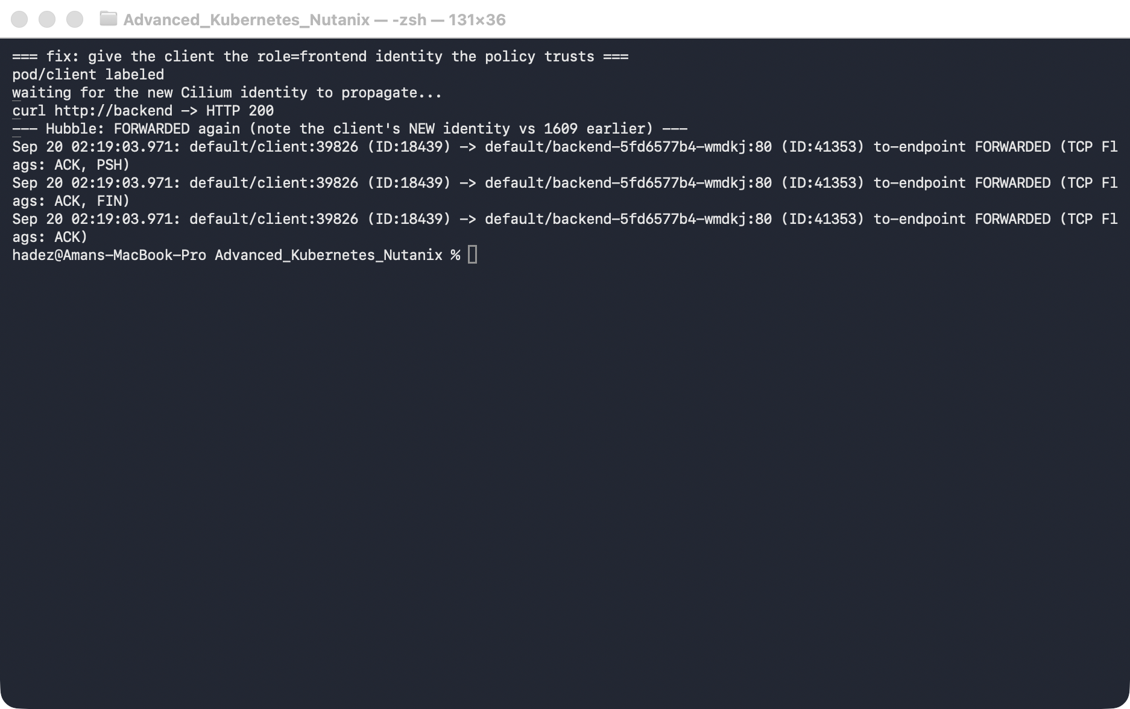
What this means: adding the role=frontend label gave the client a new Cilium identity, and that new identity matches the policy's fromEndpoints. The verdict flipped because the identity changed, not because the policy did. That's identity-based networking in one screenshot.
⚠️ Gotcha — identity propagation isn't instant. Immediately after kubectl label, the very next curl can still be DROPPED for a few seconds: the Pod's new identity has to be computed and pushed to every node's datapath. In our run it took ~10 seconds. If you test too quickly you'll wrongly conclude the fix failed — wait a moment, or watch hubble observe until you see the identity number change.

Step 5 — Clean up
kind delete cluster --name cilium-lab

What you learned
You saw… | in Step | proof
Cilium can be the CNI and replace kube-proxy | 1 | cilium status: OK, nodes Ready, kube-proxy absent
Hubble shows per-flow verdicts with identities | 2 | FORWARDED flows, client ID:1609
One policy flips the selected endpoint to default-deny | 3 | previously-working client now DROPPED
A drop is traceable to Policy denied in Hubble | 3 | Policy denied DROPPED (TCP Flags: SYN)
Policy is identity-based; labels drive identity | 4 | client ID:1609 → ID:18439 on relabel, verdict flips
Identity propagation has a short delay | 4 gotcha

Evidence
Real screenshots for this lab are in artifacts/lab-08/screenshots/ (4 images), and a full command transcript is in artifacts/lab-08/evidence/lab-07-cilium-hubble.txt.

Next: Lab 9 — Make Two Clusters Behave Like One (Multi-Cluster Service Mesh with Istio)

