Lab 12 — Bring a Deleted Namespace Back from Backup (Velero)
DataCouch — Advanced Kubernetes (Nutanix)
Table of Contents

Day 3 · Stateful Workloads, Persistent Storage & Service Exposure
YES — Tested end-to-end on a real GKE cluster (advk8s-lab, dcproject-462806) with Velero backing up to an in-cluster MinIO (S3-compatible) bucket. Every screenshot is a real capture. The payoff: you kubectl delete namespace an entire application, then bring it all back — Deployment, Service, and its data — from a backup, with catalog: widget-9000=42.00 intact.

What you'll learn
- The difference between a volume snapshot (Lab 11 — one disk, same storage system) and a backup (this lab — whole namespaces of objects and data, in external object storage you can restore anywhere).
- How to run Velero against S3-compatible object storage — here in-cluster MinIO, exactly the pattern you'd use with Nutanix Objects.
- How to back up a namespace, prove it's stored, delete the namespace completely, and restore it.

What you'll do
You'll stand up MinIO as an S3 target and install Velero pointing at it. Then you'll create an app with data, back up its namespace, delete the whole namespace, and restore it from the backup — verifying every object and its data returns.

Time & cost
- Time: ~45 minutes.
- Cost: negligible — MinIO and Velero run as small Pods on the shared GKE cluster; no cloud object storage needed.

Before you start
- Where you'll work: in a terminal on your own machine.
- Tools you need: gcloud, kubectl, and the velero CLI (brew install velero).
- Cluster: a GKE cluster (this course's shared advk8s-lab).
Nutanix note. Velero is the standard Kubernetes backup tool and is platform-agnostic. We back up to in-cluster MinIO here so the lab is self-contained and needs no cloud credentials — but the object-store config is identical for Nutanix Objects (also S3-compatible): you'd just point s3Url at your Nutanix Objects endpoint and use its access keys. Everything else in this lab is unchanged on NKE.

The idea in 60 seconds
A snapshot (Lab 11) copies one volume within the same storage system — great for fast single-disk recovery, useless if the whole cluster or namespace is gone. A backup captures your Kubernetes objects (Deployments, Services, ConfigMaps, …) and volume data, and writes them to external object storage. Because the backup lives outside the cluster, you can restore a deleted namespace — or rebuild onto a brand-new cluster entirely.
Velero is the tool: it watches for Backup/Restore custom resources, serialises the selected objects, and stores them in an S3 bucket. Here that bucket is MinIO running in the cluster.
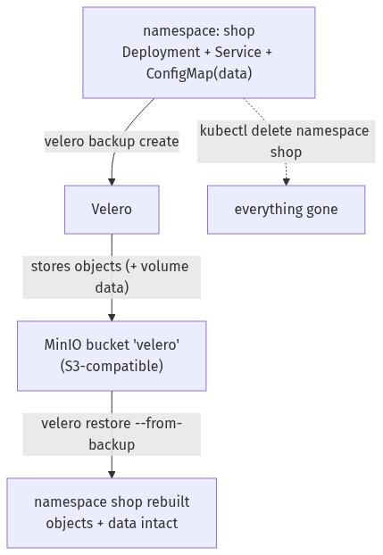

Step 1 — Stand up the backup target (MinIO) and install Velero
Goal: deploy MinIO as an S3 target, create a bucket, and install Velero pointing at it.
1. Deploy MinIO and a Service (MinIO dropped its latest tag, so use a current RELEASE.* image — the quay.io mirror is reliable):
kubectl create namespace velero
kubectl apply -n velero -f - <<'EOF'
apiVersion: apps/v1
kind: Deployment
metadata: {name: minio, labels: {app: minio}}
spec:
replicas: 1
selector: {matchLabels: {app: minio}}
template:
metadata: {labels: {app: minio}}
spec:
containers:
- name: minio
image: quay.io/minio/minio:RELEASE.2025-09-07T16-13-09Z-cpuv1
args: ["server", "/data", "--console-address", ":9001"]
env:
- {name: MINIO_ROOT_USER, value: minioadmin}
- {name: MINIO_ROOT_PASSWORD, value: minioadmin}
ports: [{containerPort: 9000}]
---
apiVersion: v1
kind: Service
metadata: {name: minio}
spec:
selector: {app: minio}
ports: [{port: 9000, targetPort: 9000}]
EOF
kubectl -n velero rollout status deployment/minio --timeout=150s
2. Create the velero bucket with a one-shot mc (MinIO client) Job:
kubectl -n velero apply -f - <<'EOF'
apiVersion: batch/v1
kind: Job
metadata: {name: mc-mkbucket}
spec:
backoffLimit: 3
template:
spec:
restartPolicy: OnFailure
containers:
- name: mc
image: quay.io/minio/mc:RELEASE.2025-08-13T08-35-41Z-cpuv1
command: ["sh","-c","until mc alias set local http://minio:9000 minioadmin minioadmin; do sleep 2; done; mc mb -p local/velero; mc ls local"]
EOF
kubectl -n velero wait --for=condition=complete job/mc-mkbucket --timeout=120s
3. Install Velero pointing at MinIO (these are throwaway MinIO creds, not cloud credentials):
cat > /tmp/velero-creds <<'EOF'
[default]
aws_access_key_id=minioadmin
aws_secret_access_key=minioadmin
EOF
velero install \
--provider aws \
--plugins velero/velero-plugin-for-aws:v1.11.1 \
--bucket velero \
--secret-file /tmp/velero-creds \
--use-volume-snapshots=false \
--use-node-agent \
--backup-location-config region=minio,s3ForcePathStyle=true,s3Url=http://minio.velero.svc:9000 \
--namespace velero
kubectl -n velero rollout status deployment/velero --timeout=150s
velero backup-location get
What you should see: the backup location default reports PHASE: Available — Velero can reach the MinIO bucket.
What this means: Velero is installed and its S3 target is validated. On NKE you'd point s3Url at Nutanix Objects instead; nothing else changes.

Step 2 — Create an app with data, and back it up
Goal: back up a whole namespace to MinIO.
kubectl create namespace shop
kubectl -n shop create deployment web --image=nginx:1.27-alpine
kubectl -n shop create configmap catalog --from-literal=featured="widget-9000" --from-literal=price="42.00"
kubectl -n shop expose deployment web --port=80
velero backup create shop-backup --include-namespaces shop --wait
velero backup describe shop-backup
What you should see: the backup reaches Phase: Completed, with something like 16 items backed up (the namespace and everything in it), and the catalog data is widget-9000=42.00.
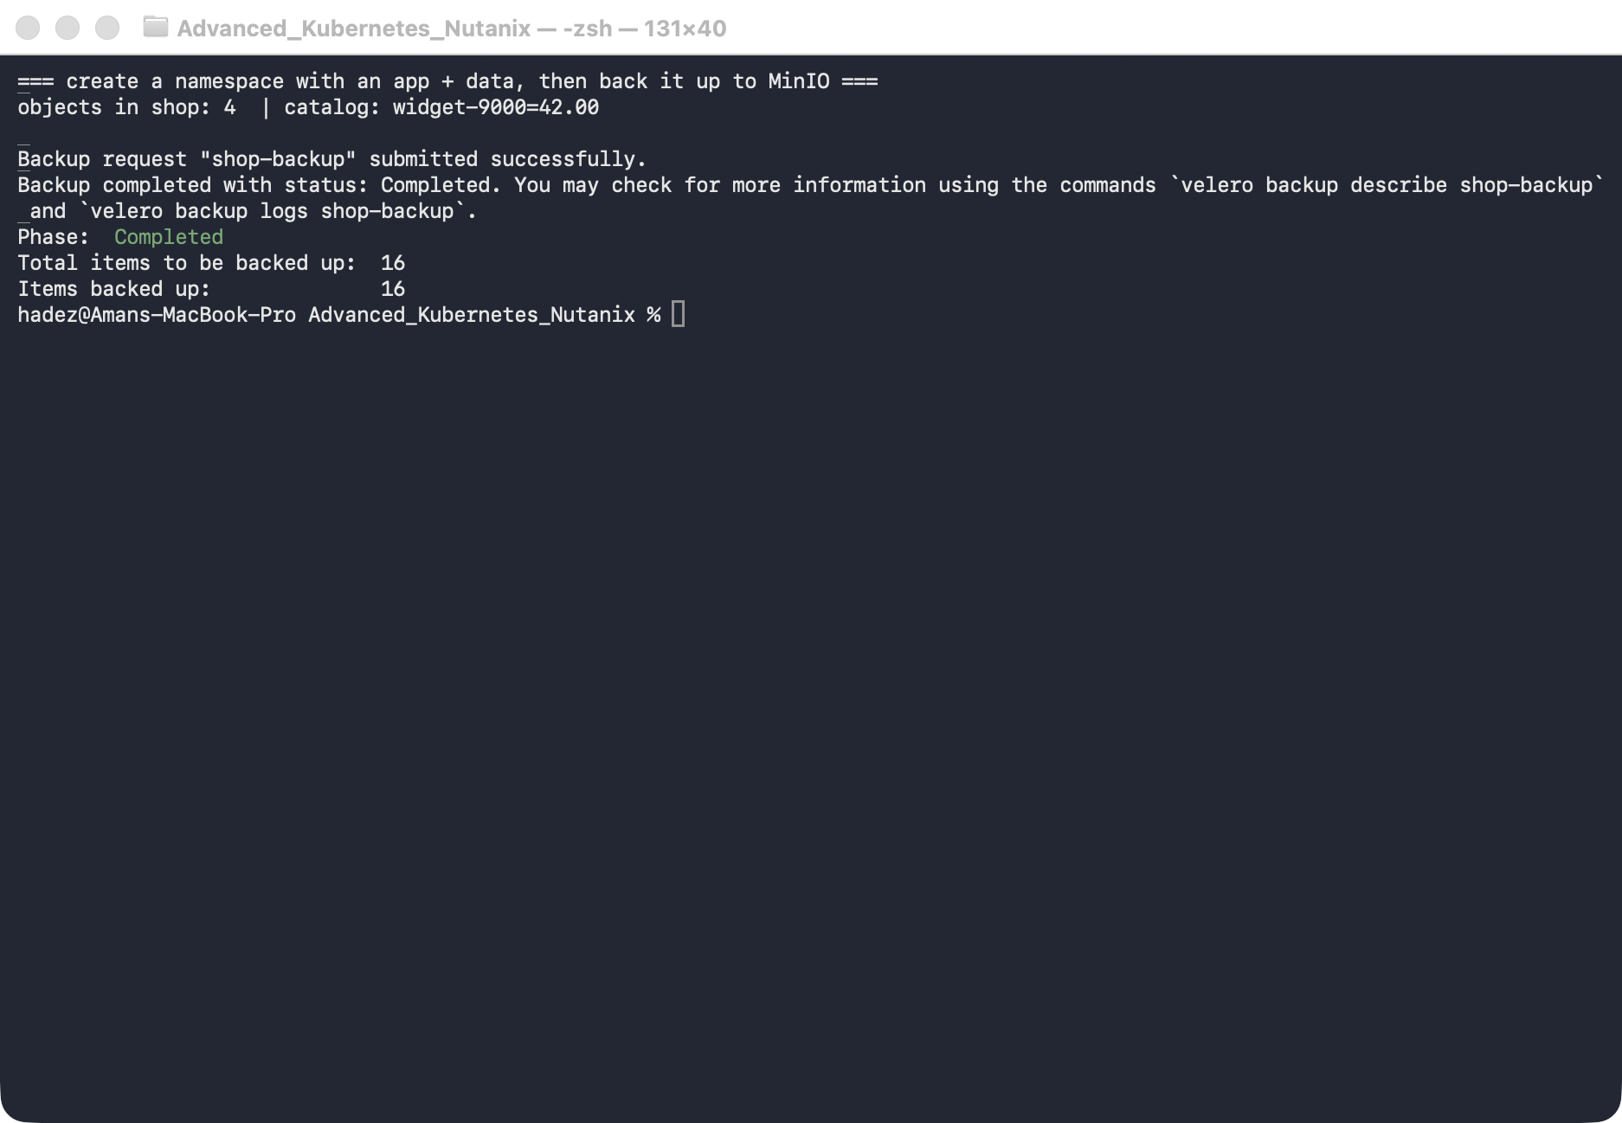
What this means: Velero serialised every object in shop and wrote them to the MinIO bucket. That backup now exists independently of the cluster.

Step 3 — Delete the entire namespace
Goal: simulate a real disaster — the whole namespace is gone.
kubectl delete namespace shop
kubectl get ns shop --ignore-not-found
velero backup get
What you should see: shop is gone (no output), but shop-backup is still listed as Completed.
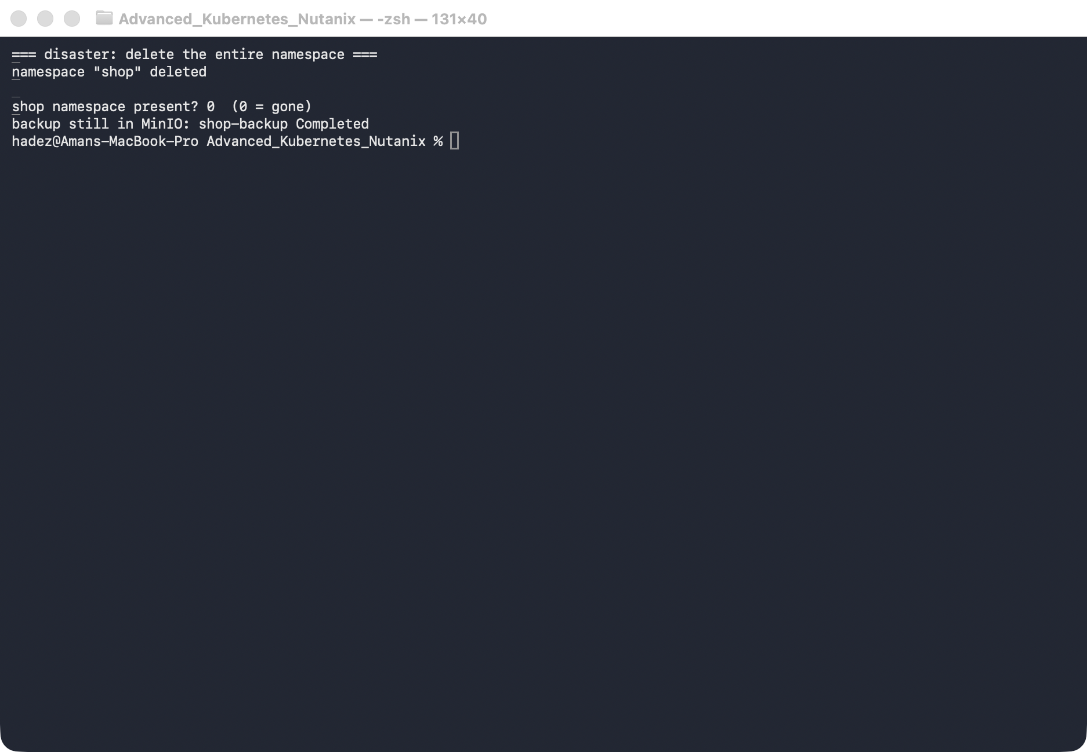
What this means: the live application is completely gone — Deployment, Service, ConfigMap, all of it. The only copy is the backup in MinIO.

Step 4 — Restore, and verify the data came back
Goal: restore the namespace from the backup and prove everything returned.
velero restore create shop-restore --from-backup shop-backup --wait
kubectl get ns shop
kubectl -n shop get deploy,svc,cm
kubectl -n shop get cm catalog -o jsonpath='{.data.featured}={.data.price}{"\n"}'
What you should see: the restore completes, shop is Active again, web (Deployment + Service) and catalog are back, and the ConfigMap data reads widget-9000=42.00 — exactly as before.
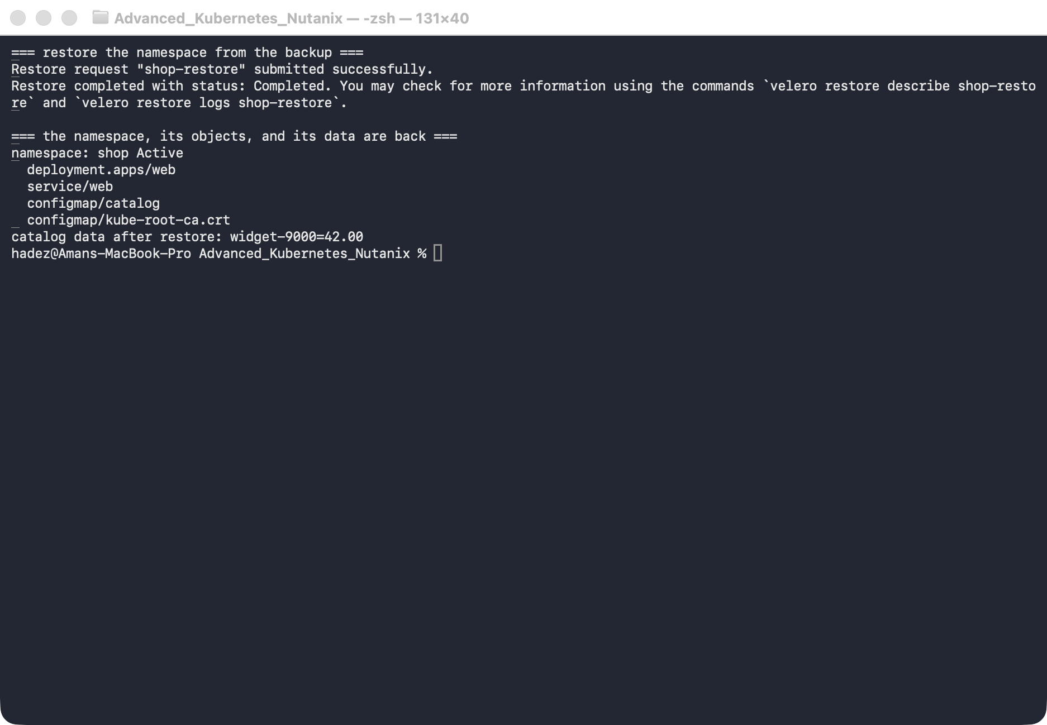
What this means: a fully deleted namespace came back, objects and data intact, from external storage. Because the backup lives in object storage, the very same command could restore this app onto a different cluster — which is the real power of a backup over a snapshot.

Step 5 — Clean up
kubectl delete namespace shop --ignore-not-found
velero backup delete shop-backup --confirm
# to remove Velero + MinIO entirely:
# kubectl delete namespace velero

What you learned
You saw… | in Step | proof
Velero backs up to S3-compatible storage (MinIO / Nutanix Objects) | 1 | backup location Available
A namespace backup captures all its objects | 2 | Completed, 16 items
The backup survives the cluster's objects | 3 | namespace deleted, backup remains
A deleted namespace restores with data intact | 4 | shop Active, catalog=widget-9000=42.00
Backups (unlike snapshots) can restore to another cluster | 4

Evidence
Real screenshots for this lab are in artifacts/lab-12/screenshots/ (3 images), and a command transcript is in artifacts/lab-12/evidence/lab-09-velero-backup-restore.txt.

Next: Lab 13 — Give On-Prem Services a Real IP (Bare-Metal LoadBalancer with MetalLB)

