Lab 18 — Ask for a Device by Its Properties (Dynamic Resource Allocation for Accelerators)
DataCouch — Advanced Kubernetes (Nutanix)
Table of Contents

Day 5 · Kubernetes as the AI-Native Platform
YES — Tested end-to-end on a real Kubernetes 1.34 kind cluster with the upstream DRA example driver publishing simulated GPUs. Every screenshot is a real capture. The payoff: instead of asking for "1 GPU" and hoping, a Pod asks for a device that matches a CEL expression on the device's attributes — and the scheduler places it only on a node that actually has a matching device, injecting that exact GPU. A Pod whose selector matches nothing stays Pending.

What you'll learn
- Why the old device-plugin model (nvidia.com/gpu: 1) is too coarse: you can't say which kind of GPU, how much memory, which model, or share one device across Pods.
- What Dynamic Resource Allocation (DRA) adds: drivers publish devices with rich attributes (model, memory, UUID, driver version…) in ResourceSlices, and workloads select them with CEL expressions.
- How the scheduler uses those claims to place a Pod only where a matching device exists — and how an unsatisfiable claim leaves a Pod Pending.

What you'll do
You'll stand up a DRA driver that advertises simulated GPUs on two nodes, then submit two Pods: one selecting a specific GPU by an attribute that exists only on one node, and one selecting a model that doesn't exist. You'll watch the first land on the matching node with the GPU injected, and the second stay Pending.

Time & cost
- Time: ~40 minutes.
- Cost: $0 — a local kind cluster with simulated GPUs (no real accelerator needed).

Before you start
- Where you'll work: in a terminal on your own machine.
- Tools you need: docker, kind, kubectl, helm, git.
- Cluster: you'll create a fresh Kubernetes 1.34 kind cluster in Step 1 — DRA is GA in 1.34 and enabled by default, so no feature-gate wrangling.
Nutanix note. DRA is how modern Kubernetes exposes accelerators — GPUs, and increasingly NICs and other specialised hardware. On a Nutanix cluster with GPUs (passthrough or vGPU), you'd run a real DRA driver (e.g. NVIDIA's) that publishes the actual cards as devices with their true attributes; workloads then request "a GPU with ≥ 40Gi memory of this model" and land only on nodes that have one. We use the upstream example driver with simulated GPUs so the mechanics are identical but you need no real hardware.

The idea in 60 seconds
With the classic device plugin, a Pod asks for nvidia.com/gpu: 1 — an opaque count. You can't express "a GPU with at least 40Gi", "an A100, not a T4", or "share this GPU across two Pods".
DRA changes the model. A driver publishes each device it manages into a ResourceSlice, with attributes (model, uuid, driverVersion) and capacity (memory, compute). A workload creates a ResourceClaim (usually via a ResourceClaimTemplate) that names a DeviceClass and adds CEL selectors over those attributes. The scheduler finds a node whose slice has a device satisfying the claim, allocates that device, and the driver injects it into the container. No matching device anywhere → the Pod can't be scheduled.
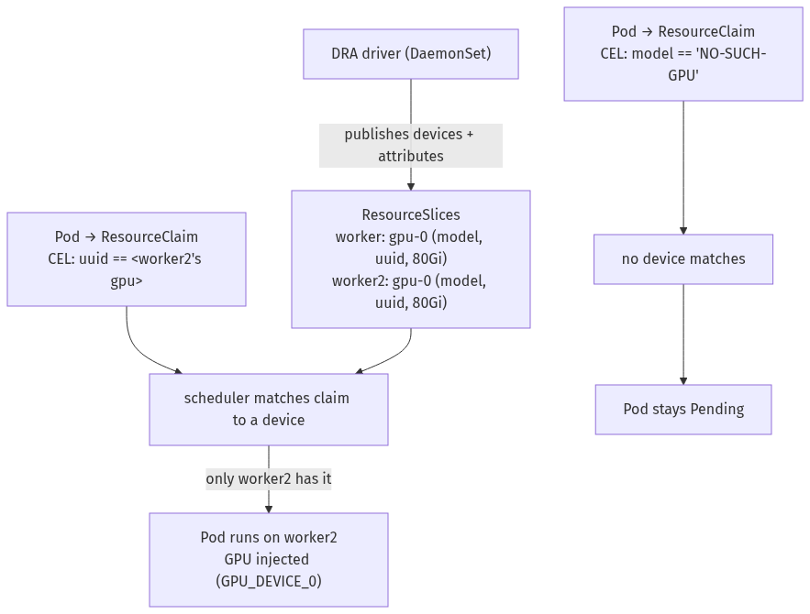

Step 1 — Create a 1.34 cluster and install the DRA driver
Goal: get a cluster with DRA on, and a driver advertising simulated GPUs on the two worker nodes.
1. Create the cluster (2 workers so a device can exist on one node and not the other):
cat > /tmp/dra-kind.yaml <<'EOF'
kind: Cluster
apiVersion: kind.x-k8s.io/v1alpha4
nodes:
- role: control-plane
- role: worker
- role: worker
EOF
kind create cluster --name dra-lab --image kindest/node:v1.34.0 --config /tmp/dra-kind.yaml
kubectl api-resources --api-group=resource.k8s.io
You should see deviceclasses, resourceclaims, resourceclaimtemplates, and resourceslices under resource.k8s.io/v1 — DRA is live.
2. Install the example driver (its image is published to registry.k8s.io, so no local build needed):
git clone --depth 1 --branch v0.5.0 https://github.com/kubernetes-sigs/dra-example-driver /tmp/dra-example-driver
helm install dra-example-driver /tmp/dra-example-driver/deployments/helm/dra-example-driver \
--namespace dra-example-driver --create-namespace
kubectl -n dra-example-driver rollout status ds/dra-example-driver-kubeletplugin --timeout=150s
3. See the devices it advertises:
kubectl get deviceclasses
kubectl get resourceslices -o custom-columns='NODE:.spec.nodeName,DRIVER:.spec.driver,DEVICE:.spec.devices[0].name,MODEL:.spec.devices[0].attributes.model.string,MEMORY:.spec.devices[0].capacity.memory.value'
What you should see: a DeviceClass named gpu.example.com, and a ResourceSlice on each worker advertising a gpu-0 of model LATEST-GPU-MODEL with 80Gi — each with its own attributes (model, uuid, index, driverVersion).
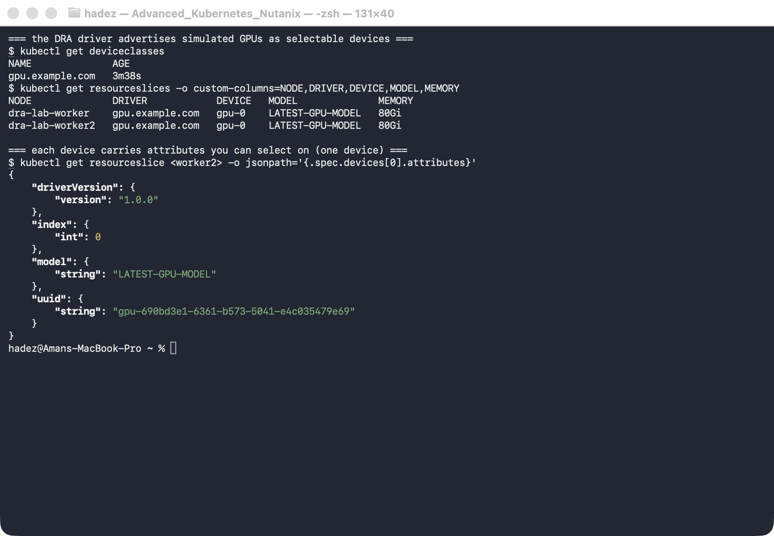
What this means: the cluster now knows about specific, richly-described devices — not just a count. That's what you'll select against.

Step 2 — Request a device by attribute, and watch placement follow
Goal: submit one Pod that selects a device present only on worker2, and one that selects a device that doesn't exist.
1. Capture the UUID of a GPU that lives on worker2 (so we can target that node by device attribute):
W2_SLICE=$(kubectl get resourceslice -o jsonpath='{range .items[*]}{.metadata.name}{" "}{.spec.nodeName}{"\n"}{end}' | awk '$2=="dra-lab-worker2"{print $1; exit}')
W2_UUID=$(kubectl get resourceslice "$W2_SLICE" -o jsonpath='{.spec.devices[0].attributes.uuid.string}')
echo "$W2_UUID"
2. Create the matching Pod — its claim uses a CEL selector on that UUID:
kubectl create namespace dra-demo
kubectl apply -f - <<EOF
apiVersion: resource.k8s.io/v1
kind: ResourceClaimTemplate
metadata: {namespace: dra-demo, name: gpu-on-worker2}
spec:
spec:
devices:
requests:
- name: gpu
exactly:
deviceClassName: gpu.example.com
selectors:
- cel: {expression: "device.attributes['gpu.example.com'].uuid == '${W2_UUID}'"}
---
apiVersion: v1
kind: Pod
metadata: {namespace: dra-demo, name: pod-match}
spec:
containers:
- name: ctr
image: ubuntu:22.04
command: ["bash","-c","env | grep GPU_DEVICE; trap 'exit 0' TERM; sleep 9999 & wait"]
resources: {claims: [{name: gpu}]}
resourceClaims:
- {name: gpu, resourceClaimTemplateName: gpu-on-worker2}
EOF
3. Create the non-matching Pod — its claim selects a model that doesn't exist:
kubectl apply -f - <<'EOF'
apiVersion: resource.k8s.io/v1
kind: ResourceClaimTemplate
metadata: {namespace: dra-demo, name: gpu-nonexistent}
spec:
spec:
devices:
requests:
- name: gpu
exactly:
deviceClassName: gpu.example.com
selectors:
- cel: {expression: "device.attributes['gpu.example.com'].model == 'NO-SUCH-GPU-MODEL'"}
---
apiVersion: v1
kind: Pod
metadata: {namespace: dra-demo, name: pod-nomatch}
spec:
containers:
- name: ctr
image: ubuntu:22.04
command: ["bash","-c","trap 'exit 0' TERM; sleep 9999 & wait"]
resources: {claims: [{name: gpu}]}
resourceClaims:
- {name: gpu, resourceClaimTemplateName: gpu-nonexistent}
EOF
4. Watch where they land, and what got allocated:
kubectl -n dra-demo get pods -o wide
kubectl -n dra-demo get resourceclaims -o custom-columns='CLAIM:.metadata.name,ALLOCATED_DEVICE:.status.allocation.devices.results[0].device,ON_NODE:.status.allocation.devices.results[0].pool'
kubectl -n dra-demo logs pod-match | grep GPU_DEVICE
What you should see: pod-match is Running on dra-lab-worker2 — the only node with the requested UUID — its claim allocated gpu-0 on worker2, and its container has GPU_DEVICE_0=gpu-0 injected. pod-nomatch is Pending with an unallocated claim, because no device anywhere matches its selector.
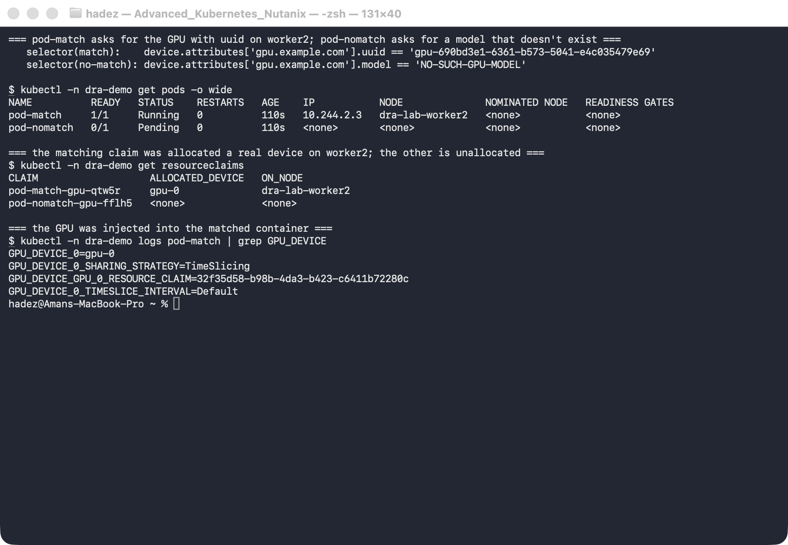
What this means: the Pod's attribute request drove placement. The scheduler didn't just find "a GPU" — it found the specific device satisfying the CEL selector, on the one node that had it, and refused to place the Pod that asked for something no device could provide.
⚠️ Gotcha — a Pending DRA Pod looks like a normal scheduling failure. pod-nomatch sits Pending with FailedScheduling: … cannot allocate all claims. If you forget it's a DRA claim, you'll hunt for taints or node capacity. Always check the ResourceClaim (kubectl get resourceclaim) — an <none> allocation means no device satisfied the selector, which is a claim problem, not a node-resources problem.

Step 3 — Clean up
kind delete cluster --name dra-lab

What you learned
You saw… | in Step | proof
A DRA driver advertises devices with rich attributes | 1 | ResourceSlice per node: model, uuid, 80Gi
A workload selects a device with a CEL attribute expression | 2 | claim selector on uuid / model
Placement follows the claim — only a matching node works | 2 | pod-match on worker2, device gpu-0 allocated there
The device is injected into the container | 2 | GPU_DEVICE_0=gpu-0 in the logs
An unsatisfiable claim leaves the Pod Pending | 2 | pod-nomatch Pending, claim unallocated

Evidence
Real screenshots for this lab are in artifacts/lab-18/screenshots/ (2 images), and a command transcript is in artifacts/lab-18/evidence/lab-15a-dra.txt.

Next: Lab 19 — Queue a Distributed Training Job Behind a Quota (Kueue-Managed PyTorchJob)

