Lab 22 — Give Each Pod Only Its Own Identity, and Run Only Signed Images (Workload Identity + Binary Authorization)
DataCouch — Advanced Kubernetes (Nutanix)
Table of Contents

Day 5 · Kubernetes as the AI-Native Platform
YES — Tested end-to-end on a real GKE cluster. Every screenshot is a real capture. Two payoffs: a Pod bound to a specific Google identity reads a bucket while an unbound Pod gets 403 with no usable identity at all; and an unsigned image is denied admission until you sign its exact digest — then the same image runs.

What you'll learn
- How Workload Identity Federation maps a specific Kubernetes ServiceAccount to a specific Google service account — and what identity every other Pod gets instead (a placeholder, not the node's powerful default).
- How Binary Authorization enforces "only images signed by a trusted attestor may run", end to end: a Cloud KMS signing key, an attestor, a cluster policy, and the full deny → sign → allow cycle.
- Two real gotchas you'll hit in practice: Binary Authorization's digest-only requirement, and cross-architecture image pushes from Apple Silicon.

What you'll do
You'll create a Workload-Identity-enabled GKE cluster, bind a KSA to a GSA and prove access from both a bound and an unbound Pod, then turn on Binary Authorization and walk an image through deny (by tag), deny (unsigned), sign, and allow.

Time & cost
- Time: ~75 minutes.
- Cost: small — one 2-node e2-medium cluster + a Cloud KMS key (a few cents) + free-tier API usage. A few dollars if you tear down promptly.

Before you start
- Where you'll work: in a terminal, with gcloud authenticated to a real GCP project with billing enabled.
- Tools you need: gcloud (with beta: gcloud components install beta), kubectl, and Docker running locally (to push a test image).
Nutanix note — this lab is the most GCP-specific in the course, deliberately. Workload Identity Federation and Binary Authorization are managed GKE features, so you see the polished version of two ideas you'll implement differently on NKE: on Nutanix, per-Pod identity is typically done with SPIFFE/SPIRE (issuing short-lived SVIDs to workloads), and image-signing enforcement with cosign (Sigstore) signatures verified by a Kyverno verifyImages policy at admission (see Lab C for Kyverno). The concepts — least-privilege per-workload identity, and admit-only-signed-images — are exactly the same; only the implementing components change. Learn the model here, then map it to SPIRE + cosign/Kyverno on-prem.

The idea in 60 seconds
Two independent trust controls:
- Workload Identity stops every Pod from inheriting the node's powerful identity. You bind one KSA to one GSA; only Pods using that KSA get that GSA's permissions. Everyone else resolves to a placeholder that can't do anything.
- Binary Authorization stops unvetted images from running. An attestor (a Container Analysis note + a KMS public key) must have a valid signature over an image's digest before the cluster admits it.
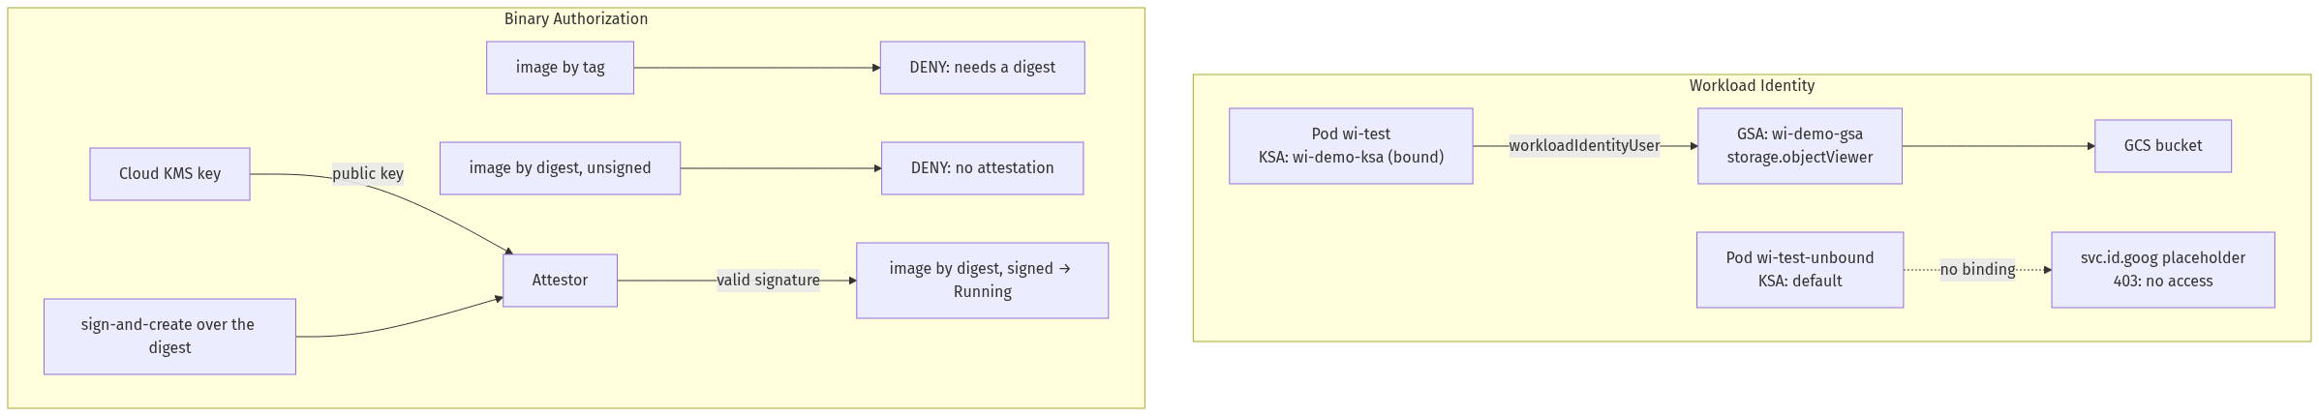

Step 1 — Create a Workload-Identity-enabled cluster
Goal: stand up a GKE cluster with a workload pool (this is what turns Workload Identity on).
export PROJECT_ID=YOUR_GCP_PROJECT_ID
gcloud services enable \
binaryauthorization.googleapis.com containeranalysis.googleapis.com cloudkms.googleapis.com \
--project=$PROJECT_ID
gcloud container clusters create advk8s-security \
--project=$PROJECT_ID --zone=us-central1-a \
--num-nodes=2 --machine-type=e2-medium --disk-size=30 \
--workload-pool=${PROJECT_ID}.svc.id.goog \
--release-channel=regular
gcloud container clusters get-credentials advk8s-security --zone us-central1-a --project=$PROJECT_ID
kubectl get nodes
What you should see: two nodes, Ready.
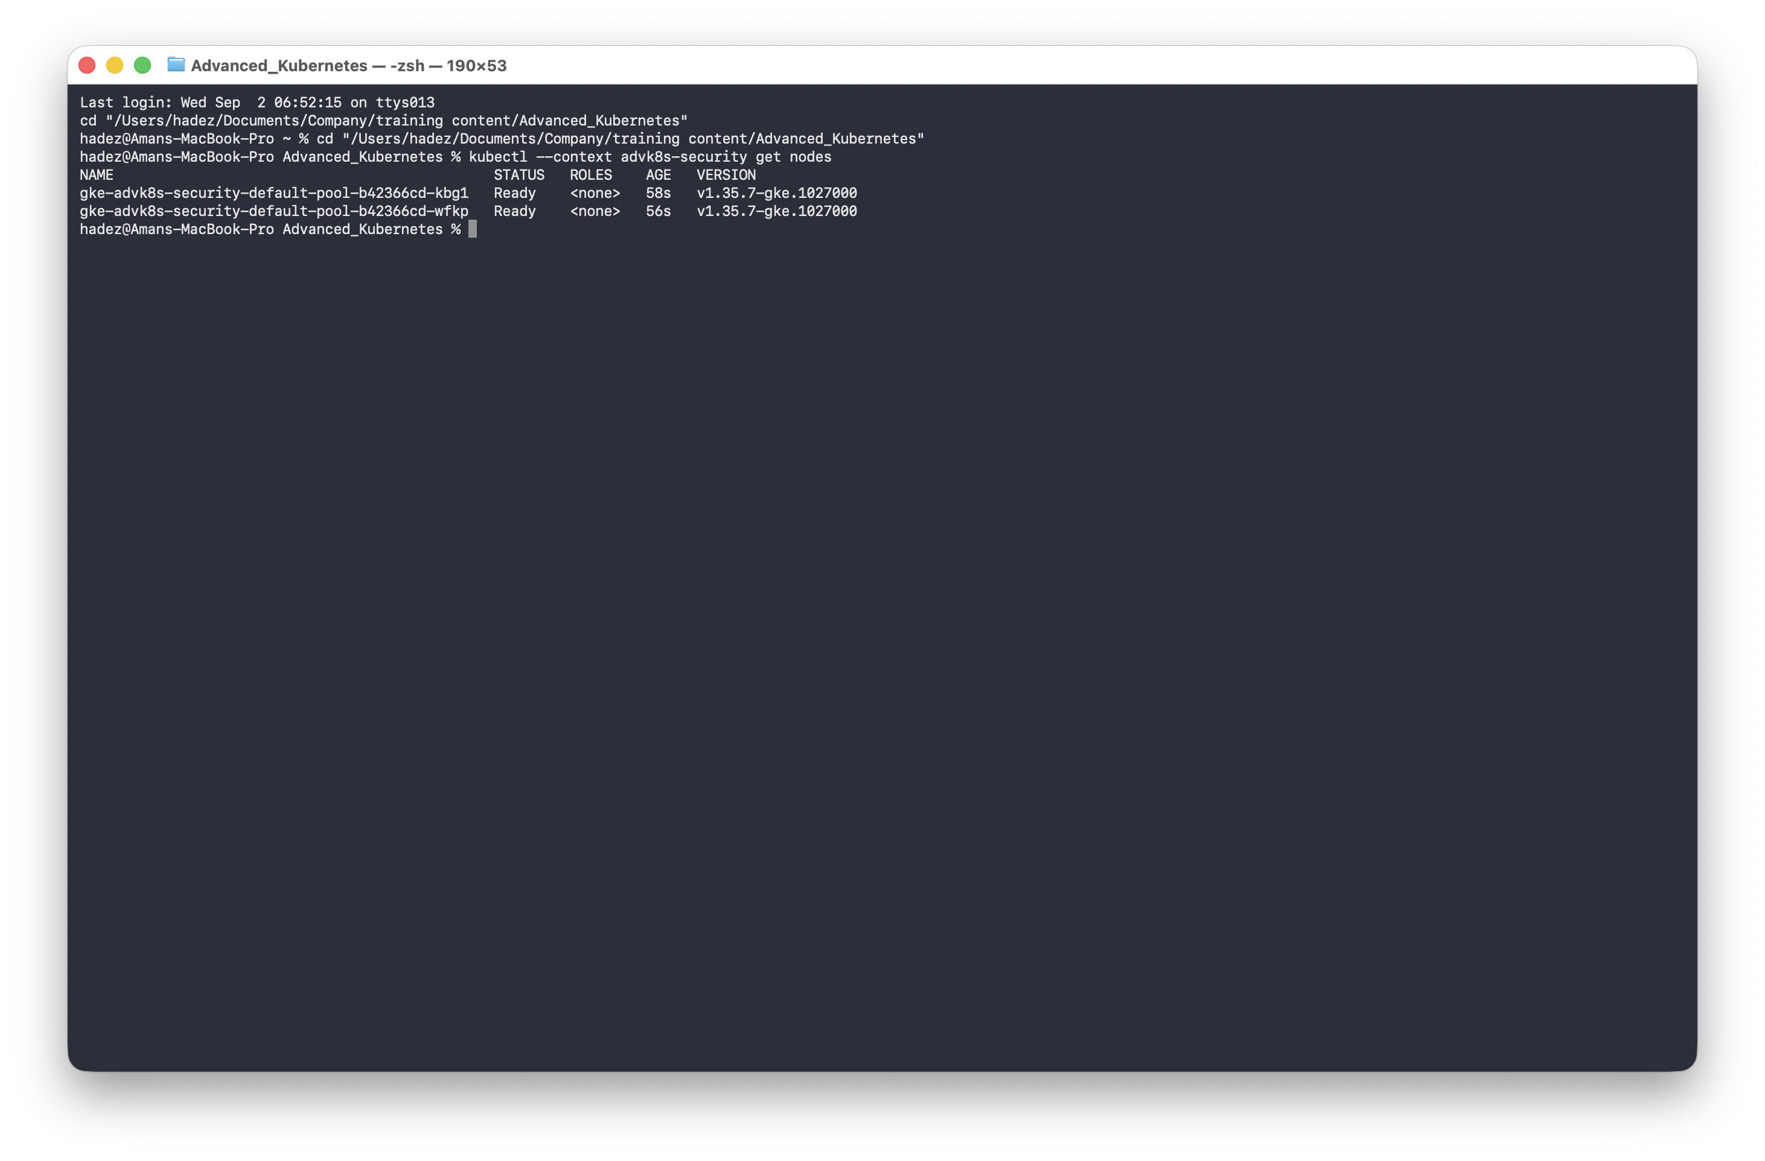
What this means: --workload-pool is the flag that enables Workload Identity for the cluster. (You can add it later with clusters update, but setting it at creation avoids a second wait.)

Step 2 — Bind an identity, and prove it from both sides
Goal: bind one KSA to one GSA, then show a bound Pod can read a bucket and an unbound Pod cannot.
1. Create and bind the identities:
kubectl create serviceaccount wi-demo-ksa
gcloud iam service-accounts create wi-demo-gsa --project=$PROJECT_ID --display-name="WI demo GSA"
gcloud iam service-accounts add-iam-policy-binding \
wi-demo-gsa@${PROJECT_ID}.iam.gserviceaccount.com \
--role roles/iam.workloadIdentityUser \
--member "serviceAccount:${PROJECT_ID}.svc.id.goog[default/wi-demo-ksa]" --project=$PROJECT_ID
kubectl annotate serviceaccount wi-demo-ksa \
iam.gke.io/gcp-service-account=wi-demo-gsa@${PROJECT_ID}.iam.gserviceaccount.com
2. Give the GSA a real bucket to read:
BUCKET="gs://${PROJECT_ID}-wi-demo-$(date +%s)"
gcloud storage buckets create $BUCKET --project=$PROJECT_ID --location=us-central1
echo "hello from workload identity federation" | gcloud storage cp - ${BUCKET}/test-file.txt
gcloud storage buckets add-iam-policy-binding $BUCKET \
--member="serviceAccount:wi-demo-gsa@${PROJECT_ID}.iam.gserviceaccount.com" \
--role="roles/storage.objectViewer"
3. Run a Pod using the bound KSA and check its identity + access:
kubectl apply -f - <<EOF
apiVersion: v1
kind: Pod
metadata: {name: wi-test}
spec:
serviceAccountName: wi-demo-ksa
containers:
- {name: gcloud, image: google/cloud-sdk:slim, command: ["sleep","3600"]}
EOF
kubectl wait --for=condition=Ready pod/wi-test --timeout=90s
kubectl exec wi-test -- curl -sS -H "Metadata-Flavor: Google" \
"http://metadata.google.internal/computeMetadata/v1/instance/service-accounts/default/email"
kubectl exec wi-test -- gcloud storage cat "${BUCKET}/test-file.txt"
What you should see: the Pod's identity resolves to wi-demo-gsa@… and it reads the file: hello from workload identity federation.
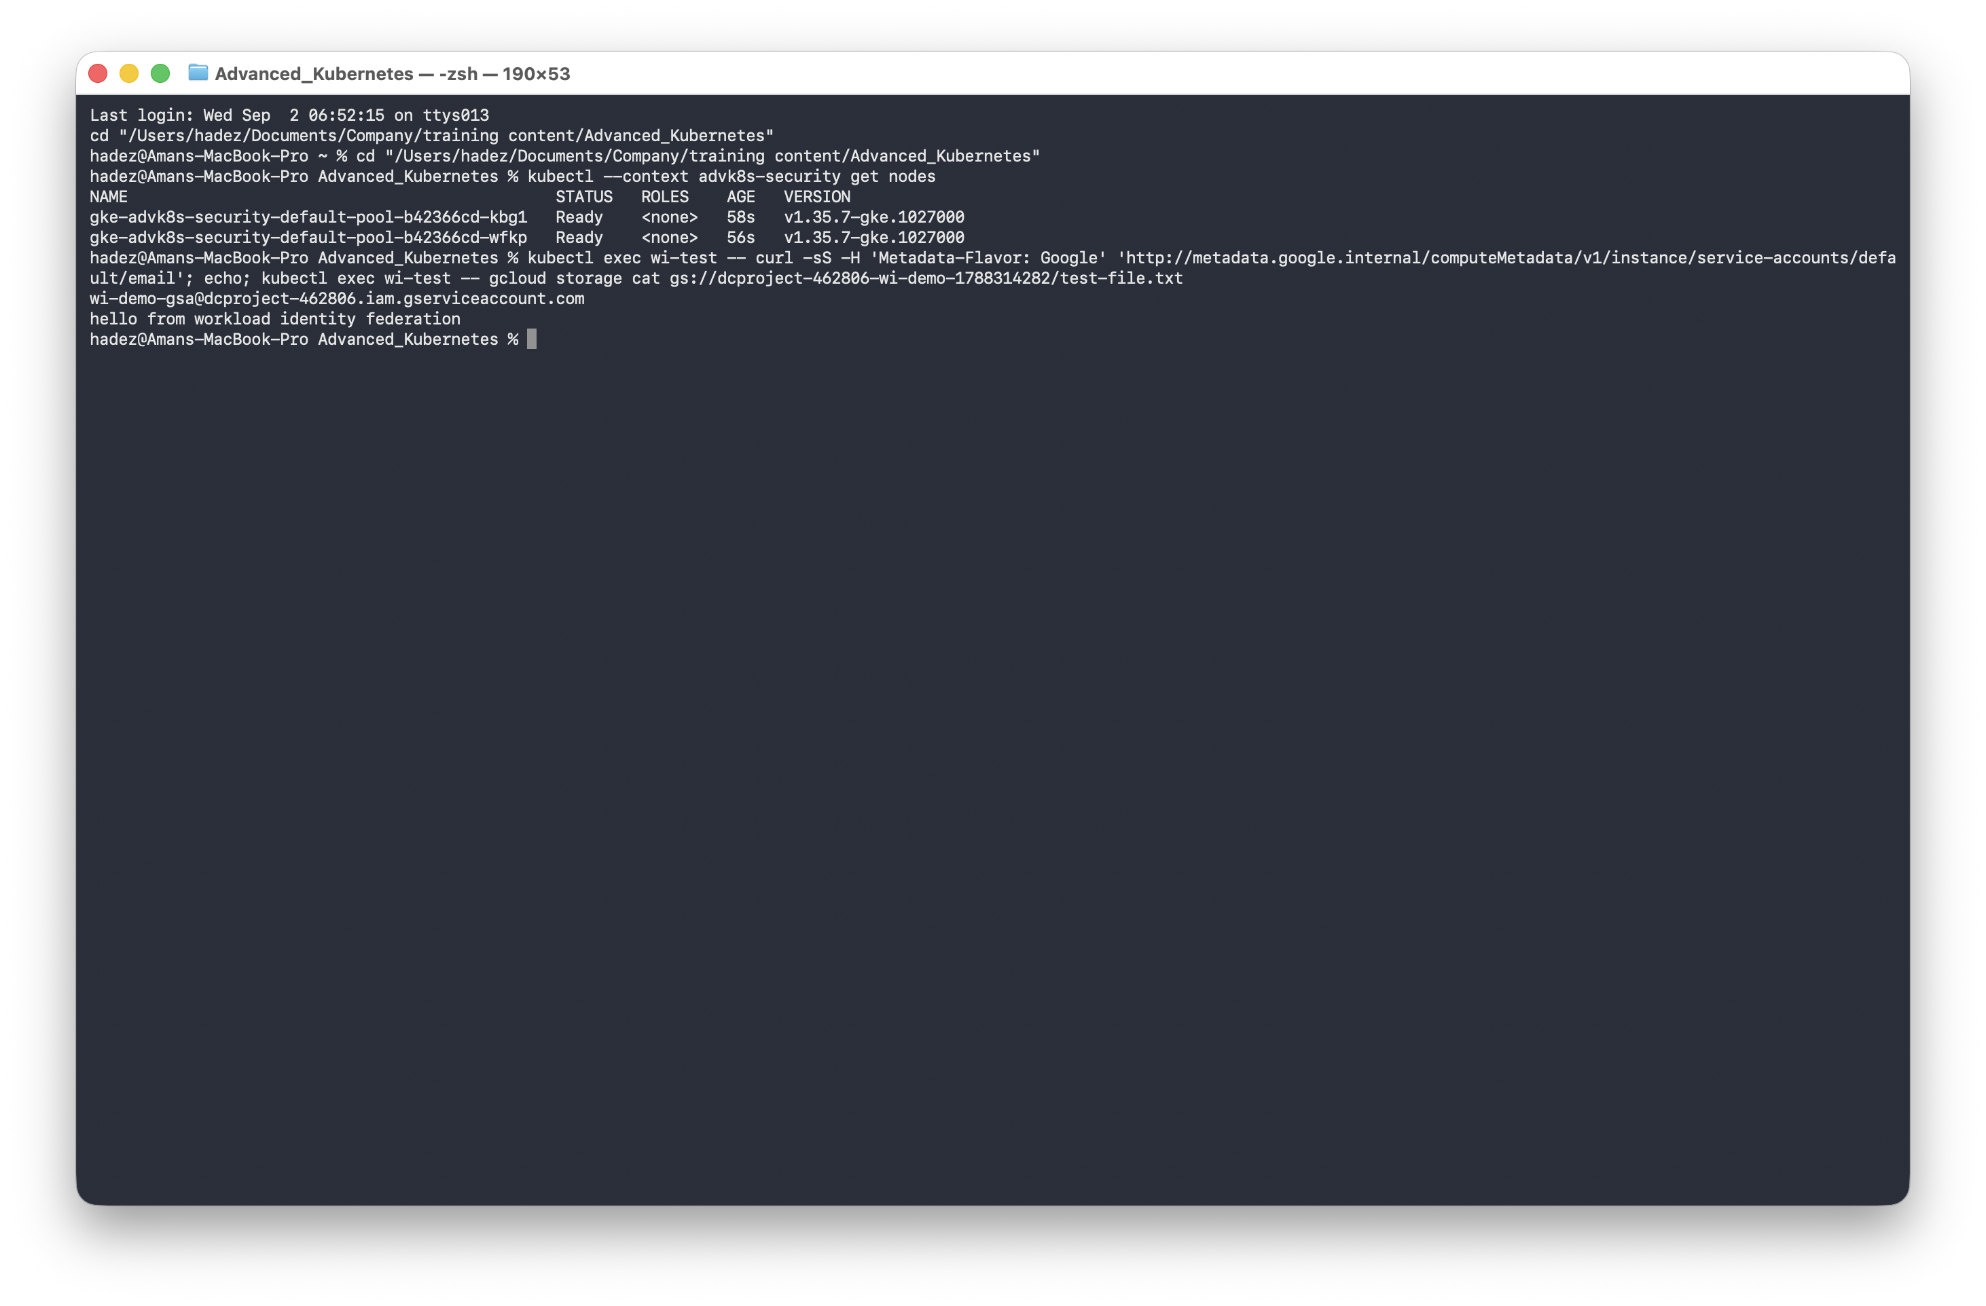
⚠️ Gotcha — a brand-new cluster's metadata server needs a moment. On a freshly created cluster, the first gcloud storage cat inside the Pod can fail with MetadataServerException: … metadata server is concealed, even though the curl identity check already returns the correct GSA. It's a propagation delay in the metadata proxy sidecar settling on a new node — wait a few seconds and retry before suspecting your IAM bindings.
4. Now run a Pod using the default, unbound KSA:
kubectl apply -f - <<EOF
apiVersion: v1
kind: Pod
metadata: {name: wi-test-unbound}
spec:
containers:
- {name: gcloud, image: google/cloud-sdk:slim, command: ["sleep","3600"]}
EOF
kubectl wait --for=condition=Ready pod/wi-test-unbound --timeout=90s
kubectl exec wi-test-unbound -- curl -sS -H "Metadata-Flavor: Google" \
"http://metadata.google.internal/computeMetadata/v1/instance/service-accounts/default/email"
kubectl exec wi-test-unbound -- gcloud storage cat "${BUCKET}/test-file.txt"
What you should see: the identity resolves to the placeholder PROJECT_ID.svc.id.goog, and the read is denied with HTTP 403 (Caller does not have storage.objects.get access).
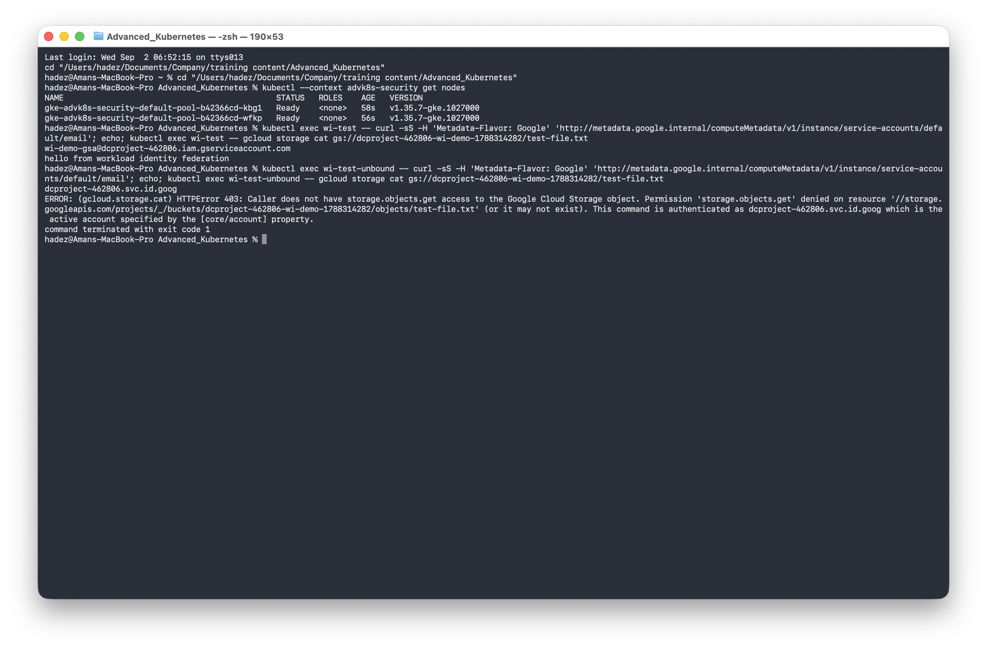
What this means: the unbound Pod does not fall back to the node's identity — it gets a placeholder that's usable for nothing. That's the security property: a compromised Pod's blast radius shrinks from "the whole node's identity" to "nothing, unless that Pod was explicitly bound." Clean up: kubectl delete pod wi-test wi-test-unbound.

Step 3 — Turn on Binary Authorization with a KMS-backed attestor
Goal: require that images be signed by a trusted attestor before they can run.
1. Enable enforcement (a real control-plane update — takes several minutes):
gcloud container clusters update advk8s-security --zone us-central1-a \
--binauthz-evaluation-mode=PROJECT_SINGLETON_POLICY_ENFORCE --project=$PROJECT_ID
2. Create the attestor, a KMS signing key, and attach the public key:
export NOTE_ID=advk8s-attestor-note ATTESTOR_NAME=advk8s-attestor
cat > /tmp/note_payload.json <<EOF
{"name":"projects/${PROJECT_ID}/notes/${NOTE_ID}","attestation":{"hint":{"human_readable_name":"AdvK8s lab attestor"}}}
EOF
curl -sS -X POST -H "Content-Type: application/json" \
-H "Authorization: Bearer $(gcloud auth print-access-token)" \
-H "x-goog-user-project: ${PROJECT_ID}" --data-binary @/tmp/note_payload.json \
"https://containeranalysis.googleapis.com/v1/projects/${PROJECT_ID}/notes/?noteId=${NOTE_ID}"
gcloud --project="${PROJECT_ID}" container binauthz attestors create "${ATTESTOR_NAME}" \
--attestation-authority-note="${NOTE_ID}" --attestation-authority-note-project="${PROJECT_ID}"
gcloud kms keyrings create advk8s-binauthz-keyring --location us-central1 --project=$PROJECT_ID
gcloud kms keys create advk8s-attestor-key --location us-central1 \
--keyring advk8s-binauthz-keyring --purpose asymmetric-signing \
--default-algorithm ec-sign-p256-sha256 --protection-level software --project=$PROJECT_ID
gcloud --project="${PROJECT_ID}" container binauthz attestors public-keys add \
--attestor="${ATTESTOR_NAME}" --keyversion-project="${PROJECT_ID}" \
--keyversion-location=us-central1 --keyversion-keyring=advk8s-binauthz-keyring \
--keyversion-key=advk8s-attestor-key --keyversion=1
3. Set a policy requiring this attestor (whitelist your distro's system image registries, or the cluster's own internals break):
cat > /tmp/binauthz-policy.yaml <<EOF
defaultAdmissionRule:
enforcementMode: ENFORCED_BLOCK_AND_AUDIT_LOG
evaluationMode: REQUIRE_ATTESTATION
requireAttestationsBy:
- projects/${PROJECT_ID}/attestors/${ATTESTOR_NAME}
globalPolicyEvaluationMode: ENABLE
name: projects/${PROJECT_ID}/policy
admissionWhitelistPatterns:
- {namePattern: gcr.io/gke-release/*}
- {namePattern: registry.k8s.io/*}
- {namePattern: gke.gcr.io/*}
EOF
gcloud container binauthz policy import /tmp/binauthz-policy.yaml --project=$PROJECT_ID
4. Push a test image to Artifact Registry:
gcloud artifacts repositories create advk8s-images --repository-format=docker --location=us-central1 --project=$PROJECT_ID
gcloud auth configure-docker us-central1-docker.pkg.dev --quiet
docker tag nginx:1.27-alpine us-central1-docker.pkg.dev/${PROJECT_ID}/advk8s-images/nginx:1.27-alpine
docker push us-central1-docker.pkg.dev/${PROJECT_ID}/advk8s-images/nginx:1.27-alpine
⚠️ Gotcha — Apple Silicon pushes an arm64 image; GKE nodes are amd64. From an M-series Mac, docker push sends arm64 by default. Binary Authorization only checks the digest, so the Pod admits — then crashes with exec format error. Fix by resolving and copying the amd64-specific digest directly (a plain docker pull --platform linux/amd64 does not reliably fix a cached arm64 tag):
docker buildx imagetools inspect nginx:1.27-alpine | grep -A3 "linux/amd64" # get the amd64 digest
docker buildx imagetools create \
--tag us-central1-docker.pkg.dev/${PROJECT_ID}/advk8s-images/nginx:1.27-alpine-amd64 \
docker.io/library/nginx:1.27-alpine@sha256:<amd64-digest>
What this means: the attestor is the unit of trust — a KMS key pair whose public half the cluster trusts. Nothing is signed yet, so nothing custom can run.

Step 4 — The deny → sign → allow cycle
Goal: walk one image from rejected to running by signing its digest.
IMAGE="us-central1-docker.pkg.dev/${PROJECT_ID}/advk8s-images/nginx:1.27-alpine-amd64"
DIGEST=$(gcloud artifacts docker images describe $IMAGE --format='value(image_summary.digest)')
IMAGE_BY_DIGEST="us-central1-docker.pkg.dev/${PROJECT_ID}/advk8s-images/nginx@${DIGEST}"
Attempt 1 — by mutable tag:
kubectl run unattested-test --image="$IMAGE" --restart=Never
What you should see: VIOLATES_POLICY: Expected digest with sha256 scheme, but got tag or malformed digest.
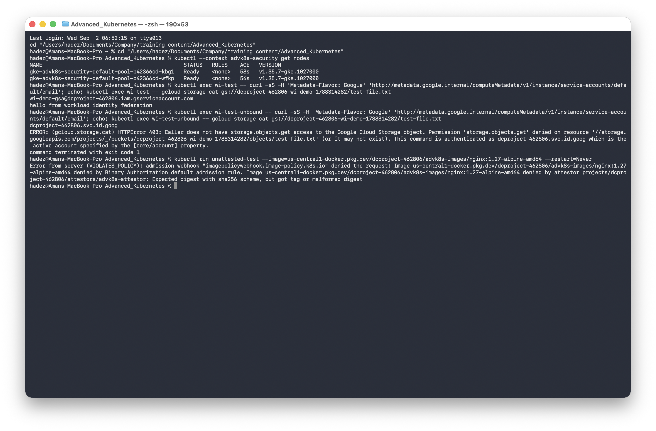
Attempt 2 — by digest, but unsigned:
kubectl run binauthz-test --image="$IMAGE_BY_DIGEST" --restart=Never
What you should see: VIOLATES_POLICY: No attestations found that were valid and signed by a key trusted by the attestor.
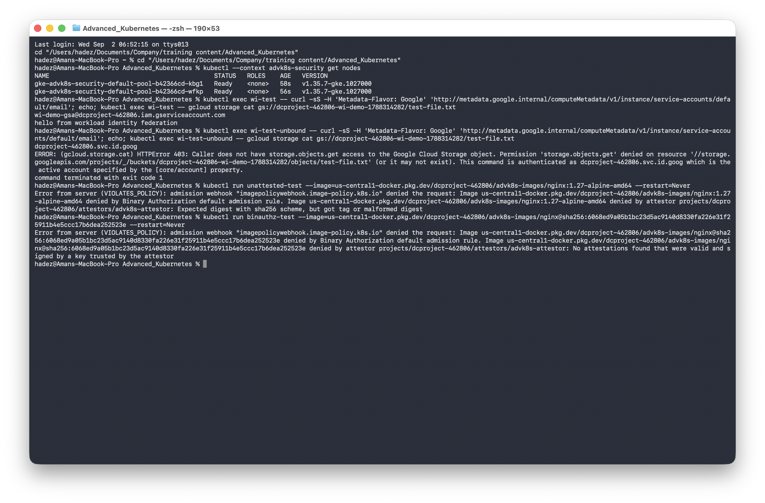
Sign the digest, then Attempt 3:
gcloud beta container binauthz attestations sign-and-create \
--project=$PROJECT_ID --artifact-url="$IMAGE_BY_DIGEST" \
--attestor=advk8s-attestor --attestor-project=$PROJECT_ID \
--keyversion-project=$PROJECT_ID --keyversion-location=us-central1 \
--keyversion-keyring=advk8s-binauthz-keyring --keyversion-key=advk8s-attestor-key --keyversion=1
kubectl run binauthz-test --image="$IMAGE_BY_DIGEST" --restart=Never
kubectl get pod binauthz-test
What you should see: the same digest that was denied twice is now admitted and Running.
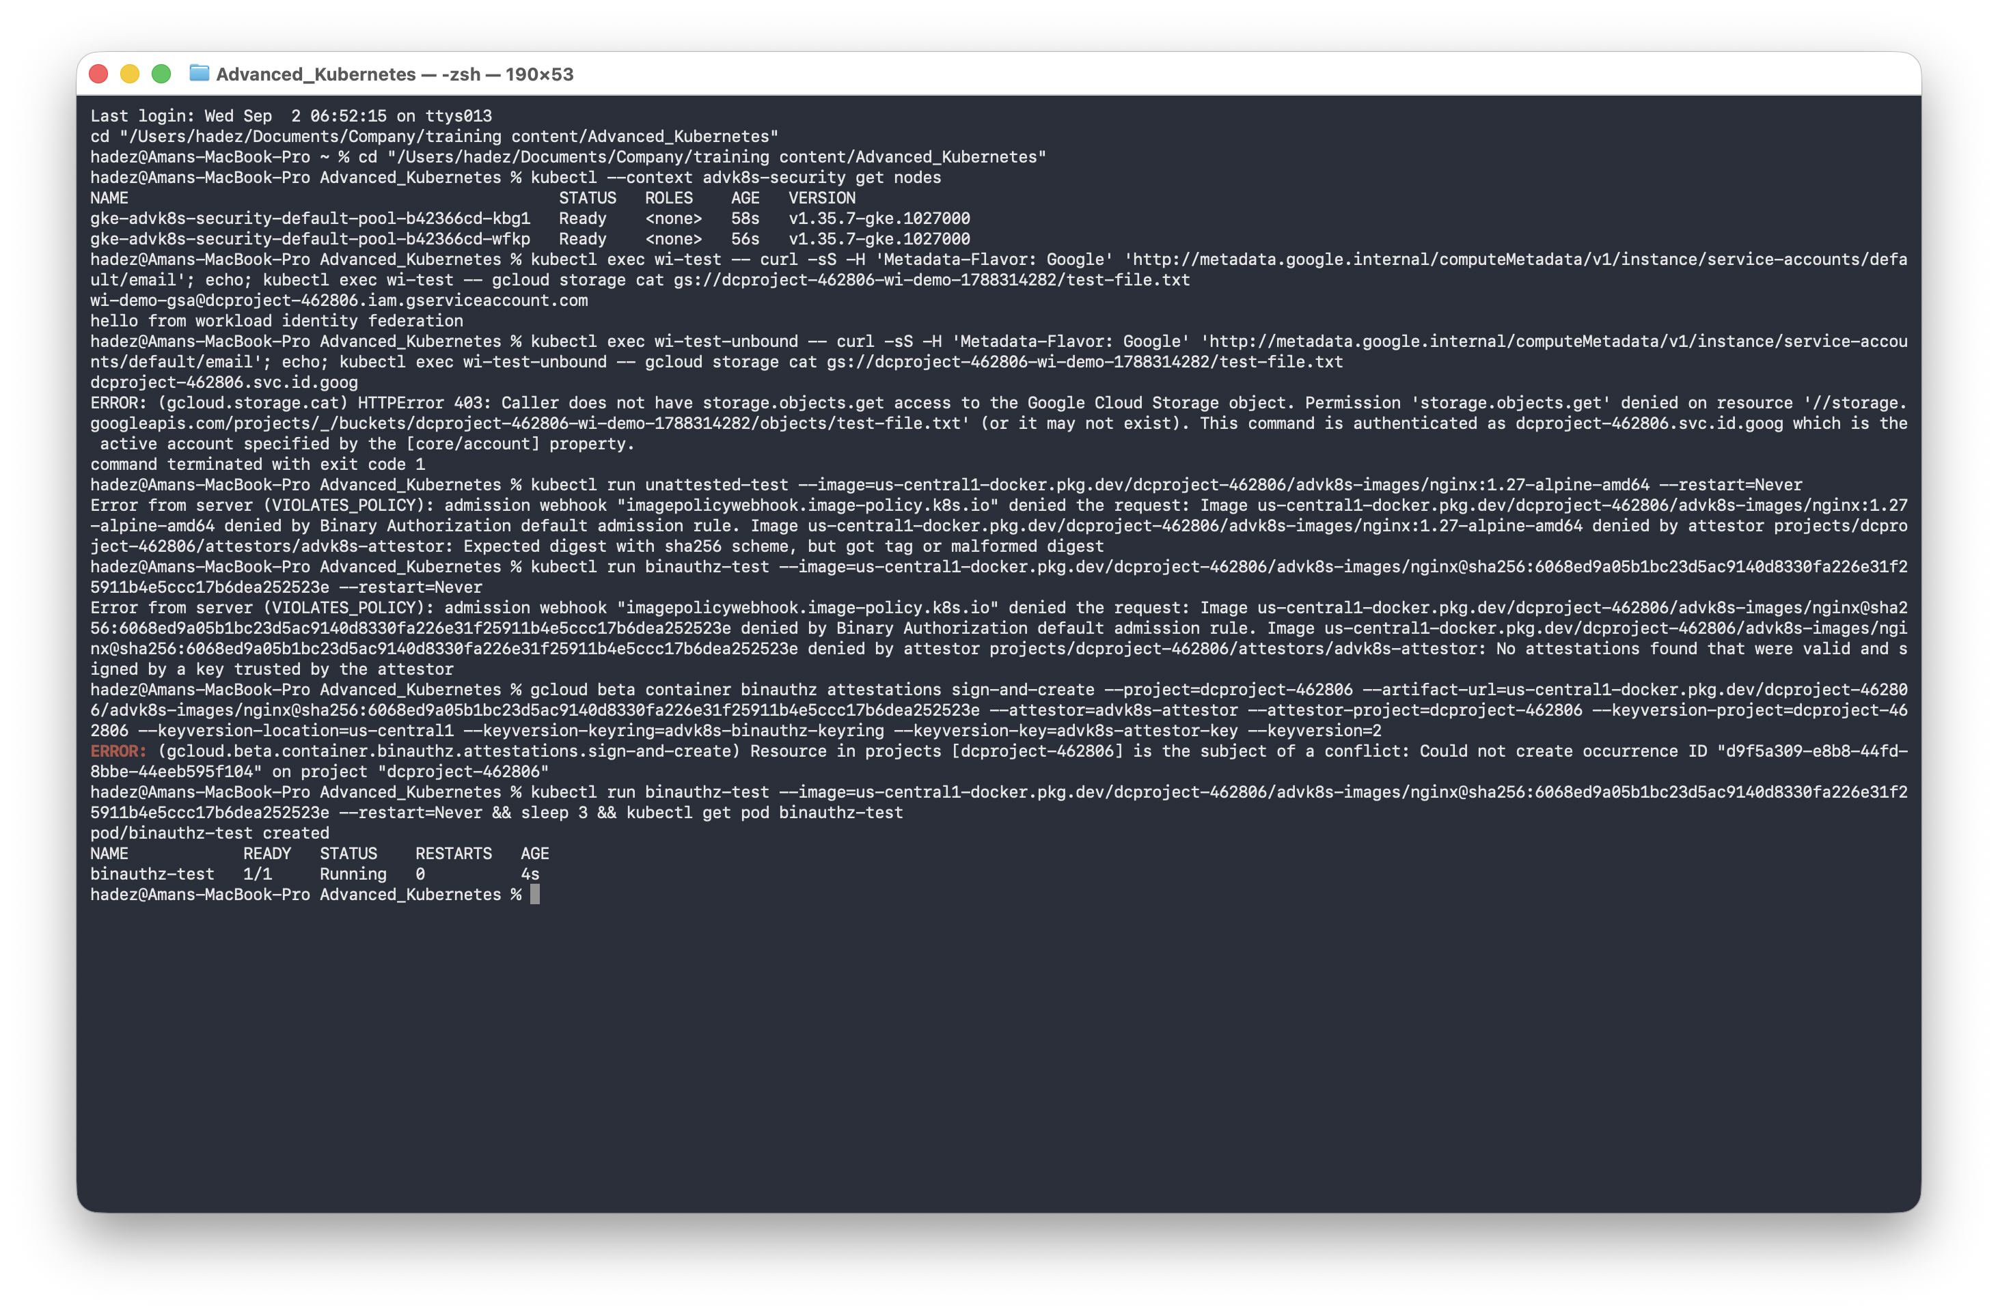
What this means: admission is bound to an immutable digest with a valid signature — never a tag (which could point at different content tomorrow) and never an unsigned image. Sign in CI only after your scans pass, and only vetted images ever reach the cluster.

Step 5 — Clean up
kubectl delete pod wi-test wi-test-unbound binauthz-test 2>/dev/null
gcloud storage rm -r $BUCKET
gcloud iam service-accounts delete wi-demo-gsa@${PROJECT_ID}.iam.gserviceaccount.com --quiet
gcloud container binauthz attestors delete advk8s-attestor --project=$PROJECT_ID --quiet
gcloud kms keys versions destroy 1 --key=advk8s-attestor-key --keyring=advk8s-binauthz-keyring --location=us-central1 --project=$PROJECT_ID --quiet
gcloud artifacts repositories delete advk8s-images --location=us-central1 --project=$PROJECT_ID --quiet
gcloud container clusters delete advk8s-security --zone us-central1-a --project=$PROJECT_ID --quiet
(A KMS key version can be scheduled for destruction, but the keyring itself can't be deleted — that's deliberate GCP behaviour. An empty keyring costs nothing.)

What you learned
You saw… | in Step | proof
A bound KSA Pod acts as its GSA and can access granted resources | 2 | resolves to wi-demo-gsa@…, reads the bucket
An unbound Pod gets no usable identity | 2 | placeholder svc.id.goog, 403 denied
Binary Authorization rejects tag references | 4 | Expected digest with sha256 scheme
It rejects unsigned images | 4 | No attestations found … trusted by the attestor
A signed digest is admitted and runs | 4 | binauthz-test 1/1 Running

Evidence
Real screenshots for this lab are in artifacts/lab-22/screenshots/ (6 images), and command transcripts are in artifacts/lab-22/evidence/.

Next: Lab 23 — Catch a Container Misbehaving at Runtime (Falco)

