Lab 26 — Capstone: Production War-Room (Six Fault Domains, One Recovery)
DataCouch — Advanced Kubernetes (Nutanix)
Table of Contents

Day 5 · Kubernetes as the AI-Native Platform
YES — Tested end-to-end on a real GKE cluster (advk8s-lab). Every screenshot is a real capture. The payoff: you inherit a namespace broken across six independent fault domains at once, triage it with kubectl, fix each root cause, and end with every workload healthy — then write the postmortem.

What you'll do
This is the capstone. You'll seed one incident that breaks an application six different ways — scheduling, images, config, networking, lifecycle, and storage — then work as the on-call engineer: triage → diagnose → fix → verify, and produce a postmortem. It exercises the diagnostic muscles from across the whole course.

Time & cost
- Time: ~60 minutes.
- Cost: negligible — one namespace of small workloads on the shared GKE cluster.

Before you start
- Where you'll work: in a terminal with kubectl pointed at a GKE cluster.
- Tools you need: gcloud, kubectl.
- Mindset: don't fix blindly. For each broken workload, find the symptom (get), the root cause (describe/get -o yaml), then the fix. That triage loop is the real skill.
Nutanix note. Nothing here is cloud-specific — every fault and fix is standard Kubernetes and behaves identically on NKE. This is the exact shape of a real on-prem incident: several unrelated things break at once and you have only kubectl and your head. The one storage detail that changes on Nutanix is the StorageClass name (you'd use your Nutanix CSI class instead of GKE's standard-rwo); the diagnosis — a PVC stuck Pending on a non-existent class — is the same.

The scenario
You're paged: the warroom app is down. Six things are wrong simultaneously, each in a different domain you studied this week:
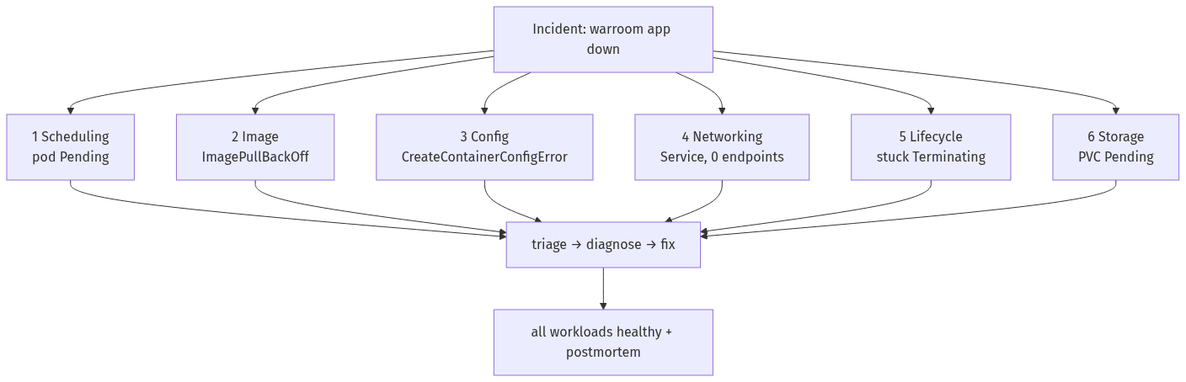

Step 1 — Seed the incident
Goal: create the broken state. (In a real incident this is what you'd find; here you seed it so you can practise the recovery.)
Apply the six-fault bundle:
kubectl create namespace warroom
kubectl -n warroom apply -f - <<'EOF'
# 1 scheduling: impossible nodeSelector
apiVersion: apps/v1
kind: Deployment
metadata: {name: orders, labels: {app: orders}}
spec: {replicas: 1, selector: {matchLabels: {app: orders}}, template: {metadata: {labels: {app: orders}}, spec: {nodeSelector: {disktype: nvme}, containers: [{name: c, image: nginx:1.27-alpine}]}}}
---
# 2 image: typo'd tag
apiVersion: apps/v1
kind: Deployment
metadata: {name: payments, labels: {app: payments}}
spec: {replicas: 1, selector: {matchLabels: {app: payments}}, template: {metadata: {labels: {app: payments}}, spec: {containers: [{name: c, image: nginx:1.27-alpnie}]}}}
---
# 3 config: envFrom a missing ConfigMap
apiVersion: apps/v1
kind: Deployment
metadata: {name: checkout, labels: {app: checkout}}
spec: {replicas: 1, selector: {matchLabels: {app: checkout}}, template: {metadata: {labels: {app: checkout}}, spec: {containers: [{name: c, image: nginx:1.27-alpine, envFrom: [{configMapRef: {name: checkout-config}}]}]}}}
---
# 4 networking: Service selector typo (pods are healthy)
apiVersion: apps/v1
kind: Deployment
metadata: {name: frontend, labels: {app: frontend}}
spec: {replicas: 2, selector: {matchLabels: {app: frontend}}, template: {metadata: {labels: {app: frontend}}, spec: {containers: [{name: c, image: nginx:1.27-alpine, ports: [{containerPort: 80}]}]}}}
---
apiVersion: v1
kind: Service
metadata: {name: frontend}
spec: {selector: {app: frontendd}, ports: [{port: 80, targetPort: 80}]}
---
# 6 storage: PVC with a non-existent StorageClass, mounted by analytics
apiVersion: v1
kind: PersistentVolumeClaim
metadata: {name: data}
spec: {accessModes: ["ReadWriteOnce"], storageClassName: fast-nvme, resources: {requests: {storage: 1Gi}}}
---
apiVersion: apps/v1
kind: Deployment
metadata: {name: analytics, labels: {app: analytics}}
spec: {replicas: 1, selector: {matchLabels: {app: analytics}}, template: {metadata: {labels: {app: analytics}}, spec: {containers: [{name: c, image: nginx:1.27-alpine, volumeMounts: [{name: d, mountPath: /data}]}], volumes: [{name: d, persistentVolumeClaim: {claimName: data}}]}}}
EOF
# 5 lifecycle: a resource stuck Terminating on a finalizer
kubectl -n warroom apply -f - <<'EOF'
apiVersion: v1
kind: ConfigMap
metadata: {name: legacy-record, finalizers: ["warroom.example.com/blocker"]}
data: {note: "old data"}
EOF
kubectl -n warroom delete configmap legacy-record --wait=false

Step 2 — Triage: see everything that's wrong
Goal: get the full picture before touching anything.
kubectl -n warroom get pods
kubectl -n warroom get endpoints frontend
kubectl -n warroom get pvc data
kubectl -n warroom get configmap legacy-record -o jsonpath='{.metadata.name} deletionTimestamp={.metadata.deletionTimestamp} finalizers={.metadata.finalizers}{"\n"}'
What you should see: six distinct symptoms — orders/analytics Pending, payments ImagePullBackOff, checkout CreateContainerConfigError, frontend pods Running but its Service has no endpoints, the data PVC Pending, and legacy-record with a deletionTimestamp set but not gone.
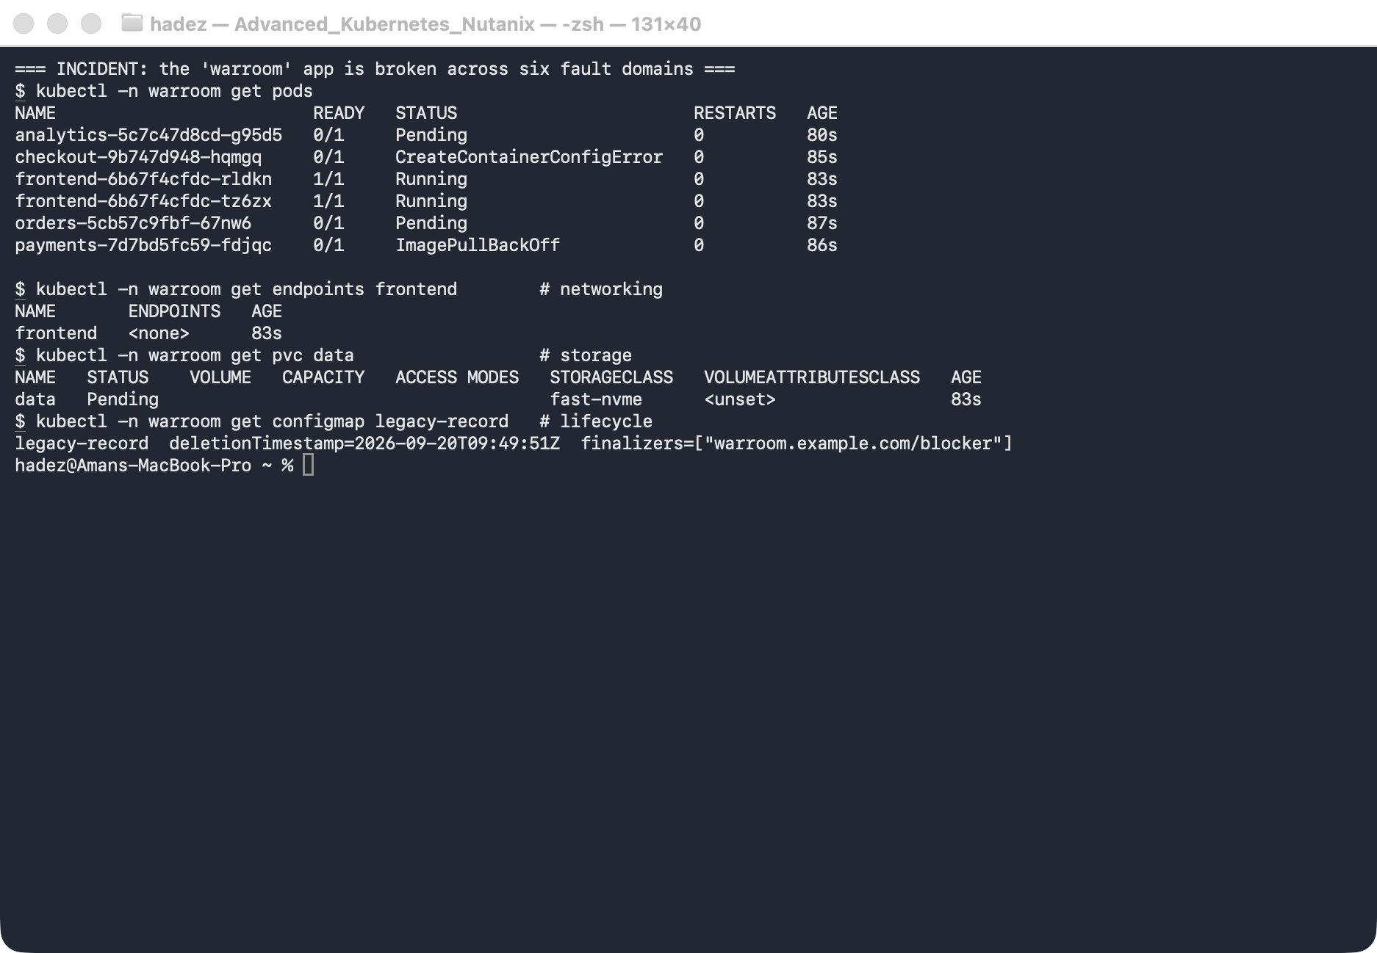
What this means: these are six independent failures, each with a different signature. Recognising the signature is half the diagnosis — Pending vs ImagePullBackOff vs CreateContainerConfigError each point at a different domain.

Step 3 — Diagnose and fix each domain
For each, the diagnostic that reveals the root cause is shown first, then the fix.
1. Scheduling — orders Pending. kubectl -n warroom describe pod -l app=orders shows node(s) didn't match node selector: disktype=nvme. No node has that label.
kubectl -n warroom patch deploy orders --type=json -p '[{"op":"remove","path":"/spec/template/spec/nodeSelector"}]'
2. Image — payments ImagePullBackOff. describe pod shows Failed to pull image "nginx:1.27-alpnie" — a typo in the tag.
kubectl -n warroom set image deploy/payments c=nginx:1.27-alpine
3. Config — checkout CreateContainerConfigError. describe pod shows configmap "checkout-config" not found — the container's envFrom references a ConfigMap that doesn't exist.
kubectl -n warroom create configmap checkout-config --from-literal=MODE=prod --from-literal=TIMEOUT=30
4. Networking — frontend Service has 0 endpoints. The pods are healthy, so compare labels: kubectl -n warroom get svc frontend -o jsonpath='{.spec.selector}' shows app=frontendd but the pods are app=frontend — a selector typo.
kubectl -n warroom patch svc frontend --type=merge -p '{"spec":{"selector":{"app":"frontend"}}}'
5. Lifecycle — legacy-record stuck Terminating. It has a deletionTimestamp but a finalizer (warroom.example.com/blocker) whose controller doesn't exist, so nothing clears it.
kubectl -n warroom patch configmap legacy-record --type=merge -p '{"metadata":{"finalizers":[]}}'
6. Storage — data PVC Pending, analytics Pending. describe pvc data shows it references StorageClass fast-nvme, which doesn't exist. storageClassName is immutable, so recreate the PVC (and the pod that mounts it) with a real class:
kubectl -n warroom delete deploy analytics
kubectl -n warroom delete pvc data
kubectl -n warroom apply -f - <<'EOF'
apiVersion: v1
kind: PersistentVolumeClaim
metadata: {name: data}
spec: {accessModes: ["ReadWriteOnce"], resources: {requests: {storage: 1Gi}}} # default StorageClass
EOF
kubectl -n warroom apply -f - <<'EOF'
apiVersion: apps/v1
kind: Deployment
metadata: {name: analytics, labels: {app: analytics}}
spec: {replicas: 1, selector: {matchLabels: {app: analytics}}, template: {metadata: {labels: {app: analytics}}, spec: {containers: [{name: c, image: nginx:1.27-alpine, volumeMounts: [{name: d, mountPath: /data}]}], volumes: [{name: d, persistentVolumeClaim: {claimName: data}}]}}}
EOF

Step 4 — Verify the cluster is fully healthy
Goal: confirm every domain is green.
kubectl -n warroom get pods
kubectl -n warroom get endpoints frontend
kubectl -n warroom get pvc data
kubectl -n warroom get configmap legacy-record # expect NotFound
What you should see: all six pods Running, frontend now has real endpoint IPs, the data PVC is Bound (StorageClass standard-rwo), and legacy-record is gone (NotFound).
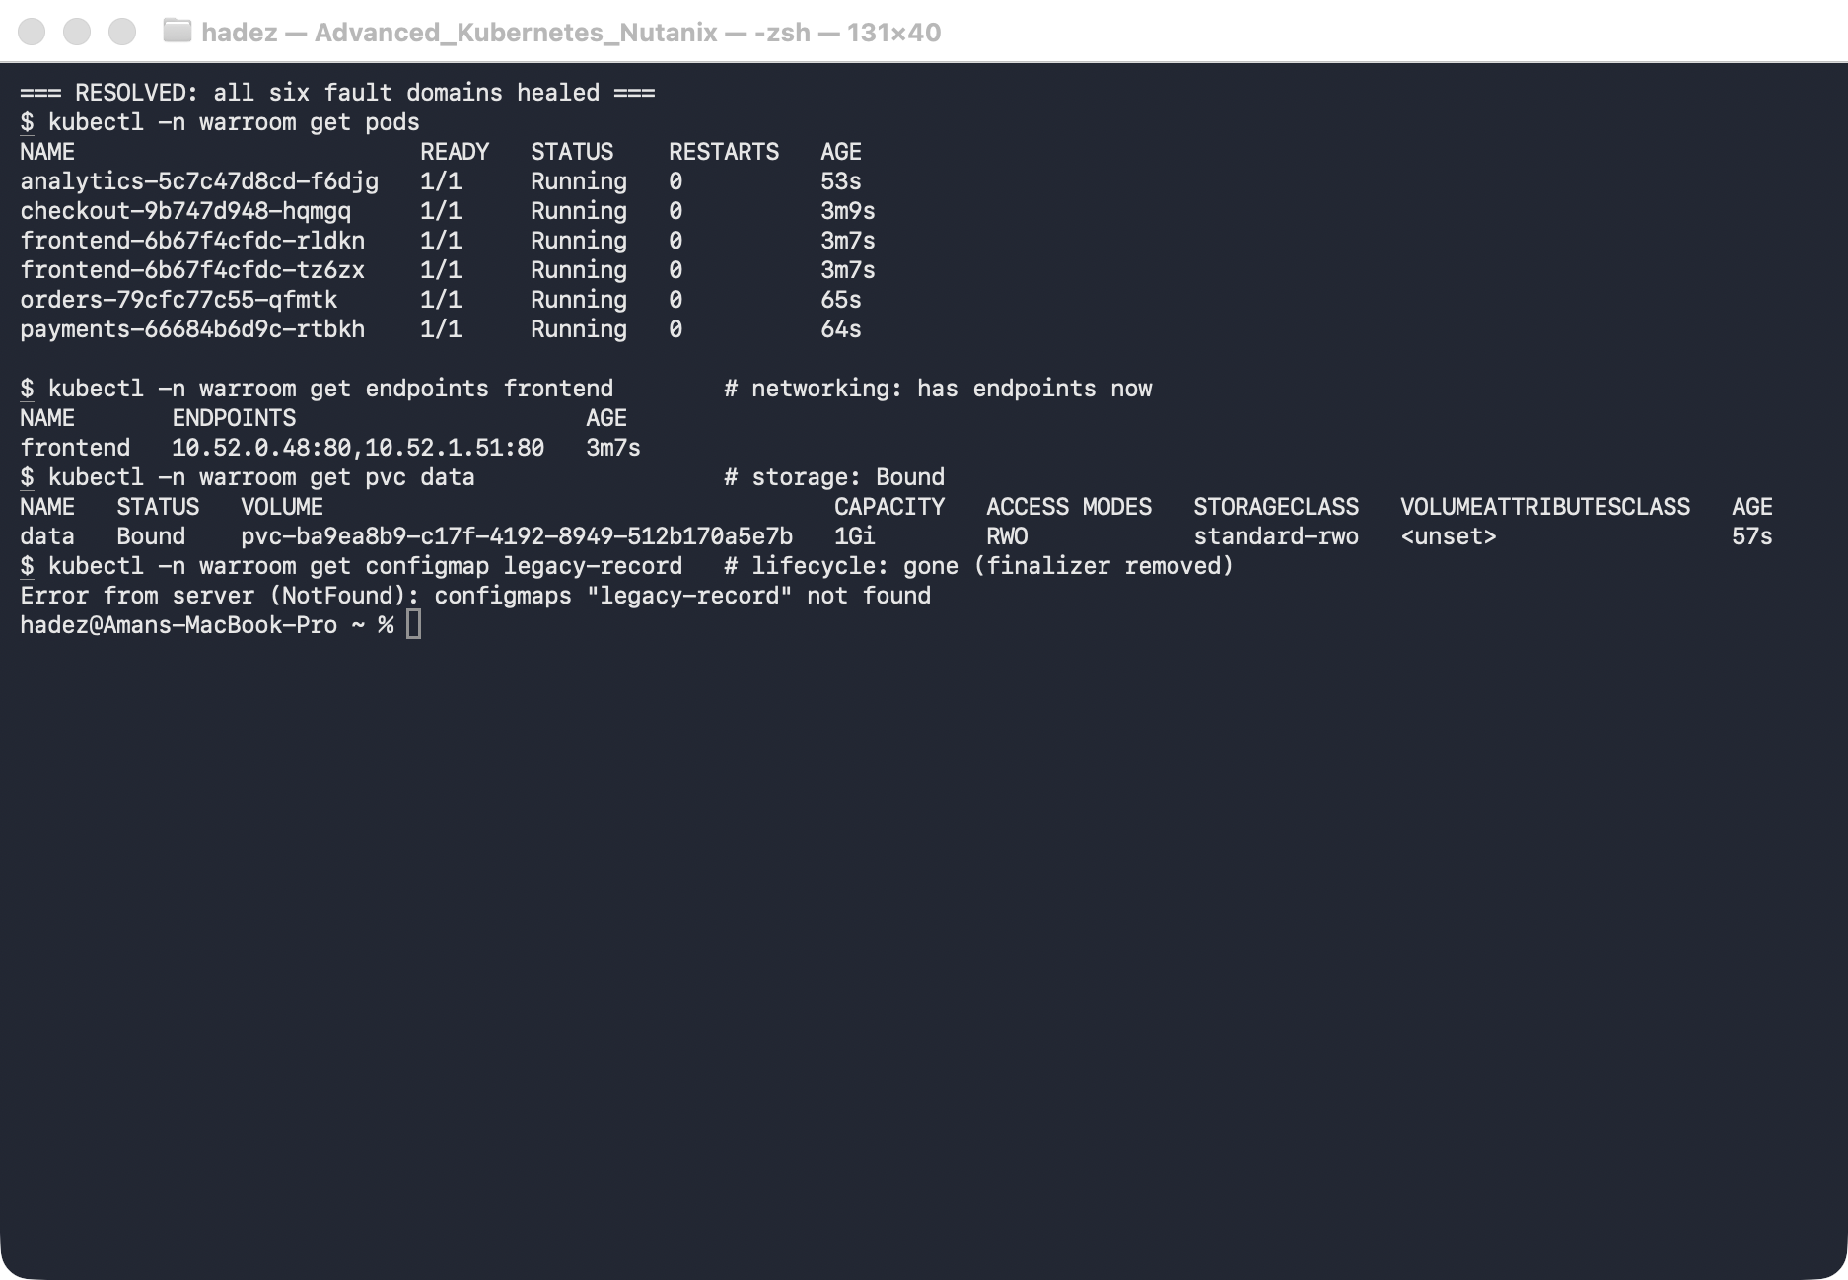
What this means: you took a cluster failing six different ways to fully healthy — each fix targeted at a root cause you diagnosed, not guessed.

Step 5 — The postmortem
# | Domain | Symptom | How you found it | Root cause | Fix | Course link
1 | Scheduling | orders Pending | describe pod → node-selector event | nodeSelector: disktype=nvme matches no node | remove the nodeSelector | Lab 4
2 | Image | payments ImagePullBackOff | describe pod → pull error | typo nginx:1.27-alpnie | correct the tag | Lab C/D
3 | Config | checkout CreateContainerConfigError | describe pod → configmap … not found | missing checkout-config ConfigMap | create the ConfigMap | Lab 11/1
4 | Networking | frontend Service, 0 endpoints | compare Service selector to pod labels | selector typo app=frontendd | fix the selector | Lab B/10
5 | Lifecycle | legacy-record stuck Terminating | get -o jsonpath → finalizer + deletionTimestamp | orphaned finalizer, no controller | clear the finalizer | Lab 5
6 | Storage | data PVC Pending | describe pvc → no such StorageClass | storageClassName: fast-nvme | recreate with a real class | Lab 8
Prevention (the real postmortem output): admission policy to reject images by tag and unknown StorageClasses (Labs C/D/17), CI validation of Service selectors against pod labels, alerting on Pending/ImagePullBackOff/non-Ready endpoints, and a guardrail against orphaned finalizers.

Step 6 — Clean up
kubectl delete namespace warroom --ignore-not-found

What you learned
You saw… | in Step | proof
Six independent faults each have a distinct signature | 2 | Pending vs ImagePullBackOff vs CreateContainerConfigError vs 0-endpoints vs Terminating vs PVC-Pending
Diagnosis comes before the fix | 3 | each fix targeted a root cause from describe/get -o yaml
A multi-domain incident can be driven to fully healthy | 4 | all pods Running, endpoints present, PVC Bound, stuck resource gone
Every fault maps back to a course topic | 5 | postmortem links each to its lab

Evidence
Real screenshots for this lab are in artifacts/lab-26/screenshots/ (2 images), and a command transcript is in artifacts/lab-26/evidence/lab-18-capstone.txt.

This is the end of the course. Across all 26 labs you traced Kubernetes' reconciliation and control plane, operated it under pressure, ran stateful workloads and exposed them, delivered with GitOps across a fleet, scheduled AI/accelerator workloads, and secured and stress-tested the platform — each claim backed by a real command against real infrastructure. Now you can walk into a war-room and drive it back to green.

