DataCouch — Advanced Kubernetes (Nutanix)
Table of Contents

Day 3 · GitOps, Fleet Management & Multi-Cluster Governance — Module 10
YES — Built and verified end-to-end on two kind clusters (Kubernetes 1.37.0) with Flux 2.9.5 and a Gitea 1.22 server inside the fleet — one repository, no internet. Every value below came from that run. The property worth the whole lab: one commit, one repository, and production does not move until a human merges a pull request.

What you'll learn
- How one Git repository drives many clusters without a branch or a folder per cluster.
- How per-cluster overlays work in Flux — variable substitution from a ConfigMap each cluster carries itself.
- How to build rollout rings: a canary that tracks main and a production ring that tracks release, with a merge as the gate.
- What drift correction means in a fleet — each cluster returns to its own rendered value, not a shared constant.

What you'll do
You'll register two clusters against a single Git repository, give each its own identity, and watch the same manifest render differently on each. Then you'll ship a version bump to the canary only, promote it to production by merging a PR, and finish by drifting one cluster and watching Flux correct it without touching the other.

Time & cost
- Time: ~70 minutes.
- Cost: $0 — two local kind clusters.

Before you start
- Tools: docker, kind, kubectl, flux.
- Two clusters. fleet-01 is the canary and also hosts the Git server; fleet-02 is production.
- Prior labs: Lab 15 — GitOps with Flux for the single-cluster basics, and Lab 27 — Tenant Quota Governance if you want the Gitea recipe in full.

Why this lab uses Flux and Lab 16 uses Rancher Fleet
Both are legitimate. Lab 16 runs three clusters under Rancher Fleet, a purpose-built fleet controller with its own GitRepo and target-customisation model. This lab does the same job with Flux, which is what the course outline specifies and what most platform teams already run for single-cluster GitOps. Run either; run both if you want the comparison, which is a genuinely good design discussion.
Nutanix note. Nothing here depends on a cloud. The pattern — one repository, per-cluster substitution, branch-gated rings — is exactly how you would drive a set of on-prem NKE clusters, and the Git server living inside the fleet is often a requirement rather than a convenience.

The idea in 60 seconds
The naive way to run a fleet is a branch or a directory per cluster. It works until the tenth cluster, at which point a change means ten near-identical edits and the drift between them is invisible.
The alternative: the policy lives in Git once, and each cluster supplies its own values. Flux's postBuild.substituteFrom reads a ConfigMap on the cluster and substitutes it into the manifests at apply time. Same commit, different render.
Rings come from the same idea one level up: which revision a cluster tracks is itself per-cluster config. A canary tracking main and production tracking release turns "promote to production" into "merge a pull request" — reviewable, auditable, revertable.

Step 1 — Two clusters and one Git server (15 min)
Goal: a repository both clusters can reach, with no internet involved.
kind clusters share a Docker network, so a NodePort on one is reachable from the other.
cat <<'EOF' | kind create cluster --config -
kind: Cluster
apiVersion: kind.x-k8s.io/v1alpha4
name: fleet-01
nodes:
- role: control-plane
extraPortMappings:
- { containerPort: 30300, hostPort: 30300, protocol: TCP }
EOF
kind create cluster --name fleet-02
Put Gitea on fleet-01 behind that NodePort:
kubectl --context kind-fleet-01 create ns git-server
kubectl --context kind-fleet-01 -n git-server create deployment gitea --image=gitea/gitea:1.22
kubectl --context kind-fleet-01 -n git-server set env deploy/gitea \
GITEA__database__DB_TYPE=sqlite3 GITEA__security__INSTALL_LOCK=true
kubectl --context kind-fleet-01 -n git-server expose deploy/gitea \
--port=3000 --type=NodePort \
--overrides='{"spec":{"ports":[{"port":3000,"targetPort":3000,"nodePort":30300}]}}'
Find the address the other cluster will use:
docker inspect fleet-01-control-plane -f '{{.NetworkSettings.Networks.kind.IPAddress}}'
# 172.19.0.2 -> http://172.19.0.2:30300/labadmin/fleet.git
Create the account and repository (see Lab 27, Step 1 for the full commands).
⚠️ Gotcha — the Gitea Pod is Running before it serves HTTP. Wait on curl -sf http://localhost:3000/api/healthz inside the Pod, not on the rollout, or creating the admin user fails with a bare exit code 1.
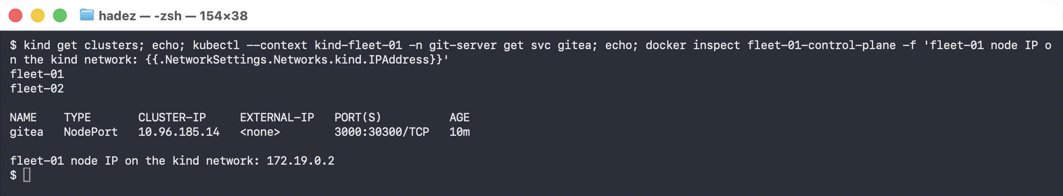

Step 2 — One manifest, written for many clusters (10 min)
Goal: put variables in Git where most people put values.
Commit base/app.yaml:
apiVersion: apps/v1
kind: Deployment
metadata:
name: web
namespace: storefront
labels:
cluster: "${CLUSTER_NAME}"
tier: "${CLUSTER_TIER}"
spec:
replicas: ${WEB_REPLICAS}
template:
spec:
containers:
- name: web
image: nginx:${WEB_VERSION}
Nothing in this file names a cluster. It is the shared contract; the values arrive from wherever it is applied.

Step 3 — Give each cluster its identity (10 min)
Goal: the same Kustomization, two different renders.
Install Flux on both, point both at the same URL, then give each its own ConfigMap:
# canary
kubectl --context kind-fleet-01 -n flux-system create configmap cluster-vars \
--from-literal=CLUSTER_NAME=fleet-01 --from-literal=CLUSTER_TIER=canary \
--from-literal=WEB_REPLICAS=3 --from-literal=WEB_VERSION=1.27-alpine
# production
kubectl --context kind-fleet-02 -n flux-system create configmap cluster-vars \
--from-literal=CLUSTER_NAME=fleet-02 --from-literal=CLUSTER_TIER=production \
--from-literal=WEB_REPLICAS=2 --from-literal=WEB_VERSION=1.27-alpine
The Kustomization is byte-identical on both clusters:
spec:
path: ./base
prune: true
sourceRef: { kind: GitRepository, name: fleet }
postBuild:
substituteFrom:
- { kind: ConfigMap, name: cluster-vars }
What you should see:
kind-fleet-01 revision=main@sha1:3a929cfa...
kind-fleet-02 revision=main@sha1:3a929cfa...
kind-fleet-01 replicas=3 tier=canary cluster=fleet-01
kind-fleet-02 replicas=2 tier=production cluster=fleet-02
What this means. Identical revision 3a929cfa on both. Different replica counts, different labels. Adding a tenth cluster is one ConfigMap — not a tenth copy of the manifests.
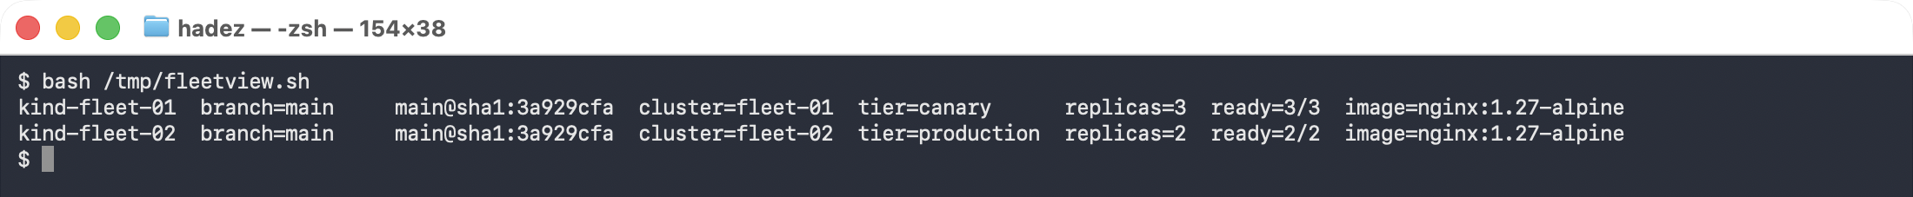
⚠️ Gotcha — an unset variable does not fail loudly. If a cluster's ConfigMap is missing a key, substitution leaves the literal ${WEB_REPLICAS} in place and the apply fails with a type error that does not mention the variable. Check the Kustomization's Ready condition, and consider postBuild.substitute defaults for anything optional.

Step 4 — Build the rollout rings (10 min)
Goal: make "which version is this cluster on" a per-cluster decision with a human gate.
Create a release branch, and point production at it:
# via the Gitea API, branch 'release' from 'main'
kubectl --context kind-fleet-02 patch gitrepository fleet -n flux-system --type merge \
-p '{"spec":{"ref":{"branch":"release"}}}'
kind-fleet-01 branch=main image=nginx:1.27-alpine
kind-fleet-02 branch=release image=nginx:1.27-alpine
What this means. The canary follows the tip of development. Production follows a branch that only moves when someone moves it. Both still read the same repository and the same path.
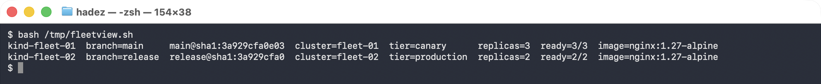

Step 5 — Ship it to the canary only (10 min)
Commit a version bump to main:
- image: nginx:${WEB_VERSION}
+ image: nginx:1.29-alpine
Wait one reconcile interval, then look at both:
kind-fleet-01 branch=main image=nginx:1.29-alpine ready=3/3
kind-fleet-02 branch=release image=nginx:1.27-alpine ready=2/2
Production did not move. One commit, one repository, and the blast radius was exactly one ring — enforced by the branch each cluster tracks rather than by anyone remembering to be careful.
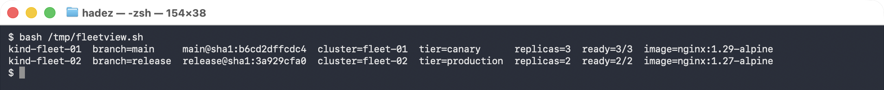
This is the step to sit on. Ask the room what would have happened with a single shared branch: the answer is that the same commit reaches every cluster within a reconcile interval, which is the failure mode the outline names as "a change reaching every cluster simultaneously."

Step 6 — Promote (5 min)
Promotion is a pull request from main into release:
# open and merge via the Gitea API (or the web UI)
POST /api/v1/repos/labadmin/fleet/pulls {"head":"main","base":"release", ...}
POST /api/v1/repos/labadmin/fleet/pulls/1/merge {"Do":"merge"}
kind-fleet-01 branch=main image=nginx:1.29-alpine ready=3/3
kind-fleet-02 branch=release image=nginx:1.29-alpine ready=2/2
What this means. The gate was a merge — reviewable, attributable and revertable. And note production kept its own replica count of 2 throughout: promoting a version did not overwrite the cluster's identity, because version and identity come from different places.
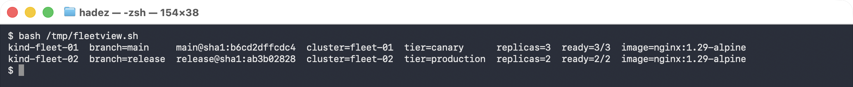

Step 7 — Drift, on one cluster only (10 min)
kubectl --context kind-fleet-02 -n storefront scale deploy/web --replicas=7
immediately : replicas=7
after Flux : replicas=2 (back to what Git renders for THIS cluster)
fleet-01 : replicas=3 (never touched)
What this means. Drift correction is per cluster, to that cluster's rendered value — not to a fleet-wide constant. fleet-02 returns to 2 while fleet-01 stays on 3, because each is being reconciled against its own render of the same commit.
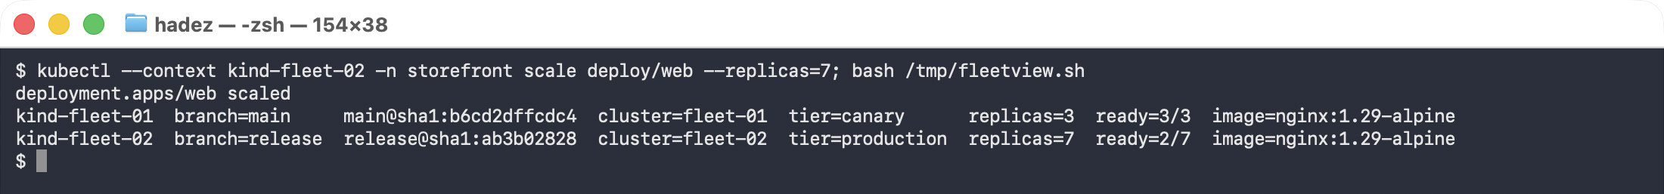
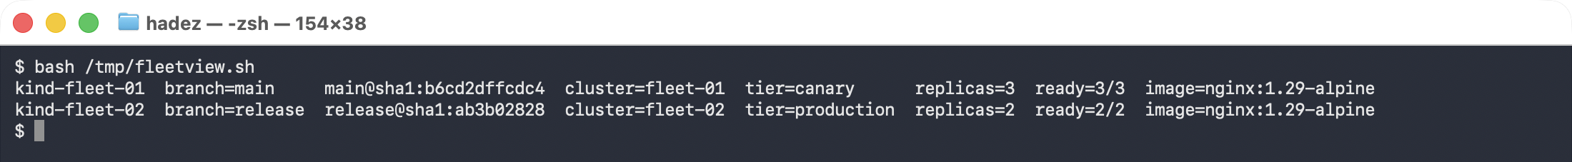
That distinction is what makes per-cluster overlays safe. Without it, a fleet-wide "correct the drift" would flatten every cluster to the same shape.

Step 8 — Do it again yourself, unassisted
Why: two clusters and two rings is the smallest fleet that is still a fleet. The judgement starts at three.
Your task. Add a third cluster, fleet-03, as a second production ring in a different region — and give it a configuration that genuinely differs, not just a different replica count.
You get the acceptance criteria and nothing else:
- Three clusters, one repository, no new branches beyond main and release
- fleet-03 differs from fleet-02 in at least one way that is not expressible by changing a number — an extra resource, or one omitted
- A release reaches canary, then both production clusters, in that order, with one merge
- Drift on fleet-03 corrects to fleet-03's values
- One sentence on what you would do if fleet-03 needed to stay a version behind indefinitely
Done when you can answer: "a security patch must reach all three clusters in the next hour. What do you do, and what do you lose by doing it?"
No commands here. Steps 1–7 have the pattern.

Step 9 — Clean up
kind delete cluster --name fleet-01
kind delete cluster --name fleet-02

What you learned
You saw… | in Step | proof
One repository can drive many clusters | 3 | both on revision main@sha1:3a929cfa
Per-cluster overlays come from the cluster, not the repo | 3 | replicas=3 tier=canary vs replicas=2 tier=production
Rollout rings are just per-cluster refs | 4 | canary branch=main, production branch=release
A commit reaches only the ring that tracks it | 5 | canary 1.29, production still 1.27
Promotion is a reviewable merge | 6 | PR main → release, production moves to 1.29
Promoting a version preserves cluster identity | 6 | production stayed at 2 replicas across the upgrade
Drift corrects to that cluster's value | 7 | fleet-02 7 → 2 while fleet-01 stayed at 3

Evidence
A full transcript is in artifacts/lab-29/evidence/lab-29-flux-fleet-two-clusters.txt — captured 2026-09-25 across both clusters, covering the shared revision, both renders, the staged upgrade timeline and the drift correction.
Real terminal captures are in artifacts/lab-29/screenshots/ (7 images) from a live two-cluster run on 2026-09-27 — Kubernetes 1.37.0, Flux 2.9.5, Gitea 1.22. The helper used for the side-by-side view is artifacts/lab-29/fleetview.sh.
Note. The screenshots come from a later run than the transcript, so the revisions differ — the images show 3a929cfa / b6cd2dff / ab3b0282, the transcript shows f56fb79e. Every behaviour is identical.

Related: Lab 16 — Fleet Registration & Staged Rollout does the same job with Rancher Fleet across three clusters. Comparing the two is the Module 10 design discussion.

