Lab 7 — Find the Cluster's Breaking Point (Cluster Scale Knee-Point)
DataCouch — Advanced Kubernetes (Nutanix)
Table of Contents

Day 2 · Extending and Operating the Platform Under Pressure
YES — Tested end-to-end on a real GKE cluster (advk8s-day2, dcproject-462806), a fixed two-node pool. Every number and the graph come from a real run. What you'll prove: time-to-ready is flat and near-instant while Pods fit — then at one specific replica count it falls off a cliff, because the cluster ran out of schedulable CPU. That's the knee, and it's far below the cluster's raw vCPU count.

What you'll learn
- What a scaling knee-point is: the replica count where time-to-ready stops being flat and degrades sharply.
- Why a cluster's real capacity is far smaller than its raw vCPU count — system Pods (kube-dns, kube-proxy, …) reserve a big slice of every node before your first Pod lands.
- How to measure the knee yourself: scale in steps, time each step to Ready, and read the curve.
- What actually happens past the knee (Pending Pods, Insufficient cpu) and the three ways to move it out.

What you'll do
You'll take a fixed two-node cluster, scale a Deployment up in steps (2, 4, 6, … 16 replicas), and time how long each step takes to become fully Ready. You'll plot the result and see a flat line that suddenly cliffs — the knee — then look at exactly why the Pods past it can't schedule.

Time & cost
- Time: ~35 minutes.
- Cost: negligible beyond the Day-2 cluster — this runs on the fixed two nodes and adds no capacity.

Before you start
- Where you'll work: in a terminal on your own machine.
- Tools you need: gcloud, kubectl.
- Cluster: reuse the Day-2 GKE cluster from Lab 6, as a fixed two-node pool (autoscaling off, so the knee is a clean, fixed boundary rather than a moving target):
gcloud container clusters update advk8s-day2 --zone us-central1-a \
--no-enable-autoscaling --node-pool default-pool
gcloud container clusters resize advk8s-day2 --node-pool default-pool --num-nodes 2 --zone us-central1-a --quiet
Nutanix note. The measurement technique and the finding — real capacity is far below raw vCPU, and time-to-ready cliffs at the boundary — are identical on any platform. The per-node system reservation differs (GKE's managed DaemonSets vs. NKE's), so the exact knee replica count is platform-specific, but the shape is universal. On NKE you'd move the knee out with a bigger node pool or the Kubernetes Cluster Autoscaler, exactly as GKE does (we turned autoscaling off here on purpose so the boundary stays put and is measurable).

The idea in 60 seconds
A node's allocatable CPU is already less than its physical vCPU (the kubelet/OS reserve some). Then, before any of your workloads land, system Pods — kube-dns, kube-proxy, node-local-dns, CSI drivers, metrics — reserve a big chunk of what's left. So a cluster's real capacity for your Pods is a small fraction of its "2 vCPU × 2 nodes = 4 cores" on paper.
While your Pods fit into that real free CPU, the scheduler places them in seconds — the flat part of the curve. The instant a step asks for more than the free CPU can hold, the extra Pods go Pending with Insufficient cpu, and on a fixed cluster they stay there. That's the knee — a hard boundary, which makes scale-up time bimodal: near-instant below it, never above it.
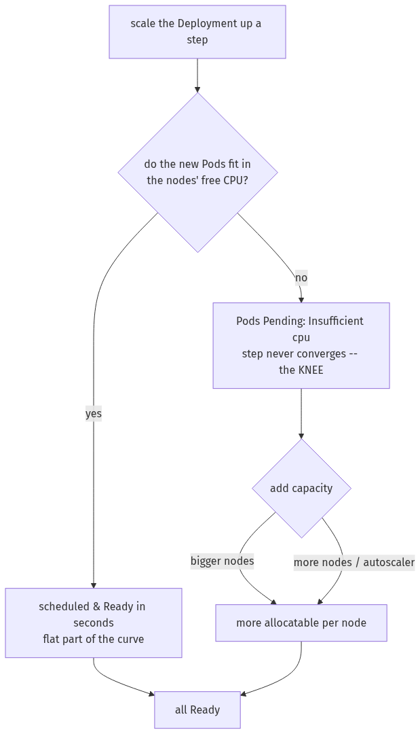

Step 1 — See how little CPU is actually free
Goal: confirm a fixed two-node pool and measure the real free capacity, then create the Deployment you'll scale.
1. Check the nodes and how much CPU is already reserved, then create a Deployment whose Pods each request 50m:
kubectl get nodes --no-headers | grep -c ' Ready ' # 2
# how much CPU is already spoken for, per node:
kubectl describe nodes | grep -A6 'Allocated resources' | grep -E 'cpu'
kubectl create deployment scaletest --image=nginx:1.27 --replicas=0
kubectl set resources deployment scaletest --requests=cpu=50m
What you should see: two nodes, each with 940m allocatable but a large fraction already requested by kube-system (in our run ~753m on one node, ~561m on the other — two kube-dns Pods at ~260m each dominate). Only **~560m** is free cluster-wide — about eleven 50m Pods.
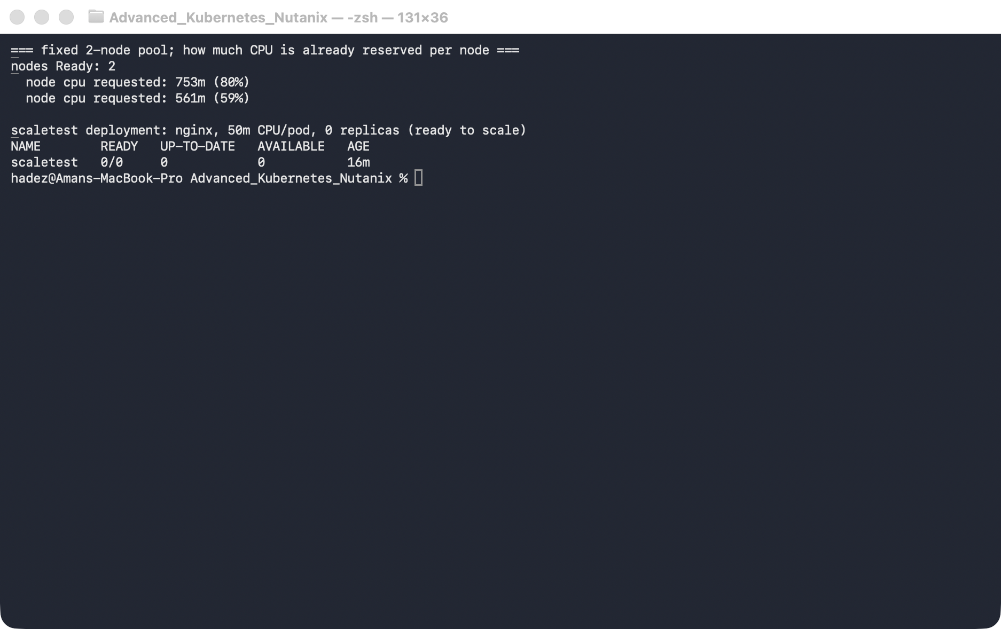
What this means: that ~560m is the real capacity, and it's where the knee will land — around 11–12 of your Pods, not the 4 cores the cluster advertises.

Step 2 — Measure: scale in steps and time each to Ready
Goal: scale through a sequence of replica counts, timing each step to fully Ready (capped at 20s — past that we call it "did not converge").
1. Run the measurement loop:
for N in 2 4 6 8 10 12 14 16; do
start=$(date +%s)
kubectl scale deployment scaletest --replicas=$N
kubectl rollout status deployment/scaletest --timeout=20s
end=$(date +%s)
ready=$(kubectl get pods -l app=scaletest --field-selector=status.phase=Running --no-headers | wc -l | tr -d ' ')
pending=$(kubectl get pods -l app=scaletest --field-selector=status.phase=Pending --no-headers | wc -l | tr -d ' ')
echo "replicas=$N time=$((end-start))s ready=$ready pending=$pending"
done
What you should see: flat and fast up to the boundary, then a wall:
replicas | time to Ready | ready | pending
2 | 2s | 2 | 0
4 | 2s | 4 | 0
6 | 2s | 6 | 0
8 | 3s | 8 | 0
10 | 3s | 10 | 0
12 | 22s (timeout) | 10 | 2
14 | 22s (timeout) | 10 | 4
16 | 23s (timeout) | 10 | 6
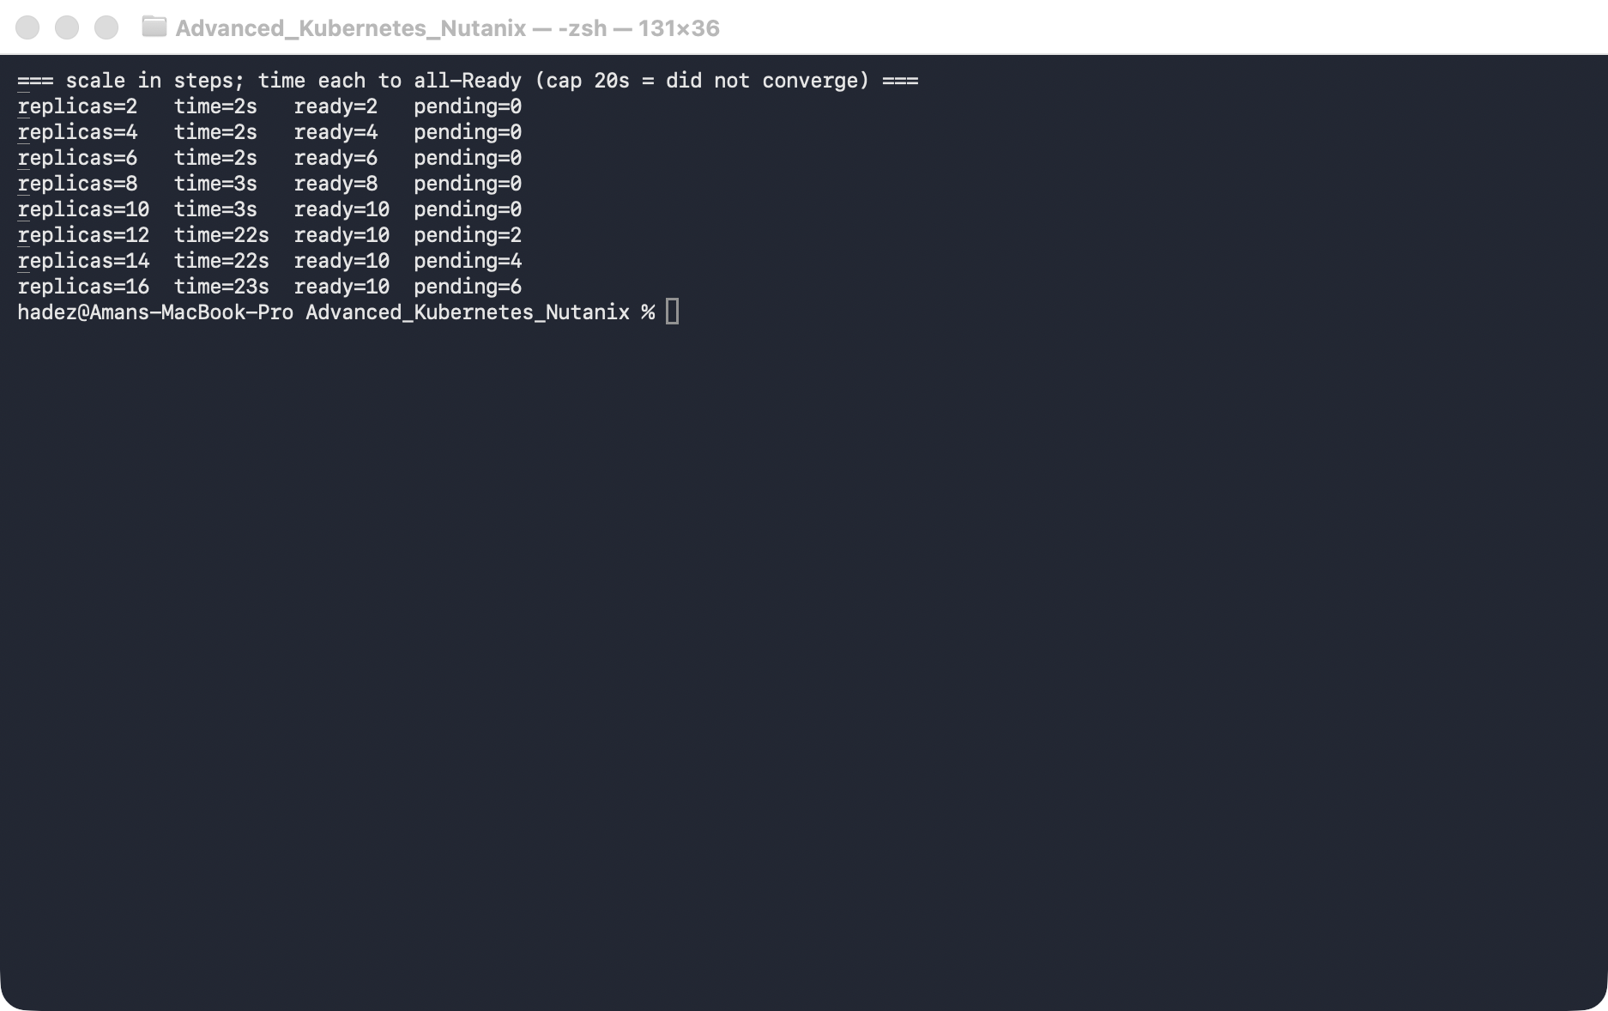
What this means: up to 10 replicas everything is Ready in 2–3 seconds. At 12, two Pods can't be placed — ready sticks at 10 and the step times out. The cluster's real capacity is exactly 10 of these 50m Pods (≈500m), matching the ~560m free from Step 1. The knee is at 12.

Step 3 — Graph the knee
Goal: plot time-to-ready against replicas so the knee is unmistakable.
The chart below is generated from the measurement above (a small script, tools/scale_chart.py, turns the numbers into this SVG/PNG):
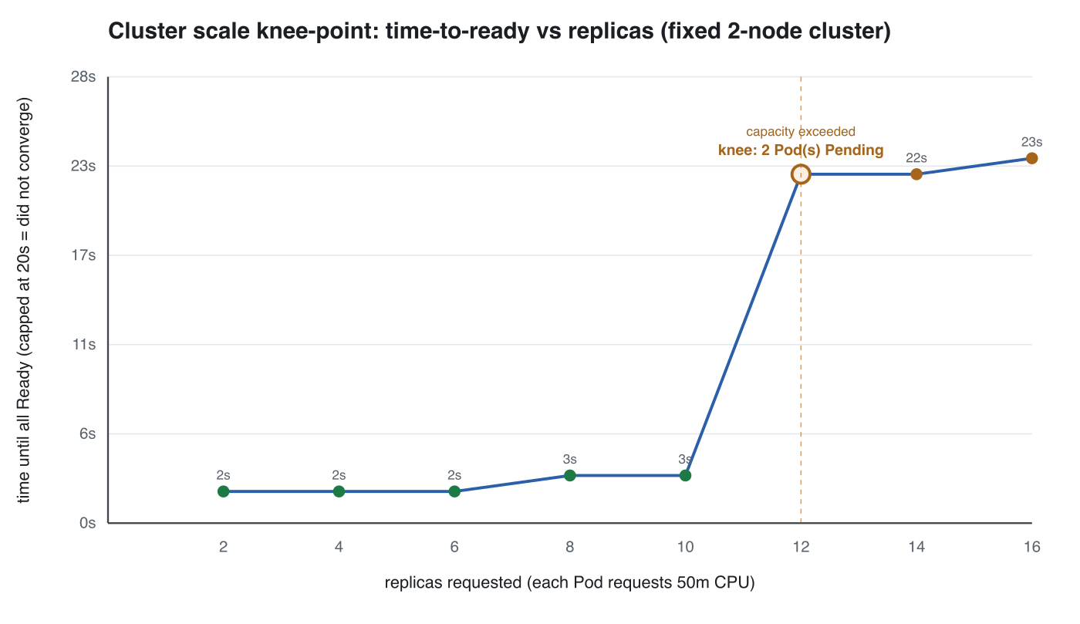
What this means: the green points (2–10) sit flat along the bottom at 2–3 seconds. Then the line goes almost vertical — the orange point at 12 is the knee, where Pods started going Pending and the step stopped converging. There's no gentle ramp: the jump from "instant" to "never" happens between two adjacent steps. That's why the average scale-up time is a useless planning number, and the knee is the only one that matters.

Step 4 — Look at what's stuck past the knee
Goal: confirm the cliff is unschedulable Pods, not slow ones.
1. List the Pending Pods and read why:
kubectl get pods -l app=scaletest --field-selector=status.phase=Pending
PEND=$(kubectl get pods -l app=scaletest --field-selector=status.phase=Pending -o jsonpath='{.items[0].metadata.name}')
kubectl describe pod "$PEND" | grep -m1 'Insufficient cpu'
What you should see: several Pending Pods, and a FailedScheduling event reading 0/2 nodes are available: 2 Insufficient cpu.
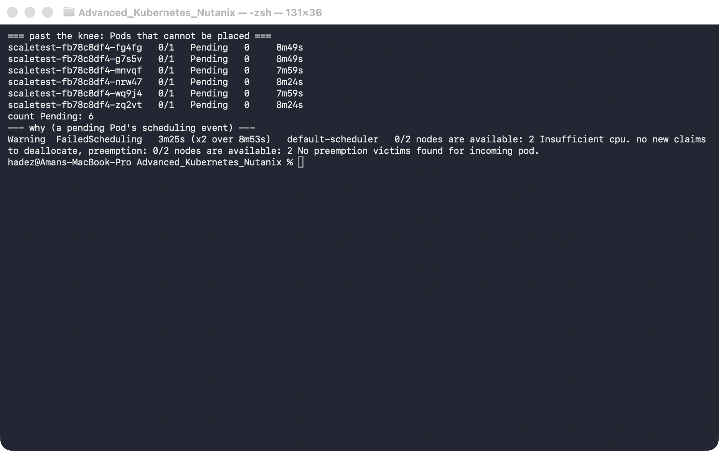
What this means: these Pods aren't slow — they're unschedulable. On this fixed cluster they'll wait forever. Moving the knee out means adding real capacity: bigger nodes (more allocatable each), more nodes, or the cluster autoscaler — which watches for exactly these Pending Pods and provisions a node automatically (we turned it off here so the boundary would stay put).

Step 5 — Clean up
kubectl delete deployment scaletest
Leave advk8s-day2 for Lab 10, or delete it if you're done with Day 2:
gcloud container clusters delete advk8s-day2 --zone us-central1-a --quiet

What you learned
You saw… | in Step | proof
Real capacity ≪ raw vCPU (system Pods reserve a lot) | 1 | ~560m free of 1880m allocatable
Time-to-ready is flat while Pods fit | 2 / 3 | flat low steps
It cliffs at the replica count that exceeds free CPU | 3 | the knee on the graph
Past the knee, Pods are Pending (Insufficient cpu), not slow | 4 | FailedScheduling event
Move the knee out with bigger/more nodes or the autoscaler | 4

Evidence
Real screenshots and the generated chart are in artifacts/lab-07/, and the captured measurements are in artifacts/lab-07/evidence/lab-06-cluster-scale-knee-point.txt.

Next: Lab 8 — Trace a Blocked Network Flow to the Exact Policy (Cilium & Hubble)

