Lab 9 — Make Two Clusters Behave Like One (Multi-Cluster Service Mesh with Istio)
DataCouch — Advanced Kubernetes (Nutanix)
Table of Contents

Day 2 · Extending and Operating the Platform Under Pressure
YES — Tested end-to-end on a real two-cluster GKE platform (platform-a, platform-b). Every screenshot is a real capture. The payoff: a backend on platform-a calls http://database:5432 by plain Service name and the request is routed across the mesh to the real database Pod on platform-b — proven by inspecting the Envoy sidecar's own endpoint list and seeing a remote-cluster Pod IP.

What you'll learn
- Istio's multi-primary, multi-network model: one control plane per cluster, a shared root of trust, connected by east-west gateways rather than assuming direct pod-to-pod routing.
- Why a shared root CA is what makes cross-cluster mTLS trustworthy — two independent cluster CAs would never trust each other's workload certs.
- How the same Service name in both clusters becomes one logical service, so a caller uses a Service name instead of a hand-copied load-balancer IP.
- How to prove cross-cluster routing by inspecting the Envoy sidecar's endpoints.

What you'll do
You'll generate a shared CA, install Istio on both clusters, stand up east-west gateways, exchange remote secrets so each control plane discovers the other's endpoints, then route a call from platform-a to a database that only exists on platform-b — by name.

Time & cost
- Time: ~75 minutes — the most involved lab of the day.
- Cost: two small GKE clusters plus two extra load balancers (the east-west gateways).

Before you start
- Where you'll work: in a terminal with kubectl contexts named platform-a and platform-b for two GKE clusters, and istioctl installed.
- Assumed setup: both clusters run the course storefront app (a backend Deployment on platform-a; the real database Pod on platform-b). This lab wires the two clusters into one mesh so backend can reach database by name.
Nutanix note. Istio is platform-agnostic; this multi-primary/multi-network topology installs identically across NKE clusters — including across sites, which is a common Nutanix pattern (a mesh spanning two data centres or a DC and an edge). The only GKE-specific parts are the two clusters' provisioning and the LoadBalancer Services fronting the east-west gateways; on-prem those gateways get their external IPs from MetalLB (Lab 13) or Nutanix load balancing instead. The certs, Istio install, remote-secret exchange, and cross-cluster discovery are unchanged.

The idea in 60 seconds
In multi-primary, multi-network, each cluster runs its own istiod and they're peers. "Multi-network" means Istio does not assume platform-a's pods can reach platform-b's pod IPs directly — cross-cluster traffic flows through a per-cluster east-west gateway (an Istio-managed Envoy exposed by a load balancer).
For this to be trustworthy, both clusters' workload certs must chain to the same root CA — so you generate one root and a per-cluster intermediate before installing Istio. Then you exchange remote secrets so each istiod can watch the other's services. Once both clusters have a database Service of the same name, Istio treats them as one logical service, and a call to database from platform-a is routed to the real endpoint on platform-b.
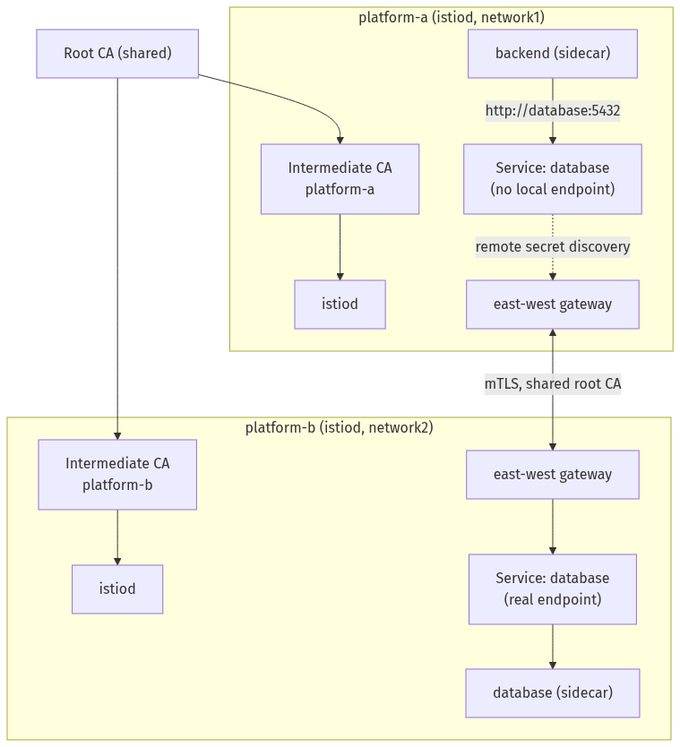

Step 1 — Generate a shared root CA and per-cluster intermediates
Goal: create one root CA and an intermediate per cluster, and install them as each cluster's cacerts.
mkdir -p /tmp/istio-certs && cd /tmp/istio-certs
ISTIO_VERSION=1.31.0 # match your installed istioctl version
curl -L https://github.com/istio/istio/releases/download/${ISTIO_VERSION}/istio-${ISTIO_VERSION}-osx-arm64.tar.gz -o istio.tar.gz
tar xzf istio.tar.gz
cd istio-${ISTIO_VERSION}/tools/certs
make -f Makefile.selfsigned.mk root-ca
make -f Makefile.selfsigned.mk platform-a-cacerts
make -f Makefile.selfsigned.mk platform-b-cacerts
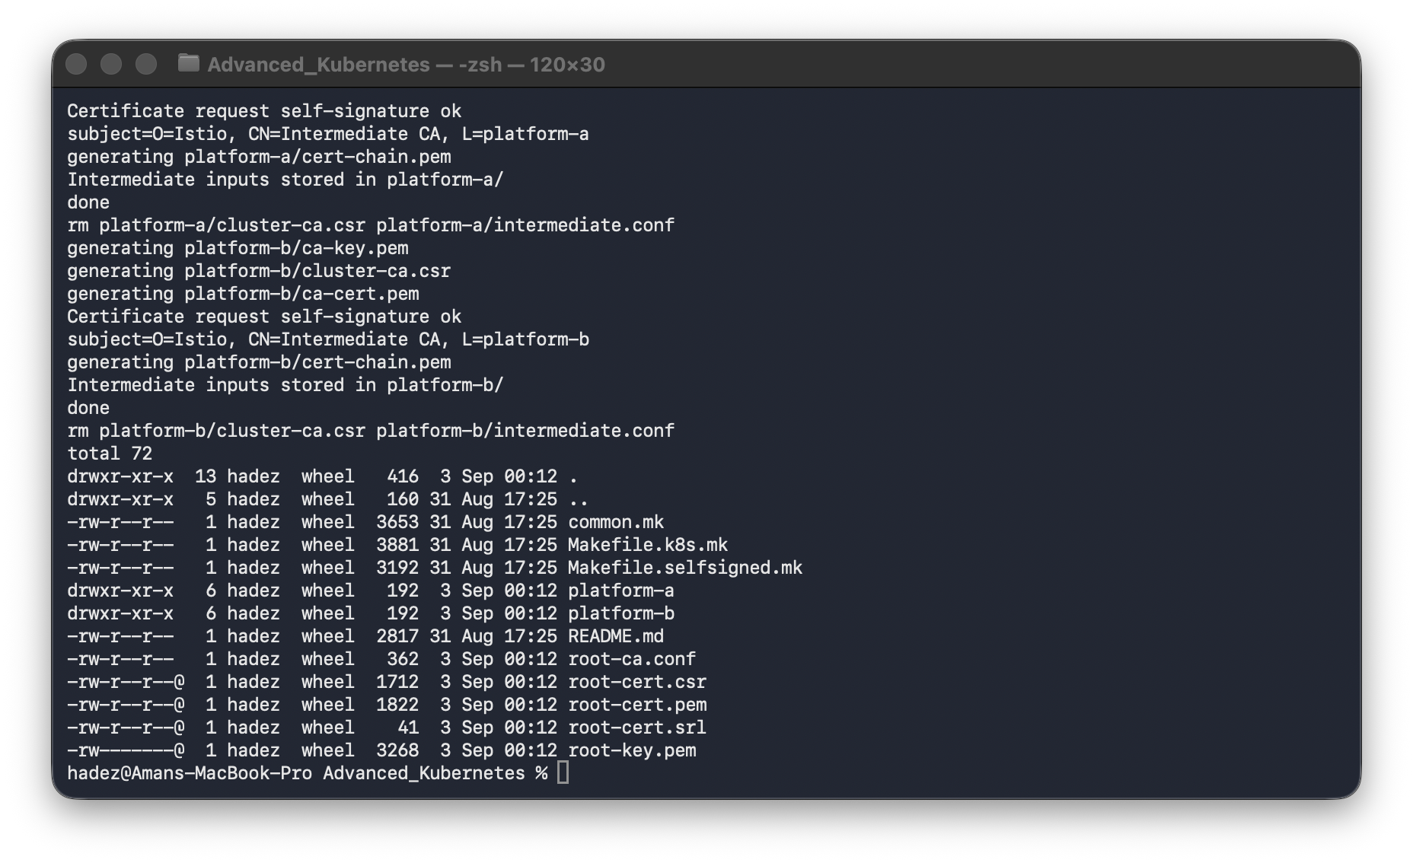
Install each intermediate as the cluster's cacerts secret:
for ctx in platform-a platform-b; do
kubectl --context $ctx create namespace istio-system
kubectl --context $ctx create secret generic cacerts -n istio-system \
--from-file=${ctx}/ca-cert.pem --from-file=${ctx}/ca-key.pem \
--from-file=${ctx}/root-cert.pem --from-file=${ctx}/cert-chain.pem
done
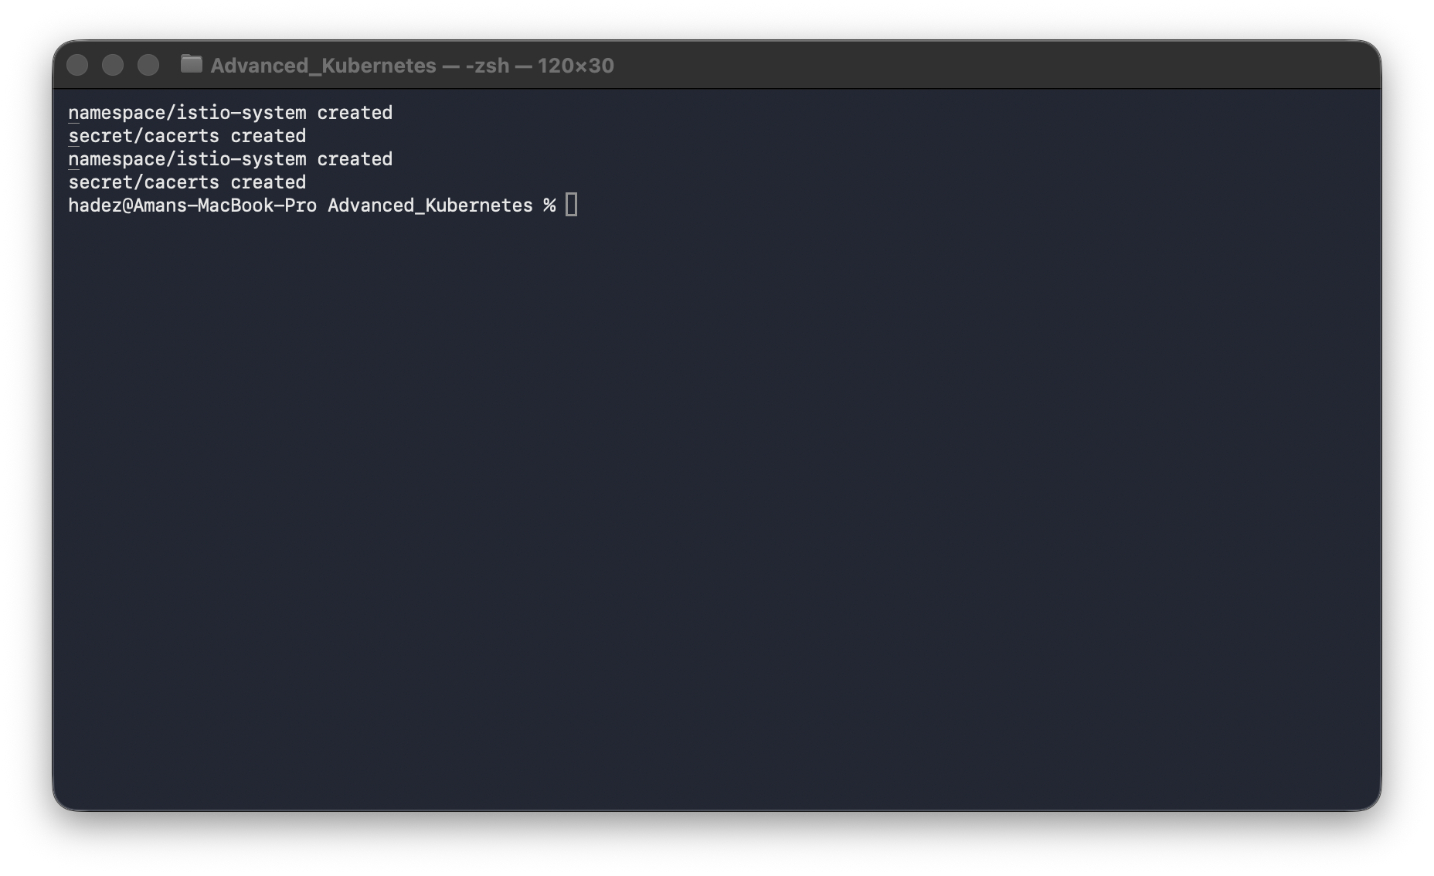
What you should see: the root CA and both intermediates generated, and cacerts created in istio-system on both clusters.
What this means: both clusters now share one root of trust, so workload certs issued by each istiod will validate across the cluster boundary — the prerequisite for cross-cluster mTLS.
⚠️ Gotcha — pin ISTIO_VERSION to your installed istioctl. This download is used only for its tools/certs Makefiles and samples/multicluster/ scripts. Mixing an older samples release with a newer installed istioctl risks IstioOperator API drift. Run istioctl version --remote=false and match it (swap osx-arm64 for linux-amd64 on Linux).

Step 2 — Install Istio on both clusters
Goal: install a control plane per cluster — same meshID, different network.
istioctl install -y --context=platform-a -f - <<EOF
apiVersion: install.istio.io/v1alpha1
kind: IstioOperator
spec:
values:
global:
meshID: mesh1
network: network1
multiCluster: {clusterName: platform-a}
EOF
istioctl install -y --context=platform-b -f - <<EOF
apiVersion: install.istio.io/v1alpha1
kind: IstioOperator
spec:
values:
global:
meshID: mesh1
network: network2
multiCluster: {clusterName: platform-b}
EOF
kubectl --context platform-a label namespace default istio-injection=enabled --overwrite
kubectl --context platform-b label namespace default istio-injection=enabled --overwrite
What you should see: clean Istio installs on both clusters (core, CNI, istiod, ingress), and default labelled for sidecar injection.
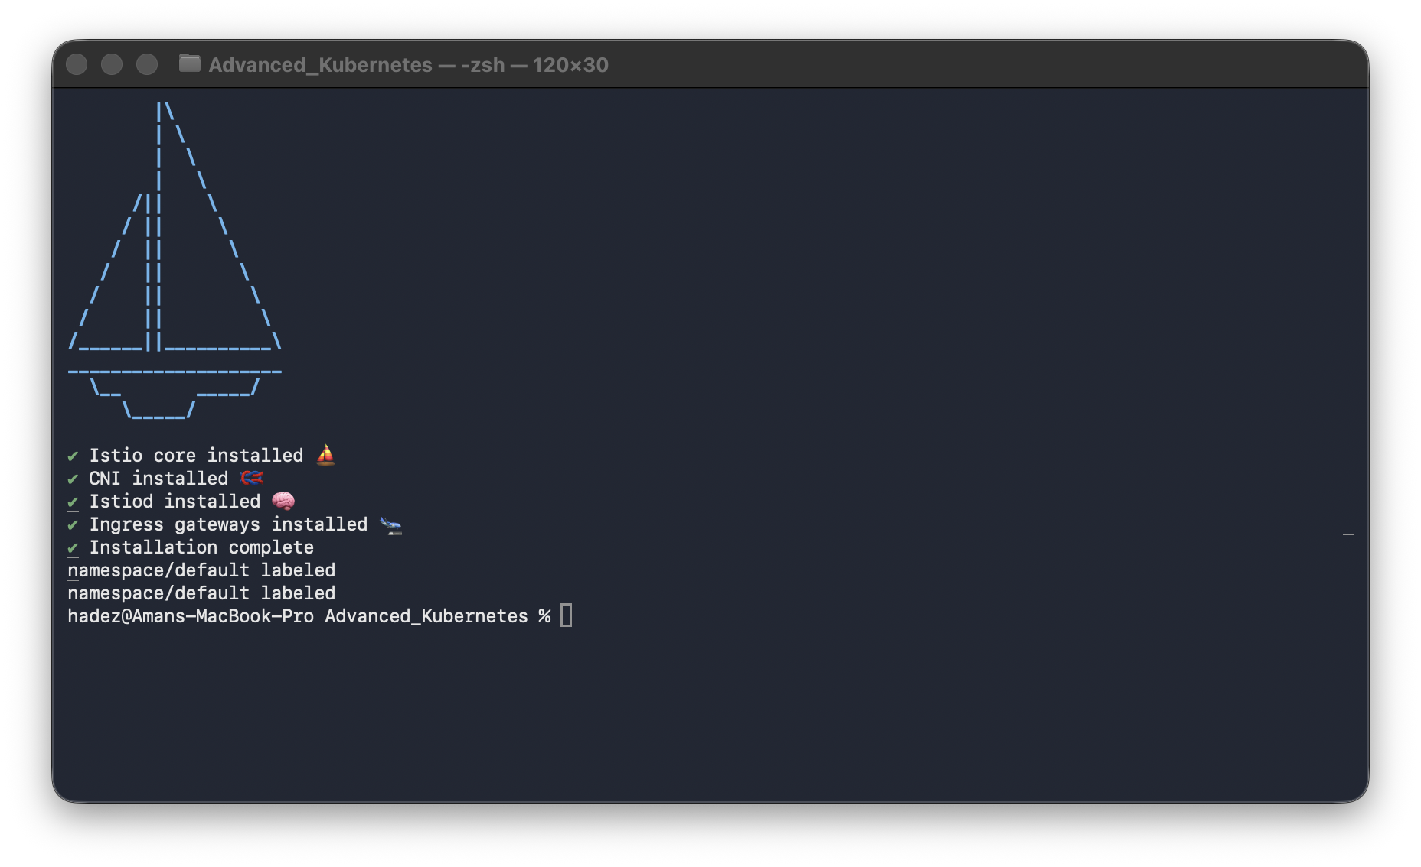
What this means: the same meshID makes them one mesh; the different network per cluster tells Istio not to assume direct pod routing between them, and to use the east-west gateway instead. (platform-a alone: 03-istio-install-a.png.)

Step 3 — Expose an east-west gateway on each cluster
Goal: give each cluster the Envoy gateway through which cross-cluster traffic flows.
cd /tmp/istio-certs/istio-${ISTIO_VERSION}
samples/multicluster/gen-eastwest-gateway.sh --mesh mesh1 --network network1 --cluster platform-a \
| istioctl --context platform-a install -y -f -
kubectl --context platform-a apply -n istio-system -f samples/multicluster/expose-services.yaml
samples/multicluster/gen-eastwest-gateway.sh --mesh mesh1 --network network2 --cluster platform-b \
| istioctl --context platform-b install -y -f -
kubectl --context platform-b apply -n istio-system -f samples/multicluster/expose-services.yaml
kubectl --context platform-a get svc istio-eastwestgateway -n istio-system
kubectl --context platform-b get svc istio-eastwestgateway -n istio-system
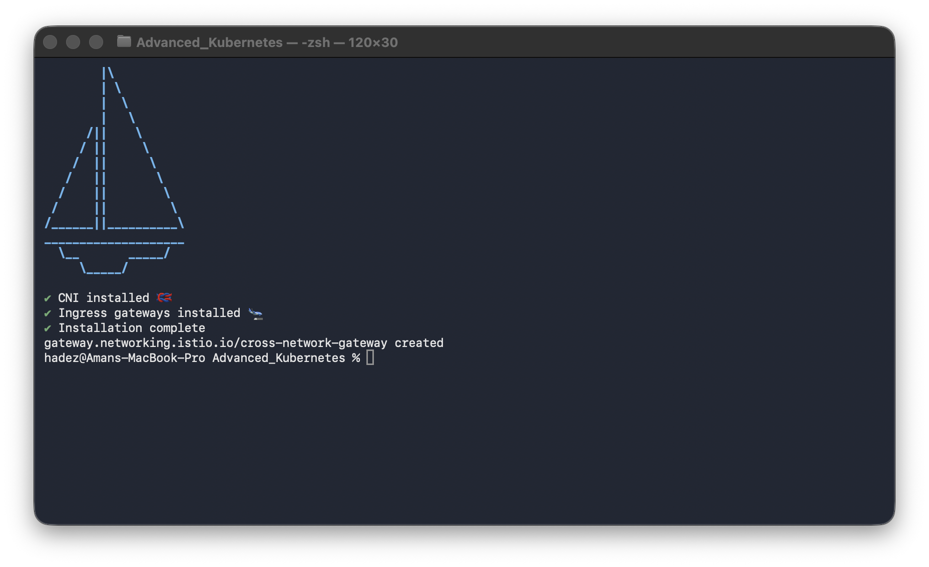
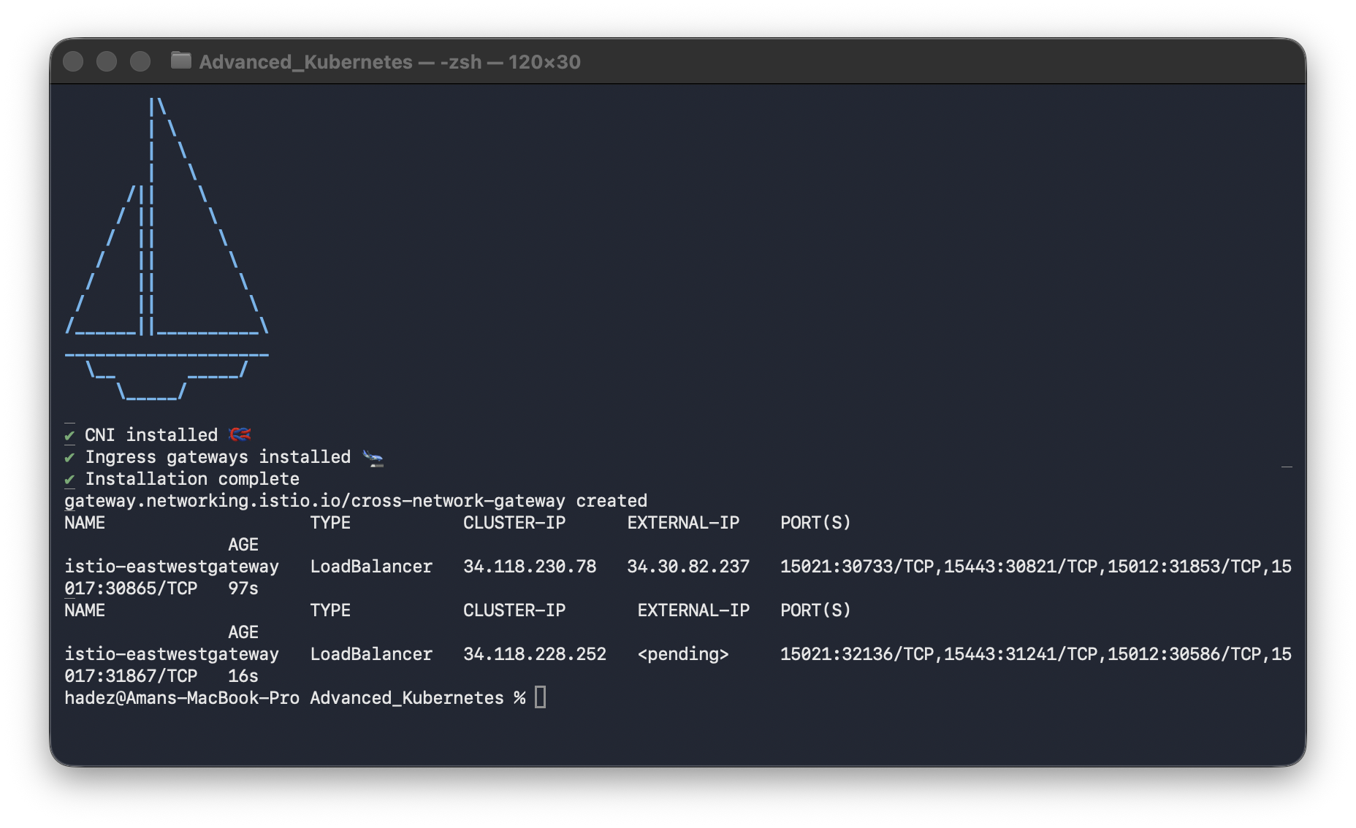
What you should see: both istio-eastwestgateway Services get real external IPs (platform-b's may take a minute longer to leave <pending>).
What this means: expose-services.yaml is what makes mesh Services reachable through the gateway — without it the gateway exists but forwards nothing.

Step 4 — Exchange remote secrets (link the two control planes)
Goal: give each istiod read access to the other cluster so it can discover its endpoints.
# wait for platform-b's gateway IP first
until kubectl --context platform-b get svc istio-eastwestgateway -n istio-system \
-o jsonpath='{.status.loadBalancer.ingress[0].ip}' 2>/dev/null | grep -q .; do sleep 5; done
istioctl create-remote-secret --context=platform-a --name=platform-a | kubectl --context=platform-b apply -f -
istioctl create-remote-secret --context=platform-b --name=platform-b | kubectl --context=platform-a apply -f -
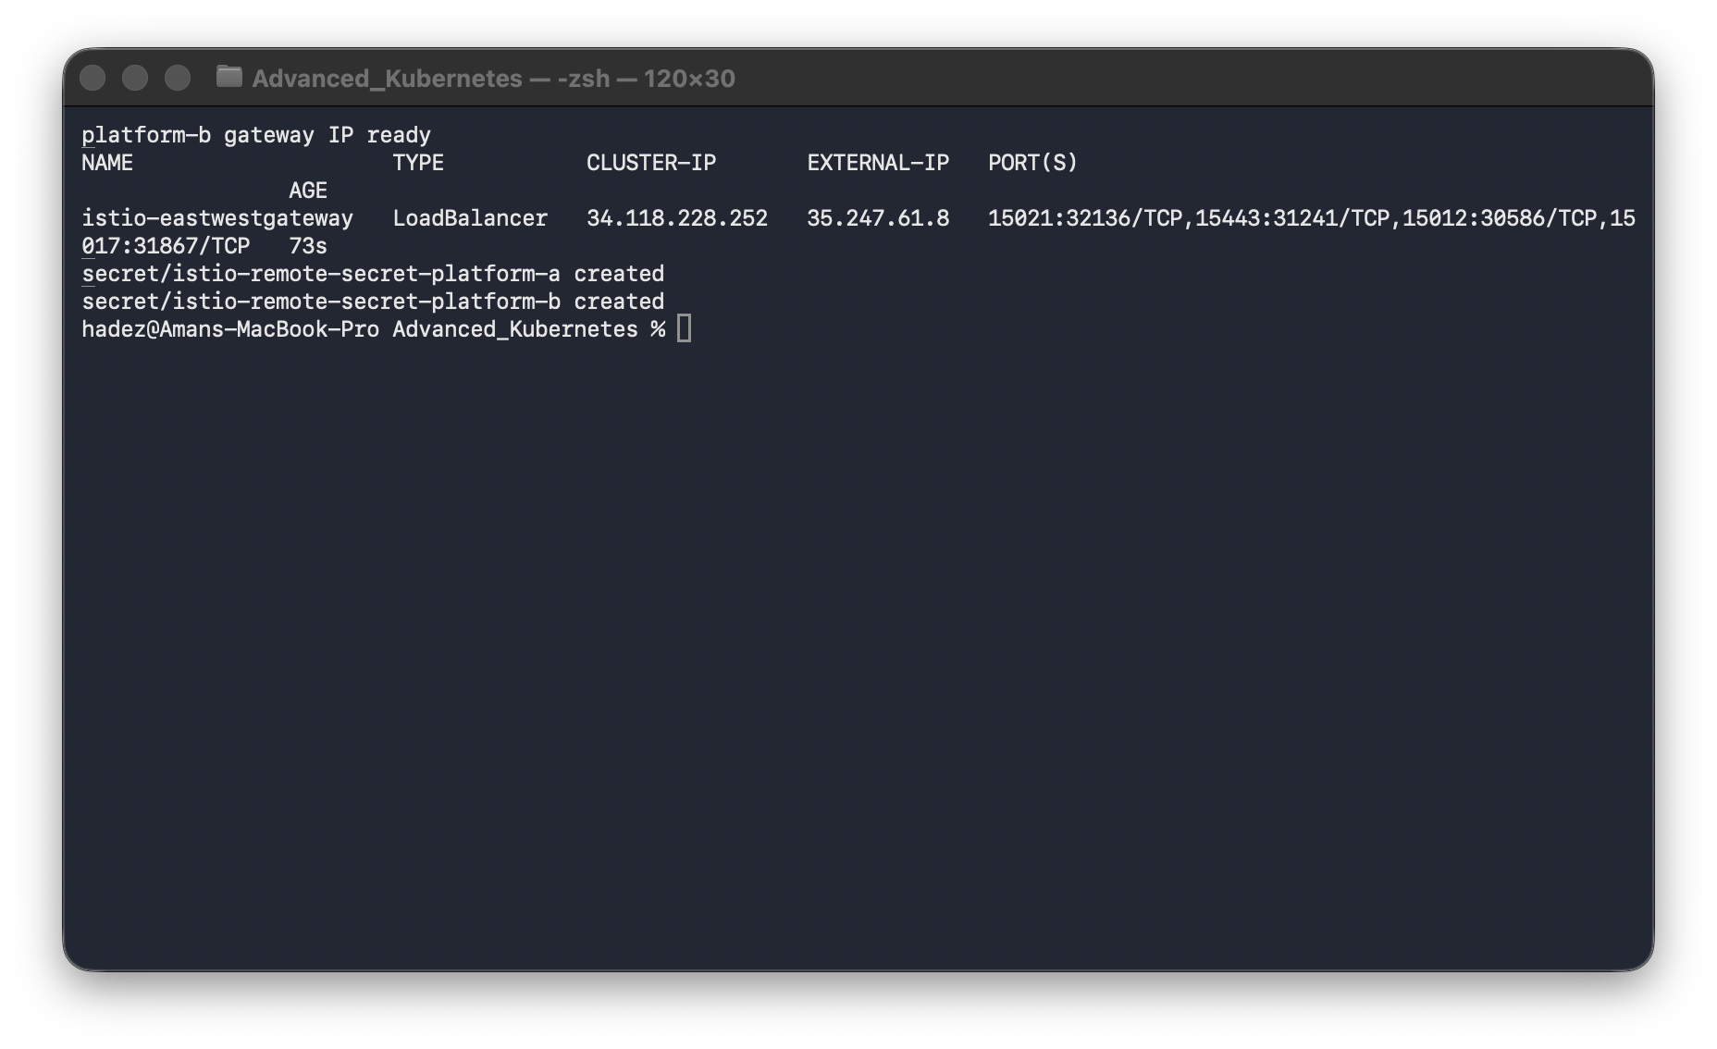
What you should see: istio-remote-secret-platform-a and -platform-b created.
What this means: each cluster's istiod now holds a client credential for the other cluster, so it can watch the other's Endpoints/Services and fold them into its own service registry. Without this step, both clusters have a healthy standalone mesh that simply doesn't know the other exists.

Step 5 — Route to a Service that lives only on the other cluster
Goal: replace a hand-copied IP with a plain Service name resolved across the mesh.
# a 'database' Service on platform-a with NO local pods — deliberately
kubectl --context platform-a apply -f - <<'EOF'
apiVersion: v1
kind: Service
metadata: {name: database}
spec:
ports: [{port: 5432, targetPort: 5432}]
selector: {app: database}
EOF
kubectl --context platform-a set env deployment/backend DB_HOST=database
kubectl --context platform-a rollout restart deployment/backend
kubectl --context platform-a rollout status deployment/backend --timeout=120s
kubectl --context platform-a exec deployment/backend -- \
python3 -c "import urllib.request; print(urllib.request.urlopen('http://localhost:8080/catalog').read().decode())"
What you should see: the real product list — [{"name":"Keyboard","price":49.99},{"name":"Mouse","price":19.99},{"name":"Monitor","price":199.99}] — even though DB_HOST is now the plain name database, whose only real endpoint is on platform-b.
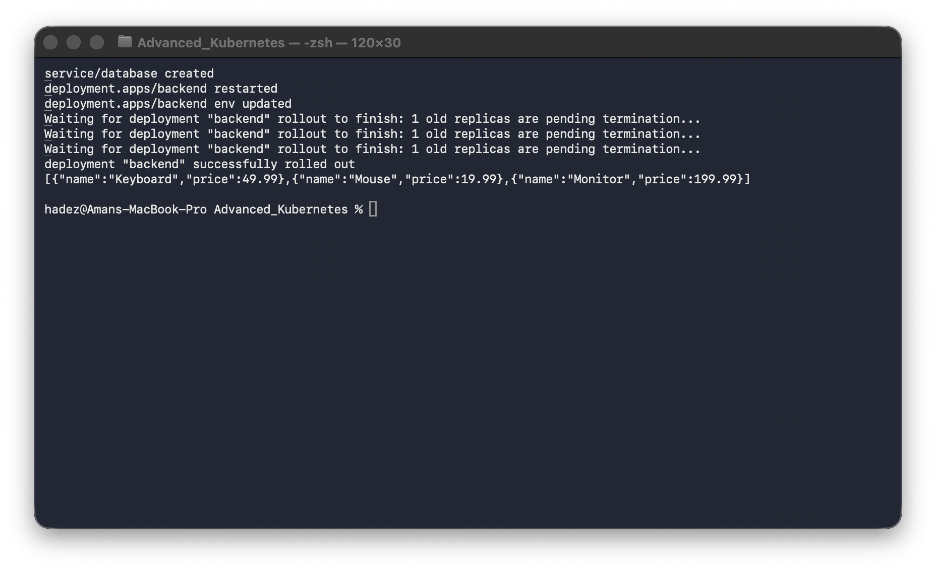
Prove it's genuinely cross-cluster by inspecting the backend sidecar's endpoints:
istioctl proxy-config endpoints deployment/backend.default --context platform-a | grep -i database
What you should see: an endpoint like 10.72.1.10:5432 HEALTHY — an IP inside platform-b's Pod CIDR (10.72.0.0/14), nowhere near platform-a's (10.84.0.0/14).
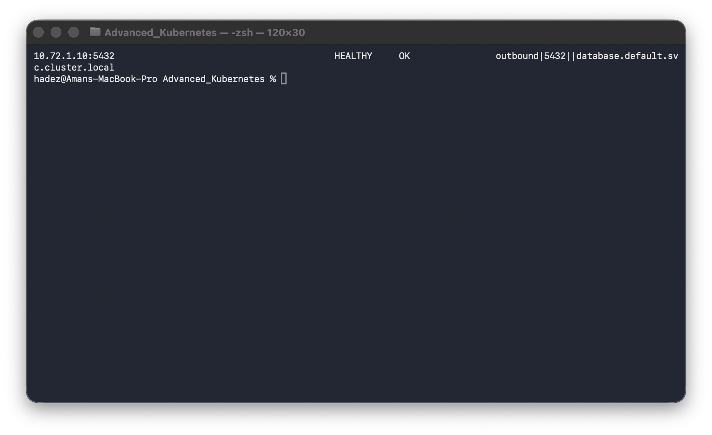
What this means: direct proof — platform-a's backend sidecar is routing this call across the mesh to the real Pod on platform-b, not to anything local. The same Service name, in both clusters, is one logical service.

What you learned
You saw… | in Step | proof
A shared root CA with per-cluster intermediates | 1 | cacerts on both clusters, one root
Multi-primary control planes, one mesh, two networks | 2 | same meshID, different network
East-west gateways expose services cross-cluster | 3 | real external IPs on both gateways
Remote secrets let each control plane see the other | 4 | istio-remote-secret-* on both
A call routes cross-cluster by Service name | 5 | Envoy endpoint = a platform-b Pod IP

Evidence
Real screenshots for this lab are in artifacts/lab-09/screenshots/ (9 images).

Next: Lab 10 — Block Bad Images Before They Run (Image Scanning & Admission Control with Kyverno)

