Lab 19 — Queue a Distributed Training Job Behind a Quota (Kueue-Managed PyTorchJob)
DataCouch — Advanced Kubernetes (Nutanix)
Table of Contents

Day 5 · Kubernetes as the AI-Native Platform
YES — Tested end-to-end on a real GKE cluster (advk8s-lab) with the Kubeflow Training Operator and Kueue v0.19. Every screenshot is a real capture. The payoff: you submit two real distributed-training jobs; Kueue admits one and holds the other because the quota is full — then, when the first finishes, it automatically admits the waiting job, which runs a genuine torch.distributed collective across three Pods (all_reduce result: 3.0).

What you'll learn
- How the Training Operator turns a PyTorchJob into master + worker Pods and wires torch.distributed for you (no manual MASTER_ADDR/RANK).
- How Kueue (Lab 14) governs those jobs: a training job that exceeds available quota is suspended until capacity frees, then admitted automatically.
- Why this pairing is how shared GPU/accelerator clusters stay both fair and busy.

What you'll do
You'll enable Kueue to manage PyTorchJobs, define a quota big enough for one job, then submit two — watching one run and one wait, and the waiter start the moment the first finishes.

Time & cost
- Time: ~40 minutes.
- Cost: negligible — small CPU-only python:3.11-slim Pods on the shared GKE cluster (no GPU needed to exercise the mechanics).

Before you start
- Where you'll work: in a terminal with kubectl pointed at a GKE cluster.
- Tools you need: gcloud, kubectl.
- Assumes Lab 14's Kueue is installed on the cluster (kueue-system). You'll add the Training Operator and turn on Kueue's PyTorchJob integration here.
Nutanix note. This is the on-prem AI-platform pattern in miniature. A Nutanix cluster with a fixed pool of GPUs is shared by several teams' training jobs; Kueue gives each team a quota floor and queues everything else, so the expensive hardware is neither monopolised nor left idle. Swap the pods' cpu request for nvidia.com/gpu and this lab is the GPU-scheduling story — the Training Operator and Kueue both run unchanged on NKE. We use CPU-only PyTorch here so you can exercise the real torch.distributed mechanics without a GPU.

The idea in 60 seconds
A PyTorchJob describes a Master replica and Worker replicas. The Training Operator creates one Pod per replica and injects the env vars torch.distributed needs (MASTER_ADDR, MASTER_PORT, WORLD_SIZE, RANK) so the processes form one process group — you never hand-wire networking.
Kueue sits in front: label the PyTorchJob with a LocalQueue, and Kueue suspends it until its ClusterQueue has enough quota. Submit more jobs than fit, and the extras wait — then get admitted, in order, as running jobs finish.
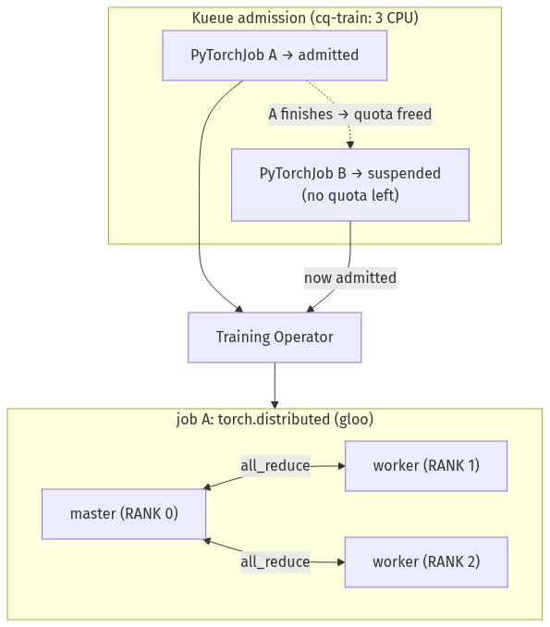

Step 1 — Install the Training Operator and let Kueue manage PyTorchJobs
Goal: get the operator running and add kubeflow.org/pytorchjob to Kueue's managed frameworks.
1. Install the Training Operator:
kubectl apply --server-side -k "github.com/kubeflow/training-operator/manifests/overlays/standalone?ref=v1.9.0"
kubectl wait --for=condition=Available --timeout=150s -n kubeflow deployment/training-operator
2. Enable the PyTorchJob integration in Kueue and restart its controller (Kueue's default framework list doesn't include it):
# add kubeflow.org/pytorchjob to integrations.frameworks in the Kueue config, then:
kubectl -n kueue-system edit cm kueue-manager-config # uncomment: - "kubeflow.org/pytorchjob"
kubectl -n kueue-system rollout restart deploy/kueue-controller-manager
kubectl -n kueue-system rollout status deploy/kueue-controller-manager --timeout=120s
What you should see: training-operator Running, and the Kueue controller back up after the restart.
What this means: the Training Operator can now reconcile PyTorchJobs, and Kueue will gate them — suspending any PyTorchJob carrying a queue label until quota is available.
⚠️ Gotcha — Kueue only manages the frameworks in its config. If kubeflow.org/pytorchjob isn't in integrations.frameworks, Kueue ignores your PyTorchJobs entirely — they run immediately with no admission control, and you'll wonder why nothing queues. The config change requires a controller restart to take effect.

Step 2 — Define a quota and the training code
Goal: create a ClusterQueue sized for exactly one job, a LocalQueue for the team, and the distributed-training script.
kubectl create namespace ml-team
# the real torch.distributed all_reduce test
cat > /tmp/dist_test.py <<'EOF'
import torch, torch.distributed as dist
dist.init_process_group(backend="gloo")
rank, world = dist.get_rank(), dist.get_world_size()
t = torch.tensor([float(rank)])
dist.all_reduce(t, op=dist.ReduceOp.SUM)
print(f"[rank {rank}/{world}] all_reduce result: {t.item()} (expected {sum(range(world))})")
EOF
kubectl -n ml-team create configmap dist-test-code --from-file=dist_test.py=/tmp/dist_test.py
kubectl apply -f - <<'EOF'
apiVersion: kueue.x-k8s.io/v1beta2
kind: ResourceFlavor
metadata: {name: default-flavor}
---
apiVersion: kueue.x-k8s.io/v1beta2
kind: ClusterQueue
metadata: {name: cq-train}
spec:
namespaceSelector: {}
resourceGroups:
- coveredResources: ["cpu"]
flavors:
- name: default-flavor
resources: [{name: cpu, nominalQuota: "3"}] # one job = 1 master + 2 workers x 1 CPU
---
apiVersion: kueue.x-k8s.io/v1beta2
kind: LocalQueue
metadata: {name: train-queue, namespace: ml-team}
spec: {clusterQueue: cq-train}
EOF
What you should see: cq-train created with a nominal quota of 3 CPU.
What this means: 3 CPU is exactly one training job's worth (master + 2 workers × 1 CPU). A second job can't fit until the first releases its quota.

Step 3 — Submit two jobs, and watch Kueue admit one and hold the other
Goal: submit two identical PyTorchJobs and see Kueue gate them.
Submit a job (repeat for train-job-b, changing the name):
kubectl -n ml-team apply -f - <<'EOF'
apiVersion: kubeflow.org/v1
kind: PyTorchJob
metadata:
name: train-job-a
labels: {kueue.x-k8s.io/queue-name: train-queue} # <-- gates it through Kueue
spec:
runPolicy: {cleanPodPolicy: None}
pytorchReplicaSpecs:
Master:
replicas: 1
restartPolicy: OnFailure
template:
spec:
containers:
- name: pytorch
image: python:3.11-slim
command: ["sh","-c","pip install --quiet torch --index-url https://download.pytorch.org/whl/cpu && python /code/dist_test.py && sleep 300"]
resources: {requests: {cpu: "1"}}
volumeMounts: [{name: code, mountPath: /code}]
volumes: [{name: code, configMap: {name: dist-test-code}}]
Worker:
replicas: 2
restartPolicy: OnFailure
template:
spec:
containers:
- name: pytorch
image: python:3.11-slim
command: ["sh","-c","pip install --quiet torch --index-url https://download.pytorch.org/whl/cpu && python /code/dist_test.py && sleep 300"]
resources: {requests: {cpu: "1"}}
volumeMounts: [{name: code, mountPath: /code}]
volumes: [{name: code, configMap: {name: dist-test-code}}]
EOF
Then check the state:
kubectl get clusterqueue cq-train -o custom-columns='NAME:.metadata.name,NOMINAL_CPU:.spec.resourceGroups[0].flavors[0].resources[0].nominalQuota,USED_CPU:.status.flavorsReservation[0].resources[0].total,ADMITTED:.status.admittedWorkloads,PENDING:.status.pendingWorkloads'
kubectl -n ml-team get pytorchjob
kubectl -n ml-team get workloads
kubectl -n ml-team get pods
What you should see: cq-train is fully used (USED_CPU 3, ADMITTED 1, PENDING 1); train-job-a is Running with 3 Pods; train-job-b is Suspended with no Pods — Kueue is holding it because there's no quota left.
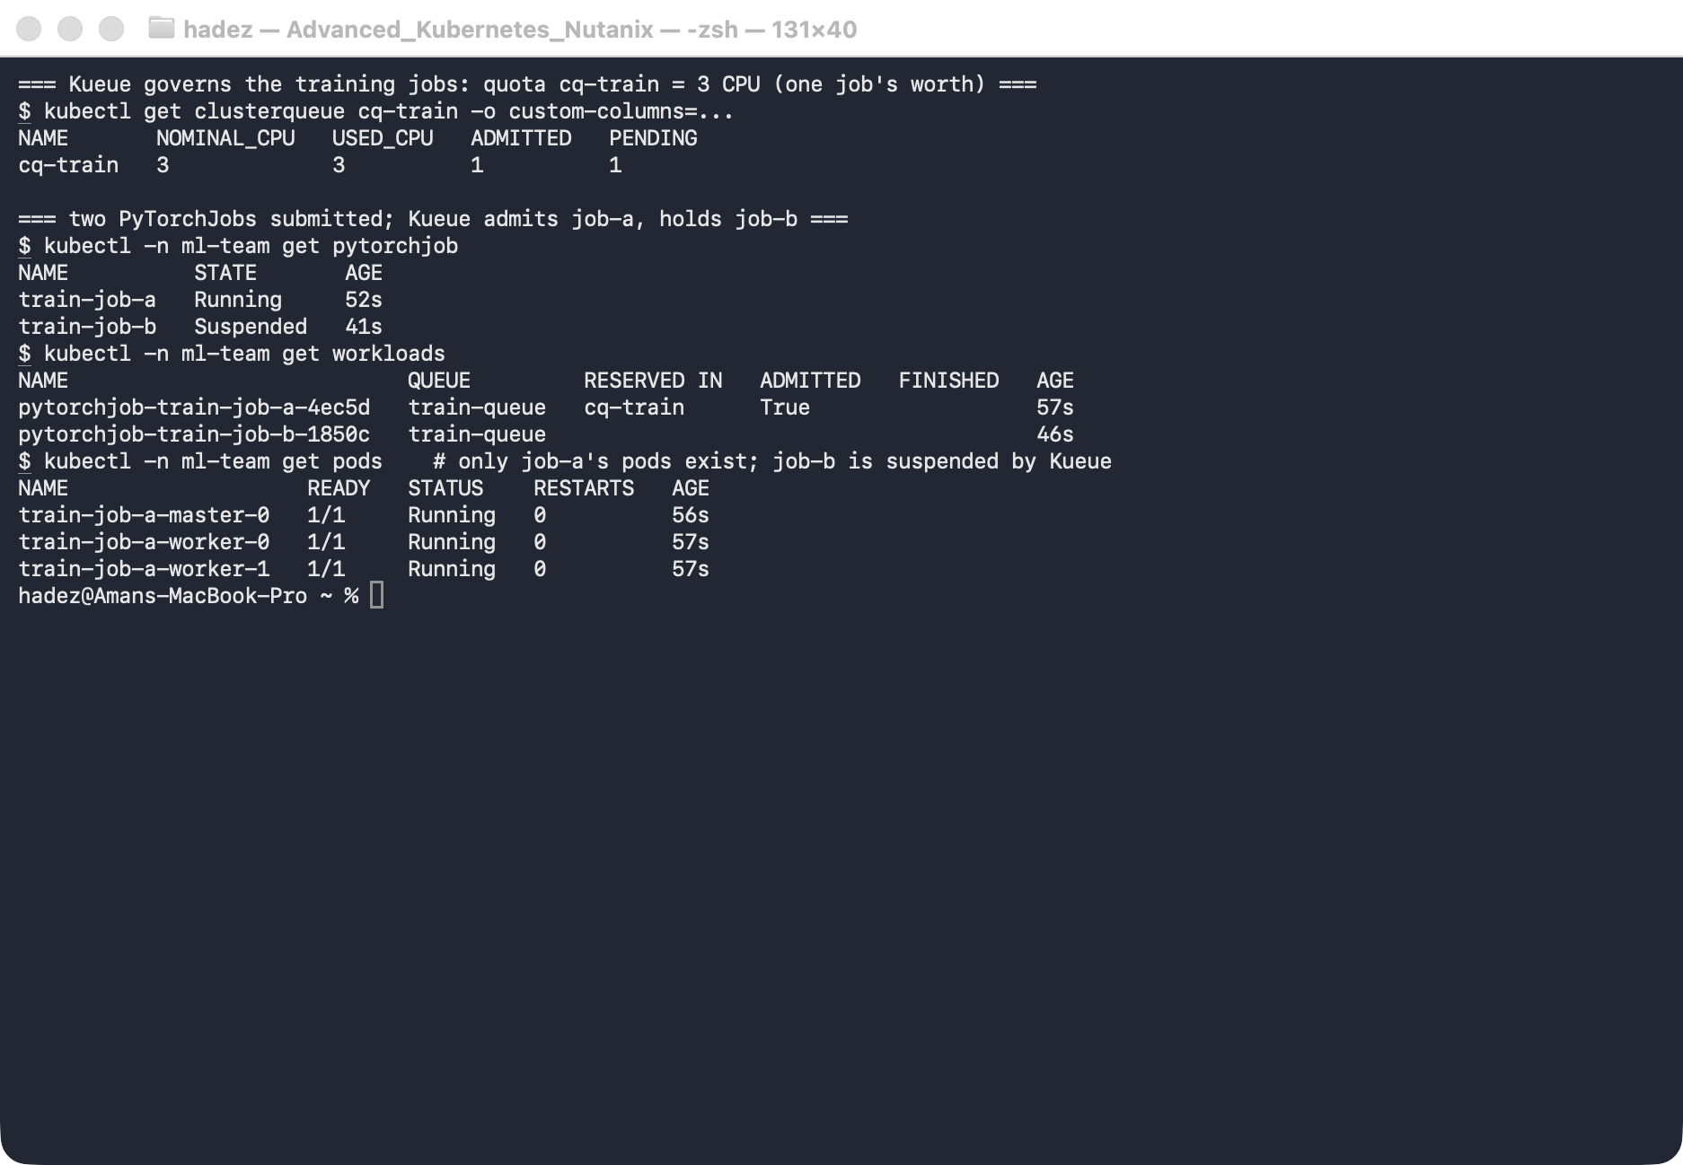
What this means: Kueue admits whole jobs only when quota exists. The waiting job consumes nothing — no half-started Pods jamming the scheduler.

Step 4 — Free the quota, and watch the waiter run real distributed training
Goal: finish/remove the first job and see Kueue admit the second, which runs a genuine torch.distributed collective.
kubectl -n ml-team delete pytorchjob train-job-a # releases its 3 CPU
# Kueue admits train-job-b automatically within seconds; it pip-installs torch, then runs:
kubectl -n ml-team get workloads
kubectl -n ml-team get pytorchjob train-job-b
kubectl -n ml-team logs train-job-b-master-0 | grep all_reduce
What you should see: train-job-b's workload flips to ADMITTED: True, its Pods start, and the master log prints [rank 0/3] all_reduce result: 3.0 (expected 3) — three ranks (master + 2 workers), each contributing its rank number (0+1+2 = 3), summed by a real torch.distributed all_reduce across three separate Pods.
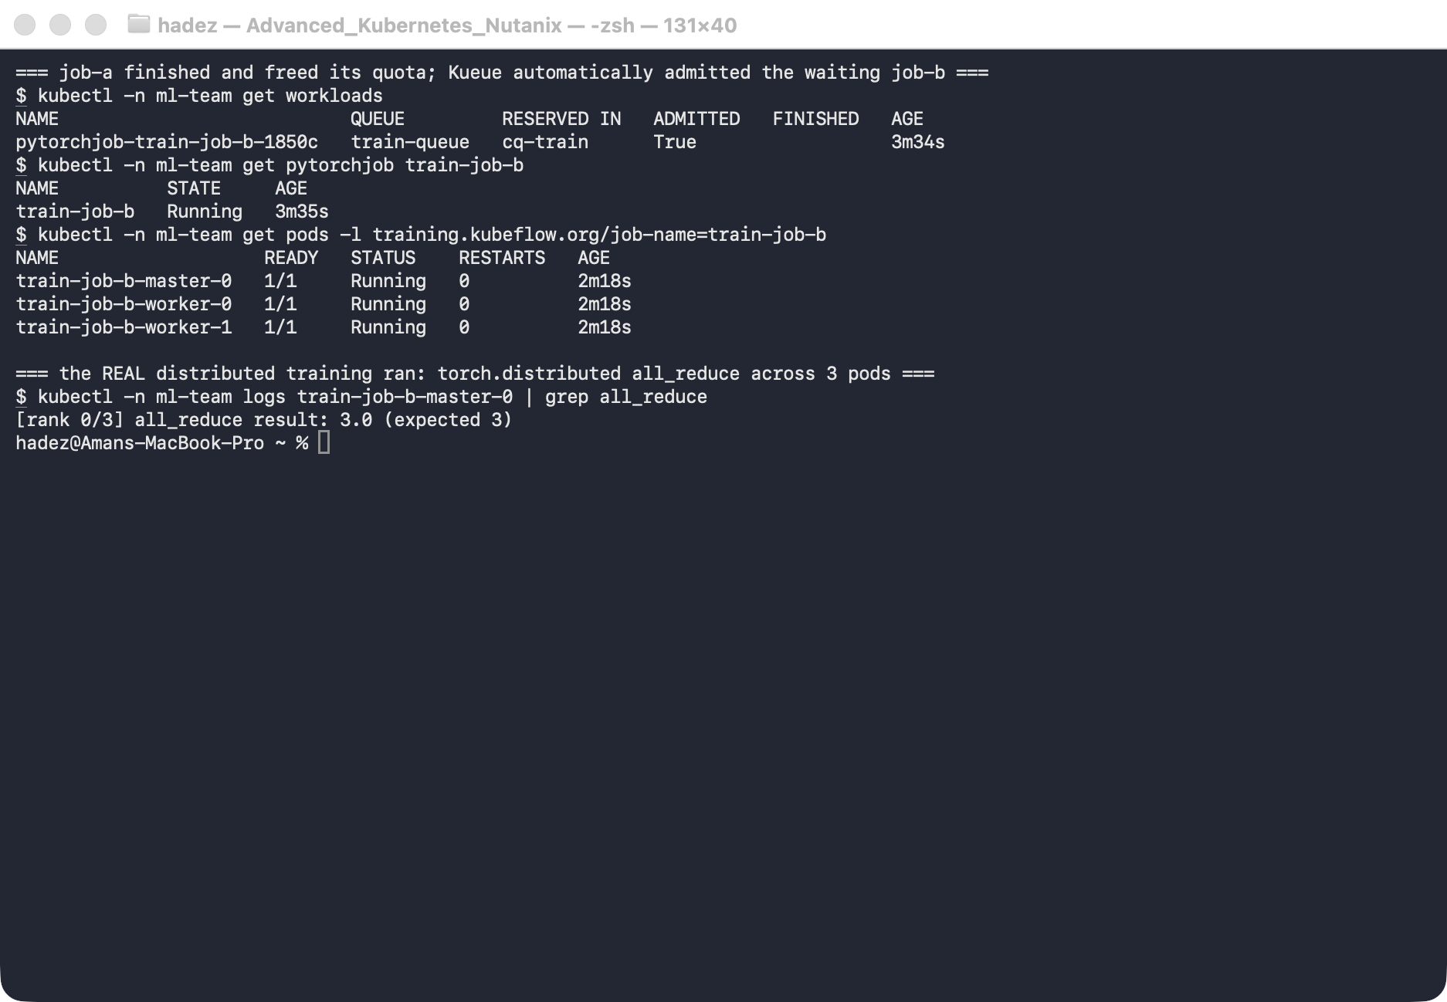
What this means: two things at once. The training is real — a distributed collective formed across Pods with zero manual networking, thanks to the Training Operator. And the governance is real — Kueue queued job-b behind job-a and admitted it the instant capacity appeared. That's exactly how a shared accelerator pool serves many teams without starving or idling.

Step 5 — Clean up
kubectl delete namespace ml-team --ignore-not-found
kubectl delete clusterqueue cq-train --ignore-not-found
kubectl delete resourceflavor default-flavor --ignore-not-found
# optionally remove the Training Operator:
# kubectl delete -k "github.com/kubeflow/training-operator/manifests/overlays/standalone?ref=v1.9.0"

What you learned
You saw… | in Step | proof
The Training Operator turns a PyTorchJob into master+worker Pods | 3 | train-job-a → 3 Pods, no manual networking
Kueue gates training jobs by quota | 3 | job-a admitted, job-b Suspended, no pods
A waiting job is admitted automatically when quota frees | 4 | delete job-a → job-b Admitted: True
Real distributed training runs across the Pods | 4 | all_reduce result: 3.0 (expected 3)

Evidence
Real screenshots for this lab are in artifacts/lab-19/screenshots/ (2 images), and a command transcript is in artifacts/lab-19/evidence/lab-15b-distributed-training.txt.

Next: Lab 20 — Scale Out and Right-Size a Workload (Advanced HPA & VPA Patterns)

