Lab 24 — Let an AI Agent Read the Cluster but Never Change It (Guardrailed Agentic Kubernetes)
DataCouch — Advanced Kubernetes (Nutanix)
Table of Contents

Day 5 · Kubernetes as the AI-Native Platform
YES — Tested end-to-end on a real GKE cluster (advk8s-lab) using native ValidatingAdmissionPolicy (GA). Every screenshot is a real capture. The payoff: an "agent" identity that RBAC would let mutate the cluster has every write denied and audited by an admission-time guardrail — while its reads keep working normally.

What you'll learn
- Why giving an AI agent a kubectl credential is risky: an over-broad (or compromised) agent can delete, scale, or reconfigure things.
- How to build a guardrail that is independent of the agent's RBAC — a ValidatingAdmissionPolicy that denies mutations from the agent's identity at admission time, and audits the attempt.
- Why admission-time policy is the right layer for this: it catches the action regardless of how the agent got its permissions.

What you'll do
You'll create an agent ServiceAccount with deliberately over-broad RBAC (it can read and write), then add a ValidatingAdmissionPolicy that denies any create/update/delete from that identity. You'll confirm the agent still reads fine, but every mutation is denied and logged — and that normal admins are unaffected.

Time & cost
- Time: ~30 minutes.
- Cost: negligible — a ServiceAccount, a policy, and one small Deployment.

Before you start
- Where you'll work: in a terminal with kubectl pointed at a GKE cluster (Kubernetes 1.30+ for ValidatingAdmissionPolicy).
- Tools you need: gcloud, kubectl.
- Cluster: a GKE cluster (this course's shared advk8s-lab).
Nutanix note. As teams wire LLM agents and autonomous operators into their clusters, the question "what can this agent actually do?" becomes a real security control. On NKE you'd apply exactly this pattern: ValidatingAdmissionPolicy is built into Kubernetes (no external controller like Kyverno/OPA needed), so it's the lightest way to put an identity-scoped, audited guardrail on agent actions on-prem. The key idea — enforce at admission on the identity, not only via RBAC — means the guardrail holds even if someone later widens the agent's RBAC or its token leaks.

The idea in 60 seconds
RBAC decides whether an identity is allowed to do something. But RBAC is easy to over-grant ("just give the agent edit so it stops erroring"), and a leaked agent token inherits whatever RBAC the agent had. A ValidatingAdmissionPolicy (VAP) adds a second, independent gate: after authz, the API server evaluates a CEL policy against the request — including who is making it (request.userInfo) — and can deny it, audit it, or both.
So even if the agent's RBAC says "yes, you may delete," the VAP says "not from this identity" — and records the attempt.
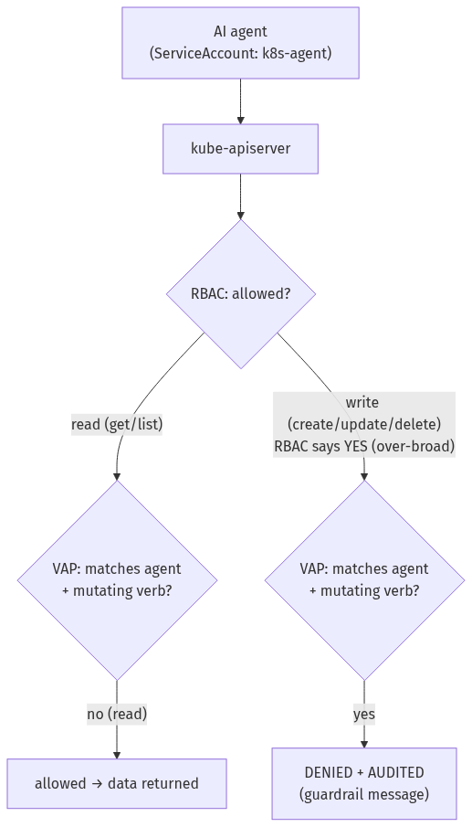

Step 1 — Create an (over-permissioned) agent identity
Goal: give the agent a ServiceAccount whose RBAC allows both reads and writes — the realistic "we granted it too much" starting point.
kubectl create namespace agent-workspace
kubectl -n agent-workspace create serviceaccount k8s-agent
kubectl apply -f - <<'EOF'
apiVersion: rbac.authorization.k8s.io/v1
kind: Role
metadata: {name: agent-role, namespace: agent-workspace}
rules:
- apiGroups: [""]
resources: ["pods","configmaps","services"]
verbs: ["get","list","watch","create","update","patch","delete"] # <-- includes writes
- apiGroups: ["apps"]
resources: ["deployments"]
verbs: ["get","list","watch","create","update","patch","delete"]
---
apiVersion: rbac.authorization.k8s.io/v1
kind: RoleBinding
metadata: {name: agent-binding, namespace: agent-workspace}
subjects:
- {kind: ServiceAccount, name: k8s-agent, namespace: agent-workspace}
roleRef: {kind: Role, name: agent-role, apiGroup: rbac.authorization.k8s.io}
EOF
kubectl -n agent-workspace create deployment web --image=nginx:1.27-alpine
# confirm RBAC really would allow both:
kubectl auth can-i list pods --as=system:serviceaccount:agent-workspace:k8s-agent -n agent-workspace
kubectl auth can-i delete deployments --as=system:serviceaccount:agent-workspace:k8s-agent -n agent-workspace
What you should see: both auth can-i checks return yes — the agent can read and write, and it reads a demo Deployment fine.
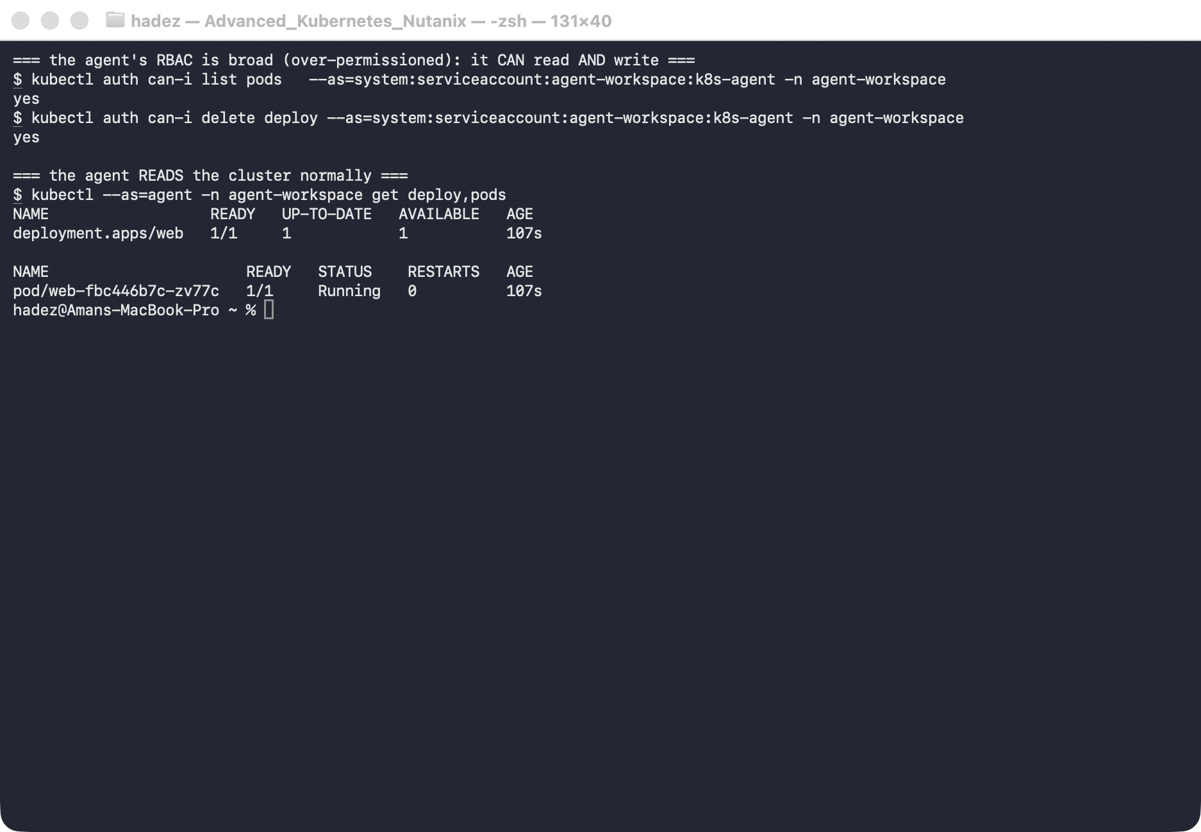
What this means: this is the danger. With this RBAC alone, an agent that decides (or is tricked into deciding) to delete deployment web would succeed. RBAC is not enough of a guardrail here.

Step 2 — Add an identity-scoped guardrail
Goal: deny mutations from the agent identity at admission, and audit them — regardless of RBAC.
kubectl apply -f - <<'EOF'
apiVersion: admissionregistration.k8s.io/v1
kind: ValidatingAdmissionPolicy
metadata: {name: agent-readonly-guardrail}
spec:
failurePolicy: Fail
matchConstraints:
resourceRules:
- apiGroups: ["", "apps"]
apiVersions: ["*"]
operations: ["CREATE","UPDATE","DELETE"] # only mutating verbs
resources: ["*"]
matchConditions:
- name: only-the-agent
expression: "request.userInfo.username == 'system:serviceaccount:agent-workspace:k8s-agent'"
validations:
- expression: "false" # anything reaching here is denied
message: "Guardrail: the k8s-agent identity is read-only. Mutation denied and audited."
---
apiVersion: admissionregistration.k8s.io/v1
kind: ValidatingAdmissionPolicyBinding
metadata: {name: agent-readonly-guardrail-binding}
spec:
policyName: agent-readonly-guardrail
validationActions: ["Deny","Audit"] # deny AND record it in the audit log
EOF
What this means: the policy only evaluates requests where the user is the agent and the verb is mutating (matchConditions + operations). For those, the validation is hard-coded false, so they're denied — and validationActions: ["Deny","Audit"] means each denied attempt is also written to the API audit log.

Step 3 — Prove reads work, mutations are denied and logged
Goal: confirm the guardrail blocks the agent's writes (with a clear reason) but not its reads or anyone else's writes.
AGENT=system:serviceaccount:agent-workspace:k8s-agent
kubectl get validatingadmissionpolicybinding agent-readonly-guardrail-binding -o jsonpath='{.spec.validationActions}'; echo
# a mutation RBAC allows — but the guardrail denies:
kubectl --as=$AGENT -n agent-workspace delete deployment web
kubectl --as=$AGENT -n agent-workspace create configmap x --from-literal=a=b
# a normal admin is unaffected:
kubectl -n agent-workspace label deployment web tier=frontend --overwrite
What you should see: the binding reports ["Deny","Audit"]; both agent mutations are denied with ValidatingAdmissionPolicy 'agent-readonly-guardrail' … denied request: Guardrail: the k8s-agent identity is read-only. Mutation denied and audited.; and the admin's label succeeds.
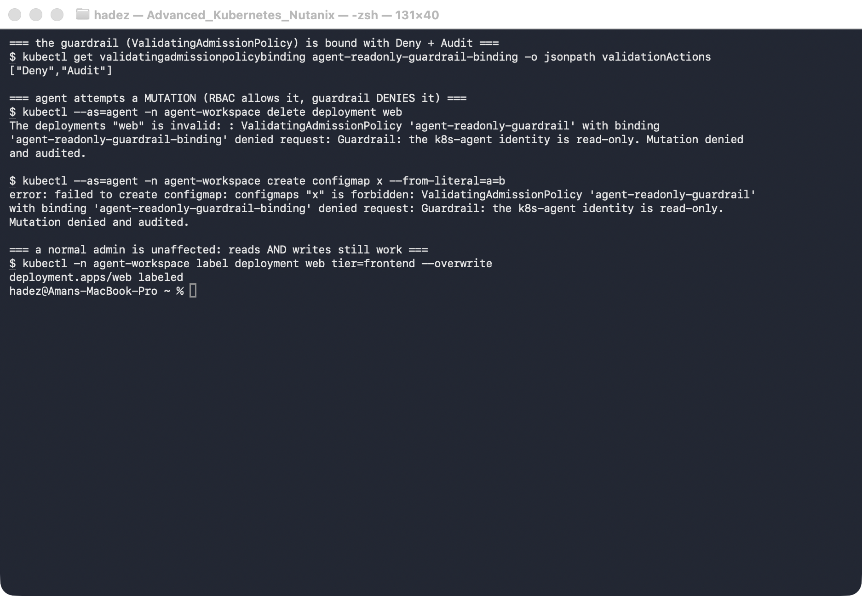
What this means: the guardrail stopped the agent's writes even though RBAC allowed them — the exact defence-in-depth you want around an autonomous identity. The denial carries a human-readable reason (useful to feed back to the agent), and the Audit action means every attempt is logged for review. The scoping is precise: reads and other users are untouched.
⚠️ Gotcha — RBAC-only "read-only" is fragile for agents. It's tempting to just give the agent a view-only Role and call it done. But agent RBAC drifts (someone widens it to fix an error), and a leaked token inherits whatever RBAC exists at that moment. An admission-time guardrail keyed on the identity holds regardless — it's the difference between "we hope its RBAC stays narrow" and "its writes are structurally refused." Keep both: least-privilege RBAC and the guardrail.

Step 4 — Clean up
kubectl delete validatingadmissionpolicybinding agent-readonly-guardrail-binding --ignore-not-found
kubectl delete validatingadmissionpolicy agent-readonly-guardrail --ignore-not-found
kubectl delete namespace agent-workspace --ignore-not-found

What you learned
You saw… | in Step | proof
An agent's RBAC can be over-broad (reads and writes) | 1 | can-i delete deployments → yes
A VAP guardrail denies mutations from the agent identity | 3 | delete/create → denied request: Guardrail …
Denials are audited, not just blocked | 2–3 | binding validationActions: ["Deny","Audit"]
Reads and other users are unaffected | 1,3 | agent get works; admin label succeeds

Evidence
Real screenshots for this lab are in artifacts/lab-24/screenshots/ (2 images), and a command transcript is in artifacts/lab-24/evidence/lab-17-agentic-guardrails.txt.

Next: Lab 25 — Break It on Purpose to Prove It's Resilient (Chaos Engineering with Chaos Mesh)

