Lab 01 — Reconciliation Tracing
DataCouch — Advanced Kubernetes (Nutanix)
Table of Contents

Day 1 · How Kubernetes Really Works
YES — Tested end-to-end on a real 4-node kind cluster (Kubernetes v1.37.0). Every command here was actually run and every screenshot is a real capture of that run.

What you'll learn
- The reconcile loop — the single idea behind every Kubernetes controller: compare desired state (.spec) with observed state (.status) and keep closing the gap, forever.
- How to watch that loop work live, and how to read the two numbers that tell you whether a controller has caught up: generation vs observedGeneration.
- Why Kubernetes is level-triggered — so a deleted Pod, a hand-edited ReplicaSet, and a dead node all get fixed by the exact same mechanism.
- How to trace a self-healing action back to the controller that performed it.

What you'll do
You'll create a Deployment that asks for 3 Pods, then break it four different ways — delete a Pod, hand-edit its ReplicaSet, take a whole node offline, and change the spec — and each time you'll watch Kubernetes quietly put it back to what you asked for. By the end you'll have seen the reconcile loop, not just read about it.

Time & cost
- Time: ~40 minutes.
- Cost: $0 — everything runs on a free local kind cluster.

Before you start
- Where you'll work: on your own computer, in a terminal. This lab uses a local kind cluster (Kubernetes in Docker) — no cloud account, nothing to pay for.
- Tools you need (see the Setup Environment Guide if any are missing):
  - docker — installed and running
  - kind — to create the cluster
  - kubectl — to talk to it
- Heads-up: Step 3 needs two terminal windows open side by side. Everything else uses one.
Nutanix note. The reconcile loop is core Kubernetes — it behaves identically on a Nutanix (NKE) cluster, on GKE, or on local kind. We use kind here so it's free and instant. On a real NKE cluster the only differences are how you create the cluster (through Prism Central / the NKE console) and the node names you'll see — every command and result below is the same.

The idea in 60 seconds
Almost everything in Kubernetes is a controller running the same never-ending loop:
- Read the desired state — what you asked for (the object's .spec).
- Read the observed state — what actually exists right now (.status, plus the real Pods).
- If they differ, take one action to close the gap. Then start over.
Two properties make this powerful, and you'll watch both in this lab:
- Level-triggered, not edge-triggered. A controller doesn't react to an event ("a Pod was deleted") — it reacts to the current situation ("I want 3, I count 2"). So it doesn't matter how things drifted; the fix is always the same.
- Ownership. Higher-level objects own lower-level ones — a Deployment owns a ReplicaSet, which owns Pods — and each owner constantly repairs its children.
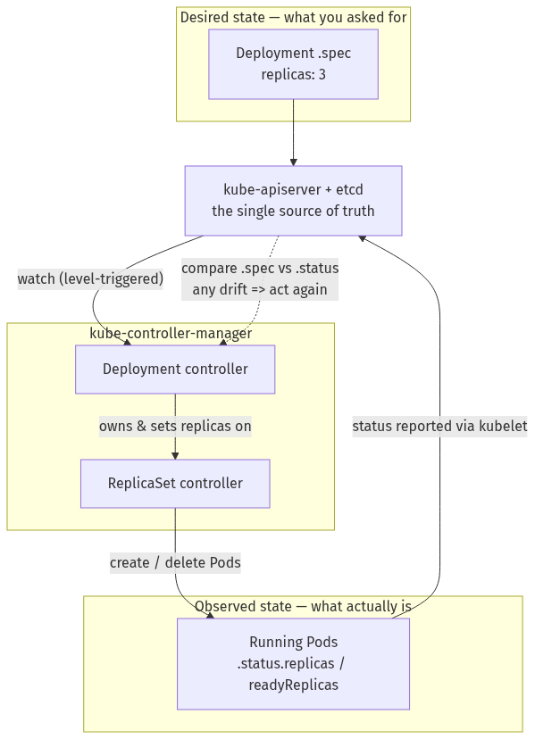
That loop is what you'll trace for the rest of the lab.

Step 1 — Create your cluster and declare what you want
Goal: stand up a 4-node cluster and create a Deployment that asks for 3 Pods — your "desired state."
1. Open a terminal. Create the cluster config file by pasting this in:
cat > day1-kind.yaml <<'EOF'
kind: Cluster
apiVersion: kind.x-k8s.io/v1alpha4
name: advk8s-day1
nodes:
- role: control-plane
- role: worker
- role: worker
- role: worker
EOF
(We want 4 nodes because in Step 5 you'll take one offline and watch its Pods move — you can't show that on a single-node cluster.)
2. Create the cluster (this takes a minute or two the first time while it downloads the node image):
kind create cluster --config day1-kind.yaml --wait 180s
kubectl get nodes -o wide
3. Tell Kubernetes you want 3 copies of a web server:
kubectl create deployment web --image=nginx:1.27 --replicas=3
kubectl rollout status deployment/web --timeout=90s
What you should see: four nodes listed as Ready (one control-plane and three workers), all on v1.37.0, then the Deployment finishing with deployment "web" successfully rolled out.
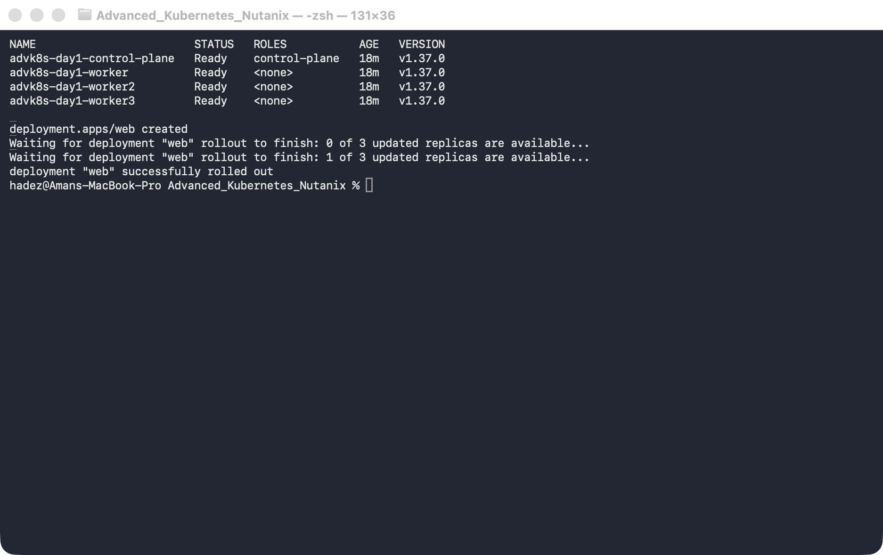
What this means: you've declared a desired state — "I want 3 web Pods." You didn't say where to put them or how to keep them alive; from here on, a controller does that for you. Keep this cluster running — Labs 2–4 reuse it.

Step 2 — See "desired vs observed" in one place
Goal: look at the two halves of the loop — what you asked for, and what actually exists — on a single object.
1. Ask for both halves at once:
kubectl get deploy web -o jsonpath='spec.replicas={.spec.replicas} status.replicas={.status.replicas} ready={.status.readyReplicas} generation={.metadata.generation} observedGeneration={.status.observedGeneration}{"\n"}'
2. Look at the ownership chain — Deployment → ReplicaSet → Pod (quote the column spec so your shell doesn't treat the [0] as a filename pattern):
kubectl get rs -l app=web -o 'custom-columns=RS:.metadata.name,DESIRED:.spec.replicas,OWNER:.metadata.ownerReferences[0].kind'
kubectl get pods -l app=web -o wide
What you should see: the first command prints
spec.replicas=3 status.replicas=3 ready=3 generation=1 observedGeneration=1
and the Pods are spread across all three worker nodes.
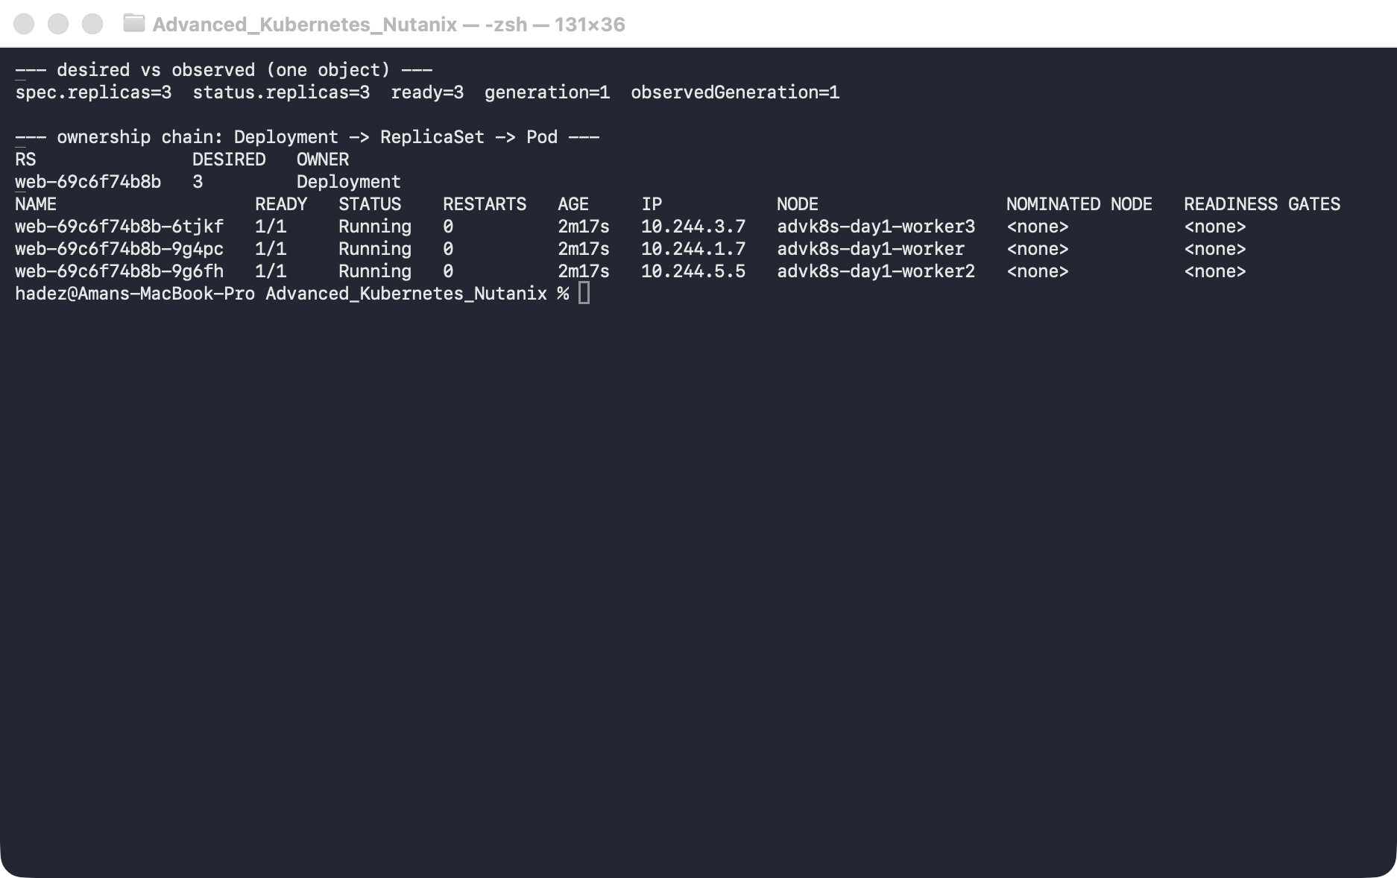
What this means: desired (spec.replicas=3) and observed (status.replicas=3 ready=3) agree — the loop is at rest. The OWNER of the ReplicaSet is Deployment, and you never chose which node each Pod lands on; the scheduler placed them and the ReplicaSet controller keeps the count. Remember generation and observedGeneration — you'll use them in Step 6.

Step 3 — Break it #1: delete a Pod (you'll need two terminals)
Goal: delete a running Pod and watch the ReplicaSet controller notice and replace it.
1. In your first terminal, start a live watch and leave it running:
kubectl get pods -l app=web -w
2. In a second terminal window, delete one of the Pods:
kubectl delete pod "$(kubectl get pods -l app=web -o jsonpath='{.items[0].metadata.name}')"
Now look back at the first terminal.
What you should see: the deleted Pod goes to Terminating, and a brand-new Pod appears within seconds. In our run the replacement showed AGE 5s while its two siblings were at 2m25s.
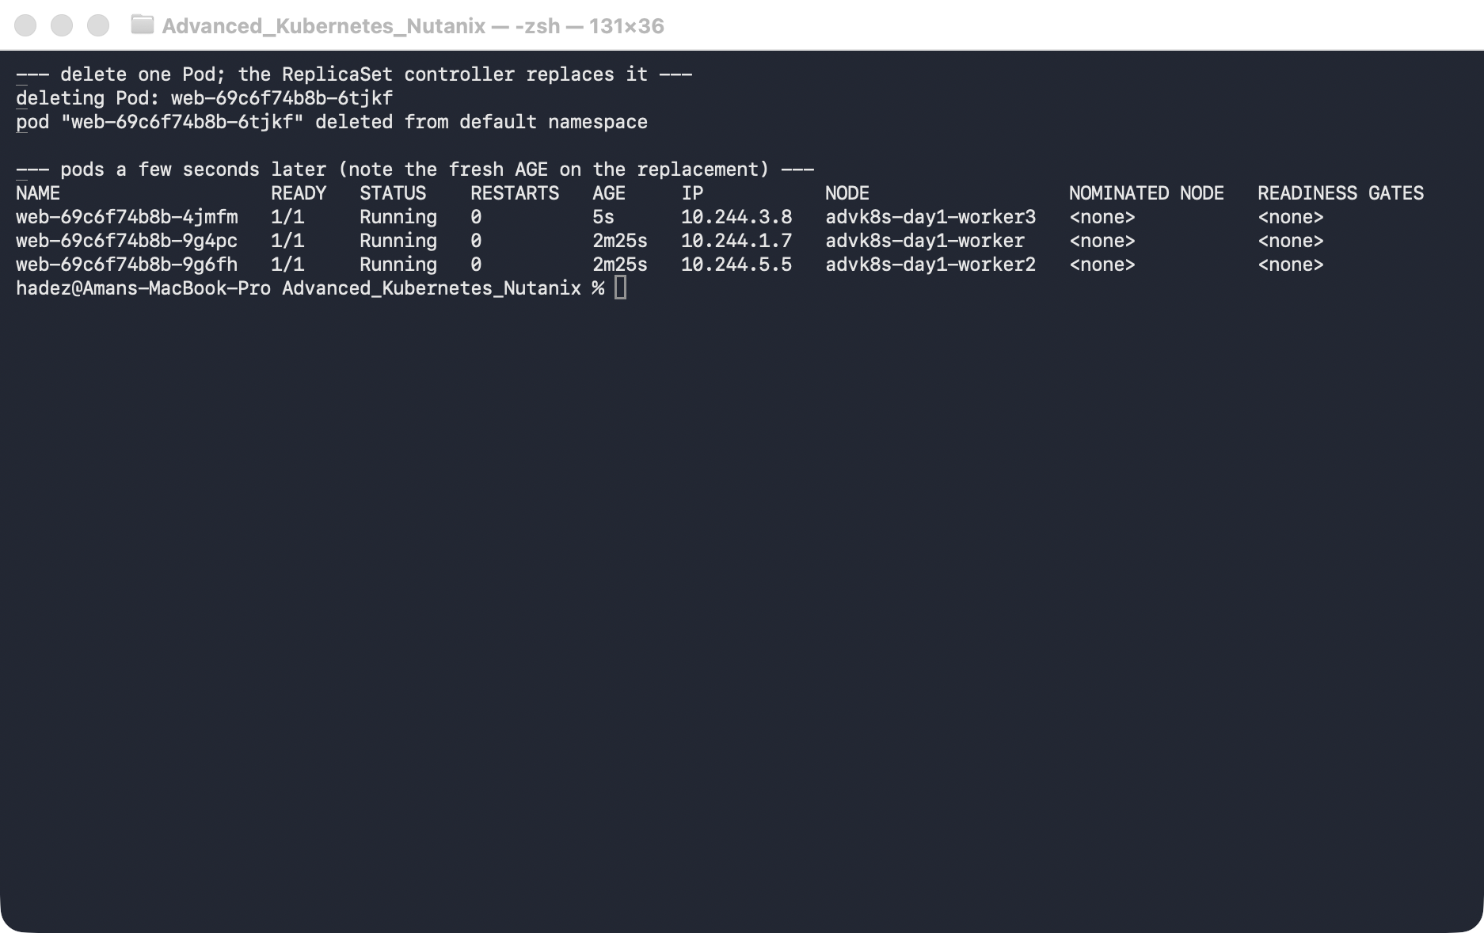
What this means: nobody told the controller "a Pod was deleted." On its next pass it simply counted "2 running, I want 3" and created one. You briefly had 2 Pods; the loop brought you back to 3. That's level-triggering.

Step 4 — Break it #2: hand-edit the ReplicaSet
Goal: bypass the Deployment and edit its child directly, and watch the Deployment overwrite you — proof that owners defend their children.
1. Try to force the ReplicaSet down to 1 replica:
RS=$(kubectl get rs -l app=web -o jsonpath='{.items[0].metadata.name}')
kubectl scale rs "$RS" --replicas=1
kubectl get rs "$RS" -o jsonpath='rs.spec.replicas={.spec.replicas}{"\n"}'
2. Now delete the whole ReplicaSet and watch the Deployment rebuild it:
kubectl delete rs "$RS"
sleep 4
kubectl get rs -l app=web
kubectl get pods -l app=web
What you should see: the scale command succeeds — but the very next line already reads rs.spec.replicas=3, not 1. And after you delete the ReplicaSet, an identically-named one reappears with 3 fresh Pods (AGE 4s).
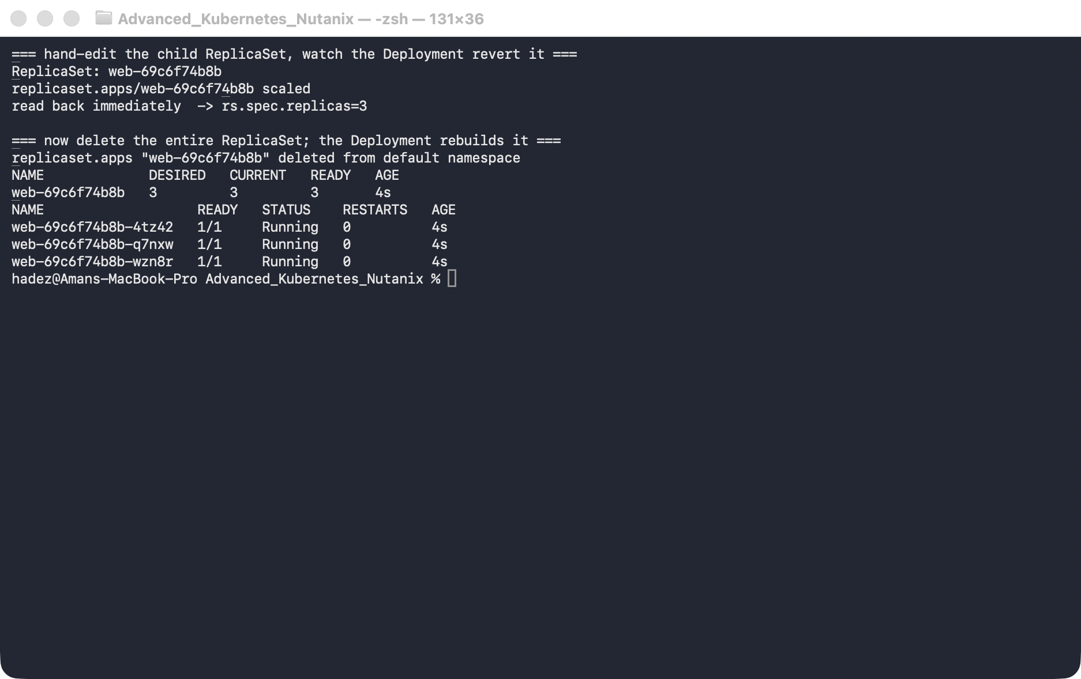
⚠️ Gotcha — the loop is faster than you are. Your kubectl scale rs … --replicas=1 really did set it to 1. But the Deployment controller owns that ReplicaSet, saw the change, and reverted it to 3 before your next command could read it back. If you want to actually see the flip, run kubectl get rs "$RS" -w in a second terminal while you scale — you'll catch the 1 → 3 bounce.
What this means: you can't manage a Deployment's ReplicaSet by hand — the owner continuously reconciles it back to what the Deployment says. Same with deleting it: the Deployment just rebuilds it from the desired spec (same name, because the name is a hash of the unchanged Pod template).

Step 5 — Break it #3: take a whole node offline
Goal: remove an entire node from service and watch its Pods reschedule onto the survivors, with the count preserved.
1. Scale up a little so there's something to move, then drain the busiest node (drain = cordon it off and evict its Pods):
kubectl scale deployment web --replicas=5
kubectl get pods -l app=web -o wide # note which node has the most Pods
VICTIM=$(kubectl get pods -l app=web -o wide --no-headers | awk '{print $7}' | sort | uniq -c | sort -rn | head -1 | awk '{print $2}')
kubectl drain "$VICTIM" --ignore-daemonsets --delete-emptydir-data --timeout=60s
kubectl get node "$VICTIM"
kubectl get pods -l app=web -o wide
What you should see: the node becomes Ready,SchedulingDisabled, its web Pods are evicted, and within seconds you're back to 5 running Pods — now spread only across the two remaining workers, none on the drained node. (The kindnet / kube-proxy system Pods are correctly left alone.)
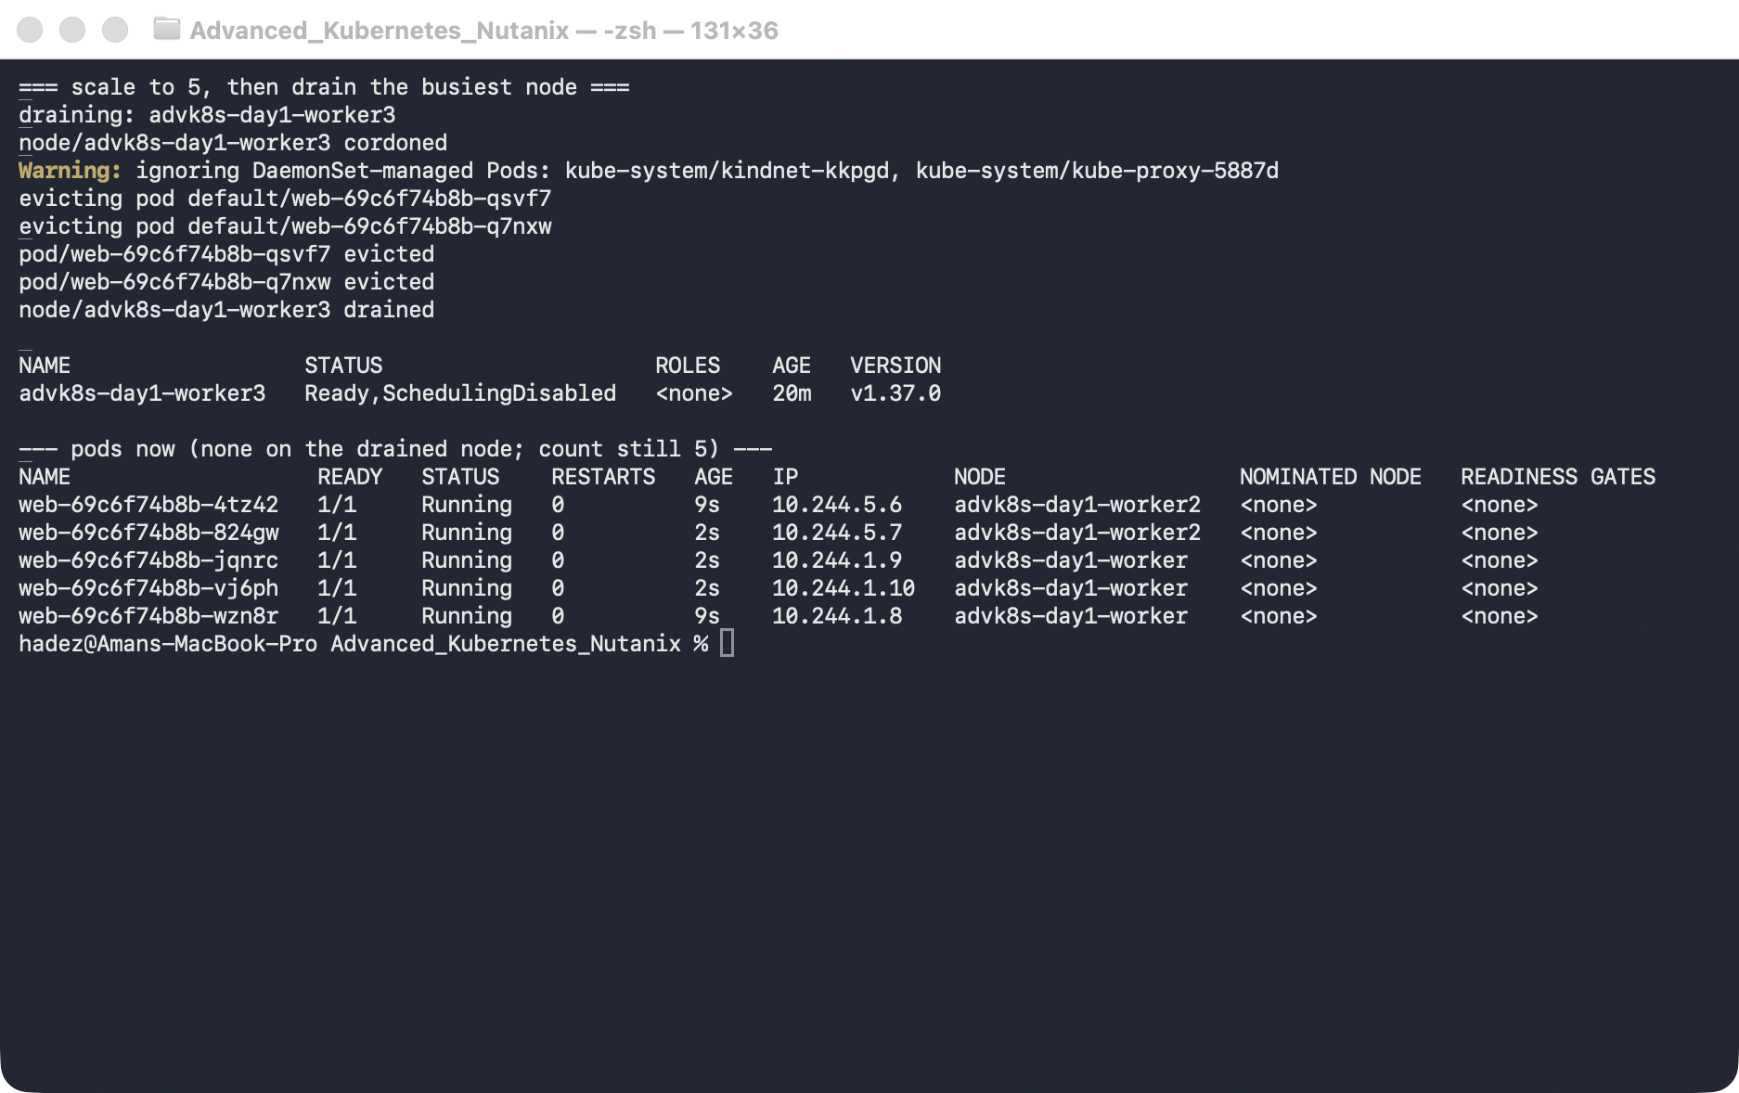
2. Put the node back when you're done:
kubectl uncordon "$VICTIM"
What this means: losing a node is just another kind of drift. The loop saw "I want 5, I can reach 3, and this node is off-limits" and rescheduled onto the healthy nodes. A drain is the graceful version; a node that simply dies takes the same path, just slower (Kubernetes waits ~5 minutes before evicting Pods from an unreachable node).

Step 6 — Watch a spec change converge
Goal: change the desired state and watch the two "have we caught up?" signals behave differently.
1. Ask for 6 Pods, then immediately check the status:
kubectl scale deployment web --replicas=6
kubectl get deploy web -o jsonpath='gen={.metadata.generation} observedGen={.status.observedGeneration} status.replicas={.status.replicas} ready={.status.readyReplicas}{"\n"}'
kubectl rollout status deployment/web --timeout=60s
kubectl get deploy web -o jsonpath='gen={.metadata.generation} observedGen={.status.observedGeneration} status.replicas={.status.replicas} ready={.status.readyReplicas}{"\n"}'
What you should see: the moment you scale, gen and observedGen both jump together (to 3 in our run), but ready lags — right after the change it read status.replicas=6 ready=5, then climbed to ready=6.
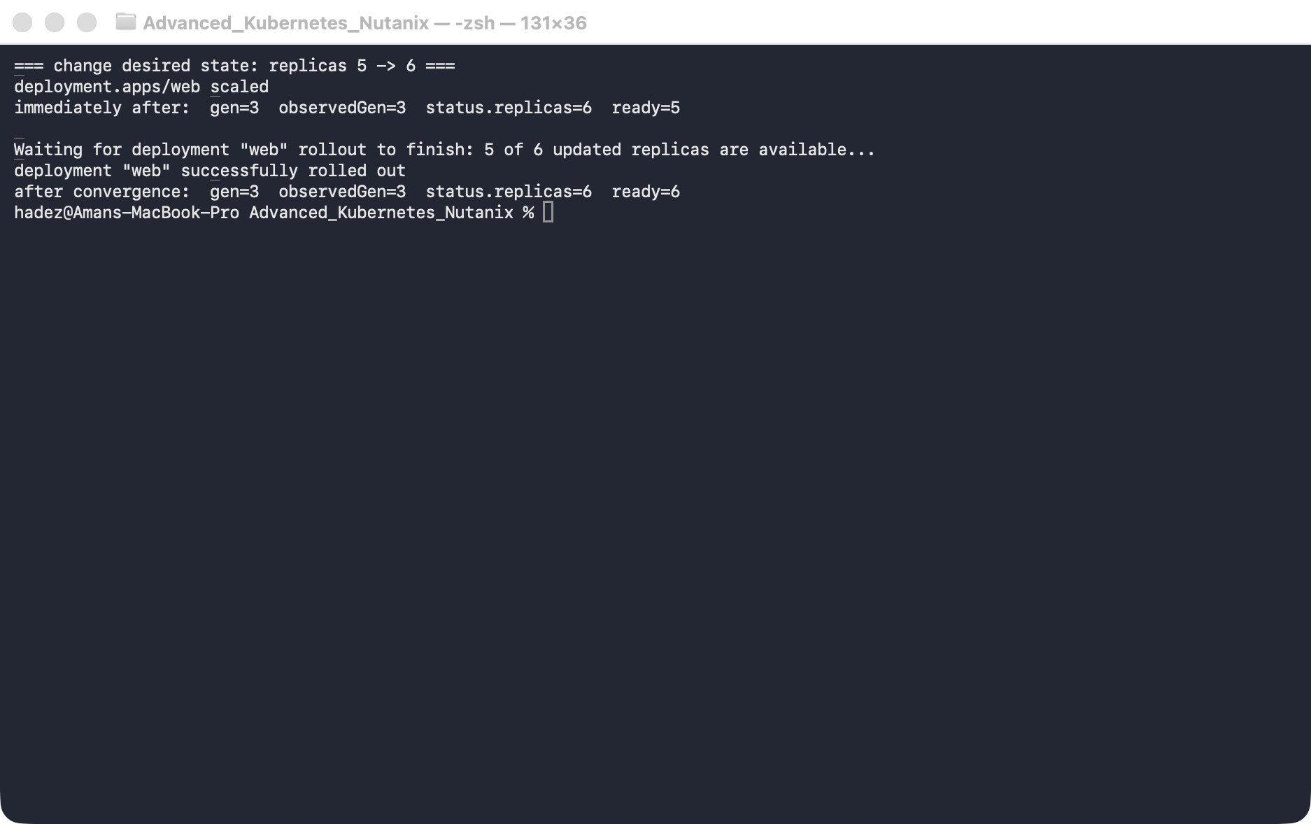
What this means — this is the distinction most people miss:
- generation vs observedGeneration answers "has the controller noticed my latest change?" — that's near-instant.
- ready / status.replicas vs spec.replicas answers "has the controller actually finished the work?" — that takes as long as the work takes.
So observedGeneration catching up does not mean your rollout is done; watch readyReplicas for that.

Step 7 — (Optional) Trace who did the work
Goal: see that every self-healing action above had a named actor.
kubectl get events --sort-by=.lastTimestamp | tail -20
What you should see: a stream naming the controllers — deployment/web ScalingReplicaSet …, replicaset/web-… SuccessfulCreate Created pod …, pod/… Scheduled … (the scheduler), and pod/… Pulled / Started (the kubelet). Each part of the loop has an owner.
⚠️ Gotcha — the controller log is full of conflicts, and that's healthy. If you read the controller directly with kubectl -n kube-system logs kube-controller-manager-advk8s-day1-control-plane | grep -i replicaset, you'll see lines like "Unhandled Error" … "read version: 3258 is not as new as written version: 3266". That's optimistic concurrency: the controller tried to write from a slightly stale view, the API server rejected it, and it simply re-reads and retries. Nothing is broken — a level-triggered controller expects to lose races and just re-measures. The events above are the reliable trace; the raw log is noisy by design.

Clean up
Leave the cluster running for Labs 2–4 — just remove this lab's Deployment:
kubectl delete deployment web
If you're stopping entirely and want the resources back:
kind delete cluster --name advk8s-day1

What you learned
You saw… | in Step | proof
Desired vs observed state on one object | 2 | spec.replicas=3 … ready=3
A deleted Pod healed within seconds | 3 | replacement Pod at AGE 5s
Owners defend their children (level-triggered) | 4 | hand-scaled ReplicaSet reverted faster than you could read it
A lost node reschedules Pods, count preserved | 5 | drained node → 5/5 running on the survivors
"Noticed" (observedGeneration) ≠ "finished" (readyReplicas) | 6 | both jump, then ready catches up
Every fix has a named controller | 7 | replicaset-controller, default-scheduler, kubelet in the events

Evidence
The real screenshots for this lab are in artifacts/lab-01/screenshots/ (6 images), and a full transcript of the commands and output is in artifacts/lab-01/evidence/lab-01-reconciliation.txt.

Next: Lab 2 — Stop One Client From Taking Down the API Server (API Priority & Fairness)

