DataCouch — Advanced Kubernetes (Nutanix)
Table of Contents

Day 4 · GitOps, Multi-Cluster & Advanced Scheduling
YES — Tested end-to-end on a real GKE cluster (advk8s-lab, dcproject-462806) with Flux v2. Every screenshot is a real capture. The payoff: you deliver an app to the cluster without ever running kubectl apply — Flux pulls it from Git — and then you delete the live Deployment and watch Flux put it back, because Git says it should exist.

What you'll learn
- What GitOps actually means: Git is the single source of truth, and an in-cluster agent continuously makes the cluster match it — the same reconciliation idea from Lab 1, now applied to your whole app.
- How Flux works: a GitRepository source (what to watch) plus a Kustomization (what to apply and how often).
- How to run Flux against a local Git server, so the lab works with no internet access.
- What a bad commit does to a running cluster — and why lastAppliedRevision and lastAttemptedRevision are the two fields to read when something stops updating.
- Why GitOps gives you drift detection and self-healing for free: anything that diverges from Git is reverted.

What you'll do
You'll install Flux on the cluster, point it at a Git repo — public, or a Gitea server running inside the cluster if your room has no internet — and let it deploy an app. Then you'll simulate drift by deleting the running Deployment and watch Flux put it back. Finally you'll commit a broken manifest and find out what that does to a running system.

Time & cost
- Time: ~35 minutes.
- Cost: negligible — Flux controllers and podinfo are small Pods on the shared GKE cluster.

Before you start
- Where you'll work: in a terminal on your own machine.
- Tools you need: gcloud, kubectl, and the flux CLI (brew install fluxcd/tap/flux).
- Cluster: a GKE cluster (this course's shared advk8s-lab).
- No GitHub account needed: we use flux install (controllers only) and point at a public repo, so you never need a Git token for this lab.
Nutanix note. Flux is CNCF-graduated and completely platform-agnostic — it runs identically on NKE. In fact GitOps is the recommended operating model for on-prem fleets: instead of engineers running kubectl against production Nutanix clusters (untracked, un-reviewable), every change is a Git commit that Flux pulls and applies. That gives you an audit trail, code review, and instant rollback (git revert) on infrastructure you can't always reach interactively.

The idea in 60 seconds
Normally you push changes to a cluster: you run kubectl apply from your laptop or CI. GitOps inverts this — the cluster pulls. An agent inside the cluster (Flux) watches a Git repo and continuously reconciles the cluster to match it. Two Flux objects do this:
- a GitRepository — where to look (repo URL, branch, poll interval),
- a Kustomization — what to apply (a path in that repo), how often, and whether to prune (delete things removed from Git).
Because Flux reconciles on a loop, the cluster is always converging on Git. Change the cluster by hand and it drifts; Flux notices and reverts it. The only durable way to change anything is to change Git.
flowchart TB
GIT["Git repo<br/>(desired state: podinfo manifests)"] -->|"GitRepository: poll every 1m"| SRC["source-controller<br/>(fetches the revision)"]
SRC --> KUST["Kustomization: apply ./kustomize<br/>prune=true, interval=1m"]
KUST -->|"kustomize-controller applies"| CLUSTER["cluster: Deployment + Service + HPA"]
CLUSTER -.->|"someone deletes the Deployment (drift)"| DRIFT["cluster ≠ Git"]
DRIFT -->|"next reconcile"| KUST
KUST -->|"re-applies from Git"| CLUSTER

Step 1 — Install Flux on the cluster
Goal: get the Flux controllers running. (No Git bootstrap, no token — just the agents.)
1. Check prerequisites, then install:
flux check --pre
flux install
2. Confirm the controllers are up:
kubectl -n flux-system get pods
What you should see: four Deployments Running in flux-system — source-controller (fetches Git), kustomize-controller (applies manifests), plus helm-controller and notification-controller.
What this means: the reconciliation engine is now living in your cluster. It isn't watching anything yet — you'll tell it what to watch next.

Step 2 — Point Flux at a Git repo and let it deploy the app
Goal: declare a Git source and a Kustomization, and watch the app appear — without ever applying it yourself.

⚠️ Use a local Git server if your room is restricted
The public repo below is convenient, and it is the first thing to fail in an air-gapped client environment or behind a corporate proxy. Verified 2026-09-25: Flux drives perfectly well from a Gitea server running inside the cluster, with no internet involved at any point.
kubectl create ns git-server
kubectl -n git-server create deployment gitea --image=gitea/gitea:1.22
kubectl -n git-server set env deploy/gitea \
GITEA__database__DB_TYPE=sqlite3 GITEA__security__INSTALL_LOCK=true
kubectl -n git-server expose deploy/gitea --port=3000
POD=$(kubectl -n git-server get pod -l app=gitea -o name | head -1)
kubectl -n git-server exec $POD -- su git -c \
"gitea admin user create --username labadmin --password labpass123 \
--email lab@example.com --admin --must-change-password=false"
Then point the GitRepository at http://gitea.git-server.svc.cluster.local:3000/labadmin/<repo>.git with a secretRef holding those credentials. The full recipe, including pushing manifests through Gitea's API, is Step 1 of Lab 27 — Tenant Quota Governance.
⚠️ Gotcha: the Gitea Pod reports Running well before it serves HTTP. Wait on curl -sf http://localhost:3000/api/healthz inside the Pod, not on the rollout, or the user creation fails with a bare exit code 1.
1. Create the GitRepository source (a public repo, polled every minute):
kubectl create namespace podinfo
flux create source git podinfo \
--url=https://github.com/stefanprodan/podinfo \
--branch=master \
--interval=1m
2. Create the Kustomization that applies the manifests in ./kustomize into the podinfo namespace, pruning anything removed from Git:
flux create kustomization podinfo \
--source=GitRepository/podinfo \
--path="./kustomize" \
--prune=true \
--interval=1m \
--target-namespace=podinfo \
--wait
3. Confirm Flux is reconciling, and that the app is running:
flux get sources git
flux get kustomizations
kubectl -n podinfo get deploy,svc,hpa
What you should see: both the source and the Kustomization report READY: True with a revision like master@sha1:dd507173, and podinfo (Deployment + Service + HPA) is running in the podinfo namespace — you never ran kubectl apply for it.
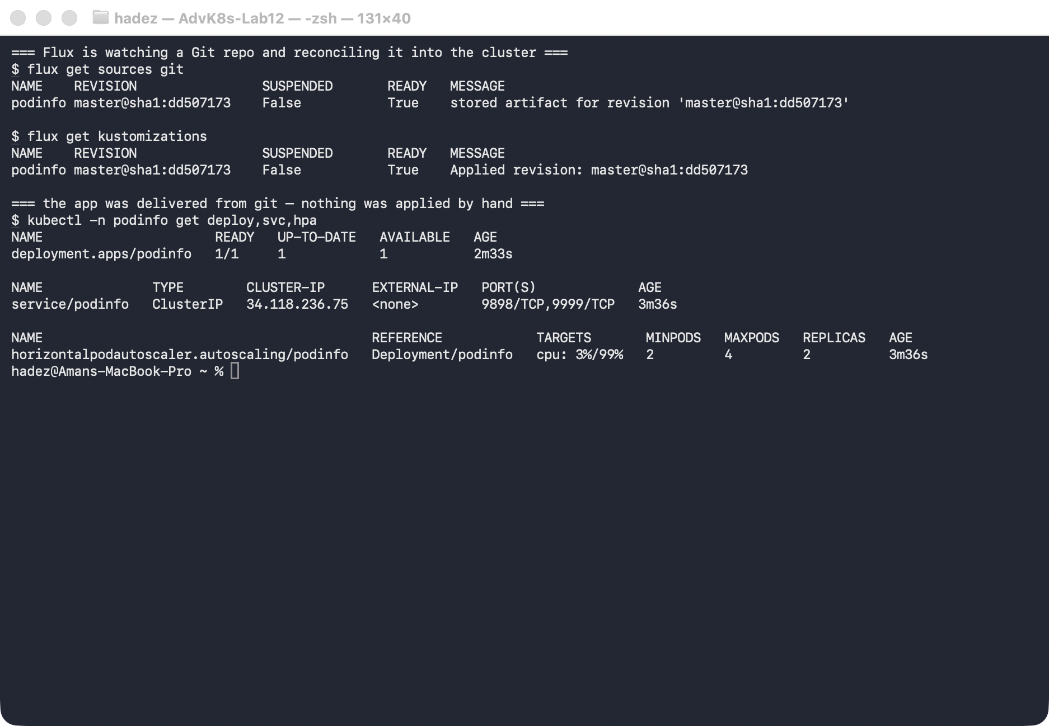
What this means: the app's desired state lives in Git, and Flux pulled it and applied it. From here on, the way to change this app is to change Git — not the cluster.

Step 3 — Cause drift, and watch Flux self-heal
Goal: change the cluster out from under Flux and prove it reverts you.
1. Delete the live Deployment — the cluster now disagrees with Git:
kubectl -n podinfo delete deploy podinfo
kubectl -n podinfo get deploy podinfo
2. Trigger a reconcile (Flux would do this on its own within the 1-minute interval; we force it so you don't wait):
flux reconcile kustomization podinfo --with-source
kubectl -n podinfo get deploy podinfo
What you should see: right after the delete, kubectl get deploy podinfo returns NotFound — but after the reconcile, the Deployment is back (podinfo 1/1), recreated from Git.
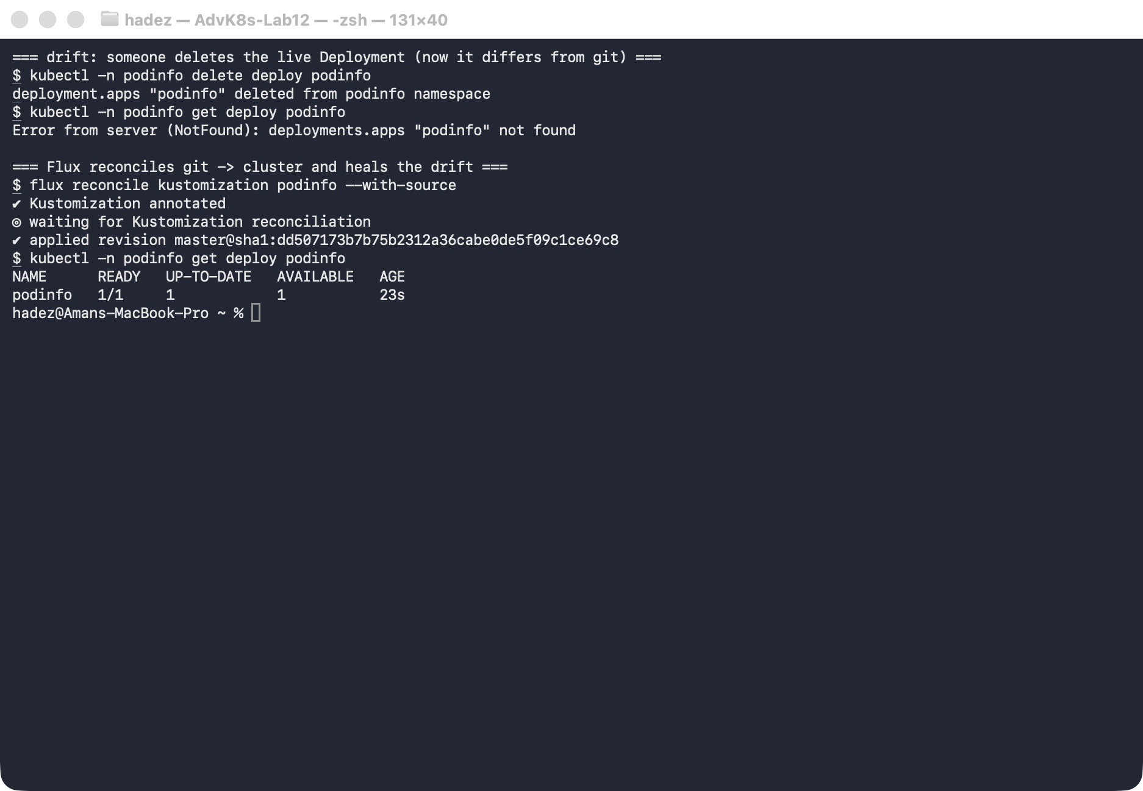
What this means: this is GitOps self-healing. Flux compared the cluster to Git, saw the Deployment was missing, and re-applied it. The same thing happens to any manual change — an edited image tag, a scaled replica count, a deleted Service — because Git, not the cluster, is the source of truth.
⚠️ Gotcha — don't fight the reconciler. Because Flux reverts drift, a "quick manual kubectl edit in production" will silently disappear at the next reconcile, which is baffling if you don't know Flux is running. To make a real change, commit it to Git (or flux suspend kustomization <name> first if you genuinely need to pause reconciliation for a break-glass fix). Manual edits are for debugging only.

Step 4 — Break a manifest, and read the failure
Goal: find out what a bad commit actually does to a running system. The answer is reassuring, and only believable once you have watched it.
Edit the Deployment in Git so replicas is a word instead of a number — the kind of thing a hand- edit produces at 17:55 on a Friday:
spec:
replicas: two # was: 2
Commit it, then ask Flux:
flux reconcile kustomization shop-config --with-source
flux get kustomizations
What you should see — READY flips to False with the exact reason:
NAME REVISION READY MESSAGE
shop-config main@sha1:12cb3b31 False Deployment/shop/storefront dry-run failed:
failed to create typed patch object
(shop/storefront; apps/v1, Kind=Deployment):
.spec.replicas: expected numeric (int or float), got string
The same message is on the resource, which is where you'd read it in a pipeline:
kubectl -n flux-system get kustomization shop-config \
-o jsonpath='{.status.conditions[?(@.type=="Ready")].message}'
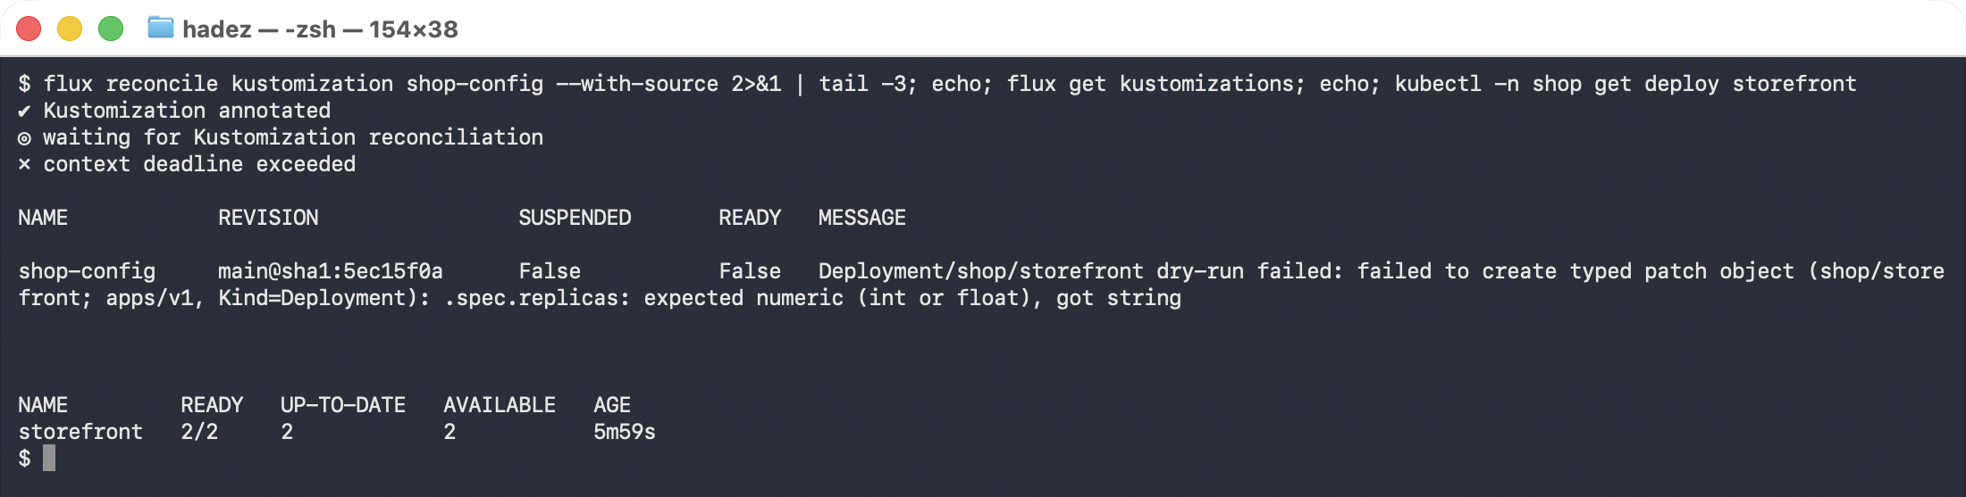
Now check what is actually running:
kubectl -n shop get deploy storefront
NAME READY UP-TO-DATE AVAILABLE AGE
storefront 2/2 2 2 5m15s
Untouched. Five minutes old, still serving. The bad commit never reached the cluster.
Why — and this is the whole point of the step:
kubectl -n flux-system get kustomization shop-config \
-o jsonpath='lastApplied={.status.lastAppliedRevision}{"\n"}lastAttempted={.status.lastAttemptedRevision}'
lastApplied = main@sha1:12cb3b31... ← the last revision that worked
lastAttempted = main@sha1:63db2b0c... ← the one that is failing
Flux dry-runs every change before applying it. When the dry-run fails it refuses the whole revision and keeps serving the last good one — and it records both, so "what is live?" and "what is Git asking for?" are two separate, readable fields.
⚠️ Gotcha — flux reconcile exits non-zero with context deadline exceeded. That is the CLI giving up waiting for a reconciliation that will never succeed, not a timeout in the cluster. The real error is in the Ready condition; go there rather than re-running the command.
Fix it and watch it recover:
# set replicas back to a number, commit, then:
flux reconcile kustomization shop-config --with-source
flux get kustomizations
shop-config main@sha1:3aacd02d True Applied revision: main@sha1:3aacd02d
storefront 4/4 4 4
lastApplied = lastAttempted = main@sha1:3aacd02d
The two revision fields converging is your signal that Git and the cluster agree again.
What this changes about rollback. You do not roll back the cluster — you revert the commit. The cluster was never in the bad state to begin with, which is why a GitOps rollback is a git revert and a reconcile rather than a recovery operation.

Step 5 — Clean up
kubectl delete namespace podinfo --ignore-not-found
flux delete source git podinfo --silent
flux delete kustomization podinfo --silent
# to remove Flux itself:
# flux uninstall --silent

What you learned
You saw… | in Step | proof
Flux runs the reconciliation engine inside the cluster | 1 | four controllers Running in flux-system
A GitRepository + Kustomization delivers an app from Git | 2 | both READY: True; podinfo running, never kubectl apply-ed
The cluster converges on the Git revision | 2 | Applied revision: master@sha1:dd507173
Manual drift is detected and reverted (self-healing) | 3 | Deployment deleted → NotFound → restored on reconcile
Flux runs from a Git server inside the cluster, with no internet | 2 | source URL is a .svc.cluster.local address
A bad commit is refused at dry-run, not applied | 4 | READY=False, .spec.replicas: expected numeric … got string
The running workload is untouched by a failed revision | 4 | storefront 2/2 still serving, 5m15s old
lastApplied vs lastAttempted tells you live-vs-wanted | 4 | 12cb3b31 applied while 63db2b0c kept failing

Evidence
A transcript of the local-Git-server path and the broken-manifest diagnosis is in artifacts/lab-15/evidence/lab-15-local-git-and-broken-manifest.txt — captured 2026-09-25 on Kubernetes 1.37.0 with Flux 2.9.5 and an in-cluster Gitea, covering every output quoted in Steps 2 and 4.

Original GKE evidence
Real screenshots for this lab are in artifacts/lab-15/screenshots/ (2 images), and a command transcript is in artifacts/lab-15/evidence/lab-12-flux.txt.

Next: Lab 16 — Drive Many Clusters from One Git Repo (Fleet Registration & Staged Rollout)

