Lab 2 — Stop One Client From Taking Down the API Server (API Priority & Fairness)
DataCouch — Advanced Kubernetes (Nutanix)
Table of Contents

Day 1 · How Kubernetes Really Works
YES — Tested end-to-end on a real 4-node kind cluster (Kubernetes v1.37.0). Every screenshot is a real capture. The headline you'll prove yourself: a noisy client confined to a tiny lane loses 17 of 60 requests to HTTP 429, while a critical request in another lane stays 200 the whole time.

What you'll learn
- The full path a request takes through kube-apiserver: TLS + authentication → API Priority & Fairness → authorization (RBAC) → admission → etcd — and how to watch it live.
- How API Priority & Fairness (APF) sorts every request into a lane ("priority level") with its own concurrency budget, so one runaway client can't starve everyone else — including the control plane.
- How to read the APF headers that tell you which lane a request used.
- How to build your own lane, trap a noisy client in it, and prove with real 429s and metrics that critical traffic sails through untouched.

What you'll do
You'll first watch a single request travel through the API server. Then you'll look at the lanes Kubernetes ships with, build a deliberately tiny lane, trap a "storm" client in it, and hit the API server with 60 simultaneous requests from that client — watching APF reject the overflow while an admin request stays healthy.

Time & cost
- Time: ~45 minutes.
- Cost: $0 — runs on the local kind cluster from Lab 1.

Before you start
- Where you'll work: in a terminal on your own machine.
- Cluster: this lab reuses the advk8s-day1 cluster from Lab 1. If you deleted it, recreate it with the day1-kind.yaml from Lab 1, Step 1. APF is on by default — nothing to install.
- Tools you need: kubectl and curl.
Nutanix note. APF is a core kube-apiserver feature, on by default on NKE, GKE, EKS, AKS, and kind alike. FlowSchemas, priority levels, the seat maths, the metrics — all identical on a real Nutanix (NKE) cluster. The only thing that differs is the total number of seats, which scales with the API server's size (bigger on a production control plane than on kind).

The idea in 60 seconds
When you run kubectl get pods, the request doesn't go straight to storage. It runs a gauntlet inside kube-apiserver:
- TLS + authentication — who are you?
- API Priority & Fairness — which lane is this, and is there a free seat? (the part most people don't know exists)
- Authorization (RBAC) — are you allowed?
- Admission — defaulting, validation, webhooks.
- etcd — the read/write finally happens.
Step 2 is this lab. Before APF existed, one misbehaving client — a hot LIST loop, a broken operator — could eat the API server's entire request budget and freeze the whole cluster. APF fixes that by sorting every request into a priority level with a bounded number of concurrency seats. A storm in one lane can't steal seats from another. Two objects define the lanes:
- FlowSchema — the matcher: "requests from these identities go to this lane."
- PriorityLevelConfiguration — the lane itself: how many seats (its nominalConcurrencyShares), and whether an overflow request waits (Queue) or is rejected immediately (Reject).
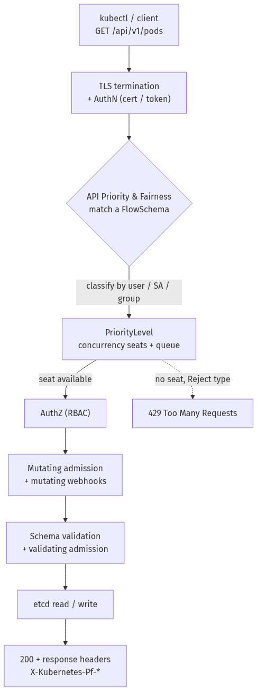

Step 1 — Watch a single request's whole journey
Goal: see the raw HTTP request and the APF headers the API server stamps on every reply.
1. In your terminal, run any command with -v=8 (verbose enough to print the HTTP exchange) and filter to the interesting lines:
kubectl get ns -v=8 2>&1 | grep -iE '"Request" verb=|"Response" status=|X-Kubernetes-Pf'
What you should see: the request line — "Request" verb="GET" url="https://127.0.0.1.../api/v1/namespaces?limit=500" — then "Response" status="200 OK", and two headers: X-Kubernetes-Pf-Flowschema-Uid and X-Kubernetes-Pf-Prioritylevel-Uid.
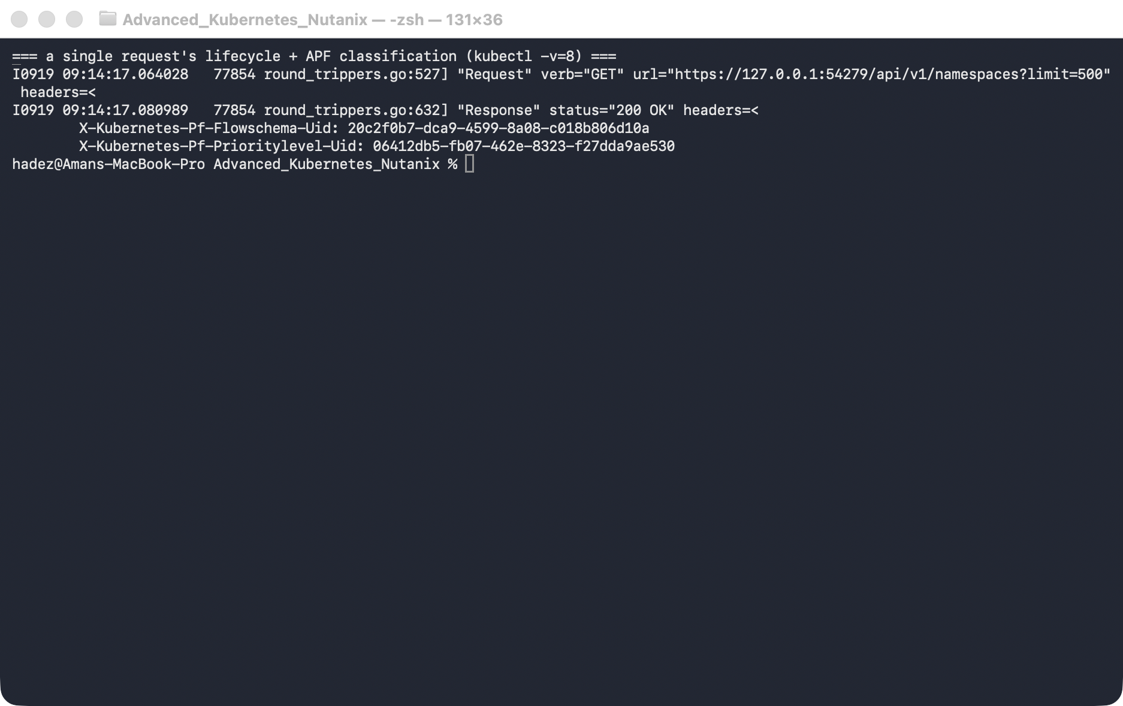
What this means: every request the API server serves is classified into a lane, and those two Pf (Priority-and-Fairness) headers tell you exactly which FlowSchema matched and which priority level it used. (In kubectl v1.37 the -v=8 output is structured — verb="GET" url=… — not the older GET https://… line you may see in blog posts.)

Step 2 — Look at the lanes Kubernetes ships with
Goal: see the built-in FlowSchemas and priority levels, and notice how the control plane protects its own traffic.
1. List the FlowSchemas in precedence order, then the priority levels:
kubectl get flowschemas -o 'custom-columns=NAME:.metadata.name,PRIORITYLEVEL:.spec.priorityLevelConfiguration.name,PRECEDENCE:.spec.matchingPrecedence'
kubectl get prioritylevelconfigurations -o 'custom-columns=NAME:.metadata.name,TYPE:.spec.type,SHARES:.spec.limited.nominalConcurrencyShares'
What you should see: a precedence-ordered list — exempt (1) and probes (2) at the top, then system-* and kube-controller-manager/kube-scheduler schemas (100–900), and ordinary traffic falling through to service-accounts (9000) → global-default (9900) → catch-all (10000).
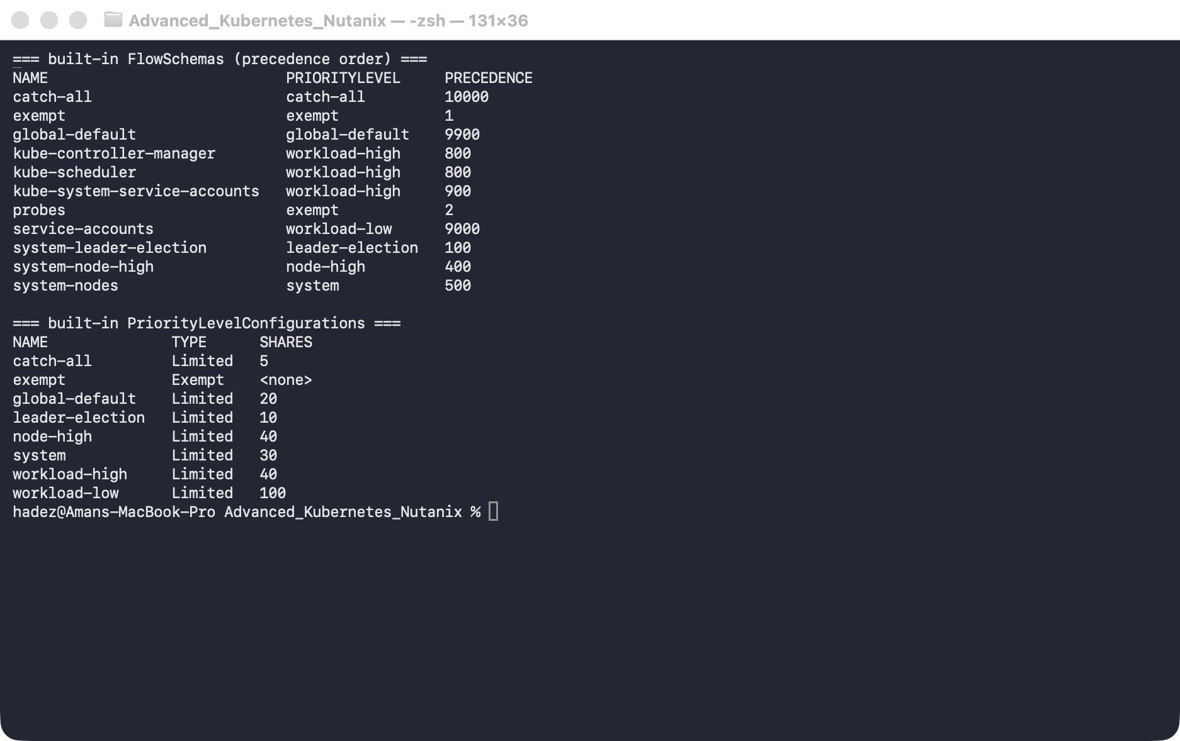
What this means: the design goal is visible right here. exempt/probes are never throttled (that's how health probes and leader election always get through), and control-plane traffic sits in high-priority reserved lanes. No amount of user traffic can starve them, because user traffic lives in the lower-priority lanes at the bottom.

Step 3 — Build a tiny lane and trap a noisy client in it
Goal: create a lane with almost no seats, route a made-up user storm-user into it, and see how few seats it actually gets.
1. Apply a small priority level (Reject = overflow gets an instant 429) and a FlowSchema that routes storm-user to it:
kubectl apply -f - <<'EOF'
apiVersion: flowcontrol.apiserver.k8s.io/v1
kind: PriorityLevelConfiguration
metadata:
name: restricted-storm
spec:
type: Limited
limited:
nominalConcurrencyShares: 1
limitResponse:
type: Reject
---
apiVersion: flowcontrol.apiserver.k8s.io/v1
kind: FlowSchema
metadata:
name: storm-user-fs
spec:
priorityLevelConfiguration:
name: restricted-storm
matchingPrecedence: 200
distinguisherMethod:
type: ByUser
rules:
- subjects:
- kind: User
user:
name: storm-user
resourceRules:
- verbs: ["*"]
apiGroups: ["*"]
resources: ["*"]
clusterScope: true
namespaces: ["*"]
EOF
2. Give storm-user read permission (so its requests come back 200/429, not 403):
kubectl create clusterrolebinding storm-user-view --clusterrole=view --user=storm-user
3. Confirm the routing, and check how many seats each lane got:
# impersonate storm-user and read the PriorityLevel header back:
kubectl get pods -A --as=storm-user -v=8 2>&1 | grep -i 'Prioritylevel-Uid'
# seats each lane actually received (proportional to its shares):
kubectl get --raw /metrics | grep '^apiserver_flowcontrol_nominal_limit_seats' \
| grep -E 'restricted-storm|global-default|workload-low'
What you should see: restricted-storm gets 3 seats, versus 49 for global-default and 244 for workload-low.
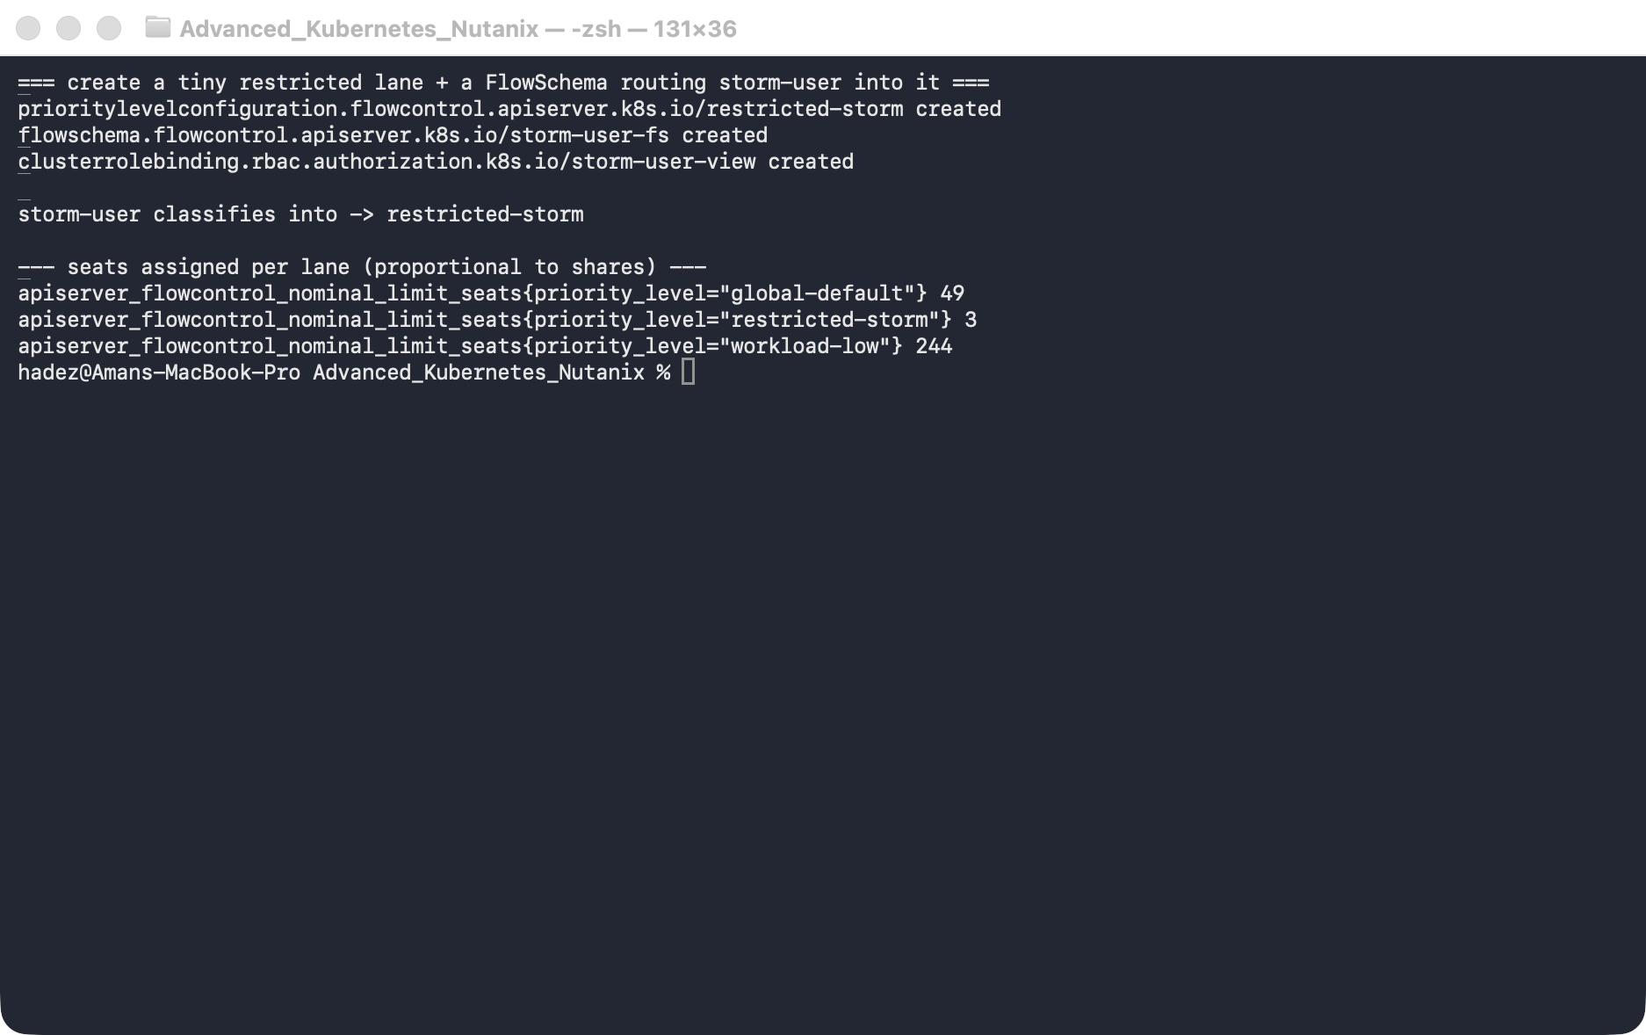
What this means: you didn't pick "3" — APF computed it by splitting the API server's total concurrency budget in proportion to each lane's shares (and nominalConcurrencyShares: 1 is as small as it goes). Three seats is a very narrow lane, which makes the next step deterministic: hit it with more than 3 simultaneous requests and the rest must be rejected.

Step 4 — Storm it, and watch critical traffic survive
Goal: fire 60 simultaneous requests as storm-user and one admin request alongside, and prove the storm is contained.
We'll hit the REST API through kubectl proxy with curl rather than plain kubectl — the gotcha below explains why.
1. Run the whole storm as one block:
kubectl proxy --port=18080 >/tmp/kproxy.log 2>&1 &
PROXY=$!
sleep 2
# 60 simultaneous requests as the noisy client; record each one's HTTP status:
tmp=$(mktemp -d); pids=()
for i in $(seq 1 60); do
curl -s --max-time 20 -o /dev/null -w "%{http_code}\n" \
-H "Impersonate-User: storm-user" \
"http://127.0.0.1:18080/api/v1/pods?limit=1000" > "$tmp/$i" &
pids+=($!)
done
wait "${pids[@]}" # wait ONLY on the curls, not the proxy
echo "storm status distribution:"; cat "$tmp"/* | sort | uniq -c
# one "critical" admin request in the same window:
curl -s --max-time 20 -o /dev/null -w "admin GET /api/v1/namespaces -> %{http_code}\n" \
"http://127.0.0.1:18080/api/v1/namespaces"
# APF's own count of what it rejected:
kubectl get --raw /metrics | grep '^apiserver_flowcontrol_rejected_requests_total' | grep 'restricted-storm'
kill $PROXY; rm -rf "$tmp"
What you should see: of the 60 storm requests, roughly 43 came back 200 and 17 came back 429; the admin request returned 200; and the rejection counter for restricted-storm is non-zero.
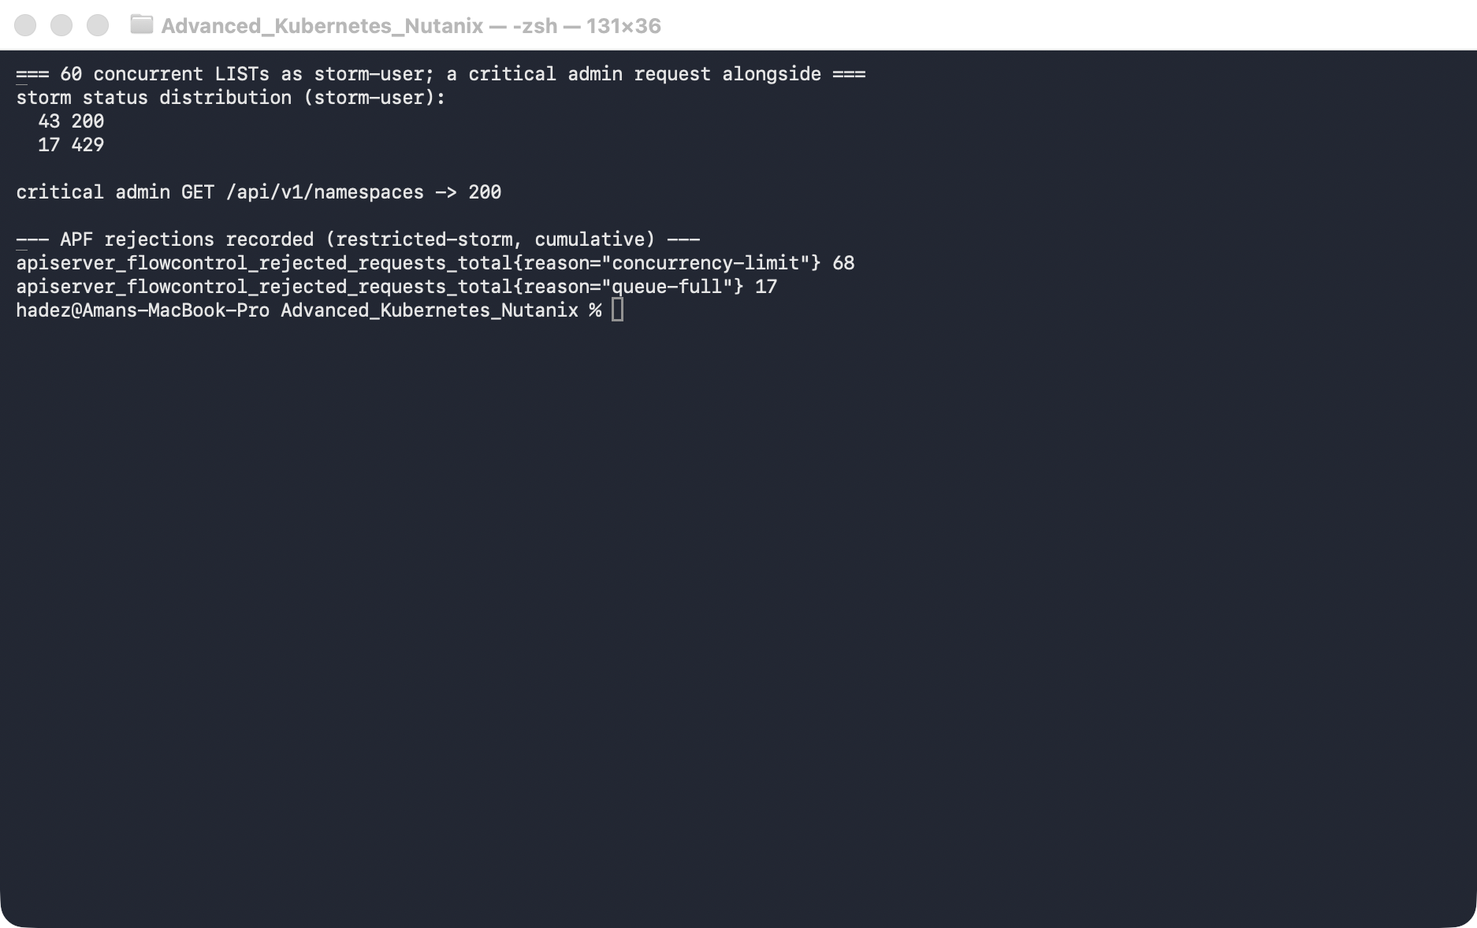
What this means: APF rejected exactly the overflow that couldn't grab one of the 3 seats — and it did so inside the storm's own lane. The admin request, in a different lane, never noticed. That's the whole point: a client hammering the API server is boxed into its lane and cannot starve anyone else. (Your exact split will vary by a few requests run to run.)
⚠️ Gotcha — kubectl hides the throttling from you. If you run the storm with kubectl get pods --as=storm-user in a loop instead of raw curl, you'll barely see any 429s — the requests just get slow. That's because the library kubectl is built on automatically retries 429s with backoff, so a throttled request eventually succeeds. To actually observe APF you must look at the raw HTTP status (hence curl) or the apiserver_flowcontrol_rejected_requests_total metric. This fools people into thinking APF "isn't doing anything."
⚠️ Gotcha — don't let wait hang forever. In the script, a bare wait would also wait on the kubectl proxy & you started (which never exits), so the loop would appear to hang. That's why we capture the curl PIDs and wait "${pids[@]}" on just those.

Step 5 — Clean up
Goal: remove the custom lane so the cluster is back to its default landscape. Leave the cluster running for Labs 3–4.
kubectl delete flowschema storm-user-fs
kubectl delete prioritylevelconfiguration restricted-storm
kubectl delete clusterrolebinding storm-user-view
What you should see: all three objects report deleted, and a kubectl get flowschema storm-user-fs now returns NotFound.
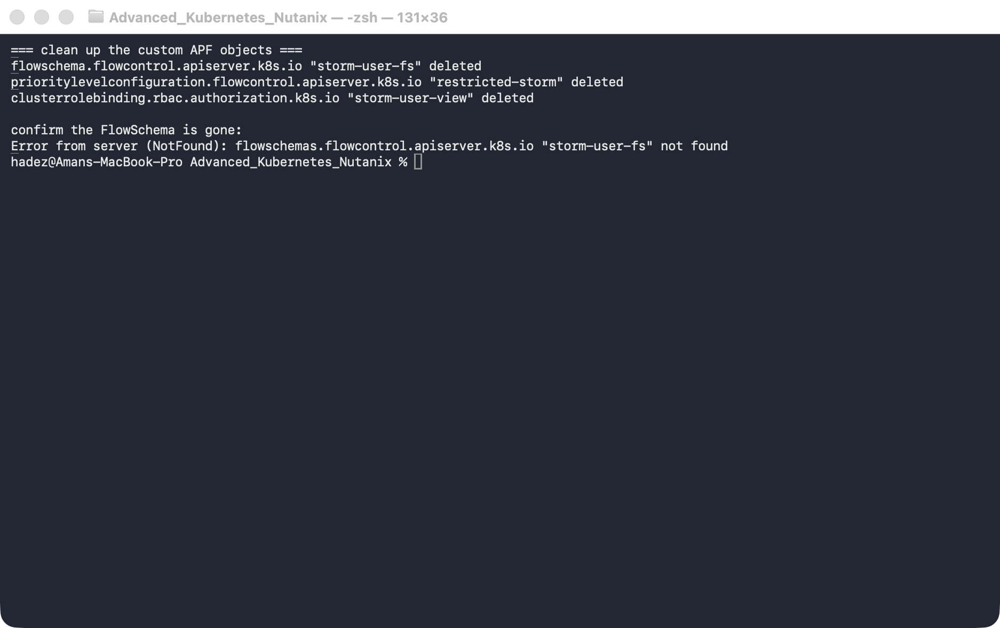
What this means: the built-in FlowSchemas and priority levels remain; only your custom lane is gone.

What you learned
You saw… | in Step | proof
Every request is classified by APF into a lane | 1 | X-Kubernetes-Pf-* headers on a 200
The control plane has reserved lanes user traffic can't starve | 2 | exempt/system-* precedence vs global-default/catch-all
Seats are allocated in proportion to a lane's shares | 3 | restricted-storm=3, global-default=49, workload-low=244
A confined storm is throttled, not the whole API server | 4 | ~43×200 / 17×429 for storm-user, admin stays 200
APF records exactly what it rejected | 4 | apiserver_flowcontrol_rejected_requests_total{…reason="concurrency-limit"}
kubectl's retry masks 429s; raw HTTP / metrics reveal them | 4 gotcha

Evidence
Real screenshots for this lab are in artifacts/lab-02/screenshots/ (5 images), and a full command transcript is in artifacts/lab-02/evidence/lab-02-api-priority-fairness.txt.

Next: Lab 3 — etcd Quota Alarm & Recovery

