Lab 3 — Recover a Cluster That's Gone Read-Only (etcd Quota & Recovery)
DataCouch — Advanced Kubernetes (Nutanix)
Table of Contents

Day 1 · How Kubernetes Really Works
YES — Tested end-to-end on a real, dedicated kind cluster (Kubernetes v1.37.0, etcd v3.7.0) that we deliberately drove into a read-only state and then recovered. Every screenshot is a real capture. The moment you'll reproduce: after filling etcd past its quota, kubectl create fails cluster-wide with database space exceeded — and a three-command runbook brings it back.

What you'll learn
- What etcd's --quota-backend-bytes does, and what happens the instant the database crosses it: a NOSPACE alarm and a cluster-wide read-only state.
- How to see the failure from both sides — the etcd alarm and the database space exceeded error every user hits.
- Why reads keep working while all writes fail — the single most confusing etcd incident in production.
- The real recovery runbook — compact → defrag → disarm — and why you need all three, in that order.
- Why deleting the offending data alone doesn't give the space back until you compact and defrag.

What you'll do
You'll build a throwaway cluster, shrink etcd's quota so you can fill it quickly, then create ConfigMaps until etcd goes read-only. You'll confirm the whole cluster is stuck (writes fail, reads work), then run the recovery runbook to bring it back and reclaim the space.

Time & cost
- Time: ~40 minutes.
- Cost: $0 — runs on a local kind cluster.

Before you start
- Where you'll work: in a terminal on your own machine.
- Tools you need: docker, kind, kubectl.
- ⚠️ This lab uses its own dedicated, throwaway cluster — not the Day-1 shared one. You're going to deliberately corrupt etcd into a read-only state, and you never practise that on a cluster you care about. You'll create an etcd-lab cluster and delete it at the end.
Nutanix note — and why this one is kind. etcd, its quota, the NOSPACE alarm, and the compact/defrag/disarm runbook are identical everywhere — etcd is etcd. What differs is access: on a managed platform (NKE, GKE, EKS, AKS) you don't edit etcd's static-pod manifest yourself — the platform sets the quota, and you'd use its etcd-maintenance tooling or a support case to compact/defrag. We use kind precisely because it gives you full control-plane access, so you can practise the recovery and recognise it instantly when it happens on NKE.

The idea in 60 seconds
etcd stores every Kubernetes object, and it keeps a history of revisions, not just the latest value — so it grows with every write, every controller update, every Event and Lease renewal. To stop a runaway from filling the disk, etcd enforces --quota-backend-bytes. When the database file crosses that size, etcd does something drastic on purpose: it raises a NOSPACE alarm and refuses all writes, cluster-wide. Reads still work. It would rather go read-only than corrupt itself by running out of disk.
Recovery is always the same three steps, and you need all three:
- compact — discard old revisions from the history (frees space logically inside the file).
- defrag — actually shrink the file to return the freed pages (compaction alone doesn't shrink it).
- alarm disarm — the alarm does not clear itself; you must explicitly disarm it before writes resume.
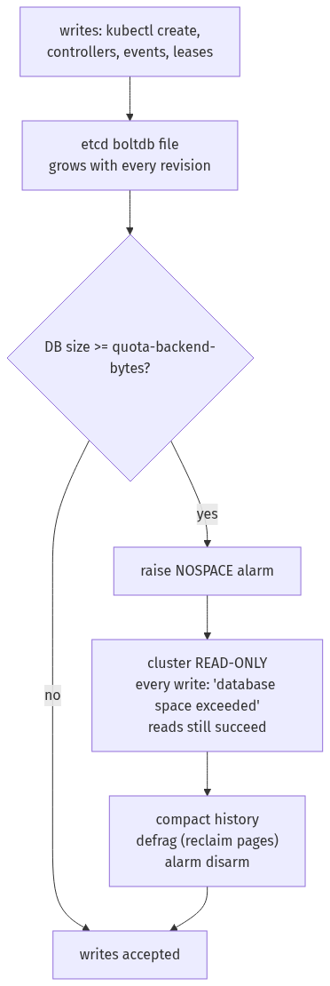

Step 1 — Build a throwaway cluster and shrink etcd's quota
Goal: stand up a dedicated cluster and lower etcd's quota to 16 MiB so you can fill it in minutes instead of hours.
1. Create the cluster:
kind create cluster --name etcd-lab --wait 120s
2. Lower the quota. etcd runs as a static Pod on the control-plane node; add a flag to its manifest and the kubelet restarts etcd automatically:
docker exec etcd-lab-control-plane \
sed -i '/^ - etcd$/a\ - --quota-backend-bytes=16777216' \
/etc/kubernetes/manifests/etcd.yaml
3. Set up a one-word helper for the long etcdctl command (with all its TLS flags), then check the new quota took effect:
e() {
kubectl -n kube-system exec etcd-etcd-lab-control-plane -- etcdctl \
--endpoints=https://127.0.0.1:2379 \
--cacert=/etc/kubernetes/pki/etcd/ca.crt \
--cert=/etc/kubernetes/pki/etcd/server.crt \
--key=/etc/kubernetes/pki/etcd/server.key "$@"
}
e endpoint status -w fields | grep -E '"DBSize"|"DBSizeInUse"|"DBSizeQuota"'
(We grep the -w fields output because the full -w table is 17 columns wide and unreadable.)
What you should see: DBSizeQuota now reads 16777216 (16 MiB), with DBSize only ~0.5–2 MB — so there's ~15 MB of headroom to fill.
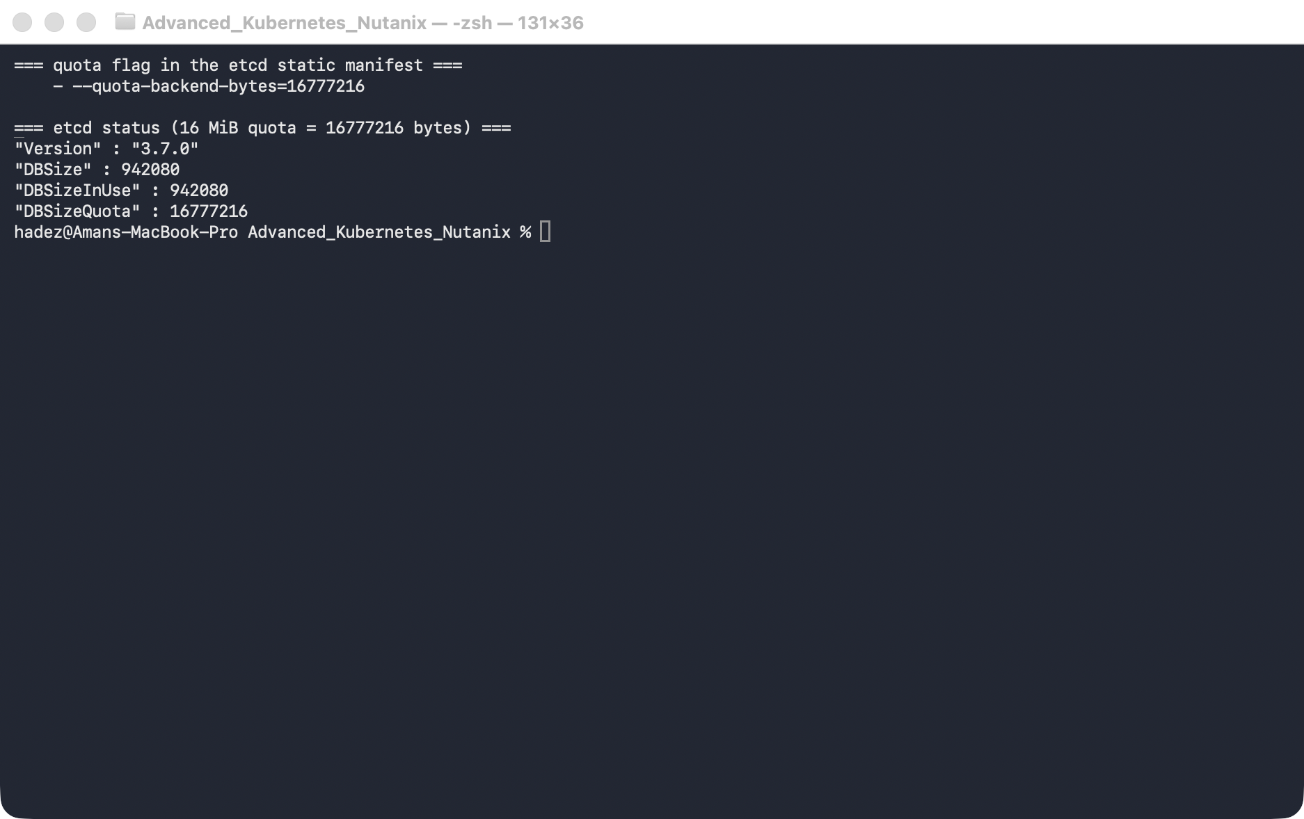
What this means: you've turned a 2 GiB safety valve into a 16 MiB one, so the rest of the lab runs in minutes. Everything else about etcd's behaviour is unchanged.

Step 2 — Fill etcd until it goes read-only
Goal: create ~1 MB ConfigMaps in a loop until etcd refuses a write.
1. Make a 1 MB blob and create ConfigMaps until one fails:
head -c 900000 /dev/zero | tr '\0' 'a' > /tmp/blob.txt
kubectl create namespace fill
for i in $(seq 1 40); do
out=$(kubectl -n fill create configmap fill-$i --from-file=blob=/tmp/blob.txt 2>&1)
echo "$out" | grep -qi 'space exceeded' && { echo "FAILED at #$i: $out"; break; }
done
What you should see: a dozen ConfigMaps get created, then one fails — in our run at #14:
error: failed to create configmap: etcdserver: mvcc: database space exceeded
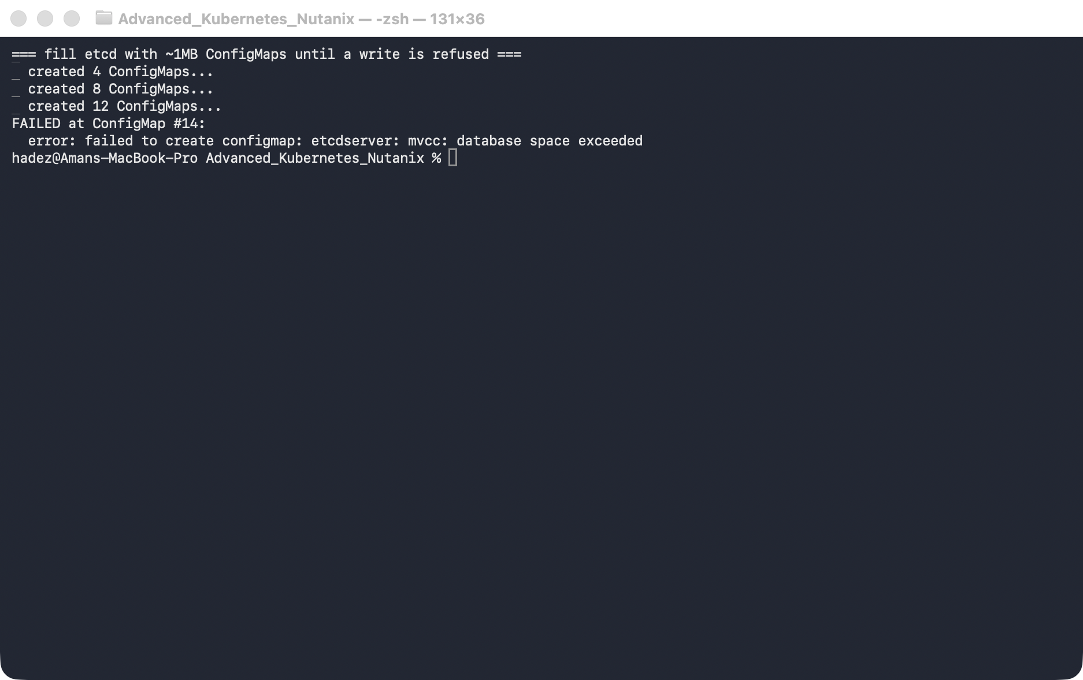
What this means: the database crossed 16 MiB and etcd raised its NOSPACE alarm. (The exact number where it fails varies by a ConfigMap or two, depending on other cluster churn.) From this instant, etcd is read-only.

Step 3 — Confirm the whole cluster is read-only
Goal: see the failure from both sides — the etcd alarm, and the error any user gets — and confirm reads still work.
1. Check the alarm, try a write in an unrelated namespace, try a read, and look at the sizes:
e alarm list # the etcd side
kubectl create configmap canary --from-literal=a=b # any write, anywhere
kubectl get ns # reads still work
e endpoint status -w fields | grep -E 'DBSize|Quota'
What you should see:
- e alarm list → memberID:… alarm:NOSPACE
- the canary write (a different namespace!) fails with the same database space exceeded
- kubectl get ns returns instantly — reads are fine
- DBSize ≈ 17 MB, having met DBSizeQuota = 16.8 MB
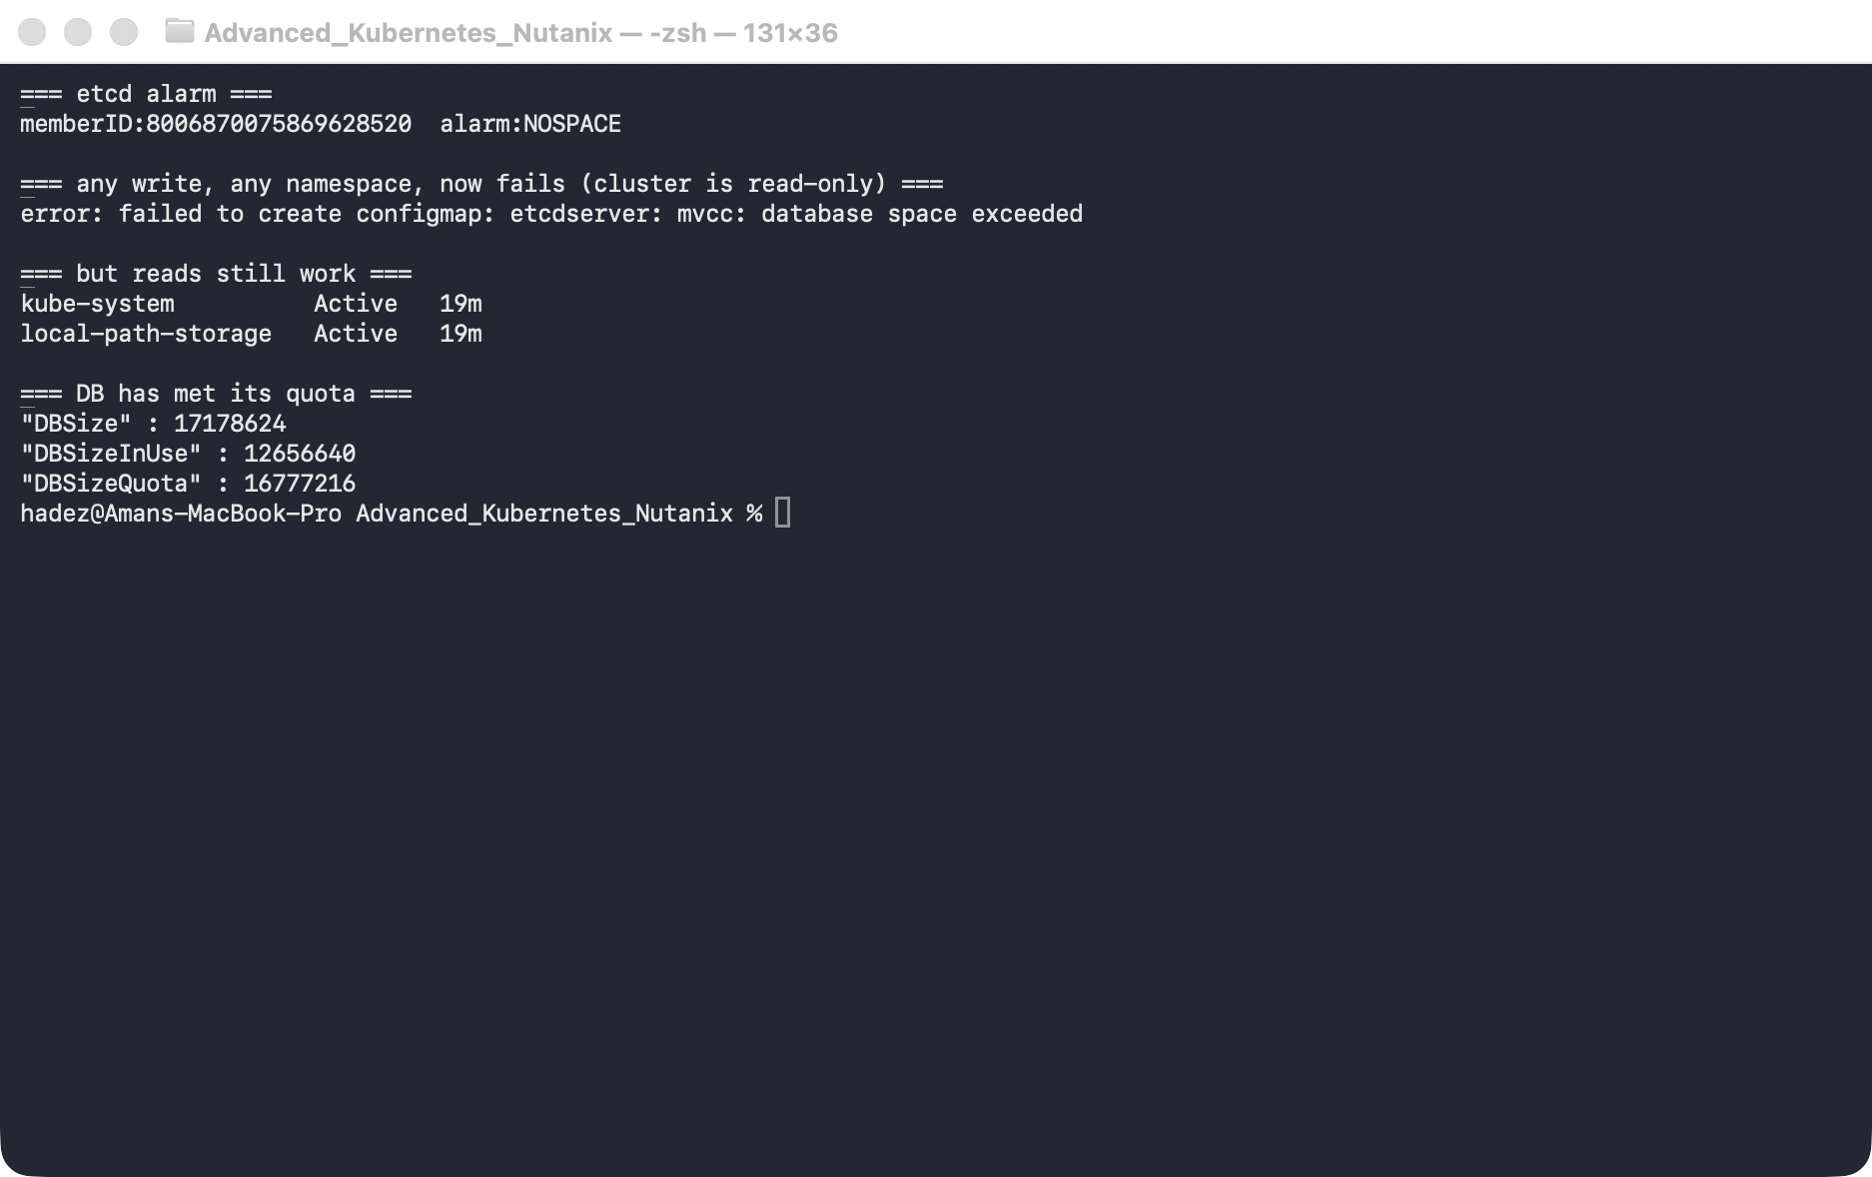
What this means: it's not just your namespace — the entire cluster can't accept writes. New Pods won't create, Deployments won't scale, kubectl apply hangs.
⚠️ Gotcha — this looks like an outage, not a disk problem. Because reads work and only writes fail, people report "I can't create pods" or "apply hangs" with no obvious disk error at the node level. The tell is any write returning database space exceeded plus etcdctl alarm list showing NOSPACE. Check the alarm first — it points straight at the cause.

Step 4 — Recover: compact → defrag → disarm
Goal: run the three-step runbook and watch writes come back.
1. Get the current revision, then run the runbook:
REV=$(e endpoint status -w fields | grep '"Revision"' | head -1 | grep -oE '[0-9]+')
e compact "$REV"
e defrag --command-timeout=30s
e alarm disarm
e alarm list # should now be empty
kubectl create configmap canary --from-literal=a=b # writes work again
What you should see:
- compacted revision <N> (e.g. 1998)
- Finished defragmenting etcd member[…]. took ~211ms — and DBSize drops from ~17 MB toward ~14 MB
- alarm disarm prints the alarm it cleared; alarm list is now empty
- kubectl create configmap canary → configmap/canary created
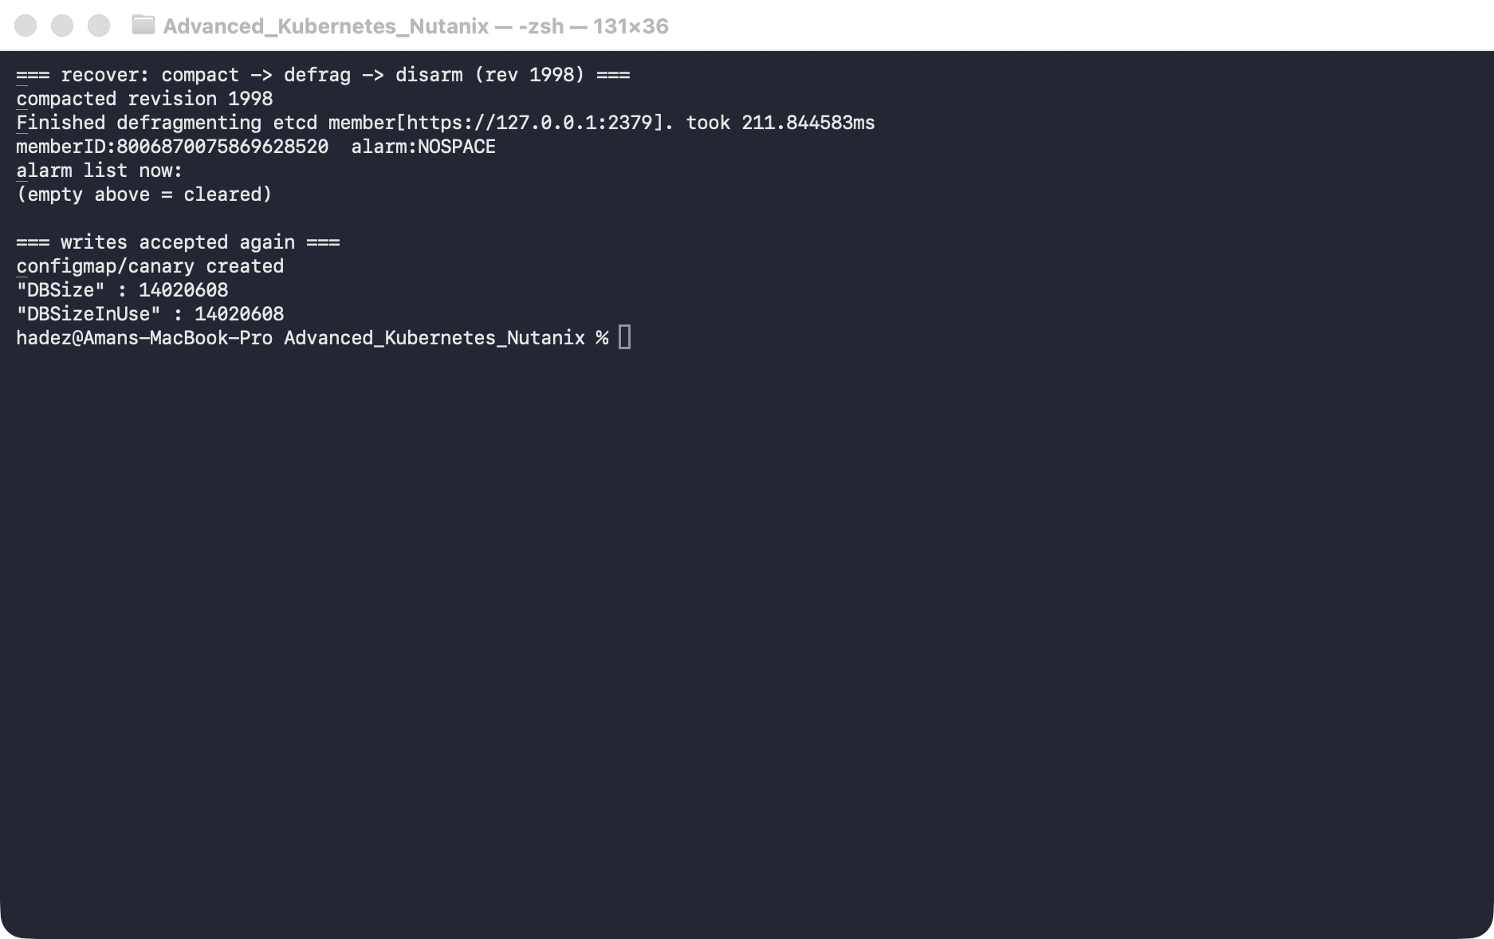
What this means: the cluster is writable again. Compaction dropped the old revision history, defrag returned the freed pages to the filesystem (shrinking the file below the quota), and disarm cleared the latch.
⚠️ Gotcha — disarm is not optional, and order matters. If you defrag but forget alarm disarm, the DB is small again yet writes still fail — the alarm latches until you clear it. And if you disarm before you've actually freed space (compact + defrag), the very next write pushes you back over quota and re-arms it within seconds. Compact, then defrag, then disarm — every time.

Step 5 — Reclaim the space the junk is still holding
Goal: the alarm is clear, but your 12+ fill ConfigMaps are still live keys eating ~11 MB. Delete them, then compact + defrag again to actually return the space.
1. Delete the junk and reclaim:
kubectl delete namespace fill
kubectl delete configmap canary
REV=$(e endpoint status -w fields | grep '"Revision"' | head -1 | grep -oE '[0-9]+')
e compact "$REV"
e defrag --command-timeout=30s
e endpoint status -w fields | grep -E '"DBSize"|DBSizeInUse'
What you should see: DBSize falls to ~0.5 MB — back below where you started.
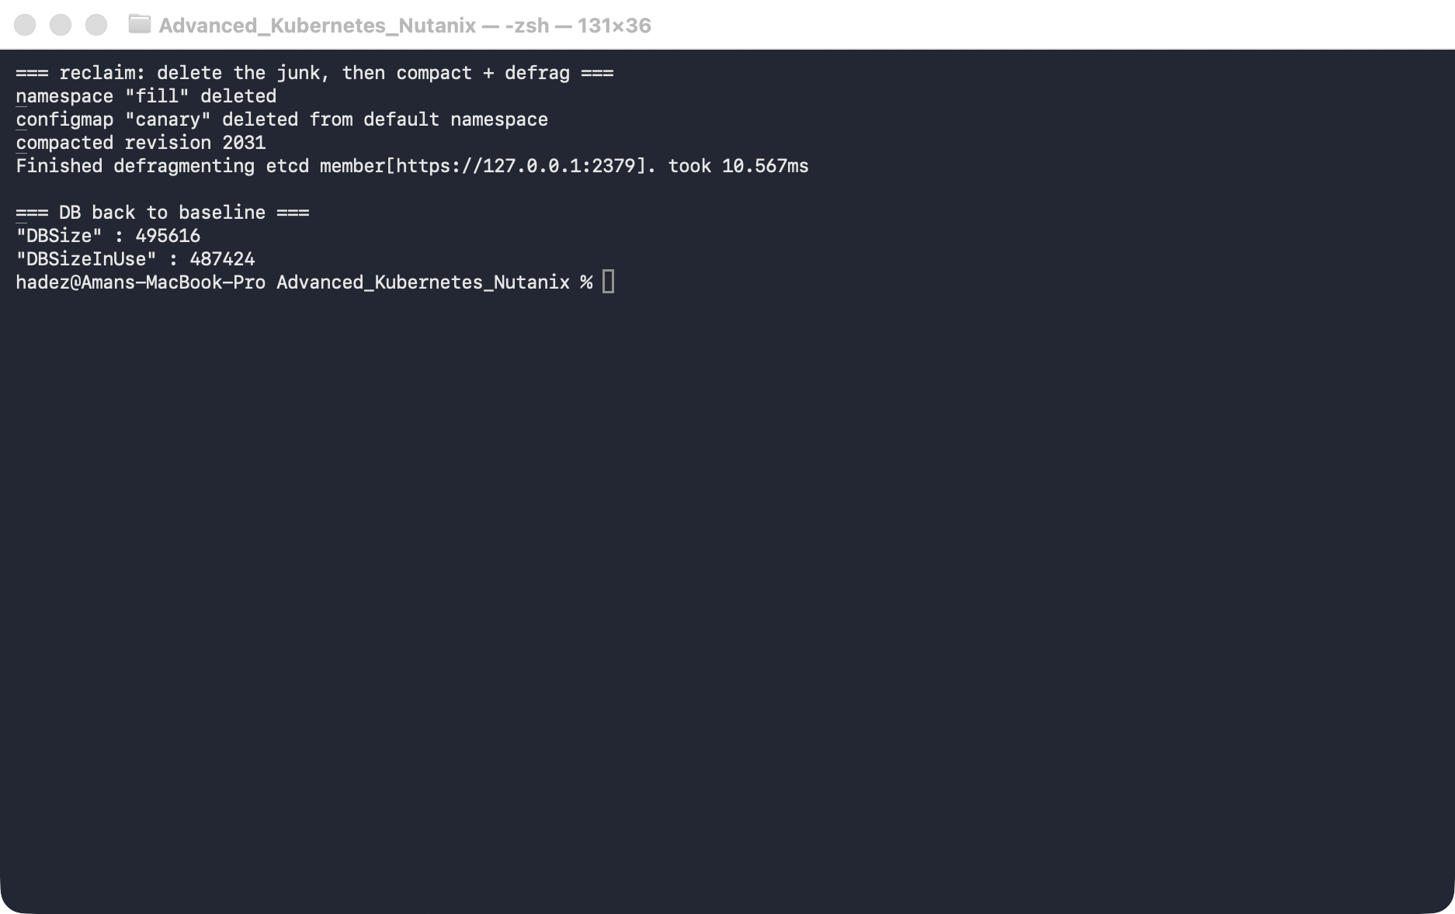
What this means: this is the follow-up most runbooks skip — disarming gets you writing again, but deleting + compacting + defragging is what actually gives the disk space back. Compaction only drops superseded revisions; a live ConfigMap keeps its space until you delete it and defrag.

Step 6 — Clean up
This was a throwaway cluster — delete it:
kind delete cluster --name etcd-lab
(If you wanted to keep it instead, you'd remove the --quota-backend-bytes line from the manifest to restore the default 2 GiB quota, and the kubelet would restart etcd.)

What you learned
You saw… | in Step | proof
--quota-backend-bytes caps the etcd DB size | 1 | DBSizeQuota=16777216 after the manifest edit
Crossing the quota raises NOSPACE and blocks writes | 2 | fill loop fails with database space exceeded
The read-only state is cluster-wide; reads still work | 3 | canary write fails, alarm:NOSPACE, get ns succeeds
compact → defrag → disarm restores writes | 4 | configmap/canary created after the runbook
Disarm latches; order matters | 4 gotcha
Reclaiming space needs delete + compact + defrag | 5 | DBSize back to ~0.5 MB

Evidence
Real screenshots for this lab are in artifacts/lab-03/screenshots/ (5 images), and a full command transcript is in artifacts/lab-03/evidence/lab-03-etcd-quota-recovery.txt.

Next: Lab 4 — Pending-Pod Diagnostics

