Lab 8 — StatefulSets, PVCs & Volume Snapshots
DataCouch — Advanced Kubernetes (Nutanix)
Table of Contents

Day 3 · Stateful Workloads, Persistent Storage & Service Exposure
YES — Tested end-to-end on a real GKE cluster (advk8s-lab, dcproject-462806) using real Persistent Disks and CSI volume snapshots. Every screenshot is a real capture. The payoff you'll see: you write data, snapshot it, delete the StatefulSet and its disk entirely, then bring the data back from the snapshot onto a brand-new volume — important-data-v1, intact.

What you'll learn
- How a StatefulSet gives each Pod its own stable PVC via a volumeClaimTemplate, backed by a real cloud disk.
- How to take a VolumeSnapshot of a live PVC through the CSI driver, and confirm it's readyToUse.
- How to restore a snapshot onto a new PVC using dataSource, and verify the data survived a full destroy/restore cycle.
- Why a snapshot in the same storage system is a fast recovery tool — and where its limits are (that's what Lab 9's Velero backup covers).

What you'll do
You'll run a StatefulSet with a persistent volume, write a known value into it, snapshot the volume, then delete the whole StatefulSet and its PVC to simulate a disaster. Finally you'll restore the snapshot onto a fresh PVC and prove the original data is still there.

Time & cost
- Time: ~40 minutes (much of it waiting for real disks to provision).
- Cost: a few cents of Persistent Disk on the shared GKE cluster.

Before you start
- Where you'll work: in a terminal on your own machine.
- Tools you need: gcloud, kubectl.
- Cluster: a GKE cluster (this course's shared advk8s-lab). GKE ships the CSI snapshot CRDs but no VolumeSnapshotClass by default — you'll create one in Step 2.
Nutanix note. StatefulSets, PVCs, VolumeSnapshot, and the dataSource-restore mechanism are all standard Kubernetes/CSI — identical on NKE. The only platform-specific piece is the CSI driver name: here it's pd.csi.storage.gke.io (Google Persistent Disk); on Nutanix it's the Nutanix CSI driver (csi.nutanix.com), which likewise supports VolumeSnapshot. Swap the driver name in the VolumeSnapshotClass and everything else in this lab is unchanged.

The idea in 60 seconds
A StatefulSet is how you run stateful apps: each replica gets a stable identity (db-0, db-1, …) and its own PVC from a volumeClaimTemplate, so a Pod that restarts reattaches to the same disk. A PVC is bound to a real volume provisioned by a CSI driver (here Google Persistent Disk).
A VolumeSnapshot asks that CSI driver to take a point-in-time copy of the volume. It's fast and space-efficient, and — crucially — you can create a new PVC from a snapshot (spec.dataSource), which is how you recover. That's the cycle you'll run: snapshot → destroy → restore.
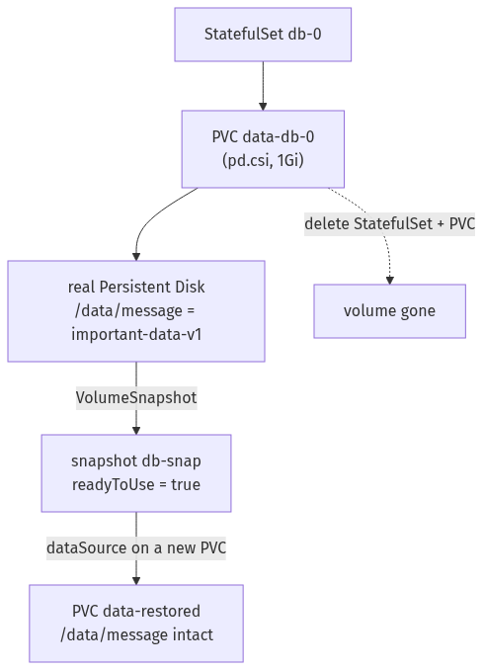

Step 1 — Run a StatefulSet and write data to its volume
Goal: create a StatefulSet whose Pod has its own persistent disk, and put a known value on it.
1. Create the StatefulSet (it declares a volumeClaimTemplate), wait for it, then write a file:
kubectl apply -f - <<'EOF'
apiVersion: apps/v1
kind: StatefulSet
metadata: {name: db}
spec:
serviceName: db
replicas: 1
selector: {matchLabels: {app: db}}
template:
metadata: {labels: {app: db}}
spec:
containers:
- name: app
image: busybox:1.36
command: ["sh","-c","sleep 3600"]
volumeMounts: [{name: data, mountPath: /data}]
volumeClaimTemplates:
- metadata: {name: data}
spec:
accessModes: ["ReadWriteOnce"]
storageClassName: standard-rwo
resources: {requests: {storage: 1Gi}}
EOF
kubectl rollout status statefulset/db --timeout=120s
kubectl exec db-0 -- sh -c 'echo "important-data-v1" > /data/message; cat /data/message'
kubectl get pvc data-db-0
What you should see: the rollout completes, cat /data/message prints important-data-v1, and kubectl get pvc data-db-0 shows a Bound 1Gi PVC.
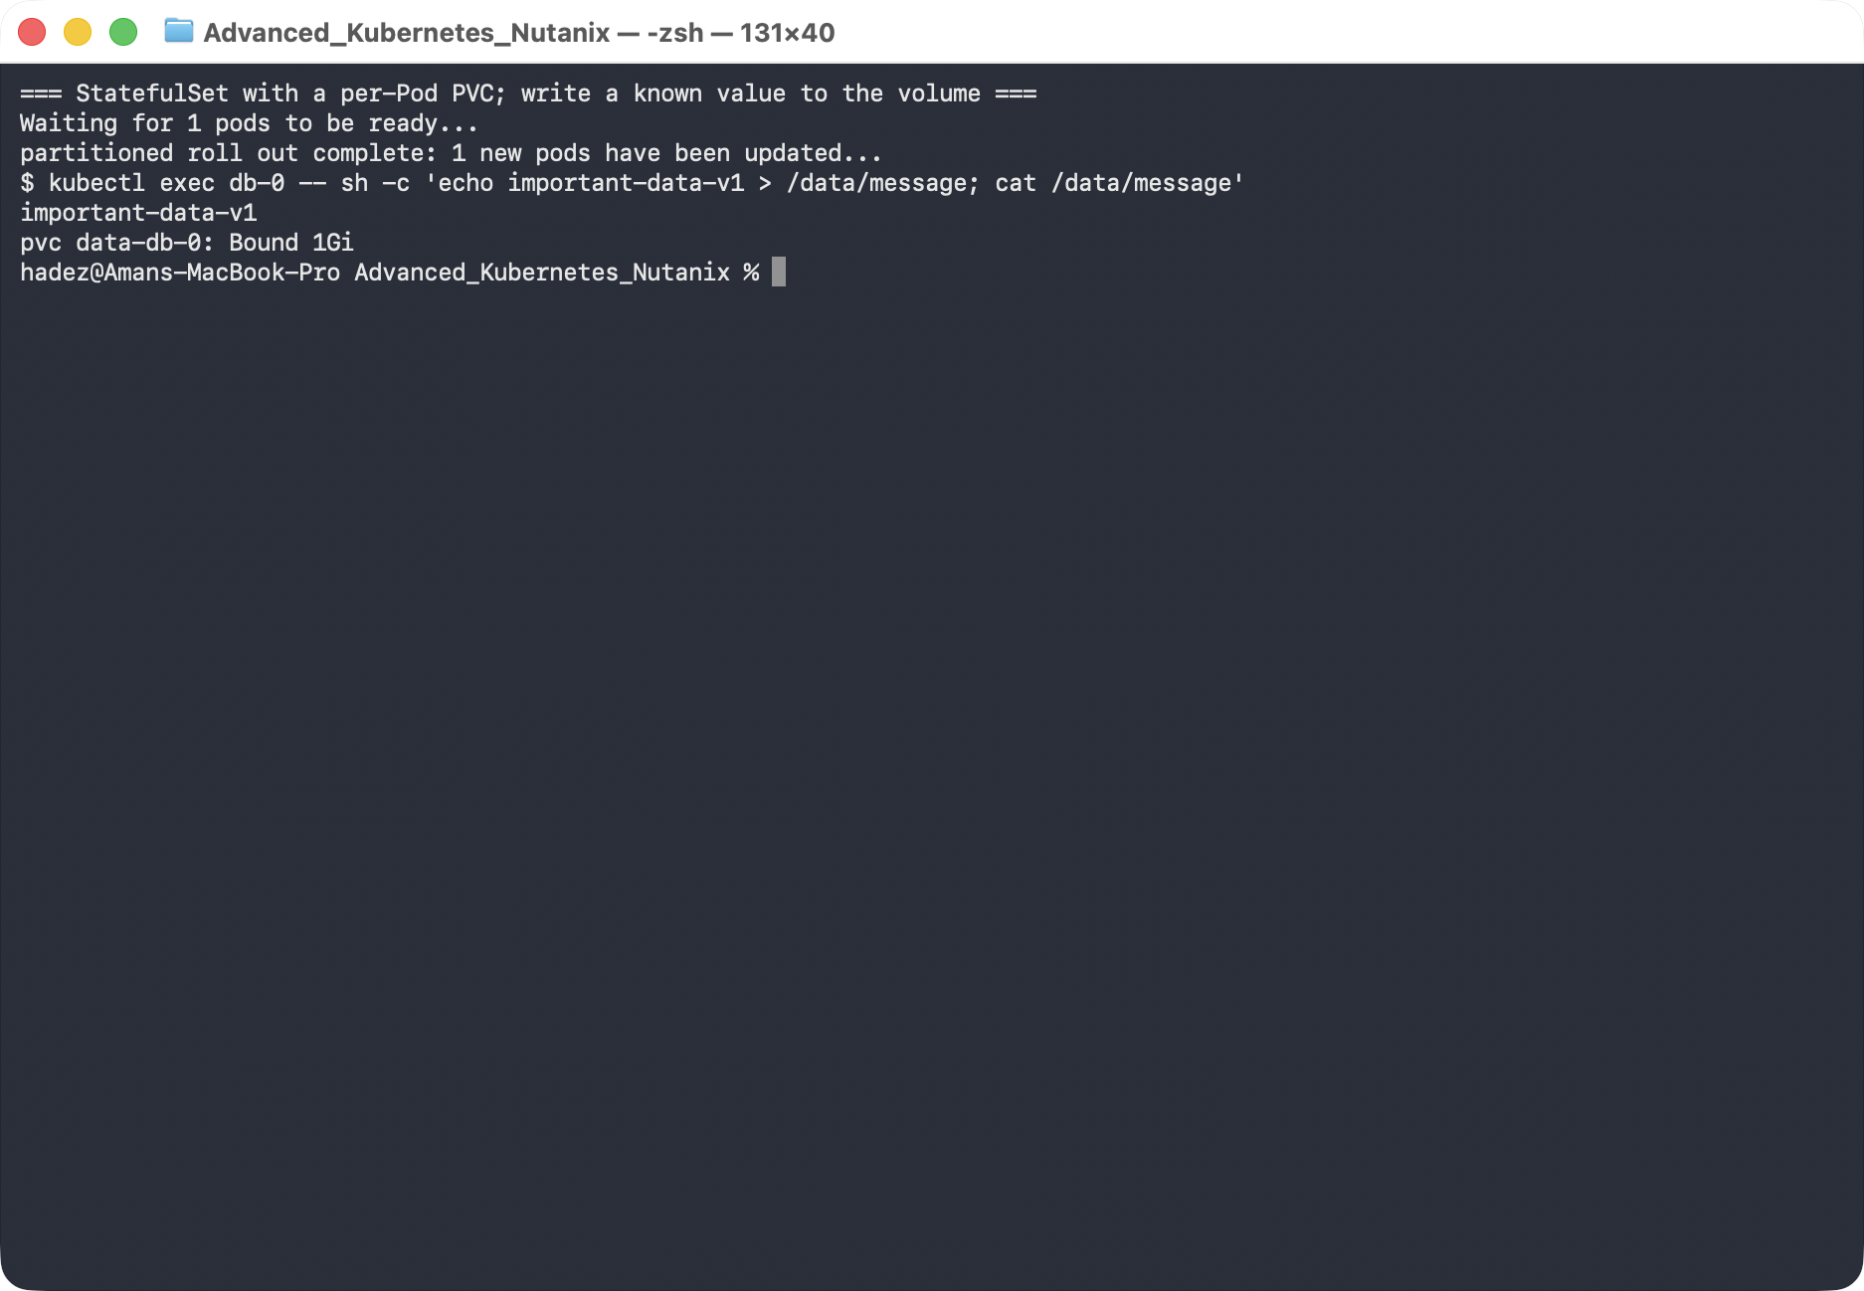
What this means: the StatefulSet created a PVC named data-db-0 (template name + Pod name), CSI provisioned a real Persistent Disk for it, and your file lives on that disk — not in the Pod.

Step 2 — Snapshot the volume
Goal: create a VolumeSnapshot of the PVC and confirm it's usable.
1. Create a VolumeSnapshotClass (GKE doesn't ship one), then snapshot the PVC:
kubectl apply -f - <<'EOF'
apiVersion: snapshot.storage.k8s.io/v1
kind: VolumeSnapshotClass
metadata: {name: pd-snapclass}
driver: pd.csi.storage.gke.io
deletionPolicy: Delete
EOF
kubectl apply -f - <<'EOF'
apiVersion: snapshot.storage.k8s.io/v1
kind: VolumeSnapshot
metadata: {name: db-snap}
spec:
volumeSnapshotClassName: pd-snapclass
source: {persistentVolumeClaimName: data-db-0}
EOF
kubectl wait --for=jsonpath='{.status.readyToUse}'=true volumesnapshot/db-snap --timeout=120s
kubectl get volumesnapshot db-snap
What you should see: db-snap with READYTOUSE: true and RESTORESIZE: 1Gi.
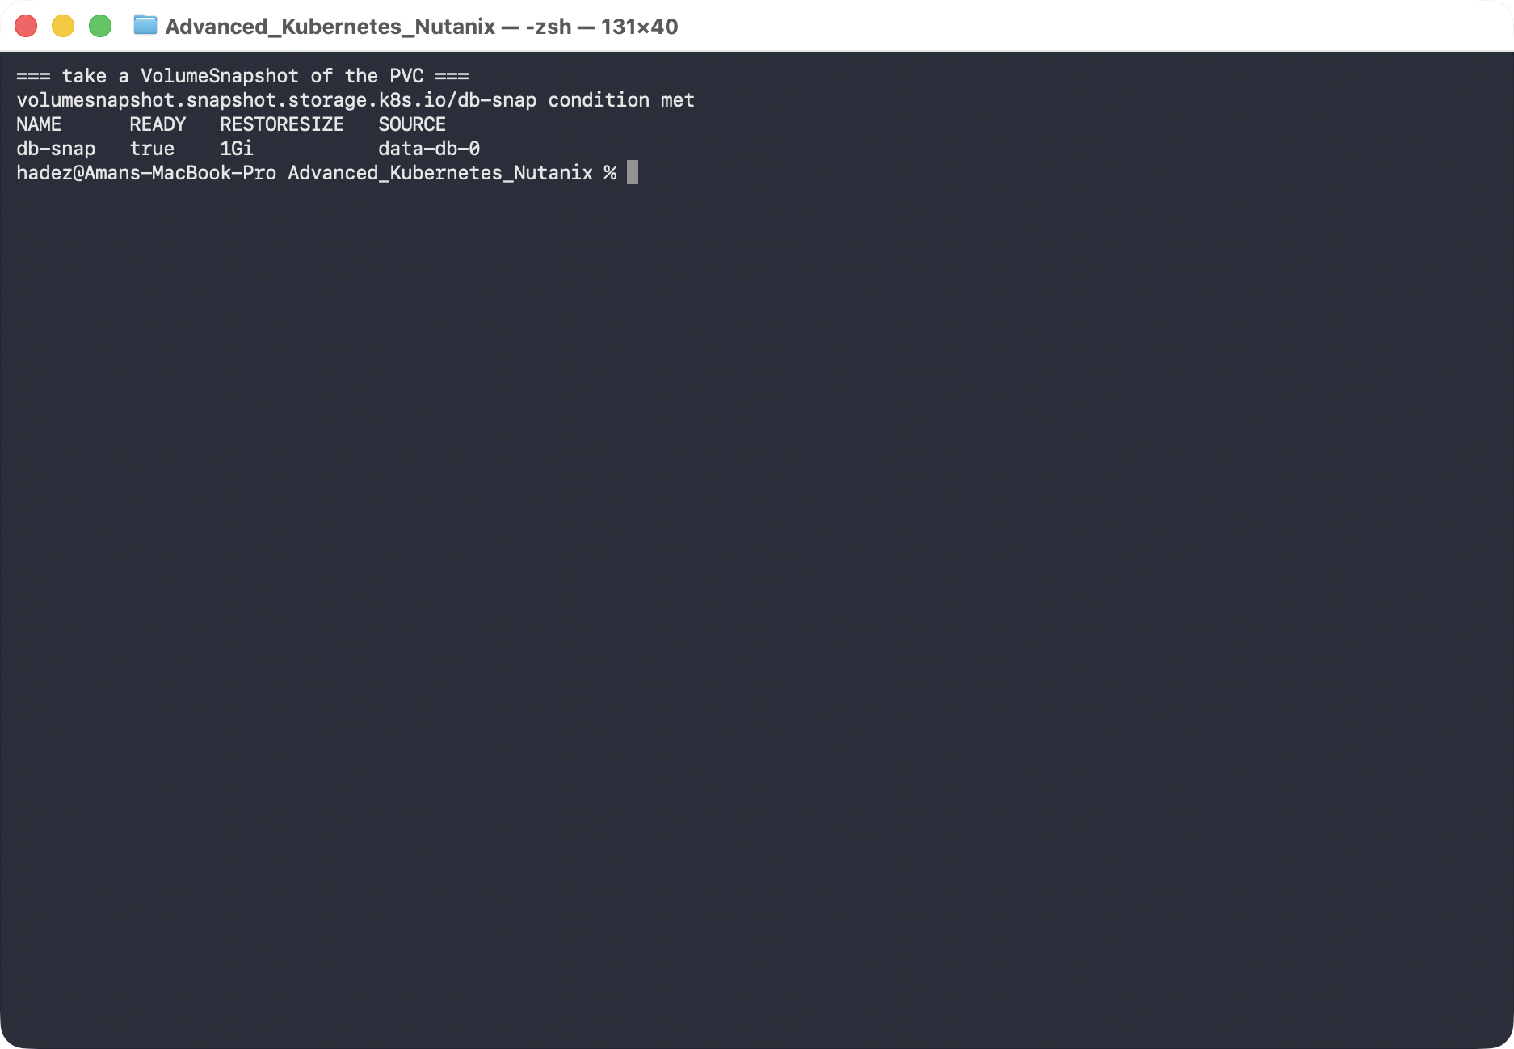
What this means: the CSI driver captured a point-in-time copy of the disk. It exists independently of the PVC now — you could delete the original and still restore from this.

Step 3 — Simulate a disaster
Goal: destroy the StatefulSet and its volume, so recovery has to come from the snapshot.
kubectl delete statefulset db
kubectl delete pvc data-db-0
kubectl get pvc data-db-0 --ignore-not-found
kubectl get volumesnapshot db-snap
What you should see: data-db-0 is gone (no output), but db-snap is still present and ready.
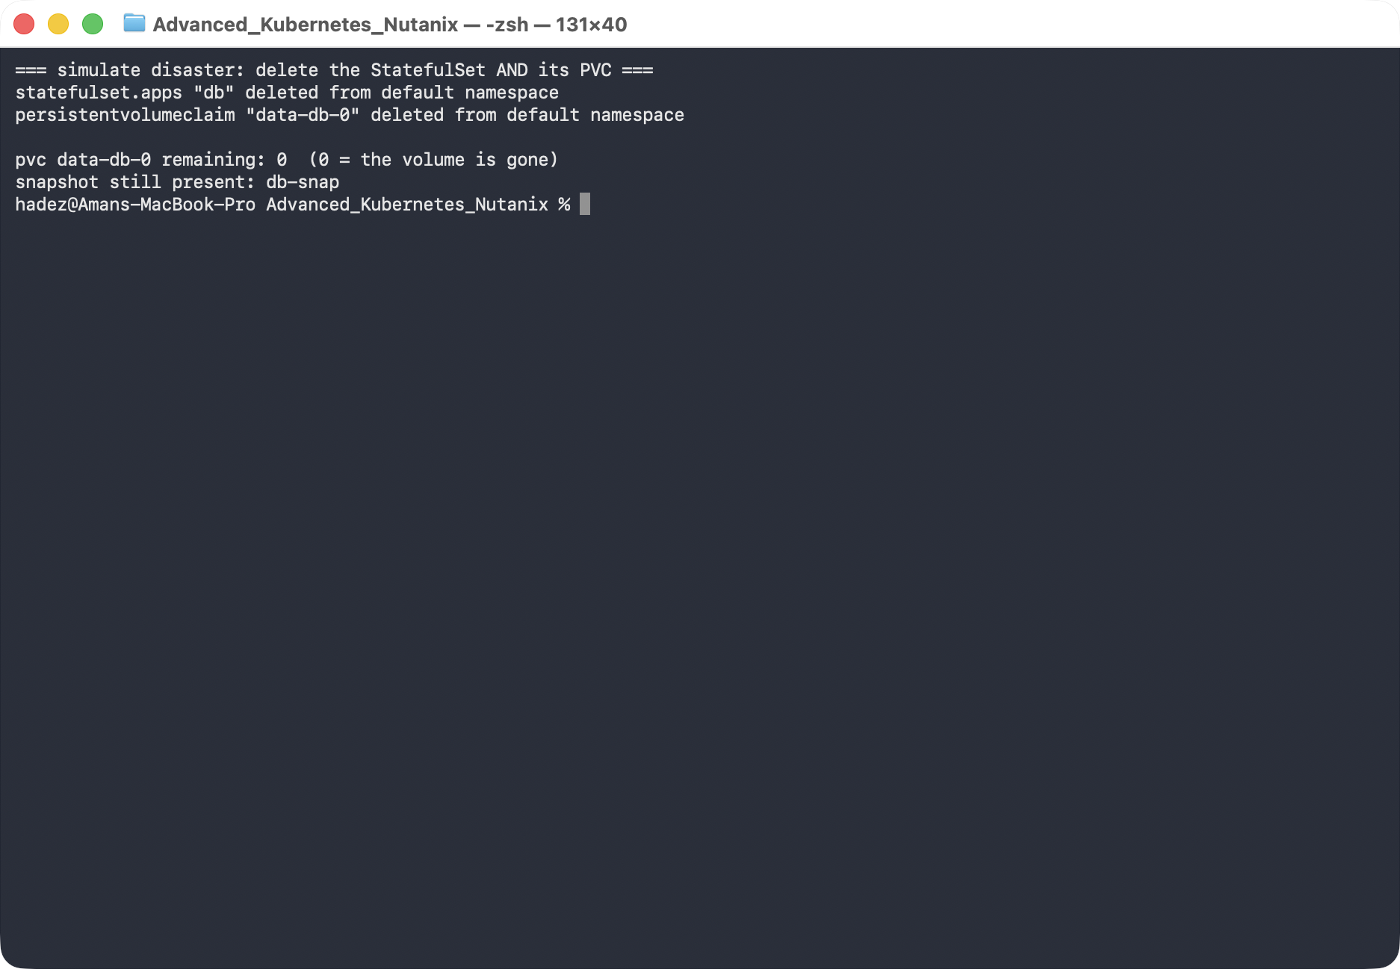
What this means: the live volume no longer exists — this is the "someone deleted the wrong thing" or "the disk is gone" scenario. The only copy of your data is the snapshot.

Step 4 — Restore from the snapshot and verify
Goal: create a new PVC from the snapshot and prove the data survived.
kubectl apply -f - <<'EOF'
apiVersion: v1
kind: PersistentVolumeClaim
metadata: {name: data-restored}
spec:
storageClassName: standard-rwo
dataSource: {name: db-snap, kind: VolumeSnapshot, apiGroup: snapshot.storage.k8s.io}
accessModes: ["ReadWriteOnce"]
resources: {requests: {storage: 1Gi}}
---
apiVersion: v1
kind: Pod
metadata: {name: restore-check}
spec:
containers:
- name: app
image: busybox:1.36
command: ["sh","-c","sleep 3600"]
volumeMounts: [{name: data, mountPath: /data}]
volumes:
- name: data
persistentVolumeClaim: {claimName: data-restored}
EOF
kubectl wait --for=condition=Ready pod/restore-check --timeout=120s
kubectl exec restore-check -- cat /data/message
What you should see: cat /data/message prints important-data-v1 — the exact value from before the disaster.
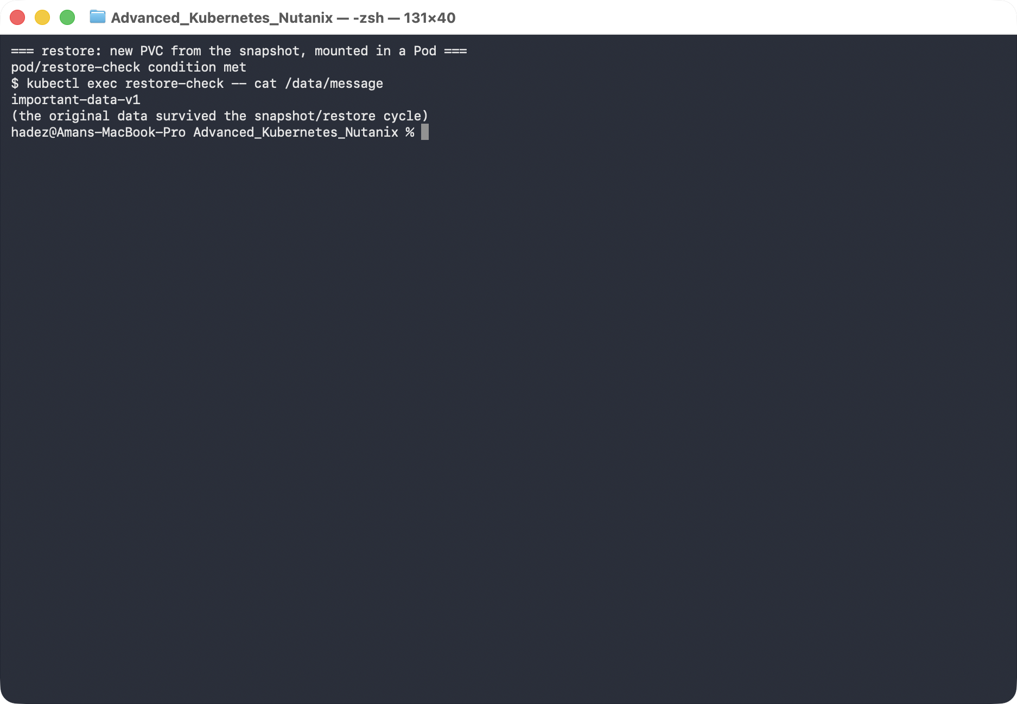
What this means: the snapshot's dataSource pre-populated a brand-new disk with the snapshot's contents, so the data survived a complete destroy/restore cycle. This is the fast path for recovering a single volume.
Where snapshots stop. A VolumeSnapshot lives in the same storage system and doesn't capture your Kubernetes objects (the StatefulSet, Services, ConfigMaps). For "restore a whole namespace, objects and data, possibly to another cluster," you need a backup tool that captures both — that's Lab 9 (Velero).

Step 5 — Clean up
kubectl delete pod restore-check --ignore-not-found
kubectl delete pvc data-restored --ignore-not-found
kubectl delete volumesnapshot db-snap --ignore-not-found
kubectl delete volumesnapshotclass pd-snapclass --ignore-not-found

What you learned
You saw… | in Step | proof
A StatefulSet gives each Pod its own PVC/disk | 1 | data-db-0 Bound, file on the disk
You can snapshot a live PVC via CSI | 2 | db-snap readyToUse=true, 1Gi
A snapshot outlives its source volume | 3 | PVC deleted, snapshot remains
A snapshot restores onto a new PVC via dataSource | 4 | data-restored Bound, data intact
Data survives a full destroy/restore cycle | 4 | important-data-v1 after restore

Evidence
Real screenshots for this lab are in artifacts/lab-08/screenshots/ (4 images), and a command transcript is in artifacts/lab-08/evidence/lab-08-statefulsets-snapshots.txt.

Next: Lab 9 — Backup & Restore with Velero

