Lab 10 — Bare-Metal LoadBalancer with MetalLB
DataCouch — Advanced Kubernetes (Nutanix)
Table of Contents

Day 3 · Stateful Workloads, Persistent Storage & Service Exposure
YES — Tested end-to-end on a real 4-node kind cluster with MetalLB v0.14.9. Every screenshot is a real capture. You'll watch a Service type=LoadBalancer sit at <pending> forever, then get a real, reachable IP from MetalLB — and keep that IP working after you kill the node that was announcing it.

What you'll learn
- Why Service type=LoadBalancer gives an EXTERNAL-IP on a cloud (GKE) but stays <pending> on bare metal / on-prem — there's no cloud load-balancer controller.
- How MetalLB fills that gap: an IPAddressPool plus Layer-2 advertisement that assigns an address and announces it from a node.
- How MetalLB survives a node failure — the address is re-announced from another node.
- Why this is one of the most Nutanix-relevant labs: on-prem NKE clusters need exactly this.

What you'll do
You'll expose a Deployment as a LoadBalancer and see it stuck <pending>. Then you'll install MetalLB, give it an address pool, and watch the Service get a reachable IP. Finally you'll docker stop the node announcing that IP and prove the Service stays up.

Time & cost
- Time: ~40 minutes.
- Cost: $0 — runs on a local kind cluster.

Before you start
- Where you'll work: in a terminal on your own machine.
- Tools you need: docker, kind, kubectl.
- Cluster: a multi-node kind cluster (this course's advk8s-day1, 1 control-plane + 3 workers — you need multiple nodes for the failover step).
Nutanix note — and why this one is kind, not GKE. On GKE a LoadBalancer Service is handled for you by a Google Cloud load balancer, so MetalLB would be redundant. MetalLB is for bare-metal and on-prem clusters that have no cloud LB — which is exactly the situation on a Nutanix on-prem cluster. So this lab runs on kind to simulate bare metal. On real NKE you'd install MetalLB the same way (or use Nutanix's own load-balancing), point the IPAddressPool at a range on your Nutanix network, and everything else here is identical.

The idea in 60 seconds
Service type=LoadBalancer asks the cluster for an external IP. On a cloud, a controller calls the cloud API and provisions a real load balancer, filling in EXTERNAL-IP. On bare metal there's no such controller, so the field stays <pending> — the Service works inside the cluster but has no external address.
MetalLB is that missing controller for bare metal. You give it a pool of IPs (IPAddressPool) from your network, and in Layer-2 mode one node answers ARP for each assigned IP and forwards traffic to the Service. If that node dies, MetalLB re-elects another node to announce the IP — so the address survives node failure.
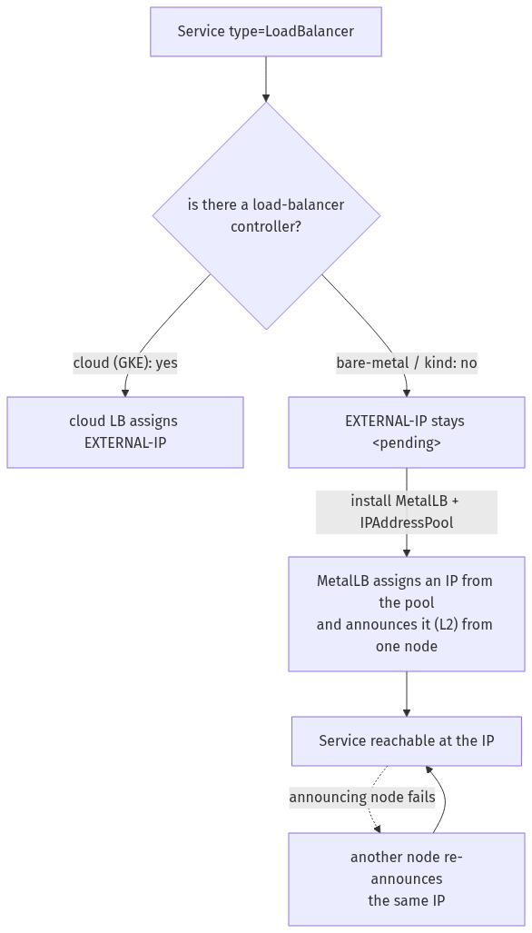

Step 1 — Watch a LoadBalancer Service hang at <pending>
Goal: see that, without a cloud LB, an external IP never appears.
1. Expose a Deployment as a LoadBalancer:
kubectl create deployment web --image=nginx:1.27-alpine
kubectl expose deployment web --port=80 --type=LoadBalancer --name=web-lb
kubectl get svc web-lb
What you should see: web-lb of type LoadBalancer with EXTERNAL-IP: <pending> — and it will stay that way indefinitely.
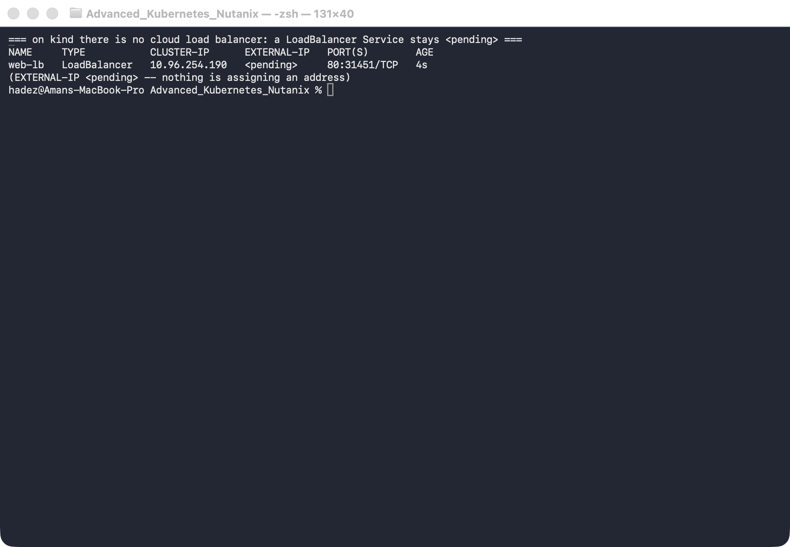
What this means: nothing in a bare-metal cluster is watching for LoadBalancer Services to assign them an address. The Service has a ClusterIP and works inside the cluster, but there's no external IP. On Nutanix on-prem you'd hit exactly this.

Step 2 — Install MetalLB and give it an address pool
Goal: install MetalLB, hand it a range of IPs from the cluster's network, and watch the Service get a reachable address.
1. Install MetalLB and wait for it:
kubectl apply -f https://raw.githubusercontent.com/metallb/metallb/v0.14.9/config/manifests/metallb-native.yaml
kubectl -n metallb-system rollout status deployment/controller --timeout=150s
kubectl -n metallb-system rollout status daemonset/speaker --timeout=120s
2. Give it an IPAddressPool from the kind docker subnet (find yours with docker network inspect kind; here it's 172.19.0.0/16, so we use a high, unused range):
kubectl apply -f - <<'EOF'
apiVersion: metallb.io/v1beta1
kind: IPAddressPool
metadata: {name: kind-pool, namespace: metallb-system}
spec:
addresses: ["172.19.255.200-172.19.255.250"]
---
apiVersion: metallb.io/v1beta1
kind: L2Advertisement
metadata: {name: l2, namespace: metallb-system}
spec:
ipAddressPools: [kind-pool]
EOF
kubectl get svc web-lb
3. Reach the IP from inside the cluster network (on Docker-Desktop-for-Mac the docker subnet isn't routable from your Mac, so curl from a node):
IP=$(kubectl get svc web-lb -o jsonpath='{.status.loadBalancer.ingress[0].ip}')
docker exec advk8s-day1-worker3 curl -s -o /dev/null -w "HTTP %{http_code}\n" http://$IP
What you should see: web-lb now has a real EXTERNAL-IP (e.g. 172.19.255.200), and the curl returns HTTP 200.
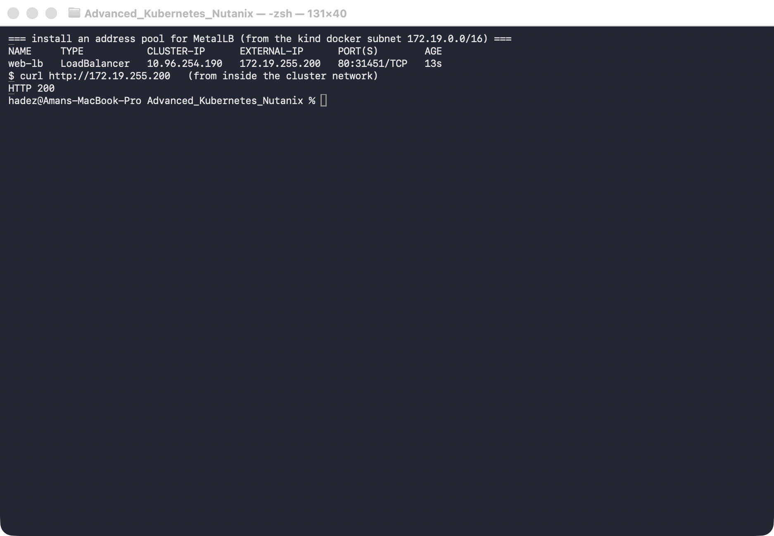
What this means: MetalLB is the load-balancer controller the cluster was missing. It picked an address from your pool and is announcing it (Layer-2) from one node, so the Service is now reachable at a stable IP.

Step 3 — Survive a node failure
Goal: kill the node that's announcing the IP and prove the Service stays reachable.
1. Find the announcing node, then stop it:
IP=$(kubectl get svc web-lb -o jsonpath='{.status.loadBalancer.ingress[0].ip}')
kubectl describe svc web-lb | grep 'announcing from node' # e.g. advk8s-day1-worker
# simulate a node failure:
docker stop advk8s-day1-worker
2. Wait for Kubernetes to mark the node NotReady, then curl the same IP from a surviving node:
kubectl get node advk8s-day1-worker # NotReady after a few seconds
kubectl describe svc web-lb | grep 'announcing from node' # now a DIFFERENT node
docker exec advk8s-day1-worker3 curl -s -o /dev/null -w "HTTP %{http_code}\n" http://$IP
What you should see: after the node goes NotReady, MetalLB shows the IP announcing from node "advk8s-day1-worker2" (a different node), and curling the same IP returns HTTP 200.
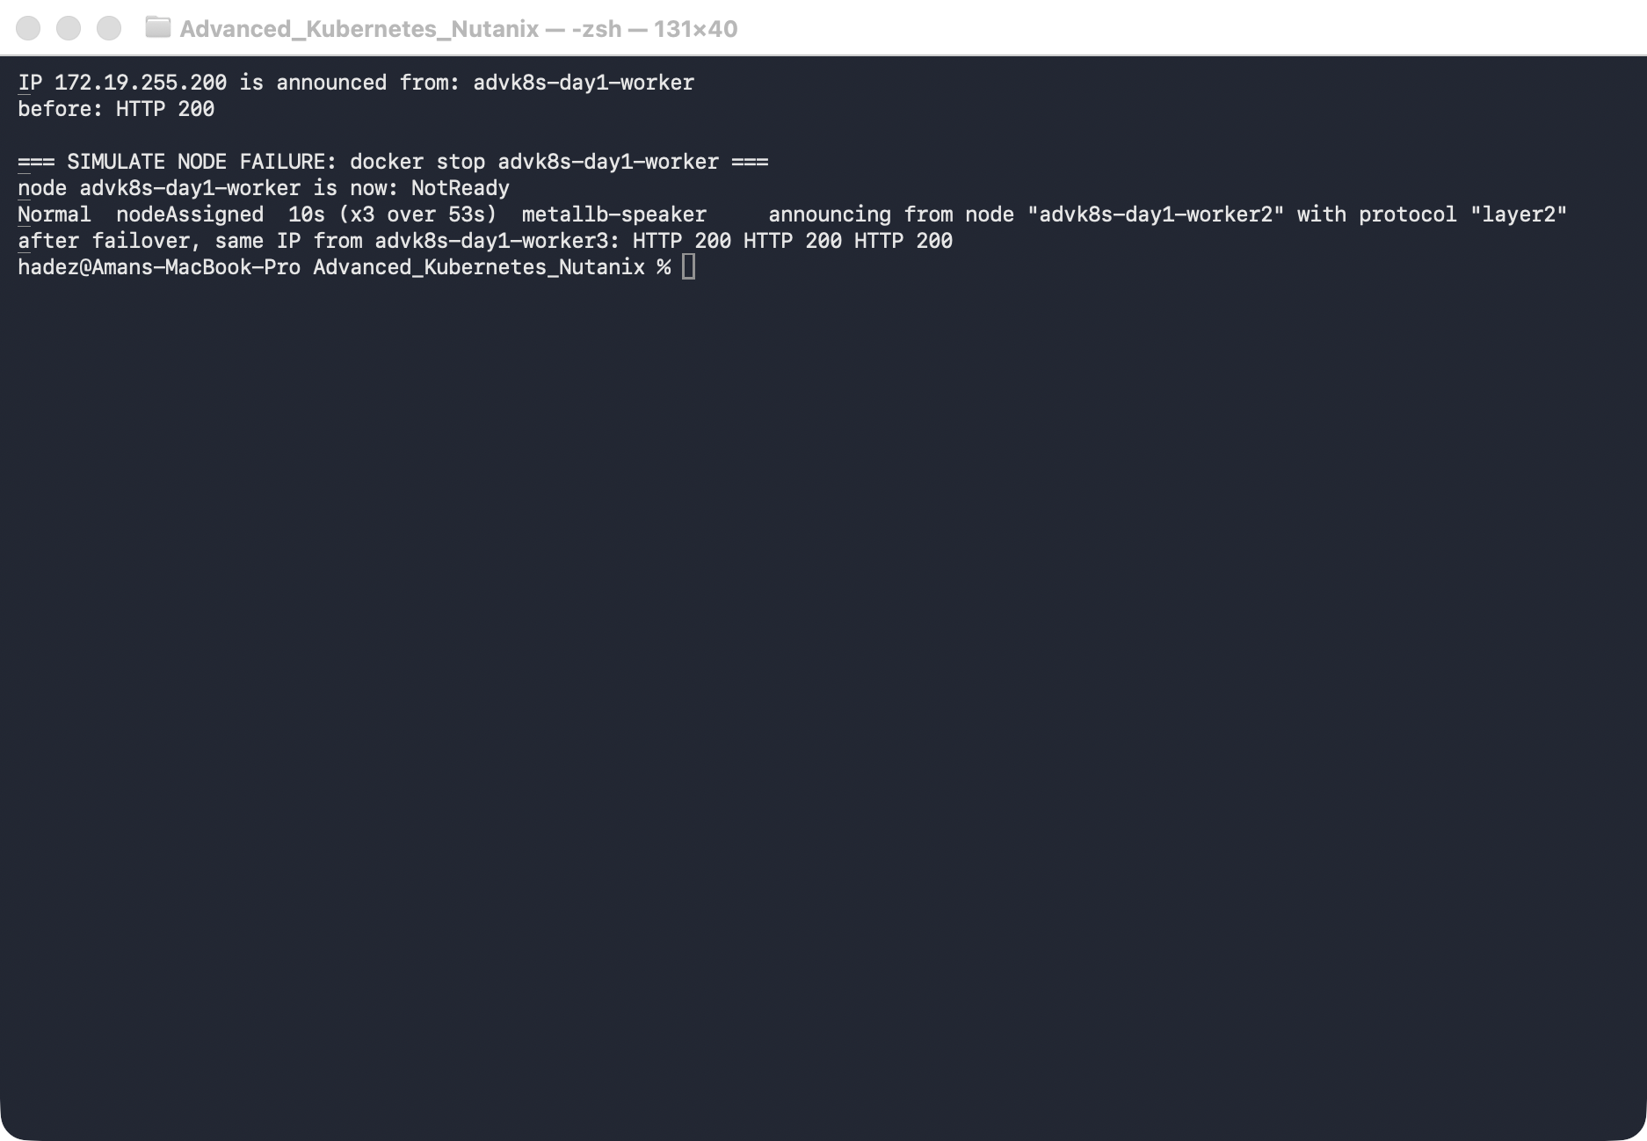
⚠️ Gotcha — there's a brief failover window. For the first few seconds after the node stops, curl may fail (HTTP 000): Kubernetes hasn't yet marked the node NotReady, so it still routes some traffic to the dead Pod, and the L2 announcement hasn't moved. Once the node is NotReady (endpoints pruned) and MetalLB re-announces from a healthy node, it recovers. This is normal L2 failover behaviour — L2 mode fails over, it doesn't load-balance across nodes.
3. Restore the node:
docker start advk8s-day1-worker

Step 4 — Clean up
kubectl delete svc web-lb --ignore-not-found
kubectl delete deployment web --ignore-not-found
# to remove MetalLB: kubectl delete -f https://raw.githubusercontent.com/metallb/metallb/v0.14.9/config/manifests/metallb-native.yaml

What you learned
You saw… | in Step | proof
A LoadBalancer Service stays <pending> on bare metal | 1 | EXTERNAL-IP <pending> on kind
MetalLB assigns a real IP from a pool | 2 | web-lb gets 172.19.255.200, curl 200
The IP is reachable via L2 announcement from a node | 2 | curl 200 from another node
The IP survives the announcing node failing | 3 | re-announced from a different node, curl 200
L2 mode fails over (brief window), it doesn't balance | 3 gotcha

Evidence
Real screenshots for this lab are in artifacts/lab-10/screenshots/ (3 images), and a command transcript is in artifacts/lab-10/evidence/lab-10-metallb.txt.

Next: Lab 11 — Log-Based Diagnosis with Loki

