Lab 12 — GitOps Delivery with Flux
DataCouch — Advanced Kubernetes (Nutanix)
Table of Contents

Day 4 · GitOps, Multi-Cluster & Advanced Scheduling
YES — Tested end-to-end on a real GKE cluster (advk8s-lab, dcproject-462806) with Flux v2. Every screenshot is a real capture. The payoff: you deliver an app to the cluster without ever running kubectl apply — Flux pulls it from Git — and then you delete the live Deployment and watch Flux put it back, because Git says it should exist.

What you'll learn
- What GitOps actually means: Git is the single source of truth, and an in-cluster agent continuously makes the cluster match it — the same reconciliation idea from Lab 1, now applied to your whole app.
- How Flux works: a GitRepository source (what to watch) plus a Kustomization (what to apply and how often).
- Why GitOps gives you drift detection and self-healing for free: anything that diverges from Git is reverted.

What you'll do
You'll install Flux on the cluster, point it at a public Git repo, and let it deploy an app (podinfo). Then you'll simulate drift — delete the running Deployment — and watch Flux reconcile the cluster back to what Git declares.

Time & cost
- Time: ~35 minutes.
- Cost: negligible — Flux controllers and podinfo are small Pods on the shared GKE cluster.

Before you start
- Where you'll work: in a terminal on your own machine.
- Tools you need: gcloud, kubectl, and the flux CLI (brew install fluxcd/tap/flux).
- Cluster: a GKE cluster (this course's shared advk8s-lab).
- No GitHub account needed: we use flux install (controllers only) and point at a public repo, so you never need a Git token for this lab.
Nutanix note. Flux is CNCF-graduated and completely platform-agnostic — it runs identically on NKE. In fact GitOps is the recommended operating model for on-prem fleets: instead of engineers running kubectl against production Nutanix clusters (untracked, un-reviewable), every change is a Git commit that Flux pulls and applies. That gives you an audit trail, code review, and instant rollback (git revert) on infrastructure you can't always reach interactively.

The idea in 60 seconds
Normally you push changes to a cluster: you run kubectl apply from your laptop or CI. GitOps inverts this — the cluster pulls. An agent inside the cluster (Flux) watches a Git repo and continuously reconciles the cluster to match it. Two Flux objects do this:
- a GitRepository — where to look (repo URL, branch, poll interval),
- a Kustomization — what to apply (a path in that repo), how often, and whether to prune (delete things removed from Git).
Because Flux reconciles on a loop, the cluster is always converging on Git. Change the cluster by hand and it drifts; Flux notices and reverts it. The only durable way to change anything is to change Git.
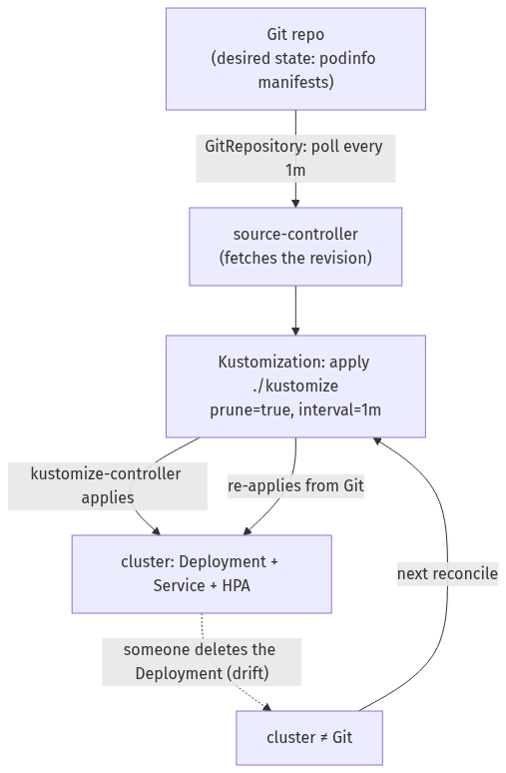

Step 1 — Install Flux on the cluster
Goal: get the Flux controllers running. (No Git bootstrap, no token — just the agents.)
1. Check prerequisites, then install:
flux check --pre
flux install
2. Confirm the controllers are up:
kubectl -n flux-system get pods
What you should see: four Deployments Running in flux-system — source-controller (fetches Git), kustomize-controller (applies manifests), plus helm-controller and notification-controller.
What this means: the reconciliation engine is now living in your cluster. It isn't watching anything yet — you'll tell it what to watch next.

Step 2 — Point Flux at a Git repo and let it deploy the app
Goal: declare a Git source and a Kustomization, and watch the app appear — without ever applying it yourself.
1. Create the GitRepository source (a public repo, polled every minute):
kubectl create namespace podinfo
flux create source git podinfo \
--url=https://github.com/stefanprodan/podinfo \
--branch=master \
--interval=1m
2. Create the Kustomization that applies the manifests in ./kustomize into the podinfo namespace, pruning anything removed from Git:
flux create kustomization podinfo \
--source=GitRepository/podinfo \
--path="./kustomize" \
--prune=true \
--interval=1m \
--target-namespace=podinfo \
--wait
3. Confirm Flux is reconciling, and that the app is running:
flux get sources git
flux get kustomizations
kubectl -n podinfo get deploy,svc,hpa
What you should see: both the source and the Kustomization report READY: True with a revision like master@sha1:dd507173, and podinfo (Deployment + Service + HPA) is running in the podinfo namespace — you never ran kubectl apply for it.
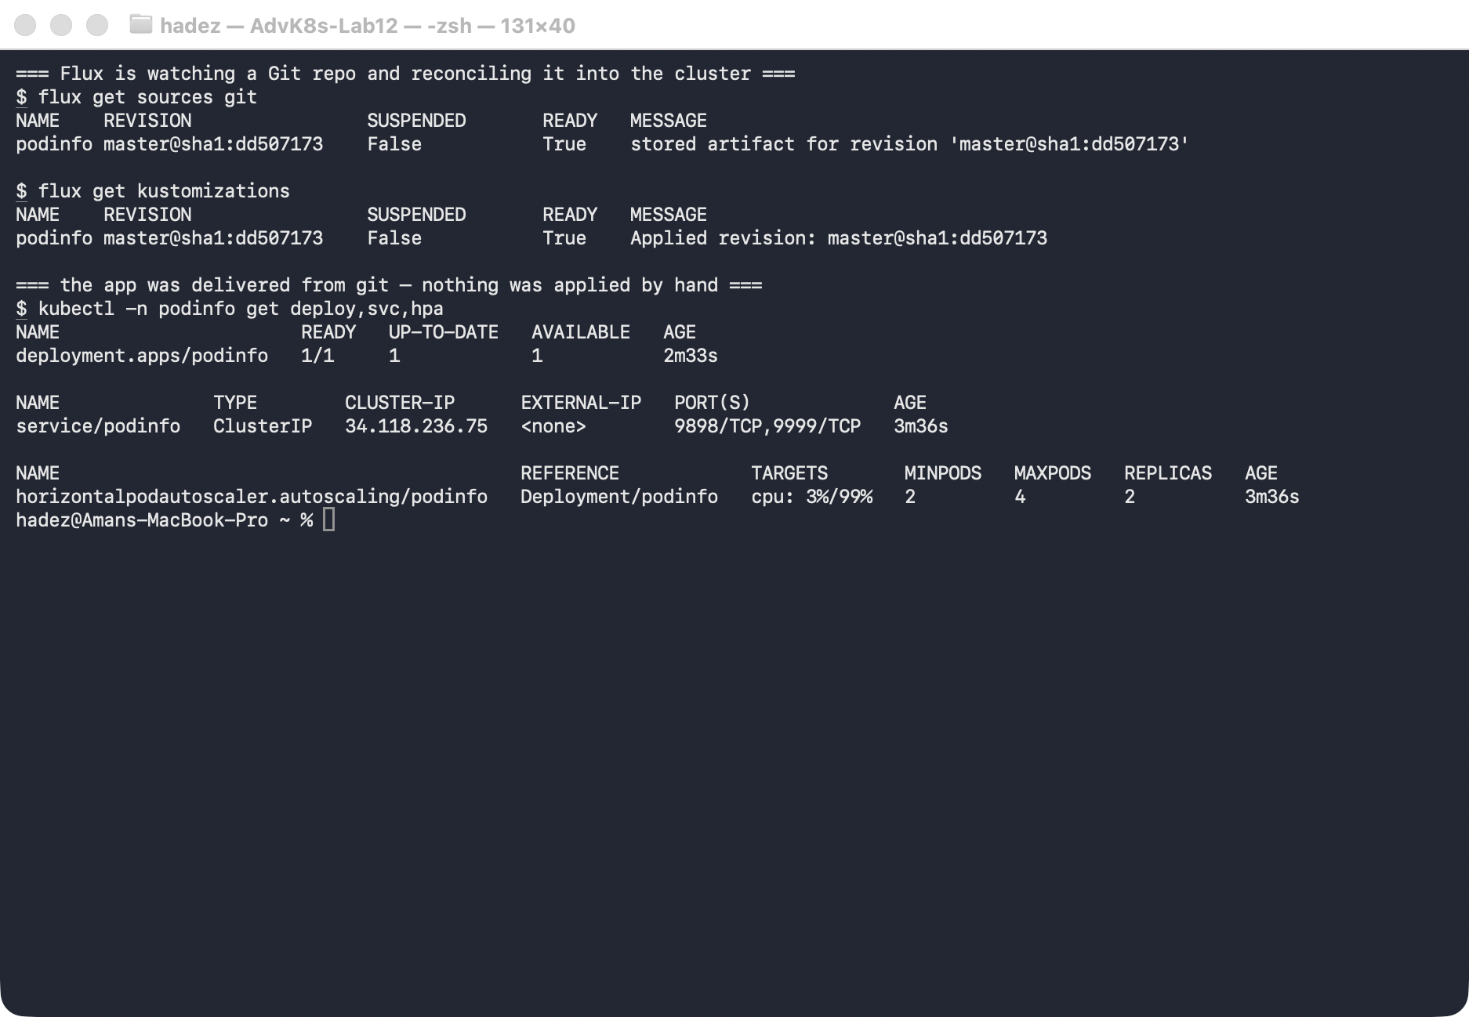
What this means: the app's desired state lives in Git, and Flux pulled it and applied it. From here on, the way to change this app is to change Git — not the cluster.

Step 3 — Cause drift, and watch Flux self-heal
Goal: change the cluster out from under Flux and prove it reverts you.
1. Delete the live Deployment — the cluster now disagrees with Git:
kubectl -n podinfo delete deploy podinfo
kubectl -n podinfo get deploy podinfo
2. Trigger a reconcile (Flux would do this on its own within the 1-minute interval; we force it so you don't wait):
flux reconcile kustomization podinfo --with-source
kubectl -n podinfo get deploy podinfo
What you should see: right after the delete, kubectl get deploy podinfo returns NotFound — but after the reconcile, the Deployment is back (podinfo 1/1), recreated from Git.
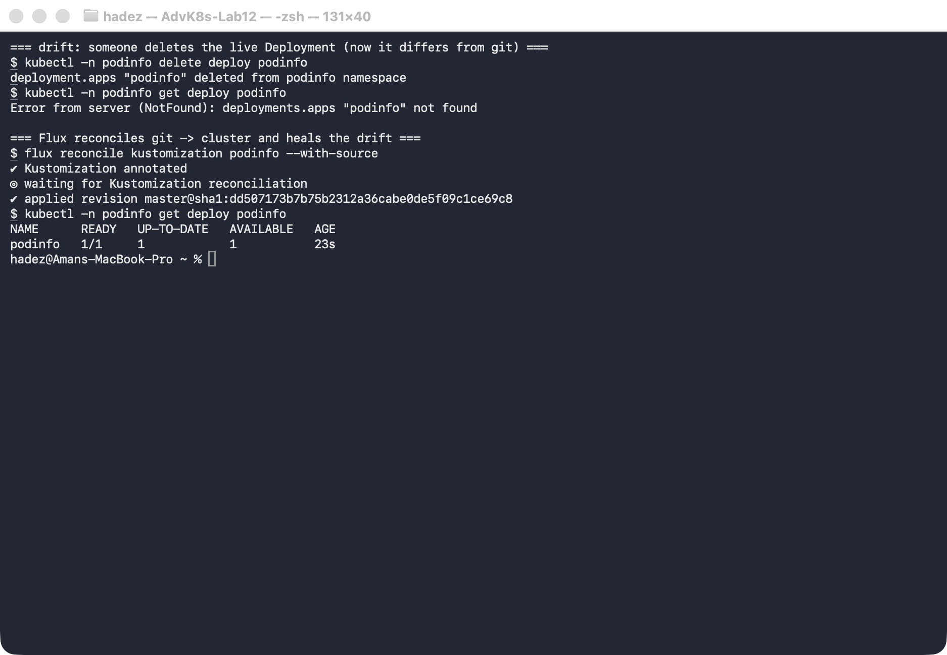
What this means: this is GitOps self-healing. Flux compared the cluster to Git, saw the Deployment was missing, and re-applied it. The same thing happens to any manual change — an edited image tag, a scaled replica count, a deleted Service — because Git, not the cluster, is the source of truth.
⚠️ Gotcha — don't fight the reconciler. Because Flux reverts drift, a "quick manual kubectl edit in production" will silently disappear at the next reconcile, which is baffling if you don't know Flux is running. To make a real change, commit it to Git (or flux suspend kustomization <name> first if you genuinely need to pause reconciliation for a break-glass fix). Manual edits are for debugging only.

Step 4 — Clean up
kubectl delete namespace podinfo --ignore-not-found
flux delete source git podinfo --silent
flux delete kustomization podinfo --silent
# to remove Flux itself:
# flux uninstall --silent

What you learned
You saw… | in Step | proof
Flux runs the reconciliation engine inside the cluster | 1 | four controllers Running in flux-system
A GitRepository + Kustomization delivers an app from Git | 2 | both READY: True; podinfo running, never kubectl apply-ed
The cluster converges on the Git revision | 2 | Applied revision: master@sha1:dd507173
Manual drift is detected and reverted (self-healing) | 3 | Deployment deleted → NotFound → restored on reconcile

Evidence
Real screenshots for this lab are in artifacts/lab-12/screenshots/ (2 images), and a command transcript is in artifacts/lab-12/evidence/lab-12-flux.txt.

Next: Lab 13 — Managing a Fleet of Clusters

