Lab 13 — Fleet Registration & Staged Rollout
DataCouch — Advanced Kubernetes (Nutanix)
Table of Contents

Day 4 · GitOps, Multi-Cluster & Advanced Scheduling
YES — Tested end-to-end on three real clusters — a Fleet manager plus two downstream clusters (staging, prod) — with Rancher Fleet v0.16. Every screenshot is a real capture. The payoff: you register two clusters into a fleet, deliver an app to both of them from a single Git repo, then delete the app on one cluster and watch Fleet put it back — a fleet-wide rollout and self-healing you drive from one place.

What you'll learn
- What changes when you go from one cluster (Lab 12, Flux) to many: you need a way to register clusters and target rollouts to groups of them.
- How Rancher Fleet registers downstream clusters to a manager and represents each one as a Cluster object you can label and select.
- How a single GitRepo fans out to every matching cluster, and how drift correction heals a cluster that's been changed out-of-band.

What you'll do
You'll create three clusters, install Fleet on the manager, register the other two as staging and prod, then deploy an app to both via one GitRepo. Finally you'll cause drift on one cluster and watch Fleet correct it.

Time & cost
- Time: ~60 minutes.
- Cost: $0 — all three clusters are local kind clusters.

Before you start
- Where you'll work: in a terminal on your own machine.
- Tools you need: docker, kind, kubectl, helm.
- Cluster: you'll create three fresh kind clusters in Step 1. (This is deliberately kind: a "fleet" needs several clusters, and spinning up three managed cloud clusters just to demonstrate registration would be slow and costly.)
Nutanix note. Managing a fleet of clusters is the on-prem reality: an enterprise runs many NKE clusters (per site, per environment, per tenant) and can't hand-run kubectl against each. Fleet is exactly this control plane — and it's the engine inside Rancher, which is a common management layer for Nutanix Kubernetes estates. On real infrastructure the three clusters here would be NKE clusters; the registration, targeting, and drift-correction steps are identical. We use kind only so you can stand up a whole fleet on one laptop for free.

The idea in 60 seconds
Flux (Lab 12) reconciled one cluster from Git. A fleet needs two more things: a way to enroll clusters, and a way to target a rollout at some of them (e.g. staging first, then prod).
Fleet has a manager cluster running the Fleet controller. Downstream clusters run a small agent that registers back to the manager using a token; each registered cluster becomes a Cluster object you can label (env=staging, env=prod). You then create a GitRepo with targets that select clusters by label — one Git commit rolls out to every matching cluster. Turn on correctDrift and Fleet will re-apply anything that's changed on a downstream cluster out-of-band.
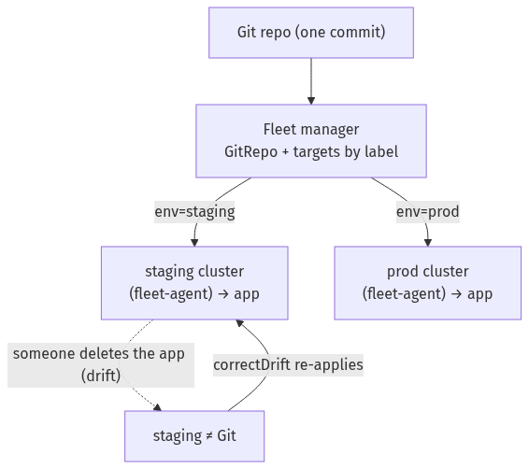

Step 1 — Stand up the fleet: three clusters
Goal: create a manager and two downstream clusters, all reachable from each other.
for c in fleet-mgr fleet-stg fleet-prod; do kind create cluster --name "$c"; done
kind get clusters
Because all kind clusters share the kind Docker network, the downstream agents can reach the manager's API by its container IP. Find that IP now — you'll need it in Step 2:
docker network inspect kind -f '{{range .Containers}}{{.Name}} {{.IPv4Address}}{{"\n"}}{{end}}'
What you should see: three clusters, and the fleet-mgr-control-plane container with an IP like 172.19.0.2. Note the manager's IP.
What this means: you now have a mini multi-cluster estate. The manager will run Fleet; the other two will be managed.

Step 2 — Install Fleet on the manager
Goal: run the Fleet controller on fleet-mgr, told how downstream agents should reach it.
helm repo add fleet https://rancher.github.io/fleet-helm-charts/
helm repo update fleet
MGR_IP=172.19.0.2 # from Step 1
API_URL="https://${MGR_IP}:6443"
CA=$(kubectl --context kind-fleet-mgr config view --raw --minify \
-o jsonpath='{.clusters[0].cluster.certificate-authority-data}')
helm --kube-context kind-fleet-mgr -n cattle-fleet-system install --create-namespace \
fleet-crd fleet/fleet-crd
helm --kube-context kind-fleet-mgr -n cattle-fleet-system install fleet fleet/fleet \
--set apiServerURL="$API_URL" \
--set apiServerCA="$CA"
kubectl --context kind-fleet-mgr -n cattle-fleet-system rollout status deploy/fleet-controller --timeout=180s
What you should see: fleet-controller, gitjob, and helmops Pods Running in cattle-fleet-system. The manager also registers itself as a cluster named local.
What this means: the fleet's control plane is live. apiServerURL/apiServerCA are baked into the registration tokens so agents know where — and how securely — to call home.

Step 3 — Register the two downstream clusters
Goal: enrol fleet-stg and fleet-prod into the fleet, labelled by environment.
1. Create a registration token on the manager:
kubectl --context kind-fleet-mgr create namespace fleet-default
kubectl --context kind-fleet-mgr apply -f - <<'EOF'
apiVersion: fleet.cattle.io/v1alpha1
kind: ClusterRegistrationToken
metadata: {name: downstream-token, namespace: fleet-default}
spec: {ttl: 24h}
EOF
2. Extract the agent values and the CA as raw PEM:
kubectl --context kind-fleet-mgr -n fleet-default get secret downstream-token \
-o jsonpath='{.data.values}' | base64 -d > /tmp/token-values.yaml
# pull apiServerCA out as a real PEM file, and strip it from the values file:
python3 - <<'PY'
import base64, yaml
v = yaml.safe_load(open('/tmp/token-values.yaml'))
open('/tmp/ca.pem','w').write(base64.b64decode(v['apiServerCA']).decode())
del v['apiServerCA']
yaml.safe_dump(v, open('/tmp/agent-values.yaml','w'))
PY
3. Install the agent on each downstream, labelling it:
for pair in "kind-fleet-stg:staging" "kind-fleet-prod:prod"; do
CTX="${pair%%:*}"; ENV="${pair##*:}"
helm --kube-context "$CTX" -n cattle-fleet-system install --create-namespace \
fleet-agent fleet/fleet-agent \
-f /tmp/agent-values.yaml \
--set-file apiServerCA=/tmp/ca.pem \
--set-string labels.env="$ENV"
done
4. Confirm both clusters registered:
kubectl --context kind-fleet-mgr -n fleet-local get clusters.fleet.cattle.io
kubectl --context kind-fleet-mgr -n fleet-default get clusters.fleet.cattle.io -L env
What you should see: the manager's own local cluster, plus two downstream Cluster objects (auto-named cluster-…) with ENV showing staging and prod, each BUNDLES-READY 2/2.
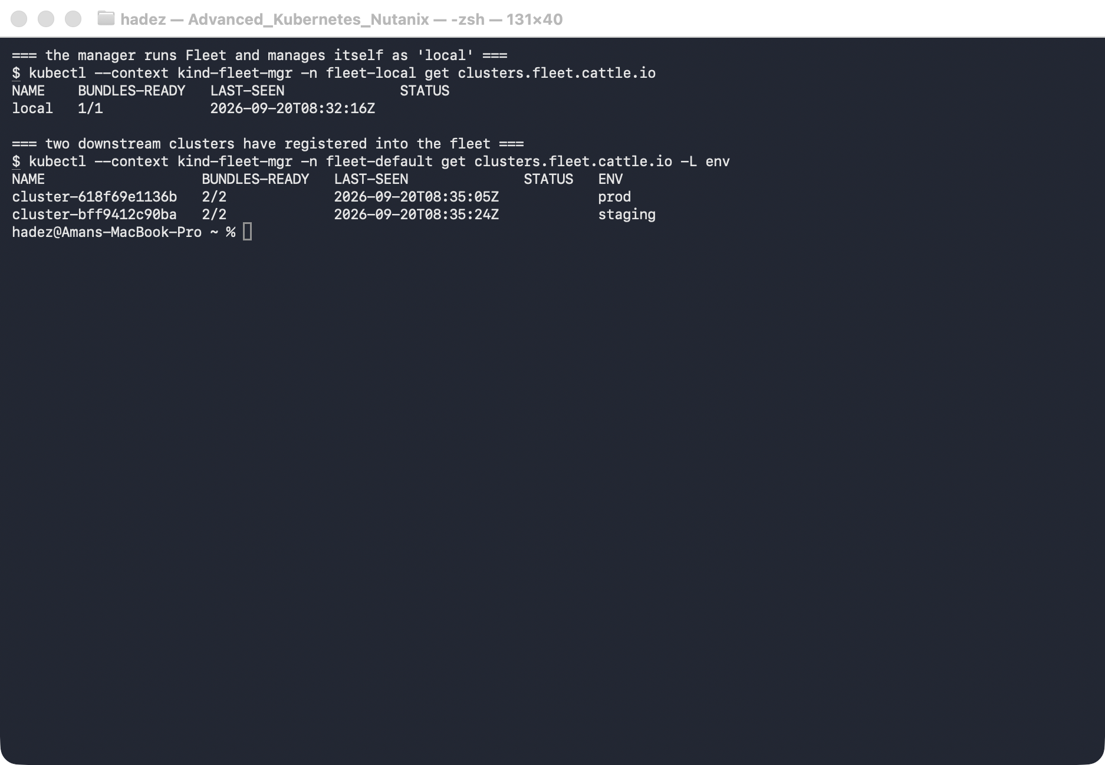
What this means: three clusters are now under one control plane, and the env labels give you a way to target rollouts at groups of them.
⚠️ Gotcha — the CA must be raw PEM, not base64. The token secret stores apiServerCA base64-encoded. If you feed that base64 string straight to the agent chart, Helm base64-encodes it again into the agent's secret, and the agent fails with unable to parse bytes as PEM block. That's why Step 3.2 decodes it to a real PEM file and Step 3.3 passes it with --set-file (which supplies the file's raw contents). Symptom to recognise: the agent logs Cannot find fleet-agent secret, running registration in a loop and no Cluster ever appears.

Step 4 — Deliver one app to the whole fleet from one Git repo
Goal: deploy the same app to both downstream clusters from a single GitRepo.
1. Give the downstream clusters a metrics-server — the app we'll deploy (podinfo) ships an HPA, and Fleet won't mark the rollout Ready until the HPA can compute (which needs metrics):
for CTX in kind-fleet-stg kind-fleet-prod; do
kubectl --context "$CTX" apply -f https://github.com/kubernetes-sigs/metrics-server/releases/latest/download/components.yaml
kubectl --context "$CTX" -n kube-system patch deployment metrics-server --type=json \
-p='[{"op":"add","path":"/spec/template/spec/containers/0/args/-","value":"--kubelet-insecure-tls"}]'
done
2. Create the GitRepo, targeting both environments:
kubectl --context kind-fleet-mgr apply -f - <<'EOF'
apiVersion: fleet.cattle.io/v1alpha1
kind: GitRepo
metadata: {name: podinfo, namespace: fleet-default}
spec:
repo: https://github.com/stefanprodan/podinfo
branch: master
paths: ["kustomize"]
targetNamespace: fleet-demo
correctDrift: {enabled: true}
targets:
- name: staging
clusterSelector: {matchLabels: {env: staging}}
- name: prod
clusterSelector: {matchLabels: {env: prod}}
EOF
3. Watch it roll out, then confirm the app is on both clusters:
kubectl --context kind-fleet-mgr -n fleet-default get gitrepo podinfo
kubectl --context kind-fleet-stg -n fleet-demo get deploy podinfo
kubectl --context kind-fleet-prod -n fleet-demo get deploy podinfo
What you should see: the GitRepo reports BUNDLEDEPLOYMENTS-READY 2/2 at commit dd507173…, and podinfo is running 2/2 in the fleet-demo namespace on both clusters — from one repo, one commit.
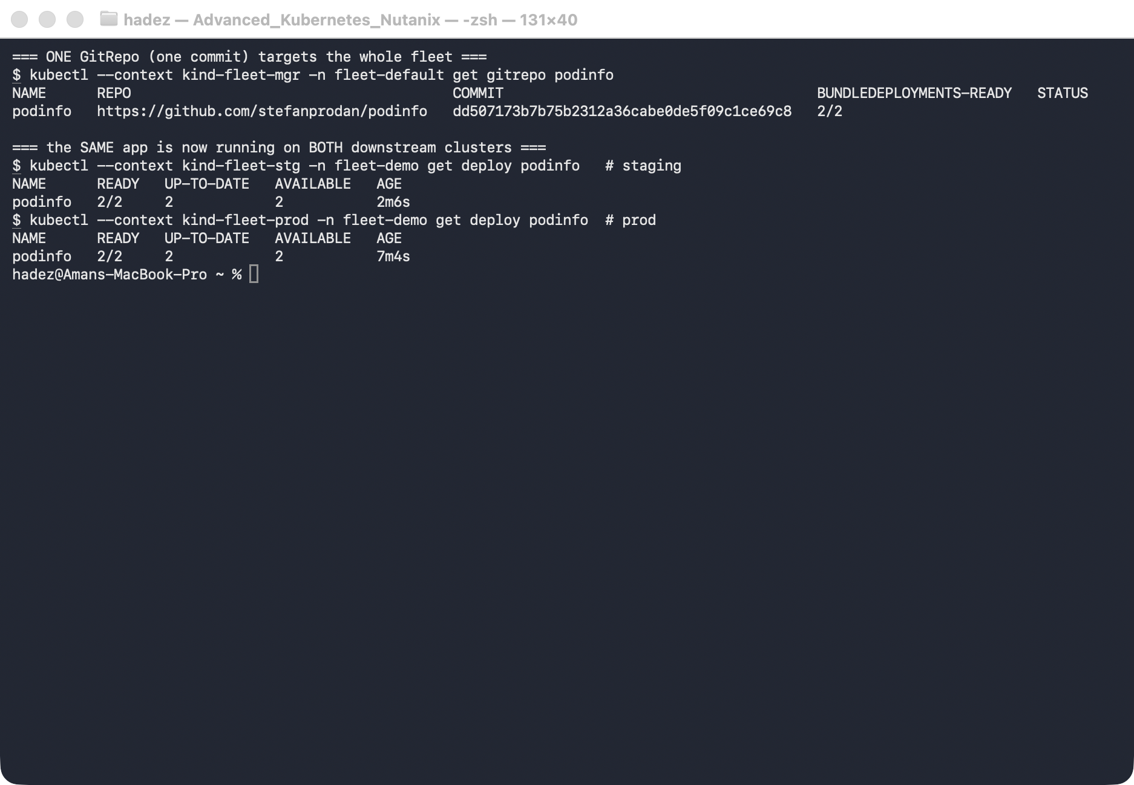
What this means: you delivered to the whole fleet from a single source of truth. To do a staged rollout (roll to staging, verify, then prod), you'd add a rolloutStrategy or split the targets — the targeting mechanism is the same, just sequenced.

Step 5 — Catch and correct drift on one cluster
Goal: change one cluster out-of-band and prove Fleet heals only that cluster.
kubectl --context kind-fleet-stg -n fleet-demo delete deploy podinfo # drift on staging
kubectl --context kind-fleet-stg -n fleet-demo get deploy podinfo # -> NotFound
kubectl --context kind-fleet-prod -n fleet-demo get deploy podinfo # prod: unaffected
# ...wait a few seconds...
kubectl --context kind-fleet-stg -n fleet-demo get deploy podinfo # -> back, 2/2
What you should see: right after the delete, staging reports NotFound while prod is untouched at 2/2. Within seconds, correctDrift re-applies the Deployment and staging is back to 2/2.
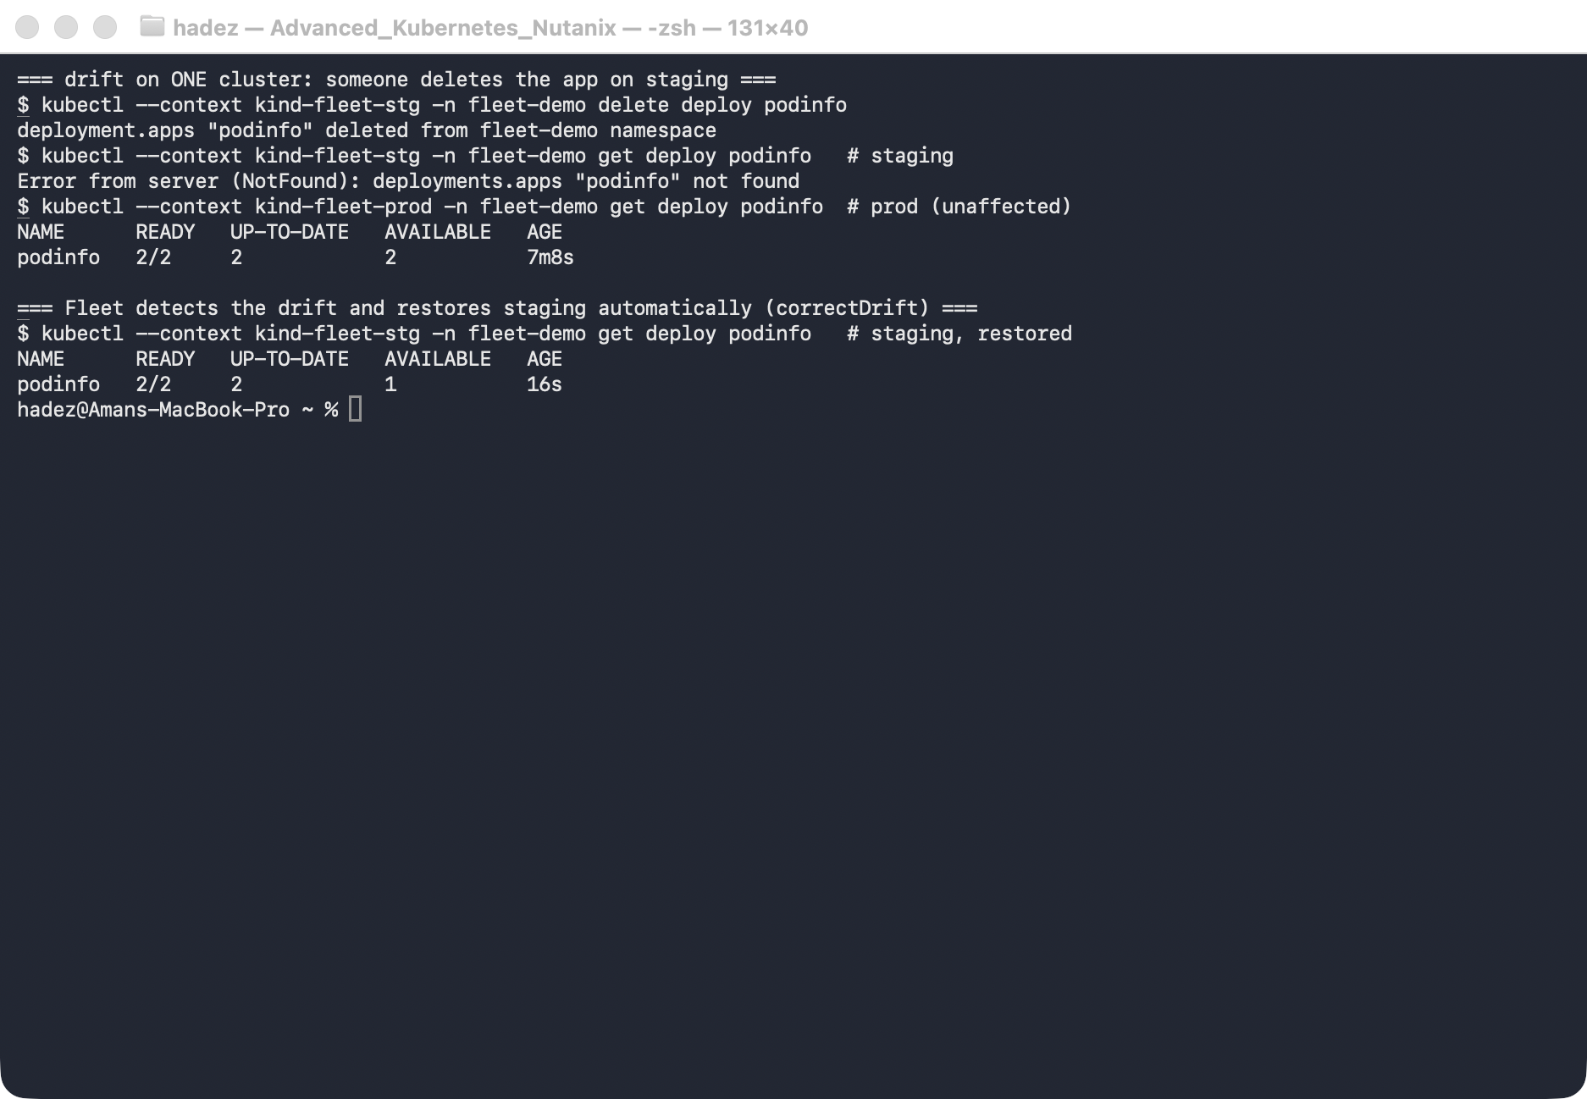
What this means: Fleet continuously reconciles each cluster against Git. Drift on one cluster is detected and corrected there, without touching the rest of the fleet — self-healing at fleet scale.

Step 6 — Clean up
for c in fleet-mgr fleet-stg fleet-prod; do kind delete cluster --name "$c"; done

What you learned
You saw… | in Step | proof
Downstream clusters register into a manager and become labelled Cluster objects | 3 | local + staging + prod, BUNDLES-READY 2/2
One GitRepo fans out to every matching cluster | 4 | one repo/commit → podinfo 2/2 on both clusters
Targeting is by cluster label | 4 | targets select env: staging and env: prod
Drift on one cluster is caught and corrected there only | 5 | staging deleted → restored; prod untouched

Evidence
Real screenshots for this lab are in artifacts/lab-13/screenshots/ (3 images), and a command transcript is in artifacts/lab-13/evidence/lab-13-fleet.txt.

Next: Lab 14 — Multi-Tenant Quota Governance with Kueue

