Lab 14 — Multi-Tenant Quota Governance with Kueue
DataCouch — Advanced Kubernetes (Nutanix)
Table of Contents

Day 4 · GitOps, Multi-Cluster & Advanced Scheduling
YES — Tested end-to-end on a real GKE cluster (advk8s-lab, dcproject-462806) with Kueue v0.19. Every screenshot is a real capture. The payoff: a tenant asks for more CPU than its own quota, gets blocked with a precise "1 more needed" message — then, the moment a neighbouring tenant frees capacity, Kueue admits the same job by borrowing from the shared cohort. No edits, no re-submit.

What you'll learn
- Why plain ResourceQuota is too rigid for multi-tenant batch: it either wastes capacity (hard caps that sit idle) or lets one tenant starve the rest.
- How Kueue governs jobs with ClusterQueues (a tenant's quota), LocalQueues (the namespace-facing handle), and cohorts (a group of ClusterQueues that can lend each other unused quota).
- How a job that exceeds its tenant's quota is suspended until capacity exists — and how cohort borrowing admits it automatically when a neighbour is idle.

What you'll do
You'll install Kueue, define two tenants (team-a, team-b) with 1 CPU of quota each in a shared cohort. You'll fill team-b's quota, watch team-a's oversized job get blocked, then free team-b and watch team-a borrow the freed capacity and run.

Time & cost
- Time: ~35 minutes.
- Cost: negligible — a few short-lived busybox Pods on the shared GKE cluster.

Before you start
- Where you'll work: in a terminal on your own machine.
- Tools you need: gcloud, kubectl.
- Cluster: a GKE cluster (this course's shared advk8s-lab).
Nutanix note. Kueue is platform-agnostic and runs identically on NKE. It's the natural fit for on-prem AI/ML and batch platforms, where a fixed pool of expensive nodes (GPUs especially) is shared by several teams. Cohorts let you give each team a guaranteed floor while allowing idle capacity to flow to whoever needs it — exactly the utilisation problem Nutanix customers face when consolidating GPU workloads onto shared clusters. You'd swap cpu here for nvidia.com/gpu and the model is the same.

The idea in 60 seconds
A ResourceQuota caps a namespace hard: unused quota is wasted, and there's no way to lend it out. Kueue governs at the job level instead. Each tenant gets a ClusterQueue with a nominal quota — its guaranteed floor. Put several ClusterQueues in the same cohort and any of them can borrow another's unused nominal quota. When a tenant later needs its own quota back, Kueue reclaims it (preempting borrowed workloads if configured).
Jobs don't schedule directly. You label a Job with a LocalQueue; Kueue suspends it, decides whether quota (own + borrowable) is available, and only then admits it — unsuspending it so the scheduler runs its Pods.
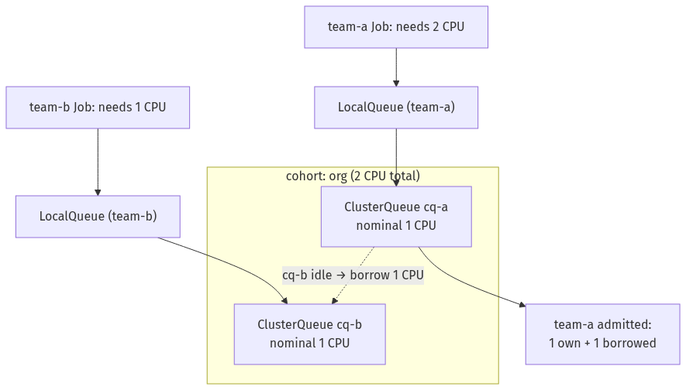

Step 1 — Install Kueue
Goal: run the Kueue controller.
kubectl apply --server-side -f https://github.com/kubernetes-sigs/kueue/releases/download/v0.19.5/manifests.yaml
kubectl -n kueue-system rollout status deploy/kueue-controller-manager --timeout=180s
What you should see: kueue-controller-manager Running in kueue-system.
What this means: Kueue's admission webhook and controller are live. From now on, any Job labelled with a queue is gated by Kueue.

Step 2 — Define two tenants sharing a cohort
Goal: give team-a and team-b 1 CPU of quota each, in a shared cohort so they can lend to each other.
kubectl create namespace team-a
kubectl create namespace team-b
kubectl apply -f - <<'EOF'
apiVersion: kueue.x-k8s.io/v1beta2
kind: ResourceFlavor
metadata: {name: default-flavor}
---
apiVersion: kueue.x-k8s.io/v1beta2
kind: ClusterQueue
metadata: {name: cq-a}
spec:
cohortName: org # <-- same cohort as cq-b
namespaceSelector: {}
resourceGroups:
- coveredResources: ["cpu"]
flavors:
- name: default-flavor
resources: [{name: cpu, nominalQuota: "1"}]
---
apiVersion: kueue.x-k8s.io/v1beta2
kind: ClusterQueue
metadata: {name: cq-b}
spec:
cohortName: org # <-- same cohort as cq-a
namespaceSelector: {}
resourceGroups:
- coveredResources: ["cpu"]
flavors:
- name: default-flavor
resources: [{name: cpu, nominalQuota: "1"}]
---
apiVersion: kueue.x-k8s.io/v1beta2
kind: LocalQueue
metadata: {name: team-queue, namespace: team-a}
spec: {clusterQueue: cq-a}
---
apiVersion: kueue.x-k8s.io/v1beta2
kind: LocalQueue
metadata: {name: team-queue, namespace: team-b}
spec: {clusterQueue: cq-b}
EOF
kubectl get clusterqueue
What you should see: cq-a and cq-b, both in cohort org.
What this means: each tenant has a guaranteed 1 CPU (its nominal quota), and because they share a cohort, either can borrow the other's idle CPU.
What's a LocalQueue for? Tenants submit jobs to a LocalQueue in their own namespace; it points at a ClusterQueue. This keeps the quota policy (cluster-scoped, admin-owned) separate from the submission handle (namespace-scoped, tenant-facing).

Step 3 — Fill team-b, then watch team-a get blocked
Goal: occupy team-b's quota, then submit an oversized team-a job and see Kueue refuse to admit it.
1. team-b uses its full 1 CPU:
kubectl apply -f - <<'EOF'
apiVersion: batch/v1
kind: Job
metadata: {name: filler, namespace: team-b, labels: {kueue.x-k8s.io/queue-name: team-queue}}
spec:
parallelism: 1
completions: 1
suspend: true
template:
spec:
restartPolicy: Never
containers:
- {name: c, image: busybox:1.36, command: ["sh","-c","sleep 1800"], resources: {requests: {cpu: "1"}}}
EOF
2. team-a submits a job needing 2 CPU — double its own quota:
kubectl apply -f - <<'EOF'
apiVersion: batch/v1
kind: Job
metadata: {name: big-job, namespace: team-a, labels: {kueue.x-k8s.io/queue-name: team-queue}}
spec:
parallelism: 2
completions: 2
suspend: true
template:
spec:
restartPolicy: Never
containers:
- {name: c, image: busybox:1.36, command: ["sh","-c","sleep 1800"], resources: {requests: {cpu: "1"}}}
EOF
3. Inspect the quota and why team-a is stuck:
kubectl get clusterqueue -o custom-columns='NAME:.metadata.name,COHORT:.spec.cohortName,NOMINAL_CPU:.spec.resourceGroups[0].flavors[0].resources[0].nominalQuota,USED_CPU:.status.flavorsReservation[0].resources[0].total,BORROWED:.status.flavorsReservation[0].resources[0].borrowed,ADMITTED:.status.admittedWorkloads,PENDING:.status.pendingWorkloads'
kubectl get workloads -A
kubectl -n team-a get pods
WL=$(kubectl -n team-a get workloads -o jsonpath='{.items[0].metadata.name}')
kubectl -n team-a get workload "$WL" -o jsonpath='{.status.conditions[?(@.type=="QuotaReserved")].message}{"\n"}'
What you should see: team-b's workload is Admitted in cq-b; team-a's workload is not admitted and has no Pods (Kueue keeps the Job suspended). The reason reads: insufficient unused quota for cpu in flavor default-flavor, 1 more needed — team-a has its own 1 CPU but needs 1 more, and the cohort has none to lend because team-b is using cq-b.
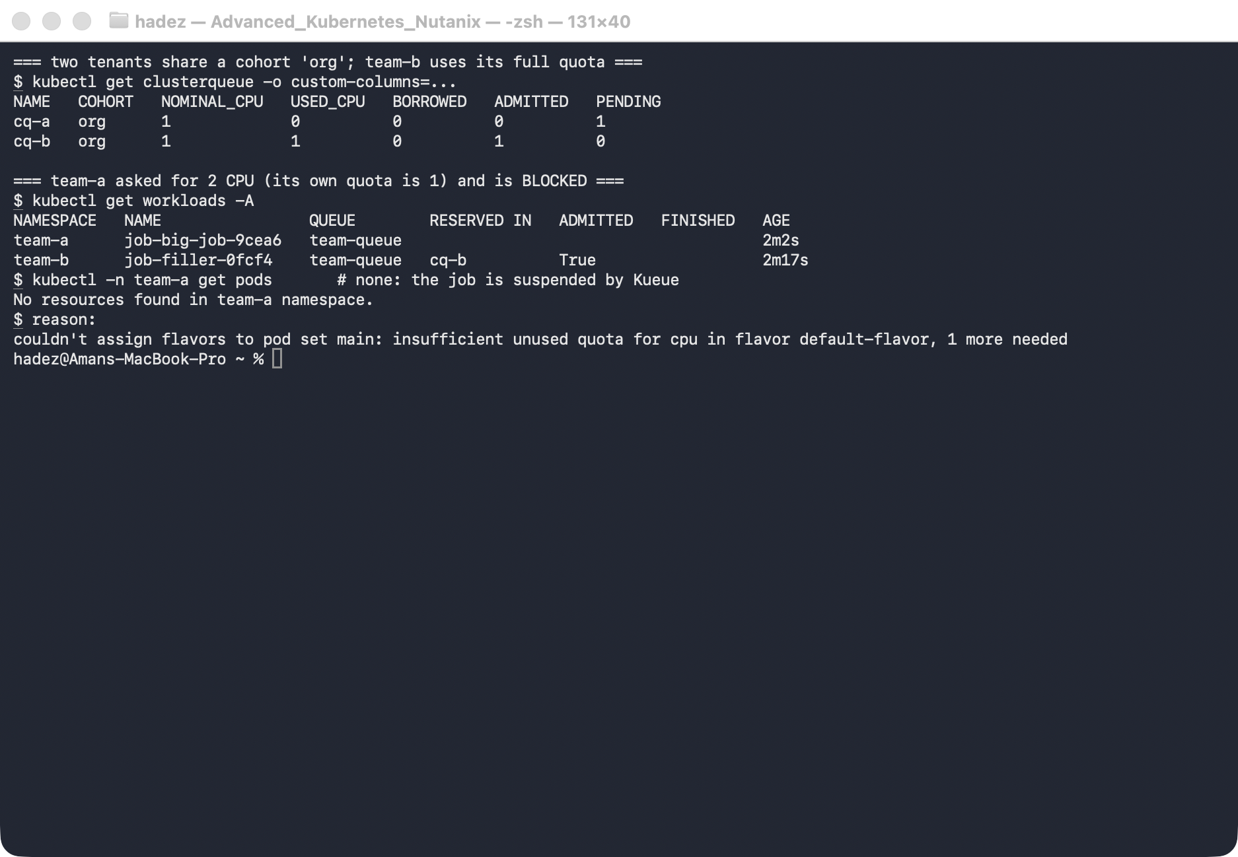
What this means: Kueue admits whole jobs only when the total quota (own + borrowable) is available. Instead of letting team-a half-start and jam the cluster, it holds the job suspended and tells you exactly how much is missing.

Step 4 — Free team-b and watch team-a borrow
Goal: free the neighbour's capacity and see Kueue admit the blocked job automatically.
kubectl -n team-b delete job filler # cq-b is now idle
# ...wait a few seconds for Kueue to re-evaluate...
kubectl get clusterqueue -o custom-columns='NAME:.metadata.name,COHORT:.spec.cohortName,NOMINAL_CPU:.spec.resourceGroups[0].flavors[0].resources[0].nominalQuota,USED_CPU:.status.flavorsReservation[0].resources[0].total,BORROWED:.status.flavorsReservation[0].resources[0].borrowed,ADMITTED:.status.admittedWorkloads,PENDING:.status.pendingWorkloads'
kubectl get workloads -A
kubectl -n team-a get pods
What you should see: cq-a now shows USED_CPU 2 with BORROWED 1 — it's using its own 1 CPU plus 1 borrowed from the cohort. team-a's workload is Admitted in cq-a, and its 2 Pods are Running. You never touched the team-a job — Kueue admitted it the moment capacity appeared.
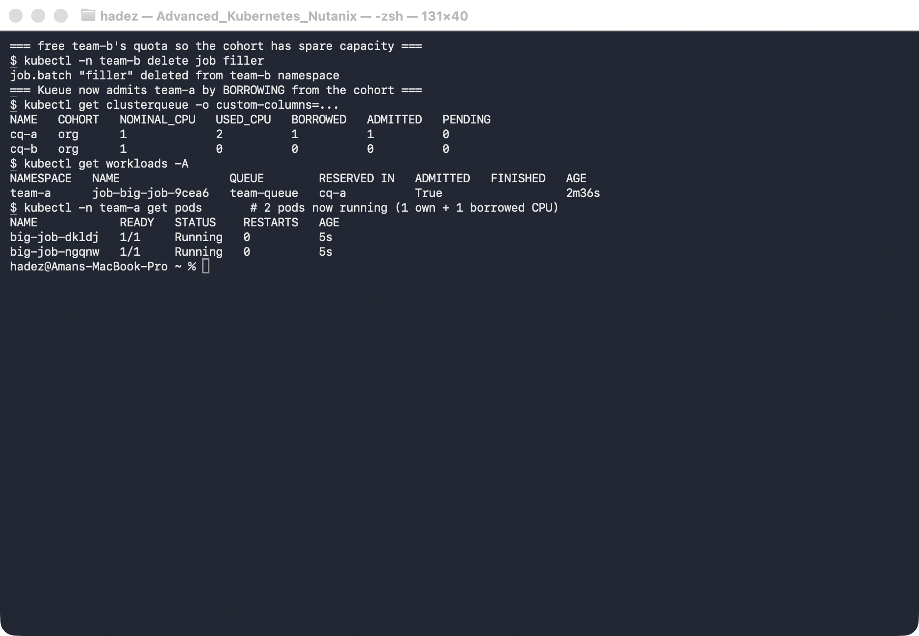
What this means: this is the whole point of cohorts — guaranteed floors with elastic sharing. Each tenant is promised its 1 CPU, but idle capacity flows to whoever needs it, so the cluster stays busy instead of sitting half-empty behind rigid quotas.

Step 5 — Clean up
kubectl delete namespace team-a team-b --ignore-not-found
kubectl delete clusterqueue cq-a cq-b --ignore-not-found
kubectl delete resourceflavor default-flavor --ignore-not-found
# to remove Kueue entirely:
# kubectl delete -f https://github.com/kubernetes-sigs/kueue/releases/download/v0.19.5/manifests.yaml

What you learned
You saw… | in Step | proof
Kueue gates jobs by ClusterQueue quota, keeping them suspended | 3 | team-a job has no Pods while blocked
A job over its tenant's quota is blocked with a precise reason | 3 | insufficient unused quota for cpu … 1 more needed
Cohort members borrow each other's idle quota | 4 | cq-a BORROWED 1, USED_CPU 2
Borrowing admits the blocked job automatically | 4 | team-a Admitted, 2 Pods Running

Evidence
Real screenshots for this lab are in artifacts/lab-14/screenshots/ (2 images), and a command transcript is in artifacts/lab-14/evidence/lab-14-kueue.txt.

Next: Lab 15A — Dynamic Resource Allocation for Accelerators

