Lab 16 — Inference Autoscaling Signals
DataCouch — Advanced Kubernetes (Nutanix)
Table of Contents

Day 5 · Kubernetes as the AI-Native Platform
YES — Tested end-to-end on a real GKE cluster (advk8s-lab). Every screenshot is a real capture. The payoff: you send the same burst of traffic at one inference replica and at four, and watch the signal that matters for LLM serving — time-to-first-token — collapse from ~8s to ~1.6s as the request queue depth spreads across replicas.

What you'll learn
- Which signal actually tells you an inference service is overloaded: not CPU%, but queue depth (requests waiting for an accelerator) and time-to-first-token (TTFT).
- Why a single inference replica serialises requests — one "accelerator" processes one generation at a time, so extra requests queue and TTFT climbs linearly with the queue.
- How scaling out drains the queue and restores TTFT — the basis for autoscaling an inference deployment on queue depth.

What you'll do
You'll deploy a small inference service that simulates a single-accelerator worker, drive a fixed concurrent burst at it, measure the TTFT spike and queue depth, then scale to four replicas and re-run the identical burst to watch it recover.

Time & cost
- Time: ~35 minutes.
- Cost: negligible — small CPU-only Pods on the shared GKE cluster.
Honest scope note. This lab uses a simulated inference server (a single-worker service where each request takes a fixed "generation" time) rather than a real GPU-backed model, so it runs anywhere with no accelerator and no multi-GB model download. The behaviour it reproduces is real: the queue-depth-and-TTFT signal, and its recovery under scale-out, are exactly what you see with a real LLM server (vLLM, TGI, Triton) — see the Nutanix note for the real metric names.

Before you start
- Where you'll work: in a terminal with kubectl pointed at a GKE cluster.
- Tools you need: gcloud, kubectl.
- Cluster: a GKE cluster (this course's shared advk8s-lab).
Nutanix note. On a real Nutanix GPU-inference platform you'd serve models with vLLM, TGI, or Triton, which expose exactly these signals as Prometheus metrics — vLLM publishes vllm:num_requests_waiting (queue depth) and vllm:time_to_first_token_seconds. You'd wire those into an HPA (via prometheus-adapter or KEDA) so the deployment scales on queue depth, not CPU — because a GPU can be 100% "busy" and still have a growing queue, and CPU utilisation tells you nothing about TTFT. This lab teaches the signal; on-prem you point the same autoscaling logic at the real metric.

The idea in 60 seconds
An inference replica has a worker (a GPU, here simulated) that generates one response at a time. Send more concurrent requests than there are workers and the extras queue. Each queued request's time-to-first-token is roughly (its queue position) × (generation time) — so TTFT climbs linearly with load on a fixed number of replicas.
CPU utilisation is a poor signal here (a saturated GPU reads ~100% whether the queue is empty or 50 deep). The signals that matter are queue depth and TTFT. When they spike, you scale out: more replicas = more workers = shorter queue per replica = lower TTFT.
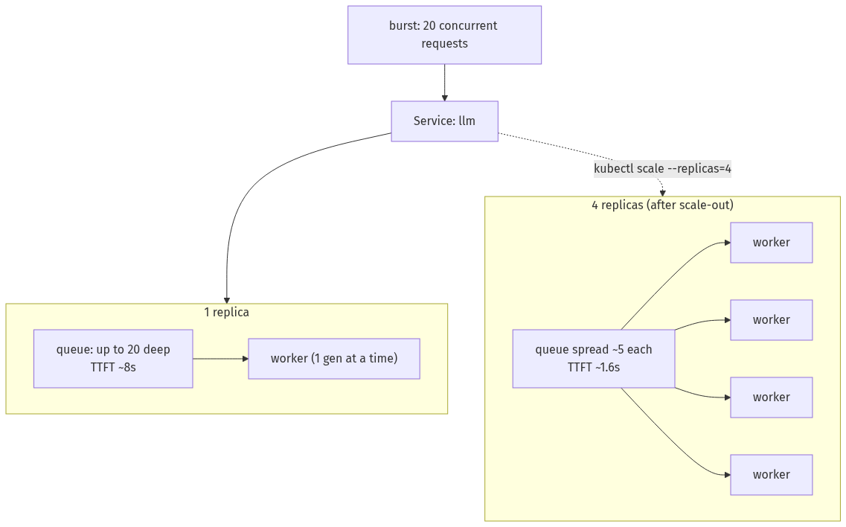

Step 1 — Deploy the inference service
Goal: stand up a single-replica service that serialises "generation" like one accelerator would.
The app (a FastAPI service) holds a worker semaphore of 1 — each /infer acquires it, "generates" for 0.4s, releases it. Concurrent requests queue on that semaphore, and /stats reports the peak queue depth seen.
kubectl create namespace inference
# app.py served from a ConfigMap (semaphore=1 worker; /infer, /stats, /healthz) —
# see artifacts/lab-16/evidence for the full app.py
kubectl -n inference create configmap infer-app --from-file=app.py=/path/to/app.py
kubectl -n inference apply -f - <<'EOF'
apiVersion: apps/v1
kind: Deployment
metadata: {name: llm, labels: {app: llm}}
spec:
replicas: 1
selector: {matchLabels: {app: llm}}
template:
metadata: {labels: {app: llm}}
spec:
containers:
- name: llm
image: python:3.11-slim
command: ["sh","-c","pip install --quiet fastapi uvicorn && uvicorn app:app --host 0.0.0.0 --port 8000 --app-dir /code"]
ports: [{containerPort: 8000}]
resources: {requests: {cpu: 200m}}
readinessProbe: {httpGet: {path: /healthz, port: 8000}, initialDelaySeconds: 5, periodSeconds: 3}
volumeMounts: [{name: code, mountPath: /code}]
volumes: [{name: code, configMap: {name: infer-app}}]
---
apiVersion: v1
kind: Service
metadata: {name: llm}
spec:
selector: {app: llm}
ports: [{port: 80, targetPort: 8000}]
EOF
kubectl -n inference rollout status deploy/llm --timeout=150s
What you should see: one llm Pod Running and Ready.
What this means: you have one inference "accelerator." It can generate one response at a time — anything beyond that will queue.

Step 2 — Drive load at one replica and watch TTFT spike
Goal: send a fixed concurrent burst and measure the latency signal.
The load client fires 200 requests at concurrency 20 and reports TTFT percentiles:
# load.py (from a ConfigMap): 200 requests, 20 concurrent, prints TTFT p50/p95/max
kubectl -n inference run loadtest --image=python:3.11-slim --restart=Never --rm -i \
--overrides='{"spec":{"volumes":[{"name":"s","configMap":{"name":"load-script"}}],"containers":[{"name":"loadtest","image":"python:3.11-slim","command":["python","/s/load.py","200","20"],"volumeMounts":[{"name":"s","mountPath":"/s"}]}]}}'
# then check the queue depth the replica saw:
POD=$(kubectl -n inference get pod -l app=llm -o jsonpath='{.items[0].metadata.name}')
kubectl -n inference exec "$POD" -- python -c "import urllib.request;print(urllib.request.urlopen('http://localhost:8000/stats').read().decode())"
What you should see: TTFT p50 ≈ 8.0s (p95 and max also ~8s), and the replica's peak_queue_depth: 20 — all 20 concurrent requests piled up behind the single worker.
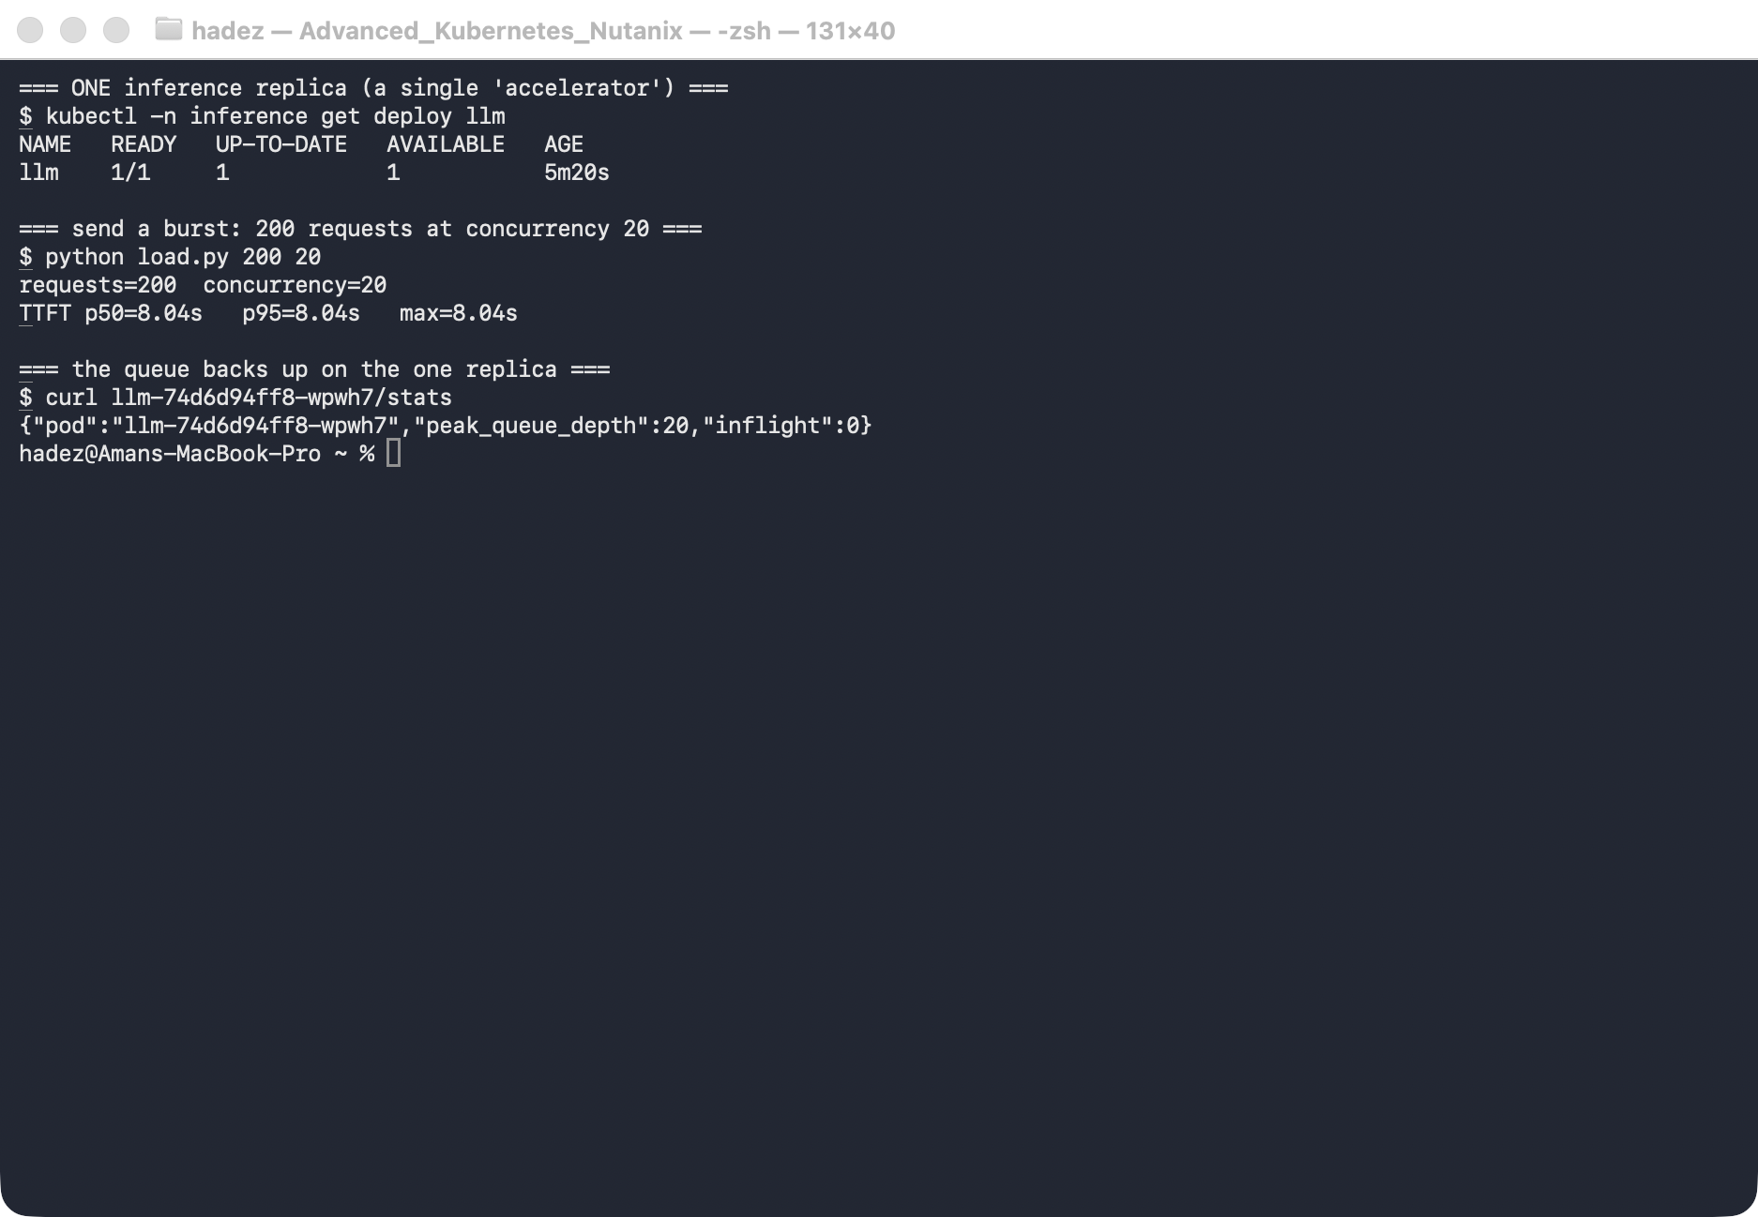
What this means: the service is up and returning correct responses, but every user waits ~8 seconds for their first token. CPU wouldn't have warned you clearly — the queue depth and TTFT do. This is the "spike under load" you'd alert on.

Step 3 — Scale out and re-run the identical burst
Goal: add workers and watch TTFT recover.
kubectl -n inference scale deploy/llm --replicas=4
kubectl -n inference rollout status deploy/llm --timeout=180s
# exactly the same load as before:
kubectl -n inference run loadtest --image=python:3.11-slim --restart=Never --rm -i \
--overrides='{"spec":{"volumes":[{"name":"s","configMap":{"name":"load-script"}}],"containers":[{"name":"loadtest","image":"python:3.11-slim","command":["python","/s/load.py","200","20"],"volumeMounts":[{"name":"s","mountPath":"/s"}]}]}}'
# queue depth per replica now:
for p in $(kubectl -n inference get pod -l app=llm -o jsonpath='{.items[*].metadata.name}'); do
echo -n "$p "; kubectl -n inference exec "$p" -- python -c "import urllib.request,json;print('peak_queue_depth='+str(json.load(urllib.request.urlopen('http://localhost:8000/stats'))['peak_queue_depth']))"
done
What you should see: under the same burst, TTFT p50 drops to ~1.6s (from ~8s), and the queue is spread across the four replicas — none sees the full depth of 20.
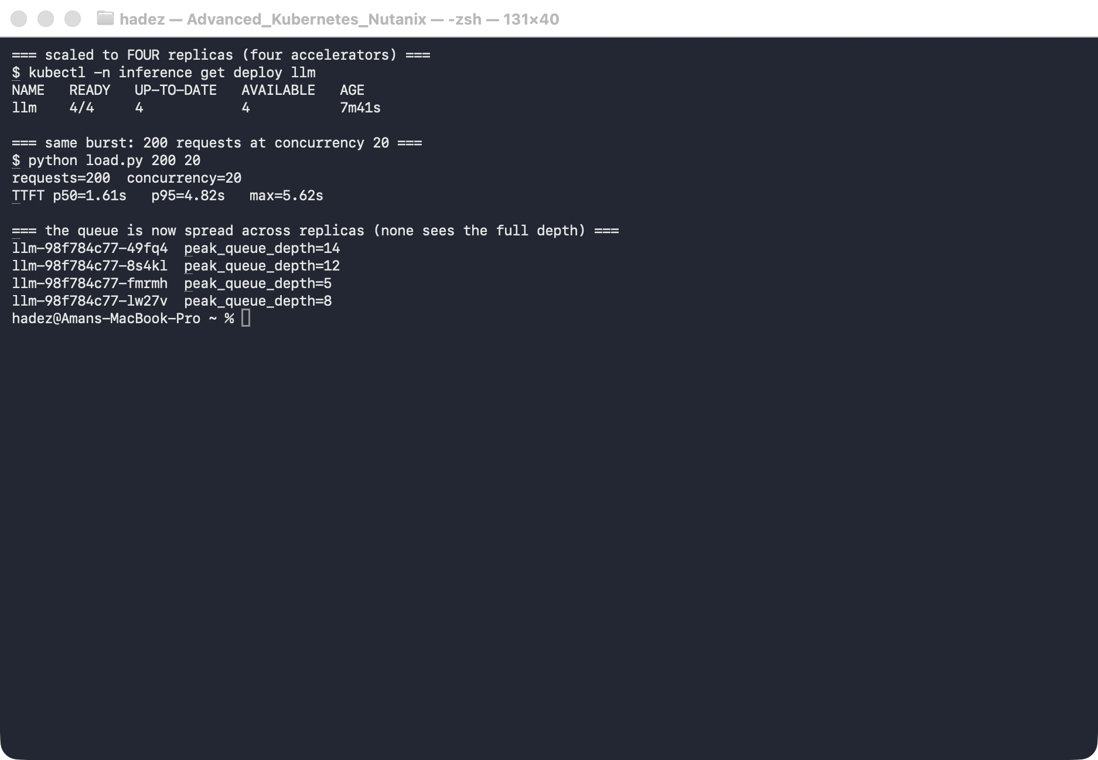
What this means: four workers drain the queue roughly four times faster, so time-to-first-token recovers to an acceptable range. This is the whole basis of inference autoscaling: watch queue depth / TTFT, scale replicas when they spike. (Load-balancing across replicas is L4 and slightly uneven, so per-replica peaks vary — but no replica carries the full queue, and the aggregate TTFT recovers.)
⚠️ Gotcha — don't autoscale inference on CPU. A busy accelerator reads ~100% CPU whether its queue is empty or 50 deep, so a CPU-target HPA reacts late or not at all. Scale on queue depth (or TTFT/pending-requests) exposed by the model server, via a custom-metrics HPA or KEDA. CPU-based autoscaling is the classic reason an inference service "wasn't scaling" while users watched TTFT climb.

Step 4 — Clean up
kubectl delete namespace inference --ignore-not-found

What you learned
You saw… | in Step | proof
A single inference replica serialises requests | 1–2 | peak_queue_depth: 20 on one replica
Overload shows up as TTFT + queue depth, not CPU | 2 | TTFT p50 ~8s under a 20-concurrent burst
Scaling out drains the queue and restores TTFT | 3 | TTFT p50 ~8s → ~1.6s on the same load
The queue spreads across replicas after scale-out | 3 | no replica sees the full depth of 20

Evidence
Real screenshots for this lab are in artifacts/lab-16/screenshots/ (2 images), and the app/load code plus a command transcript are in artifacts/lab-16/evidence/.

Next: Lab 17 — Guardrailed Agentic Kubernetes

