Lab C — Image Scanning & Admission Control with Kyverno
DataCouch — Advanced Kubernetes (Nutanix)
Table of Contents

Day 2 · Extending and Operating the Platform Under Pressure
YES — Tested end-to-end on a real GKE cluster (advk8s-lab, dcproject-462806) with Kyverno 1.19 installed. Every screenshot is a real capture. The lesson that sticks: a Pod can pass every admission policy you write and still crash at runtime — because admission checks the spec, not whether the image was actually built to obey it.

What you'll learn
- How to scan a container image for known vulnerabilities with Trivy, and why image choice alone changes your risk by an order of magnitude.
- How to enforce cluster-wide guardrails at admission time with Kyverno ValidatingPolicy (the current CEL-based API — not the deprecated ClusterPolicy).
- Two production-grade policies: reject :latest/untagged images, and require runAsNonRoot + resource limits.
- The crucial limit of admission control: it validates the spec, so a spec-compliant Pod on the wrong image is admitted and then crashes — and the fix is the image, not the policy.

What you'll do
You'll install Kyverno, scan two images with Trivy to see the difference, then write two admission policies and test both the allowed and blocked cases. Then you'll hit the trap on purpose — a Pod that satisfies your policy but still can't run — and fix it properly.

Time & cost
- Time: ~40 minutes.
- Cost: negligible beyond the shared workhorse GKE cluster. Everything here is control-plane and a few tiny Pods.

Before you start
- Where you'll work: in a terminal on your own machine.
- Tools you need: gcloud, kubectl, helm, and trivy (brew install trivy). The Kyverno CLI is optional; the cluster component is installed via Helm below.
- Cluster: use a GKE cluster (this course's shared advk8s-lab), then install Kyverno:
helm repo add kyverno https://kyverno.github.io/kyverno/
helm repo update
helm install kyverno kyverno/kyverno -n kyverno --create-namespace
kubectl wait --for=condition=Ready pod -n kyverno --all --timeout=180s
Kyverno API note. Kyverno is mid-migration to a new policy API. The original kyverno.io/v1 ClusterPolicy (in almost every older blog post) is deprecated and being removed; the replacement is policies.kyverno.io/v1 ValidatingPolicy, which uses CEL expressions. This lab uses ValidatingPolicy throughout, so it won't go stale — if a tutorial elsewhere opens with kind: ClusterPolicy, treat it as historical.
Nutanix note. Trivy and Kyverno are platform-agnostic — they behave identically on NKE, GKE, and kind. Nothing here depends on GKE; we run it on GKE because Day 2 is cloud-first. On NKE this lab is unchanged.

The idea in 60 seconds
There are two independent lines of defence, and this lab shows both — plus the gap between them:
- Scanning (out-of-band): trivy image <name> inspects an image's packages against vulnerability databases before you deploy. It tells you what's wrong with the image; it doesn't stop anyone deploying it.
- Admission control (in-band): Kyverno runs as an admission webhook — every kubectl apply is checked against your policies before the object is stored. A violating Pod is rejected outright.
The catch: admission only sees the Pod spec. It can require runAsNonRoot: true, but it can't know whether the image actually tolerates running as non-root. So a Pod can pass admission and still crash. You'll see exactly that.
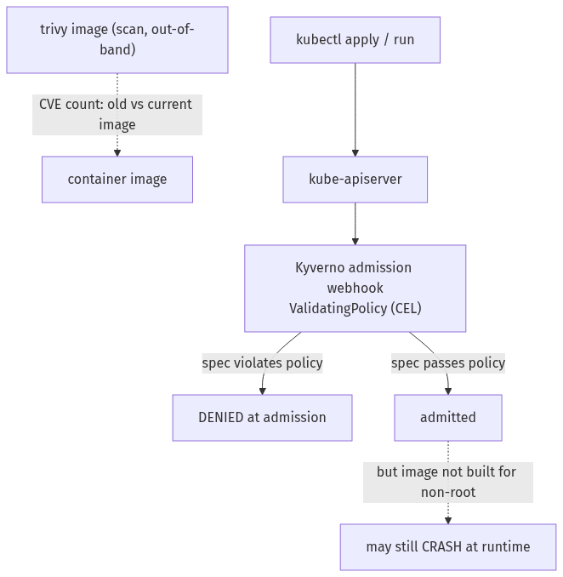

Step 1 — Scan two images with Trivy
Goal: see how much image choice alone changes your vulnerability exposure.
1. Scan an old image and a current slim one (this runs locally — it doesn't touch the cluster):
trivy image --severity HIGH,CRITICAL nginx:1.16
trivy image --severity HIGH,CRITICAL nginx:1.27-alpine
What you should see: the old nginx:1.16 (Debian) reports 166 HIGH/CRITICAL (127 HIGH, 39 CRITICAL); the current nginx:1.27-alpine reports 39 — never zero, but ~4× fewer, and mostly lower-severity.
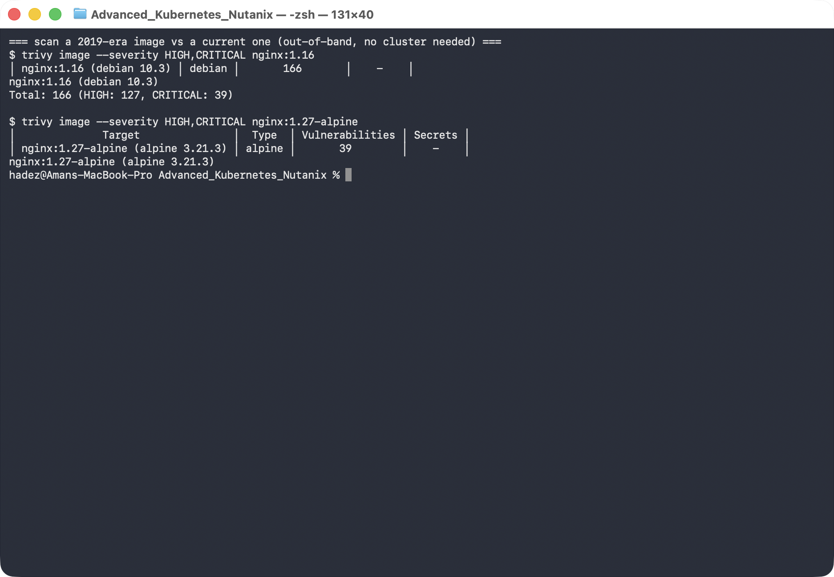
What this means: before any policy, picking a smaller, current base image is the single biggest lever on your CVE count. Trivy is how you see that number; the policies below are how you enforce standards on top of it.
In production you'd usually run Trivy continuously in-cluster (the Trivy Operator generates a VulnerabilityReport per workload) and have admission consult those reports. That's the natural next step once you're comfortable with the two halves — scanning and enforcement — separately.

Step 2 — Policy 1: reject :latest and untagged images
Goal: enforce that every Pod pins an explicit image tag.
1. Apply the policy:
kubectl apply -f - <<'EOF'
apiVersion: policies.kyverno.io/v1
kind: ValidatingPolicy
metadata:
name: disallow-latest-tag
spec:
validationActions: [Deny]
matchConstraints:
resourceRules:
- apiGroups: ['']
apiVersions: [v1]
operations: [CREATE, UPDATE]
resources: [pods]
validations:
- message: "Container images must specify an explicit tag, not :latest or no tag at all."
expression: |
object.spec.containers.all(c,
c.image.contains(':') && !c.image.endsWith(':latest'))
EOF
2. Test both sides:
kubectl run bad-pod --image=nginx:latest --restart=Never
kubectl run good-pod --image=nginx:1.27-alpine --restart=Never
What you should see: bad-pod is denied — admission webhook "vpol.validate.kyverno.svc-fail" denied the request: Policy disallow-latest-tag failed: … — while good-pod is created.
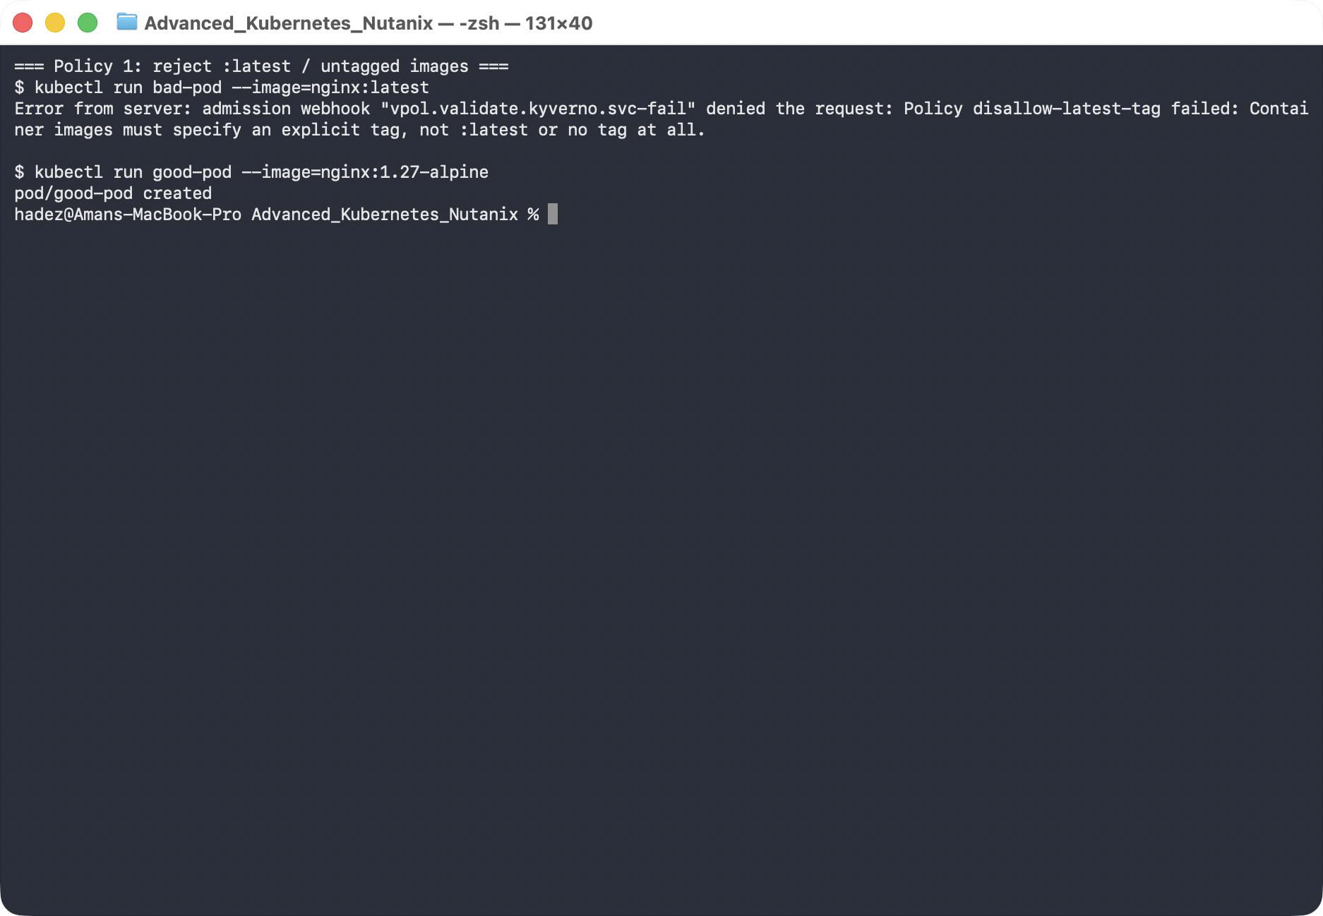
What this means: the policy runs before the Pod is stored, so an untagged image never even gets scheduled. :latest is a moving target that breaks reproducibility and rollbacks — this rejects it cluster-wide.

Step 3 — Policy 2: require non-root + limits — and the trap on the other side
Goal: require every container to run as non-root with resource limits, then discover why that's necessary but not sufficient.
1. Apply the policy:
kubectl apply -f - <<'EOF'
apiVersion: policies.kyverno.io/v1
kind: ValidatingPolicy
metadata:
name: require-nonroot-and-limits
spec:
validationActions: [Deny]
matchConstraints:
resourceRules:
- apiGroups: ['']
apiVersions: [v1]
operations: [CREATE, UPDATE]
resources: [pods]
validations:
- message: "Every container must set securityContext.runAsNonRoot: true."
expression: |
object.spec.containers.all(c,
has(c.securityContext) && has(c.securityContext.runAsNonRoot) &&
c.securityContext.runAsNonRoot == true)
- message: "Every container must define CPU and memory limits."
expression: |
object.spec.containers.all(c,
has(c.resources) && has(c.resources.limits) &&
has(c.resources.limits.cpu) && has(c.resources.limits.memory))
EOF
2. First the obvious violation — a bare Pod (no securityContext):
kubectl apply -f - <<'EOF'
apiVersion: v1
kind: Pod
metadata: {name: bad-pod-2}
spec:
containers: [{name: app, image: nginx:1.27-alpine}]
EOF
It's denied — Every container must set securityContext.runAsNonRoot: true.
3. Now a Pod that satisfies the policy — stock nginx, with everything asked for:
kubectl apply -f - <<'EOF'
apiVersion: v1
kind: Pod
metadata: {name: good-pod-2}
spec:
containers:
- name: app
image: nginx:1.27-alpine
securityContext: {runAsNonRoot: true, runAsUser: 101}
resources: {limits: {cpu: "250m", memory: "128Mi"}}
EOF
kubectl get pod good-pod-2
kubectl logs good-pod-2
What you should see: good-pod-2 is admitted — then goes to Error/CrashLoopBackOff. Its logs show nginx: [emerg] mkdir() "/var/cache/nginx/client_temp" failed (13: Permission denied).
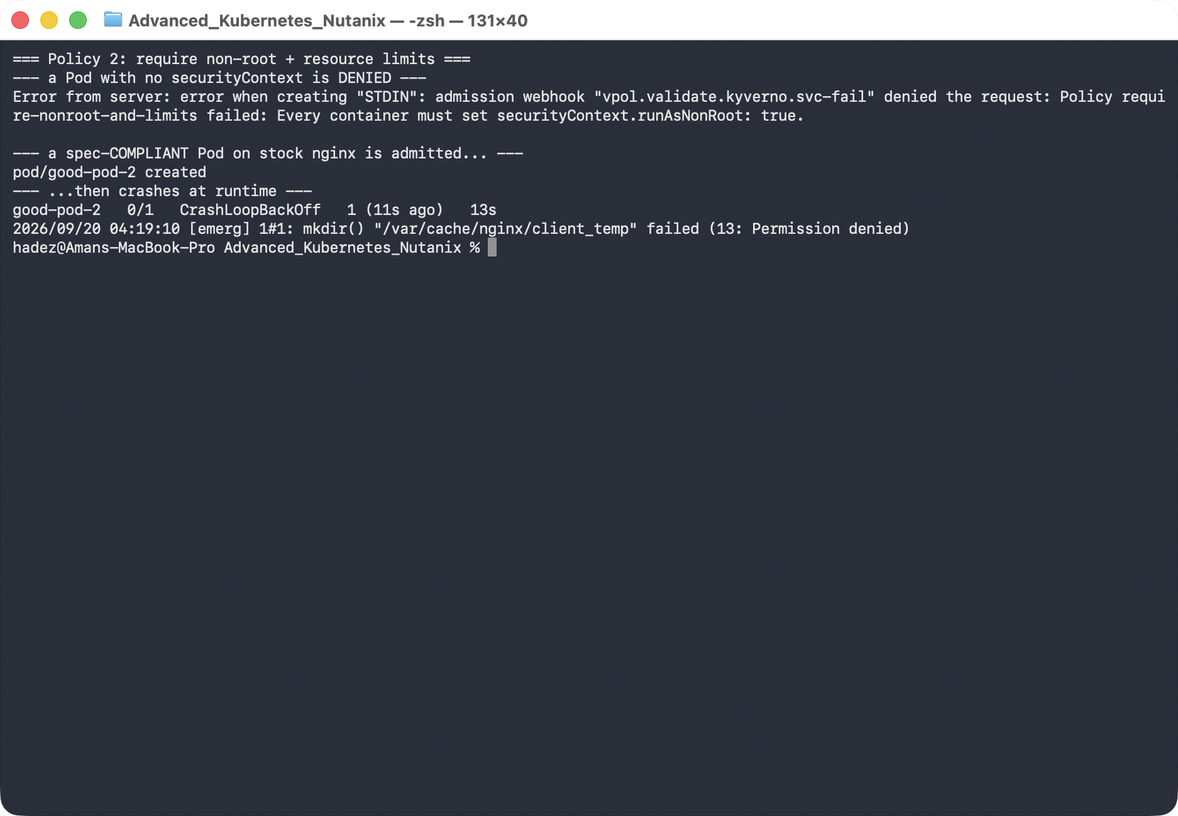
What this means — this is the point of the lab, not a mistake. The policy only checked the spec. The stock nginx image writes to root-owned paths (/var/cache/nginx/…) at startup regardless of runAsNonRoot. Setting that flag on an image that doesn't expect it just moves the failure from admission time to runtime. Admission control is necessary, but it can't vouch for the image.

Step 4 — The real fix: an image built to run unprivileged
Goal: keep the exact same policy-compliant spec, but use an image designed for non-root.
kubectl delete pod good-pod-2 --wait=false
kubectl apply -f - <<'EOF'
apiVersion: v1
kind: Pod
metadata: {name: good-pod-3}
spec:
containers:
- name: app
image: nginxinc/nginx-unprivileged:1.27-alpine
securityContext: {runAsNonRoot: true, runAsUser: 101}
resources: {limits: {cpu: "250m", memory: "128Mi"}}
EOF
kubectl get pod good-pod-3
What you should see: good-pod-3 reaches Running — same spec, same policy, but on nginxinc/nginx-unprivileged, an image that expects to run as non-root.
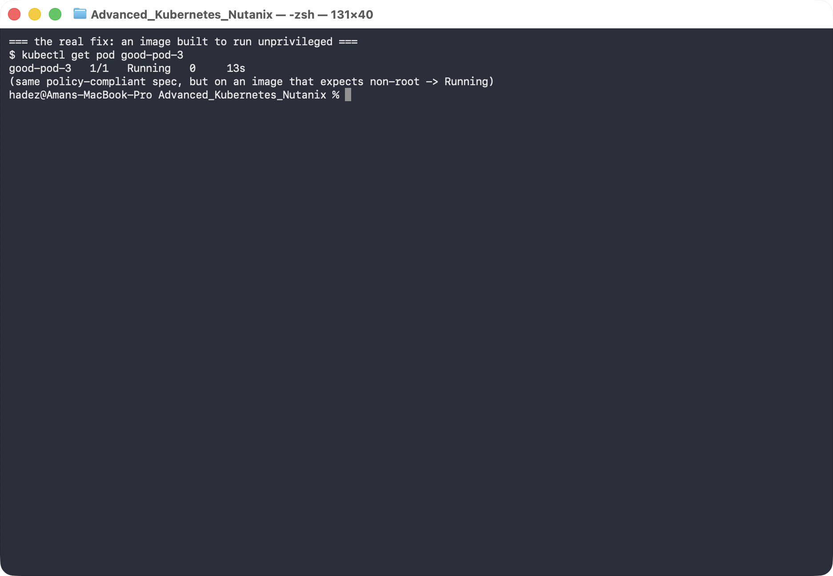
What this means: the durable fix for "runs as root" is a container image built to run unprivileged — the policy enforces the requirement, but only the right image satisfies it at runtime.

Step 5 — Clean up
kubectl delete pod good-pod good-pod-3 --ignore-not-found
kubectl delete validatingpolicy disallow-latest-tag require-nonroot-and-limits
Leave the cluster running for the rest of the course, or uninstall Kyverno with helm uninstall kyverno -n kyverno.

What you learned
You saw… | in Step | proof
Image choice alone changes CVE count by ~10× | 1 | Trivy: old Debian nginx vs current Alpine
Admission runs before the object is stored | 2 | bad-pod denied at kubectl run
A spec-compliant Pod can still be wrong | 3 | good-pod-2 admitted, then mkdir … Permission denied
Admission checks the spec, not the image | 3 | crash is at runtime, not admission
The fix for "runs as root" is the image | 4 | good-pod-3 Running on nginx-unprivileged

Evidence
Real screenshots for this lab are in artifacts/lab-C/screenshots/.

Next: Lab 8 — StatefulSets, PVCs & Volume Snapshots (Day 3)

