Lab E — Runtime Security with Falco
DataCouch — Advanced Kubernetes (Nutanix)
Table of Contents

Day 5 · Kubernetes as the AI-Native Platform
YES — Tested end-to-end on a real kind cluster. Every screenshot is a real capture of a genuine kernel-level Falco alert — not a simulated log line. The payoff: you'll read /etc/shadow inside a container, install a tool after it started, and read a decoy file — and watch Falco fire a precise, context-rich alert on each, including one your own custom rule catches.

What you'll learn
- What Falco actually watches — kernel syscalls via eBPF — and why that catches things happening inside a running container, which admission control (Lab C's Kyverno) structurally cannot see.
- How to read a real Falco alert: process, parent, command line, container, image, and Kubernetes pod/namespace, all in one line.
- How to write and deploy your own detection rule.

What you'll do
You'll install Falco with its modern eBPF driver, trigger two built-in detections (sensitive-file read; a binary installed and run after startup), then write a custom "canary file" rule and trigger it.

Time & cost
- Time: ~40 minutes.
- Cost: $0 — runs entirely on a local kind cluster.

Before you start
- Where you'll work: in a terminal on your own machine.
- Tools you need: docker, kind, kubectl, helm.
- Cluster: you'll create a fresh kind cluster in Step 1.
- Feasibility note: Falco hooks kernel syscalls, which sounds like it wouldn't work inside a container on Docker Desktop's virtualised Linux. It does — this was fully verified on Docker Desktop for Mac (Apple Silicon) using the modern_ebpf driver, with real detections of real events. On native Linux it works at least as well.
Nutanix note. Falco is CNCF-graduated and completely platform-agnostic — it runs the same on NKE. Runtime security is arguably more important on-prem, where you own the whole stack: Falco gives you kernel-level visibility into what containers actually do on your Nutanix nodes, feeding the same alerts into your SIEM. This lab is kind only because it needs no cloud features; the install and rules are identical on a Nutanix cluster.

The idea in 60 seconds
Lab C's Kyverno is an admission controller: it inspects a Pod spec once, before the Pod exists, and can only reason about what's declared. It has no idea what the container does once running.
Falco is runtime security. It taps the kernel via eBPF and watches actual syscalls — file opens, process launches, network connections — as they happen. That catches things no spec could predict: a container reading /etc/shadow, a binary installed and executed after startup, a shell spawned in a stateless web server. The two layers are complementary: admission control stops bad configuration; Falco catches bad behaviour in configurations that looked fine at admission time.
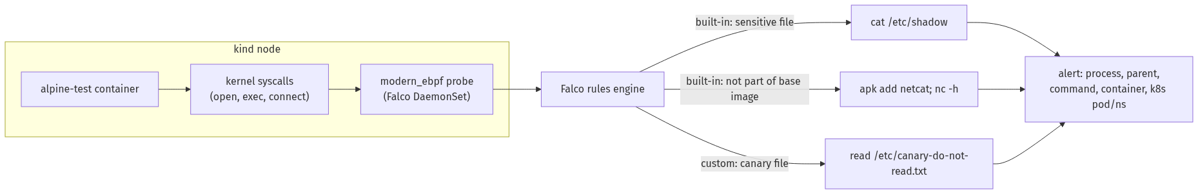

Step 1 — Install Falco with the eBPF driver
Goal: get Falco watching syscalls on the node.
kind create cluster --name falco-lab
helm repo add falcosecurity https://falcosecurity.github.io/charts
helm repo update
helm install falco falcosecurity/falco \
--namespace falco --create-namespace \
--set driver.kind=modern_ebpf \
--set tty=true
kubectl wait --for=condition=Ready pod -l app.kubernetes.io/name=falco -n falco --timeout=120s
kubectl get pods -n falco
What you should see: the falco Pod Running. You may see startup warnings about failed to determine tracepoint … creat / TOCTOU mitigation — these are expected and non-fatal; Falco names exactly what's degraded (a race-condition mitigation for two syscalls) and confirms detection itself is unaffected.
What this means: driver.kind=modern_ebpf is the CO-RE (Compile Once, Run Everywhere) probe — it needs no matching kernel headers, which is what makes Falco viable inside a kind node on a virtualised kernel. Falco is now watching every syscall on the node.

Step 2 — Trigger a built-in detection: reading a sensitive file
Goal: do something that looks like post-compromise reconnaissance and watch Falco catch it.
kubectl run alpine-test --image=alpine:3.20 --restart=Never -- sleep 3600
kubectl wait --for=condition=Ready pod/alpine-test --timeout=60s
kubectl exec alpine-test -- cat /etc/shadow
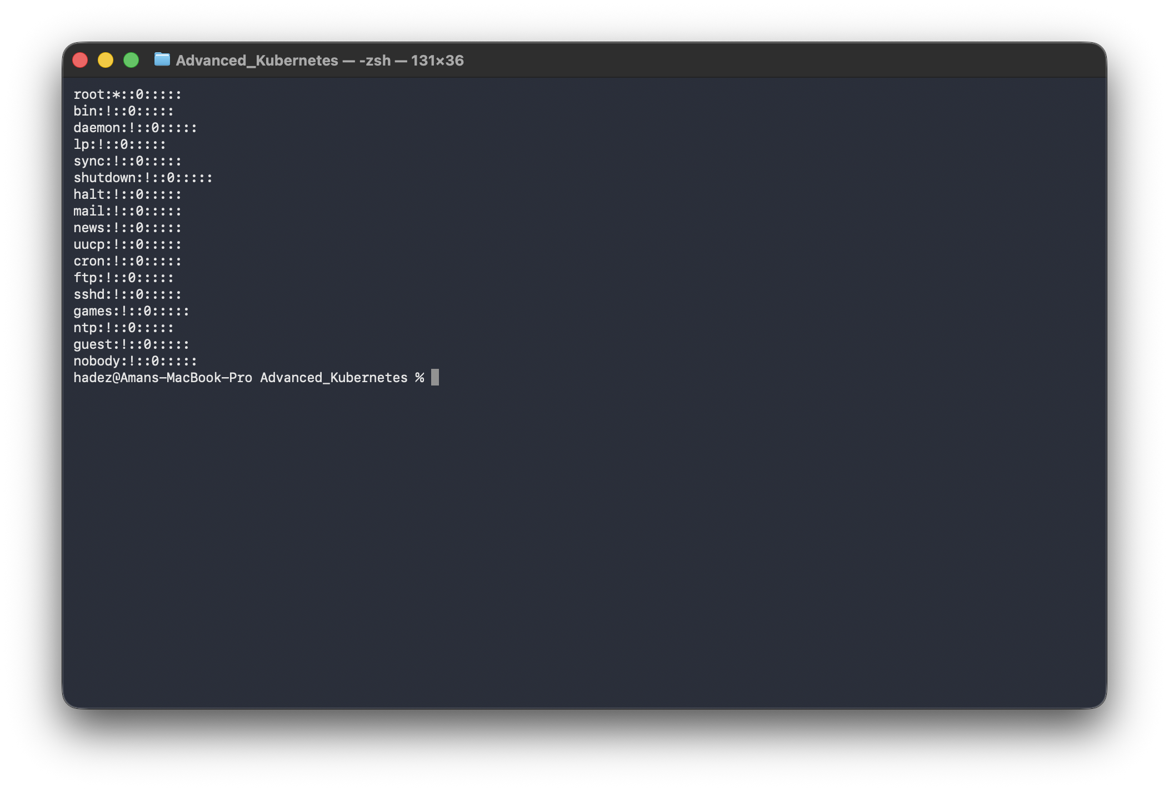
Now read Falco's log:
kubectl logs -n falco -l app.kubernetes.io/name=falco -c falco --tail=20
What you should see: a Warning alert — Sensitive file opened for reading by non-trusted program — naming file=/etc/shadow, process=cat, its parent, the full command, the container, image, and the Kubernetes pod/namespace.
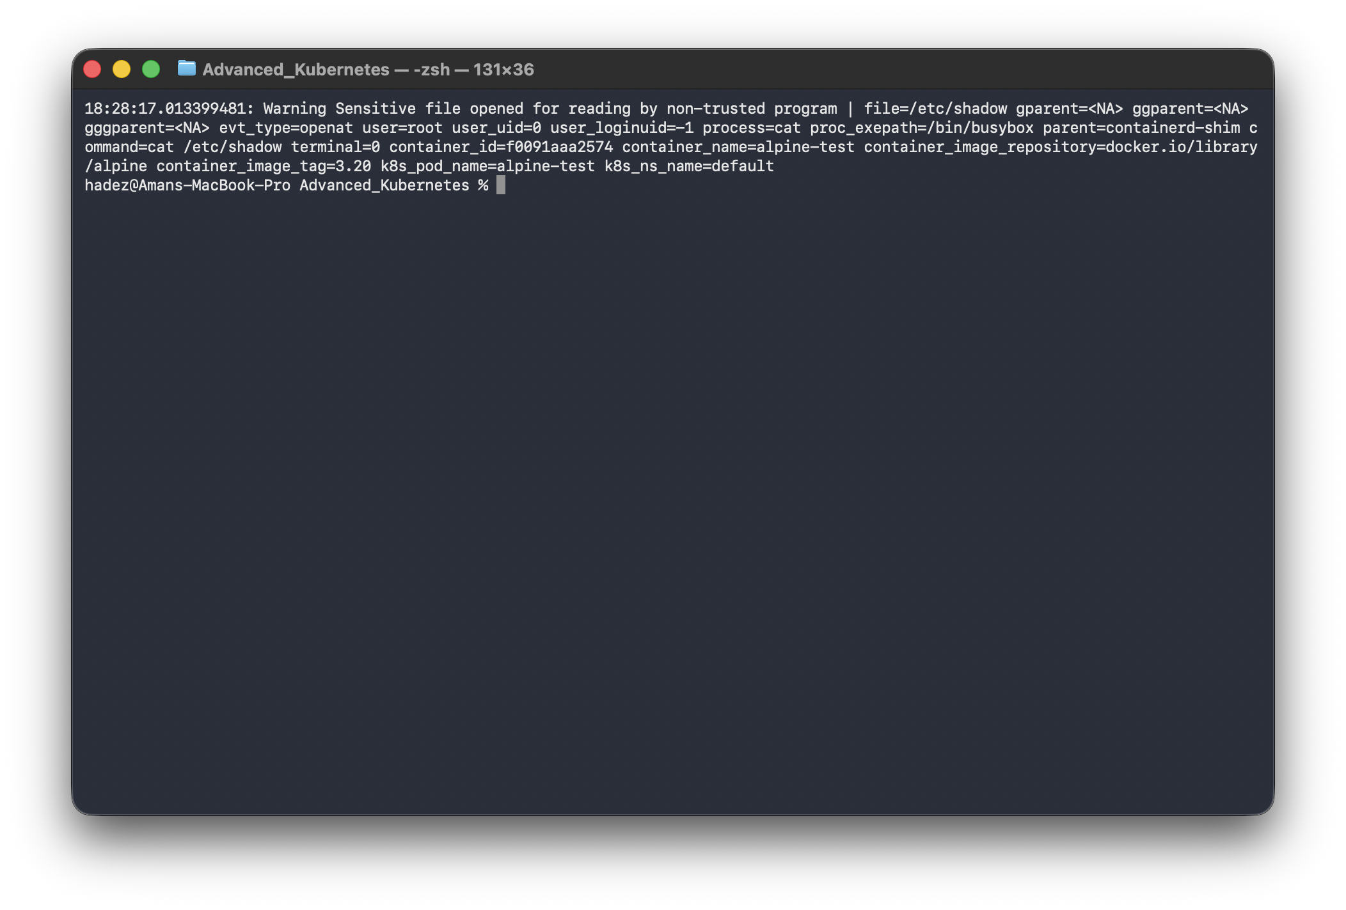
Warning Sensitive file opened for reading by non-trusted program | file=/etc/shadow
process=cat parent=sh command=cat /etc/shadow container_name=alpine-test
container_image_repository=docker.io/library/alpine k8s_pod_name=alpine-test k8s_ns_name=default
What this means: one alert carries everything you need to act — which file, which process, its parent, the exact command, the container/image, and the pod/namespace — no cross-referencing three systems.

Step 3 — Trigger a built-in detection: runtime tampering
Goal: install and run a tool after the container started — the exact move an attacker makes for a foothold — and see why Falco flags it.
kubectl exec alpine-test -- sh -c "apk add --no-cache netcat-openbsd; nc -h"
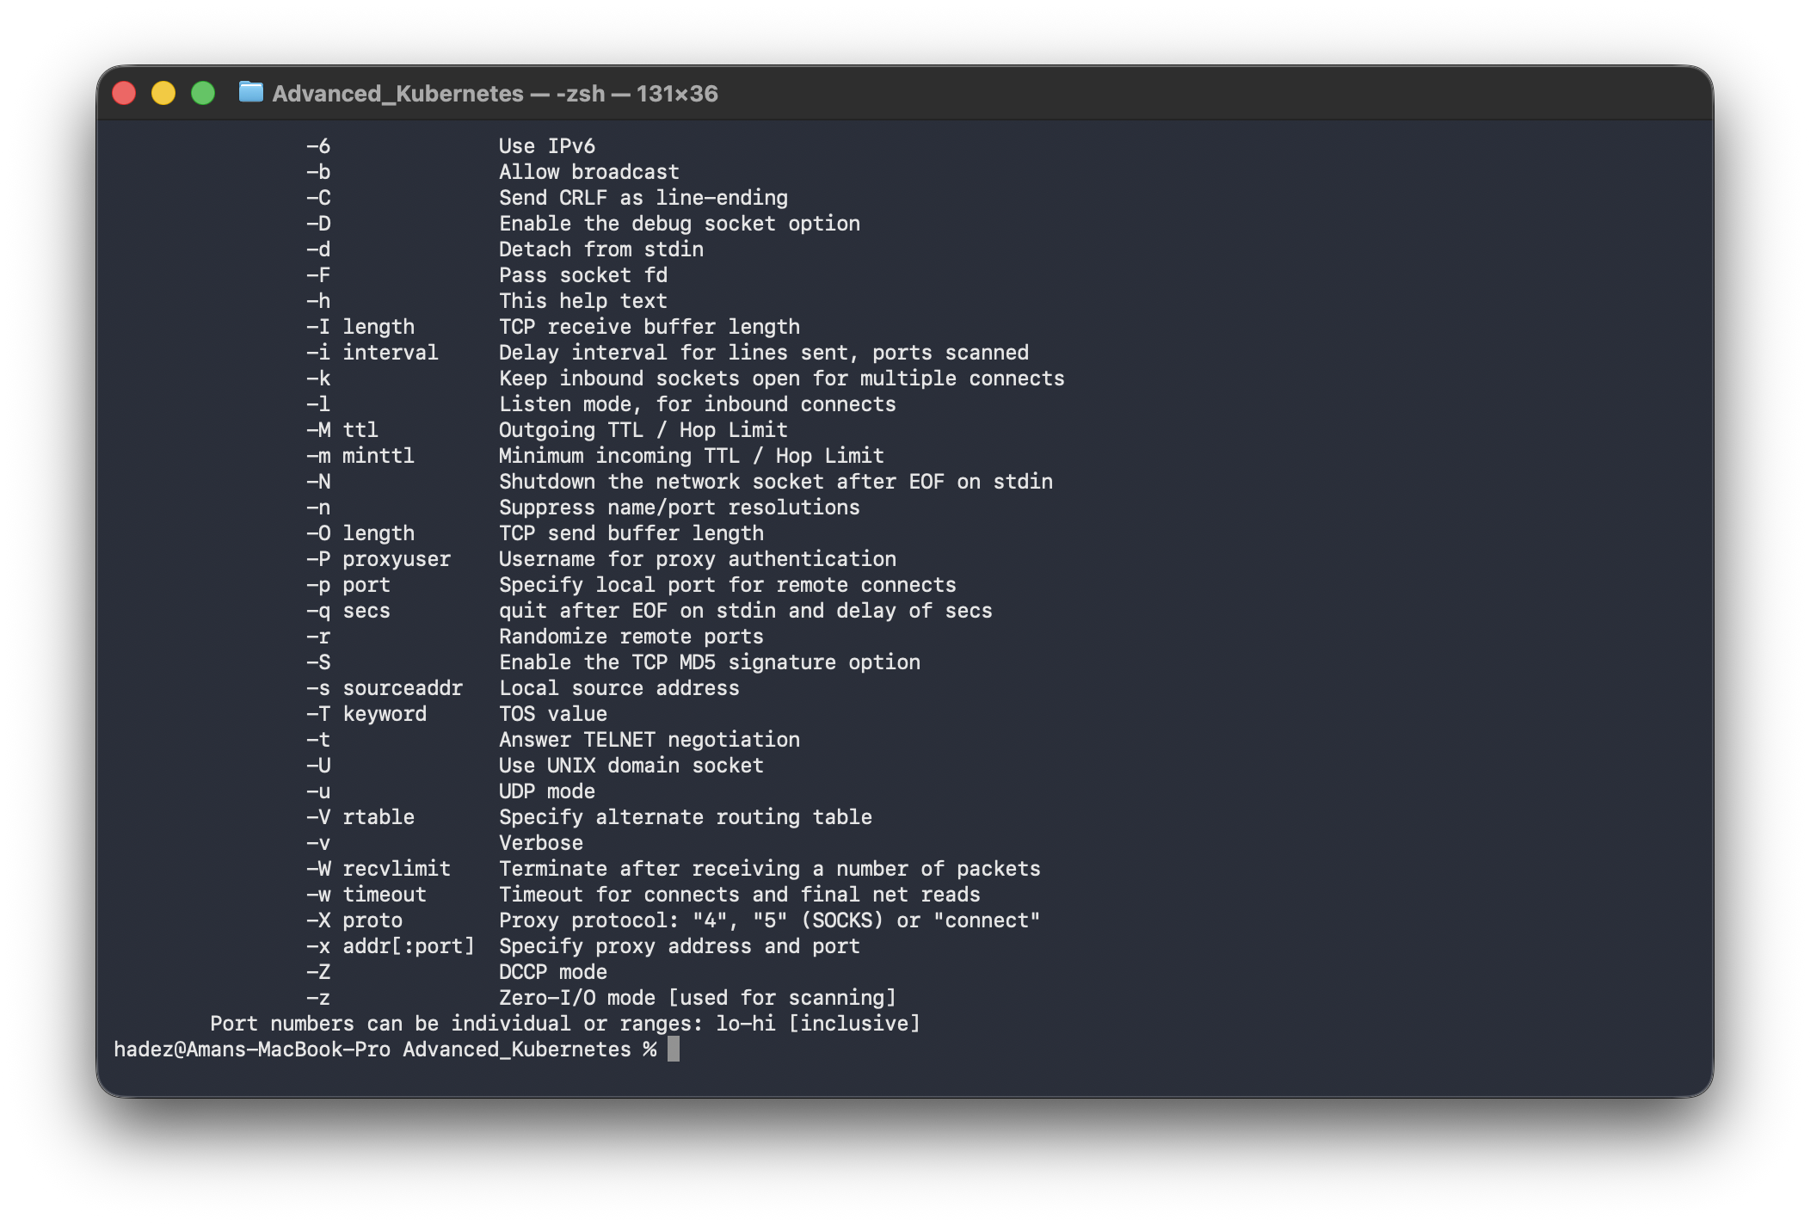
kubectl logs -n falco -l app.kubernetes.io/name=falco -c falco --tail=30 | grep -i "not part of base"
What you should see: a Critical alert — Executing binary not part of base image — with exe_flags=EXE_WRITABLE|EXE_UPPER_LAYER.
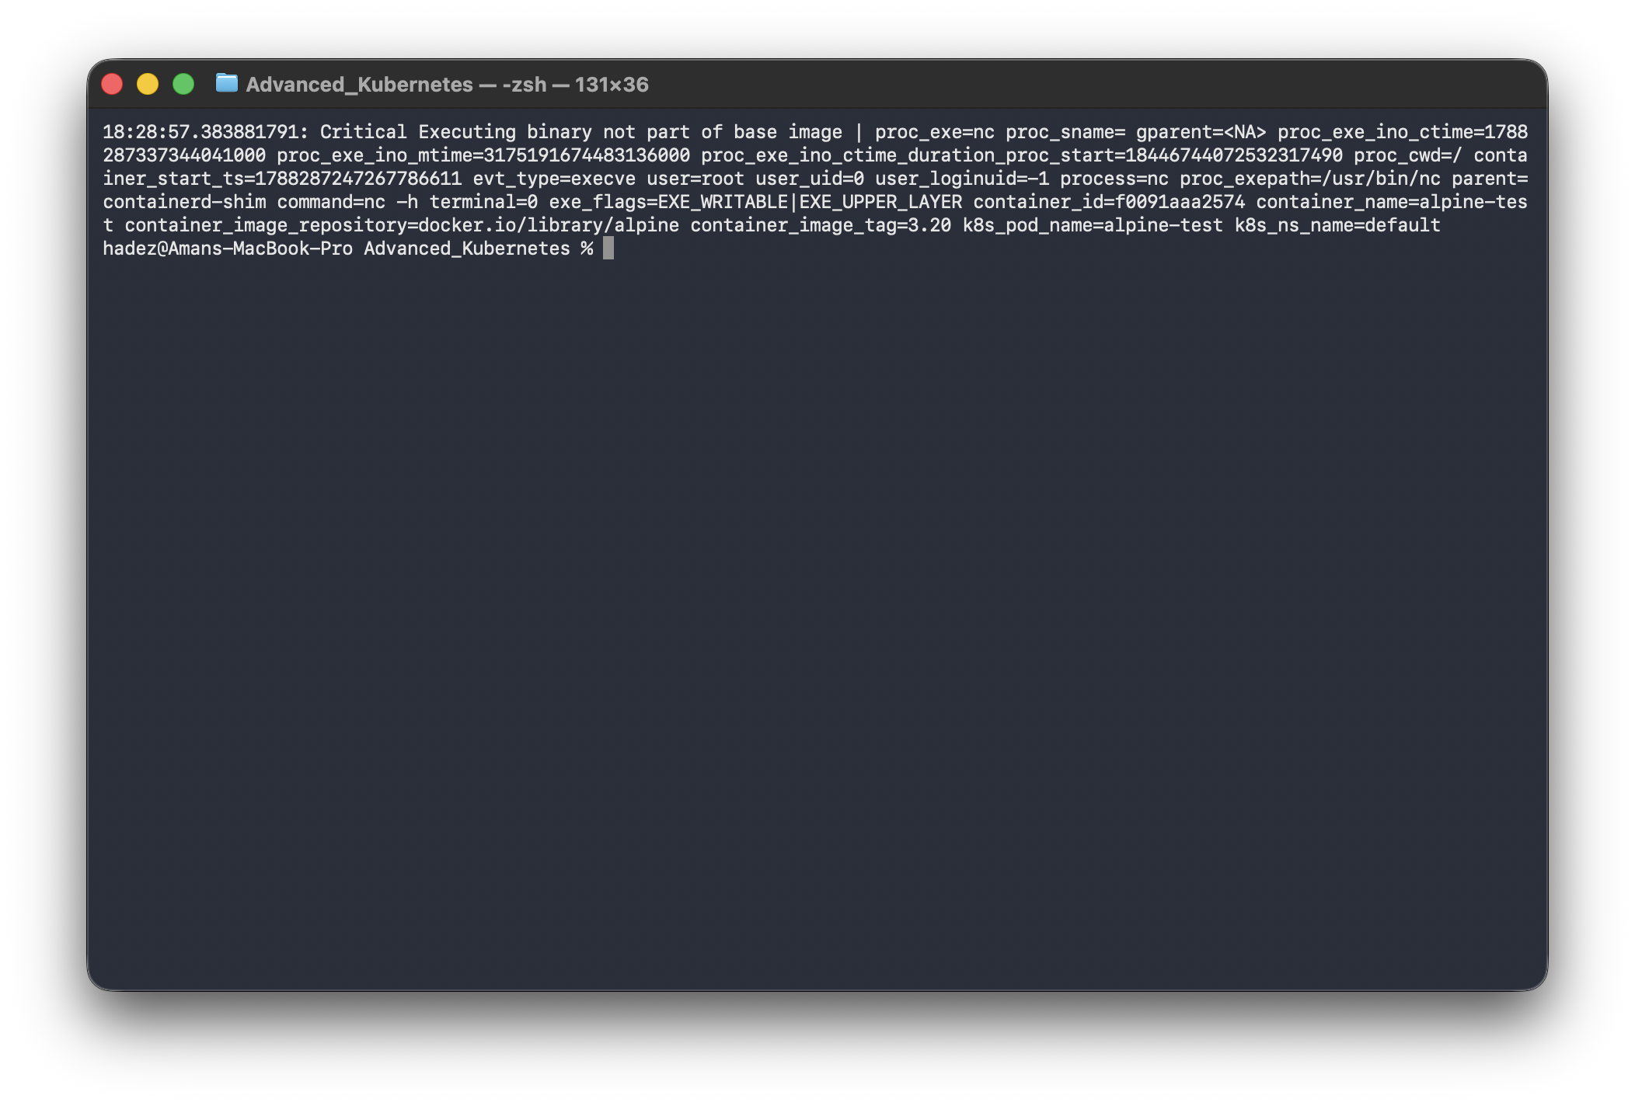
Critical Executing binary not part of base image | proc_exe=nc
exe_flags=EXE_WRITABLE|EXE_UPPER_LAYER command=nc -h
container_name=alpine-test container_image_repository=docker.io/library/alpine
What this means: alpine:3.20 doesn't ship netcat-openbsd — we installed it live. The flags say why it's suspicious: the binary lives in the container's writable overlay layer, not the read-only image layer. A well-built image's processes never need this; an attacker planting a reverse shell or scanner very often does. Lab C's image scan structurally cannot catch this — the scan runs against the image; this behaviour only exists once the container is a running, mutated instance.

Step 4 — Write your own detection rule
Goal: add a workload-specific rule — a decoy ("canary") file nothing legitimate should ever read.
cat > /tmp/falco-custom-rules.yaml <<'EOF'
customRules:
rules-custom.yaml: |-
- rule: Canary File Accessed
desc: Detect any read of our planted decoy file -- nothing legitimate should ever touch it
condition: >
open_read and container and fd.name = "/etc/canary-do-not-read.txt"
output: >
Canary file was read (user=%user.name command=%proc.cmdline
container=%container.name image=%container.image.repository)
priority: CRITICAL
tags: [container, canary, mitre_discovery]
EOF
helm upgrade falco falcosecurity/falco \
--namespace falco \
--set driver.kind=modern_ebpf --set tty=true \
-f /tmp/falco-custom-rules.yaml
kubectl rollout status daemonset/falco -n falco --timeout=90s
Trigger it:
kubectl exec alpine-test -- sh -c "echo secret > /etc/canary-do-not-read.txt"
kubectl exec alpine-test -- cat /etc/canary-do-not-read.txt
kubectl logs -n falco -l app.kubernetes.io/name=falco -c falco --tail=10
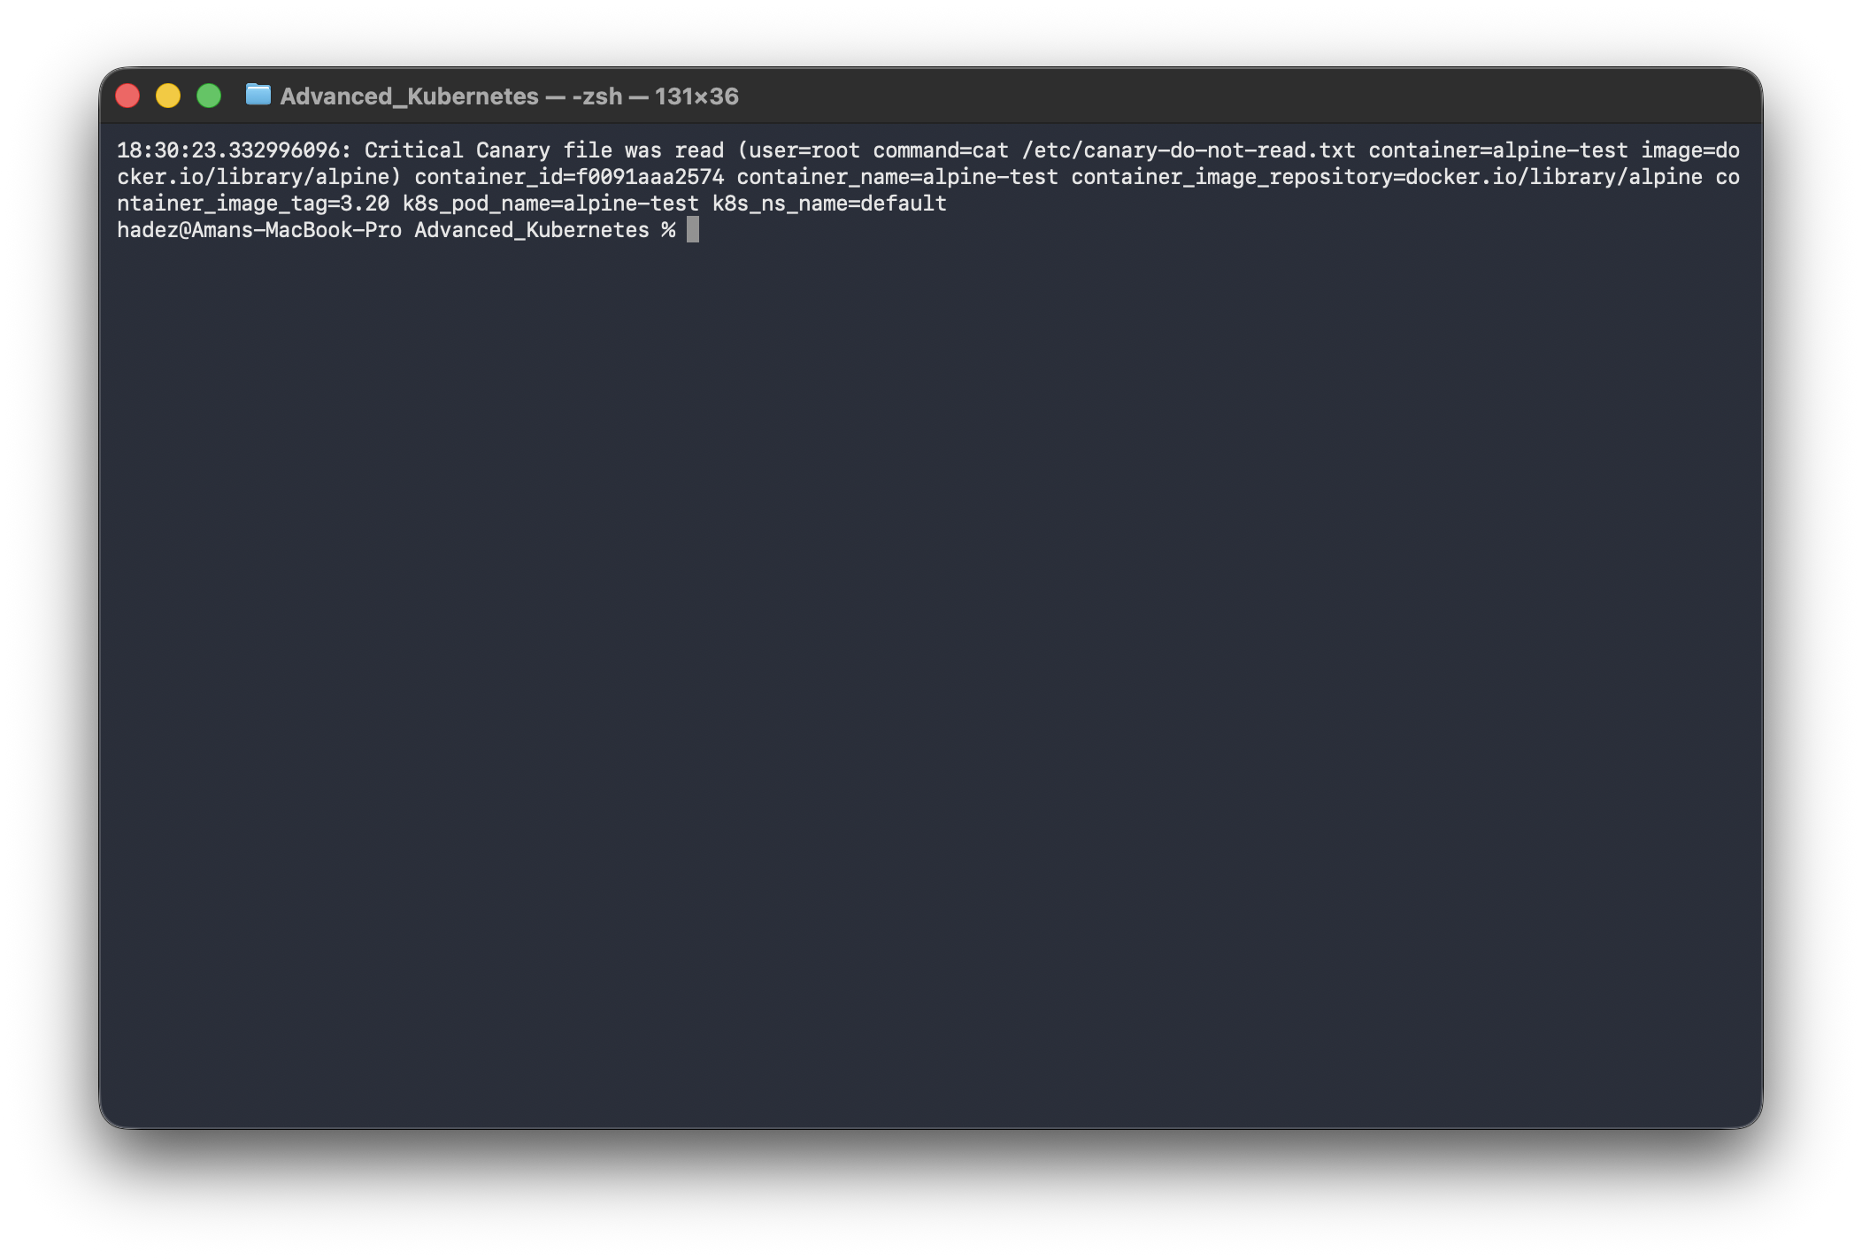
What you should see: a Critical alert from your rule — Canary file was read — with the user, command, container, and image.
Critical Canary file was read (user=root command=cat /etc/canary-do-not-read.txt
container_name=alpine-test image=docker.io/library/alpine)
What this means: built-in rules are general-purpose; real deployments add high-signal rules for what a specific workload should never do. A canary file is one of the highest-signal, lowest-noise detections you can add.
⚠️ Gotcha — a rule that loads cleanly can still silently never fire. An earlier version of this rule matched process execution (spawned_process and container and proc.name = "nc"). It loaded with schema validation: ok but never fired, even though the same nc run was independently caught by the built-in rule in Step 3. Rephrasing it around a different event class (open_read / fd.name, as above) worked immediately. If your custom rule loads fine but never triggers, restructure the condition around a different event type before assuming your YAML syntax is broken. Full evidence (including the failed attempt): artifacts/lab-E/evidence/lab-E-falco-runtime-security.txt.

Step 5 — Clean up
kind delete cluster --name falco-lab

What you learned
You saw… | in Step | proof
Falco watches live syscalls, not just specs | 1 | eBPF probe running on the node
A built-in rule catches a sensitive-file read | 2 | Sensitive file opened … /etc/shadow
A built-in rule catches a binary added after startup | 3 | not part of base image, EXE_WRITABLE|EXE_UPPER_LAYER
A custom rule catches workload-specific behaviour | 4 | Canary file was read from your rule

Evidence
Real screenshots for this lab are in artifacts/lab-E/screenshots/ (7 images), and a command transcript is in artifacts/lab-E/evidence/lab-E-falco-runtime-security.txt.

Next: Lab G — Chaos Engineering with Chaos Mesh

