Lab F — Advanced HPA & VPA Autoscaling
DataCouch — Advanced Kubernetes (Nutanix)
Table of Contents

Day 5 · Kubernetes as the AI-Native Platform
YES — Tested end-to-end on a real kind cluster. Every command was run start to finish and every screenshot is a real capture — including a live GUI view of the VPA object. The payoff: you'll watch an HPA drive a Deployment 1 → 6 replicas in ~90 seconds under load and then step it back down without flapping, and watch a VPA resize a running Pod's CPU/memory with zero restarts.

What you'll learn
- How to tune HorizontalPodAutoscaler behavior beyond the default: fast, aggressive scale-up and slow, cautious scale-down with a stabilization window, so a brief dip in load doesn't collapse your replicas.
- How the Vertical Pod Autoscaler recommends right-sized requests from real measured usage — and then applies them in place (the /resize subresource) with no Pod restart.
- Why you don't point HPA and VPA at the same metric on the same workload.

What you'll do
You'll install metrics-server, apply an HPA with asymmetric behaviour and drive it up and down with a load generator, then use a VPA (recommendation first, then live in-place resize) on a deliberately under-provisioned app.

Time & cost
- Time: ~40 minutes.
- Cost: $0 — runs entirely on a local kind cluster.

Before you start
- Where you'll work: in a terminal on your own machine.
- Tools you need: docker, kind, kubectl, helm, git.
- Cluster: you'll create a fresh kind cluster in Step 1.
Nutanix note. HPA and VPA are core/standard Kubernetes and behave identically on NKE — this lab is kind only because it needs no cloud features. The one thing that changes on-prem is what backs the scaling: HPA adds Pods, and if the cluster runs out of node capacity those Pods sit Pending until a node appears. On Nutanix that means pairing this with node auto-provisioning (Karpenter-style, or NKE node pools) so horizontal scaling has somewhere to land. VPA's in-place resize is especially valuable on fixed on-prem capacity, where right-sizing requests reclaims stranded headroom without disruptive restarts.

The idea in 60 seconds
Two different axes of autoscaling:
- HPA scales out — more replicas — when a per-Pod metric (here CPU utilisation) crosses a target. Its behavior block lets you make scale-up and scale-down asymmetric: jump up fast to absorb a spike, but come down slowly and in steps so you don't thrash.
- VPA scales up — bigger requests/limits on the same Pod — based on observed usage. Its modern InPlaceOrRecreate mode resizes a live container instead of evicting it.
Both need a metrics source (metrics-server). And you keep them apart: if HPA and VPA both act on CPU for one workload, they chase each other's tails.
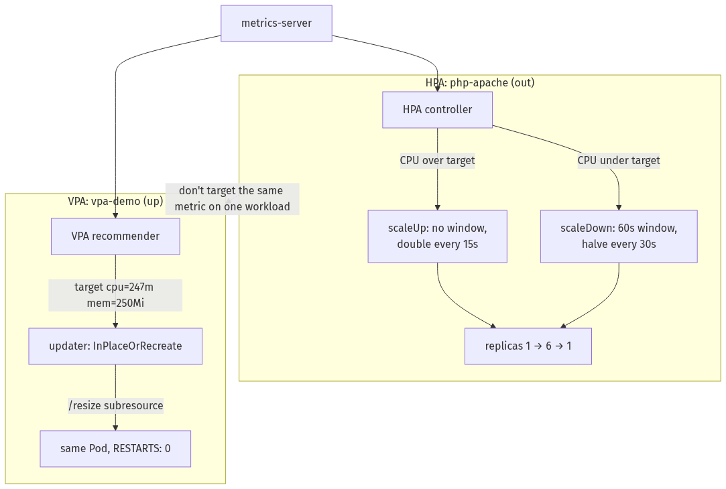

Step 1 — Create the cluster and install metrics-server
Goal: get a cluster that actually reports CPU/memory numbers — nothing autoscales without them.
kind create cluster --name autoscale-lab
kubectl apply -f https://github.com/kubernetes-sigs/metrics-server/releases/latest/download/components.yaml
kubectl patch deployment metrics-server -n kube-system --type='json' \
-p='[{"op":"add","path":"/spec/template/spec/containers/0/args/-","value":"--kubelet-insecure-tls"}]'
kubectl wait --for=condition=Available --timeout=120s -n kube-system deployment/metrics-server
kubectl top nodes
What you should see: kubectl top nodes returns real CPU/memory numbers (not an error) — metrics-server is reporting.
What this means: the autoscalers now have data to act on. --kubelet-insecure-tls is the standard kind accommodation (the kubelet's serving cert isn't signed for what metrics-server verifies by default); it's not a real security compromise on localhost.
⚠️ Gotcha — cloud provisioning silently steals your kubectl context. If you also have a GKE/EKS/AKS cluster creating in another terminal, gcloud container clusters create (and equivalents) switch your kubectl current-context to the new cluster the moment it finishes — even in the background. We hit exactly this: commands started hitting the wrong cluster until kubectl config current-context gave it away. Check your context before any command whose blast radius matters.

Step 2 — Advanced HPA: fast up, slow down
Goal: make an HPA that absorbs a spike instantly but refuses to thrash on the way down.
1. Deploy a CPU-bound app:
kubectl apply -f - <<'EOF'
apiVersion: apps/v1
kind: Deployment
metadata: {name: php-apache}
spec:
replicas: 1
selector: {matchLabels: {run: php-apache}}
template:
metadata: {labels: {run: php-apache}}
spec:
containers:
- name: php-apache
image: registry.k8s.io/hpa-example
ports: [{containerPort: 80}]
resources:
requests: {cpu: 200m, memory: 64Mi}
limits: {cpu: 500m, memory: 128Mi}
---
apiVersion: v1
kind: Service
metadata: {name: php-apache}
spec:
ports: [{port: 80}]
selector: {run: php-apache}
EOF
kubectl wait --for=condition=Available --timeout=90s deployment/php-apache
2. Apply the HPA with asymmetric behavior — scale up instantly (stabilizationWindowSeconds: 0, up to +100%/15s), scale down slowly (60s window, then only −50%/30s):
kubectl apply -f - <<'EOF'
apiVersion: autoscaling/v2
kind: HorizontalPodAutoscaler
metadata: {name: php-apache-hpa}
spec:
scaleTargetRef: {apiVersion: apps/v1, kind: Deployment, name: php-apache}
minReplicas: 1
maxReplicas: 6
metrics:
- type: Resource
resource: {name: cpu, target: {type: Utilization, averageUtilization: 50}}
behavior:
scaleUp:
stabilizationWindowSeconds: 0
policies:
- {type: Percent, value: 100, periodSeconds: 15}
- {type: Pods, value: 2, periodSeconds: 15}
selectPolicy: Max
scaleDown:
stabilizationWindowSeconds: 60
policies:
- {type: Percent, value: 50, periodSeconds: 30}
selectPolicy: Min
EOF
kubectl get hpa php-apache-hpa
What you should see: a baseline of 1 replica at low CPU (well under the 50% target).
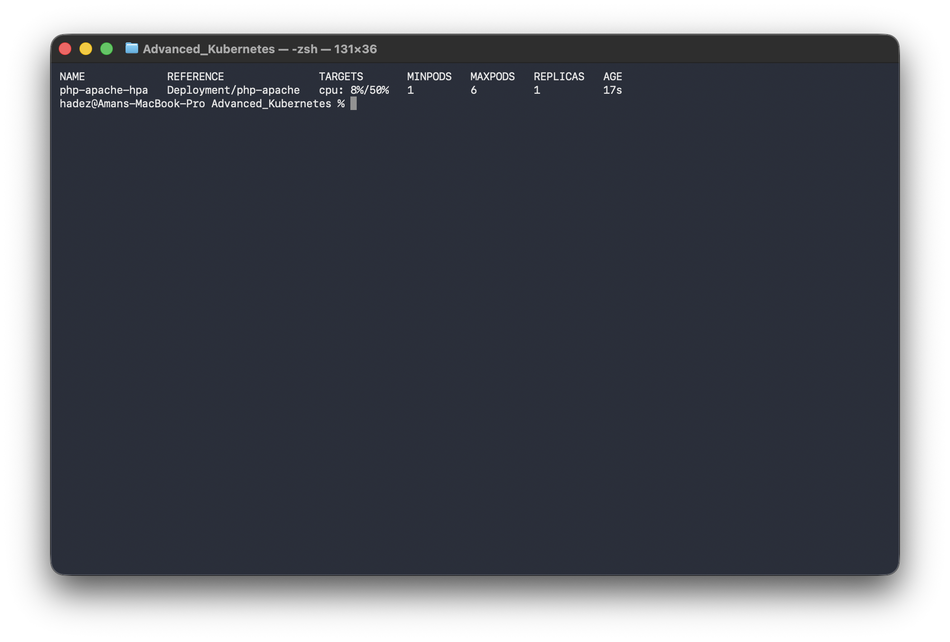
3. Generate load and watch it climb:
kubectl run load-generator --image=busybox --restart=Never -- \
/bin/sh -c "while true; do wget -q -O- http://php-apache; done"
watch kubectl get hpa php-apache-hpa
What you should see: CPU shoots past target and the HPA scales 1 → 6 within about 90 seconds — the aggressive Percent 100/15s + Pods 2/15s policies (whichever is bigger, selectPolicy: Max) let it climb fast.
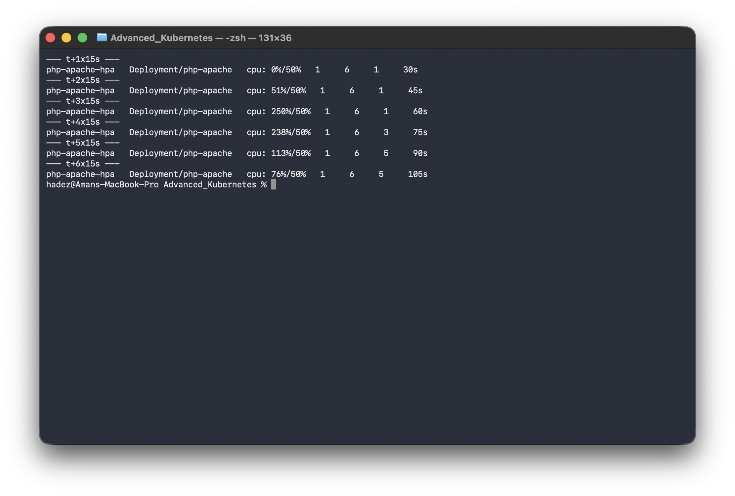
Time | CPU | Replicas
t+20s | 121%/50% | 1
t+40s | 153%/50% | 3
t+60s | 85%/50% | 6
4. Remove the load and watch the controlled descent:
kubectl delete pod load-generator
watch kubectl get hpa php-apache-hpa
What you should see: CPU drops to 0% almost instantly, but replicas hold at 6 for a full 60 seconds (the stabilization window), then step down 6 → 3 → 1 in 50% increments — never collapsing straight to minReplicas.
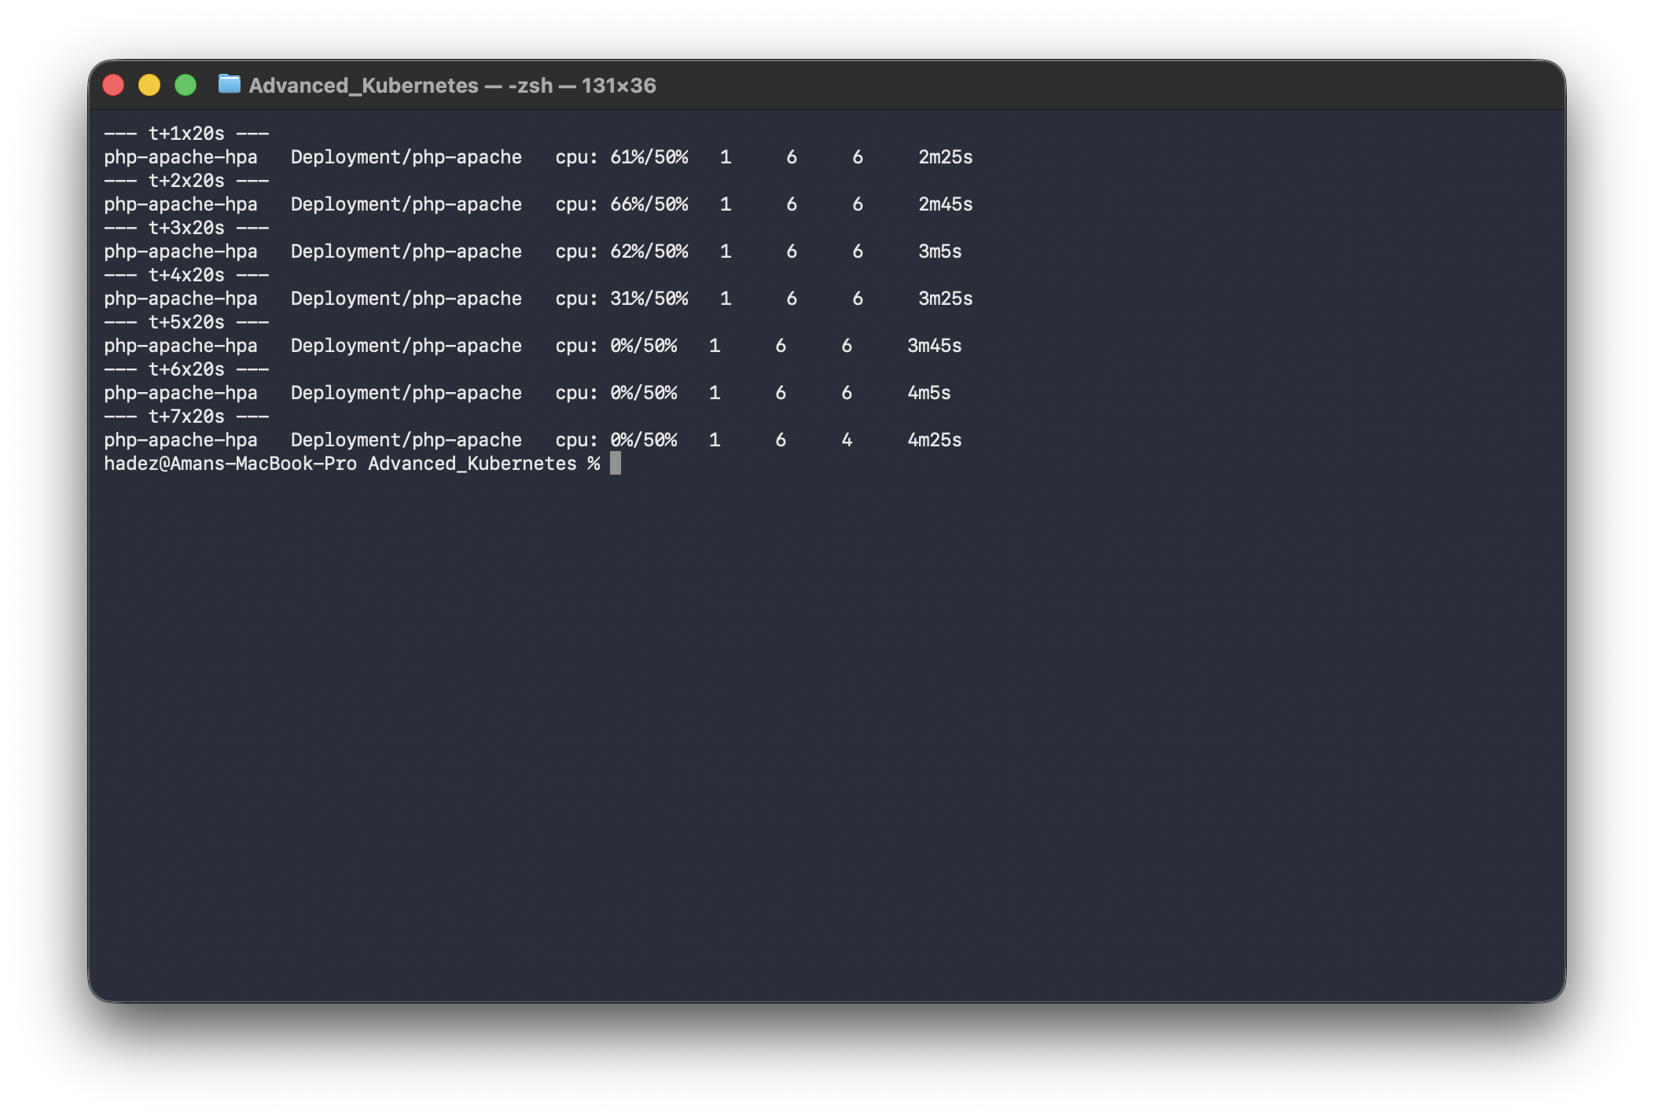
Time since load removed | CPU | Replicas
t+0s | 61%/50% | 6
t+20s | 0%/50% | 6 (inside the 60s window — no action despite 0% CPU)
t+80s | 0%/50% | 3 (window expired; −50% step)
t+100s | 0%/50% | 1 (second −50% step)
What this means: this asymmetry is the whole point. Scale-up is instant so users don't feel a spike; scale-down is deliberate so a momentary lull doesn't tear down capacity you'll need again seconds later. Full data: artifacts/lab-F/evidence/lab-F-advanced-hpa-behavior.txt.

Step 3 — VPA: right-size from real usage, then resize live
Goal: let the VPA recommend correct requests for an under-provisioned app, then apply them to a running Pod with no restart.
1. Deploy a deliberately under-provisioned app (asks for 100m CPU but burns a whole core) — on a separate Deployment from the HPA, so they don't fight:
kubectl apply -f - <<'EOF'
apiVersion: apps/v1
kind: Deployment
metadata: {name: vpa-demo}
spec:
replicas: 2
selector: {matchLabels: {app: vpa-demo}}
template:
metadata: {labels: {app: vpa-demo}}
spec:
containers:
- name: stress
image: polinux/stress
resources:
requests: {cpu: 100m, memory: 50Mi}
limits: {cpu: 200m, memory: 100Mi}
command: ["stress"]
args: ["--cpu", "1", "--timeout", "999999s"]
EOF
kubectl wait --for=condition=Available --timeout=90s deployment/vpa-demo
2. Install the VPA from the canonical in-tree chart:
git clone --depth 1 https://github.com/kubernetes/autoscaler.git /tmp/autoscaler-repo
helm install vpa /tmp/autoscaler-repo/vertical-pod-autoscaler/charts/vertical-pod-autoscaler -n kube-system
kubectl wait --for=condition=Ready pod -n kube-system -l app.kubernetes.io/instance=vpa --timeout=120s
⚠️ Gotcha — don't use hack/vpa-up.sh on a shallow clone. That other "official" installer fails with fatal: invalid reference: vertical-pod-autoscaler-1.7.1 on a --depth 1 clone, because it resolves an image tag from a git tag the shallow clone doesn't have. The in-repo Helm chart above avoids this.
3. Start in recommendation-only mode (updateMode: "Off" — observe, don't act):
kubectl apply -f - <<'EOF'
apiVersion: autoscaling.k8s.io/v1
kind: VerticalPodAutoscaler
metadata: {name: vpa-demo}
spec:
targetRef: {apiVersion: apps/v1, kind: Deployment, name: vpa-demo}
updatePolicy: {updateMode: "Off"}
EOF
# ...wait several minutes for it to build a usage history...
kubectl describe vpa vpa-demo
What you should see: a recommendation targeting roughly cpu=247m, memory=250Mi — about 2.5× the CPU and 5× the memory originally requested, derived purely from observed usage.
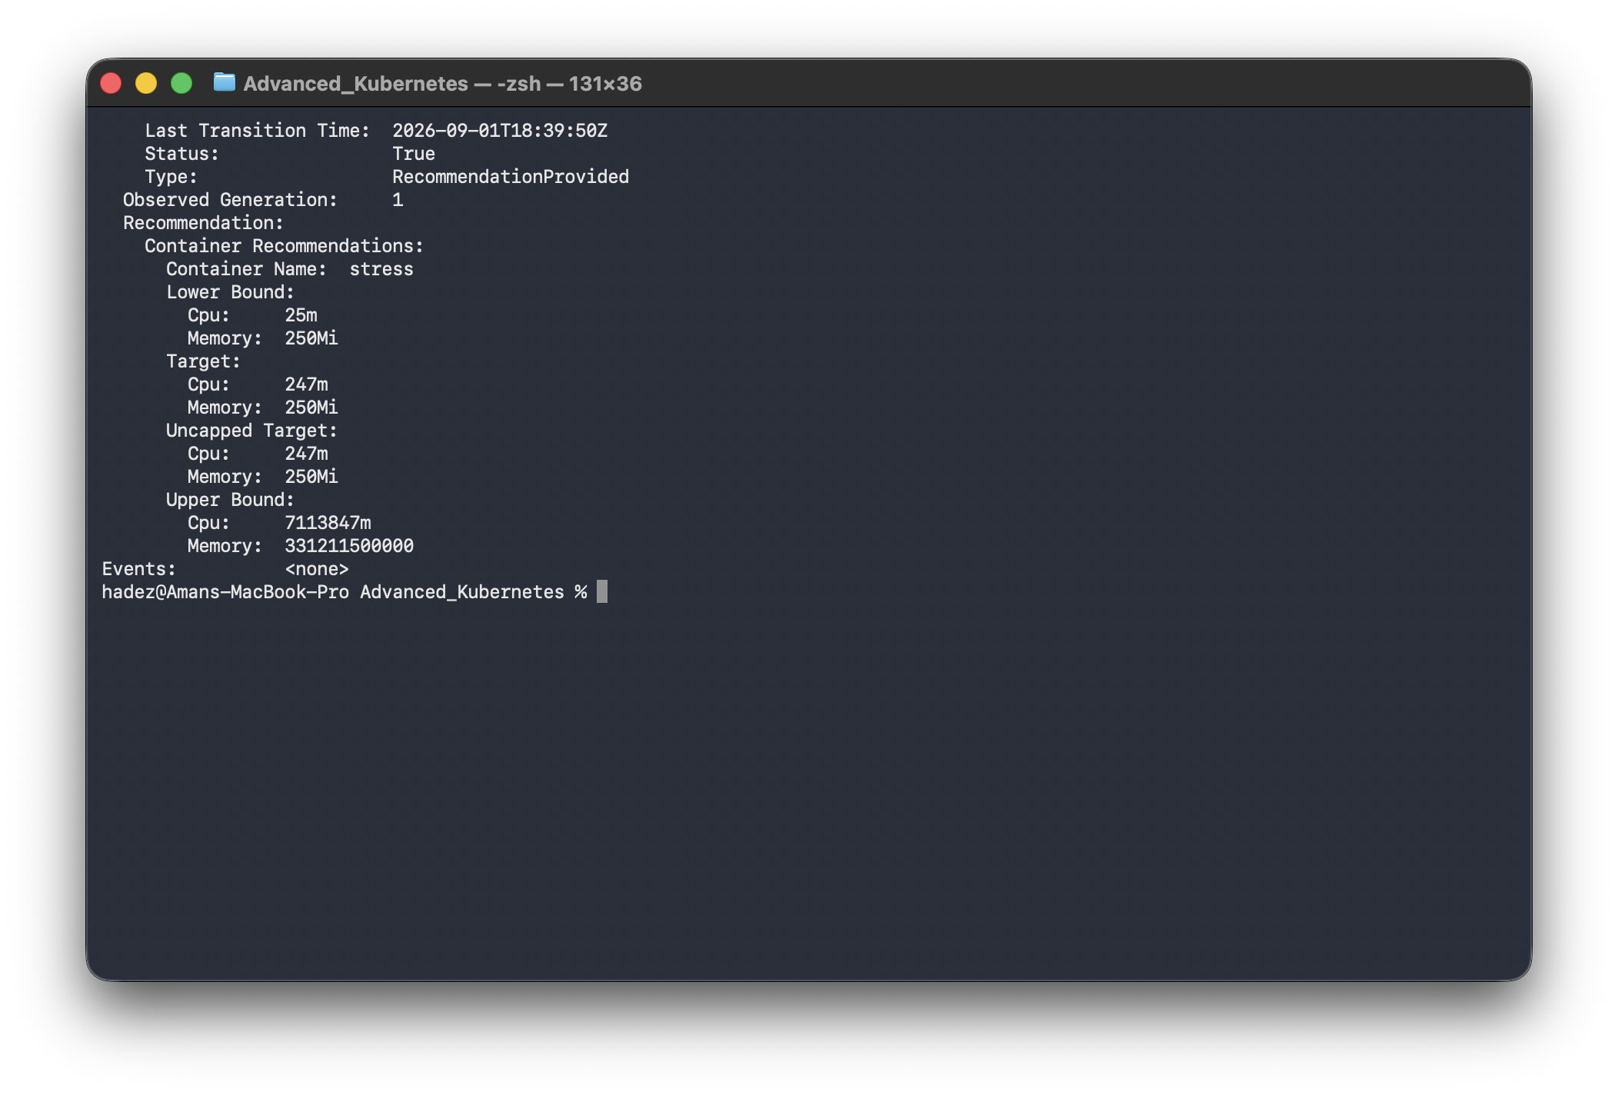
Recommendation:
Container Name: stress
Lower Bound: cpu=170m memory=250Mi
Target: cpu=247m memory=250Mi
Upper Bound: cpu=50460m memory=2349382352
4. Switch to InPlaceOrRecreate and watch a live resize. First record the before requests:
kubectl patch vpa vpa-demo --type=merge -p '{"spec":{"updatePolicy":{"updateMode":"InPlaceOrRecreate"}}}'
kubectl get pods -l app=vpa-demo -o jsonpath='{range .items[*]}{.metadata.name}{" "}{.spec.containers[0].resources.requests}{"\n"}{end}'
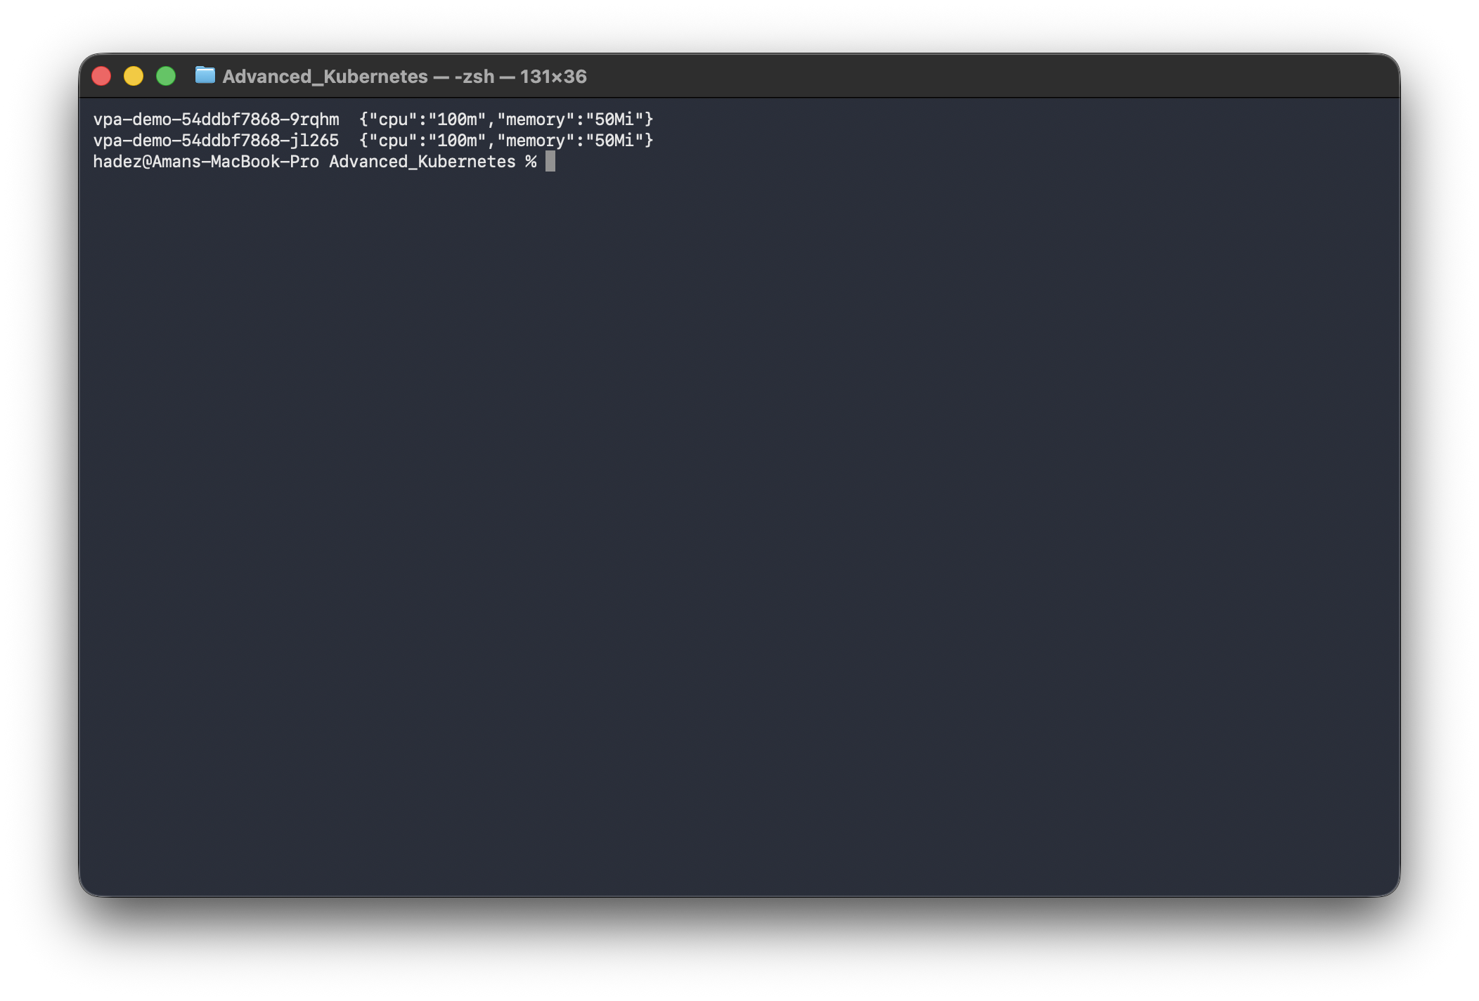
Wait ~1 minute for the updater's loop, then check again:
kubectl get pods -l app=vpa-demo
kubectl get pods -l app=vpa-demo -o jsonpath='{range .items[*]}{.metadata.name}{" "}{.spec.containers[0].resources.requests}{"\n"}{end}'
What you should see: the same Pod names, RESTARTS: 0, but requests now cpu=587m, memory=250Mi — the resources changed underneath live, running containers.
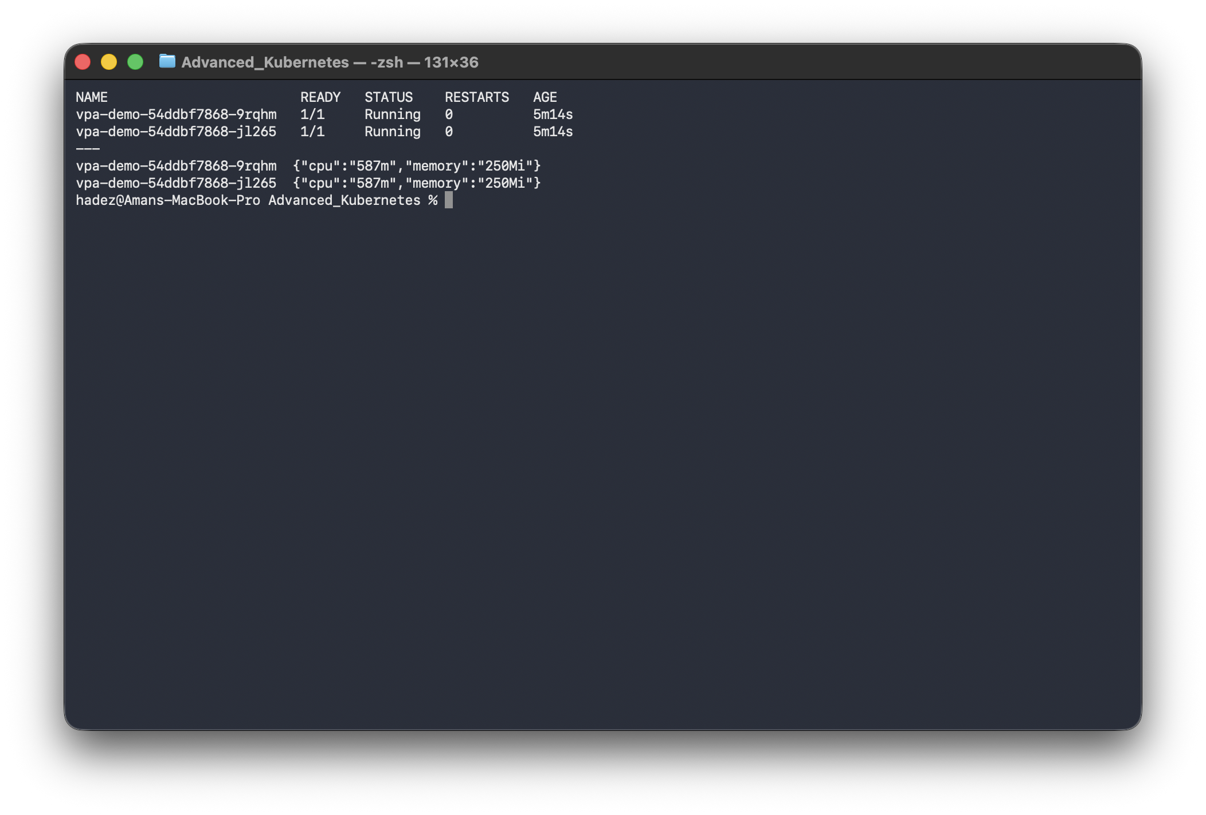
NAME READY STATUS RESTARTS AGE
vpa-demo-54ddbf7868-9rqhm 1/1 Running 0 5m14s
vpa-demo-54ddbf7868-jl265 1/1 Running 0 5m14s
# requests: {"cpu":"587m","memory":"250Mi"} (both pods)
What this means: InPlaceOrRecreate isn't a rename of the deprecated Auto mode — it uses the /resize subresource to change a running container's resources with zero disruption, only falling back to evict-and-recreate when a live resize isn't possible. (The applied 587m is higher than the earlier 247m target because the stress load kept running, so the recommender's target kept climbing — expected, not a discrepancy.) The updater log confirms In-place patched pod /resize subresource and an InPlaceResizedByVPA event. Full data: artifacts/lab-F/evidence/lab-F-vpa-recommendation.txt, artifacts/lab-F/evidence/lab-F-vpa-inplace-resize.txt.
5. (Optional) see the VPA object in a GUI — Headlamp → Configuration → VPAs shows the same object live:
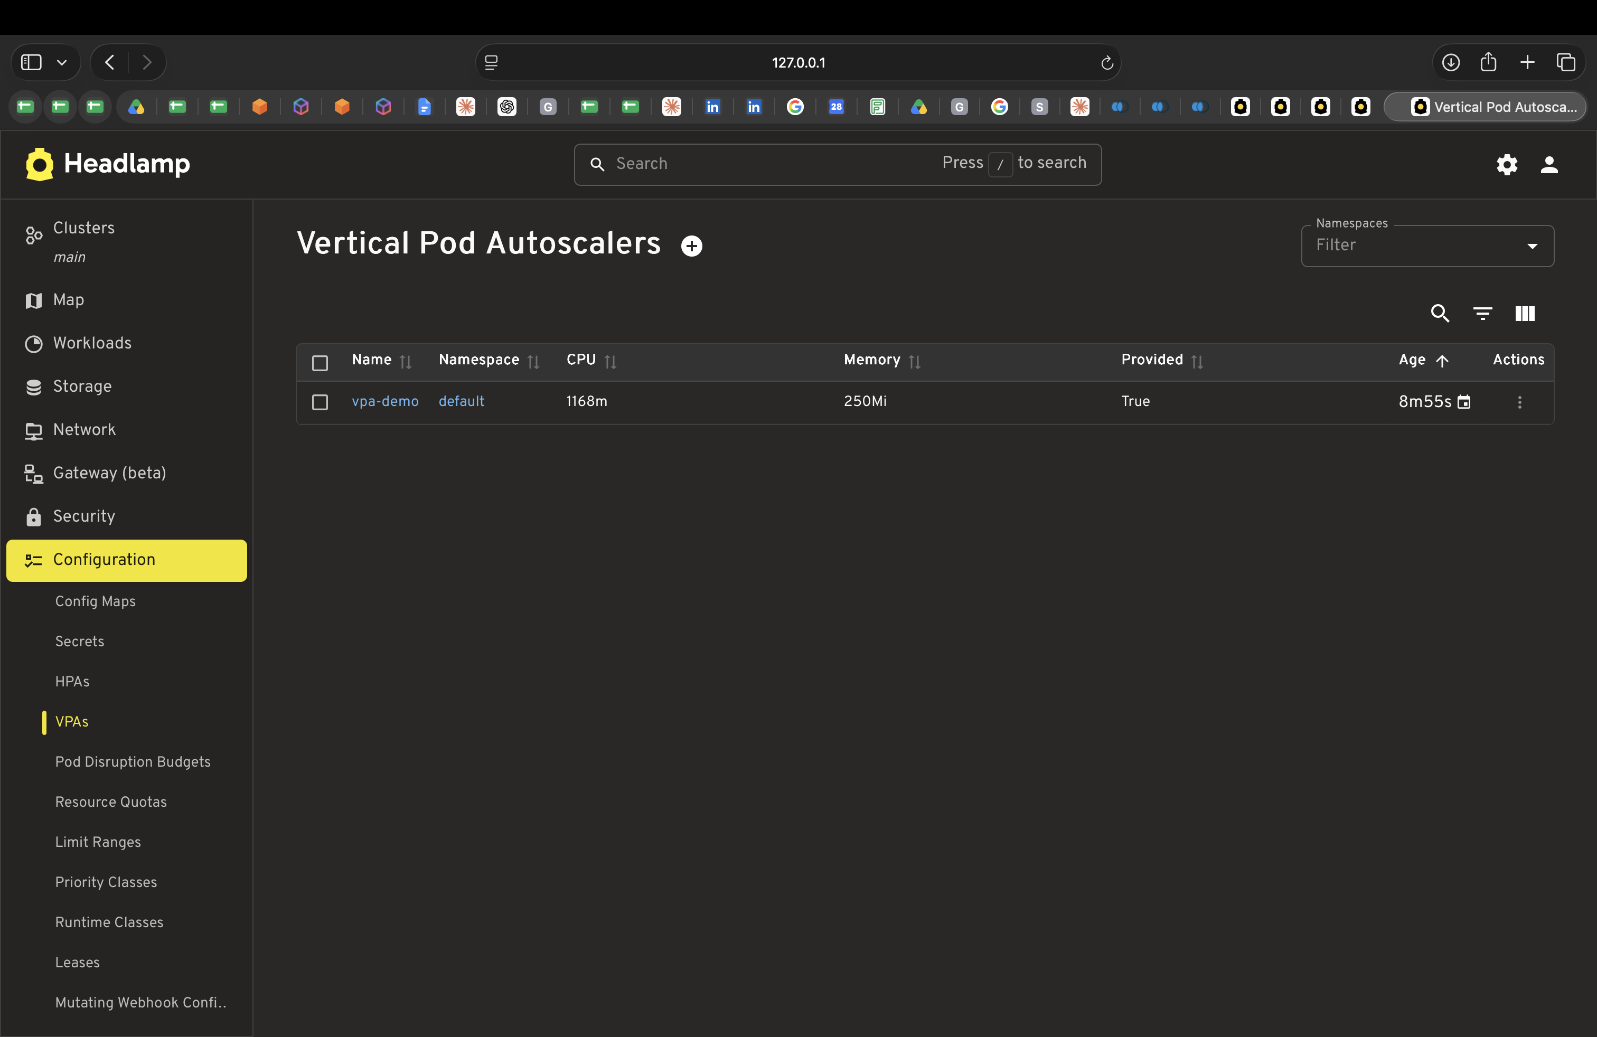

Step 4 — Clean up
kind delete cluster --name autoscale-lab
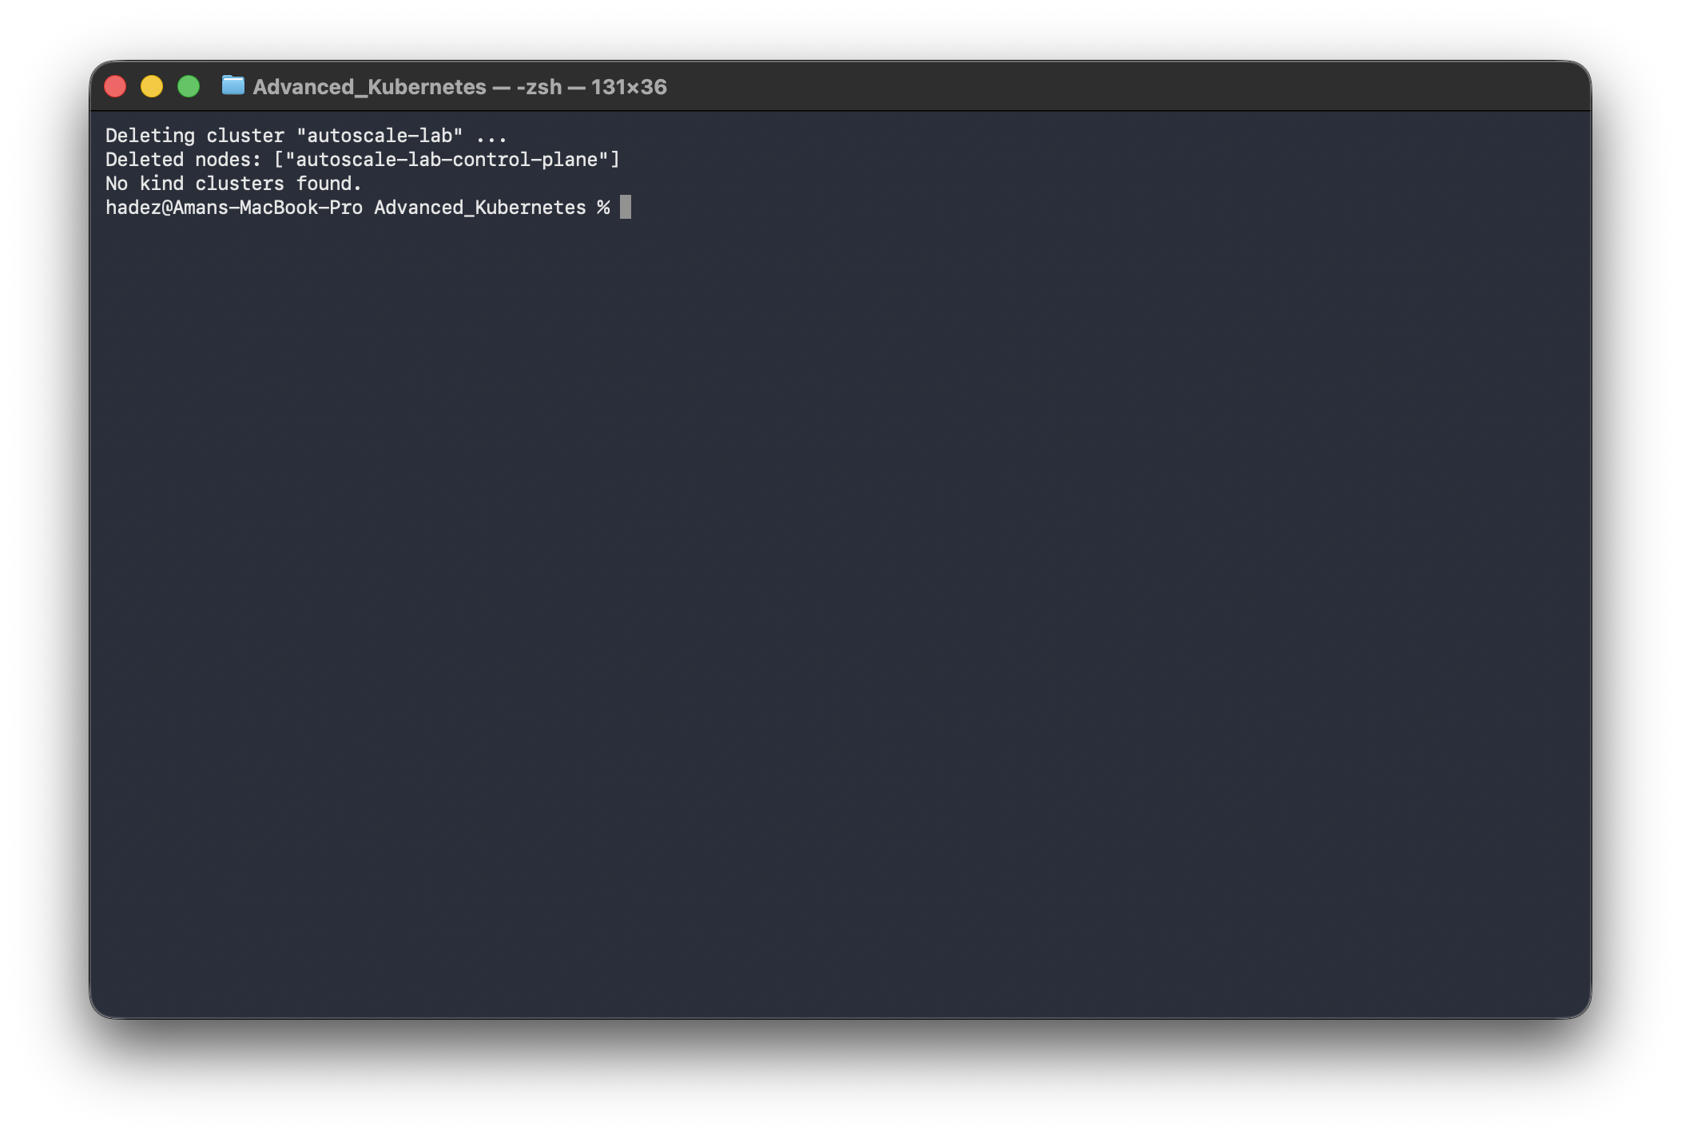

What you learned
You saw… | in Step | proof
HPA scale-up can be tuned fast and aggressive | 2 | 1 → 6 replicas in ~90s
HPA scale-down uses a stabilization window + steps | 2 | held 60s, then 6→3→1
VPA recommends right-sized requests from real usage | 3 | cpu 100m→247m, mem 50Mi→250Mi
VPA InPlaceOrRecreate resizes a live Pod, no restart | 3 | same pods, RESTARTS: 0, requests changed
HPA and VPA are kept on separate workloads | 3 | different Deployments, no metric conflict

Evidence
Real screenshots for this lab are in artifacts/lab-F/screenshots/ (8 images), and command transcripts are in artifacts/lab-F/evidence/.

Next: Lab 16 — Inference Autoscaling Signals

