Lab G — Chaos Engineering with Chaos Mesh
DataCouch — Advanced Kubernetes (Nutanix)
Table of Contents

Day 5 · Kubernetes as the AI-Native Platform
YES — Tested end-to-end on a real kind cluster. Every screenshot is a real capture — including a real, unplanned outage this experiment triggered that the original design didn't anticipate (Step 4). The payoff: you'll kill a Pod and watch Kubernetes heal it, then inject network latency and discover it can take a Service to zero healthy endpoints — a failure mode you'd never find by reading YAML.

What you'll learn
- How Chaos Mesh injects real faults (kill a Pod, add network latency) via CRDs and a per-node daemon — and auto-reverts them after a duration.
- How a PodChaos kill triggers Kubernetes' own self-healing.
- How a NetworkChaos delay, run for real, surfaces a hidden interaction: a readinessProbe timeout shorter than the injected delay knocks every replica out of readiness at once — and how the real client latency is roughly double the configured delay.

What you'll do
You'll deploy a 3-replica app, install Chaos Mesh, kill one Pod (and watch it return), then inject 2s of latency on all replicas — watch it cause an outage, diagnose it, fix the probe, and re-measure.

Time & cost
- Time: ~50 minutes.
- Cost: $0 — runs entirely on a local kind cluster.

Before you start
- Where you'll work: in a terminal on your own machine.
- Tools you need: docker, kind, kubectl, helm.
- Cluster: you'll create a fresh kind cluster in Step 1.
Nutanix note. Chaos Mesh is a CNCF project and platform-agnostic — identical on NKE. Chaos engineering matters most where you own the failure domains: on a Nutanix cluster you'd use exactly these experiments to validate that your on-prem apps survive node loss, network partitions, and slow dependencies before a real incident proves they don't. This lab is kind only because it needs no cloud features.

The idea in 60 seconds
Chaos Mesh installs CRDs (PodChaos, NetworkChaos, IOChaos, StressChaos…), a controller that watches them, and a per-node chaos-daemon that carries out the disruption at the container/kernel level (kill a process, inject tc netem latency rules, mount a faulty FS layer). You declare what to break and which Pods via a selector; Chaos Mesh does the mechanics. Every experiment has a duration and auto-reverts when it expires — so it's safe to run against something you care about.
The point isn't breaking things for fun: it's turning "we assume our timeout/retry config handles failure" into "we watched it handle a real, injected failure" — and sometimes finding the assumption was wrong in a way you never thought to check.
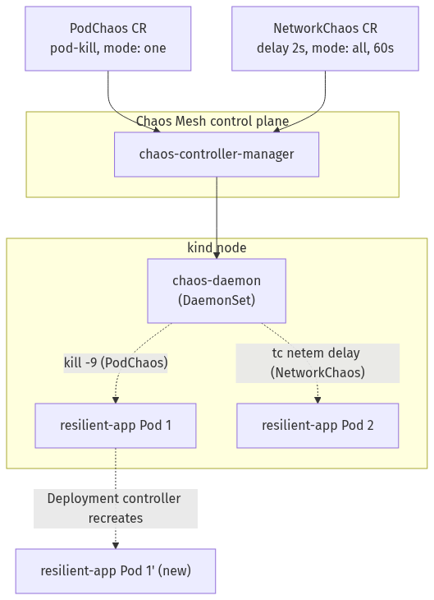

Step 1 — Create the cluster and a resilient target app
Goal: deploy a 3-replica app that has redundancy to lose.
kind create cluster --name chaos-lab
kubectl apply -f - <<'EOF'
apiVersion: apps/v1
kind: Deployment
metadata: {name: resilient-app}
spec:
replicas: 3
selector: {matchLabels: {app: resilient-app}}
template:
metadata: {labels: {app: resilient-app}}
spec:
containers:
- name: app
image: nginxinc/nginx-unprivileged:1.27-alpine
ports: [{containerPort: 8080}]
readinessProbe:
httpGet: {path: /, port: 8080}
periodSeconds: 2
EOF
kubectl expose deployment resilient-app --port=80 --target-port=8080
kubectl wait --for=condition=Available --timeout=120s deployment/resilient-app
What you should see: 3 resilient-app Pods, all ready.
What this means: 3 replicas (not 1) so self-healing has something to operate on. Note the readinessProbe uses Kubernetes' default timeoutSeconds: 1 (not set explicitly) — that default becomes the whole story in Step 4.

Step 2 — Install Chaos Mesh
Goal: get the controller and node daemon running.
helm repo add chaos-mesh https://charts.chaos-mesh.org
helm repo update
helm install chaos-mesh chaos-mesh/chaos-mesh -n chaos-mesh --create-namespace \
--set chaosDaemon.runtime=containerd \
--set chaosDaemon.socketPath=/run/containerd/containerd.sock
kubectl wait --for=condition=Available --timeout=120s -n chaos-mesh deployment/chaos-controller-manager
kubectl get pods -n chaos-mesh
What you should see: every Chaos Mesh component Running — chaos-controller-manager (3 replicas), a chaos-daemon (one per node), chaos-dashboard, and chaos-dns-server.
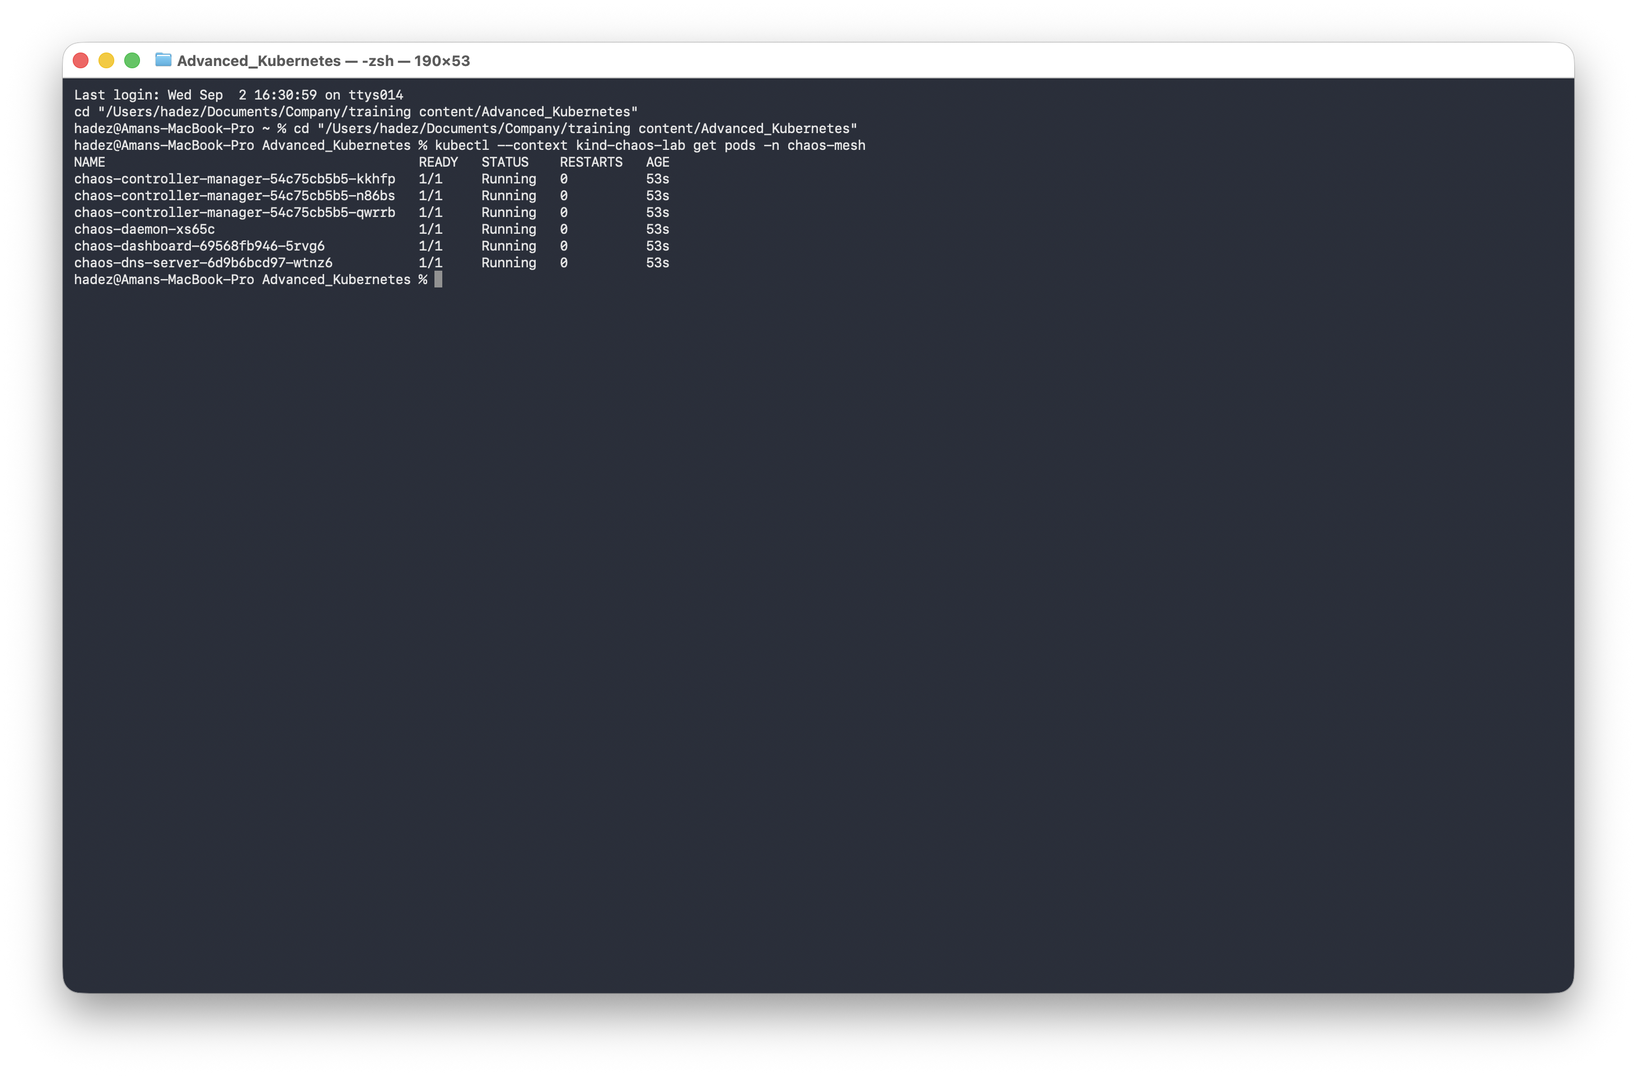
What this means: chaosDaemon.runtime=containerd matters for kind specifically — its nodes run containerd, and the daemon must talk to the right socket to control the correct processes.

Step 3 — PodChaos: kill a Pod, watch it come back
Goal: inject a real Pod kill and watch Kubernetes reconcile.
kubectl get pods -l app=resilient-app
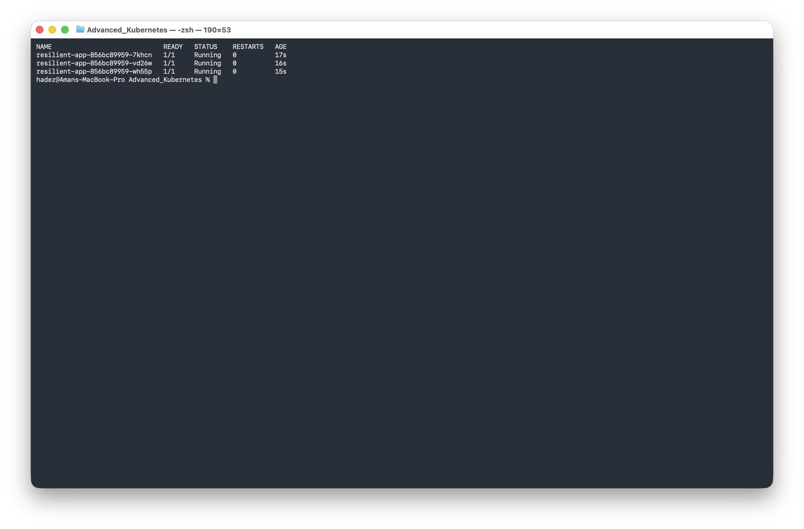
kubectl apply -f - <<'EOF'
apiVersion: chaos-mesh.org/v1alpha1
kind: PodChaos
metadata: {name: kill-one-pod}
spec:
action: pod-kill
mode: one
selector:
labelSelectors: {app: resilient-app}
EOF
kubectl get pods -l app=resilient-app
What you should see: one Pod (e.g. -7khcn) is gone; the other two are the same Pods, just older; and a brand-new Pod (e.g. -wtt5t) has appeared in its place.
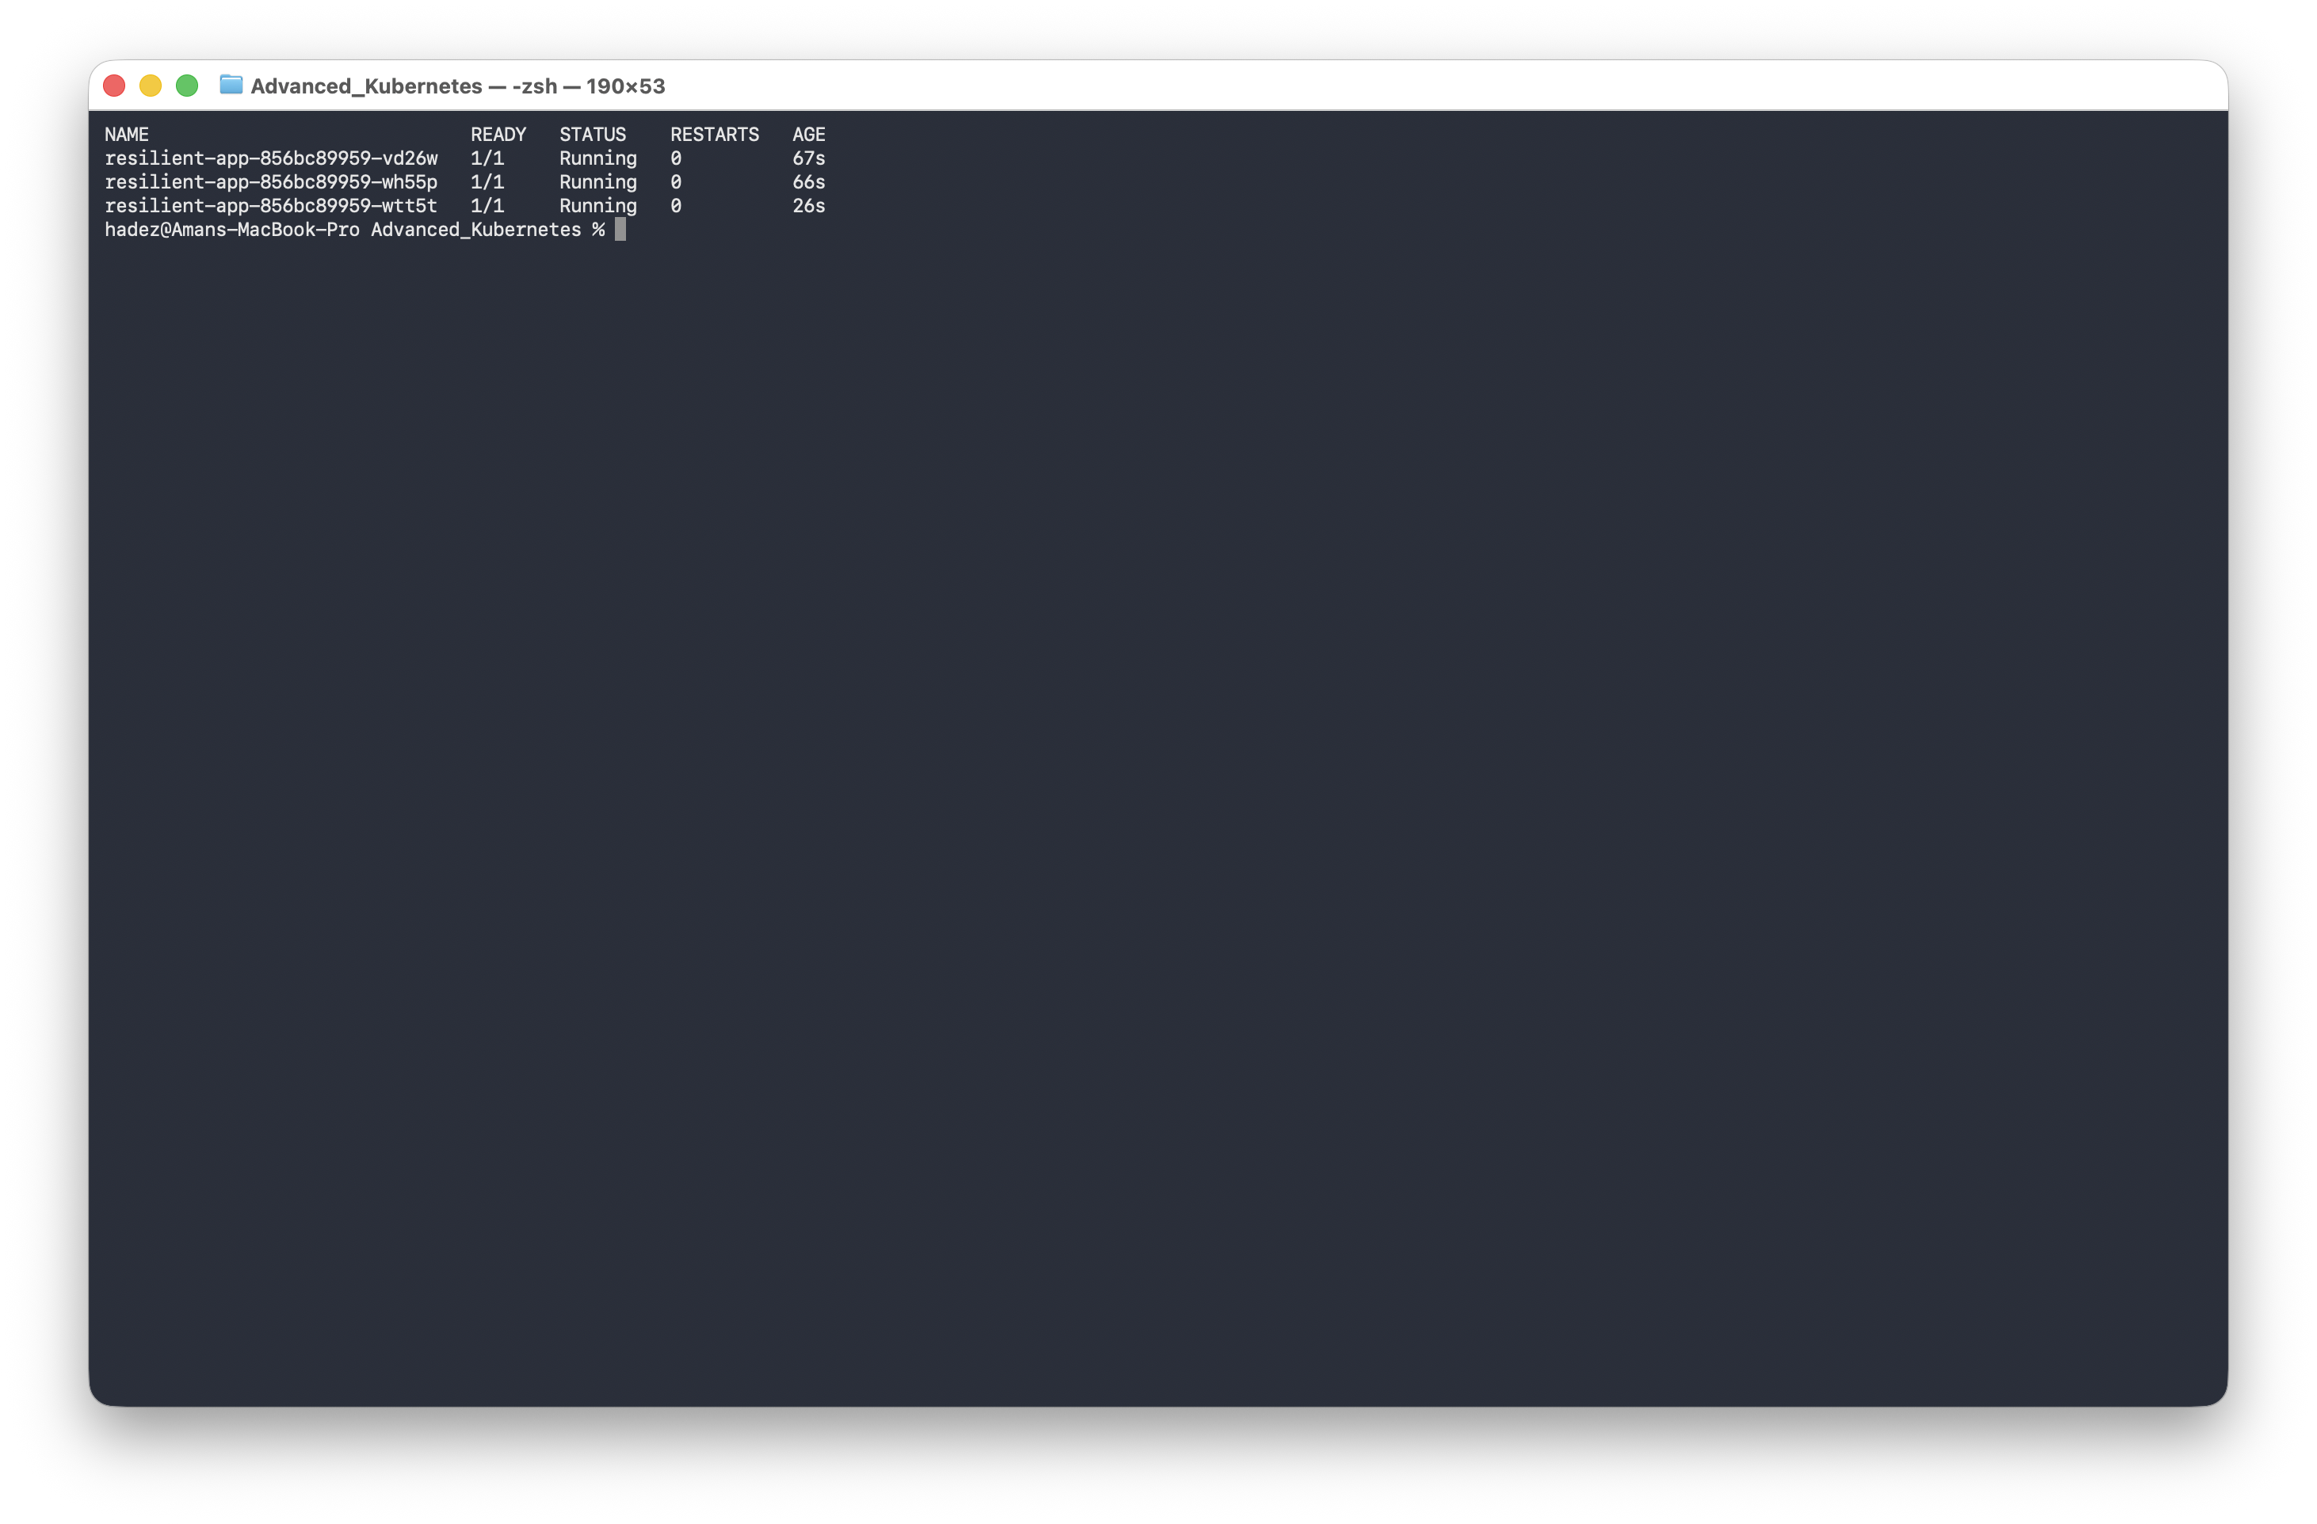
What this means: mode: one kills exactly one matching Pod (a realistic single-instance failure). The recovery is plain Kubernetes reconciliation — the Deployment controller replaces the killed Pod with zero help from Chaos Mesh past the initial kill. action: pod-kill is one-shot, so no duration is needed.

Step 4 — NetworkChaos: inject latency, and find a real outage
Goal: inject 2s of latency on every replica and observe the client's experience — which turns out to be worse than "slow."
kubectl apply -f - <<'EOF'
apiVersion: chaos-mesh.org/v1alpha1
kind: NetworkChaos
metadata: {name: add-latency}
spec:
action: delay
mode: all
selector:
labelSelectors: {app: resilient-app}
delay: {latency: "2s", jitter: "200ms"}
duration: "60s"
EOF
kubectl describe pod -l app=resilient-app | grep -A2 Unhealthy
What you should see: instead of "slow but working," the readinessProbe starts failing on all three Pods at once — context deadline exceeded — because a 2-second-delayed probe response can't land inside the default 1-second timeout. The Service's endpoints drop to zero ready backends for stretches of the window; a client gets connection refused.
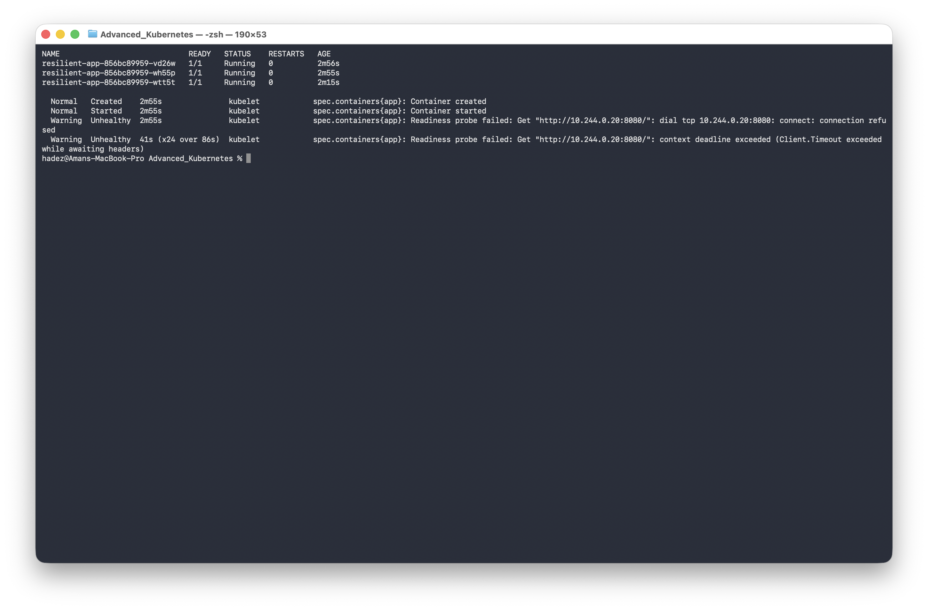
⚠️ Gotcha — NetworkChaos didn't slow the app down, it took it offline. With mode: all delaying every replica and the probe on the default timeoutSeconds: 1, all three Pods failed readiness simultaneously — no healthy replica to fall back on. This is materially worse than "added latency," and it's exactly what chaos engineering exists to surface: nobody sets timeoutSeconds: 1 thinking about network chaos, until something like this makes them.
The fix — raise the probe timeout above the injected delay, live:
kubectl patch deployment resilient-app --type=json -p='[
{"op":"add","path":"/spec/template/spec/containers/0/readinessProbe/timeoutSeconds","value":5}
]'
kubectl rollout status deployment/resilient-app
Re-run the same experiment and measure real client latency:
kubectl apply -f - <<'EOF'
apiVersion: chaos-mesh.org/v1alpha1
kind: NetworkChaos
metadata: {name: add-latency}
spec:
action: delay
mode: all
selector: {labelSelectors: {app: resilient-app}}
delay: {latency: "2s", jitter: "200ms"}
duration: "60s"
EOF
kubectl run curl-test --image=curlimages/curl --rm -i --restart=Never -- \
curl -s -o /dev/null -w "Total time: %{time_total}s\n" http://resilient-app.default.svc --max-time 10
What you should see: all three Pods stay 1/1 Running under the same chaos (the probe fix worked), and the measured latency is ~4.2s — nearly double the configured 2s.
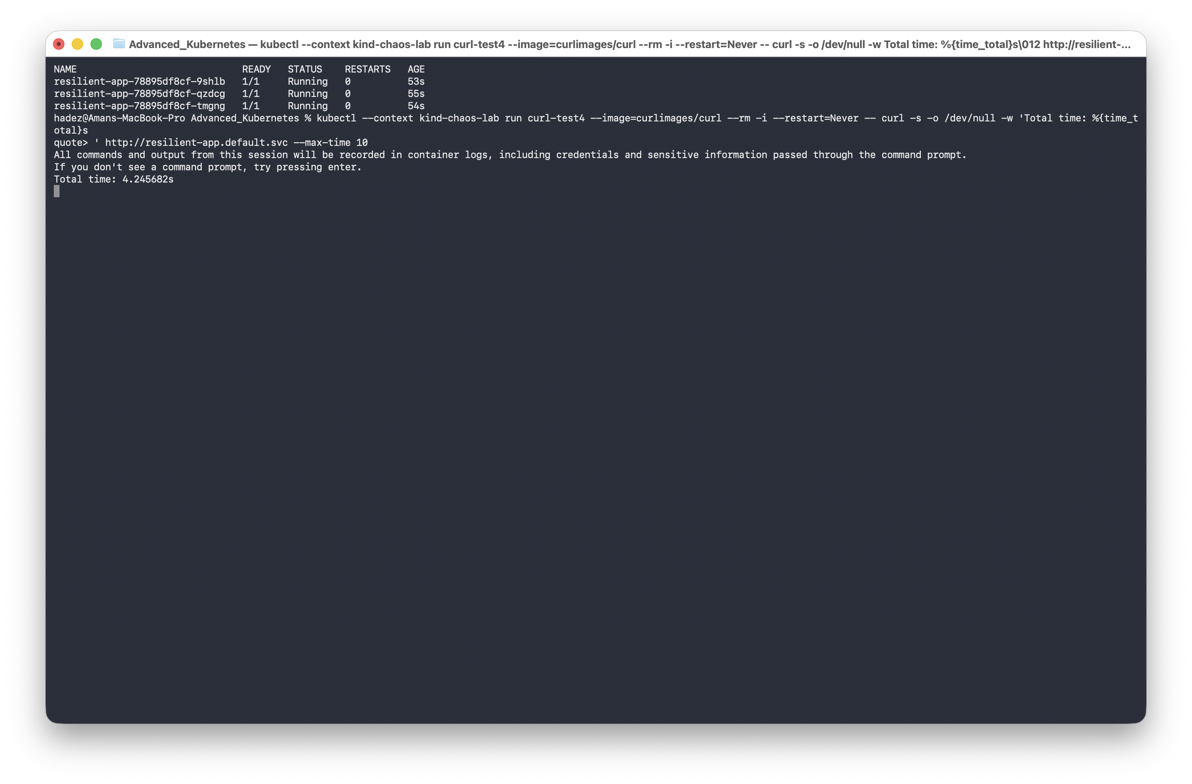
⚠️ Gotcha — the real latency was ~4s, not ~2s. tc netem delay applies per packet, not per request. One HTTP request over a fresh connection eats the delay on the TCP handshake and again on the request/response — two delayed round trips, so ~2s configured shows as ~4s observed. Size any perTryTimeout or SLO budget against the measured ~4s, not the YAML's 2s.
What this means: chaos engineering turned two theoretical assumptions ("our probe is fine", "2s delay = 2s latency") into two proven, surprising facts. That's the entire value: making resilience config provable instead of assumed.

Step 5 — Clean up
kubectl delete podchaos kill-one-pod --ignore-not-found
kubectl delete networkchaos add-latency --ignore-not-found
kind delete cluster --name chaos-lab
(Experiments also auto-revert at the end of their duration — no manual cleanup needed mid-experiment.)

What you learned
You saw… | in Step | proof
PodChaos kills a real Pod; the Deployment controller replaces it | 3 | -7khcn gone, -wtt5t new; other two untouched
NetworkChaos + a too-short probe timeout took the Service to zero endpoints | 4 | all pods Unhealthy, context deadline exceeded
Raising readinessProbe.timeoutSeconds restores service under the same chaos | 4 | all 3 Pods stay 1/1 Running
tc netem latency is per-packet: ~2s configured → ~4s observed | 4 | Total time: 4.245682s

Evidence
Real screenshots for this lab are in artifacts/lab-G/screenshots/ (5 images).

Next: Lab 17 — Guardrailed Agentic Kubernetes

