Lab 1 — Environment Setup & First Terraform Project
DataCouch — Intermediate Terraform
Table of Contents

Maps to: Setting up Learning Environments; Terraform Project (files, HCL, types, resources, commands, terraform init) Duration: ~45 minutes Status: Tested end-to-end on 2026-09-05 (macOS Darwin 25.5.0, Terraform v1.15.7, AWS provider v6.63.0) against a live AWS account in us-east-1. Every command output, instance ID, timing and error message in this document came from a real run.
Prerequisite: 00-shared-setup.md completed.

1. Lab Overview & Objectives
You are going to write one file, run three commands, and end up with a real EC2 instance running in your AWS account — one you can find in the console, ping from the CLI, and destroy again in thirty seconds.
That is deliberately a small amount of infrastructure. The point of this lab is not the instance; it is the loop: config → init → plan → apply → state → destroy. Every other lab in this course is that same loop with more interesting things inside it. If the loop is not solid here, nothing later will be.
Learning objectives — by the end of this lab you will be able to:
- Write a minimal but correct Terraform project: a terraform block with pinned provider constraints, a provider block, a resource, and outputs.
- Explain what each of init, plan and apply actually does — specifically, which of them talk to AWS and which do not.
- Read an execution plan, including what (known after apply) means and why almost every attribute shows it on a first run.
- Prove from outside Terraform that the resource is real, and prove from inside Terraform that your configuration and reality still agree.
The most surprising measured result in this lab: the validation suite at §5 has six checks. After someone added a single tag to the instance through the AWS console, five of the six still passed — the instance was still running, still correctly named, still had a valid public IP. Only the sixth check, terraform plan -detailed-exitcode, caught it. "The apply succeeded" and "the infrastructure matches the configuration" are different claims, and only one of them is worth anything the day after.

2. Prerequisites & Environment Setup

2.1 Software
Requirement | Tested with
Terraform CLI | v1.15.7 (darwin_arm64)
AWS CLI v2 | 2.35.11
AWS credentials | valid, with EC2 create/describe/terminate rights

2.2 Region
Every command in this lab assumes us-east-1. Export it before you start:
export AWS_REGION=us-east-1
export AWS_DEFAULT_REGION=us-east-1

2.3 Cost and time
Resources created | 1 × t3.micro EC2 instance
Measured price | $0.0104 per instance-hour (AWS Pricing API, us-east-1, 2026-09-05)
Measured create time | 18 seconds
Measured destroy time | 22–32 seconds across three runs
Realistic cost of this lab | under $0.02 if you destroy at the end
Hands-on time | ~45 minutes
The instance is not free-tier-guaranteed — t3.micro is free-tier eligible only for the first 12 months of a new account, and only up to 750 hours/month. Assume you are paying, and destroy.

2.4 Create the working directory
mkdir -p ~/terraform-course/lab-1-first-project && cd ~/terraform-course/lab-1-first-project

3. Architecture
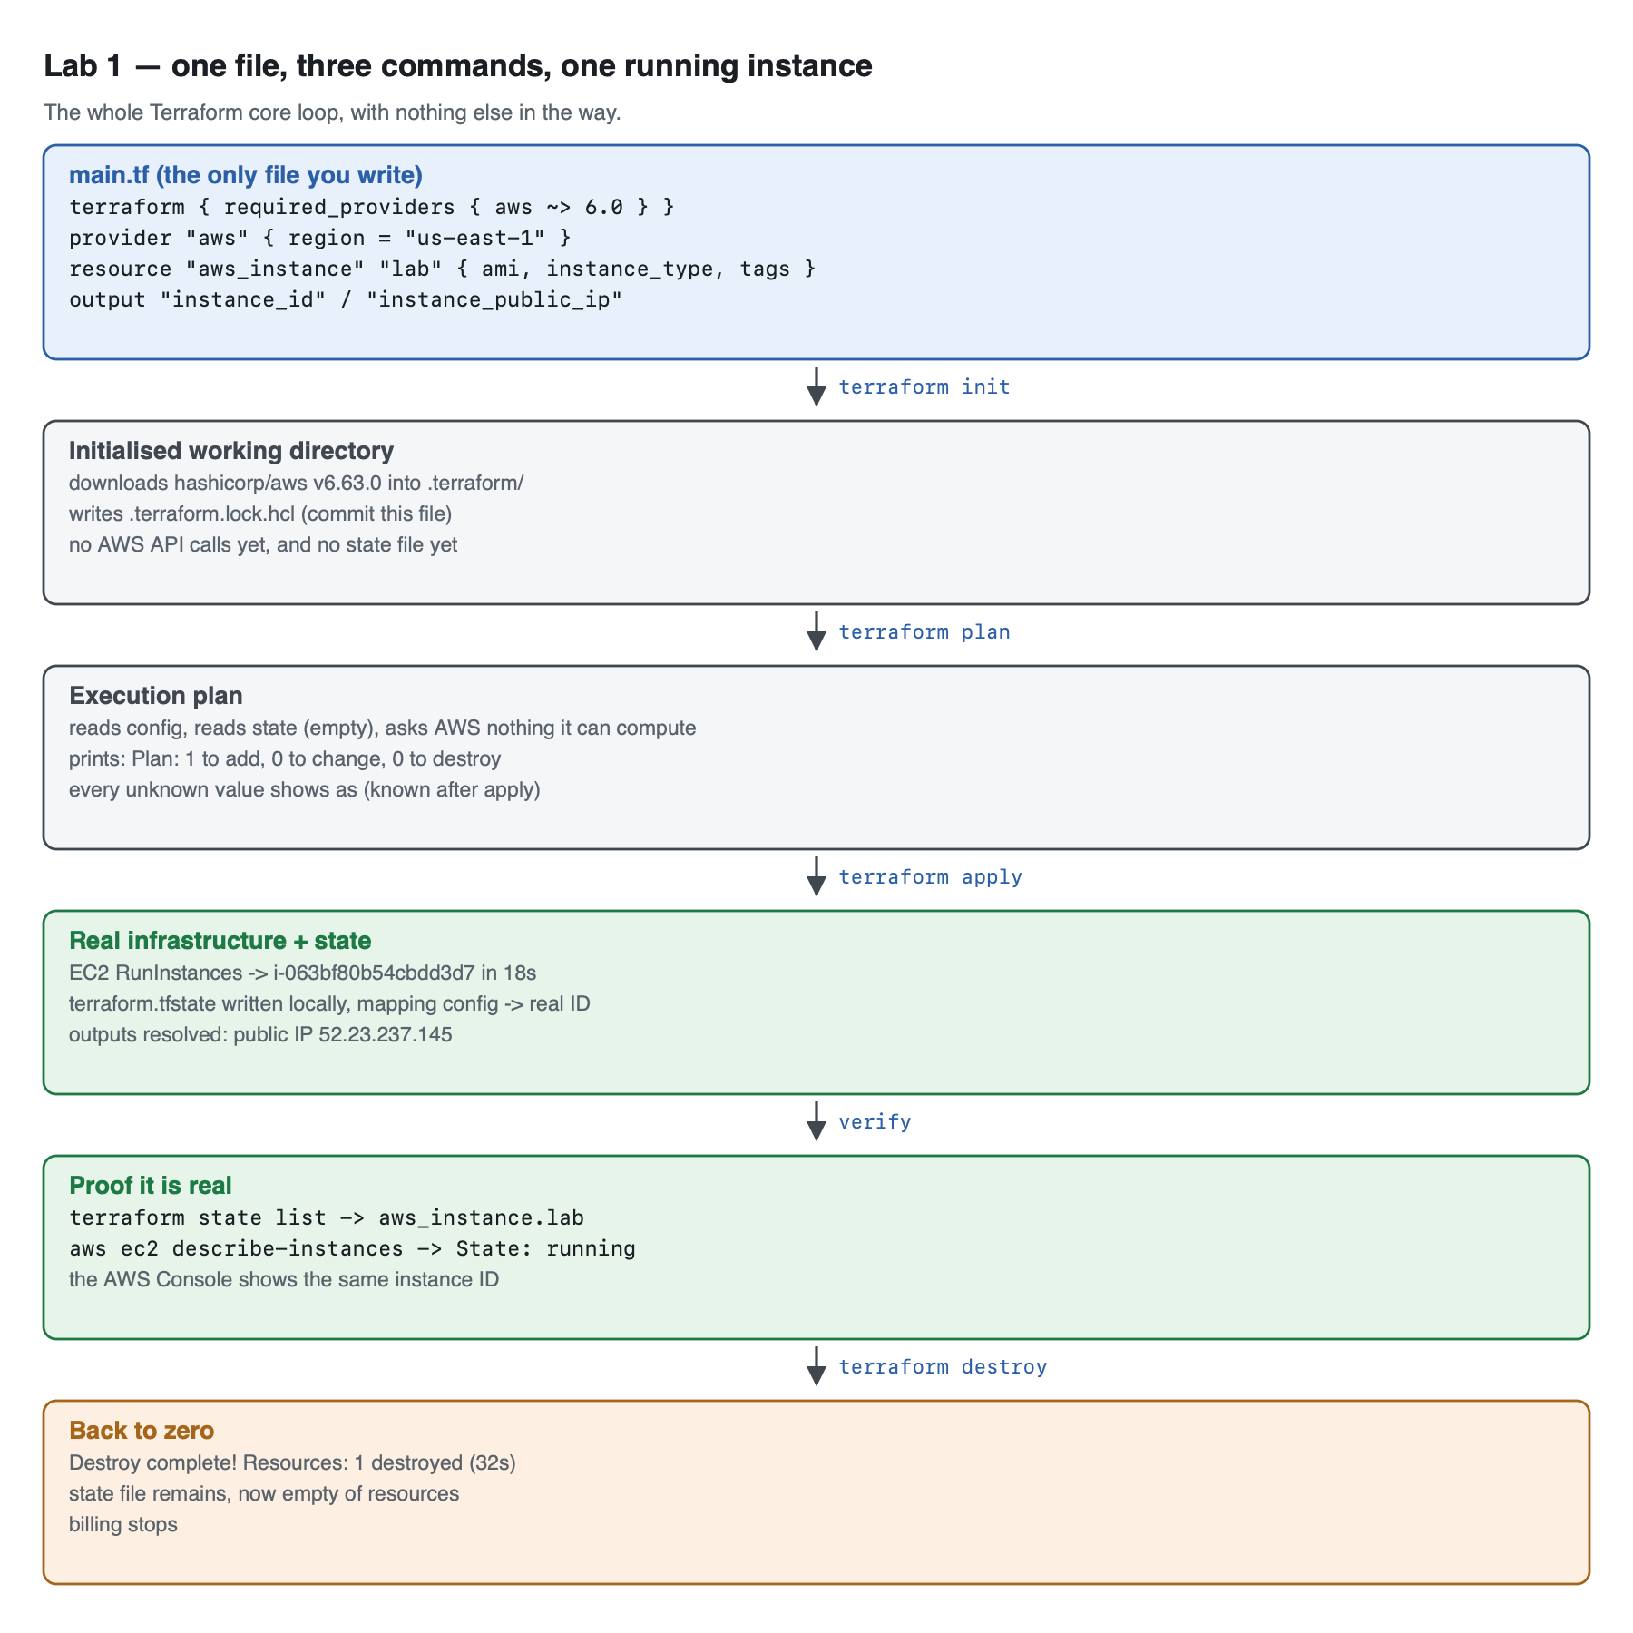
Vector version: lab-1-architecture.svg
The same flow, linear, if you prefer it in text:
main.tf ← the only file you write
terraform { required_providers { aws ~> 6.0 } }
provider "aws" { region = "us-east-1" }
resource "aws_instance" "lab" { ami, instance_type, tags }
output instance_id, instance_public_ip
│
├── terraform init ──────► .terraform/ (provider binary,
│ .terraform.lock.hcl downloaded)
│ NO AWS calls, NO state yet
│
├── terraform plan ──────► "Plan: 1 to add, 0 to change, 0 to destroy"
│ reads config + state; nothing is created
│
├── terraform apply ─────► EC2 RunInstances ───► i-09b4c73740225e37c (18s)
│ terraform.tfstate ───► config ↔ real-ID map
│ outputs ───► 54.145.168.39
│
├── verification
│ inside Terraform: terraform state list → aws_instance.lab
│ outside Terraform: aws ec2 describe-instances → State: running
│ agreement: terraform plan -detailed-exitcode → exit 0
│
└── terraform destroy ───► "Resources: 1 destroyed" (22s), billing stops
Three things worth understanding before you run anything:
- init makes no AWS calls. It resolves and downloads the provider plugin and writes a lock file. You can run it with no credentials at all. People frequently believe init "connects to AWS"; it does not, which is why a credentials problem does not surface until plan.
- plan creates nothing, but it is not free of side effects on your understanding of state. It reads your config and your state, and refreshes state from AWS. On a first run there is no state, so almost everything is (known after apply).
- State is the whole trick. terraform.tfstate is the map from aws_instance.lab (your name) to i-09b4c73740225e37c (AWS's name). Delete it and Terraform forgets it owns the instance — the instance keeps running and keeps billing. That is Lab 3's subject.

4. Step-by-Step Instructions

Step 1 — Write main.tf
Why: Terraform has no project scaffolding command — no terraform new. A project is simply a directory containing .tf files, and Terraform loads all of them and treats them as one merged configuration. Filenames are a convention for humans, not a rule. We start with everything in one file so nothing is hidden, and split it up in Lab 2.
cat > main.tf << 'EOF'
terraform {
required_version = ">= 1.5.0"
required_providers {
aws = {
source = "hashicorp/aws"
version = "~> 6.0"
}
}
}
provider "aws" {
region = "us-east-1"
}
resource "aws_instance" "lab" {
ami = "ami-081b0a6eac00b4f53" # Amazon Linux 2023, us-east-1
instance_type = "t3.micro"
tags = {
Name = "tf-lab1-first-instance"
Lab = "1"
Course = "intermediate-terraform"
}
}
output "instance_id" {
description = "The EC2 instance ID Terraform created."
value = aws_instance.lab.id
}
output "instance_public_ip" {
description = "Public IPv4 address assigned to the instance."
value = aws_instance.lab.public_ip
}
EOF
Read what you just wrote, block by block:
Block | What it is | Why it is here
terraform { required_version } | settings for Terraform itself | fails fast on an old CLI instead of throwing a confusing syntax error
required_providers | which plugins, from where, at what version | ~> 6.0 means "≥ 6.0, < 7.0" — you get patches and features, never a breaking major
provider "aws" | configuration for one plugin | region here; credentials come from the environment, never from this file
resource "aws_instance" "lab" | one real thing to create | aws_instance is the type (fixed by the provider), lab is the local name (yours)
output | a value to surface after apply | how you get data out of Terraform and into your terminal or another module
Never put credentials in the provider block. It accepts access_key and secret_key arguments, and every leaked-secrets incident involving Terraform starts with someone using them. The provider reads the same environment variables and ~/.aws/credentials file the AWS CLI does.
The hardcoded AMI is a deliberate flaw. ami-081b0a6eac00b4f53 is Amazon Linux 2023 in us-east-1 on 2026-09-05. AMI IDs are region-specific and change whenever AWS publishes a new image. This config is therefore already slightly wrong, and will be more wrong next month. Lab 2 fixes it properly with a data source. Notice the problem now so the fix means something.

Step 2 — terraform init
Why: Terraform ships with no providers built in. init reads required_providers, resolves a version that satisfies your constraint, downloads it, and records the exact version and checksums in a lock file so that everyone on your team gets the identical plugin.
terraform init
Expected output (real, from the authoring run):
Initializing provider plugins found in the configuration...
- Finding hashicorp/aws versions matching "~> 6.0"...
- Installing hashicorp/aws v6.63.0...
- Installed hashicorp/aws v6.63.0 (signed by HashiCorp)
Initializing the backend...
Terraform has created a lock file .terraform.lock.hcl to record the provider
selections it made above. Include this file in your version control repository
so that Terraform can guarantee to make the same selections by default when
you run "terraform init" in the future.
Terraform has been successfully initialized!
Look at what appeared:
ls -la
- .terraform/ — the downloaded provider binary. Large, machine-specific, git-ignore it.
- .terraform.lock.hcl — the resolved version and its checksums. Small, portable, commit it.
Tested detail: the constraint ~> 6.0 resolved to v6.63.0 on 2026-09-05. Yours may resolve higher — that is the constraint working as designed. If you want the exact provider this lab was tested with, the lock file is how you'd pin it, not the version constraint.
init needs no AWS credentials. Prove it to yourself if you like: rm -rf .terraform && env -u AWS_ACCESS_KEY_ID -u AWS_PROFILE terraform init still succeeds. It is a package-manager step, not a cloud step.

Step 3 — terraform plan
Why: plan is the safety mechanism that distinguishes Terraform from a shell script. It computes the difference between what you declared, what it has recorded in state, and what exists in AWS — and shows you the result before anything changes. In a real team this output is what gets reviewed in a pull request.
terraform plan
Expected output — abridged from the real run; the full capture is in artifacts/lab-1/output/02-plan.txt:
Terraform used the selected providers to generate the following execution
plan. Resource actions are indicated with the following symbols:
+ create
Terraform will perform the following actions:
# aws_instance.lab will be created
+ resource "aws_instance" "lab" {
+ ami = "ami-081b0a6eac00b4f53"
+ arn = (known after apply)
+ associate_public_ip_address = (known after apply)
+ availability_zone = (known after apply)
+ id = (known after apply)
+ instance_state = (known after apply)
+ instance_type = "t3.micro"
+ private_ip = (known after apply)
+ public_ip = (known after apply)
+ region = "us-east-1"
+ subnet_id = (known after apply)
+ tags = {
+ "Course" = "intermediate-terraform"
+ "Lab" = "1"
+ "Name" = "tf-lab1-first-instance"
}
...
}
Plan: 1 to add, 0 to change, 0 to destroy.
Changes to Outputs:
+ instance_id = (known after apply)
+ instance_public_ip = (known after apply)
─────────────────────────────────────────────────────────────────────────────
Note: You didn't use the -out option to save this plan, so Terraform can't
guarantee to take exactly these actions if you run "terraform apply" now.
Read the plan properly — this is the skill:
- Plan: 1 to add, 0 to change, 0 to destroy. is the line to read first, and in a real change, the only number that matters is to destroy. Train yourself now.
- (known after apply) means "AWS decides this, not you". You did not choose the instance ID, the AZ, the subnet or the public IP, so Terraform cannot show them yet. On a first apply, most attributes look like this. It is not a warning.
- + region = "us-east-1" appearing as a resource attribute is new in AWS provider v6 — every resource now carries a region argument that defaults to the provider's. In v5 and earlier this line does not appear. If you are following an older tutorial, this is why your output has an extra line.
- The closing Note: is telling you this plan is advisory. terraform apply will recompute it. To guarantee that what you reviewed is exactly what runs, use terraform plan -out=tfplan then terraform apply tfplan — which is what CI pipelines do.
Nothing has been created. Confirm it:
ls terraform.tfstate 2>&1
Expected output: ls: terraform.tfstate: No such file or directory — plan writes no state.

Step 4 — terraform apply
Why: This is the step that costs money and creates something you must remember to remove. Everything before it was rehearsal.
terraform apply
Terraform re-prints the plan and stops for confirmation. Type yes.
Expected output (tail of the real run):
Plan: 1 to add, 0 to change, 0 to destroy.
Changes to Outputs:
+ instance_id = (known after apply)
+ instance_public_ip = (known after apply)
aws_instance.lab: Creating...
aws_instance.lab: Still creating... [00m10s elapsed]
aws_instance.lab: Creation complete after 18s [id=i-063bf80b54cbdd3d7]
Apply complete! Resources: 1 added, 0 changed, 0 destroyed.
Outputs:
instance_id = "i-063bf80b54cbdd3d7"
instance_public_ip = "52.23.237.145"
Your instance ID and IP will differ. That is the point — those are the values AWS chose, which is exactly why they were (known after apply) a moment ago.
Measured create time in the authoring run: 18 seconds.
The -auto-approve flag skips the confirmation prompt. It is correct in CI and a bad habit at a terminal. This document uses it only because the authoring runs were scripted.

Step 5 — Prove it is real, from both sides
Why: A green "Apply complete!" tells you the API call returned 200. It does not tell you the instance is running, or that AWS recorded what you asked for. Verify from inside Terraform and from outside it — those are genuinely different questions.
From inside Terraform:
terraform state list
terraform output
Expected output:
aws_instance.lab
instance_id = "i-063bf80b54cbdd3d7"
instance_public_ip = "52.23.237.145"
terraform show prints every recorded attribute. The interesting ones:
terraform show | grep -E '^\s+(id|ami|instance_type|instance_state|public_ip|private_ip|availability_zone|arn)\s+='
Expected output:
ami = "ami-081b0a6eac00b4f53"
arn = "arn:aws:ec2:us-east-1:<ACCOUNT_ID>:instance/i-063bf80b54cbdd3d7"
availability_zone = "us-east-1d"
id = "i-063bf80b54cbdd3d7"
instance_state = "running"
instance_type = "t3.micro"
private_ip = "172.31.18.61"
public_ip = "52.23.237.145"
Note availability_zone = "us-east-1d" — you never specified an AZ. AWS picked one, and Terraform recorded the choice. That recorded value is what makes drift detectable later.
From outside Terraform — this is the part that actually proves the infrastructure exists, because it does not consult Terraform's state at all:
aws ec2 describe-instances --instance-ids $(terraform output -raw instance_id) \
--query 'Reservations[0].Instances[0].{ID:InstanceId,State:State.Name,Type:InstanceType,AZ:Placement.AvailabilityZone,PublicIP:PublicIpAddress,Name:Tags[?Key==`Name`]|[0].Value}' \
--output table
Expected output:
----------------------------------------
| DescribeInstances |
+-----------+--------------------------+
| AZ | us-east-1d |
| ID | i-063bf80b54cbdd3d7 |
| Name | tf-lab1-first-instance |
| PublicIP | 52.23.237.145 |
| State | running |
| Type | t3.micro |
+-----------+--------------------------+
And from the AWS Console, which is the version to show a sceptical colleague: EC2 → Instances, filter by the tag Course = intermediate-terraform. Your instance is there, with the name you declared in HCL.

Step 6 — Look inside the state file
Why: State is the single concept that most distinguishes Terraform from a deployment script, and the fastest way to demystify it is to read it. It is only JSON.
python3 -m json.tool terraform.tfstate | head -30
grep -c '"type"' terraform.tfstate
Things to notice:
- "serial" increments on every state-changing operation — it is how Terraform detects that someone else wrote the state after you read it.
- "lineage" is a UUID identifying this state's history. Two states with different lineages are not the same infrastructure, even if they describe identical resources.
- Under resources[0].instances[0].attributes is a full snapshot of every attribute AWS returned. This is a plaintext copy of your infrastructure. Here it is harmless. In a config with an RDS password it is not, and no amount of sensitive = true in your HCL encrypts it on disk. That is the argument for the remote backend you build in Lab 8.
Do not edit this file by hand. There are terraform state subcommands for every legitimate manipulation. Hand-editing is how people end up with a serial that lies.

Step 7 — Do it again yourself, in a second region, unassisted
Why: One guided pass is not skill. This lab handed you a working AMI ID; the version of this task you will meet in real life does not, and the reason it does not is the exact flaw this lab deliberately shipped with.
Your task. In a new directory (lab-1-practice/), deploy one t3.micro Amazon Linux 2023 instance into us-west-2 instead of us-east-1. You may not reuse ami-081b0a6eac00b4f53 — it does not exist in us-west-2, and if you try it you will get a real error worth reading.
You get the acceptance criteria and nothing else:
- terraform apply succeeds in us-west-2 with no hardcoded AMI copied from another region's console.
- aws ec2 describe-instances --region us-west-2 shows the instance running, tagged Course=intermediate-terraform.
- Your config contains no access_key or secret_key.
- terraform plan -detailed-exitcode exits 0 immediately after the apply.
- terraform destroy removes it, and the §6 backstop query in the shared setup returns nothing for both regions.
Done when you can state, in one sentence, how you obtained the correct AMI ID for us-west-2 and why that method will still be right in six months when this document's hardcoded ID is wrong.
No commands are given here. Steps 1–6 have them; the exercise is discovering that "the AMI ID" is not a constant, which is the problem Lab 2 opens with.

5. Validation / Verification
Save this as validate.sh in your lab directory and run it after terraform apply. It is also committed at lab-1-first-project/validate.sh.
cat > validate.sh << 'EOF'
#!/usr/bin/env bash
# Lab 1 validation. Run from the lab-1-first-project directory after `terraform apply`.
set -uo pipefail
fail=0
check() { if [ "$2" = "$3" ]; then echo "PASS $1"; else echo "FAIL $1 (got '$2', want '$3')"; fail=1; fi }
ID=$(terraform output -raw instance_id 2>/dev/null)
IP=$(terraform output -raw instance_public_ip 2>/dev/null)
# 1. Terraform believes it manages exactly one resource.
check "state holds exactly 1 resource" "$(terraform state list | wc -l | tr -d ' ')" "1"
# 2. That resource is the instance we named.
check "the managed resource is aws_instance.lab" "$(terraform state list)" "aws_instance.lab"
# 3. AWS agrees the instance exists and is running.
check "AWS reports the instance running" \
"$(aws ec2 describe-instances --instance-ids "$ID" --query 'Reservations[0].Instances[0].State.Name' --output text)" \
"running"
# 4. The tag AWS holds matches the tag we declared.
check "Name tag round-tripped to AWS" \
"$(aws ec2 describe-instances --instance-ids "$ID" --query "Reservations[0].Instances[0].Tags[?Key=='Name']|[0].Value" --output text)" \
"tf-lab1-first-instance"
# 5. The output is a routable public IPv4, not empty and not a private range.
if [[ "$IP" =~ ^([0-9]{1,3}\.){3}[0-9]{1,3}$ ]] && [[ ! "$IP" =~ ^(10\.|172\.(1[6-9]|2[0-9]|3[01])\.|192\.168\.) ]]; then
echo "PASS public IP is a routable IPv4 ($IP)"
else
echo "FAIL public IP looks wrong: '$IP'"; fail=1
fi
# 6. THE ONE THE HAPPY PATH MISSES: config and reality still agree.
terraform plan -detailed-exitcode -no-color > /dev/null 2>&1
case $? in
0) echo "PASS no drift: plan reports zero changes" ;;
2) echo "FAIL DRIFT: plan wants to change something — run 'terraform plan' to see what"; fail=1 ;;
*) echo "FAIL plan errored"; fail=1 ;;
esac
echo
[ $fail -eq 0 ] && echo "Lab 1 validation: ALL CHECKS PASSED" || echo "Lab 1 validation: FAILURES ABOVE"
exit $fail
EOF
chmod +x validate.sh
./validate.sh
Actual output from the authoring run (instance i-09b4c73740225e37c, exit code 0):
PASS state holds exactly 1 resource
PASS the managed resource is aws_instance.lab
PASS AWS reports the instance running
PASS Name tag round-tripped to AWS
PASS public IP is a routable IPv4 (54.145.168.39)
PASS no drift: plan reports zero changes
Lab 1 validation: ALL CHECKS PASSED
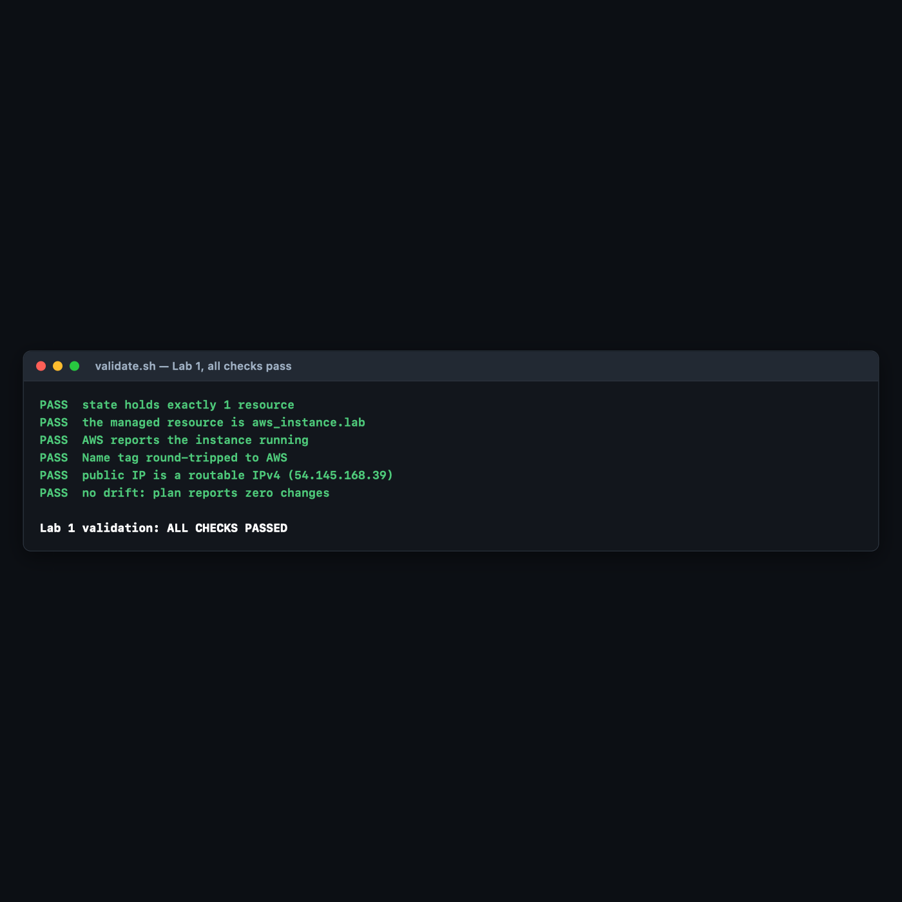

Why check 6 is the only one that earns its place
Checks 1–5 all interrogate the happy path: did the thing get made, is it running, is it named right. Check 6 asks a different question — does the configuration still describe reality?
This was not a theoretical concern; it was measured. With the instance still running, a single tag was added through the AWS API, exactly as a colleague clicking around the console would:
aws ec2 create-tags --resources $(terraform output -raw instance_id) \
--tags Key=Owner,Value=someone-in-the-console
./validate.sh
Actual output — five passes and one failure, exit code 1:
PASS state holds exactly 1 resource
PASS the managed resource is aws_instance.lab
PASS AWS reports the instance running
PASS Name tag round-tripped to AWS
PASS public IP is a routable IPv4 (54.145.168.39)
FAIL DRIFT: plan wants to change something — run 'terraform plan' to see what
Lab 1 validation: FAILURES ABOVE
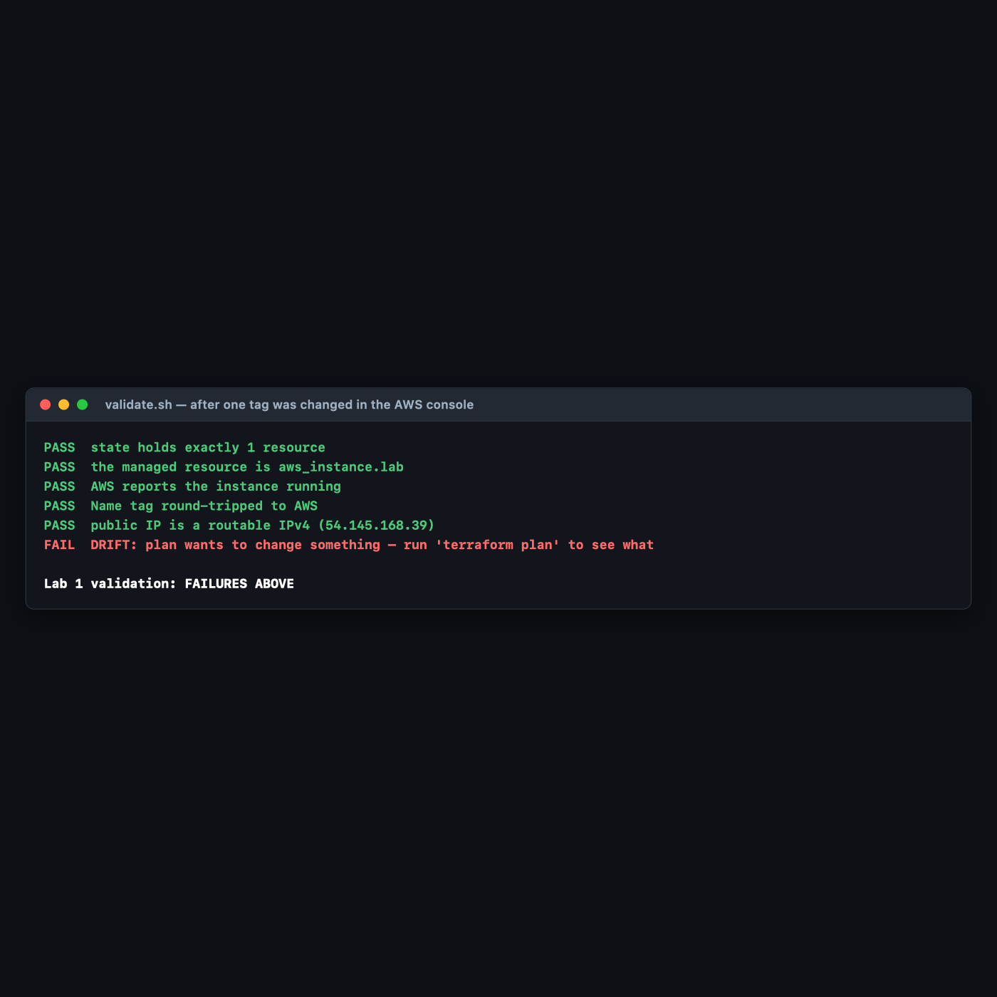
terraform plan then names the culprit precisely:
# aws_instance.lab will be updated in-place
~ resource "aws_instance" "lab" {
id = "i-09b4c73740225e37c"
~ tags = {
"Course" = "intermediate-terraform"
"Lab" = "1"
"Name" = "tf-lab1-first-instance"
- "Owner" = "someone-in-the-console" -> null
}
~ tags_all = {
- "Owner" = "someone-in-the-console" -> null
# (3 unchanged elements hidden)
}
# (39 unchanged attributes hidden)
Read the - "Owner" = "someone-in-the-console" -> null line carefully. Terraform is not offering to keep the console change — it is proposing to delete it, because the configuration is the source of truth and the configuration has never heard of Owner. That asymmetry is the entire subject of Lab 3.
-detailed-exitcode is the flag that makes plan usable in automation: 0 = no changes, 1 = error, 2 = changes pending. A nightly job running terraform plan -detailed-exitcode and alerting on 2 is a drift detector you can build this afternoon.

6. Troubleshooting Tips
Each of these was hit for real while building this lab.
Error: invalid AWS Region: with nothing after the colon
Error: invalid AWS Region:
with provider["registry.terraform.io/hashicorp/aws"],
on main.tf line 1, in provider "aws":
1: provider "aws" {}
The error names your provider block, which sends most people editing main.tf. The actual cause is that no region is set anywhere — not in the block, not in ~/.aws/config, not in the environment. The empty string after the colon is the diagnosis. Fix with export AWS_REGION=us-east-1, or by hardcoding region in the provider block as this lab does.
init succeeds but plan fails with a credentials error
Expected, not a bug. init is a plugin download and never authenticates. Credentials are first exercised by plan. Confirm them independently with aws sts get-caller-identity before blaming Terraform.
The plan shows a region attribute you have never seen before
+ region = "us-east-1" inside the resource body is AWS provider v6 behaviour — every resource gained a per-resource region override. Tutorials written against v5 will not show it. Nothing is wrong.
InvalidAMIID.NotFound when you change region
AMI IDs are region-scoped. ami-081b0a6eac00b4f53 exists in us-east-1 and nowhere else. This is the failure the Step 7 practice task is built around, and the reason Lab 2 replaces the hardcoded ID with a data source.
terraform destroy says "Destroy complete! Resources: 0 destroyed"
Terraform is only ever aware of what is in this directory's state. If you ran apply in a different directory, or deleted terraform.tfstate, the instance is still running and still billing. Fall back to the tag-based backstop query in 00-shared-setup.md §6 and terminate by instance ID.
Apply hangs at Still creating... for minutes
18 seconds is normal for t3.micro. Several minutes usually means a capacity or quota problem in the chosen AZ, and it will eventually surface as a real API error — let it fail and read the message rather than pressing Ctrl-C, which risks losing the record of a resource that was in fact created.

7. Cleanup Steps
Destroy the instance. This is not optional — it is the only thing in this lab that costs money.
terraform destroy
Type yes. Expected output:
aws_instance.lab: Destroying... [id=i-063bf80b54cbdd3d7]
aws_instance.lab: Still destroying... [id=i-063bf80b54cbdd3d7, 00m10s elapsed]
aws_instance.lab: Still destroying... [id=i-063bf80b54cbdd3d7, 00m30s elapsed]
aws_instance.lab: Destruction complete after 32s
Destroy complete! Resources: 1 destroyed.
Measured destroy time across three authoring runs: 22s, 32s, 32s.
Confirm nothing survived:
aws ec2 describe-instances \
--filters Name=tag:Course,Values=intermediate-terraform \
Name=instance-state-name,Values=running,pending,stopped \
--query 'Reservations[].Instances[].InstanceId' --output text
Expected output: nothing at all — zero bytes, exit code 0.
Keep these, and here is why:
Keep | Why
main.tf | Lab 2 refactors this exact file. Do not delete it.
.terraform.lock.hcl | Records that this lab ran against AWS provider v6.63.0. It is your reproducibility record and belongs in version control.
terraform.tfstate | After destroy it still exists, now holding zero resources but retaining serial and lineage (measured after the authoring run: "serial": 8, "resources": []). Lab 3 reads this file.
validate.sh | Later labs extend the same pattern.
Delete .terraform/ if you want the disk space back — measured at 789 MB in the authoring run, essentially all of it the AWS provider binary. terraform init re-creates it in seconds.

Optional extensions
- Make the plan binding. Re-run the lab with terraform plan -out=tfplan followed by terraform apply tfplan, and observe that apply no longer prompts for confirmation — it has already been given an approved plan. Then try modifying main.tf between the two commands and watch Terraform refuse the stale plan. This is exactly how a CI pipeline is structured.
- Break the version constraint on purpose. Change version = "~> 6.0" to "~> 5.0" and run terraform init -upgrade. Note which provider version resolves, then run terraform plan and find the region attribute missing from the output. You have just reproduced the difference between this document and every v5-era tutorial you will find online.
- Delete the state file and feel the consequence. With the instance running, mv terraform.tfstate /tmp/, then run terraform plan. Terraform proposes to create a second instance, because it no longer knows the first exists. Restore the file with mv and confirm the plan goes quiet. (Do this before destroy, not after — and do not skip restoring it.)
- Build the drift detector. Wrap terraform plan -detailed-exitcode in a cron job or CI scheduled workflow that alerts on exit code 2. Ten lines of YAML, and it catches every console change anyone on your team makes.
- Re-measure the price. The $0.0104/hr in §2.3 is a snapshot from 2026-09-05. Re-run the Pricing API query in 00-shared-setup.md §7 for your own region and check whether this document's cost table is still true.

