Lab 2 — Input Variables, Locals & Data Sources
DataCouch — Intermediate Terraform
Table of Contents

Maps to: Extending Your Project (Input Variables, Locals, Data Sources, Local-Exec / Local-Remote / Null) Duration: ~60 minutes Status: Tested end-to-end on 2026-09-05 (Terraform v1.15.7, AWS provider v6.63.0, null provider v3.3.1) against a live AWS account in us-east-1. Every command output, AMI ID, instance ID and error message below came from a real run — including the one that failed.
Prerequisites: 00-shared-setup.md, and Lab 1.

1. Lab Overview & Objectives
Lab 1's config had a flaw you were told to notice: a hardcoded AMI ID that is wrong in every other region and goes stale within weeks. This lab removes every hardcoded value from it — and in doing so introduces the three mechanisms that make Terraform configurations reusable rather than disposable:
- variables — values a human supplies
- locals — values Terraform computes from them
- data sources — values AWS supplies at plan time
You will finish by changing one line in one file and watching a running EC2 instance resize itself, a public IP get reassigned, and a file on your laptop rewrite itself — without editing a single .tf file.
Learning objectives — by the end of this lab you will be able to:
- Split a monolithic config into variables.tf, locals.tf, data.tf, main.tf and outputs.tf, and explain what belongs in each.
- Write validation blocks that reject bad input with a useful message, and state accurately when in the run those blocks are evaluated.
- Replace a hardcoded AMI with an aws_ami data source, and explain why the "latest" AMI is not a single well-defined thing.
- Use null_resource with local-exec and triggers to run a post-deploy action, and identify the trigger gap that makes its output silently go stale.
The most surprising measured result in this lab: the aws_ami data source resolved to ami-025b6f0b1ac2ef9f7 — a different image from the ami-081b0a6eac00b4f53 hardcoded in Lab 1. Neither is wrong. They are the same Amazon Linux 2023 release, published the same second, differing only in kernel version (6.1 vs 6.18). "Get the latest AMI" turns out to be a policy decision your filter string encodes, not a fact you look up. §4 Step 3 has the evidence.

2. Prerequisites & Environment Setup

2.1 Software
Requirement | Tested with
Terraform CLI | v1.15.7
AWS provider | v6.63.0 (resolved from ~> 6.0)
null provider | v3.3.1 (resolved from ~> 3.2)
AWS CLI v2 | 2.35.11
Python 3 | 3.14.x — the validation script uses it to parse JSON outputs

2.2 Cost and time
Resources created | 1 × EC2 instance (t3.micro, briefly t3.small) + 1 × null_resource (free)
Measured price | t3.micro $0.0104/hr; t3.small $0.0208/hr (2× micro)
Measured create time | 17 seconds
Measured resize time | 31 seconds (stop → modify → start, in place)
Measured destroy time | 32 seconds
Realistic cost | under $0.05
Hands-on time | ~60 minutes

2.3 Speed up provider downloads before you start
Each new lab directory downloads its own copy of the AWS provider. Measured size of a single .terraform/ directory in Lab 1: 789 MB. Across nine labs that is both slow and fragile — during authoring, one download died mid-transfer:
Error while installing hashicorp/aws v6.63.0: releases.hashicorp.com: read
tcp ...:443: read: connection reset by peer
Set a shared plugin cache once, and every subsequent terraform init reuses one copy:
mkdir -p ~/.terraform.d/plugin-cache
export TF_PLUGIN_CACHE_DIR="$HOME/.terraform.d/plugin-cache"
Add that export to your shell profile alongside AWS_REGION. Measured cache size after this course's providers: 809 MB total, shared, instead of 789 MB per directory.

2.4 Create the working directory
mkdir -p ~/terraform-course/lab-2-variables && cd ~/terraform-course/lab-2-variables
export AWS_REGION=us-east-1 AWS_DEFAULT_REGION=us-east-1

3. Architecture
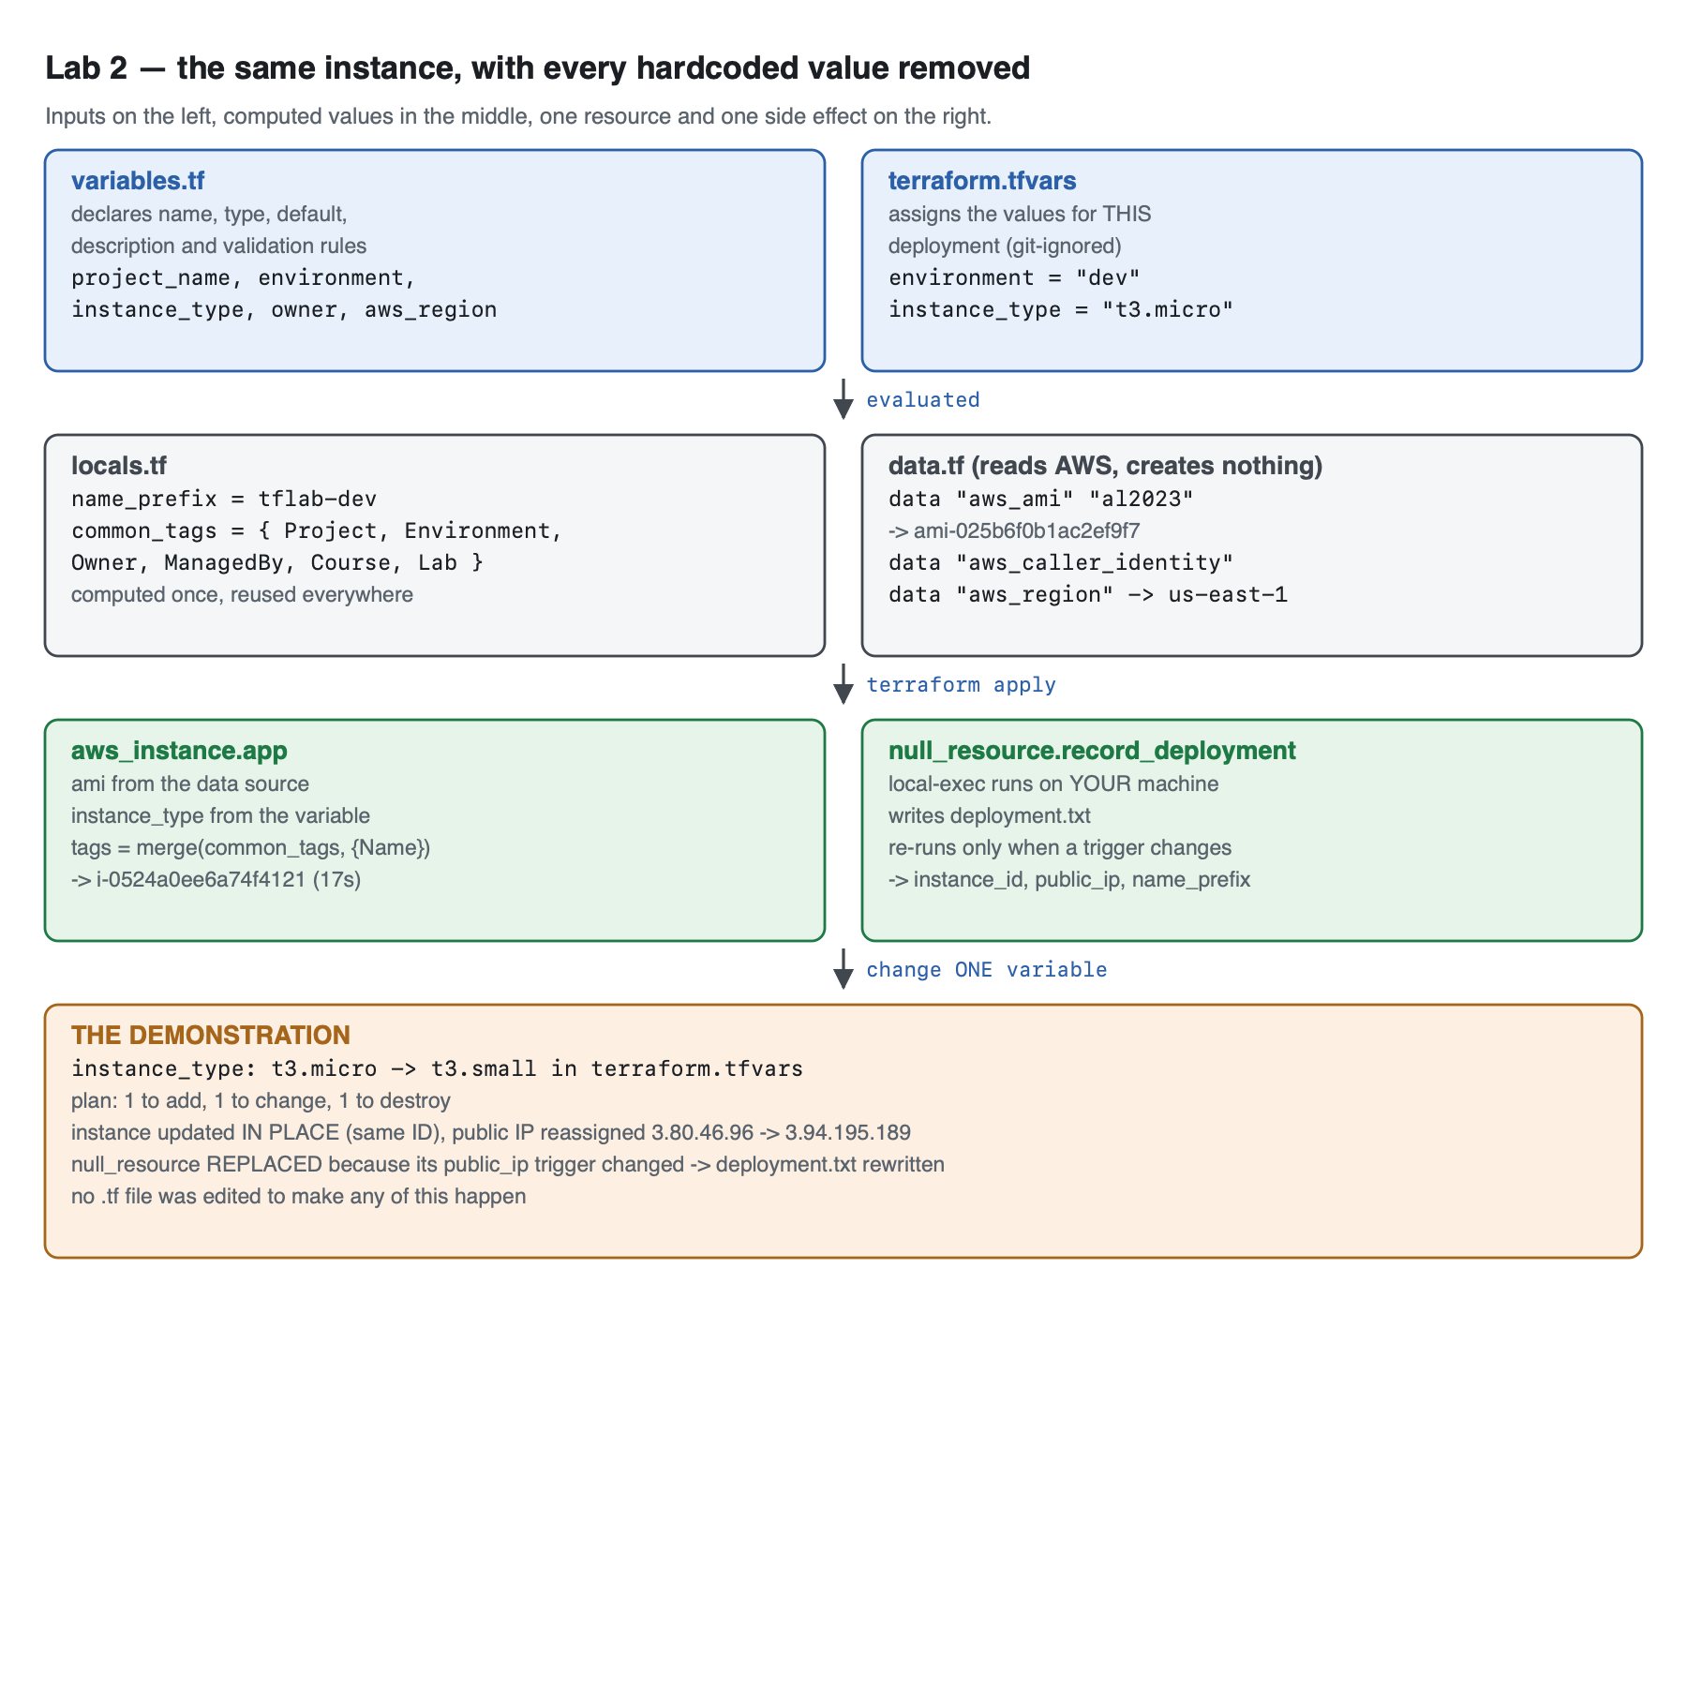
Vector version: lab-2-architecture.svg
The same structure in text:
INPUTS (a human sets these)
variables.tf ....... declares: name, type, default, description, validation
terraform.tfvars ... assigns: environment="dev", instance_type="t3.micro"
│
▼
COMPUTED (Terraform derives these)
locals.tf .......... name_prefix = "tflab-dev" ← from 2 variables
common_tags = { Project, Environment, Owner,
ManagedBy, Course, Lab }
data.tf ............ aws_ami.al2023 → ami-025b6f0b1ac2ef9f7 (reads AWS,
aws_caller_identity → <ACCOUNT_ID> creates
aws_region → us-east-1 nothing)
│
▼
REAL RESOURCES
aws_instance.app ............... i-0524a0ee6a74f4121 (17s)
ami ← data source
instance_type ← variable
tags ← merge(local.common_tags, { Name = "${name_prefix}-app" })
│
▼ (depends on the instance's id and ip)
null_resource.record_deployment
local-exec runs on YOUR machine, not the instance
writes deployment.txt
re-runs only when one of its `triggers` changes
│
▼
THE DEMONSTRATION — edit terraform.tfvars, nothing else
instance_type "t3.micro" → "t3.small"
→ instance updated IN PLACE, same ID, public IP 3.80.46.96 → 3.94.195.189
→ null_resource REPLACED (its public_ip trigger moved) → deployment.txt rewritten
The distinction that matters most: a resource block creates and owns something. A data block only reads. terraform destroy will never delete anything a data source found. If you are ever unsure whether a config will damage an existing resource, check whether it is referenced as data. or as resource. — that prefix is the whole answer.

4. Step-by-Step Instructions

Step 1 — Split the configuration into files
Why: Terraform merges every .tf file in the directory into one configuration, so the split is purely for humans. It is worth doing anyway: it means a reviewer can read variables.tf to learn the interface without reading the implementation, which is exactly what they will want when this becomes a module in Lab 5.
cat > versions.tf << 'EOF'
terraform {
required_version = ">= 1.5.0"
required_providers {
aws = {
source = "hashicorp/aws"
version = "~> 6.0"
}
null = {
source = "hashicorp/null"
version = "~> 3.2"
}
}
}
provider "aws" {
region = var.aws_region
}
EOF
Note region = var.aws_region — the provider itself is now parameterised, which is what makes the Lab 1 practice task (deploy to another region) a one-line change rather than an edit.

Step 2 — Declare the inputs
Why: A variable without a description and a type is a trap for the next person. A variable without validation is a trap for you: it lets a typo reach the AWS API, where the error message is about an API contract rather than about your intent.
cat > variables.tf << 'EOF'
variable "aws_region" {
description = "AWS region to deploy into. AMI lookup is region-aware, so this is now safe to change."
type = string
default = "us-east-1"
}
variable "project_name" {
description = "Short project identifier used to build every resource name."
type = string
default = "tflab"
validation {
condition = can(regex("^[a-z0-9-]{2,16}$", var.project_name))
error_message = "project_name must be 2-16 characters of lowercase letters, digits or hyphens."
}
}
variable "environment" {
description = "Deployment environment. Drives naming and the instance size map."
type = string
default = "dev"
validation {
condition = contains(["dev", "staging", "prod"], var.environment)
error_message = "environment must be one of: dev, staging, prod."
}
}
variable "instance_type" {
description = "EC2 instance type. Set explicitly to override the per-environment default."
type = string
default = "t3.micro"
}
variable "owner" {
description = "Team or person accountable for these resources. Applied as a tag."
type = string
default = "platform-team"
}
EOF
cat > terraform.tfvars << 'EOF'
project_name = "tflab"
environment = "dev"
instance_type = "t3.micro"
owner = "platform-team"
EOF
variables.tf declares; terraform.tfvars assigns. That separation is the point. The declaration file is committed and reviewed; the assignment file is environment-specific and, in the shared setup's .gitignore, deliberately untracked.
Variable precedence, highest wins:
Source | Wins over
-var on the command line | everything below
-var-file=… | terraform.tfvars
terraform.tfvars / *.auto.tfvars | environment variables
TF_VAR_name environment variable | the default
default in the declaration | nothing
Verified during authoring — with instance_type = "t3.small" in terraform.tfvars:
terraform plan -var 'instance_type=t3.medium' | grep instance_type
~ instance_type = "t3.small" -> "t3.medium"
The command-line flag won, as documented.

Step 3 — Replace the hardcoded AMI with a data source
Why: This is the fix for Lab 1's deliberate flaw. A data source asks AWS a question at plan time and uses the answer, so the config stays correct as AWS publishes new images and works unchanged in any region.
cat > data.tf << 'EOF'
# Ask AWS for the current Amazon Linux 2023 image instead of hardcoding an ID
# that is wrong in every other region and goes stale within weeks.
data "aws_ami" "al2023" {
most_recent = true
owners = ["amazon"]
filter {
name = "name"
values = ["al2023-ami-2023.*-kernel-6.1-x86_64"]
}
filter {
name = "state"
values = ["available"]
}
}
# Who am I, and where am I? Useful in outputs and for building ARNs.
data "aws_caller_identity" "current" {}
data "aws_region" "current" {}
EOF
owners = ["amazon"] is a security control, not a formality. Without it, most_recent = true will happily select an image published by any AWS account whose AMI name matches your filter. Always constrain owners.

The measured result: "latest" is not one thing
The data source resolved to this:
resolved_ami = {
"creation_date" = "2026-08-26T15:34:22.000Z"
"id" = "ami-025b6f0b1ac2ef9f7"
"name" = "al2023-ami-2023.12.20260831.0-kernel-6.1-x86_64"
}
That is not the AMI Lab 1 hardcoded (ami-081b0a6eac00b4f53). Both were checked against AWS on the same day:
aws ec2 describe-images --image-ids ami-081b0a6eac00b4f53 ami-025b6f0b1ac2ef9f7 \
--query 'sort_by(Images,&CreationDate)[].{ID:ImageId,Name:Name,Created:CreationDate}' --output table
-----------------------------------------------------------------------------------------------------------
| DescribeImages |
+---------------------------+------------------------+----------------------------------------------------+
| Created | ID | Name |
+---------------------------+------------------------+----------------------------------------------------+
| 2026-08-26T15:34:22.000Z | ami-025b6f0b1ac2ef9f7 | al2023-ami-2023.12.20260831.0-kernel-6.1-x86_64 |
| 2026-08-26T15:34:22.000Z | ami-081b0a6eac00b4f53 | al2023-ami-2023.12.20260831.0-kernel-6.18-x86_64 |
+---------------------------+------------------------+----------------------------------------------------+
Same Amazon Linux 2023 build (2023.12.20260831.0), published in the same second, differing only in kernel line: 6.1 versus 6.18. Lab 1's ID came from AWS's kernel-default SSM pointer, which now means 6.18. This lab's filter explicitly asks for kernel-6.1.
Neither is "the latest AMI". There is no such thing. most_recent = true returns the newest image matching your filter, and your filter is a policy statement about which image family you want. Confirm the two pointers differ for yourself:
for p in al2023-ami-kernel-default-x86_64 al2023-ami-kernel-6.1-x86_64; do
printf "%-34s " "$p"
aws ssm get-parameters --names /aws/service/ami-amazon-linux-latest/$p --query 'Parameters[0].Value' --output text
done
al2023-ami-kernel-default-x86_64 ami-081b0a6eac00b4f53
al2023-ami-kernel-6.1-x86_64 ami-025b6f0b1ac2ef9f7
A filter-precision trap worth internalising: the glob al2023-ami-2023.*-kernel-6.1-x86_64 matches only the 6.1 line, because -x86_64 immediately follows 6.1. Write …-kernel-6.1*-x86_64 instead — one extra asterisk — and it matches kernel-6.18 too, so most_recent silently starts picking a different kernel. That is a one-character change with a production-kernel-upgrade blast radius.
most_recent = true makes your config non-deterministic on purpose. The AMI can change under you between a plan and a later apply, which will show up as a proposed instance replacement. For production, many teams pin the AMI ID in a variable and bump it deliberately. Know which trade-off you are choosing.

Step 4 — Compute values with locals
Why: A local is a value you name once and reuse. Where a variable is an input from outside, a local is a conclusion drawn inside. The test for which to use: could a caller reasonably want to override it? If yes, variable. If it is always derived from other values, local.
cat > locals.tf << 'EOF'
locals {
# A naming convention computed once and used everywhere. Change the convention
# here and every resource name in the project follows.
name_prefix = "${var.project_name}-${var.environment}"
# Tags every resource should carry, merged with per-resource tags at use site.
common_tags = {
Project = var.project_name
Environment = var.environment
Owner = var.owner
ManagedBy = "terraform"
Course = "intermediate-terraform"
Lab = "2"
}
# A derived value that is not just string concatenation: locals can hold logic.
is_production = var.environment == "prod"
}
EOF
local.common_tags is the pattern to take away from this lab. Defining a tag map once and merging it at every use site is how you make the cleanup query in 00-shared-setup.md §6 reliable — every resource is findable because every resource was tagged from the same source.

Step 5 — The resource and the post-deploy hook
Why: null_resource is Terraform's escape hatch: a resource that creates nothing in any cloud but can hang provisioners and triggers off the lifecycle of things that do. Here it records the deployment to a local file.
cat > main.tf << 'EOF'
resource "aws_instance" "app" {
ami = data.aws_ami.al2023.id
instance_type = var.instance_type
tags = merge(local.common_tags, {
Name = "${local.name_prefix}-app"
})
}
# Post-deploy hook: write the deployed instance's details to a local file.
# triggers force the provisioner to re-run whenever the instance changes.
resource "null_resource" "record_deployment" {
triggers = {
instance_id = aws_instance.app.id
public_ip = aws_instance.app.public_ip
}
provisioner "local-exec" {
command = <<-CMD
printf '%s\n' \
"deployed_at=$(date -u +%Y-%m-%dT%H:%M:%SZ)" \
"name=${local.name_prefix}-app" \
"instance_id=${aws_instance.app.id}" \
"public_ip=${aws_instance.app.public_ip}" \
"instance_type=${aws_instance.app.instance_type}" \
"ami=${aws_instance.app.ami}" \
> deployment.txt
CMD
}
}
EOF
Three things to understand here:
- merge() composes the tag maps. The per-resource Name is added to the shared common_tags without either one being retyped. If both defined the same key, the later argument wins.
- local-exec runs on the machine running Terraform — your laptop or your CI runner — not on the EC2 instance. The provisioner that runs commands on the instance is remote-exec, which needs SSH connectivity, a key pair and a reachable security group. local-exec needs none of that, which is why it is the right choice for recording an outcome.
- triggers is the only thing that makes a null_resource re-run. Without it, the resource is created once and never touched again no matter what happens around it. This config's trigger list is deliberately incomplete — §5 measures exactly what that costs.
null_resource versus terraform_data: since Terraform 1.4 there is a built-in terraform_data resource that does the same job with no external provider. This lab uses null_resource because the course outline names it and because you will meet it in every existing codebase. For new code, terraform_data is preferable — it drops the hashicorp/null dependency entirely.
Provisioners are a last resort, and HashiCorp says so in its own docs. They run outside Terraform's dependency graph, they cannot be planned (Terraform cannot know what a shell command will do), and a failed provisioner taints the resource. Recording an output to a file is a legitimate use. Configuring software on an instance is not — that is what user_data (Lab 4) or a configuration-management tool is for.

Step 6 — Outputs, then apply
Why: Outputs are the config's public surface. Anything a human or a calling module needs after apply should be an output, not something you go digging in state for.
cat > outputs.tf << 'EOF'
output "name_prefix" {
description = "The computed naming convention every resource in this project uses."
value = local.name_prefix
}
output "resolved_ami" {
description = "The AMI the data source selected, and its publication date."
value = {
id = data.aws_ami.al2023.id
name = data.aws_ami.al2023.name
creation_date = data.aws_ami.al2023.creation_date
}
}
output "instance" {
description = "Key facts about the deployed instance."
value = {
id = aws_instance.app.id
public_ip = aws_instance.app.public_ip
instance_type = aws_instance.app.instance_type
name_tag = aws_instance.app.tags["Name"]
}
}
output "deployed_into" {
description = "Region the provider actually used."
value = data.aws_region.current.region
}
EOF
terraform init
terraform validate
terraform apply -auto-approve
Expected output — terraform validate first:
Success! The configuration is valid.
Then the tail of the real apply:
aws_instance.app: Creating...
aws_instance.app: Still creating... [00m10s elapsed]
aws_instance.app: Creation complete after 17s [id=i-0524a0ee6a74f4121]
null_resource.record_deployment: Creating...
null_resource.record_deployment: Provisioning with 'local-exec'...
null_resource.record_deployment (local-exec): Executing: ["/bin/sh" "-c" "printf '%s\n' ...]
null_resource.record_deployment: Creation complete after 0s [id=8243200869286460042]
Apply complete! Resources: 2 added, 0 changed, 0 destroyed.
Outputs:
deployed_into = "us-east-1"
instance = {
"id" = "i-0524a0ee6a74f4121"
"instance_type" = "t3.micro"
"name_tag" = "tflab-dev-app"
"public_ip" = "3.80.46.96"
}
name_prefix = "tflab-dev"
resolved_ami = {
"creation_date" = "2026-08-26T15:34:22.000Z"
"id" = "ami-025b6f0b1ac2ef9f7"
"name" = "al2023-ami-2023.12.20260831.0-kernel-6.1-x86_64"
}
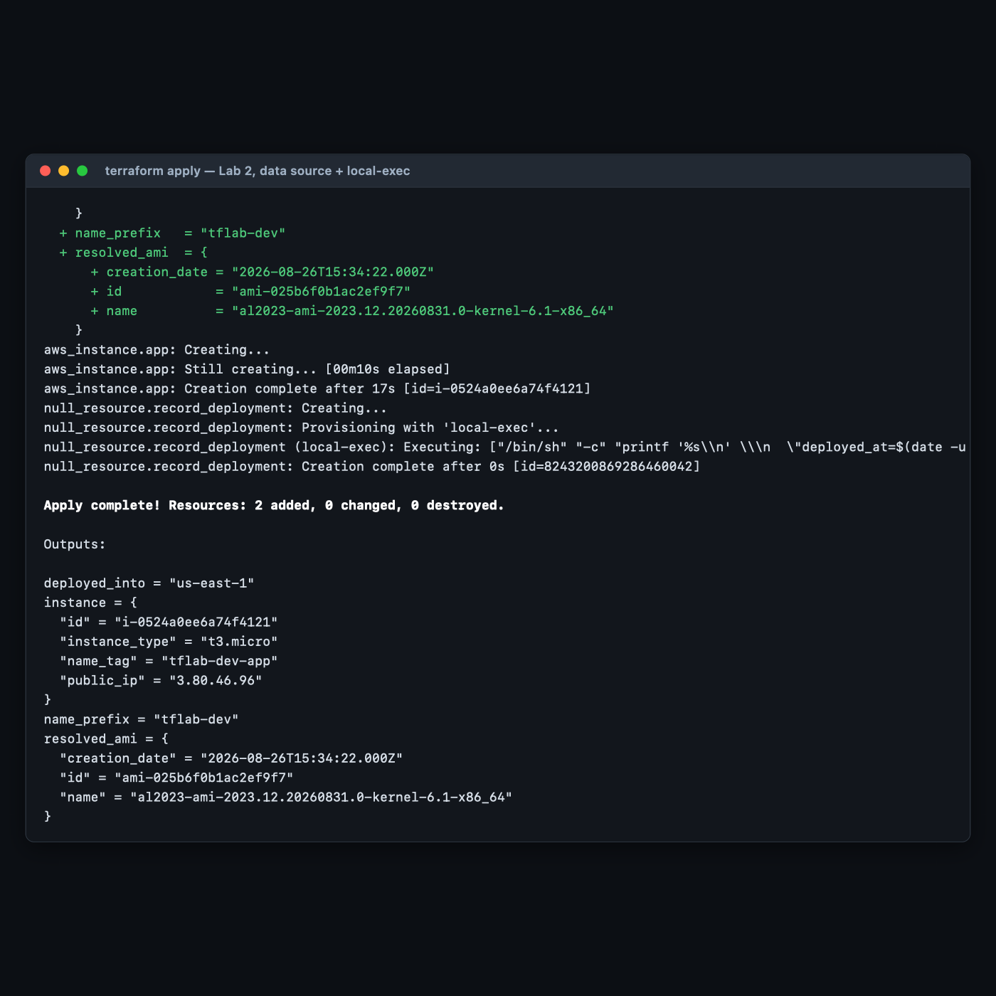
The local-exec proof file — this is on your machine, written by the provisioner:
cat deployment.txt
deployed_at=2026-09-05T13:22:17Z
name=tflab-dev-app
instance_id=i-0524a0ee6a74f4121
public_ip=3.80.46.96
instance_type=t3.micro
ami=ami-025b6f0b1ac2ef9f7
Note name=tflab-dev-app — that string exists nowhere in any file you wrote. It was computed from project_name and environment by the local, and it reached both the AWS tag and this file.

Step 7 — Prove the validation rules work
Why: A validation rule you have never seen fire is a rule you do not know is correct.
terraform plan -var 'environment=production'
Expected output:
Error: Invalid value for variable
on variables.tf line 18:
18: variable "environment" {
├────────────────
│ var.environment is "production"
environment must be one of: dev, staging, prod.
This was checked by the validation rule at variables.tf:23,3-13.
The rule caught production where the allowed value is prod — a plausible typo that would otherwise have produced a mis-tagged instance rather than an error. The regex rule behaves the same way:
terraform plan -var 'project_name=My_Project'
Error: Invalid value for variable
on variables.tf line 7:
7: variable "project_name" {
├────────────────
│ var.project_name is "My_Project"
A correction to the intuition, measured during authoring. It is tempting to say validation "fails fast, before Terraform talks to AWS". That is not what happens. The full output of the failing plan begins:
data.aws_ami.al2023: Reading...
data.aws_caller_identity.current: Reading...
data.aws_region.current: Reading...
data.aws_region.current: Read complete after 0s [id=us-east-1]
data.aws_caller_identity.current: Read complete after 0s [id=<ACCOUNT_ID>]
data.aws_ami.al2023: Read complete after 2s [id=ami-025b6f0b1ac2ef9f7]
Planning failed. Terraform encountered an error while generating this plan.
The three data sources were read first, and only then did the variable validation fail. Variable validation protects you from creating resources with bad input; it does not prevent data source reads, which are still real, billable-in-principle AWS API calls. If a data source has a side effect or a cost you care about, validation is not the gate you think it is.

Step 8 — The payoff: change one value, change the infrastructure
Why: This is the whole argument for the refactor. If parameterising the config did not make change cheap, it would just be extra files.
Edit one line in terraform.tfvars:
sed -i '' 's/instance_type = "t3.micro"/instance_type = "t3.small"/' terraform.tfvars
terraform plan
Expected output (filtered to the interesting lines):
~ update in-place
# aws_instance.app will be updated in-place
~ resource "aws_instance" "app" {
~ instance_type = "t3.micro" -> "t3.small"
~ public_dns = "ec2-3-80-46-96.compute-1.amazonaws.com" -> (known after apply)
~ public_ip = "3.80.46.96" -> (known after apply)
# null_resource.record_deployment must be replaced
~ id = "8243200869286460042" -> (known after apply)
~ triggers = { # forces replacement
~ "public_ip" = "3.80.46.96" -> (known after apply)
Plan: 1 to add, 1 to change, 1 to destroy.
Read the cascade — three separate things are happening:
- The instance is updated in place, not replaced. instance_type is a modifiable attribute; AWS stops the instance, changes the type and starts it again. The instance ID survives.
- public_ip becomes (known after apply) because a stop/start releases the public IPv4 and assigns a new one. Nobody asked for this; it is a consequence of the resize. This is exactly why production services sit behind an Elastic IP or a load balancer.
- null_resource.record_deployment must be replaced — not because you changed it, but because its public_ip trigger is about to change. # forces replacement names the culprit precisely.
Apply it:
terraform apply -auto-approve
aws_instance.app: Still modifying... [id=i-0524a0ee6a74f4121, 00m30s elapsed]
aws_instance.app: Modifications complete after 31s [id=i-0524a0ee6a74f4121]
null_resource.record_deployment: Creating...
null_resource.record_deployment: Provisioning with 'local-exec'...
null_resource.record_deployment: Creation complete after 0s [id=6631334042495409418]
Apply complete! Resources: 1 added, 1 changed, 1 destroyed.
Outputs:
instance = {
"id" = "i-0524a0ee6a74f4121"
"instance_type" = "t3.small"
"name_tag" = "tflab-dev-app"
"public_ip" = "3.94.195.189"
}
Same instance ID. New size. New public IP. And deployment.txt rewrote itself:
deployed_at=2026-09-05T13:23:55Z
name=tflab-dev-app
instance_id=i-0524a0ee6a74f4121
public_ip=3.94.195.189
instance_type=t3.small
ami=ami-025b6f0b1ac2ef9f7
You edited one value in one file. Confirm in the AWS Console: the instance is now t3.small.

Step 9 — Do it again yourself, a per-environment size map, unassisted
Why: You have now parameterised values. The next step — and the thing that makes Lab 5's modules work — is parameterising policy: letting one input decide several others.
Your task. Right now environment and instance_type are independent, so nothing stops someone deploying environment = "prod" on a t3.micro, or dev on something expensive. Make environment drive the instance size, while still allowing a deliberate override.
Implement it so that:
- A local map holds the size policy: dev → t3.micro, staging → t3.small, prod → t3.medium.
- Setting only environment = "staging" in terraform.tfvars produces a t3.small, with no instance_type line present at all.
- Explicitly setting instance_type still wins, so an engineer can override the policy for a one-off without editing the map.
- The unused local.is_production you wrote in Step 4 either earns its place or gets deleted.
You get the acceptance criteria and nothing else:
- terraform apply with environment = "staging" and no instance_type set yields a running t3.small, confirmed with aws ec2 describe-instances.
- terraform plan -var 'instance_type=t3.micro' on that same config proposes a change to t3.micro, proving the override still works.
- terraform plan -var 'environment=qa' still fails on the existing validation rule.
- terraform plan -detailed-exitcode exits 0 after the apply.
- deployment.txt shows the environment-derived type, not a stale one.
Done when you can explain why your override mechanism produces the right answer for both "user set nothing" and "user set something", and say which Terraform value — null, "", or the absence of a key — you used to tell those two cases apart.
No commands are given here. Steps 1–8 have every pattern you need; the exercise is combining a lookup/map local with a conditional so that one input safely governs another.

5. Validation / Verification
Save as validate.sh and run after terraform apply. Also committed at lab-2-variables/validate.sh.
#!/usr/bin/env bash
# Lab 2 validation. Run from lab-2-variables/ after `terraform apply`.
set -uo pipefail
fail=0
check() { if [ "$2" = "$3" ]; then echo "PASS $1"; else echo "FAIL $1 (got '$2', want '$3')"; fail=1; fi }
PREFIX=$(terraform output -raw name_prefix)
ID=$(terraform output -json instance | python3 -c 'import json,sys;print(json.load(sys.stdin)["id"])')
IP=$(terraform output -json instance | python3 -c 'import json,sys;print(json.load(sys.stdin)["public_ip"])')
TYPE=$(terraform output -json instance | python3 -c 'import json,sys;print(json.load(sys.stdin)["instance_type"])')
AMI=$(terraform output -json resolved_ami | python3 -c 'import json,sys;print(json.load(sys.stdin)["id"])')
# 1. The local computed the naming convention from the two variables in tfvars.
WANT_PREFIX="$(grep '^project_name' terraform.tfvars | cut -d'"' -f2)-$(grep '^environment' terraform.tfvars | cut -d'"' -f2)"
check "name_prefix is computed from two variables" "$PREFIX" "$WANT_PREFIX"
# 2. That computed name actually reached AWS as a tag.
check "Name tag on the real instance matches the local" \
"$(aws ec2 describe-instances --instance-ids "$ID" --query "Reservations[0].Instances[0].Tags[?Key=='Name']|[0].Value" --output text)" \
"${PREFIX}-app"
# 3. common_tags were merged, not overwritten by the per-resource Name tag.
check "merge() kept ManagedBy from common_tags" \
"$(aws ec2 describe-instances --instance-ids "$ID" --query "Reservations[0].Instances[0].Tags[?Key=='ManagedBy']|[0].Value" --output text)" \
"terraform"
# 4. The instance really is running the AMI the data source chose.
check "instance AMI == data source AMI (nothing hardcoded)" \
"$(aws ec2 describe-instances --instance-ids "$ID" --query 'Reservations[0].Instances[0].ImageId' --output text)" \
"$AMI"
# 5. The provisioner produced its file.
if [ -f deployment.txt ]; then echo "PASS local-exec wrote deployment.txt"; else echo "FAIL deployment.txt missing"; fail=1; fi
# 6. THE ONES THE HAPPY PATH MISSES: is deployment.txt actually CURRENT?
FILE_IP=$(grep '^public_ip=' deployment.txt | cut -d= -f2)
FILE_TYPE=$(grep '^instance_type=' deployment.txt | cut -d= -f2)
check "deployment.txt IP is current, not stale" "$FILE_IP" "$IP"
check "deployment.txt instance_type is current, not stale" "$FILE_TYPE" "$TYPE"
FILE_NAME=$(grep '^name=' deployment.txt | cut -d= -f2)
check "deployment.txt name is current, not stale" "$FILE_NAME" "${PREFIX}-app"
# 7. Config and reality agree.
terraform plan -detailed-exitcode -no-color > /dev/null 2>&1
case $? in
0) echo "PASS no drift: plan reports zero changes" ;;
2) echo "FAIL DRIFT: plan wants to change something"; fail=1 ;;
*) echo "FAIL plan errored"; fail=1 ;;
esac
echo
[ $fail -eq 0 ] && echo "Lab 2 validation: ALL CHECKS PASSED" || echo "Lab 2 validation: FAILURES ABOVE"
exit $fail
Actual output after Step 8, exit code 0:
PASS name_prefix is computed from two variables
PASS Name tag on the real instance matches the local
PASS merge() kept ManagedBy from common_tags
PASS instance AMI == data source AMI (nothing hardcoded)
PASS local-exec wrote deployment.txt
PASS deployment.txt IP is current, not stale
PASS deployment.txt instance_type is current, not stale
PASS deployment.txt name is current, not stale
PASS no drift: plan reports zero changes
Lab 2 validation: ALL CHECKS PASSED

The staleness checks are not padding — they caught a real bug in this lab's own config
Checks 6–8 exist because terraform plan cannot tell you whether a provisioner's side effects are current. Here is the measurement that proves it.
Change only the environment — which alters the instance's tags but touches neither its ID nor its IP, and therefore trips none of the original triggers:
sed -i '' 's/environment = "dev"/environment = "staging"/' terraform.tfvars
terraform apply -auto-approve
./validate.sh
The apply succeeded and updated the instance:
# aws_instance.app will be updated in-place
Apply complete! Resources: 0 added, 1 changed, 0 destroyed.
Then eight checks passed and one failed — exit code 1:
PASS name_prefix is computed from two variables
PASS Name tag on the real instance matches the local
PASS merge() kept ManagedBy from common_tags
PASS instance AMI == data source AMI (nothing hardcoded)
PASS local-exec wrote deployment.txt
PASS deployment.txt IP is current, not stale
PASS deployment.txt instance_type is current, not stale
FAIL deployment.txt name is current, not stale (got 'tflab-dev-app', want 'tflab-staging-app')
PASS no drift: plan reports zero changes
Lab 2 validation: FAILURES ABOVE
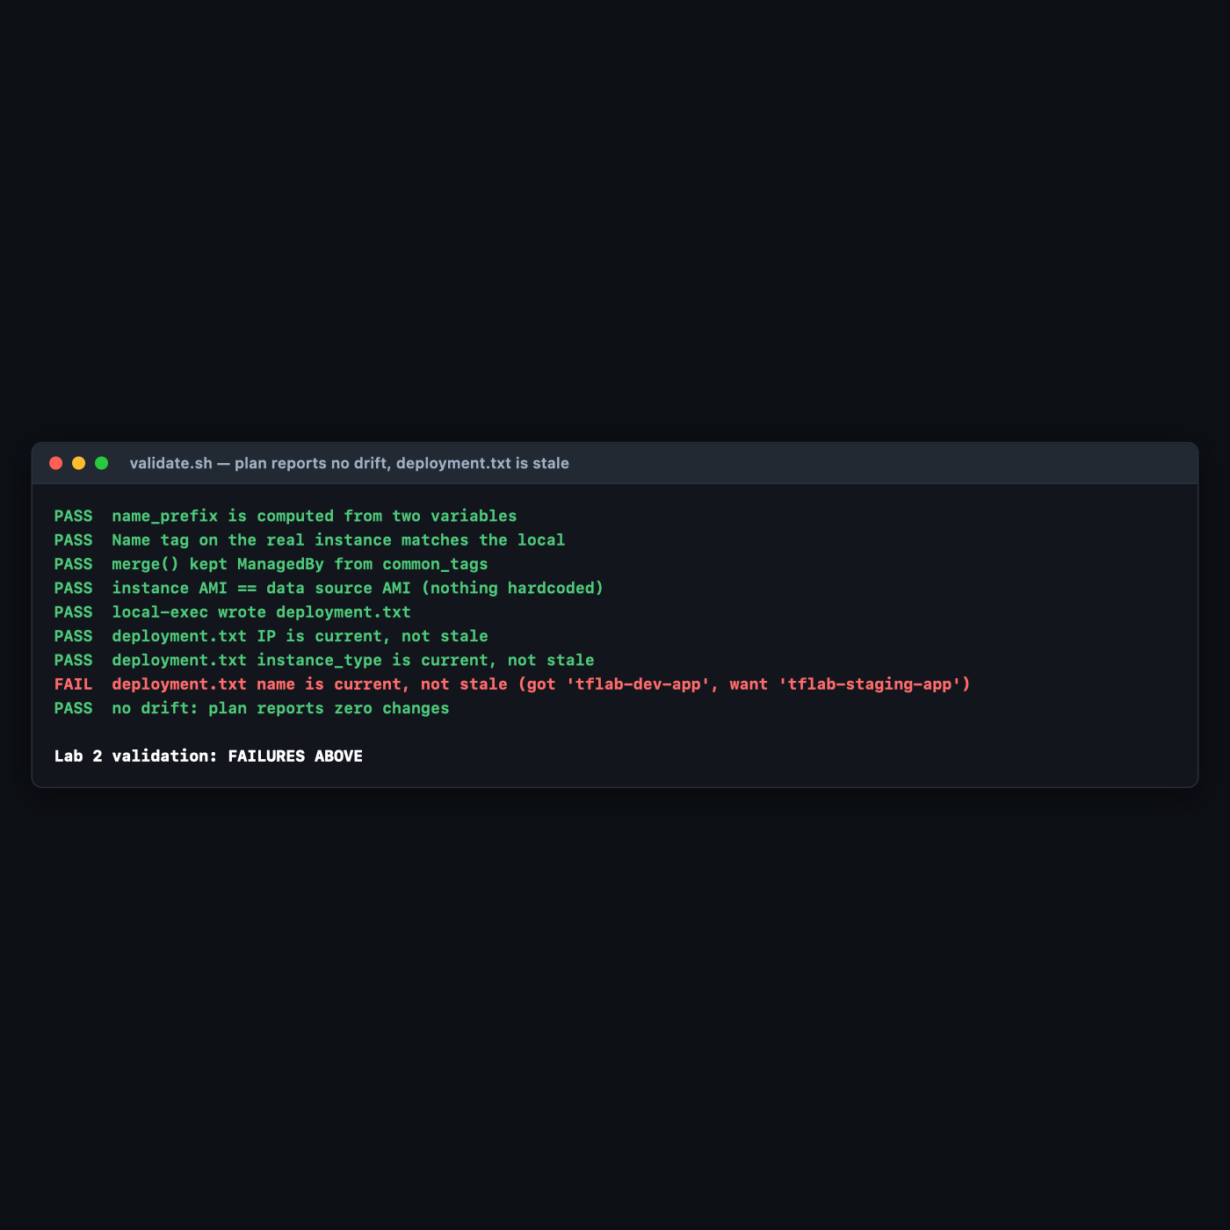
Read the last two lines together, because that combination is the entire lesson:
deployment.txt was lying, and terraform plan reported no drift.
Terraform was correct. Its state matched AWS exactly. But the file the provisioner produced still said tflab-dev-app while the instance in AWS was tagged tflab-staging-app. The null_resource did not re-run because local.name_prefix was not in its triggers.
This is the general failure mode of provisioners: their outputs live outside Terraform's model of the world, so Terraform cannot tell you when they go stale. Anything a provisioner consumes must be listed in triggers, and nothing checks that you did it.
The fix is one line:
triggers = {
instance_id = aws_instance.app.id
public_ip = aws_instance.app.public_ip
# Without this line the provisioner does not re-run when only the naming
# changes, and deployment.txt silently goes stale while `terraform plan`
# still reports no drift.
name_prefix = local.name_prefix
}
After re-applying, the null_resource was replaced and every check passed:
# null_resource.record_deployment must be replaced
Apply complete! Resources: 1 added, 0 changed, 1 destroyed.
PASS name_prefix is computed from two variables
...
PASS deployment.txt name is current, not stale
PASS no drift: plan reports zero changes
Lab 2 validation: ALL CHECKS PASSED
The shipped lab-2-variables/main.tf includes the fix. The bug is described rather than left in place so you can reproduce it deliberately by deleting that one line.

6. Troubleshooting Tips
All hit for real while building this lab.
Error while installing hashicorp/aws v6.63.0: ... read: connection reset by peer
A genuine mid-download network failure, not a config problem. The AWS provider is ~789 MB per directory. Re-run terraform init; if it recurs, set TF_PLUGIN_CACHE_DIR (§2.3) so you download it once for the whole course.
terraform validate reports Missing required provider even though main.tf is fine
Error: Missing required provider
This configuration requires provider registry.terraform.io/hashicorp/aws, but
that provider isn't available. You may be able to install it automatically by
running: terraform init
This is what a failed init looks like one command later. validate is a local, offline check and cannot run without the provider schema. Fix the init, not the config.
Your resolved_ami differs from this document's
Expected, and correct. most_recent = true returns whatever is newest on the day you run it. If it differs by more than the date — a different kernel line, say — check your filter glob against the precision trap in Step 3.
local-exec command works in your shell but fails inside Terraform
The provisioner runs through /bin/sh -c, not your interactive shell — no aliases, no functions, no zsh-only syntax. The full command Terraform executed is echoed in the apply output; copy that exact string into sh -c '...' to reproduce it outside Terraform.
deployment.txt does not update after a change
Almost always the trigger gap in §5: whatever changed is not listed in triggers. Confirm by running terraform plan — if it reports no changes to the null_resource, Terraform is behaving correctly and your trigger list is incomplete.
Validation rule does not fire when you expect it to
Check where the bad value is set. A default in variables.tf is validated too, so an invalid default breaks every plan. And note from Step 7: validation does not run before data sources are read, so a failing plan can still have made AWS API calls.

7. Cleanup Steps
terraform destroy -auto-approve
Expected output:
aws_instance.app: Still destroying... [id=i-0524a0ee6a74f4121, 00m30s elapsed]
aws_instance.app: Destruction complete after 32s
Destroy complete! Resources: 2 destroyed.
Resources: 2 destroyed — the instance and the null_resource. Destroying a null_resource costs nothing and does not undo its side effects: deployment.txt is still on your disk after destroy. That is worth seeing, because it is the same reason a provisioner that creates a DNS record or writes to a database leaves that behind too. Remove it yourself:
rm -f deployment.txt
Confirm nothing survived:
aws ec2 describe-instances \
--filters Name=tag:Course,Values=intermediate-terraform \
Name=instance-state-name,Values=running,pending,stopped \
--query 'Reservations[].Instances[].InstanceId' --output text
Expected output: nothing at all.
Keep these, and here is why:
Keep | Why
All five .tf files | Lab 5 turns exactly this config into a reusable module.
terraform.tfvars | Reset to dev / t3.micro so the lab starts clean if you repeat it.
validate.sh | Labs 3–8 extend this pattern.
.terraform.lock.hcl | Records aws v6.63.0 + null v3.3.1 — your reproducibility record.

Optional extensions
- Swap null_resource for terraform_data. Replace the resource with the built-in terraform_data, drop hashicorp/null from required_providers, re-run terraform init and confirm the null provider disappears from .terraform.lock.hcl. One less third-party dependency for identical behaviour.
- Reproduce the kernel trap. Change the AMI filter to al2023-ami-2023.*-kernel-6.1*-x86_64 (one added asterisk) and run terraform plan. Note which AMI most_recent now selects, and whether Terraform proposes to replace your instance. This is a one-character change that in a production config would silently move you to a different kernel line.
- Pin the AMI and feel the difference. Move the resolved AMI ID into a variable with the data source removed. Run plan a week later. The non-determinism is gone, and so is the automatic patching — decide which you actually want for a production workload.
- Make owner mandatory. Remove its default and run terraform plan. Terraform will prompt interactively; in CI, with -input=false, it fails instead. That is how you make a variable genuinely required, and how you find out which of your pipelines were relying on a default.
- Read the data source's full output. Run terraform console, then data.aws_ami.al2023 — the console prints every attribute the data source exposes, including block_device_mappings and architecture. Most people never discover these exist.

