Lab 3 — State Deep-Dive, Drift & Import
DataCouch — Intermediate Terraform
Table of Contents

Maps to: How Terraform Works (State, Extracting Data from Statefile, Computing/Executing Plans); Configuration Drift, Drift Use Cases, Refresh Command, Importing Existing Resources Duration: ~75 minutes Status: Tested end-to-end on 2026-09-05 (Terraform v1.15.7, AWS provider v6.63.0) against a live AWS account in us-east-1. Every plan diff, error and instance ID below came from a real run.
Prerequisites: 00-shared-setup.md, Labs 1 and 2.

1. Lab Overview & Objectives
Terraform's model has three parties, not two: the configuration you wrote, the state Terraform recorded, and the infrastructure AWS actually has. Most Terraform problems that feel mysterious are a disagreement between two of the three.
In this lab you will deliberately break that agreement — changing a running instance from outside Terraform, three different ways — then use plan and apply -refresh-only to see the disagreement from both directions. Then you will do the reverse: take a resource Terraform did not create and bring it under management with import.
Learning objectives — by the end of this lab you will be able to:
- Read a state file directly and with terraform state subcommands, and explain serial, lineage, and why data sources appear in state.
- Induce configuration drift and predict, before running anything, what terraform plan will propose to do about it.
- Distinguish terraform plan from terraform apply -refresh-only — they show the same drift with the arrows pointing in opposite directions.
- Import an existing resource using both the 1.5+ import block (with automatic config generation) and the legacy terraform import command, and prove the import was complete rather than merely successful.
The most surprising measured result in this lab: a security group was imported, and terraform state list showed it correctly. But with one ingress rule missing from the config, the very next terraform plan proposed to delete a live tcp/443 rule from a real security group — and every check short of running plan still passed. An import that "succeeded" and an import that is correct are different things, and the gap between them is firewall-shaped. §5 has the evidence.

2. Prerequisites & Environment Setup

2.1 Software
Requirement | Tested with | Note
Terraform CLI | v1.15.7 | 1.5+ is required for import blocks and -generate-config-out
AWS provider | v6.63.0
AWS CLI v2 | 2.35.11 | used to create drift and the orphan resource
Python 3 | 3.14.x | used to read the state file as JSON

2.2 Cost and time
Resources created | 1 × t3.micro EC2 + 1 × security group (free)
Measured price | $0.0104/hr for the instance; security groups cost nothing
Measured create / destroy | 17s / 21s (instance), 2s (security group)
Realistic cost | under $0.03
Hands-on time | ~75 minutes

2.3 Setup
mkdir -p ~/terraform-course/lab-3-state-drift && cd ~/terraform-course/lab-3-state-drift
export AWS_REGION=us-east-1 AWS_DEFAULT_REGION=us-east-1
export TF_PLUGIN_CACHE_DIR="$HOME/.terraform.d/plugin-cache"

3. Architecture
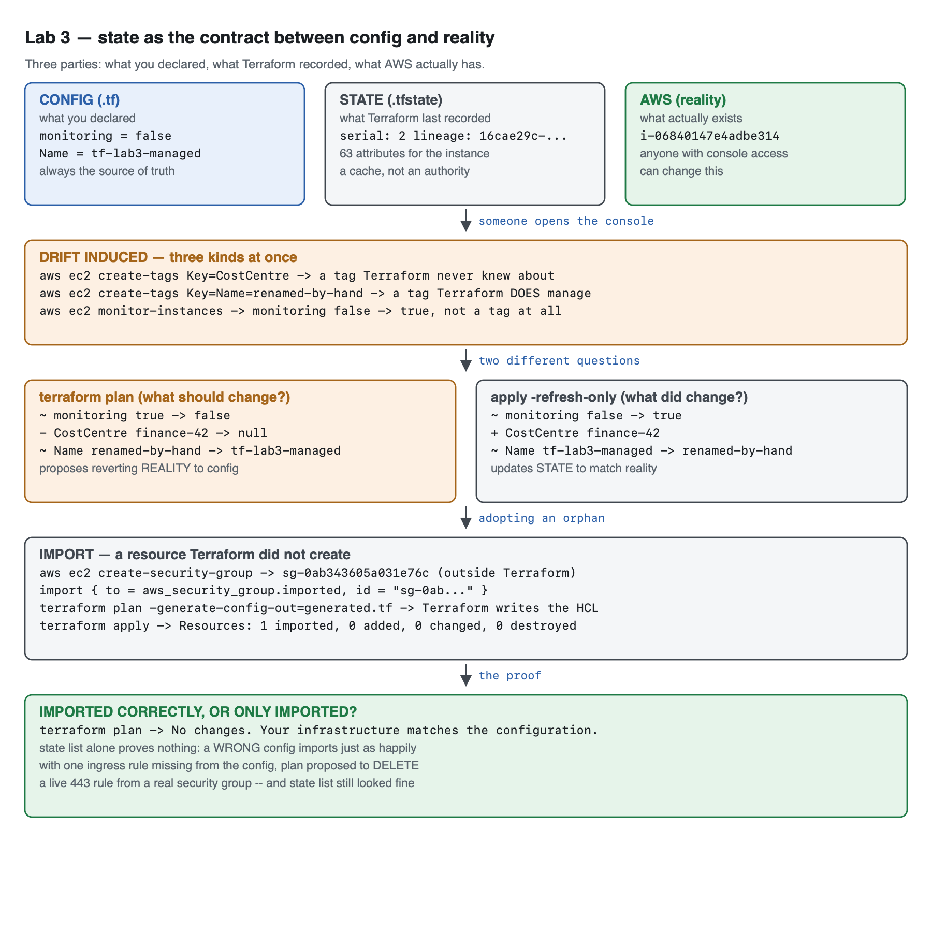
Vector version: lab-3-architecture.svg
The same idea in text:
CONFIG (.tf) STATE (.tfstate) AWS (reality)
what you declared what Terraform recorded what actually exists
monitoring = false serial: 2 i-06840147e4adbe314
Name = tf-lab3-managed 63 stored attributes anyone with console
── source of truth ── ── a cache, not truth ── access can change it
│ │ │
└─────────────────────────┴────────────────────────────┘
│
someone opens the AWS Console
│
▼
DRIFT, three kinds at once:
+ CostCentre=finance-42 a tag Terraform never knew about
~ Name=renamed-by-hand a tag Terraform DOES manage
~ monitoring: false→true not a tag at all — a real attribute
│
┌─────────────────────┴─────────────────────┐
▼ ▼
terraform plan terraform apply -refresh-only
"what SHOULD change?" "what DID change?"
~ monitoring true → false ~ monitoring false → true
- CostCentre finance-42 → null + CostCentre finance-42
~ Name renamed → tf-lab3-managed ~ Name tf-lab3 → renamed
proposes reverting REALITY updates STATE to match reality
│
▼
IMPORT — the opposite direction: a resource Terraform did not create
aws ec2 create-security-group → sg-0ab343605a031e76c (outside Terraform)
import { to = aws_security_group.imported, id = "sg-0ab..." }
terraform plan -generate-config-out=generated.tf → Terraform writes the HCL
terraform apply → "Resources: 1 imported, 0 added, 0 changed, 0 destroyed"
│
▼
THE PROOF: terraform plan → "No changes."
state list alone proves nothing — a wrong config imports just as happily
The sentence to carry out of this lab: the configuration is always the source of truth; state is only Terraform's memory of what it last saw. Every behaviour below follows from that.

4. Step-by-Step Instructions

Step 1 — Deploy something worth inspecting
Why: You need a real resource with a real ID before state means anything.
cat > versions.tf << 'EOF'
terraform {
required_version = ">= 1.5.0"
required_providers {
aws = {
source = "hashicorp/aws"
version = "~> 6.0"
}
}
}
provider "aws" {
region = var.aws_region
}
EOF
cat > variables.tf << 'EOF'
variable "aws_region" {
description = "Region for all resources in this lab."
type = string
default = "us-east-1"
}
variable "monitoring_enabled" {
description = "Whether detailed CloudWatch monitoring is on. Used to demonstrate drift on a non-tag attribute."
type = bool
default = false
}
EOF
cat > main.tf << 'EOF'
data "aws_ami" "al2023" {
most_recent = true
owners = ["amazon"]
filter {
name = "name"
values = ["al2023-ami-2023.*-kernel-6.1-x86_64"]
}
}
locals {
common_tags = {
Course = "intermediate-terraform"
Lab = "3"
ManagedBy = "terraform"
}
}
# The resource we will deliberately drift.
resource "aws_instance" "managed" {
ami = data.aws_ami.al2023.id
instance_type = "t3.micro"
monitoring = var.monitoring_enabled
tags = merge(local.common_tags, {
Name = "tf-lab3-managed"
})
}
output "managed_instance_id" {
value = aws_instance.managed.id
description = "ID of the Terraform-managed instance."
}
EOF
terraform init
terraform apply -auto-approve
Expected output:
Apply complete! Resources: 1 added, 0 changed, 0 destroyed.
Outputs:
managed_instance_id = "i-06840147e4adbe314"

Step 2 — Read the state file
Why: State is the concept people most often treat as magic. It is a JSON file. Read it.
terraform state list
Expected output:
data.aws_ami.al2023
aws_instance.managed
Notice the data source is in state. Terraform caches data source results so it can detect when they change between runs. It does not own that AMI and will never destroy it — the data. prefix is what distinguishes "recorded" from "owned".
terraform state show aws_instance.managed | head -18
Expected output:
# aws_instance.managed:
resource "aws_instance" "managed" {
ami = "ami-025b6f0b1ac2ef9f7"
arn = "arn:aws:ec2:us-east-1:<ACCOUNT_ID>:instance/i-06840147e4adbe314"
associate_public_ip_address = true
availability_zone = "us-east-1d"
disable_api_stop = false
disable_api_termination = false
ebs_optimized = false
force_destroy = false
get_password_data = false
hibernation = false
host_id = null
iam_instance_profile = null
id = "i-06840147e4adbe314"
instance_initiated_shutdown_behavior = "stop"
instance_lifecycle = null
instance_state = "running"
Extracting data from state properly. Do not grep the human-readable output — it is a display format and it changes between versions. terraform show -json is the stable, machine-readable interface:
terraform show -json | python3 -c "
import json,sys
d=json.load(sys.stdin)
for r in d['values']['root_module']['resources']:
if r['mode'] != 'managed':
print(f\"(skipping {r['address']} - mode={r['mode']}, Terraform does not own it)\")
continue
a=r['values']
print(f\"address : {r['address']}\")
print(f\"real id : {a['id']}\")
print(f\"monitoring : {a['monitoring']}\")
print(f\"tags : {a['tags']}\")
"
Expected output:
(skipping data.aws_ami.al2023 - mode=data, Terraform does not own it)
address : aws_instance.managed
real id : i-06840147e4adbe314
monitoring : False
tags : {'Course': 'intermediate-terraform', 'Lab': '3', 'ManagedBy': 'terraform', 'Name': 'tf-lab3-managed'}
The state file's own metadata:
python3 -c "
import json;d=json.load(open('terraform.tfstate'))
print('version :',d['version'])
print('terraform_version:',d['terraform_version'])
print('serial :',d['serial'])
print('lineage :',d['lineage'])
for r in d['resources']:
print(f\" - {r['mode']:8} {r['type']}.{r['name']} ({len(r['instances'][0]['attributes'])} attributes stored)\")
"
Expected output:
version : 4
terraform_version: 1.15.7
serial : 2
lineage : 16cae29c-39f9-202a-8c73-c415c697b37c
- data aws_ami.al2023 (44 attributes stored)
- managed aws_instance.managed (63 attributes stored)
Field | What it is for
version | state format version (4), not your Terraform version
serial | incremented on every state write; how remote backends detect a concurrent write
lineage | a UUID for this state's history — two states with different lineages are not the same infrastructure, and Terraform refuses to mix them
attributes stored | 63 attributes recorded for one EC2 instance, all in plaintext
That last row is the argument for Lab 8's remote backend: 63 plaintext attributes here is harmless, but the same mechanism stores an RDS password exactly as readably.

Step 3 — Induce drift, three different ways
Why: Real drift is not one phenomenon. A tag Terraform manages, a tag it does not, and a non-tag attribute all behave differently, and the differences matter.
ID=$(terraform output -raw managed_instance_id)
# 1. A tag Terraform has never heard of.
aws ec2 create-tags --resources "$ID" --tags Key=CostCentre,Value=finance-42
# 2. A tag Terraform DOES manage.
aws ec2 create-tags --resources "$ID" --tags Key=Name,Value=renamed-by-hand
# 3. Not a tag at all — a real instance attribute.
aws ec2 monitor-instances --instance-ids "$ID" \
--query 'InstanceMonitorings[0].Monitoring.State' --output text
Expected output from the third command: pending (it becomes enabled within a minute).
Confirm AWS's view:
aws ec2 describe-instances --instance-ids "$ID" \
--query 'Reservations[0].Instances[0].{Monitoring:Monitoring.State,Tags:Tags}' --output json
{
"Monitoring": "enabled",
"Tags": [
{ "Key": "CostCentre", "Value": "finance-42" },
{ "Key": "Course", "Value": "intermediate-terraform" },
{ "Key": "ManagedBy", "Value": "terraform" },
{ "Key": "Name", "Value": "renamed-by-hand" },
{ "Key": "Lab", "Value": "3" }
]
}
Before you run the next command, predict the answer: which of those three changes will terraform plan propose to undo?

Step 4 — terraform plan detects the drift
terraform plan
Expected output:
aws_instance.managed: Refreshing state... [id=i-06840147e4adbe314]
Terraform used the selected providers to generate the following execution
plan. Resource actions are indicated with the following symbols:
~ update in-place
Terraform will perform the following actions:
# aws_instance.managed will be updated in-place
~ resource "aws_instance" "managed" {
id = "i-06840147e4adbe314"
~ monitoring = true -> false
~ tags = {
- "CostCentre" = "finance-42" -> null
"Course" = "intermediate-terraform"
"Lab" = "3"
"ManagedBy" = "terraform"
~ "Name" = "renamed-by-hand" -> "tf-lab3-managed"
}
~ tags_all = {
- "CostCentre" = "finance-42" -> null
~ "Name" = "renamed-by-hand" -> "tf-lab3-managed"
# (3 unchanged elements hidden)
}
# (38 unchanged attributes hidden)
}
Plan: 0 to add, 1 to change, 0 to destroy.
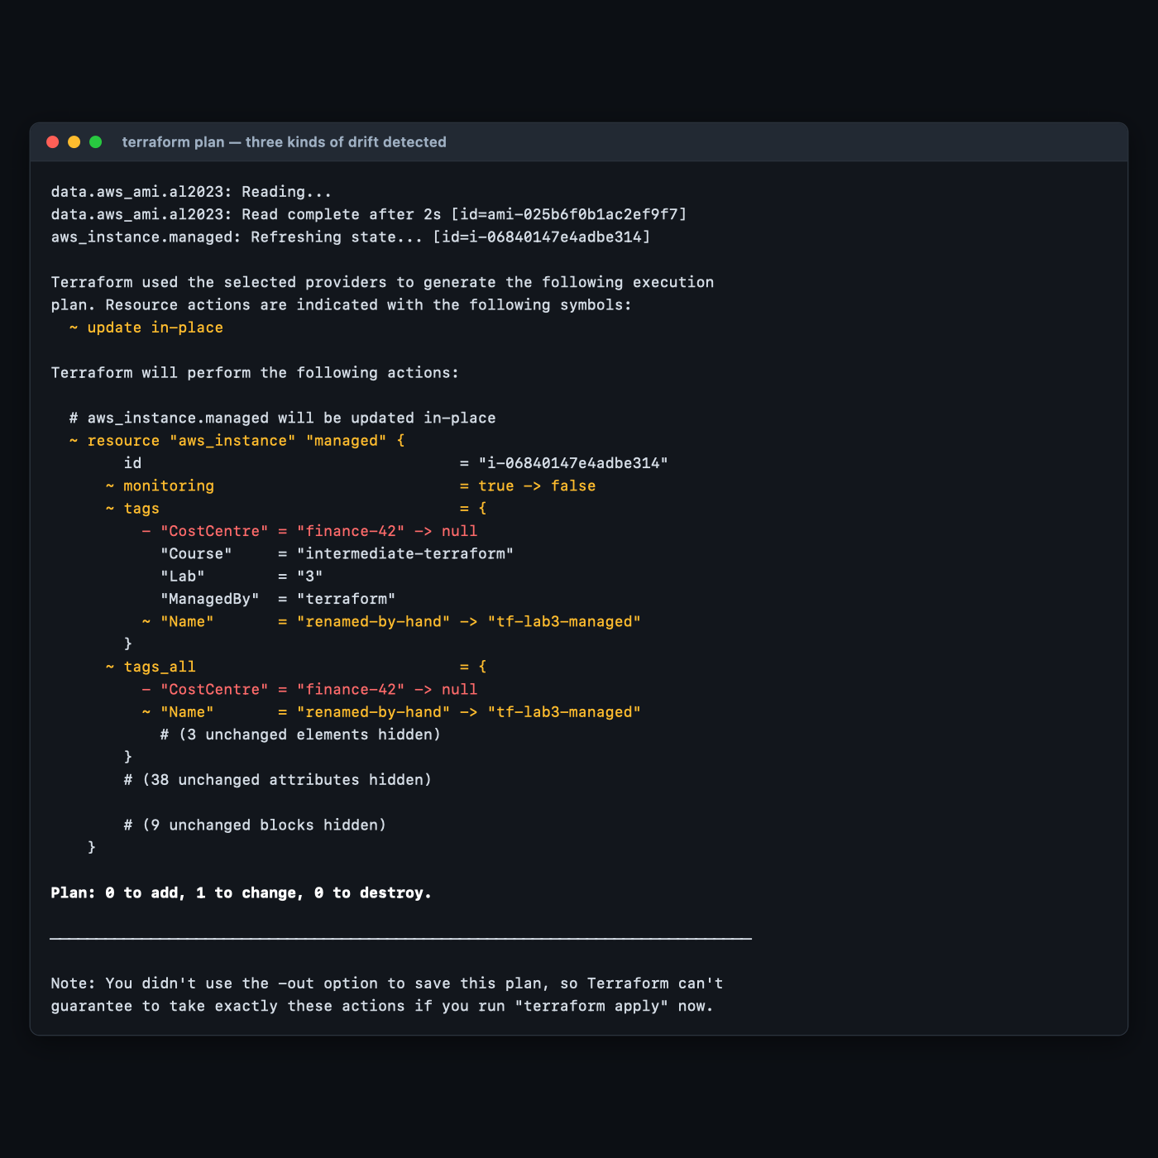
The answer to the prediction: all three. And note what Terraform proposes for each:
Drift | Plan's proposal | Why
CostCentre added | delete it (-> null) | the config's tags map does not contain it, and tags is declared exhaustively
Name changed | revert it | the config says what Name must be
monitoring enabled | turn it back off | the config says monitoring = var.monitoring_enabled, which is false
The CostCentre row is the one that surprises people: Terraform deletes tags it did not create, because tags = { ... } declares the complete desired set. If you need to allow out-of-band tags, that is what lifecycle { ignore_changes = [tags["CostCentre"]] } or provider-level default_tags are for.
For automation, get the answer as an exit code rather than by reading prose:
terraform plan -detailed-exitcode > /dev/null 2>&1; echo "exit: $?"
Expected output: exit: 2 — meaning "changes pending". That is a drift detector.

Step 5 — The same drift, seen the other way round
Why: plan answers "what should change?". Sometimes you need "what did change?" — an audit question, not a remediation one. That is apply -refresh-only.
terraform apply -refresh-only
Expected output:
Note: Objects have changed outside of Terraform
Terraform detected the following changes made outside of Terraform since the
last "terraform apply" which may have affected this plan:
# aws_instance.managed has changed
~ resource "aws_instance" "managed" {
id = "i-06840147e4adbe314"
~ monitoring = false -> true
~ tags = {
+ "CostCentre" = "finance-42"
"Course" = "intermediate-terraform"
"Lab" = "3"
"ManagedBy" = "terraform"
~ "Name" = "tf-lab3-managed" -> "renamed-by-hand"
}
}
This is a refresh-only plan, so Terraform will not take any actions to undo
these. If you were expecting these changes then you can apply this plan to
record the updated values in the Terraform state without changing any remote
objects.
Put the two outputs side by side. The arrows are reversed:
 | terraform plan | apply -refresh-only
Question | what should change? | what did change?
monitoring | true -> false | false -> true
CostCentre | - finance-42 -> null | + finance-42
Changes AWS? | yes, if you apply | never
Changes state? | yes, if you apply | yes, that is its only effect
Same drift. Opposite directions. plan shows reality being dragged back to the config; refresh-only shows state being dragged forward to reality.
Tested gotcha, and a genuine trap: the deprecated terraform refresh command silently writes state with no confirmation prompt. During authoring it was run before apply -refresh-only, and the refresh-only run then reported "No changes. Your infrastructure still matches the configuration" — not because there was no drift, but because refresh had already absorbed it. State's serial had gone 2 → 3. Use apply -refresh-only, which shows you the diff and asks before writing.
Critically, refreshing does not change what plan wants to do. After the refresh, state recorded monitoring: true and Name: renamed-by-hand, and plan still proposed:
~ monitoring = true -> false
- "CostCentre" = "finance-42" -> null
~ "Name" = "renamed-by-hand" -> "tf-lab3-managed"
Plan: 0 to add, 1 to change, 0 to destroy.
The configuration is the source of truth. Updating state changes what Terraform knows, never what it wants.
Now put reality back:
terraform apply -auto-approve

Step 6 — Create a resource Terraform does not know about
Why: Real accounts are full of infrastructure created before Terraform, or beside it. Import is how you adopt it without recreating it — which for a database or a load balancer is the difference between a migration and an outage.
VPC=$(aws ec2 describe-vpcs --filters Name=isDefault,Values=true --query 'Vpcs[0].VpcId' --output text)
SG=$(aws ec2 create-security-group --group-name tf-lab3-orphan-sg \
--description "Created outside Terraform, to be imported" --vpc-id "$VPC" \
--tag-specifications 'ResourceType=security-group,Tags=[{Key=Name,Value=tf-lab3-orphan-sg},{Key=Course,Value=intermediate-terraform},{Key=Lab,Value=3}]' \
--query 'GroupId' --output text)
echo "created: $SG"
aws ec2 authorize-security-group-ingress --group-id "$SG" \
--ip-permissions 'IpProtocol=tcp,FromPort=443,ToPort=443,IpRanges=[{CidrIp=10.0.0.0/8,Description="internal https"}]' \
--query 'SecurityGroupRules[0].SecurityGroupRuleId' --output text
terraform state list
Expected output:
created: sg-0ab343605a031e76c
sgr-01c3a08a585c0a89d
data.aws_ami.al2023
aws_instance.managed
The security group exists and has a real tcp/443 ingress rule. Terraform's state does not mention it. Remember that ingress rule — it becomes the point of the lab in §5.

Step 7 — Import it, and let Terraform write the config
Why: Before Terraform 1.5 you had to hand-write the resource block, run terraform import, then iterate on plan until the diff was empty — tedious and error-prone for anything with many attributes. The import block plus -generate-config-out does the first draft for you.
cat > import.tf << EOF
# Declarative import (Terraform 1.5+). This block says: "the resource I am about
# to describe as aws_security_group.imported already exists in AWS with this ID."
import {
to = aws_security_group.imported
id = "$SG"
}
EOF
terraform plan -generate-config-out=generated.tf
Expected output ends with:
Plan: 1 to import, 0 to add, 0 to change, 0 to destroy.
And Terraform has written generated.tf for you:
# __generated__ by Terraform
# Please review these resources and move them into your main configuration files.
# __generated__ by Terraform from "sg-0ab343605a031e76c"
resource "aws_security_group" "imported" {
description = "Created outside Terraform, to be imported"
egress = [{
cidr_blocks = ["0.0.0.0/0"]
description = ""
from_port = 0
ipv6_cidr_blocks = []
prefix_list_ids = []
protocol = "-1"
security_groups = []
self = false
to_port = 0
}]
ingress = [{
cidr_blocks = ["10.0.0.0/8"]
description = "internal https"
from_port = 443
ipv6_cidr_blocks = []
prefix_list_ids = []
protocol = "tcp"
security_groups = []
self = false
to_port = 443
}]
name = "tf-lab3-orphan-sg"
region = "us-east-1"
revoke_rules_on_delete = null
tags = {
Course = "intermediate-terraform"
Lab = "3"
Name = "tf-lab3-orphan-sg"
}
tags_all = { ... }
vpc_id = "vpc-<REDACTED>"
}
Generated config is a first draft, not a finished artifact. Note what it produced: an egress block you never wrote (AWS adds a default allow-all egress rule to every new security group), a tags_all block that duplicates tags — tags_all is a computed attribute and should normally be deleted — and hardcoded values like vpc_id that you would want to reference or parameterise. The header comment says "Please review"; it means it.
Now perform the import:
terraform apply -auto-approve
Expected output:
Plan: 1 to import, 0 to add, 0 to change, 0 to destroy.
aws_security_group.imported: Importing... [id=sg-0ab343605a031e76c]
aws_security_group.imported: Import complete [id=sg-0ab343605a031e76c]
Apply complete! Resources: 1 imported, 0 added, 0 changed, 0 destroyed.
0 added, 0 changed is the important part: nothing about the real security group was modified. It was adopted, not recreated.
Verify:
terraform state list
terraform plan
data.aws_ami.al2023
aws_instance.managed
aws_security_group.imported
No changes. Your infrastructure matches the configuration.

Step 8 — state rm and the legacy import command
Why: state rm is import's inverse: it makes Terraform forget a resource without destroying it. It is the correct tool when you are splitting one configuration into two, and a catastrophic one if you reach for it thinking it deletes something.
terraform state rm aws_security_group.imported
aws ec2 describe-security-groups --group-ids "$SG" \
--query 'SecurityGroups[0].{ID:GroupId,Name:GroupName}' --output text
Expected output:
Removed aws_security_group.imported
Successfully removed 1 resource instance(s).
sg-0ab343605a031e76c tf-lab3-orphan-sg
Terraform forgot it; AWS did not. The security group is untouched and now unmanaged again.
Re-adopt it with the pre-1.5 command form, which you will still meet in older runbooks. Remove the import block first, or Terraform will try to import a resource that is about to be imported:
rm -f import.tf
terraform import aws_security_group.imported "$SG"
terraform state list
Expected output:
Import successful!
The resources that were imported are shown above. These resources are now in
your Terraform state and will henceforth be managed by Terraform.
data.aws_ami.al2023
aws_instance.managed
aws_security_group.imported
 | import block (1.5+) | terraform import command
Lives in | version-controlled .tf file | shell history
Reviewable in a PR | yes | no
Can generate config | yes, -generate-config-out | no
Runs during | plan and apply | its own command, immediately
Removable after use | yes — delete the block | n/a
Prefer the block. The command still exists and still works.

Step 9 — Do it again yourself, adopt a resource with a real dependency, unassisted
Why: The security group you imported had no relationships. Real adoption is harder precisely because resources reference each other, and a config that hardcodes an ID it should have referenced looks correct until the day the referenced thing is replaced.
Your task. Using the AWS CLI only, create an EC2 instance that uses a new security group — both outside Terraform. Then bring both under Terraform management in this same directory, with the instance's vpc_security_group_ids referencing the imported security group resource, not its literal sg-… string.
You get the acceptance criteria and nothing else:
- Both resources appear in terraform state list.
- terraform plan reports No changes. Your infrastructure matches the configuration.
- grep -c 'sg-0' *.tf returns 0 for the instance's security group argument — the reference is a Terraform expression, not a pasted ID.
- Deleting the imported security group resource from your config and running terraform plan shows Terraform understands the dependency (it will refuse, or propose changes to the instance too).
- terraform destroy removes both cleanly, in the right order, with no DependencyViolation.
Done when you can state why referencing the resource rather than the literal ID matters here, and describe what would go wrong on a future apply if you had pasted the ID instead.
No commands are given here. Steps 6–8 have every mechanism you need; the exercise is that -generate-config-out will hardcode the ID for you, and correcting that is the actual work of an import.

5. Validation / Verification
Save as validate.sh, run after Step 8. Also at lab-3-state-drift/validate.sh.
#!/usr/bin/env bash
# Lab 3 validation. Run from lab-3-state-drift/ after the import step.
set -uo pipefail
fail=0
check() { if [ "$2" = "$3" ]; then echo "PASS $1"; else echo "FAIL $1 (got '$2', want '$3')"; fail=1; fi }
ID=$(terraform output -raw managed_instance_id)
SG=$(terraform state show -no-color aws_security_group.imported | awk '/^ +id +=/{gsub(/"/,"",$3); print $3; exit}')
check "state tracks 3 objects (data + instance + imported sg)" \
"$(terraform state list | wc -l | tr -d ' ')" "3"
check "imported SG is at aws_security_group.imported" \
"$(terraform state list | grep -c '^aws_security_group.imported$')" "1"
check "Name tag reverted to the configured value" \
"$(aws ec2 describe-instances --instance-ids "$ID" --query "Reservations[0].Instances[0].Tags[?Key=='Name']|[0].Value" --output text)" \
"tf-lab3-managed"
check "detailed monitoring reverted to disabled" \
"$(aws ec2 describe-instances --instance-ids "$ID" --query 'Reservations[0].Instances[0].Monitoring.State' --output text)" \
"disabled"
check "untracked CostCentre tag was removed by apply" \
"$(aws ec2 describe-instances --instance-ids "$ID" --query "length(Reservations[0].Instances[0].Tags[?Key=='CostCentre'])" --output text)" \
"0"
check "state holds the real SG id" \
"$(aws ec2 describe-security-groups --group-ids "$SG" --query 'SecurityGroups[0].GroupId' --output text 2>/dev/null)" \
"$SG"
# THE ONE THE HAPPY PATH MISSES: was the import COMPLETE, or only successful?
terraform plan -detailed-exitcode -no-color > /dev/null 2>&1
case $? in
0) echo "PASS import was COMPLETE: plan proposes no changes" ;;
2) echo "FAIL import was PARTIAL: plan wants to alter the imported resource"; fail=1 ;;
*) echo "FAIL plan errored"; fail=1 ;;
esac
echo
[ $fail -eq 0 ] && echo "Lab 3 validation: ALL CHECKS PASSED" || echo "Lab 3 validation: FAILURES ABOVE"
exit $fail
Actual output, exit code 0:
PASS state tracks 3 objects (data + instance + imported sg)
PASS imported SG is at aws_security_group.imported
PASS Name tag reverted to the configured value
PASS detailed monitoring reverted to disabled
PASS untracked CostCentre tag was removed by apply
PASS state holds the real SG id
PASS import was COMPLETE: plan proposes no changes
Lab 3 validation: ALL CHECKS PASSED

Why check 7 is the only one that matters
Checks 1–6 all confirm the import happened. None of them confirm it was right. Here is the measurement.
The generated config was edited to remove the ingress rule — simulating the very common case of a hand-written import config that missed an attribute:
# in generated.tf, replace the ingress block with:
ingress = []
./validate.sh
Six checks passed. One failed. Exit code 1:
PASS state tracks 3 objects (data + instance + imported sg)
PASS imported SG is at aws_security_group.imported
PASS Name tag reverted to the configured value
PASS detailed monitoring reverted to disabled
PASS untracked CostCentre tag was removed by apply
PASS state holds the real SG id
FAIL import was PARTIAL: plan wants to alter the imported resource
Lab 3 validation: FAILURES ABOVE
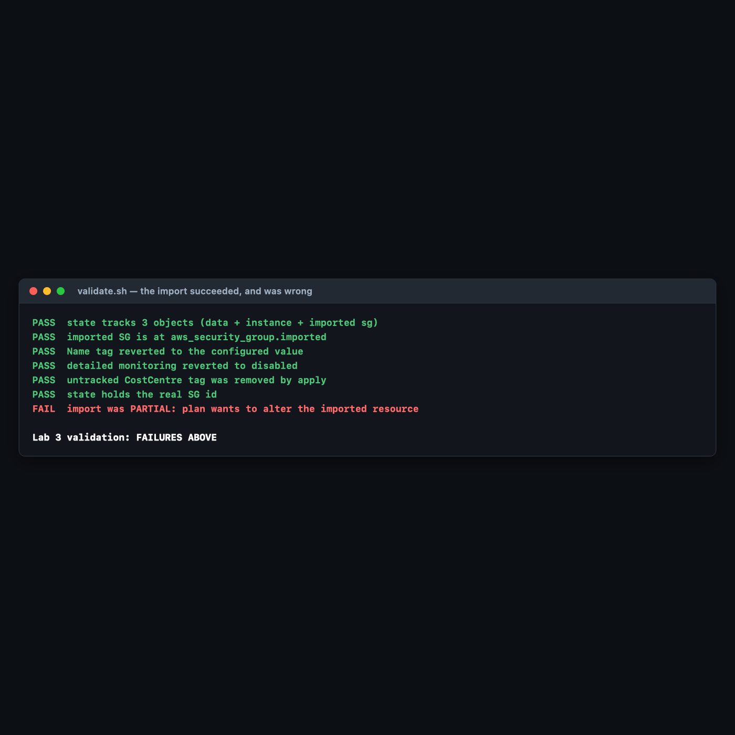
And this is what terraform plan was proposing to do to a live security group:
# aws_security_group.imported will be updated in-place
- cidr_blocks = [
- from_port = 443
- to_port = 443
Plan: 0 to add, 1 to change, 0 to destroy.
Terraform was about to delete a tcp/443 ingress rule from a real firewall — silently, as part of an ordinary apply, because the configuration did not mention it and the configuration is the source of truth.
terraform state list looked perfect throughout. The resource was imported. The import was also wrong. The only proof that an import is correct is an empty plan, and that is why every import runbook should end with terraform plan -detailed-exitcode rather than with "import successful".

6. Troubleshooting Tips
All encountered for real while building this lab.
terraform show -json | ... fails with KeyError
Hit during authoring: iterating over root_module.resources includes data sources, which do not have the attributes a managed resource has (monitoring, in that case). Filter on r['mode'] == 'managed' before touching attributes.
terraform state show output contains escape codes when redirected
terraform state show colourises even into a pipe. Pass -no-color explicitly — unlike plan, it is not inferred from the absence of a TTY in every version.
apply -refresh-only says "No changes" when you know there is drift
Something already refreshed the state — most likely the deprecated terraform refresh, which writes state with no prompt. Check whether serial in terraform.tfstate has advanced. This happened during authoring and is documented in Step 5.
Error: Duplicate import configuration for ...
You left import.tf in place and also ran terraform import on the command line. Terraform will not import the same address twice. Delete the block once the import is applied — that is the intended lifecycle for an import block.
Import succeeds but plan immediately wants to change everything
The normal state of affairs on a first attempt, and the reason -generate-config-out exists. Work through the diff attribute by attribute until the plan is empty. Do not apply to "make the diff go away" — that changes real infrastructure to match an incomplete config, which is precisely the §5 failure.
terraform state rm did not delete anything in AWS
Correct, and by design. state rm makes Terraform forget; destroy deletes. If you meant to delete, you now have an unmanaged resource still costing money — find it with the tag-based query in 00-shared-setup.md §6.

7. Cleanup Steps
terraform destroy -auto-approve
Expected output:
aws_security_group.imported: Destruction complete after 2s
aws_instance.managed: Still destroying... [id=i-06840147e4adbe314, 00m20s elapsed]
aws_instance.managed: Destruction complete after 21s
Destroy complete! Resources: 2 destroyed.
Note what just happened. The security group was created by the AWS CLI, not by Terraform — but once imported, Terraform owns it, and destroy deleted it. Confirmed:
aws: [ERROR]: An error occurred (InvalidGroup.NotFound) when calling the
DescribeSecurityGroups operation: The security group 'sg-0ab343605a031e76c' does not exist
Import is not read-only. Importing a production database you did not intend to manage puts it one terraform destroy away from deletion. Import deliberately, and consider lifecycle { prevent_destroy = true } on anything irreplaceable.
Confirm nothing survived:
aws ec2 describe-instances \
--filters Name=tag:Course,Values=intermediate-terraform \
Name=instance-state-name,Values=running,pending,stopped \
--query 'Reservations[].Instances[].InstanceId' --output text
aws ec2 describe-security-groups \
--filters Name=tag:Course,Values=intermediate-terraform \
--query 'SecurityGroups[].GroupId' --output text
Expected output: nothing from either command.
Keep these, and here is why:
Keep | Why
terraform.tfstate | Post-destroy it holds serial and lineage with zero resources — worth reading once more to see what an empty state looks like.
generated.tf | A reference example of what -generate-config-out actually produces, including the egress and tags_all blocks you have to clean up.
validate.sh | The partial-import check is worth copying into your real import runbooks.

Optional extensions
- Protect against the destroy you just saw. Re-run the import, add lifecycle { prevent_destroy = true } to the imported security group, then try terraform destroy. Read the error. That one line is the difference between an adopted production resource and a deleted one.
- Tolerate out-of-band tags. Add lifecycle { ignore_changes = [tags["CostCentre"]] } to the instance, re-add the CostCentre tag with the CLI, and run plan. Terraform now leaves it alone — the mechanism for coexisting with a cost-allocation system that tags your resources.
- Try provider-level default_tags. Move common_tags into the provider "aws" block as default_tags. Observe how tags and tags_all diverge in the plan output, and decide which you prefer for a real project.
- Break the lineage on purpose. Copy terraform.tfstate aside, run terraform apply -auto-approve, then restore the copy and run plan. The serial mismatch is exactly what a remote backend uses to stop two engineers writing state simultaneously — which is Lab 8.
- Build a real drift report. Script terraform plan -detailed-exitcode across several directories, collecting which ones return 2. That is a functioning drift-detection system, and it is about fifteen lines of shell.

