Lab 5 — Templates, Modules & Workspaces
DataCouch — Intermediate Terraform
Table of Contents

Maps to: Templates; Reuse Patterns in Terraform (Workspaces, Outputs, Modules — local and external/GitHub); Nested Directory Modules Duration: ~90 minutes Status: Tested end-to-end on 2026-09-05 (Terraform v1.15.7, AWS provider v6.63.0, terraform-aws-modules/vpc/aws v5.21.0) against a live AWS account in us-east-1. Two complete environments were deployed, verified over HTTP and destroyed.
Prerequisites: 00-shared-setup.md, Labs 1–4 — especially Lab 4, whose mini-app becomes this lab's module.

1. Lab Overview & Objectives
At the end of Lab 4 you were told to notice a feeling: copy-pasting a resource block and changing one letter. This lab is the cure.
You will package Lab 4's web server into a reusable local module, pull in an external module from the public registry for the network, and then deploy two complete environments — dev and prod — from exactly the same code, differing only in the value of terraform.workspace.
The measurable end state: three running instances across two isolated VPCs, and not one .tf file that differs between environments.
Learning objectives — by the end of this lab you will be able to:
- Write a module with a deliberate interface — typed variables in, outputs out — and explain why a module must never reach outside itself for values.
- Consume an external module from the Terraform Registry, and read the version constraints it imposes on your configuration.
- Use workspaces to deploy the same configuration multiple times with isolated state, and state honestly what workspaces do not isolate.
- Choose between workspaces and separate root directories for real environment separation.
The most surprising measured result in this lab: the obvious way to guard against an invalid workspace — a lifecycle { precondition { ... } } block — does not work. Terraform evaluated the module arguments first and failed with Attempt to get attribute from null value, pointing at a line in the VPC module that had nothing to do with the real problem. The fix was to stop being clever: a direct map index produces an error naming the actual workspace. §4 Step 3 shows both error messages side by side.

2. Prerequisites & Environment Setup

2.1 Software
Requirement | Tested with
Terraform CLI | v1.15.7
AWS provider | v6.63.0
External module | terraform-aws-modules/vpc/aws v5.21.0 (resolved from ~> 5.0)
AWS CLI v2 | 2.35.11
bash | 3.2.57 — the version macOS ships. See the §5 portability note.

2.2 Cost and time
Resources created | 27 total: 13 in dev, 14 in prod
Billable | 3 instances — 1 × t3.micro (dev) + 2 × t3.small (prod)
Measured price | dev $0.0104/hr; prod $0.0416/hr (2 × $0.0208)
Both environments together | $0.052/hr
Measured apply time | ~60s (dev), ~70s (prod)
Realistic cost | under $0.10 if you destroy at the end
Hands-on time | ~90 minutes
This is the most expensive lab in the course, because it is the only one that deliberately runs two environments at once. enable_nat_gateway = false is set on the VPC module for exactly this reason — the module's default would have added two NAT gateways at ~$0.045/hour each, which is more than every other resource in this course combined.

2.3 Setup
mkdir -p ~/terraform-course/lab-5-modules/modules/web-server
cd ~/terraform-course/lab-5-modules
export AWS_REGION=us-east-1 AWS_DEFAULT_REGION=us-east-1
export TF_PLUGIN_CACHE_DIR="$HOME/.terraform.d/plugin-cache"

3. Architecture
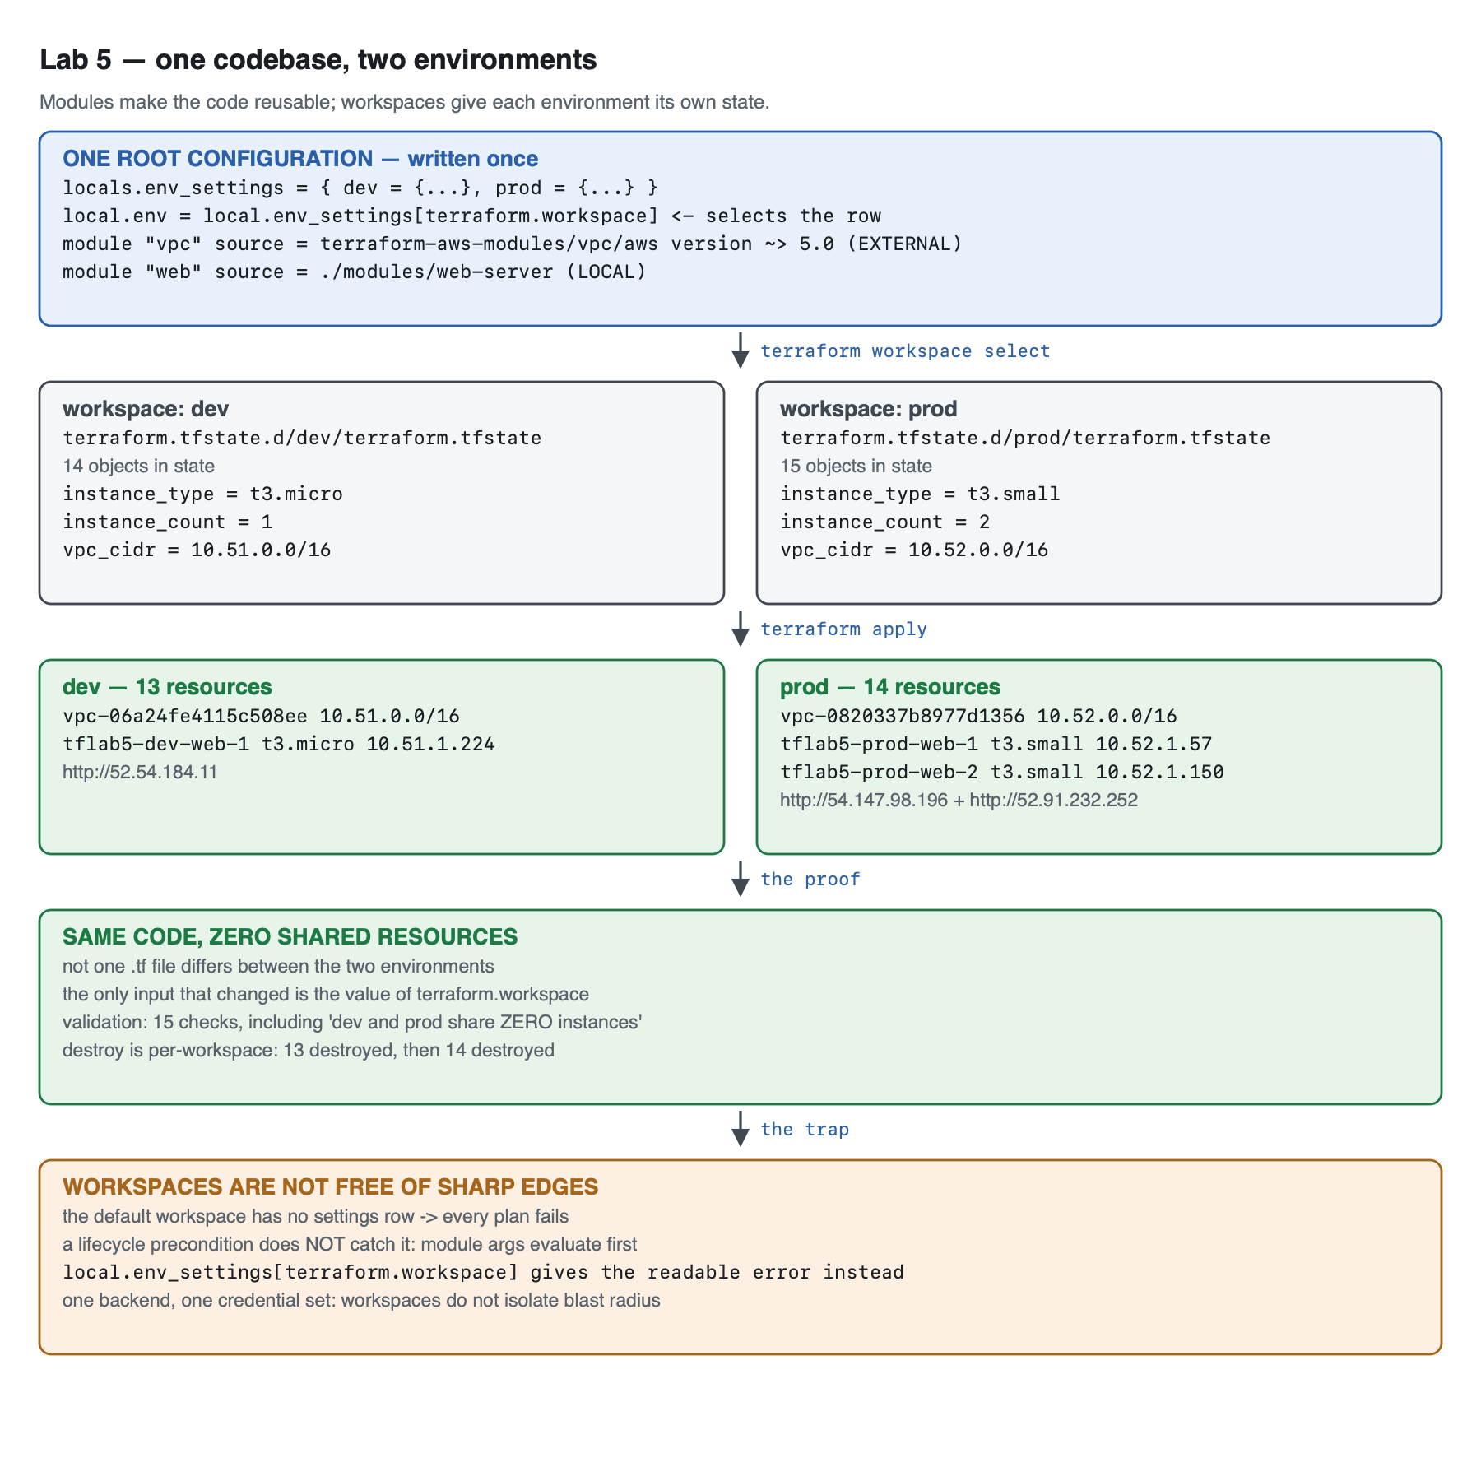
Vector version: lab-5-architecture.svg
ONE ROOT CONFIGURATION (written once)
locals.env_settings = { dev = {...}, prod = {...} }
local.env = local.env_settings[terraform.workspace] ← selects one row
│
├── module "vpc" source = terraform-aws-modules/vpc/aws ~> 5.0 EXTERNAL
└── module "web" source = ./modules/web-server LOCAL
│
┌───────────────────────────┴────────────────────────────┐
│ │
workspace: dev workspace: prod
terraform.tfstate.d/dev/terraform.tfstate terraform.tfstate.d/prod/terraform.tfstate
14 objects in state 15 objects in state
t3.micro × 1 10.51.0.0/16 t3.small × 2 10.52.0.0/16
│ │
▼ ▼
13 AWS resources 14 AWS resources
vpc-06a24fe4115c508ee vpc-0820337b8977d1356
tflab5-dev-web-1 10.51.1.224 tflab5-prod-web-1 10.52.1.57
http://52.54.184.11 tflab5-prod-web-2 10.52.1.150
http://54.147.98.196
http://52.91.232.252
Zero .tf files differ between them. Zero shared AWS resources.
The module boundary is the point. modules/web-server/ knows nothing about workspaces, environments, or which VPC it lives in. It receives a vpc_id and a subnet_id and returns urls and instance_ids. That ignorance is what makes it reusable — a module that reads terraform.workspace internally is not a module, it is a copy of your root config with extra steps.

4. Step-by-Step Instructions

Step 1 — Write the module's interface first
Why: A module's variables and outputs are its API, and the API is the part you cannot casually change later once other configurations depend on it. Design it before the implementation.
cat > modules/web-server/variables.tf << 'EOF'
# A module's variables are its API. Everything a caller may set lives here,
# with a type, a description, and a default only where a sane one exists.
variable "name" {
description = "Base name for resources this module creates. Must be unique per caller."
type = string
}
variable "subnet_id" {
description = "Subnet to place the instance in. The caller owns the network."
type = string
}
variable "vpc_id" {
description = "VPC the security group is created in."
type = string
}
variable "instance_type" {
description = "EC2 instance type."
type = string
default = "t3.micro"
}
variable "instance_count" {
description = "How many identical web servers to create."
type = number
default = 1
validation {
condition = var.instance_count >= 1 && var.instance_count <= 5
error_message = "instance_count must be between 1 and 5 (a lab guardrail, not an AWS limit)."
}
}
variable "allowed_http_cidr" {
description = "CIDR permitted to reach port 80."
type = string
default = "0.0.0.0/0"
}
variable "environment" {
description = "Environment label, surfaced on the served page and in tags."
type = string
}
variable "tags" {
description = "Additional tags merged onto every resource."
type = map(string)
default = {}
}
EOF
Which variables have defaults, and which do not, is a design decision. name, subnet_id, vpc_id and environment have none — there is no sensible default, and a caller who forgets one should get an error, not a surprise. instance_type and instance_count have defaults because "one small server" is a reasonable thing to want.
The module does not create a VPC. It takes one as input. A module that creates its own network can only ever be used once per network, and cannot be composed. Push ownership of shared infrastructure up to the caller.

Step 2 — Implement the module, then its outputs
cat > modules/web-server/main.tf << 'EOF'
terraform {
required_version = ">= 1.5.0"
required_providers {
aws = {
source = "hashicorp/aws"
version = "~> 6.0"
}
}
}
data "aws_ami" "al2023" {
most_recent = true
owners = ["amazon"]
filter {
name = "name"
values = ["al2023-ami-2023.*-kernel-6.1-x86_64"]
}
}
locals {
module_tags = merge(var.tags, {
Module = "web-server"
Environment = var.environment
})
}
resource "aws_security_group" "web" {
name = "${var.name}-web-sg"
description = "HTTP in, all out - managed by the web-server module"
vpc_id = var.vpc_id
tags = merge(local.module_tags, { Name = "${var.name}-web-sg" })
}
resource "aws_vpc_security_group_ingress_rule" "http" {
security_group_id = aws_security_group.web.id
description = "HTTP"
cidr_ipv4 = var.allowed_http_cidr
from_port = 80
to_port = 80
ip_protocol = "tcp"
}
resource "aws_vpc_security_group_egress_rule" "all" {
security_group_id = aws_security_group.web.id
description = "All outbound"
cidr_ipv4 = "0.0.0.0/0"
ip_protocol = "-1"
}
resource "aws_instance" "web" {
count = var.instance_count
ami = data.aws_ami.al2023.id
instance_type = var.instance_type
subnet_id = var.subnet_id
vpc_security_group_ids = [aws_security_group.web.id]
user_data = templatefile("${path.module}/user-data.sh.tftpl", {
name = var.name
environment = var.environment
index = count.index + 1
total = var.instance_count
})
user_data_replace_on_change = true
tags = merge(local.module_tags, { Name = "${var.name}-web-${count.index + 1}" })
}
EOF
${path.module} is mandatory here, not decorative. It resolves to the module's own directory. Write templatefile("user-data.sh.tftpl", ...) instead and Terraform looks in the root module's directory, and the module breaks the moment someone calls it from anywhere else.
${var.name} prefixes every resource name because the caller may instantiate this module more than once. aws_security_group.web with a hardcoded name = "web-sg" collides on the second call.
The outputs:
cat > modules/web-server/outputs.tf << 'EOF'
# A module communicates results ONLY through outputs. Nothing else it creates
# is reachable from the caller.
output "instance_ids" {
description = "IDs of every instance this module created."
value = aws_instance.web[*].id
}
output "public_ips" {
description = "Public IPv4 addresses of every instance."
value = aws_instance.web[*].public_ip
}
output "urls" {
description = "Ready-to-open URLs, one per instance."
value = [for ip in aws_instance.web[*].public_ip : "http://${ip}"]
}
output "security_group_id" {
description = "The security group the module created."
value = aws_security_group.web.id
}
output "instance_count" {
description = "How many instances the module actually created."
value = length(aws_instance.web)
}
EOF
Outputs are the only way out of a module. From the root you can write module.web.urls; you cannot write module.web.aws_instance.web[0].private_ip. If a caller needs it, the module must export it. This is a feature: it is what lets you rewrite a module's internals without breaking callers.
Two expression forms worth naming:
- aws_instance.web[*].id — the splat operator. With count, aws_instance.web is a list; the splat maps over it. Returns [] when count = 0, which is exactly what you want.
- [for ip in ... : "http://${ip}"] — a for expression, building the URL list. Lab 7 covers these properly.
Finally the template. It is the Lab 4 script with two extra inputs so the page announces which environment it belongs to:
cat > modules/web-server/user-data.sh.tftpl << 'EOF'
#!/bin/bash
set -euxo pipefail
dnf install -y nginx
TOKEN=$(curl -sX PUT "http://169.254.169.254/latest/api/token" \
-H "X-aws-ec2-metadata-token-ttl-seconds: 300")
meta() { curl -s -H "X-aws-ec2-metadata-token: $TOKEN" "http://169.254.169.254/latest/meta-data/$1"; }
cat > /usr/share/nginx/html/index.html << HTML
<!doctype html>
<title>${name} — ${environment}</title>
<style>
body{font-family:system-ui,sans-serif;max-width:40rem;margin:4rem auto;padding:0 1rem}
h1{color:#2b5fa8} .env{display:inline-block;padding:.2rem .6rem;border-radius:.3rem;
background:#e8f0fb;color:#2b5fa8;font-weight:600} dt{font-weight:600;margin-top:.6rem}
dd{margin:0;font-family:ui-monospace,Menlo,monospace}
</style>
<h1>${name}</h1>
<p><span class="env">${environment}</span> &nbsp; server ${index} of ${total}</p>
<dl>
<dt>Instance ID</dt><dd>$(meta instance-id)</dd>
<dt>Instance type</dt><dd>$(meta instance-type)</dd>
<dt>Availability zone</dt><dd>$(meta placement/availability-zone)</dd>
<dt>Private IP</dt><dd>$(meta local-ipv4)</dd>
<dt>Built at</dt><dd>$(date -u +%Y-%m-%dT%H:%M:%SZ)</dd>
</dl>
HTML
systemctl enable --now nginx
EOF

Step 3 — The root configuration: workspace-driven settings
Why: This is where the two environments are actually distinguished — in one locals block, rather than in two copies of a directory.
cat > versions.tf << 'EOF'
terraform {
required_version = ">= 1.5.0"
required_providers {
aws = {
source = "hashicorp/aws"
version = "~> 6.0"
}
}
}
provider "aws" {
region = var.aws_region
default_tags {
tags = {
Course = "intermediate-terraform"
Lab = "5"
ManagedBy = "terraform"
Workspace = terraform.workspace
}
}
}
EOF
cat > variables.tf << 'EOF'
variable "aws_region" {
description = "Region for all environments."
type = string
default = "us-east-1"
}
variable "project_name" {
description = "Project prefix, shared across workspaces."
type = string
default = "tflab5"
}
EOF
cat > main.tf << 'EOF'
# ---------------------------------------------------------------------------
# Per-workspace settings. ONE definition, selected by terraform.workspace.
# This is what makes dev and prod the same code with different inputs.
# ---------------------------------------------------------------------------
locals {
env_settings = {
dev = {
instance_type = "t3.micro"
instance_count = 1
vpc_cidr = "10.51.0.0/16"
}
prod = {
instance_type = "t3.small"
instance_count = 2
vpc_cidr = "10.52.0.0/16"
}
}
# Direct index, NOT lookup(..., null): an unknown workspace must fail here,
# with a message naming the key, rather than yielding null and failing later
# somewhere unrelated.
env = local.env_settings[terraform.workspace]
name = "${var.project_name}-${terraform.workspace}"
}
# ---------------------------------------------------------------------------
# EXTERNAL module, from the public Terraform Registry (backed by GitHub).
# We did not write this and do not maintain it.
# ---------------------------------------------------------------------------
module "vpc" {
source = "terraform-aws-modules/vpc/aws"
version = "~> 5.0"
name = "${local.name}-vpc"
cidr = local.env.vpc_cidr
azs = ["${var.aws_region}a"]
public_subnets = [cidrsubnet(local.env.vpc_cidr, 8, 1)]
# A NAT gateway costs ~$32/month and this lab does not need one.
enable_nat_gateway = false
map_public_ip_on_launch = true
tags = { Environment = terraform.workspace }
}
# ---------------------------------------------------------------------------
# LOCAL module, the one we wrote, called with per-workspace values.
# ---------------------------------------------------------------------------
module "web" {
source = "./modules/web-server"
name = local.name
environment = terraform.workspace
vpc_id = module.vpc.vpc_id
subnet_id = module.vpc.public_subnets[0]
instance_type = local.env.instance_type
instance_count = local.env.instance_count
tags = { Project = var.project_name }
}
EOF
cat > outputs.tf << 'EOF'
output "workspace" {
description = "Which workspace produced this deployment."
value = terraform.workspace
}
output "settings_used" {
description = "The per-workspace settings that were selected."
value = local.env
}
output "vpc_id" {
description = "VPC created by the EXTERNAL registry module."
value = module.vpc.vpc_id
}
output "urls" {
description = "Every web server URL in this environment."
value = module.web.urls
}
output "instance_ids" {
description = "Every instance ID in this environment."
value = module.web.instance_ids
}
EOF

A measured detour: how not to validate the workspace
The first version of this lab tried to catch an unsupported workspace properly, with lookup(local.env_settings, terraform.workspace, null) and a guard resource:
resource "terraform_data" "workspace_guard" {
lifecycle {
precondition {
condition = local.env != null
error_message = "Workspace '${terraform.workspace}' has no entry in local.env_settings..."
}
}
}
It does not work. Run in the default workspace, that carefully-written error message never appeared. This is what came out instead:
Error: Attempt to get attribute from null value
on main.tf line 49, in module "vpc":
49: cidr = local.env.vpc_cidr
├────────────────
│ local.env is null
This value is null, so it does not have any attributes.
Terraform evaluated the module arguments before the guard resource's precondition, so the run died on a null-attribute access pointing at the VPC module — a line that has nothing to do with the actual mistake. Preconditions guard that resource's own creation; they are not a general assertion mechanism that runs first.
Deleting the guard and indexing the map directly produces this instead:
Error: Invalid index
on main.tf line 23, in locals:
23: env = local.env_settings[terraform.workspace]
├────────────────
│ local.env_settings is object with 2 attributes
│ terraform.workspace is "default"
The given key does not identify an element in this collection value.
It names the file, the line, the workspace, and the fact that the key is missing. lookup() with a default is the wrong tool when there is no valid default — it converts a loud failure into a quiet null that surfaces somewhere else. The shipped configuration uses the direct index.

Step 4 — terraform init, and read what it tells you about the external module
terraform init
Expected output:
Initializing modules...
- web in modules/web-server
Downloading registry.terraform.io/terraform-aws-modules/vpc/aws 5.21.0 for vpc...
- vpc in .terraform/modules/vpc
Initializing provider plugins found in the configuration...
- terraform.io/builtin/terraform is built in to Terraform
- Finding hashicorp/aws versions matching ">= 5.79.0, ~> 6.0"...
- Installing hashicorp/aws v6.63.0...
- Installed hashicorp/aws v6.63.0 (signed by HashiCorp)
Terraform has been successfully initialized!
Three things to read carefully:
- Local modules are not downloaded. - web in modules/web-server — Terraform just references the directory. Edit the module and the change takes effect immediately, with no init.
- External modules are downloaded and pinned. ~> 5.0 resolved to v5.21.0, copied into .terraform/modules/vpc. Changing the constraint requires terraform init -upgrade.
- >= 5.79.0, ~> 6.0 is a merged constraint. You wrote ~> 6.0. The VPC module contributes >= 5.79.0 of its own. Terraform intersects every constraint in the dependency tree. An external module can therefore constrain your provider version — and if two modules disagree irreconcilably, init fails and you cannot use them together.
You are running someone else's code. terraform-aws-modules/vpc/aws is well maintained and widely used, but a registry module is arbitrary code executed with your AWS credentials. Pin the version (never a bare source with no version), read the changelog before bumping, and for anything sensitive, vendor it or fork it.

Step 5 — Create the workspaces and deploy dev
terraform workspace list
terraform workspace new dev
terraform workspace new prod
terraform workspace list
Expected output:
* default
default
dev
* prod
The * marks the current workspace. workspace new both creates and switches.
terraform workspace select dev
terraform apply -auto-approve
Expected output:
Switched to workspace "dev".
module.web.aws_instance.web[0]: Creating...
module.web.aws_instance.web[0]: Creation complete after 16s [id=i-0838a59d810c6b183]
Apply complete! Resources: 13 added, 0 changed, 0 destroyed.
Outputs:
instance_ids = [
"i-0838a59d810c6b183",
]
settings_used = {
"instance_count" = 1
"instance_type" = "t3.micro"
"vpc_cidr" = "10.51.0.0/16"
}
urls = [
"http://52.54.184.11",
]
vpc_id = "vpc-06a24fe4115c508ee"
workspace = "dev"

Step 6 — Deploy prod from the identical code
Why: This is the moment the lab either works or does not. Change no files. Switch workspace and apply.
terraform workspace select prod
terraform apply -auto-approve
Expected output:
Switched to workspace "prod".
module.web.aws_instance.web[0]: Creation complete after 16s [id=i-017e3d4ecd6af5af2]
module.web.aws_instance.web[1]: Creation complete after 16s [id=i-09f7f89362fe712f4]
Apply complete! Resources: 14 added, 0 changed, 0 destroyed.
Outputs:
instance_ids = [
"i-017e3d4ecd6af5af2",
"i-09f7f89362fe712f4",
]
settings_used = {
"instance_count" = 2
"instance_type" = "t3.small"
"vpc_cidr" = "10.52.0.0/16"
}
urls = [
"http://54.147.98.196",
"http://52.91.232.252",
]
vpc_id = "vpc-0820337b8977d1356"
workspace = "prod"
Two instances instead of one. t3.small instead of t3.micro. A different VPC CIDR. Zero file edits.

Step 7 — See both environments at once
find terraform.tfstate.d -name '*.tfstate' | sort
aws ec2 describe-instances \
--filters Name=tag:Course,Values=intermediate-terraform Name=instance-state-name,Values=running \
--query 'sort_by(Reservations[].Instances[],&Tags[?Key==`Name`]|[0].Value)[].{Name:Tags[?Key==`Name`]|[0].Value,Workspace:Tags[?Key==`Workspace`]|[0].Value,Type:InstanceType,AZ:Placement.AvailabilityZone,PrivateIP:PrivateIpAddress}' \
--output table
Expected output:
terraform.tfstate.d/dev/terraform.tfstate
terraform.tfstate.d/prod/terraform.tfstate
-----------------------------------------------------------------------------
| DescribeInstances |
+------------+---------------------+--------------+-----------+-------------+
| AZ | Name | PrivateIP | Type | Workspace |
+------------+---------------------+--------------+-----------+-------------+
| us-east-1a| tflab5-dev-web-1 | 10.51.1.224 | t3.micro | dev |
| us-east-1a| tflab5-prod-web-1 | 10.52.1.57 | t3.small | prod |
| us-east-1a| tflab5-prod-web-2 | 10.52.1.150 | t3.small | prod |
+------------+---------------------+--------------+-----------+-------------+
That table is the deliverable of this lab. Two environments, correct sizes, correct counts, non-overlapping private IP ranges, distinguished automatically by the Workspace tag that default_tags applied from terraform.workspace.
Open the pages. They know which environment they are:
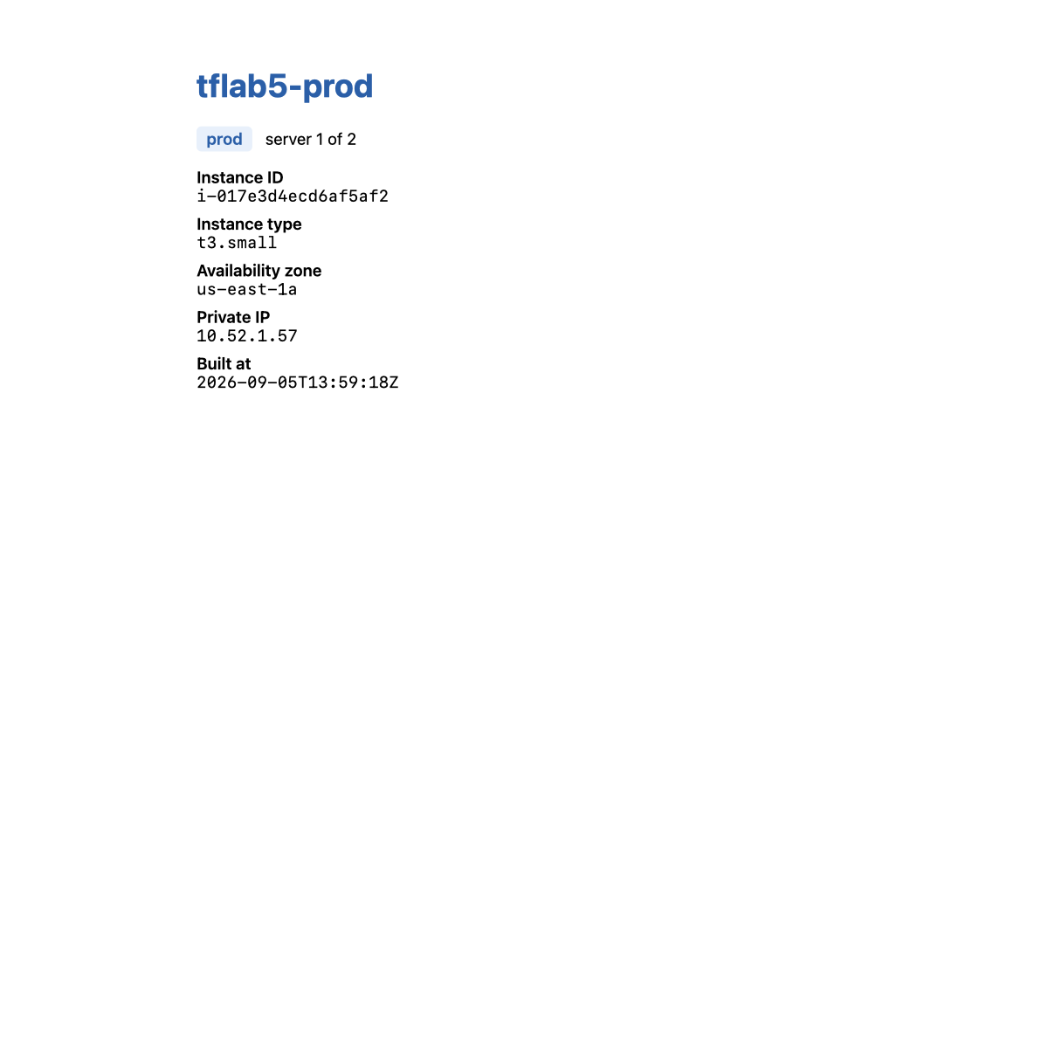
<h1>tflab5-prod</h1>
<p><span class="env">prod</span> &nbsp; server 1 of 2</p>
<dt>Instance ID</dt><dd>i-017e3d4ecd6af5af2</dd>
<dt>Instance type</dt><dd>t3.small</dd>
The dev page (lab-5-dev-page.png) says dev, server 1 of 1, t3.micro.

Step 8 — Where workspaces stop being the right answer
Why: Workspaces are frequently recommended for environment separation, and frequently the wrong tool for it. Knowing the boundary is more valuable than knowing the commands.
Workspaces isolate | Workspaces do not isolate
State — separate state file per workspace | The backend — one backend, one bucket, one lock table
Resource addresses — no collisions between environments | Credentials — the same AWS identity for dev and prod
Outputs | The code path — a bad apply in the wrong workspace hits prod
 | Permissions — nothing stops you applying prod from your laptop
The failure mode is a one-word mistake: you believe you are in dev, you are in prod, and terraform destroy does not ask which environment you meant. Guard against it:
terraform workspace show # make this a habit before every apply
Use workspaces for: short-lived parallel copies of the same thing — per-developer sandboxes, per-pull-request preview environments, testing a refactor beside the original.
Use separate root directories (environments/dev/, environments/prod/), each with its own backend and credentials, for: anything where dev and prod have different blast radii. This is what most production organisations do, and the module you wrote in Steps 1–2 is reusable across them unchanged — which is the real payoff of module-based design.

Step 9 — Do it again yourself, add a third environment, unassisted
Why: The claim this lab makes is that adding an environment is now cheap. Test the claim.
Your task. Add a staging environment: 1 × t3.small, in 10.53.0.0/16, deployed and serving, alongside dev and prod. Then make the module do something it currently cannot: give staging a restricted allowed_http_cidr — only your own IP may reach it — while dev and prod stay open.
You get the acceptance criteria and nothing else:
- terraform workspace list shows four workspaces; three have deployed infrastructure.
- Adding staging required edits to one file only, and no changes at all under modules/web-server/.
- curl from your machine gets 200 from the staging URL; the same URL from any other network gets a timeout.
- terraform output settings_used in staging reports t3.small, count 1, 10.53.0.0/16.
- The dev and prod environments are byte-identical to before — terraform plan in each reports no changes.
- All three destroy cleanly.
Done when you can say how many lines you had to change to add a whole environment, and explain why allowed_http_cidr belonged in env_settings rather than as a new module variable — or argue convincingly that it did not.
No commands are given here. Steps 3–6 have every pattern. The interesting part is that allowed_http_cidr is already a module variable with a default, so the module needs no change at all — noticing that is the exercise.

5. Validation / Verification
Save as validate.sh. Also at lab-5-modules/validate.sh.
Portability note, learned the hard way: the first version of this script used bash associative arrays (declare -A). macOS ships bash 3.2.57, where declare -A silently creates an ordinary array and the script dies with line 17: dev: unbound variable under set -u. The version below uses case functions and runs on bash 3.2.
#!/usr/bin/env bash
# Lab 5 validation. Run from lab-5-modules/. Checks BOTH workspaces.
set -uo pipefail
fail=0
check() { if [ "$2" = "$3" ]; then echo "PASS $1"; else echo "FAIL $1 (got '$2', want '$3')"; fail=1; fi }
want_type() { case "$1" in dev) echo t3.micro;; prod) echo t3.small;; esac; }
want_count() { case "$1" in dev) echo 1;; prod) echo 2;; esac; }
want_cidr() { case "$1" in dev) echo 10.51.0.0/16;; prod) echo 10.52.0.0/16;; esac; }
ORIG=$(terraform workspace show)
DEV_IDS=""; PROD_IDS=""
check "dev and prod workspaces both exist" \
"$(terraform workspace list | grep -cE '^\*? *(dev|prod)$')" "2"
check "each workspace has an isolated state file" \
"$(find terraform.tfstate.d -name '*.tfstate' | wc -l | tr -d ' ')" "2"
for ws in dev prod; do
terraform workspace select "$ws" >/dev/null 2>&1
check "[$ws] instance_count from the workspace map" \
"$(terraform output -json instance_ids | python3 -c 'import json,sys;print(len(json.load(sys.stdin)))')" \
"$(want_count "$ws")"
check "[$ws] instance_type from the workspace map" \
"$(terraform output -json settings_used | python3 -c 'import json,sys;print(json.load(sys.stdin)["instance_type"])')" \
"$(want_type "$ws")"
check "[$ws] VPC CIDR from the workspace map" \
"$(aws ec2 describe-vpcs --vpc-ids "$(terraform output -raw vpc_id)" --query 'Vpcs[0].CidrBlock' --output text)" \
"$(want_cidr "$ws")"
for url in $(terraform output -json urls | python3 -c 'import json,sys;[print(u) for u in json.load(sys.stdin)]'); do
check "[$ws] HTTP 200 from $url" \
"$(curl -s -o /dev/null -w '%{http_code}' --max-time 15 "$url")" "200"
check "[$ws] page reports its own environment" \
"$(curl -sS --max-time 15 "$url" | sed -n 's/.*<span class="env">\([a-z]*\)<\/span>.*/\1/p')" "$ws"
done
ids=$(terraform output -json instance_ids | python3 -c 'import json,sys;print(" ".join(sorted(json.load(sys.stdin))))')
if [ "$ws" = "dev" ]; then DEV_IDS="$ids"; else PROD_IDS="$ids"; fi
done
# THE ONE THE HAPPY PATH MISSES: are the two environments genuinely SEPARATE?
OVERLAP=$(python3 -c "
import sys
d=set('''$DEV_IDS'''.split()); p=set('''$PROD_IDS'''.split())
print(len(d & p))
")
check "dev and prod share ZERO instances" "$OVERLAP" "0"
terraform workspace select "$ORIG" >/dev/null 2>&1
echo
[ $fail -eq 0 ] && echo "Lab 5 validation: ALL CHECKS PASSED" || echo "Lab 5 validation: FAILURES ABOVE"
exit $fail
Actual output — 15 checks, exit code 0:
PASS dev and prod workspaces both exist
PASS each workspace has an isolated state file
PASS [dev] instance_count from the workspace map
PASS [dev] instance_type from the workspace map
PASS [dev] VPC CIDR from the workspace map
PASS [dev] HTTP 200 from http://52.54.184.11
PASS [dev] page reports its own environment
PASS [prod] instance_count from the workspace map
PASS [prod] instance_type from the workspace map
PASS [prod] VPC CIDR from the workspace map
PASS [prod] HTTP 200 from http://54.147.98.196
PASS [prod] page reports its own environment
PASS [prod] HTTP 200 from http://52.91.232.252
PASS [prod] page reports its own environment
PASS dev and prod share ZERO instances
Lab 5 validation: ALL CHECKS PASSED
The last check is the one the happy path cannot catch. Every other check would still pass if both workspaces somehow addressed the same instances — which is precisely what happens when someone parameterises a module but leaves one resource name unqualified. Intersecting the two instance-ID sets and asserting the result is empty is the only assertion here that tests separation rather than existence.

6. Troubleshooting Tips
All hit for real while building this lab.
line 17: dev: unbound variable from a validation script
bash 3.2 (macOS default) does not support declare -A associative arrays. It creates a normal array instead, and set -u then trips on the string subscript. Use case functions, or install a newer bash — but scripts you hand to a class should assume 3.2.
Error: Attempt to get attribute from null value pointing at a module argument
A lookup(..., null) somewhere upstream returned null and the error surfaced at first use, not at the mistake. See Step 3. Index the map directly so it fails where the problem is.
Error: Invalid index ... terraform.workspace is "default"
You are in the default workspace, which has no settings row. terraform workspace select dev. This is the good error — it tells you exactly what is wrong.
init fails resolving provider versions after adding an external module
External modules contribute their own required_providers constraints, and Terraform intersects them all. This lab's merged constraint was >= 5.79.0, ~> 6.0. If a module demands < 6.0 and you demand ~> 6.0, there is no solution and you must upgrade the module, downgrade your constraint, or drop one of them.
Editing the module changes nothing
Check whether you edited modules/web-server/ (the source) or .terraform/modules/ (a downloaded copy of an external module). Local modules are referenced in place and need no init; external ones are copies, and edits there are overwritten on the next init.
terraform destroy in the wrong workspace
There is no undo. Run terraform workspace show before anything destructive. This is the single biggest argument against using workspaces for real environment separation — see Step 8.
Registry module downloads fail behind a corporate proxy
terraform init fetches from registry.terraform.io over HTTPS. If it is blocked, either configure the proxy environment variables, or change source to a Git URL your network permits — source = "git::https://github.com/terraform-aws-modules/terraform-aws-vpc.git?ref=v5.21.0" is the same code, pinned by tag.

7. Cleanup Steps
Destroy each workspace separately — destroy only ever affects the current one.
for ws in dev prod; do
terraform workspace select "$ws"
terraform destroy -auto-approve
done
terraform workspace select default
Expected output:
=== destroying dev ===
Destroy complete! Resources: 13 destroyed.
=== destroying prod ===
Destroy complete! Resources: 14 destroyed.
Then remove the empty workspaces:
terraform workspace delete dev
terraform workspace delete prod
terraform workspace list
Deleted workspace "dev"!
Deleted workspace "prod"!
* default
Terraform refuses to delete a workspace whose state still holds resources — a genuinely useful guardrail. If workspace delete complains, you have not destroyed everything in it.
Confirm nothing survived — three instances and two VPCs should now be zero:
aws ec2 describe-instances \
--filters Name=tag:Course,Values=intermediate-terraform \
Name=instance-state-name,Values=running,pending,stopped \
--query 'Reservations[].Instances[].InstanceId' --output text
aws ec2 describe-vpcs --filters Name=tag:Course,Values=intermediate-terraform \
--query 'Vpcs[].VpcId' --output text
Expected output: nothing from either.
Keep these, and here is why:
Keep | Why
modules/web-server/ | The actual deliverable of this lab. It is reusable, versionable, and independent of everything around it. Lab 8 uses the same shape.
main.tf | The workspace-settings pattern is the piece most worth copying into real work.
.terraform.lock.hcl | Records aws v6.63.0 alongside the external module's constraint.
terraform.tfstate.d/ | Now empty of resources; worth looking at once to see the per-workspace layout.

Optional extensions
- Publish the module properly. Push modules/web-server/ to its own Git repository, tag it v0.1.0, and change the root source to git::https://github.com/<you>/<repo>.git?ref=v0.1.0. Now bump the tag and watch terraform init -upgrade pick it up. This is how module versioning works in practice.
- Compare workspaces against directories. Restructure into environments/dev/ and environments/prod/, each a tiny root module calling the same modules/web-server. Note what gets better (independent backends, credentials, plan safety) and what gets worse (duplicated root files). Then decide which you would use at work.
- Break the module boundary on purpose. Add terraform.workspace to the module's main.tf and observe that everything still works — then try to call that module twice from one root, or reuse it from a config that does not use workspaces. The failure explains the rule.
- Add a moved block. Rename aws_instance.web to aws_instance.server inside the module and watch plan propose to destroy and recreate everything. Then add moved { from = aws_instance.web to = aws_instance.server } and watch the plan go quiet. This is how you refactor a module that other people already depend on.
- Cost the NAT gateway you avoided. Set enable_nat_gateway = true and run terraform plan. Count the resources it adds, then price them. This lab's total cost is under ten cents; that one flag would have made it the most expensive thing in the course.

