Lab 6 — Error Handling & Debugging
DataCouch — Intermediate Terraform
Table of Contents

Maps to: Error Handling and Debugging in Terraform (Terraform vs. Provider errors, Pre-Induced Errors, dealing with conditional resource output) Duration: ~60 minutes Status: Tested end-to-end on 2026-09-05 (Terraform v1.15.7, AWS provider v6.63.0) against a live AWS account in us-east-1. Every error message below is real output from a real failed run. One exception is stated explicitly in §4 Step 6 — the IAM scenario could not be executed on this account and ships as a reference artifact instead.
Prerequisites: 00-shared-setup.md, Labs 1–5.

1. Lab Overview & Objectives
You are given a configuration with four deliberate faults, and your job is to get from a failing run to a clean terraform apply.
The faults are not random. Each one surfaces at a different stage of the Terraform lifecycle, and that is the actual subject of the lab: where an error appears tells you what kind of error it is, and therefore where to look for the fix. A syntax error and a 403 from the AWS API are not the same species of problem, and treating them the same way is why debugging Terraform feels arbitrary to people who have not learned this map.
Learning objectives — by the end of this lab you will be able to:
- Classify a Terraform failure by the stage it surfaces at — init/validate, plan, or apply — and predict where the fix lives from that alone.
- Distinguish a Terraform error (your HCL) from a provider error (the AWS API's answer), including the HTTP status codes that separate them.
- Reference a conditional (count-based) resource's attributes correctly, and explain why the obvious fix passes terraform validate and then fails at plan.
- Use TF_LOG to read the raw API request and response when the error message alone is not enough.
The most surprising measured result in this lab: terraform validate reported Success! The configuration is valid. on a configuration that could not produce a plan. validate checks syntax and types but never evaluates variable values, so an out-of-range index like aws_instance.bastion[0] — where count is 0 — sails straight through it and dies at plan. A green validate in CI is much weaker evidence than most pipelines assume. §4 Step 4 has both outputs.

2. Prerequisites & Environment Setup

2.1 Software
Requirement | Tested with
Terraform CLI | v1.15.7
AWS provider | v6.63.0
AWS CLI v2 | 2.35.11

2.2 Cost and time
Resources created | 1 × t3.micro (plus a second, briefly, when the bastion is enabled)
Measured price | $0.0104/hr
Failed applies cost | nothing — a rejected RunInstances call creates no instance
Realistic cost | under $0.02
Hands-on time | ~60 minutes
The failing runs in this lab are free. Every provider error here is a 400 rejection, which means AWS never created anything to bill you for. That is worth knowing generally: a failed apply costs nothing for the resources that failed, but resources created before the failure are real and are billing you. terraform apply is not transactional.

2.3 Setup
mkdir -p ~/terraform-course/lab-6-debugging && cd ~/terraform-course/lab-6-debugging
export AWS_REGION=us-east-1 AWS_DEFAULT_REGION=us-east-1
export TF_PLUGIN_CACHE_DIR="$HOME/.terraform.d/plugin-cache"
The broken starter is committed at lab-6-debugging/broken/; the reference solution is at lab-6-debugging/fixed/. Work in broken/ and do not read fixed/ until you are done — the whole value of this lab is in the struggle.

3. Architecture
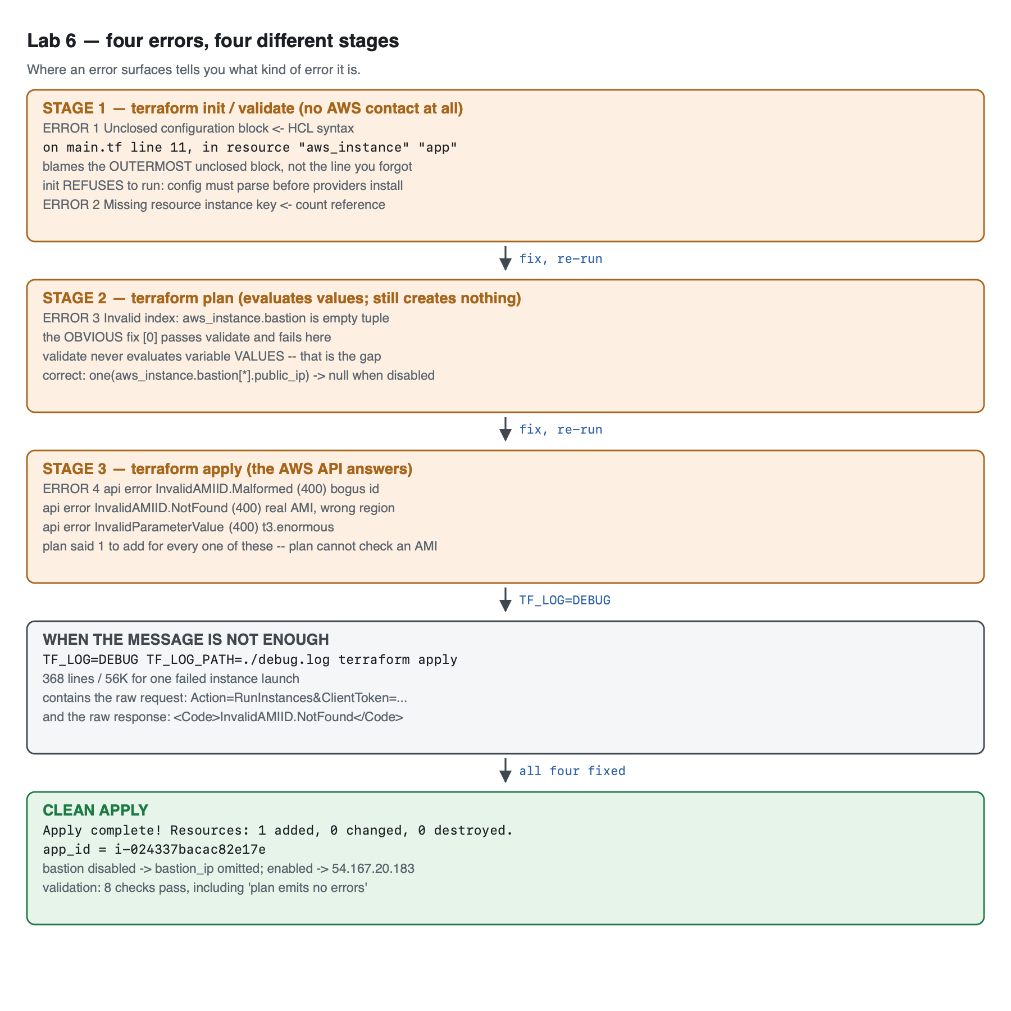
Vector version: lab-6-architecture.svg
The debugging map — memorise this table, not the individual messages:
STAGE 1 terraform init / validate no AWS contact whatsoever
├─ ERROR 1 Unclosed configuration block ← HCL syntax
└─ ERROR 2 Missing resource instance key ← count reference
Fix lives in: your HCL. Nothing else can be wrong.
STAGE 2 terraform plan evaluates values; creates nothing
└─ ERROR 3 Invalid index: ... is empty tuple ← count is 0
Fix lives in: your expressions. Note validate PASSED this.
STAGE 3 terraform apply the AWS API finally answers
├─ ERROR 4a InvalidAMIID.Malformed (HTTP 400) bogus AMI id
├─ ERROR 4b InvalidAMIID.NotFound (HTTP 400) real AMI, wrong region
├─ ERROR 4c InvalidParameterValue (HTTP 400) t3.enormous
└─ ERROR 4d UnauthorizedOperation (HTTP 403) IAM says no [see §4 Step 6]
Fix lives in: 400 → your config. 403 → your IAM policy.
WHEN THE MESSAGE IS NOT ENOUGH
TF_LOG=DEBUG TF_LOG_PATH=./debug.log terraform apply
→ 368 lines, 56K, containing the literal request and the literal response
The single most useful heuristic in this table: if plan succeeded and apply failed, the problem is not your HCL — it is something only AWS could know. And within those, 400 means you asked for something impossible; 403 means you asked for something forbidden. One is fixed in .tf, the other in IAM.

4. Step-by-Step Instructions

Step 1 — Meet the broken configuration
Why: Read it before running it. Predicting failures is a better exercise than reacting to them.
cd broken
cat main.tf outputs.tf
The starter contains four deliberate faults. See how many you can spot:
resource "aws_instance" "app" {
ami = "ami-00000000000000000"
instance_type = "t3.micro"
tags = {
Name = "tf-lab6-app"
}
resource "aws_instance" "bastion" {
count = var.enable_bastion ? 1 : 0
...
}
output "bastion_ip" {
value = aws_instance.bastion.public_ip
}

Step 2 — ERROR 1: the syntax error, and why it blames the wrong line
terraform init
Expected output:
Error: Terraform encountered problems during initialisation, including problems
with the configuration, described below.
The Terraform configuration must be valid before initialization so that
Terraform can determine which modules and providers need to be installed.
Error: Unclosed configuration block
on main.tf line 11, in resource "aws_instance" "app":
11: resource "aws_instance" "app" {
There is no closing brace for this block before the end of the file. This may
be caused by incorrect brace nesting elsewhere in this file.
Two things to take from this:
- init refused to run at all. Terraform must parse the configuration before it can know which providers to download. A syntax error therefore blocks even the plugin download — which surprises people who think of init as a purely mechanical step.
- The reported line is 11, but the missing brace is on line 17. HCL reports the outermost unclosed block, because from the parser's point of view the resource block on line 11 is the one that never ended. When you get an unclosed-block error, the line number is where the block started, not where you made the mistake. Search downward from it.
The fix is one brace:
tags = {
Name = "tf-lab6-app"
}
}
terraform fmt finds this class of bug faster than reading. Run terraform fmt on a file with mismatched braces and it will either fix the indentation in a way that makes the problem obvious, or refuse and tell you where it gave up.

Step 3 — ERROR 2: referencing a counted resource as if it were one thing
terraform init
terraform validate
Expected output:
Error: Missing resource instance key
on outputs.tf line 8, in output "bastion_ip":
8: value = aws_instance.bastion.public_ip
Because aws_instance.bastion has "count" set, its attributes must be accessed
on specific instances.
For example, to correlate with indices of a referring resource, use:
aws_instance.bastion[count.index]
This is an excellent error message: it names the file, the line, the cause, and a fix. Adding count to a resource changes its type — aws_instance.bastion stops being an object and becomes a list of objects. Every reference to it must change accordingly.

Step 4 — The obvious fix is also wrong, and validate will not tell you
Why: This is the most valuable step in the lab. The suggested fix in that error message is correct for a correlated resource and wrong for a conditional one.
Apply the obvious fix:
output "bastion_ip" {
value = aws_instance.bastion[0].public_ip
}
terraform validate
Expected output:
Success! The configuration is valid.
It is not valid. Run a plan:
terraform plan
Expected output:
Error: Invalid index
on outputs.tf line 8, in output "bastion_ip":
8: value = aws_instance.bastion[0].public_ip
├────────────────
│ aws_instance.bastion is empty tuple
The given key does not identify an element in this collection value: the
collection has no elements.
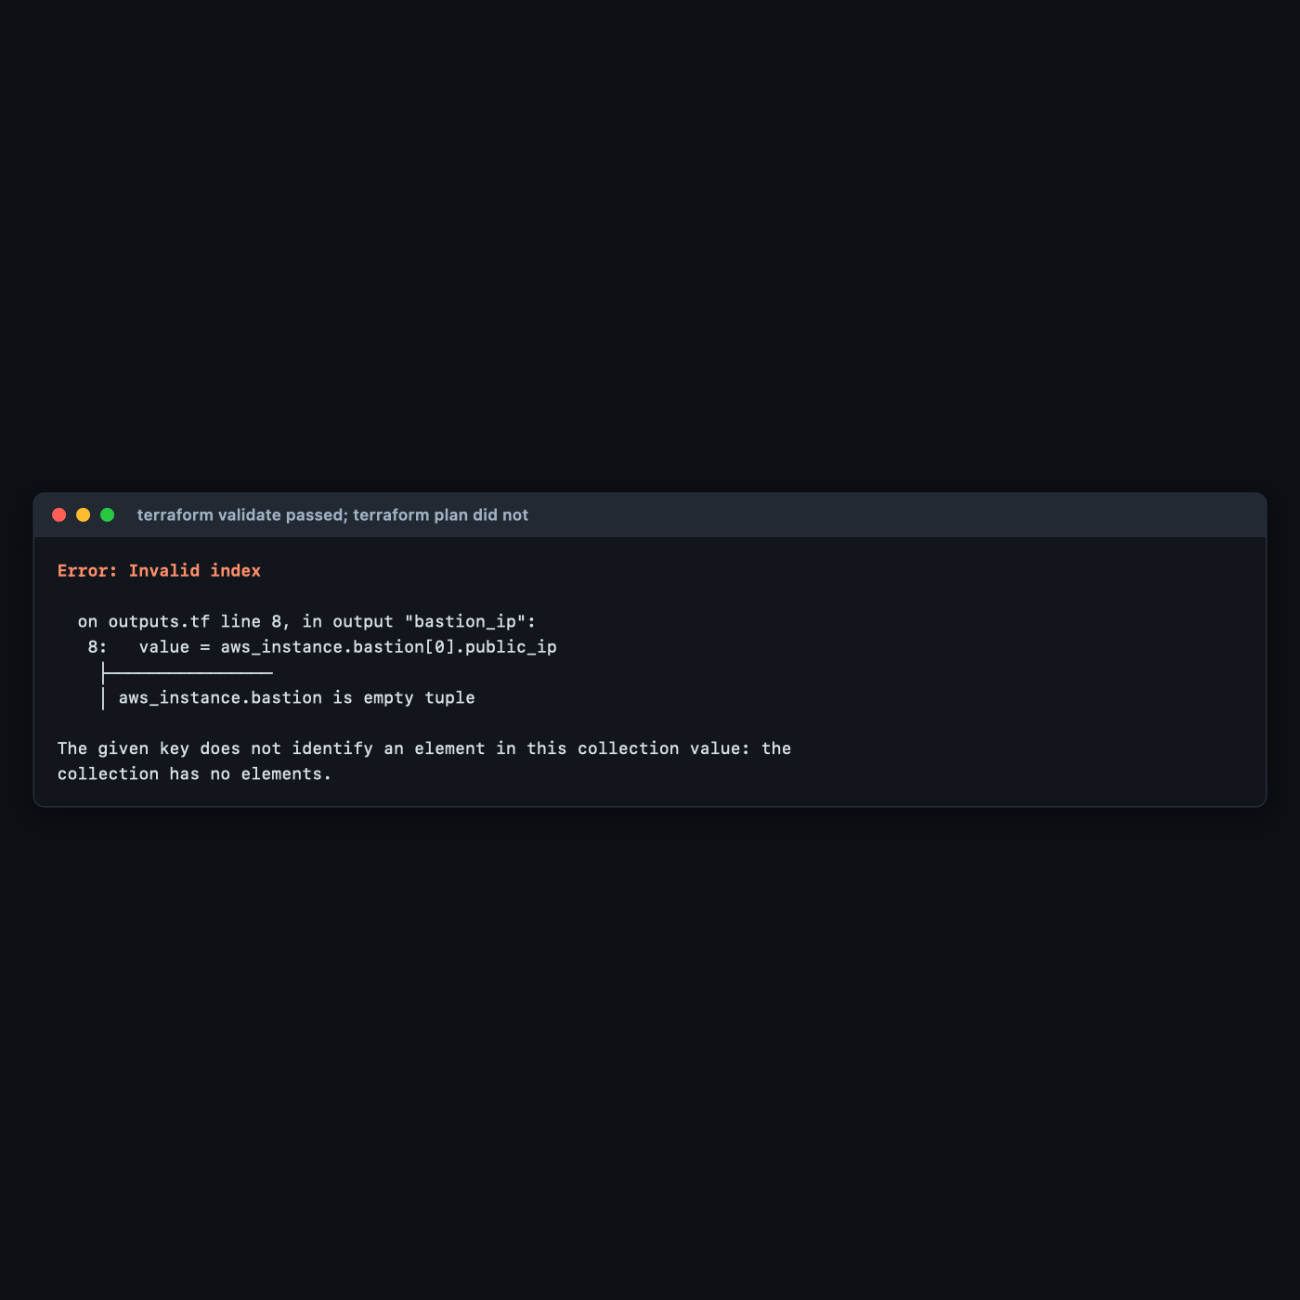
var.enable_bastion defaults to false, so count = 0, so the list is empty, so [0] does not exist.
Why validate passed: terraform validate checks that the configuration is syntactically valid and internally consistent — that referenced resources exist, that types line up, that arguments are known. It does not evaluate variable values, and it makes no API calls. It therefore cannot know that count will be 0. This is the gap: a CI pipeline whose only Terraform check is terraform validate will happily merge this code. Run terraform plan in CI, against real credentials, if you want the stronger guarantee.
The correct fix uses one():
# CORRECT: one() collapses a 0-or-1 element list to a single value or null.
# Works whether enable_bastion is true or false. try() would also work but
# hides genuine errors; one() only tolerates the empty case.
output "bastion_ip" {
description = "Bastion public IP, or null when the bastion is disabled."
value = one(aws_instance.bastion[*].public_ip)
}
Approach | count = 0 | count = 1 | Verdict
aws_instance.bastion.public_ip | error at validate | error at validate | always wrong with count
aws_instance.bastion[0].public_ip | error at plan | works | the trap
one(aws_instance.bastion[*].public_ip) | null | the IP | correct
try(aws_instance.bastion[0].public_ip, null) | null | the IP | works, but swallows unrelated errors too
one() is the purpose-built function: it takes a list of zero or one elements and returns null or that element, and it errors loudly if the list has more than one — which is exactly the behaviour you want from a conditional resource, and exactly what try() would hide.
Both directions were verified. With the bastion disabled, the output is simply absent (Terraform omits null outputs):
{'app_id': 'i-024337bacac82e17e'}
With -var enable_bastion=true, the same unchanged expression resolves:
aws_instance.bastion[0]: Creation complete after 18s [id=i-0da2afb87947556e2]
Apply complete! Resources: 1 added, 0 changed, 0 destroyed.
Outputs:
app_id = "i-024337bacac82e17e"
bastion_ip = "54.167.20.183"

Step 5 — ERROR 3: provider errors, which only apply can find
Why: Everything so far was Terraform disagreeing with your HCL. This is AWS disagreeing with your request, and it is a different debugging problem.
Now that the expressions are fixed, plan succeeds:
+ app_id = (known after apply)
Plan: 1 to add, 0 to change, 0 to destroy.
Plan says it will work. Apply:
terraform apply -auto-approve
Expected output:
Error: creating EC2 Instance: operation error EC2: RunInstances, https response error
StatusCode: 400, RequestID: 47cc041c-c41f-48e3-ada0-37ab716c8763,
api error InvalidAMIID.Malformed: Invalid id: "ami-00000000000000000" (expecting "ami-...")
with aws_instance.app,
on main.tf line 11, in resource "aws_instance" "app":
11: resource "aws_instance" "app" {
Terraform could not have caught this. Whether ami-00000000000000000 is a real image is a fact about AWS's inventory, not about your configuration. This is the fundamental limit of plan: it validates structure, and AWS validates meaning.
Three distinct provider errors, all captured from real runs:
What was wrong | Real error | Status
ami-00000000000000000 | InvalidAMIID.Malformed: Invalid id ... (expecting "ami-...") | 400
A real AMI, but from us-west-2 (ami-0bea529386a62a2ad) | InvalidAMIID.NotFound: The image id '[ami-0bea529386a62a2ad]' does not exist | 400
instance_type = "t3.enormous" | InvalidParameterValue: Invalid value 't3.enormous' for InstanceType. | 400
The middle one is the realistic failure — it is exactly what happens when someone copies an AMI ID out of a colleague's config or a blog post written for another region. It is also precisely the failure the Lab 1 practice task was designed around.
An expectation that did not survive testing. Before running these, the assumption was that a plausible-looking fake ID (ami-0123456789abcdef0 — the right length, valid hex) would return InvalidAMIID.NotFound while only a malformed one returned Malformed. It did not: AWS returned InvalidAMIID.Malformed for that ID too. Only a genuinely well-formed AMI ID belonging to another region produced NotFound. The Malformed / NotFound boundary is drawn by AWS's own validation rules, not by whether an ID looks right — do not infer more from these codes than they actually distinguish.
The fix is not to find a correct AMI ID. It is to stop hardcoding one — the data source is already in the file:
resource "aws_instance" "app" {
ami = data.aws_ami.al2023.id
instance_type = "t3.micro"

Step 6 — ERROR 4: the permission error, and why this lab does not show you real output for it
Why: Authorization failures are the fourth class, and they are the ones where the fix is not in your configuration at all.
This is the one thing in Lab 6 that was not executed. Stating why, plainly:
The AWS account these labs were authored against uses root user credentials (arn:aws:iam::<ACCOUNT_ID>:root). The root user cannot be denied by an IAM policy attached to itself. Constraining root requires an AWS Organizations Service Control Policy, which would mean modifying a live organisation — not an acceptable thing for a lab to do to someone's account. Rather than fabricate console output, the scenario ships as a runnable reference artifact: lab-6-debugging/reference/iam-denied-scenario.md.
If you are running these labs with a proper IAM user or role — which 00-shared-setup.md §3.2 recommends — you can execute it yourself in about five minutes. It attaches a deny policy, asks Terraform for a forbidden instance type, and produces an UnauthorizedOperation error.
What matters even without running it is the classification:
 | Malformed input | Denied by policy
Surfaces at | apply | apply
HTTP status | 400 | 403
Message names | the bad value | the IAM principal and action
Fix lives in | your .tf files | your IAM policy
A 403 means your configuration is probably correct. That is the single most useful thing to know about this error class, because the instinct on any failed apply is to start editing HCL — and here that is guaranteed to waste your time.

Step 7 — When the message is not enough: TF_LOG
Why: Occasionally the error is a bare 400 with no useful body, or a provider bug, or a timeout with no explanation. TF_LOG shows you the actual HTTP conversation.
TF_LOG=DEBUG TF_LOG_PATH=./debug.log terraform apply -auto-approve
wc -l debug.log
Expected output: roughly 368 lines / 56K for a single failed instance launch.
grep -n 'InvalidAMIID' debug.log | head -3
Expected output — the raw XML AWS actually sent back:
360: | <Response><Errors><Error><Code>InvalidAMIID.NotFound</Code><Message>The image id
'[ami-0bea529386a62a2ad]' does not exist</Message></Error></Errors><RequestID>be88e717-...
362: [DEBUG] provider.terraform-provider-aws_v6.63.0_x5: request failed with unretryable error
https response error StatusCode: 400, RequestID: be88e717-...
And the request Terraform sent, which is often the more useful half:
grep -n 'Action=RunInstances' debug.log | head -2
355: [DEBUG] provider.terraform-provider-aws_v6.63.0_x5: HTTP Request Sent: ...
| Action=RunInstances&ClientToken=terraform-ufVrjirhXkQd7sOCmBM16D9WgL&CreditSpecification.CpuCredits=unlimited&DisableApiTermination=false&EbsOptimized=f...
Log levels, most to least verbose: TRACE > DEBUG > INFO > WARN > ERROR.
Variable | Effect
TF_LOG=DEBUG | Terraform core and provider logs
TF_LOG_CORE=TRACE | Terraform core only — for graph and state problems
TF_LOG_PROVIDER=DEBUG | provider only — for API problems. Usually what you want.
TF_LOG_PATH=./debug.log | write to a file instead of drowning your terminal
TF_LOG output can contain credentials and secrets. It logs request bodies and headers. Never paste a raw TF_LOG dump into a public issue tracker, a support ticket, or a chat channel without reading it first. This is also why debug.log belongs in .gitignore.
Reach for TF_LOG last, not first. 368 lines for one failed API call means a real multi-resource failure produces tens of thousands. The error message, the resource address, and the line number solve the overwhelming majority of problems on their own.

Step 8 — The clean apply
With all four faults fixed:
terraform fmt -recursive
terraform validate
terraform apply -auto-approve
Expected output:
Success! The configuration is valid.
aws_instance.app: Creating...
aws_instance.app: Still creating... [00m10s elapsed]
aws_instance.app: Creation complete after 17s [id=i-024337bacac82e17e]
Apply complete! Resources: 1 added, 0 changed, 0 destroyed.
Outputs:
app_id = "i-024337bacac82e17e"
This is the lab's visible result: the same directory that could not even init now applies cleanly, and you can name which stage each of the four faults belonged to.

Step 9 — Do it again yourself, break it in a way nobody told you about, unassisted
Why: You have now fixed four faults you were told existed. Real debugging starts from a failure nobody has classified for you.
Your task. Working from the fixed/ configuration, introduce one fault of your own in each of the three stages — one that fails at validate, one that fails at plan but passes validate, and one that fails at apply but passes plan. None of them may be a fault used in this lab. Then hand the directory to a colleague, or come back to it after a break, and fix it.
You get the acceptance criteria and nothing else:
- Three faults, in three different .tf files, each failing at a different stage.
- The validate-stage fault is not a missing brace and not a count reference.
- The plan-stage fault passes terraform validate with Success! — verify this before you claim it.
- The apply-stage fault produces a 4xx from the AWS API, and is not an AMI or instance-type problem.
- For each fault, you can state the stage, the error class, and where the fix lives — before reading your own notes.
- After fixing, validate.sh from §5 passes all eight checks.
Done when you can explain why your plan-stage fault was invisible to validate, in terms of what validate is and is not allowed to do.
No commands are given here. Steps 2–7 have the whole map. The hard part is the second fault: most attempts to break plan accidentally break validate instead, and noticing why is the lesson.

5. Validation / Verification
Save as validate.sh. Also at lab-6-debugging/fixed/validate.sh.
#!/usr/bin/env bash
# Lab 6 validation. Run after you have fixed all four errors and applied.
set -uo pipefail
fail=0
check() { if [ "$2" = "$3" ]; then echo "PASS $1"; else echo "FAIL $1 (got '$2', want '$3')"; fail=1; fi }
terraform validate -no-color >/dev/null 2>&1
check "terraform validate succeeds" "$?" "0"
terraform fmt -check -recursive >/dev/null 2>&1
check "terraform fmt reports no changes needed" "$?" "0"
ID=$(terraform output -raw app_id)
check "app instance is running" \
"$(aws ec2 describe-instances --instance-ids "$ID" --query 'Reservations[0].Instances[0].State.Name' --output text)" \
"running"
# The regression check for the actual bug: a literal ami- id in any .tf file.
check "no hardcoded ami- literal remains in any .tf file" \
"$(grep -oE '"ami-[0-9a-f]+"' ./*.tf 2>/dev/null | wc -l | tr -d ' ')" "0"
check "running AMI matches what the data source resolves now" \
"$(aws ec2 describe-instances --instance-ids "$ID" --query 'Reservations[0].Instances[0].ImageId' --output text)" \
"$(aws ec2 describe-images --owners amazon \
--filters 'Name=name,Values=al2023-ami-2023.*-kernel-6.1-x86_64' 'Name=state,Values=available' \
--query 'sort_by(Images,&CreationDate)[-1].ImageId' --output text)"
terraform plan -no-color -var enable_bastion=false >/dev/null 2>&1
check "plan succeeds with the conditional resource DISABLED" "$?" "0"
terraform plan -no-color -var enable_bastion=true >/dev/null 2>&1
check "plan succeeds with the conditional resource ENABLED" "$?" "0"
# THE ONE THE HAPPY PATH MISSES: `terraform validate` passing does NOT mean a
# plan will succeed. validate never evaluates variable values.
out=$(terraform plan -no-color -var enable_bastion=false 2>&1)
if printf '%s' "$out" | grep -q 'Error:'; then
echo "FAIL plan emits no errors (validate passing is not enough)"; fail=1
else
echo "PASS plan emits no errors (validate passing is not enough)"
fi
echo
[ $fail -eq 0 ] && echo "Lab 6 validation: ALL CHECKS PASSED" || echo "Lab 6 validation: FAILURES ABOVE"
exit $fail
Actual output, exit code 0:
PASS terraform validate succeeds
PASS terraform fmt reports no changes needed
PASS app instance is running
PASS no hardcoded ami- literal remains in any .tf file
PASS running AMI matches what the data source resolves now
PASS plan succeeds with the conditional resource DISABLED
PASS plan succeeds with the conditional resource ENABLED
PASS plan emits no errors (validate passing is not enough)
Lab 6 validation: ALL CHECKS PASSED
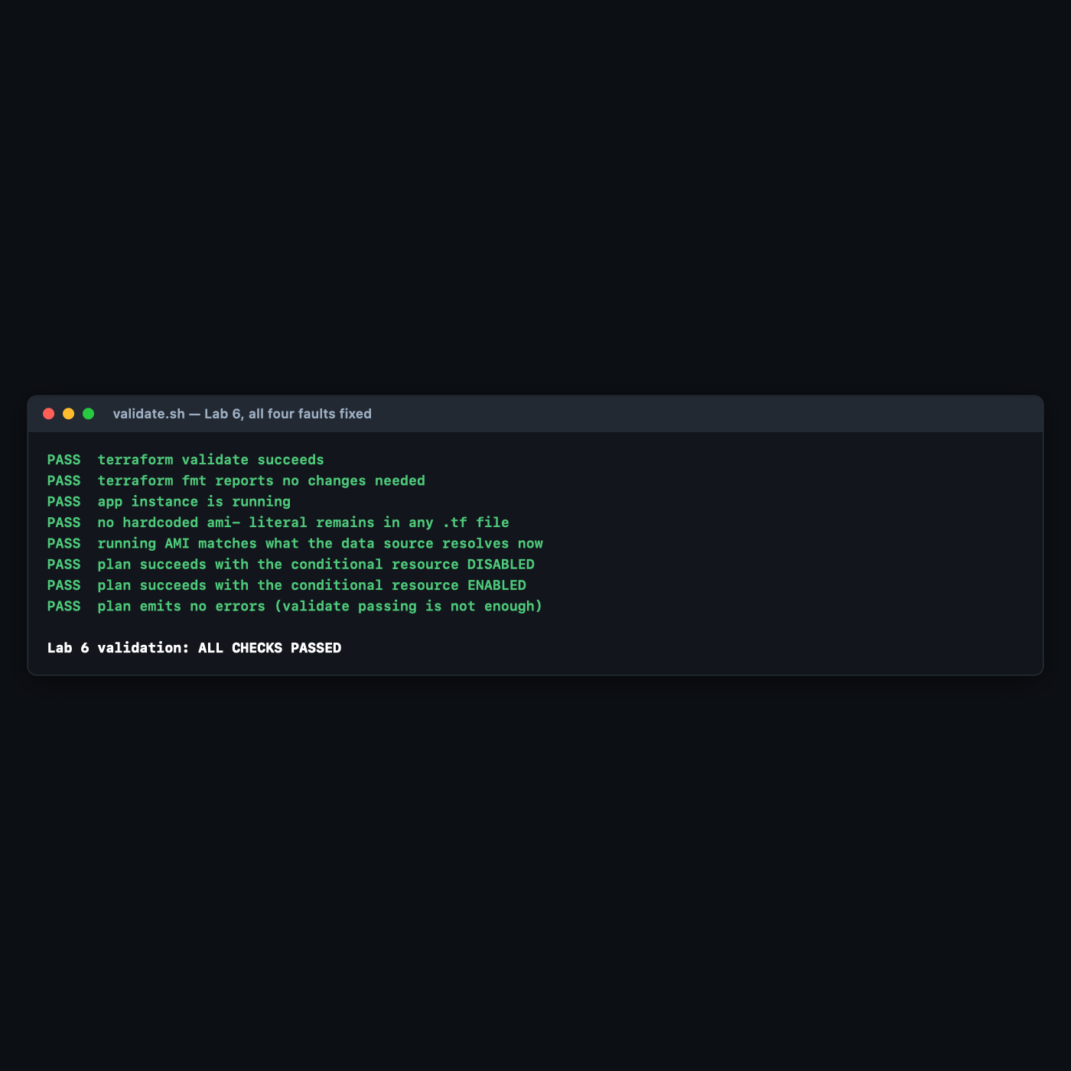
Checks 6, 7 and 8 are the ones that earn their place, and check 1 is the one that lulls you. Check 1 (validate succeeds) passed on the broken [0] version of this configuration too — that is the whole point of §4 Step 4. Checks 6 and 7 assert that a plan succeeds in both branches of the conditional, which is the property validate cannot test. Check 4 is a regression guard: it fails if anyone ever pastes a literal AMI ID back into the config, which is how this lab's most realistic bug returns.

6. Troubleshooting Tips
All encountered for real while building this lab.
terraform init fails with a configuration error before downloading anything
Not a network problem. Terraform must parse your .tf files to discover which providers to install, so any syntax error blocks init entirely. Fix the HCL first; the download is not the problem.
An unclosed-block error points at a line that looks fine
It points at where the block opened, not where the brace is missing. Read downward from that line. terraform fmt will usually make the real location obvious through its indentation.
terraform validate says Success! but plan fails
Expected behaviour, not a bug — see §4 Step 4. validate does not evaluate variable values and makes no API calls. If your CI runs only validate, it is a much weaker gate than it appears.
Invalid index ... is empty tuple
A count-based conditional resolved to zero instances and something referenced [0]. Use one(resource[*].attribute).
plan succeeds, apply fails with a 400
You asked AWS for something impossible: a nonexistent AMI, an invalid instance type, an unsupported combination. The fix is in your .tf. plan cannot catch these because only the AWS API knows.
apply fails with a 403 / UnauthorizedOperation
Your configuration is probably fine and your permissions are not. Do not start editing HCL. Read the ARN in the message, check the IAM policies attached to that principal, and look for an explicit Deny. See reference/iam-denied-scenario.md.
TF_LOG output is unreadably large
Use TF_LOG_PROVIDER=DEBUG instead of TF_LOG=DEBUG to drop Terraform's core logs, and always send it to TF_LOG_PATH rather than the terminal. 368 lines came from one failed API call; a real failure produces far more.
A partially-failed apply left resources behind
terraform apply is not transactional. Resources created before the failure exist, are in state, and are billing you. Run terraform state list after any failed apply, and terraform destroy if you are abandoning the attempt.

7. Cleanup Steps
terraform destroy -auto-approve
Expected output:
aws_instance.app: Destruction complete after 22s
Destroy complete! Resources: 1 destroyed.
If you enabled the bastion at any point, confirm it went too:
aws ec2 describe-instances \
--filters Name=tag:Course,Values=intermediate-terraform \
Name=instance-state-name,Values=running,pending,stopped \
--query 'Reservations[].Instances[].InstanceId' --output text
Expected output: nothing at all.
Delete debug.log. It contains full API request bodies:
rm -f debug.log
Keep these, and here is why:
Keep | Why
broken/ | Ships in its original four-fault state. Hand it to a colleague; it is a genuinely good exercise.
fixed/ | The reference solution — including the one() output, which is the pattern worth stealing.
reference/iam-denied-scenario.md | The scenario this lab could not execute. Run it yourself in an account with a real IAM identity.
validate.sh | Check 8 belongs in your CI pipeline.

Optional extensions
- Run the IAM scenario for real. Follow reference/iam-denied-scenario.md with a proper IAM user. Compare the 403 output against the 400s in Step 5 and confirm the status-code heuristic holds in your own account.
- Strengthen your CI gate. Take a pipeline that runs only terraform validate and add terraform plan -detailed-exitcode. Then re-introduce the [0] bug and watch which stage catches it. This is a ten-minute change that closes a real gap.
- Compare one() against try(). Replace one(...) with try(aws_instance.bastion[0].public_ip, null), then introduce a different error inside that expression — a misspelled attribute, say. try() swallows it and returns null; one() would have failed loudly. This is why try() is not a general-purpose safety net.
- Cause a partial apply. Write a config with three resources where the second is invalid. Apply it, then run terraform state list. The first resource exists and is billing you. This is the most important operational fact in this lab, and it is worth feeling once.
- Read a TRACE log. Run TF_LOG_CORE=TRACE TF_LOG_PATH=./trace.log terraform plan on the fixed config and search for walking graph. You can watch Terraform build and traverse the dependency graph that Lab 4 Step 6 only described.

