Lab 7 — Built-in Functions & Data Type Manipulation
DataCouch — Intermediate Terraform
Table of Contents

Maps to: Built-in Functions and Interpolation; Data Types (Maps, Lists); Variable Manipulation (Length, Count, Join, Split, List/Map Conversion) Duration: ~60 minutes Status: Tested end-to-end on 2026-09-05 (Terraform v1.15.7, AWS provider v6.63.0) against a live AWS account in us-east-1. Every function result, tag value and plan diff below came from a real run — including a check that failed against this lab's own configuration.
Prerequisites: 00-shared-setup.md, Labs 1–6.

1. Lab Overview & Objectives
You are going to write a list of three strings and get three EC2 instances, each with a computed name, a computed size, and eight computed tags — without typing a single resource name.
Then you will change the list and watch the infrastructure follow.
The point is not the functions themselves; they are individually trivial. The point is what becomes possible when the shape of your infrastructure is derived from data rather than transcribed by hand: adding an environment becomes a one-word edit, and it is impossible for a name and a tag to disagree because both come from the same expression.
Learning objectives — by the end of this lab you will be able to:
- Use length, join, split, trimspace, lookup, contains, distinct, element, upper and substr to transform input data into resource configuration.
- Convert a list into a map with a for expression, and explain why for_each needs one.
- Explain concretely why for_each is safer than count when the collection can change in the middle — with the plan output that proves it.
- Use terraform console to develop and debug expressions without creating anything.
The most surprising measured result in this lab: the validation suite includes a check that no environment name is hardcoded outside variables.tf. It failed against this lab's own configuration on the first run. locals.tf contained is_production = env == "prod" — a hardcoded environment name in the very file arguing against hardcoding. The fix is in §4 Step 3, and the failing output is in §5, because a regression check that has never caught anything is not evidence of anything.

2. Prerequisites & Environment Setup

2.1 Cost and time
Resources created | 3 EC2 instances: 2 × t3.micro + 1 × t3.small
Measured price | $0.0416/hr for all three
Measured create time | 17 seconds (all three in parallel)
Measured destroy time | 42 seconds
Realistic cost | under $0.05
Hands-on time | ~60 minutes
Much of this lab costs nothing at all. terraform console evaluates every expression in Step 2 without creating a single resource. Do that part first, and only apply once the expressions are right.

2.2 Setup
mkdir -p ~/terraform-course/lab-7-functions && cd ~/terraform-course/lab-7-functions
export AWS_REGION=us-east-1 AWS_DEFAULT_REGION=us-east-1
export TF_PLUGIN_CACHE_DIR="$HOME/.terraform.d/plugin-cache"

3. Architecture
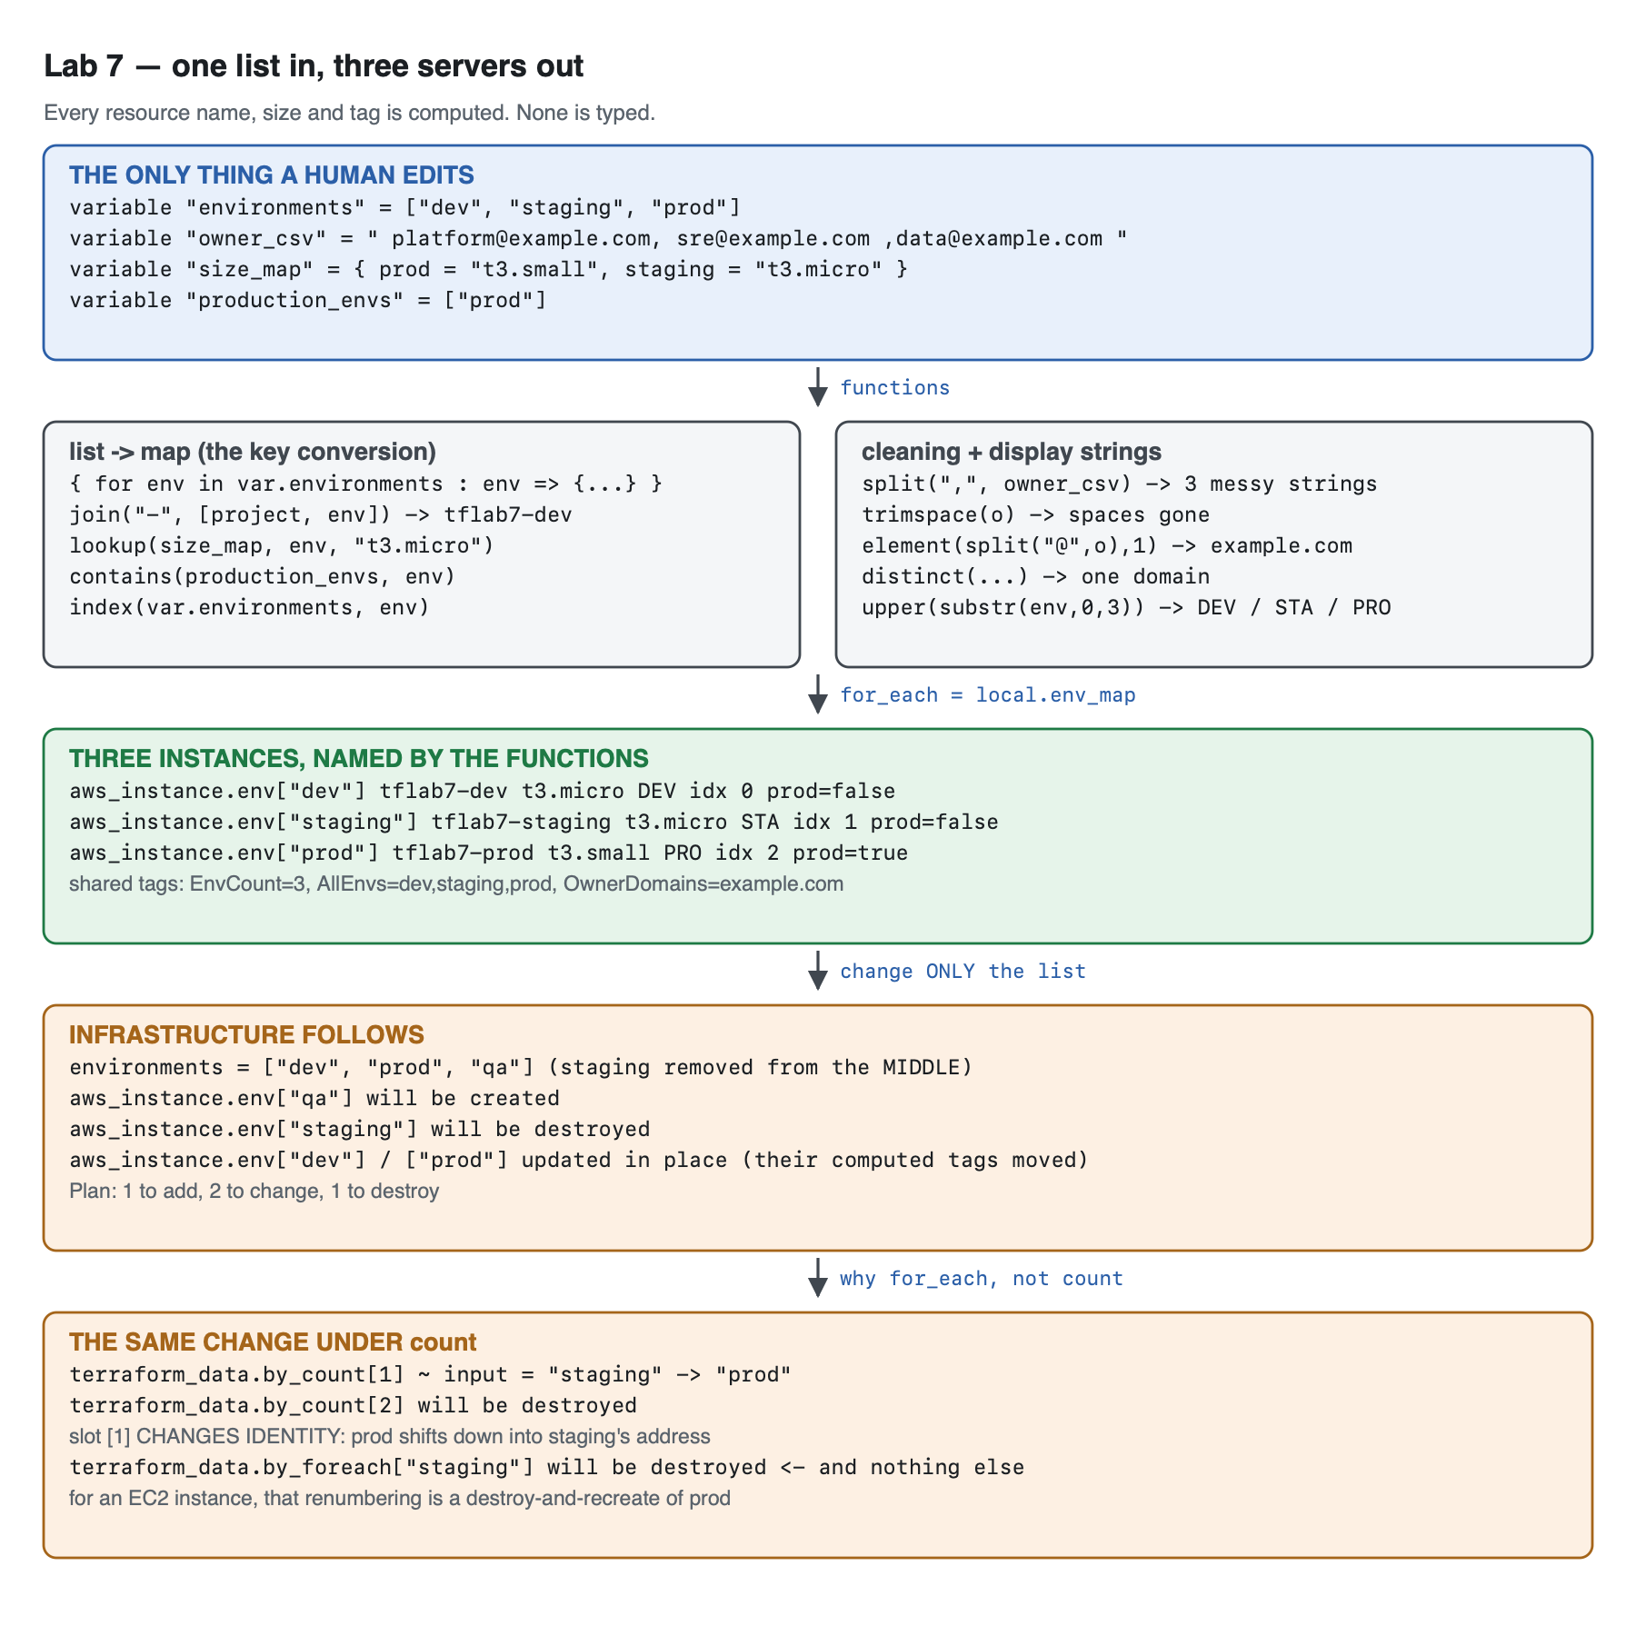
Vector version: lab-7-architecture.svg
THE ONLY THING A HUMAN EDITS
environments = ["dev", "staging", "prod"]
owner_csv = " platform@example.com, sre@example.com ,data@example.com "
size_map = { prod = "t3.small", staging = "t3.micro" }
production_envs = ["prod"]
│
▼ locals.tf
┌─────────────────────────────────┬──────────────────────────────────────┐
│ list → map (the key conversion)│ cleaning + display strings │
│ {for env in environments : │ split(",", owner_csv) → 3 messy │
│ env => { │ trimspace(o) → spaces gone │
│ join("-",[project,env]) │ element(split("@",o),1)→ example.com │
│ lookup(size_map,env,dflt) │ distinct(...) → 1 domain │
│ contains(prod_envs, env) │ upper(substr(env,0,3)) → DEV/STA/PRO │
│ index(environments, env) │ length(environments) → 3 │
│ }} │ │
└─────────────────────────────────┴──────────────────────────────────────┘
│
▼ for_each = local.env_map
aws_instance.env["dev"] tflab7-dev t3.micro DEV idx 0 prod=false
aws_instance.env["staging"] tflab7-staging t3.micro STA idx 1 prod=false
aws_instance.env["prod"] tflab7-prod t3.small PRO idx 2 prod=true
shared tags: EnvCount=3 AllEnvs=dev,staging,prod OwnerDomains=example.com
Why the list must become a map. for_each accepts a map or a set, never a list — and that is a deliberate design decision, not an inconvenience. A map keys each resource by a name, so aws_instance.env["prod"] refers to the same instance forever. A list keys by position, so removing an element shifts everything after it. §4 Step 6 measures exactly what that costs.

4. Step-by-Step Instructions

Step 1 — One list, and the messiest input you can imagine
Why: Real configuration data arrives badly formatted — from a CI variable, a CSV column, a ticket. Cleaning it in Terraform, rather than requiring humans to pre-clean it, is what these functions are for.
cat > variables.tf << 'EOF'
# THE single source of truth for this lab. Every resource name, every tag and
# the number of instances is derived from this one list. Add an element and
# infrastructure follows; nothing else in the configuration is edited.
variable "environments" {
description = "Environment names to deploy. Everything else is computed from this."
type = list(string)
default = ["dev", "staging", "prod"]
validation {
condition = length(var.environments) == length(distinct(var.environments))
error_message = "environments must not contain duplicates."
}
validation {
condition = length(var.environments) > 0
error_message = "environments must contain at least one entry."
}
}
variable "project" {
description = "Project slug used as the first element of every generated name."
type = string
default = "tflab7"
}
variable "aws_region" {
description = "Region."
type = string
default = "us-east-1"
}
# A raw, messy string of the kind you get from a CI variable or a CSV column.
variable "owner_csv" {
description = "Comma-separated owner emails, deliberately messy, to be split and cleaned."
type = string
default = " platform@example.com, sre@example.com ,data@example.com "
}
# Per-environment sizing, as a map. Demonstrates lookup() with a default.
variable "size_map" {
description = "Instance type per environment. Environments absent from this map fall back to the default."
type = map(string)
default = {
prod = "t3.small"
staging = "t3.micro"
}
}
variable "production_envs" {
description = "Environment names that should be treated as production."
type = list(string)
default = ["prod"]
}
EOF
length(x) == length(distinct(x)) is the idiomatic duplicate check. There is no has_duplicates() function; comparing a collection's length to its deduplicated length is how you express it. This matters here because a duplicate would collide as a for_each key.
size_map deliberately omits dev. That is not an oversight — Step 3 uses it to demonstrate lookup() falling back to a default, and §5 asserts both the hit and the miss.

Step 2 — Develop the expressions in terraform console — free, and instant
Why: This is the single most underused Terraform command. It evaluates any expression against your real variables and state without touching AWS. Every function below was worked out here before a resource block existed.
terraform init
echo 'length(var.environments)' | terraform console
Every expression this lab uses, with its actual output:
> length(var.environments)
3
> local.owners_raw
tolist([
" platform@example.com",
" sre@example.com ",
"data@example.com ",
])
> local.owners
[
"platform@example.com",
"sre@example.com",
"data@example.com",
]
> local.owner_domain
tolist([
"example.com",
])
> local.all_names
[
"tflab7-dev",
"tflab7-prod",
"tflab7-staging",
]
> local.env_labels
{
"dev" = "DEV"
"prod" = "PRO"
"staging" = "STA"
}
> local.env_map
{
"dev" = {
"index" = 0
"instance_type" = "t3.micro"
"is_production" = false
"name" = "tflab7-dev"
}
"prod" = {
"index" = 2
"instance_type" = "t3.small"
"is_production" = true
"name" = "tflab7-prod"
}
"staging" = {
"index" = 1
"instance_type" = "t3.micro"
"is_production" = false
"name" = "tflab7-staging"
}
}
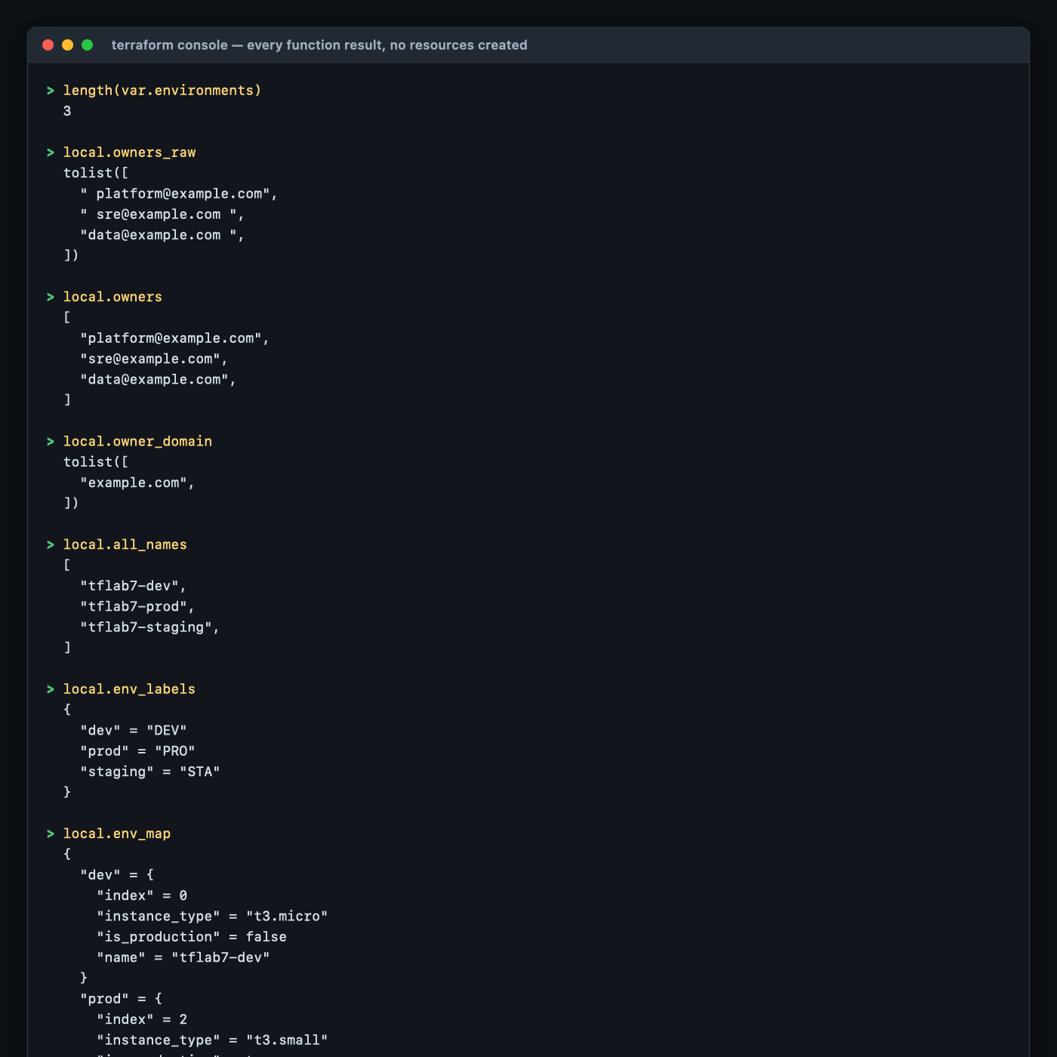
Look carefully at local.owners_raw: split() preserved every stray space exactly as it appeared in the source string. trimspace() in the next line removes them. split() does not clean anything — a very common wrong assumption.
Ordering surprise worth internalising. local.all_names came out as ["tflab7-dev", "tflab7-prod", "tflab7-staging"] — alphabetical, not the dev, staging, prod order of the input list. The expression is [for k, v in local.env_map : v.name], and iterating a map always yields keys in lexical order, regardless of how the map was built. If you need input order, iterate the list, not the map. Note also that AllEnvs in the tags is dev,staging,prod — because that one joins var.environments directly.
terraform console reads state. After an apply, aws_instance.env["prod"].public_ip returns the real address. Before one, unknown values show as (known after apply). Both are useful. Exit with Ctrl-D.

Step 3 — Compute everything in locals.tf
Why: A local is where a transformation gets a name. Inline the same expression at three use sites and you have three places to fix; name it once and you have one.
cat > locals.tf << 'EOF'
locals {
# ---- 1. length() : how many of everything ------------------------------
env_count = length(var.environments)
# ---- 2. LIST -> MAP : the single most useful conversion in Terraform ---
# for_each needs a map (or set); a list gives you index-based addressing,
# which renumbers everything when an element is removed from the middle.
# Keying by the environment name makes each resource address stable.
env_map = { for env in var.environments : env => {
name = join("-", [var.project, env])
instance_type = lookup(var.size_map, env, "t3.micro")
is_production = contains(var.production_envs, env)
index = index(var.environments, env)
} }
# ---- 3. split() + trimspace() : cleaning messy input -------------------
owners_raw = split(",", var.owner_csv)
owners = [for o in local.owners_raw : trimspace(o)]
owners_tag = join(";", local.owners)
owner_domain = distinct([for o in local.owners : element(split("@", o), 1)])
# ---- 4. upper/title/substr/format : building display strings ----------
env_labels = { for env in var.environments : env => upper(substr(env, 0, 3)) }
# ---- 5. MAP -> LIST : the reverse conversion --------------------------
all_names = [for k, v in local.env_map : v.name]
sorted = sort(local.all_names)
# ---- 6. a computed tag map applied to every instance ------------------
computed_tags = {
EnvCount = tostring(local.env_count)
AllEnvs = join(",", var.environments)
Owners = local.owners_tag
OwnerDomains = join(",", local.owner_domain)
NameFormula = "join(\"-\", [project, env])"
}
}
EOF
The function reference, as actually used here:
Function | Call in this lab | Result
length | length(var.environments) | 3
join | join("-", [var.project, env]) | "tflab7-dev"
split | split(",", var.owner_csv) | 3 strings, spaces intact
trimspace | trimspace(o) | "platform@example.com"
lookup | lookup(var.size_map, env, "t3.micro") | t3.small for prod, default for dev
contains | contains(var.production_envs, env) | true for prod
index | index(var.environments, env) | 0, 1, 2
element | element(split("@", o), 1) | "example.com"
distinct | distinct([...]) | one domain, not three
upper + substr | upper(substr(env, 0, 3)) | "DEV", "STA", "PRO"
tostring | tostring(local.env_count) | "3" — tags must be strings
sort | sort(local.all_names) | alphabetical
tostring() is not optional on tag values. AWS tags are string-to-string. Passing the number 3 gives you an "Inappropriate value for attribute tags" type error. index is likewise converted at the use site in main.tf.
is_production = contains(var.production_envs, env) — and why it is not env == "prod". The first version of this lab wrote exactly that comparison, and this lab's own validation caught it (§5). A literal "prod" inside locals.tf is a hardcoded environment name, which is the thing the entire lab argues against: rename the environment and the expression silently stops working, with no error. Environment membership is data, so it belongs in a variable.
lookup() here is a legitimate use, unlike Lab 5's. In Lab 5 a lookup() with a null default hid a real error. The difference is whether a sensible default exists. Here t3.micro is genuinely correct for any unlisted environment. There, no default was correct. Use lookup() with a default only when the default is a real answer, not a placeholder for "I do not know".

Step 4 — for_each over the computed map
cat > main.tf << 'EOF'
data "aws_ami" "al2023" {
most_recent = true
owners = ["amazon"]
filter {
name = "name"
values = ["al2023-ami-2023.*-kernel-6.1-x86_64"]
}
}
# for_each over the COMPUTED map. Not one resource name is typed by hand.
resource "aws_instance" "env" {
for_each = local.env_map
ami = data.aws_ami.al2023.id
instance_type = each.value.instance_type
tags = merge(local.computed_tags, {
Name = each.value.name
Env = each.key
EnvLabel = local.env_labels[each.key]
EnvIndex = tostring(each.value.index)
Production = tostring(each.value.is_production)
})
}
EOF
each.key is the map key ("dev"); each.value is the object you built ({name, instance_type, is_production, index}). Building a rich object as the map value, rather than looping several times over different maps, keeps everything about one environment in one place.

Step 5 — Apply, and check the tags AWS actually holds
terraform apply -auto-approve
Expected output:
aws_instance.env["dev"]: Creating...
aws_instance.env["staging"]: Creating...
aws_instance.env["prod"]: Creating...
aws_instance.env["prod"]: Creation complete after 17s [id=i-0e89907c439c9140b]
aws_instance.env["staging"]: Creation complete after 17s [id=i-0b8cd18e3f5ebdc2e]
aws_instance.env["dev"]: Creation complete after 17s [id=i-06195cf290f843f6b]
Apply complete! Resources: 3 added, 0 changed, 0 destroyed.
Look at the resource addresses. aws_instance.env["dev"], not aws_instance.env[0]. That is the for_each payoff, and Step 6 measures why it matters.
terraform output generated_names
terraform output instance_types
{
"dev" = "tflab7-dev"
"prod" = "tflab7-prod"
"staging" = "tflab7-staging"
}
{
"dev" = "t3.micro"
"prod" = "t3.small"
"staging" = "t3.micro"
}
prod got t3.small from size_map; dev is not in that map at all and fell back to the lookup() default.
Now the part that matters — what AWS actually holds:
aws ec2 describe-instances --filters Name=tag:Lab,Values=7 Name=instance-state-name,Values=running \
--query 'sort_by(Reservations[].Instances[],&Tags[?Key==`Name`]|[0].Value)[].{Name:Tags[?Key==`Name`]|[0].Value,Type:InstanceType,Label:Tags[?Key==`EnvLabel`]|[0].Value,Idx:Tags[?Key==`EnvIndex`]|[0].Value,Prod:Tags[?Key==`Production`]|[0].Value}' \
--output table
Expected output:
---------------------------------------------------------
| DescribeInstances |
+-----+--------+------------------+--------+------------+
| Idx | Label | Name | Prod | Type |
+-----+--------+------------------+--------+------------+
| 0 | DEV | tflab7-dev | false | t3.micro |
| 2 | PRO | tflab7-prod | true | t3.small |
| 1 | STA | tflab7-staging | false | t3.micro |
+-----+--------+------------------+--------+------------+
And the shared computed tags:
+--------------+----------------------------------------------------------+
| Key | Value |
+--------------+----------------------------------------------------------+
| NameFormula | join("-", [project, env]) |
| AllEnvs | dev,staging,prod |
| Owners | platform@example.com;sre@example.com;data@example.com |
| EnvCount | 3 |
| OwnerDomains| example.com |
+--------------+----------------------------------------------------------+
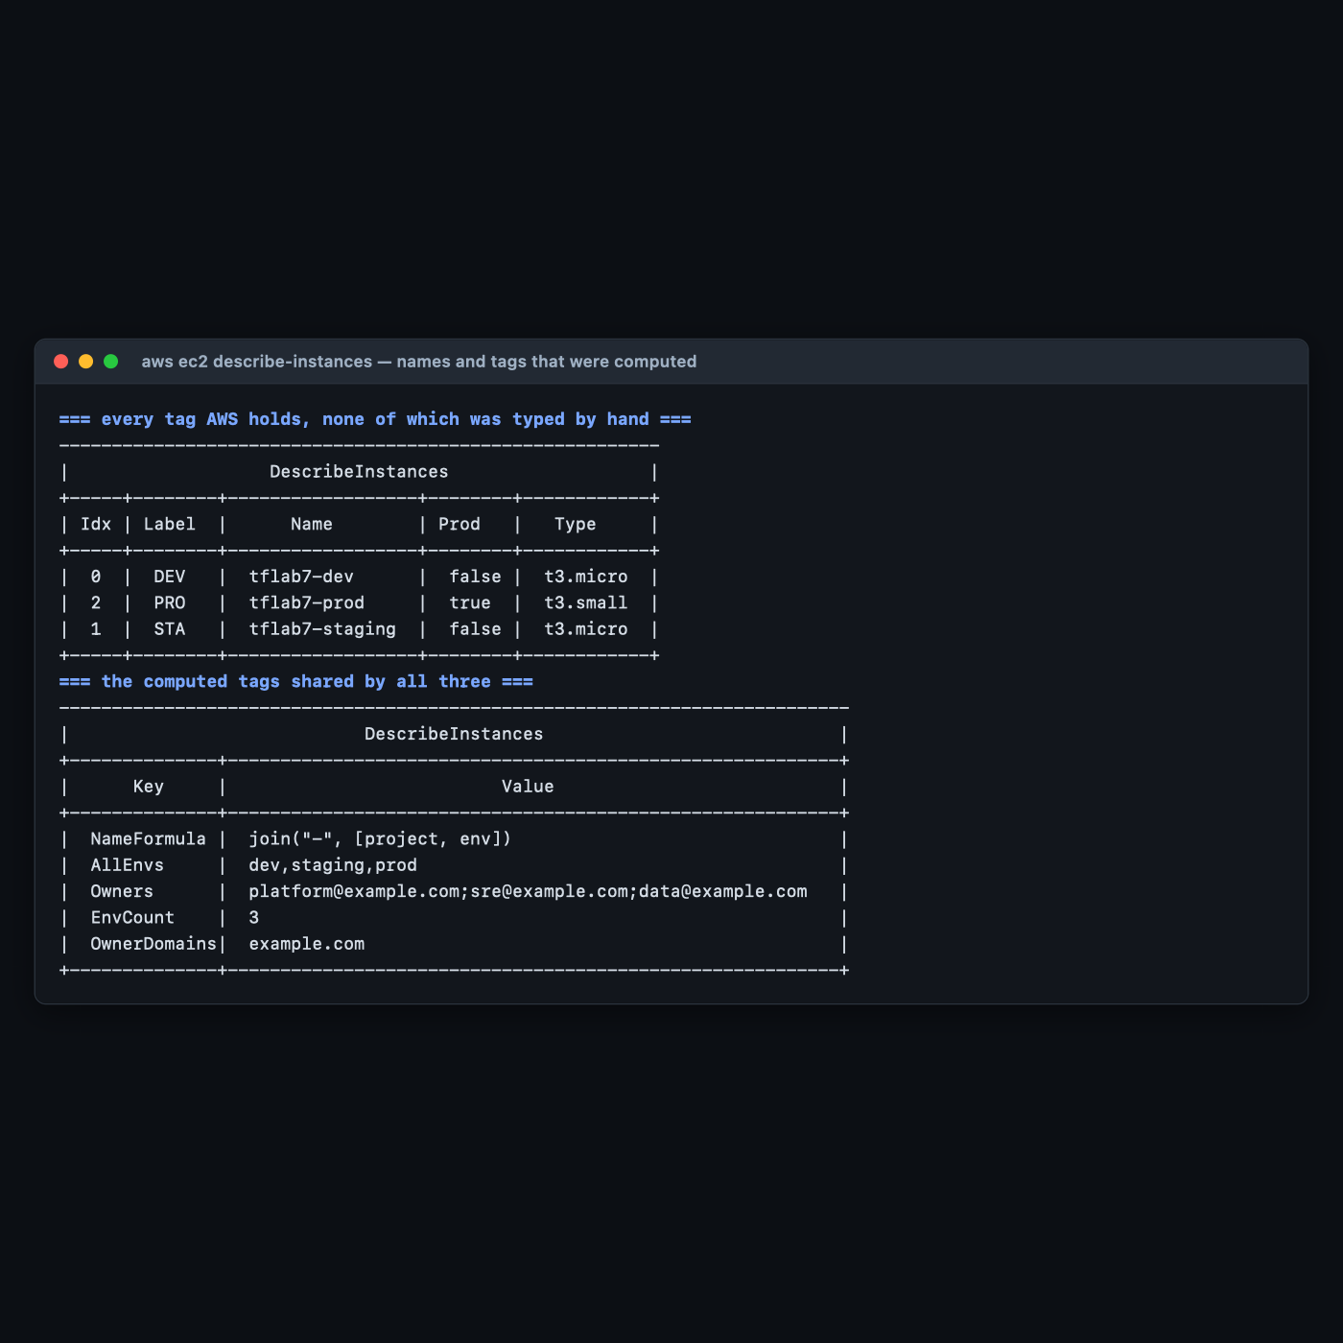
This table is the lab's deliverable. Every one of those values was computed. Owners has no stray spaces — trimspace() did that. OwnerDomains is one entry, not three — distinct() did that. EnvCount is 3 because length() said so. Nobody typed tflab7-staging anywhere.

Step 6 — Change the list, and see why for_each beats count
Why: This is the argument you will need when someone asks why not just use count.
terraform plan -var 'environments=["dev","prod","qa"]'
Expected output — staging removed from the middle, qa added:
# aws_instance.env["dev"] will be updated in-place
# aws_instance.env["prod"] will be updated in-place
# aws_instance.env["qa"] will be created
# aws_instance.env["staging"] will be destroyed
Plan: 1 to add, 2 to change, 1 to destroy.
dev and prod are updated in place, not replaced — their AllEnvs and EnvCount tags changed, nothing more. The instances survive.
Now the same change with count. This was measured with terraform_data resources, which cost nothing and create nothing in AWS:
resource "terraform_data" "by_count" {
count = length(var.environments)
input = var.environments[count.index]
}
resource "terraform_data" "by_foreach" {
for_each = toset(var.environments)
input = each.key
}
After applying with ["dev","staging","prod"]:
terraform_data.by_count[0]
terraform_data.by_count[1]
terraform_data.by_count[2]
terraform_data.by_foreach["dev"]
terraform_data.by_foreach["prod"]
terraform_data.by_foreach["staging"]
Then removing staging from the middle — ["dev","prod"]:
# terraform_data.by_count[1] will be updated in-place
# terraform_data.by_count[2] will be destroyed
# terraform_data.by_foreach["staging"] will be destroyed
Plan: 0 to add, 1 to change, 2 to destroy.
And here is what by_count[1] actually becomes:
# terraform_data.by_count[1] will be updated in-place
~ resource "terraform_data" "by_count" {
id = "4a22c2cb-072d-9dbe-cf5c-7cdf9c469e28"
~ input = "staging" -> "prod"
~ output = "staging" -> (known after apply)
Read input = "staging" -> "prod" carefully. Slot [1] changed identity. prod — which you did not touch — shifted down into the address that used to belong to staging. Meanwhile for_each destroyed exactly one thing: ["staging"].
terraform_data tolerates that in place. An EC2 instance would not. ami and most identifying attributes force replacement, so under count your production server would be destroyed and recreated because you deleted a different environment from the middle of a list.
 | count | for_each
Address | [0], [1], [2] — position | ["dev"], ["prod"] — name
Remove from the middle | everything after it shifts and rebuilds | only that one is destroyed
Accepts | any list, or a number | a map or a set only
Right for | genuinely identical, interchangeable copies — a fleet of N | anything with an identity
Use count for "give me N of these". Lab 8 does exactly that, and it is the correct choice there. Use for_each for "give me one of these per X". Getting this backwards is one of the most expensive routine mistakes in Terraform.

Step 7 — Do it again yourself, drive the network from data too, unassisted
Why: You have computed names and tags. Real infrastructure-as-data goes further: the shape of the network should come from the same list.
Your task. Extend this configuration so each environment gets its own subnet with its own non-overlapping CIDR, computed from the environment's position in the list — no CIDR typed by hand anywhere — inside a single shared VPC. Each instance must launch into its own environment's subnet.
You get the acceptance criteria and nothing else:
- One VPC; one subnet per element of var.environments; each instance in the matching subnet, confirmed with aws ec2 describe-instances --query '...SubnetId'.
- No CIDR literal appears anywhere except the VPC's own base CIDR variable.
- Changing environments to a four-element list produces four subnets with four distinct, non-overlapping CIDRs, with no edits outside variables.tf.
- Reordering the list — ["prod","dev","staging"] — produces a plan that changes no subnet CIDRs. (This is the hard one. Think about what index() returns after a reorder.)
- validate.sh still passes all ten checks.
Done when you can explain why deriving a CIDR from index() is a latent bug, and name what you used instead to get a stable per-environment address.
No commands are given here. Lab 4 Step 3 has cidrsubnet(); this lab has the map-building patterns. The reordering requirement is the real exercise: index() is stable only while the list order is, which makes it exactly the wrong thing to derive a CIDR from — the same positional-identity problem as count, wearing a different hat.

5. Validation / Verification
Save as validate.sh. Also at lab-7-functions/validate.sh.
#!/usr/bin/env bash
# Lab 7 validation. Run from lab-7-functions/ after `terraform apply`.
set -uo pipefail
fail=0
check() { if [ "$2" = "$3" ]; then echo "PASS $1"; else echo "FAIL $1 (got '$2', want '$3')"; fail=1; fi }
check "one instance per element of var.environments" \
"$(terraform state list | grep -c '^aws_instance.env\[')" "3"
for env in dev staging prod; do
check "[$env] Name tag == join(\"-\", [project, env])" \
"$(aws ec2 describe-instances --filters Name=tag:Env,Values=$env Name=instance-state-name,Values=running \
--query "Reservations[0].Instances[0].Tags[?Key=='Name']|[0].Value" --output text)" \
"tflab7-$env"
done
check "prod got t3.small from size_map" \
"$(aws ec2 describe-instances --filters Name=tag:Env,Values=prod Name=instance-state-name,Values=running \
--query 'Reservations[0].Instances[0].InstanceType' --output text)" "t3.small"
check "dev fell back to the lookup() default" \
"$(aws ec2 describe-instances --filters Name=tag:Env,Values=dev Name=instance-state-name,Values=running \
--query 'Reservations[0].Instances[0].InstanceType' --output text)" "t3.micro"
OWNERS=$(aws ec2 describe-instances --filters Name=tag:Env,Values=dev Name=instance-state-name,Values=running \
--query "Reservations[0].Instances[0].Tags[?Key=='Owners']|[0].Value" --output text)
check "trimspace() removed all whitespace from the owner list" "$OWNERS" \
"platform@example.com;sre@example.com;data@example.com"
check "EnvCount tag equals length(var.environments)" \
"$(aws ec2 describe-instances --filters Name=tag:Env,Values=dev Name=instance-state-name,Values=running \
--query "Reservations[0].Instances[0].Tags[?Key=='EnvCount']|[0].Value" --output text)" "3"
# Regression guard for the lab's actual claim.
check "no env name is hardcoded outside variables.tf" \
"$(grep -E '"(dev|staging|prod)"' main.tf locals.tf outputs.tf 2>/dev/null | wc -l | tr -d ' ')" "0"
# THE ONE THE HAPPY PATH MISSES: keyed or indexed?
IDX=$(terraform state list | grep -c '^aws_instance.env\[[0-9]')
check "resources are keyed by name, not by numeric index" "$IDX" "0"
echo
[ $fail -eq 0 ] && echo "Lab 7 validation: ALL CHECKS PASSED" || echo "Lab 7 validation: FAILURES ABOVE"
exit $fail
Actual output, exit code 0:
PASS one instance per element of var.environments
PASS [dev] Name tag == join("-", [project, env])
PASS [staging] Name tag == join("-", [project, env])
PASS [prod] Name tag == join("-", [project, env])
PASS prod got t3.small from size_map
PASS dev fell back to the lookup() default
PASS trimspace() removed all whitespace from the owner list
PASS EnvCount tag equals length(var.environments)
PASS no env name is hardcoded outside variables.tf
PASS resources are keyed by name, not by numeric index
Lab 7 validation: ALL CHECKS PASSED

Check 9 failed against this lab's own configuration
That output is from the second run. The first looked like this:
PASS EnvCount tag equals length(var.environments)
FAIL no env name is hardcoded outside variables.tf (got '1', want '0')
PASS resources are keyed by name, not by numeric index
Lab 7 validation: FAILURES ABOVE
The offending line was in locals.tf:
is_production = env == "prod"
A hardcoded environment name, in the file whose entire purpose is to stop hardcoding environment names. It is a completely natural thing to write, every other check passed, and the infrastructure was correct — prod really was tagged Production=true. The fix was to make production membership data (var.production_envs) and test it with contains().
A regression check that has never caught anything is not evidence. This one caught its author, which is the only reason it is worth including.

Why check 10 is the one the happy path cannot see
A count-based version of this configuration would produce byte-identical AWS resources: same three instances, same names, same tags, same sizes. Checks 1–9 would all pass. The difference is invisible in AWS and visible only in the Terraform state address — [0] versus ["dev"] — and it only becomes expensive later, when someone removes an element from the middle of the list. Check 10 tests the property that Step 6 shows the consequences of.

6. Troubleshooting Tips
All encountered for real while building this lab.
Inappropriate value for attribute "tags": element ... must be string
A tag value that is a number or a bool. AWS tags are string-to-string. Wrap with tostring() — this lab does it for EnvCount, EnvIndex and Production.
The given key does not identify an element in this collection value
A lookup() without a default, or a direct map index, on a key that is not present. Either add the key or supply a default — but only if the default is a real answer (see Step 3).
Invalid for_each argument ... must be a map, or set of strings
You passed a list. Convert with toset(...) if the values are the keys, or build a map with a for expression if you need richer values. This lab does the latter.
Two resources collide on the same for_each key
Duplicate entries in the source list. That is what the length(x) == length(distinct(x)) validation in Step 1 is for — without it, the error appears much later and is far less clear.
Your for expression over a map comes out in the wrong order
Not a bug. Map iteration is always lexical by key. local.all_names returns dev, prod, staging even though the input list is dev, staging, prod. Iterate the list if you need input order.
split() left whitespace in your values
split() only splits. Chain trimspace() over the result: [for o in split(",", x) : trimspace(o)].
An expression is wrong and you keep applying to find out
Stop. terraform console evaluates it instantly for free. Every function result in Step 2 was developed there before any resource existed.

7. Cleanup Steps
terraform destroy -auto-approve
Expected output:
aws_instance.env["prod"]: Destruction complete after 42s
Destroy complete! Resources: 3 destroyed.
Confirm:
aws ec2 describe-instances \
--filters Name=tag:Course,Values=intermediate-terraform \
Name=instance-state-name,Values=running,pending,stopped \
--query 'Reservations[].Instances[].InstanceId' --output text
Expected output: nothing at all.
Keep these, and here is why:
Keep | Why
locals.tf | The list-to-map for expression is the most reusable thing in this course.
validate.sh | Checks 9 and 10 are worth copying into any config that claims to be data-driven.
variables.tf | The duplicate-detection validation is a good default for any for_each source.

Optional extensions
- Add a fourth environment. Set environments = ["dev","staging","prod","qa"] and apply. Count how many files you had to edit. The answer should be one, and the diff should be one word.
- Reproduce the count disaster with real instances. Convert aws_instance.env to count, apply, then remove staging from the middle and read the plan without applying it. Note how many instances it proposes to destroy and recreate versus the for_each version's one.
- Sort by something other than the key. local.all_names comes out alphabetically. Produce the same list in the input list's order instead. ([for env in var.environments : local.env_map[env].name] — and understanding why that works is the point.)
- Break the duplicate validation. Set environments = ["dev","dev"] and run plan. Then remove the validation block and try again — compare how clear the two failures are. That is the argument for writing validations.
- Explore terraform console properly. With the infrastructure applied, try [for k, v in aws_instance.env : "${k}=${v.private_ip}"], then values(aws_instance.env)[*].id, then jsonencode(local.env_map). The console reads live state, which makes it the fastest way to answer "what does this expression actually return".

