Lab 8 — Loops, Backends & Scaling EC2
DataCouch — Intermediate Terraform
Table of Contents

Maps to: Creating Loops (via Count); Terraform Backends; Using Terraform to Configure EC2 Instances Duration: ~75 minutes Status: Tested end-to-end on 2026-09-05 (Terraform v1.15.7, AWS provider v6.63.0) against a live AWS account in us-east-1. State was really migrated to S3, really read back from a second directory, and a real lock conflict was provoked between two concurrent sessions.
Prerequisites: 00-shared-setup.md, Labs 1–7 — especially Lab 7, whose count versus for_each comparison this lab depends on.

1. Lab Overview & Objectives
Two things stand between the configurations you have written so far and something a team could actually operate.
The first is repetition: count turns one resource block into N identical instances. The second is much more important: your state file is on one laptop. Nobody else can run Terraform. There is no locking, so two people applying at once silently corrupt each other's work. There is no history, so a bad write is unrecoverable. This lab fixes that by migrating state to S3 — and then proves the migration worked by running Terraform from a directory that has never seen this infrastructure.
Learning objectives — by the end of this lab you will be able to:
- Use count to deploy N identical resources, and articulate when count is correct and when for_each is.
- Build a state backend — S3 with versioning, encryption and public access blocked — and explain the chicken-and-egg problem that forces the bootstrap to keep local state.
- Migrate an existing local state to a remote backend with terraform init -migrate-state, and verify the migration rather than assuming it.
- Explain what state locking prevents, recognise a lock conflict, and use use_lockfile instead of the now-deprecated dynamodb_table.
The most surprising measured result in this lab: the course outline specifies a DynamoDB lock table, and Terraform 1.15.7 emits a deprecation warning for it: The parameter "dynamodb_table" is deprecated. Use parameter "use_lockfile" instead. S3 gained native conditional-write locking in Terraform 1.10, and the separate lock table is no longer needed. This lab builds the DynamoDB table anyway — because you will meet it in every existing codebase — but shows both, and the real warning, in §4 Step 4.

2. Prerequisites & Environment Setup

2.1 Software
Requirement | Tested with | Note
Terraform CLI | v1.15.7 | 1.10+ required for use_lockfile
AWS provider | v6.63.0
random provider | v3.6+ | unique bucket suffix
AWS CLI v2 | 2.35.11 | used to inspect the bucket directly

2.2 AWS permissions
Beyond EC2 this lab needs s3:CreateBucket, PutBucketVersioning, PutEncryptionConfiguration, PutPublicAccessBlock, GetObject, PutObject, DeleteObject, plus dynamodb:CreateTable and DeleteTable.

2.3 Cost and time
Resources created | 3–5 × t3.micro, 1 S3 bucket, 1 DynamoDB table
Measured price | $0.0312/hr (3 nodes) rising to $0.052/hr (5 nodes)
S3 | a ~24 KB state file — fractions of a cent
DynamoDB | PAY_PER_REQUEST — no idle cost, a handful of requests
Measured create time | 18 seconds for 3 instances in parallel
Realistic cost | under $0.10
Hands-on time | ~75 minutes
force_destroy = true is set on the state bucket. That is a lab convenience and nothing else. It lets terraform destroy delete a bucket that still contains objects. On a real state bucket it is exactly the wrong setting — it removes the last barrier between a careless destroy and the loss of every state version you have.

2.4 Setup
mkdir -p ~/terraform-course/lab-8-loops-backends/{bootstrap,fleet}
cd ~/terraform-course/lab-8-loops-backends
export AWS_REGION=us-east-1 AWS_DEFAULT_REGION=us-east-1
export TF_PLUGIN_CACHE_DIR="$HOME/.terraform.d/plugin-cache"
Two directories, and the separation matters. bootstrap/ creates the backend and keeps its own state local, forever. fleet/ is the real configuration whose state moves into that backend.

3. Architecture
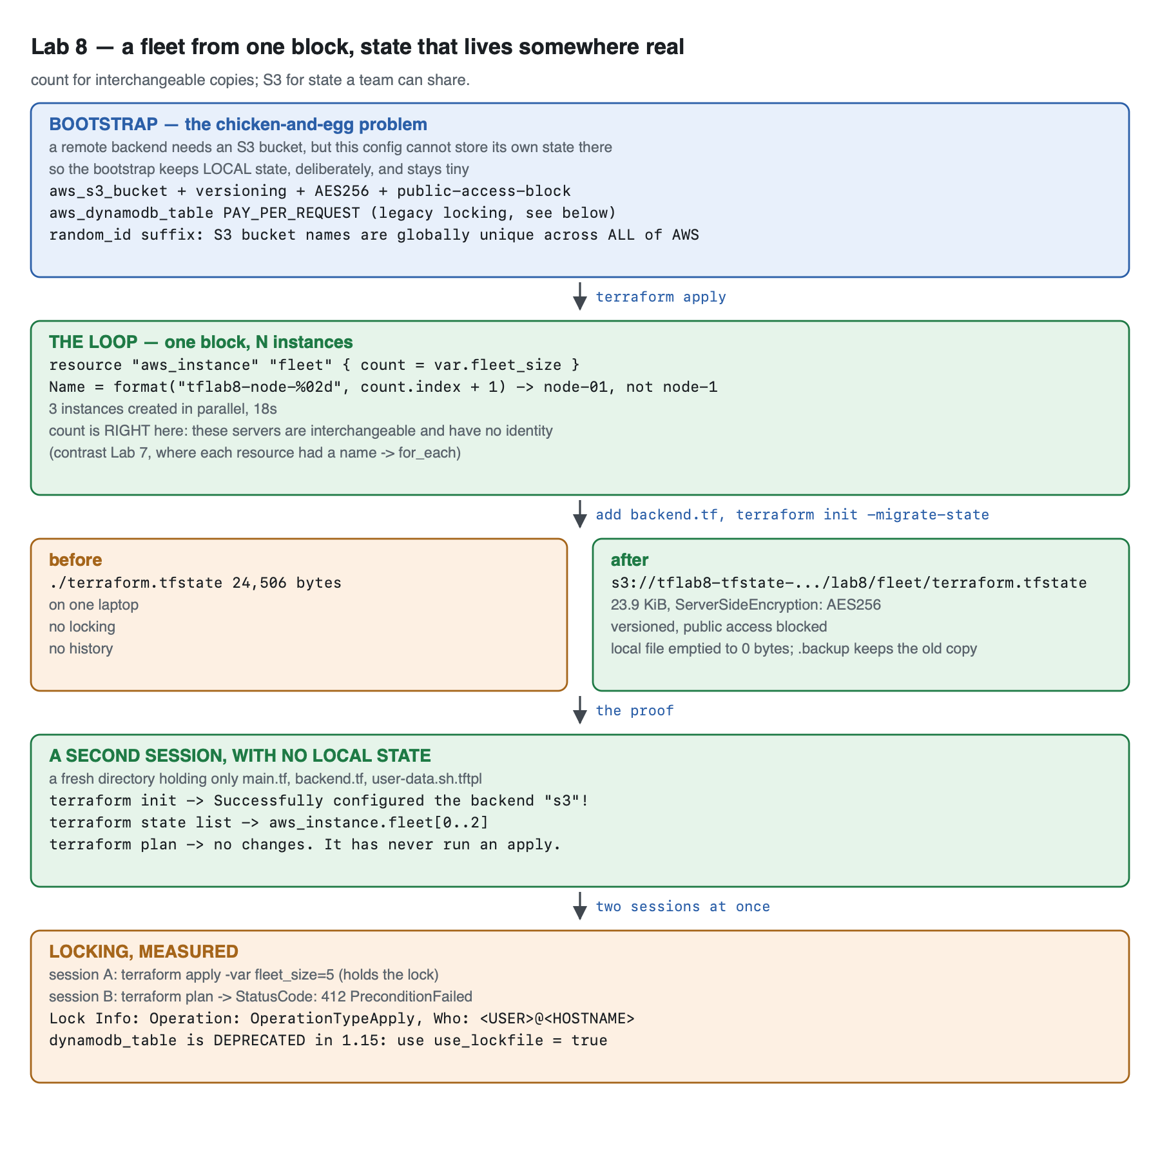
Vector version: lab-8-architecture.svg
bootstrap/ ← state stays LOCAL, forever, on purpose
aws_s3_bucket + versioning + AES256 + public-access-block
aws_dynamodb_table (PAY_PER_REQUEST)
random_id suffix ← S3 bucket names are globally unique across ALL of AWS
│
│ outputs bucket_name
▼
fleet/
resource "aws_instance" "fleet" { count = var.fleet_size }
Name = format("tflab8-node-%02d", count.index + 1)
│
├── BEFORE: ./terraform.tfstate 24,506 bytes, one laptop,
│ no locking, no history
│
│ add backend.tf → terraform init -migrate-state
▼
└── AFTER: s3://tflab8-tfstate-<rand>/lab8/fleet/terraform.tfstate
23.9 KiB · AES256 · versioned · not public
local file emptied to 0 bytes
terraform.tfstate.backup keeps the pre-migration copy
│
┌─────────────────────┴──────────────────────┐
▼ ▼
A SECOND DIRECTORY TWO SESSIONS AT ONCE
only main.tf, backend.tf, the template A: apply -var fleet_size=5
terraform init → backend configured B: plan → 412 PreconditionFailed
terraform state list → fleet[0..2] Lock Info: OperationTypeApply
terraform plan → no changes
The chicken-and-egg problem is the reason for two directories. A configuration cannot store its own state in a bucket it is currently creating — on the first apply the bucket does not exist yet. So the bootstrap keeps local state permanently. It is small, it changes almost never, and losing its state is recoverable by importing two resources. Every other configuration you own uses the backend it created.

4. Step-by-Step Instructions

Step 1 — Build the backend
Why: Every setting in this file exists because of a specific failure mode. Read them as a list of things that have gone wrong for other people.
cat > bootstrap/main.tf << 'EOF'
terraform {
required_version = ">= 1.5.0"
required_providers {
aws = { source = "hashicorp/aws", version = "~> 6.0" }
random = { source = "hashicorp/random", version = "~> 3.6" }
}
}
provider "aws" {
region = var.aws_region
default_tags {
tags = {
Course = "intermediate-terraform"
Lab = "8"
ManagedBy = "terraform"
Purpose = "tf-state-backend"
}
}
}
variable "aws_region" {
description = "Region for the state backend."
type = string
default = "us-east-1"
}
# S3 bucket names are GLOBALLY unique across every AWS account on earth.
# A fixed name in a lab guarantees a collision with the previous student.
resource "random_id" "suffix" {
byte_length = 4
}
locals {
bucket_name = "tflab8-tfstate-${random_id.suffix.hex}"
table_name = "tflab8-tfstate-locks"
}
resource "aws_s3_bucket" "state" {
bucket = local.bucket_name
# A lab convenience ONLY. Never set this on a real state bucket.
force_destroy = true
tags = { Name = local.bucket_name }
}
# Versioning is the difference between "someone corrupted state" being an
# inconvenience and being an outage. Turn it on before storing anything.
resource "aws_s3_bucket_versioning" "state" {
bucket = aws_s3_bucket.state.id
versioning_configuration {
status = "Enabled"
}
}
resource "aws_s3_bucket_server_side_encryption_configuration" "state" {
bucket = aws_s3_bucket.state.id
rule {
apply_server_side_encryption_by_default {
sse_algorithm = "AES256"
}
}
}
# State files contain every attribute of every resource in plaintext.
resource "aws_s3_bucket_public_access_block" "state" {
bucket = aws_s3_bucket.state.id
block_public_acls = true
block_public_policy = true
ignore_public_acls = true
restrict_public_buckets = true
}
# The classic lock table. Terraform 1.10+ can lock using S3 alone
# (use_lockfile = true) -- this lab demonstrates both, see Step 4.
resource "aws_dynamodb_table" "locks" {
name = local.table_name
billing_mode = "PAY_PER_REQUEST" # no idle cost
hash_key = "LockID"
attribute {
name = "LockID"
type = "S"
}
tags = { Name = local.table_name }
}
output "bucket_name" {
value = aws_s3_bucket.state.id
}
output "table_name" {
value = aws_dynamodb_table.locks.name
}
EOF
cd bootstrap
terraform init
terraform apply -auto-approve
Expected output:
bucket_name = "tflab8-tfstate-72e17aa0"
table_name = "tflab8-tfstate-locks"
Your bucket name will differ — that is random_id doing its job. S3 bucket names are unique across every AWS account in the world, so tflab8-tfstate alone would fail for the second person to run this lab.
Setting | The failure it prevents
versioning | A corrupted or truncated state write becomes recoverable. Without it, unrecoverable.
encryption | State holds every attribute of every resource in plaintext, including secrets.
public_access_block | A public state file is a complete map of your infrastructure.
PAY_PER_REQUEST on DynamoDB | Provisioned capacity bills 24/7 for a table used seconds per day.
random_id suffix | Global bucket-name collisions.
terraform destroy in bootstrap/ deletes the bucket your other state lives in. Destroy the fleet/ configuration first, always. §7 does them in that order for exactly this reason.

Step 2 — The loop: N instances from one block
Why: count is the simplest form of iteration in Terraform, and for genuinely interchangeable resources it is also the correct one.
cd ../fleet
The relevant part of fleet/main.tf:
variable "fleet_size" {
description = "How many identical web servers to run. This is the loop."
type = number
default = 3
validation {
condition = var.fleet_size >= 0 && var.fleet_size <= 6
error_message = "fleet_size must be between 0 and 6 (a lab cost guardrail)."
}
}
resource "aws_instance" "fleet" {
count = var.fleet_size
ami = data.aws_ami.al2023.id
instance_type = var.instance_type
# count.index is 0-based; humans count from 1.
user_data = templatefile("${path.module}/user-data.sh.tftpl", {
node_number = count.index + 1
fleet_size = var.fleet_size
})
user_data_replace_on_change = true
tags = {
Name = format("tflab8-node-%02d", count.index + 1)
NodeNumber = tostring(count.index + 1)
FleetSize = tostring(var.fleet_size)
}
}
The full file is at lab-8-loops-backends/fleet/main.tf.
count = 0 is legal and useful. It creates nothing, and every reference to aws_instance.fleet[*] yields an empty list rather than an error. That is how a resource is made genuinely optional — and it is the mechanism behind the var.enabled ? 1 : 0 pattern from Lab 6.
format("tflab8-node-%02d", count.index + 1) zero-pads: node-01, not node-1. This matters more than it looks — with ten or more nodes, unpadded names sort as node-1, node-10, node-2 everywhere, in every console and every log aggregator, forever.
terraform init
terraform apply -auto-approve
Expected output:
aws_instance.fleet[0]: Creation complete after 18s [id=i-0371d174875c797e6]
aws_instance.fleet[2]: Creation complete after 18s [id=i-001e19979937a6e38]
aws_instance.fleet[1]: Creation complete after 18s [id=i-0d74a00cc058dccc9]
Apply complete! Resources: 3 added, 0 changed, 0 destroyed.
All three in 18 seconds, in parallel — and note they completed out of order, because nothing makes [1] depend on [0].
terraform output node_names
ls -la terraform.tfstate
[
"tflab8-node-01",
"tflab8-node-02",
"tflab8-node-03",
]
24506 terraform.tfstate
That 24 KB file on your laptop is the problem this lab exists to solve. It is the only record that these three instances belong to this configuration. Lose it and Terraform will happily create three more.
count versus for_each, decided properly. Lab 7 measured what happens when you remove an element from the middle of a count collection: the survivors get renumbered and rebuilt. That is not a risk here, because these nodes are genuinely interchangeable — node-02 has no identity worth preserving, and scaling from 5 to 3 destroying [3] and [4] is exactly right. Use count for "N of the same thing"; use for_each for "one per named thing".

Step 3 — Migrate the state to S3
Why: This is the step that turns a personal script into shared infrastructure.
BUCKET=$(cd ../bootstrap && terraform output -raw bucket_name)
sed "s/<YOUR_BUCKET>/$BUCKET/" backend.tf.example > backend.tf
cat backend.tf
Then:
terraform init -migrate-state
Terraform detects that state exists locally and a backend has appeared, and asks:
Do you want to copy existing state to the new backend?
Pre-existing state was found while migrating the previous "local" backend to the
newly configured "s3" backend. No existing state was found in the newly
configured "s3" backend. Do you want to copy this state to the new "s3" backend?
Enter "yes" to copy and "no" to start with an empty state.
Answer yes. Answering no starts with empty state, and Terraform will then propose to create three more instances alongside the three you already have.
The authoring run used -force-copy, which answers yes automatically. That flag is right for scripted runs and wrong at a terminal, where the prompt is a useful last chance to think.
Expected output:
Initializing the backend...
Releasing state lock. This may take a few moments...
Successfully configured the backend "s3"! Terraform will automatically
use this backend unless the backend configuration changes.
Terraform has been successfully initialized!

Step 4 — dynamodb_table versus use_lockfile
Why: The course outline asks for a DynamoDB lock table, and Terraform 1.15 tells you not to use one. Both facts matter.
With dynamodb_table = "tflab8-tfstate-locks" in the backend block, the real init output ends with:
Warning: Deprecated Parameter
on backend.tf line 7, in terraform:
7: dynamodb_table = "tflab8-tfstate-locks"
The parameter "dynamodb_table" is deprecated. Use parameter "use_lockfile"
instead.
The history, briefly. S3 had no compare-and-swap, so Terraform used a DynamoDB item as a mutex — hence every S3-backend tutorial written before 2025 pairing a bucket with a lock table. In 2024 S3 gained conditional writes, and Terraform 1.10 added use_lockfile = true, which stores a small .tflock object beside the state and relies on S3 itself to arbitrate. One less resource, one less IAM policy, one less thing to forget.
 | dynamodb_table | use_lockfile = true
Terraform version | any | 1.10+
Extra resources | a DynamoDB table | none
Status in 1.15.7 | deprecated, warns | current
Lock mechanism | DynamoDB conditional put | S3 conditional write
Switch to the modern form:
terraform {
backend "s3" {
bucket = "tflab8-tfstate-72e17aa0"
key = "lab8/fleet/terraform.tfstate"
region = "us-east-1"
encrypt = true
use_lockfile = true
}
}
terraform init -reconfigure
The warning is gone. You will still meet dynamodb_table constantly in existing code and in every tutorial written before Terraform 1.10 — which is why this lab built the table and shows you both.
Backend configuration cannot use variables. bucket, key and region must be literals — the backend is initialised before variables are evaluated. That is why the bucket name is sed-substituted into the file rather than passed as var.bucket. For per-environment backends, use partial configuration: omit the values and pass them with terraform init -backend-config=prod.hcl.

Step 5 — Verify the migration rather than believing it
Why: "Successfully configured the backend" means the configuration parsed. It does not prove your state is in S3 and no longer being read from disk.
BUCKET=$(cd ../bootstrap && terraform output -raw bucket_name)
aws s3 ls "s3://$BUCKET/lab8/fleet/" --human-readable
aws s3api head-object --bucket "$BUCKET" --key lab8/fleet/terraform.tfstate \
--query '{Encryption:ServerSideEncryption,Size:ContentLength}' --output json
ls -la terraform.tfstate*
Expected output:
2026-09-05 20:24:46 23.9 KiB terraform.tfstate
{
"Encryption": "AES256",
"Size": 24506
}
0 terraform.tfstate
24506 terraform.tfstate.backup
Read those three results together:
- The state object is in S3, at the key you chose, and encrypted at rest.
- The local terraform.tfstate is now 0 bytes. Terraform emptied it rather than deleting it.
- terraform.tfstate.backup still holds the full 24,506-byte pre-migration copy. Keep it until you are confident, then delete it — it is a complete plaintext copy of your infrastructure.

Step 6 — The proof: a session that has never seen this infrastructure
Why: This is what "shared state" actually means, and it is the only convincing test.
mkdir -p /tmp/colleague && cd /tmp/colleague
cp ~/terraform-course/lab-8-loops-backends/fleet/{main.tf,backend.tf,user-data.sh.tftpl} .
ls -la
Expected output — only the files a colleague would get from git. No state, no .terraform/:
305 backend.tf
2612 main.tf
830 user-data.sh.tftpl
terraform init
terraform state list
terraform plan
Expected output:
Initializing the backend...
Successfully configured the backend "s3"!
Terraform has been successfully initialized!
data.aws_ami.al2023
aws_instance.fleet[0]
aws_instance.fleet[1]
aws_instance.fleet[2]
Terraform has compared your real infrastructure against your configuration
and found no differences, so no changes are needed.
Releasing state lock. This may take a few moments...
A directory that has never run apply knows about all three instances and proposes no changes. That is the whole point of a remote backend, demonstrated in three commands. Note also the closing Releasing state lock — even a read-only plan takes and releases the lock.

Step 7 — Provoke a lock conflict on purpose
Why: Locking is invisible until it saves you. Watch it work once so you recognise the error.
From the colleague directory, start a change that holds the lock for ~20 seconds:
cd /tmp/colleague
terraform apply -auto-approve -var fleet_size=5 &
sleep 4
Immediately, from the original directory:
cd ~/terraform-course/lab-8-loops-backends/fleet
terraform plan -lock-timeout=0s
Expected output:
StatusCode: 412, RequestID: 9D41EMTK875VTB7Y, HostID: ...
api error PreconditionFailed: At least one of the pre-conditions you
specified did not hold
Lock Info:
ID: f236c896-9c06-dac6-9585-6af449a95409
Path: tflab8-tfstate-72e17aa0/lab8/fleet/terraform.tfstate
Operation: OperationTypeApply
Who: <USER>@<HOSTNAME>
Version: 1.15.7
Created: 2026-09-05 14:57:04.386809 +0000 UTC
Terraform acquires a state lock to protect the state from being written
by multiple users at the same time. Please resolve the issue above and try
again. For most commands, you can disable locking with the "-lock=false"
flag, but this is not recommended.
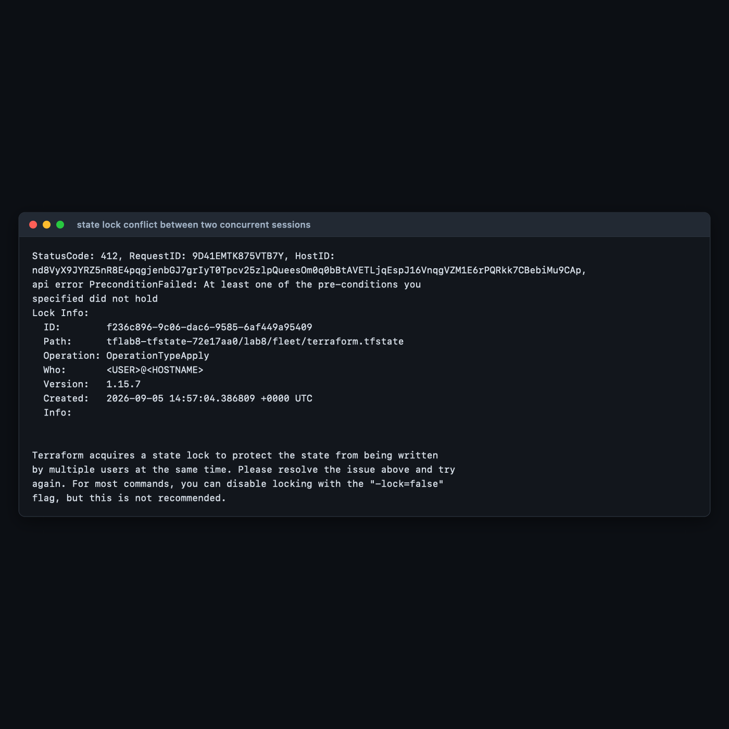
Read the details. StatusCode: 412 PreconditionFailed is S3's conditional-write rejection — that is use_lockfile working, not a bug. The Lock Info block names who holds it, which operation, and when it started. Without this, both sessions would have written state and one would have silently won.
-lock=false exists and is almost always the wrong answer. The lab used -lock-timeout=0s to fail immediately rather than wait, which is a different thing: it still respects the lock. The legitimate use for force-unlock is a lock left behind by a crashed run — and you must be certain no other apply is in flight, because breaking a live lock is how state gets corrupted.
Meanwhile the first session finished, and the fleet scaled:
aws ec2 describe-instances --filters Name=tag:Lab,Values=8 Name=instance-state-name,Values=running \
--query 'sort_by(Reservations[].Instances[],&Tags[?Key==`Name`]|[0].Value)[].{Name:Tags[?Key==`Name`]|[0].Value,Node:Tags[?Key==`NodeNumber`]|[0].Value,FleetSize:Tags[?Key==`FleetSize`]|[0].Value,AZ:Placement.AvailabilityZone}' \
--output table
-------------------------------------------------------
| DescribeInstances |
+-------------+------------+------------------+-------+
| AZ | FleetSize | Name | Node |
+-------------+------------+------------------+-------+
| us-east-1d | 5 | tflab8-node-01 | 1 |
| us-east-1d | 5 | tflab8-node-02 | 2 |
| us-east-1d | 5 | tflab8-node-03 | 3 |
| us-east-1d | 5 | tflab8-node-04 | 4 |
| us-east-1d | 5 | tflab8-node-05 | 5 |
+-------------+------------+------------------+-------+
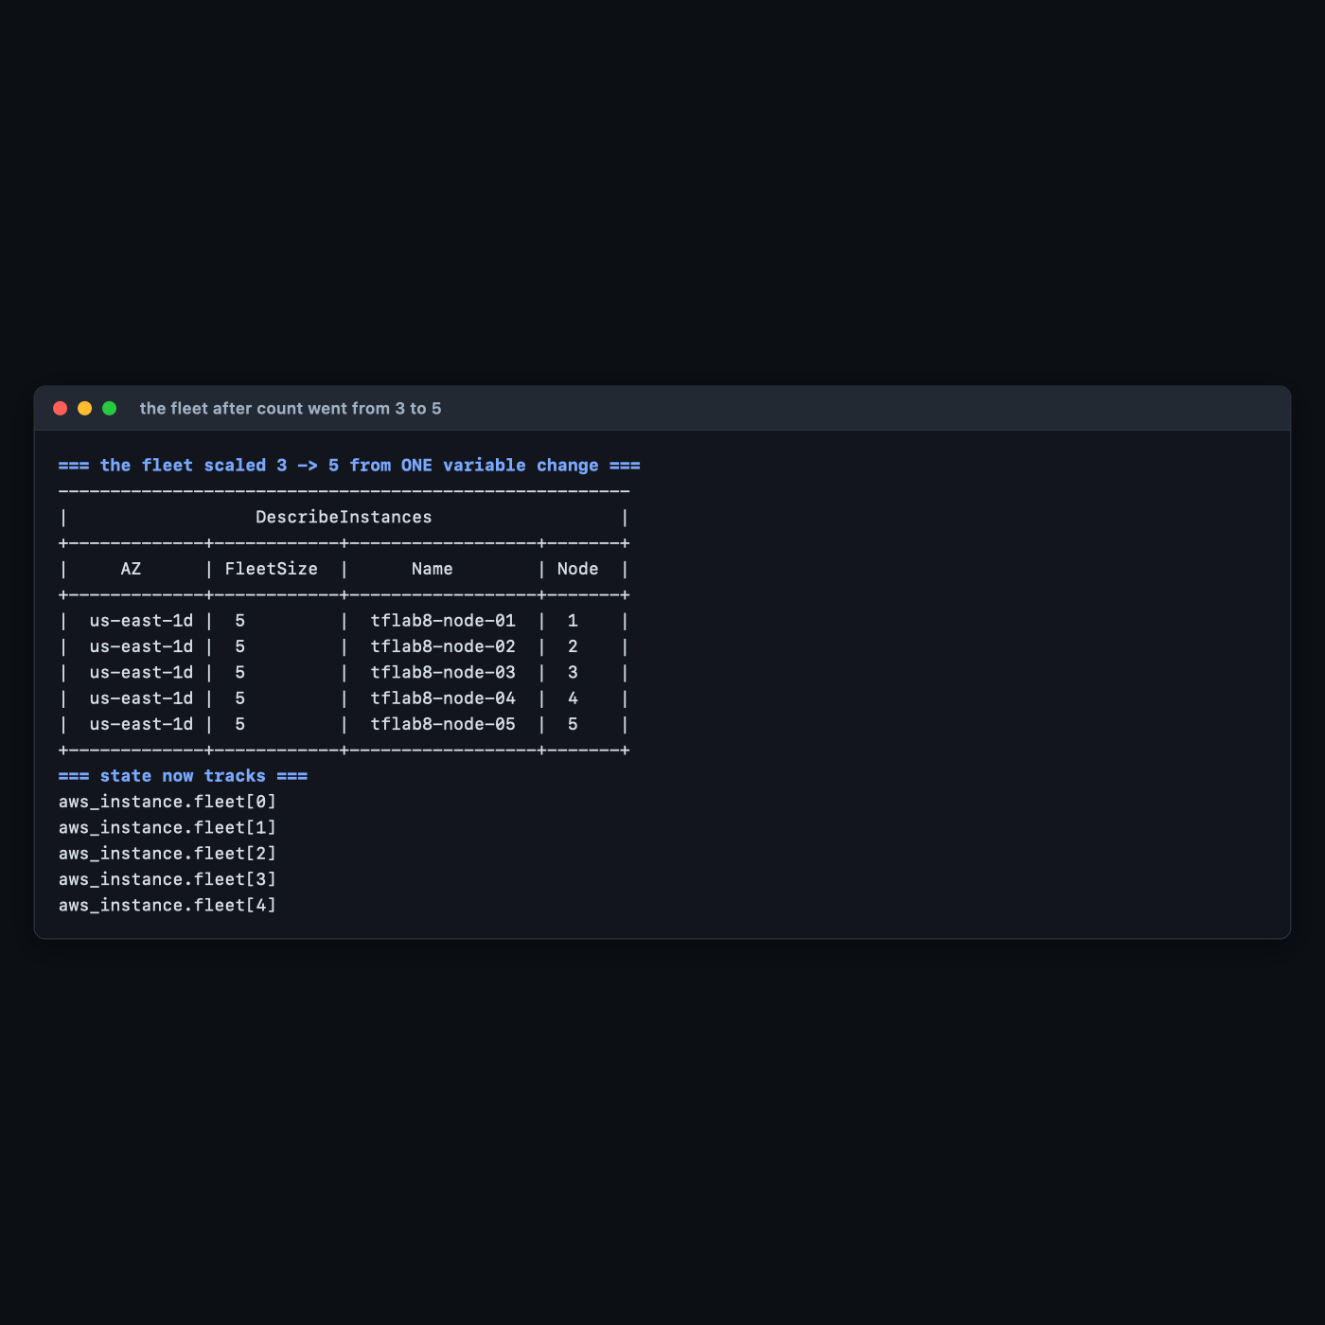
Five nodes, from changing one number. Note the FleetSize tag on nodes 1–3 also updated to 5 — those instances were modified in place, not replaced.

Step 8 — Do it again yourself, split the state, unassisted
Why: One backend and one key is where every team starts and nowhere any team stays. The next real problem is that a single state file makes every apply a whole-estate operation.
Your task. Split the fleet configuration into two independently-applied configurations sharing one bucket: a network/ config that owns a VPC and subnet, and a fleet/ config that places the instances into that subnet — without the fleet config owning or being able to destroy the network. The fleet must discover the subnet at plan time, not have it pasted in.
You get the acceptance criteria and nothing else:
- Two state keys in the same bucket, e.g. lab8/network/terraform.tfstate and lab8/fleet/terraform.tfstate, both visible with aws s3 ls --recursive.
- terraform destroy in fleet/ removes the instances and leaves the VPC untouched.
- No subnet- or vpc- literal appears in fleet/'s configuration.
- terraform plan in fleet/ after changing something in network/ picks up the change with no edits to fleet/.
- Both configurations still lock independently — an apply in one does not block the other.
Done when you can explain which mechanism you used to read one configuration's outputs from another, and name one significant drawback of it. (There is more than one valid answer, and the drawback is the interesting half.)
No commands are given here. Steps 3–6 have the backend mechanics. The part that transfers is realising that two configurations sharing a bucket but not a key is the unit of blast-radius control — the thing Lab 5 §4 Step 8 said workspaces do not give you.

5. Validation / Verification
Save as validate.sh in fleet/. Also at lab-8-loops-backends/fleet/validate.sh.
#!/usr/bin/env bash
# Lab 8 validation. Run from lab-8-loops-backends/fleet/ after migrating to S3.
set -uo pipefail
fail=0
check() { if [ "$2" = "$3" ]; then echo "PASS $1"; else echo "FAIL $1 (got '$2', want '$3')"; fail=1; fi }
BUCKET=$(grep -E '^\s*bucket' backend.tf | head -1 | cut -d'"' -f2)
KEY=$(grep -E '^\s*key' backend.tf | head -1 | cut -d'"' -f2)
N=$(terraform output -raw fleet_size)
check "state holds fleet_size instances" \
"$(terraform state list | grep -c '^aws_instance.fleet\[')" "$N"
check "AWS reports $N running fleet instances" \
"$(aws ec2 describe-instances --filters Name=tag:Lab,Values=8 Name=instance-state-name,Values=running \
--query 'length(Reservations[].Instances[])' --output text)" "$N"
check "format() produced zero-padded names" \
"$(terraform output -json node_names | python3 -c 'import json,sys;print(json.load(sys.stdin)[0])')" \
"tflab8-node-01"
check "state object exists in S3" \
"$(aws s3api head-object --bucket "$BUCKET" --key "$KEY" --query 'ContentLength' --output text >/dev/null 2>&1; echo $?)" "0"
check "S3 state object is encrypted" \
"$(aws s3api head-object --bucket "$BUCKET" --key "$KEY" --query 'ServerSideEncryption' --output text)" "AES256"
check "bucket versioning is enabled" \
"$(aws s3api get-bucket-versioning --bucket "$BUCKET" --query 'Status' --output text)" "Enabled"
check "bucket blocks all public access" \
"$(aws s3api get-public-access-block --bucket "$BUCKET" \
--query 'PublicAccessBlockConfiguration.[BlockPublicAcls,BlockPublicPolicy,IgnorePublicAcls,RestrictPublicBuckets]' \
--output text | tr -d ' \t')" "TrueTrueTrueTrue"
# THE ONE THE HAPPY PATH MISSES: is Terraform actually READING from S3, or is
# there still a populated local state file it could silently fall back to?
LOCAL_RESOURCES=$(python3 -c "
import json,os
p='terraform.tfstate'
if not os.path.exists(p) or os.path.getsize(p)==0: print(0)
else:
try: print(len(json.load(open(p)).get('resources',[])))
except Exception: print(0)
")
check "local state file holds ZERO resources after migration" "$LOCAL_RESOURCES" "0"
REMOTE_RESOURCES=$(aws s3 cp "s3://$BUCKET/$KEY" - 2>/dev/null | python3 -c "
import json,sys
try: print(len(json.load(sys.stdin).get('resources',[])))
except Exception: print(-1)
")
if [ "$REMOTE_RESOURCES" -gt 0 ]; then
echo "PASS remote state in S3 holds $REMOTE_RESOURCES resource blocks"
else
echo "FAIL remote state in S3 holds no resources (got '$REMOTE_RESOURCES')"; fail=1
fi
echo
[ $fail -eq 0 ] && echo "Lab 8 validation: ALL CHECKS PASSED" || echo "Lab 8 validation: FAILURES ABOVE"
exit $fail
Actual output, exit code 0:
PASS state holds fleet_size instances
PASS AWS reports 5 running fleet instances
PASS format() produced zero-padded names
PASS state object exists in S3
PASS S3 state object is encrypted
PASS bucket versioning is enabled
PASS bucket blocks all public access
PASS local state file holds ZERO resources after migration
PASS remote state in S3 holds 2 resource blocks
2 resource blocks is correct, not a bug: state stores one entry per resource block, and the aws_instance.fleet entry contains all five instances. The two are the AMI data source and the fleet.

Why check 8 is the one that matters
Checks 4–7 all confirm that an object exists in S3 with the right properties. None of them proves Terraform is reading it. You can have a perfectly configured, encrypted, versioned state object in S3 and still be running against a stale local file — that is what happens when someone copies state up with aws s3 cp instead of running init -migrate-state, and it is a genuinely common mistake during a migration.
Check 8 asserts the local file holds zero resources, and check 9 asserts the remote one holds some. Together they establish a single source of truth, which is the actual goal of the migration. Step 6's fresh-directory test is the same assertion made a different way, and is the one to run when you want to convince someone else.

6. Troubleshooting Tips
All hit for real while building this lab.
Warning: Deprecated Parameter ... "dynamodb_table" is deprecated
Expected on Terraform 1.10+. Replace dynamodb_table with use_lockfile = true and run terraform init -reconfigure. You can then delete the DynamoDB table entirely.
BucketAlreadyExists / BucketAlreadyOwnedByYou
S3 bucket names are globally unique across all AWS accounts. That is what the random_id suffix is for. If you removed it, put it back.
terraform init proposes to start with empty state
You answered no to the migration prompt, or ran plain init rather than init -migrate-state. Stop before applying — Terraform will otherwise create a second, duplicate set of resources. Re-run terraform init -migrate-state and answer yes.
Error acquiring the state lock when nobody else is running Terraform
A previous run crashed or was Ctrl-C'd while holding the lock. Confirm nothing is actually in flight, then terraform force-unlock <LOCK_ID> using the ID from the error. Never do this on a hunch — a broken live lock is how state gets corrupted.
Backend block rejects var.something
Backend configuration is read before variables are evaluated, so it must contain literals. Use sed to generate the file, or partial configuration with terraform init -backend-config=env.hcl.
terraform destroy in bootstrap/ fails with BucketNotEmpty
The fleet's state file is still in the bucket. Destroy fleet/ first. force_destroy = true handles it in this lab, but a real state bucket will — correctly — refuse.
Everything looks migrated but plan proposes to create resources that exist
Terraform is reading a different state than you think. Run the check-8 test: is the local terraform.tfstate empty? Does terraform state list in a fresh directory show your resources?

7. Cleanup Steps
Order matters. The fleet's state lives in the bootstrap's bucket, so the fleet goes first.
cd ~/terraform-course/lab-8-loops-backends/fleet
terraform destroy -auto-approve
Releasing state lock. This may take a few moments...
Destroy complete! Resources: 5 destroyed.
cd ../bootstrap
terraform destroy -auto-approve
random_id.suffix: Destruction complete after 0s
aws_dynamodb_table.locks: Destruction complete after 9s
Destroy complete! Resources: 6 destroyed.
Confirm everything is gone — instances, bucket and table:
aws ec2 describe-instances --filters Name=tag:Course,Values=intermediate-terraform \
Name=instance-state-name,Values=running,pending,stopped \
--query 'Reservations[].Instances[].InstanceId' --output text
aws s3 ls | grep tflab8 || echo "no tflab8 buckets"
aws dynamodb list-tables --query 'TableNames[?contains(@,`tflab8`)]' --output text
Expected output: nothing, no tflab8 buckets, nothing.
Also remove the local copies of state — they are plaintext infrastructure records:
rm -f terraform.tfstate.backup
rm -rf /tmp/colleague
Keep these, and here is why:
Keep | Why
bootstrap/main.tf | This is a genuinely reusable artifact. Almost every real Terraform project needs exactly this file once.
fleet/backend.tf.example | The backend block with use_lockfile, ready to copy. The shipped copy has a <YOUR_BUCKET> placeholder because the authoring bucket has been destroyed.
validate.sh | Check 8 is worth running after any state migration you ever perform.

Optional extensions
- Recover from a corrupted state. With the fleet applied, overwrite the S3 state object with garbage, watch Terraform fail, then recover using aws s3api list-object-versions and restore the previous version. This is the reason versioning is in Step 1, and doing it once removes most of the fear around remote state.
- Drop DynamoDB entirely. Remove aws_dynamodb_table from the bootstrap, keep use_lockfile = true, and confirm locking still works by repeating Step 7. One fewer resource, one fewer IAM permission, identical protection.
- Use partial backend configuration. Remove bucket and key from backend.tf, put them in dev.hcl and prod.hcl, and switch with terraform init -reconfigure -backend-config=prod.hcl. This is how one configuration serves several environments with genuinely separate state — the alternative to workspaces that Lab 5 §4 Step 8 recommends.
- Scale to zero. Apply with -var fleet_size=0. Everything is destroyed, the configuration stays valid, and terraform output node_names returns [] rather than erroring. This is the cheapest way to pause an environment overnight.
- Time the parallelism. Apply with fleet_size=6, then again with -parallelism=1. The default is 10 concurrent operations; forcing serial execution shows you exactly what that buys, and is a useful flag when an API starts rate-limiting you.

