Lab 9 (Capstone) — Documentation Deep-Dive Challenge
DataCouch — Intermediate Terraform
Table of Contents

Maps to: Terraform Documentation Deep-Dive; Mastery Duration: ~60 minutes Status: The reference solution was built and tested end-to-end on 2026-09-05 (Terraform v1.15.7, AWS provider v6.63.0) against a live AWS account in us-east-1. Every status code, header and error below came from that run — including a bug the author shipped and had to fix, described in §4 Step 5.
Prerequisites: 00-shared-setup.md and Labs 1–8.

1. Lab Overview & Objectives
Every lab so far handed you the code. That is the wrong way round for the work you will actually do, where the resource type you need is one nobody has written a tutorial for, and the only authority is the provider documentation.
This lab gives you no starter code. You get a goal, a set of acceptance criteria you can run yourself, and a link to the Terraform Registry. You will deploy a resource type this course has deliberately never touched.
Learning objectives — by the end of this lab you will be able to:
- Navigate the Terraform Registry provider documentation and find the resources for a feature you have never used.
- Recognise that one AWS feature is often several Terraform resources, and work out which ones and in what order.
- Diagnose failures caused by AWS defaults that the documentation's examples silently assume.
- Deploy, verify and destroy an unfamiliar resource type without a worked example.
The most surprising measured result in this lab: the reference solution — written by someone who has done this before, from the same documentation you are about to read — shipped with a bug. The page rendered â€" where an em dash should have been, in a real browser, because content_type = "text/html" omits the charset. It passed every check that existed at the time. §4 Step 5 has the before-and-after headers. The lesson is not "read more carefully"; it is look at the thing you built, because a 200 does not mean correct.

2. Prerequisites & Environment Setup

2.1 Cost and time
Resources created | 7, and not one of them is an EC2 instance
Measured price | fractions of a cent — a few KB in S3 and a handful of requests
Measured apply time | ~10 seconds
Measured destroy time | ~5 seconds
Hands-on time | ~60 minutes, most of it reading documentation
This is by far the cheapest lab in the course, which is deliberate: an open-ended challenge should not punish experimentation. Try things.

2.2 The only reference you are allowed
- The Terraform Registry AWS provider docs: https://registry.terraform.io/providers/hashicorp/aws/latest/docs
- terraform console, for trying expressions.
- The AWS service documentation, if you want it.
Not permitted, and this matters: blog posts, lab-9-capstone/reference-solution/, or an AI assistant writing the configuration for you. The skill being built here is reading a specification and turning it into working infrastructure. Outsourcing that is outsourcing the lab.

2.3 Setup
mkdir -p ~/terraform-course/lab-9-capstone && cd ~/terraform-course/lab-9-capstone
export AWS_REGION=us-east-1 AWS_DEFAULT_REGION=us-east-1
export TF_PLUGIN_CACHE_DIR="$HOME/.terraform.d/plugin-cache"

3. Architecture
Read this section after your first attempt, not before. It describes the shape of the answer, and finding that shape yourself is the exercise.
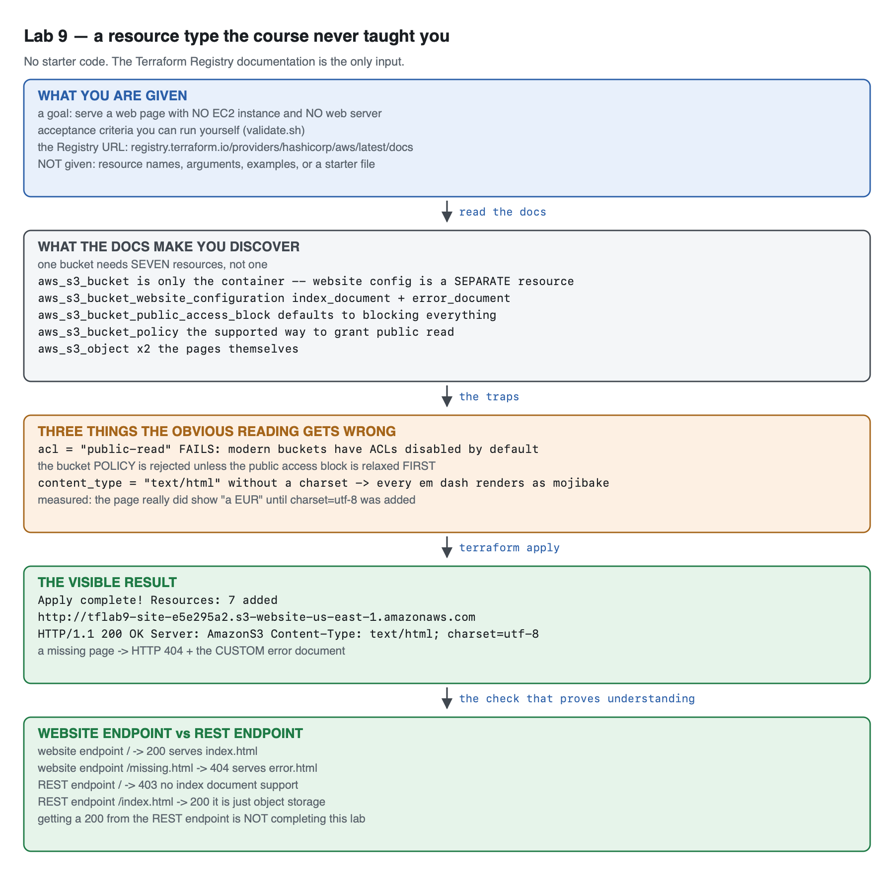
Vector version: lab-9-architecture.svg
Collapsed section in the original — Spoiler — the resource graph of the reference solution. Do not open until you have attempted the challenge.
In Word this cannot be hidden, so it is shown in full below. Skip past it if you are attempting the exercise unaided.
aws_s3_bucket.site the container, and ONLY the container
│
├── aws_s3_bucket_public_access_block.site
│ all four flags = false ← the bucket's DEFAULT is to block everything
│ │
│ ▼ depends_on
├── aws_s3_bucket_policy.site
│ s3:GetObject to Principal "*" ← the SUPPORTED way to make it public
│
├── aws_s3_bucket_website_configuration.site
│ index_document { suffix = "index.html" }
│ error_document { key = "error.html" }
│ → publishes the *website endpoint*, distinct from the REST endpoint
│
├── aws_s3_object.index content_type = "text/html; charset=utf-8"
└── aws_s3_object.error content_type = "text/html; charset=utf-8"
plus random_id.suffix, because S3 bucket names are globally unique.
RESULT: http://tflab9-site-<rand>.s3-website-us-east-1.amazonaws.com
HTTP/1.1 200 OK · Server: AmazonS3 · Content-Type: text/html; charset=utf-8
Seven resources for what AWS presents as one checkbox. That gap — between a feature in a console and the resources in a provider — is the single most useful thing this lab teaches.

4. Step-by-Step Instructions

Step 1 — The challenge
Why: Everything up to now has been guided. This is the transfer test.
Your task. Using Terraform and the AWS provider documentation only, deploy a publicly reachable web page that is served without any EC2 instance and without any web server process.
The page must be produced by Terraform — not uploaded by hand, not copied from a bucket you made in the console.
That is the whole brief. The rest of this section is about how to read documentation, not about the answer.

Step 2 — How to read a provider's documentation
Why: Registry docs have a consistent structure, and knowing it turns an hour of hunting into five minutes.
Open https://registry.terraform.io/providers/hashicorp/aws/latest/docs and use the left sidebar search. The AWS provider has well over a thousand resources; browsing is hopeless, searching is instant.
What you want | Where it is
Does this resource exist? | sidebar search, by AWS service name
What arguments does it take? | Argument Reference — required arguments are marked
What can I reference elsewhere? | Attribute Reference — this is what resource.name.thing can be
A working starting point | Example Usage at the top
How do I adopt an existing one? | Import at the bottom — also tells you the ID format
Three habits that separate fast from slow:
- Search for the AWS feature name, then read the resource list, not the first hit. Searching "s3 bucket" returns two dozen resources. That list is the answer to "which pieces exist" — scanning it is faster than reading any one page.
- Assume one feature is several resources. The AWS provider has spent years splitting monolithic resources into focused ones. Anything you remember as an argument may now be its own resource, and old tutorials will lie to you about this.
- Read Attribute Reference before you need it. It tells you what a resource exports — and frequently the attribute you need is on a different resource than you assumed.
Version-specific documentation matters. The Registry defaults to latest. If you are pinned to an older provider, use the version selector — arguments genuinely appear, deprecate and vanish between majors. Lab 4 §4 Step 3 showed a resource-level region attribute that exists in v6 and not in v5.

Step 3 — The acceptance criteria
Why: An open-ended challenge needs an objective gate, or "it worked" becomes a matter of opinion.
Save this as validate.sh and run it when you think you are done. It is also at lab-9-capstone/reference-solution/validate.sh — the script is not a spoiler, it is the specification.
Your configuration must expose two outputs for the script to work: website_endpoint and bucket_name.
You must satisfy all ten checks:
- HTTP 200 at the site root.
- The Server response header is AmazonS3.
- Content-Type includes an explicit charset.
- A missing page returns a real 404 status.
- A missing page serves your error document, not the generic one.
- Zero aws_instance resources in state.
- A bucket policy exists.
- No aws_s3_bucket_acl resource is used.
- The REST endpoint's root returns 403 — proving it is not the same thing as the website endpoint.
- The REST endpoint serves an explicit object with 200.
Checks 9 and 10 are the ones that distinguish understanding from a lucky result. Read Step 6 before you argue with them.

Step 4 — Attempt it. Come back when you have a 200, or when you are stuck.
Why: The struggle is the lab.
If you have been stuck for more than about fifteen minutes, here are hints in increasing order of specificity. Take the smallest one that unblocks you.
Collapsed section in the original — Hint 1 — the shape of the problem
In Word this cannot be hidden, so it is shown in full below. Skip past it if you are attempting the exercise unaided.
You are looking for something S3 does. Search the sidebar for s3_bucket and read the list of resources rather than opening the first one. Note how many there are.
Collapsed section in the original — Hint 2 — the bucket is not enough
In Word this cannot be hidden, so it is shown in full below. Skip past it if you are attempting the exercise unaided.
aws_s3_bucket creates storage. It does not, on its own, serve anything, and it does not make anything public. Both of those are separate resources. Find them.
Collapsed section in the original — Hint 3 — you have a bucket and a website config, and you get 403
In Word this cannot be hidden, so it is shown in full below. Skip past it if you are attempting the exercise unaided.
Correct so far. A new S3 bucket blocks public access by default, at two independent levels. You must relax the block and grant read access, in that order. The ordering is a real dependency, not a style preference.
Collapsed section in the original — Hint 4 — the tutorial you found says acl = "public-read"
In Word this cannot be hidden, so it is shown in full below. Skip past it if you are attempting the exercise unaided.
That tutorial predates a change in S3's defaults. Buckets are now created with ACLs disabled (BucketOwnerEnforced), so ACL-based approaches fail. There is a different, supported mechanism for granting public read. Check 8 in the acceptance criteria rules out the wrong one explicitly.

Step 5 — After you have it working: look at it
Why: Because the reference solution passed its own checks and was still wrong, and the only thing that revealed it was opening the page in a browser.
The first working version of the reference solution set:
content_type = "text/html" # without this S3 serves it as a download
That comment is true, and the setting is still wrong. Here is what the browser received:
Content-Type: text/html
and here is what it rendered:
This page is served by an S3 static website endpoint â€" no EC2 instance, no web server.
â€" is an em dash that was written as UTF-8 and read as latin-1. With no charset in the Content-Type header, the browser guessed, and guessed wrong. Every check that existed at that point passed. curl showed the correct character, because curl prints bytes and your terminal is already UTF-8 — so even a careful CLI check missed it.
The fix:
# "text/html" alone is NOT enough: without an explicit charset the browser
# falls back to latin-1 and every non-ASCII character is mojibake.
content_type = "text/html; charset=utf-8"
Measured, before and after:
=== BEFORE ===
Content-Type: text/html
endpoint — no EC2 in ← curl looked fine; the BROWSER did not
=== AFTER ===
Content-Type: text/html; charset=utf-8
endpoint — no EC2 in
Check 3 in the acceptance criteria exists because of this bug. A regression test is what a bug leaves behind when you fix it properly.
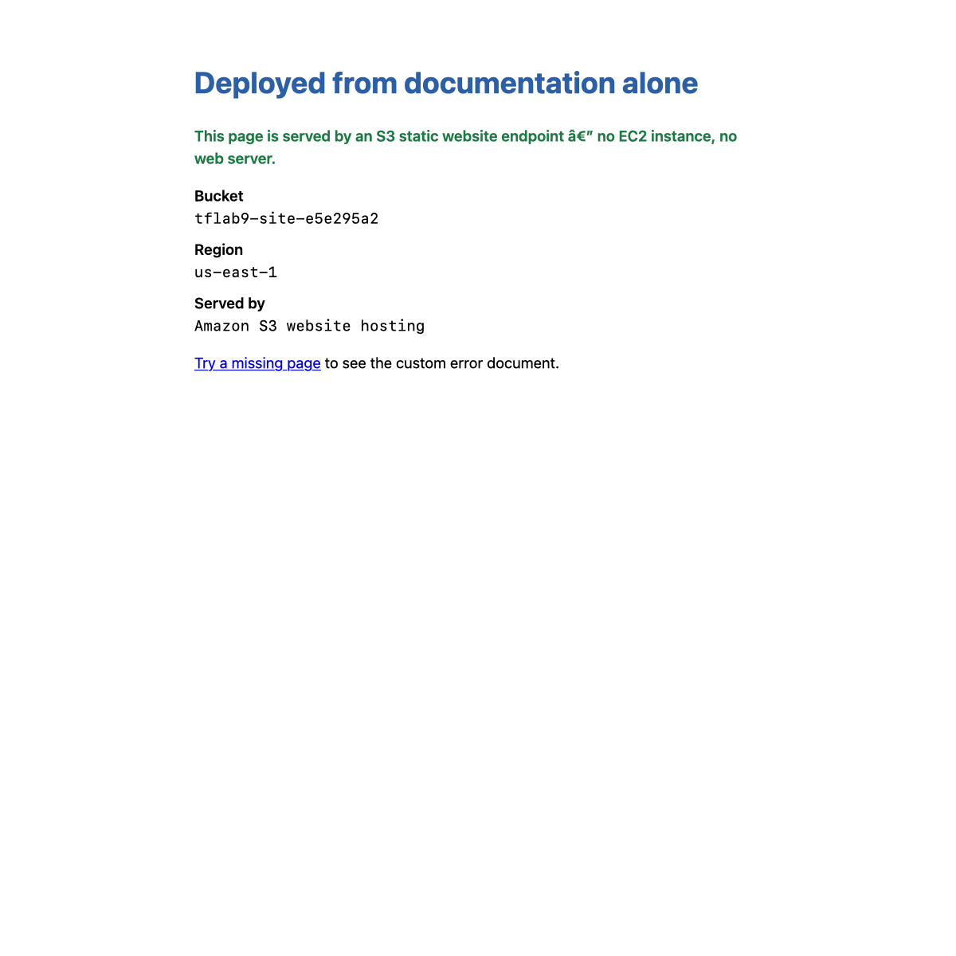

Step 6 — The distinction most people miss: two endpoints, not one
Why: This is the difference between "I made a bucket public" and "I configured static website hosting", and it is the single most common misunderstanding about S3 websites.
Every S3 bucket has a REST endpoint. A bucket with website hosting configured also gets a website endpoint. They are different hostnames with different behaviour:
WEB=$(terraform output -raw website_endpoint)
REST=$(terraform output -raw rest_endpoint)
curl -s -o /dev/null -w 'website root: HTTP %{http_code}\n' "$WEB"
curl -s -o /dev/null -w 'website /missing: HTTP %{http_code}\n' "$WEB/does-not-exist.html"
curl -s -o /dev/null -w 'REST root: HTTP %{http_code}\n' "$REST"
curl -s -o /dev/null -w 'REST /index.html: HTTP %{http_code}\n' "$REST/index.html"
Measured output:
website root: HTTP 200
website /missing: HTTP 404
REST root: HTTP 403
REST /index.html: HTTP 200
 | Website endpoint | REST endpoint
Hostname | <bucket>.s3-website-<region>.amazonaws.com | <bucket>.s3.<region>.amazonaws.com
Root request | serves your index document | 403 — there is no "index" concept
Missing key | your custom error document, 404 | an S3 XML error
Protocol | HTTP only — no TLS | HTTPS
It is | a web server | an object storage API
Getting 200 from <bucket>.s3.<region>.amazonaws.com/index.html is not completing this lab. That is object storage returning a file you asked for by name. The website endpoint is a different feature, and the index-document and error-document behaviour is what you were asked to build.
The website endpoint is HTTP-only. There is no way to put TLS on it directly. Production static sites put CloudFront in front, which terminates HTTPS and lets you keep the bucket entirely private via Origin Access Control. That is the natural next step, and it is the first optional extension.

Step 7 — Do it again yourself, a second unfamiliar resource type, unassisted
Why: You have now read the documentation for one unfamiliar service with a lab telling you when you were done. The real version has no acceptance criteria written for you.
Your task. Pick a resource type this course has never mentioned and deploy something working with it — and write your own acceptance criteria first. Suggestions, roughly in order of difficulty:
- An SNS topic with an email subscription that delivers a real message.
- A CloudWatch alarm on an EC2 metric that actually enters ALARM state.
- An Application Load Balancer in front of two instances (mind the cost — an ALB is ~$0.0225/hour plus LCUs, far more than anything else in this course, so destroy it promptly).
- A Lambda function with a function URL that returns a response.
You get the acceptance criteria and nothing else — because you are writing them:
- Before you write any HCL, write a validate.sh with at least five objective checks, including one that a superficially-working solution would fail. That last one is the hard part and the whole point.
- The configuration deploys from empty with a single terraform apply.
- Your validation passes, and you can explain what each check rules out.
- terraform destroy removes everything, and the tag-based backstop query from 00-shared-setup.md §6 returns nothing.
- You can state one thing the provider documentation did not tell you, that you found out by running it.
Done when you can name the check you wrote that a superficially-working solution would fail, and explain what class of mistake it catches. If every check you wrote passes on the first attempt, they were probably too weak — check 3 of this lab only exists because the author's first attempt was wrong in a way curl could not see.

5. Validation / Verification
#!/usr/bin/env bash
# Lab 9 capstone validation. These are the ACCEPTANCE CRITERIA -- participants
# get this script, not the solution.
set -uo pipefail
fail=0
check() { if [ "$2" = "$3" ]; then echo "PASS $1"; else echo "FAIL $1 (got '$2', want '$3')"; fail=1; fi }
URL=$(terraform output -raw website_endpoint)
BUCKET=$(terraform output -raw bucket_name)
check "HTTP 200 at the website root" \
"$(curl -s -o /dev/null -w '%{http_code}' --max-time 15 "$URL")" "200"
check "served by AmazonS3" \
"$(curl -sI --max-time 15 "$URL" | awk -F': ' 'tolower($1)=="server"{gsub(/\r/,"",$2); print $2}')" "AmazonS3"
# Without a charset every non-ASCII character is mojibake -- see Step 5.
check "Content-Type declares a charset" \
"$(curl -sI --max-time 15 "$URL" | awk -F': ' 'tolower($1)=="content-type"{gsub(/\r/,"",$2); print tolower($2)}')" \
"text/html; charset=utf-8"
check "missing page returns 404" \
"$(curl -s -o /dev/null -w '%{http_code}' --max-time 15 "$URL/no-such-page.html")" "404"
check "missing page serves the CUSTOM error document" \
"$(curl -sS --max-time 15 "$URL/no-such-page.html" | grep -c 'Served by the S3 website endpoint')" "1"
check "zero EC2 instances in this configuration" \
"$(terraform state list | grep -c '^aws_instance' || true)" "0"
check "a bucket policy exists" \
"$(aws s3api get-bucket-policy --bucket "$BUCKET" --query 'Policy' --output text >/dev/null 2>&1; echo $?)" "0"
check "no aws_s3_bucket_acl resource is used" \
"$(terraform state list | grep -c 'aws_s3_bucket_acl' || true)" "0"
# THE ONES THE HAPPY PATH MISSES: is this the WEBSITE endpoint, or just an
# object fetched over the REST endpoint? Both return 200 for /index.html.
REST="https://$BUCKET.s3.us-east-1.amazonaws.com"
check "REST endpoint root does NOT serve the index (proving these differ)" \
"$(curl -s -o /dev/null -w '%{http_code}' --max-time 15 "$REST")" "403"
check "REST endpoint DOES serve an explicit object" \
"$(curl -s -o /dev/null -w '%{http_code}' --max-time 15 "$REST/index.html")" "200"
echo
[ $fail -eq 0 ] && echo "Lab 9 validation: ALL CHECKS PASSED" || echo "Lab 9 validation: FAILURES ABOVE"
exit $fail
Actual output against the reference solution, exit code 0:
PASS HTTP 200 at the website root
PASS served by AmazonS3
PASS Content-Type declares a charset
PASS missing page returns 404
PASS missing page serves the CUSTOM error document
PASS zero EC2 instances in this configuration
PASS a bucket policy exists
PASS no aws_s3_bucket_acl resource is used
PASS REST endpoint root does NOT serve the index (proving these differ)
PASS REST endpoint DOES serve an explicit object
Lab 9 validation: ALL CHECKS PASSED

Why checks 9 and 10 are the ones that matter
Checks 1–8 can all be satisfied by a bucket that is merely public. Checks 9 and 10 together establish that the website feature is configured, by asserting a difference in behaviour between the two endpoints: the REST endpoint must return 403 at its root while still serving /index.html with 200.
A solution that made a bucket public and linked directly to .../index.html would pass checks 1, 2, 6, 7 and 8, and fail 9 — which is the correct outcome, because it did not build what was asked for.
Check 3 is the other one worth defending: it exists because the reference solution failed it, in a browser, while passing everything else.

6. Troubleshooting Tips
All hit for real while building the reference solution.
403 Forbidden from the website endpoint
The most common failure, and it has two independent causes that must both be fixed: the bucket's public access block still blocks public policies, and/or there is no bucket policy granting s3:GetObject. Relaxing the block alone grants nothing; adding the policy alone is rejected.
AccessDenied when applying the bucket policy
Ordering. The public access block must be relaxed before the policy is accepted. Terraform infers most dependencies from references, but here there is no reference between the two resources — so an explicit depends_on is required. This is one of the few places depends_on is genuinely correct.
AccessControlListNotSupported from acl = "public-read"
Modern S3 buckets are created with ACLs disabled (ObjectOwnership = BucketOwnerEnforced). Every tutorial older than that change tells you to use an ACL, and every one of them now fails. Use a bucket policy.
The browser downloads the page instead of displaying it
No content_type on the object. S3 defaults to binary/octet-stream, and browsers download that.
The page displays but non-ASCII characters are mangled
content_type = "text/html" with no charset — see Step 5. Use "text/html; charset=utf-8". Note that curl will not show you this problem.
A missing page shows a generic S3 XML error rather than your error page
Either error_document is not set in the website configuration, or the error object was never uploaded, or you are hitting the REST endpoint, which has no concept of an error document.
BucketAlreadyExists
S3 bucket names are globally unique across every AWS account. Add a random_id suffix.
terraform destroy fails with BucketNotEmpty
Terraform manages the two objects it created, but not anything else in the bucket. force_destroy = true handles it — appropriate for a lab, and something to think hard about anywhere else.

7. Cleanup Steps
terraform destroy -auto-approve
Expected output:
random_id.suffix: Destruction complete after 0s
Destroy complete! Resources: 7 destroyed.
Confirm the bucket is gone:
aws s3 ls | grep tflab9 || echo "no tflab9 buckets"
Expected output: no tflab9 buckets

Then run the course-wide sweep
This is the last lab. Confirm the whole course left nothing behind:
aws ec2 describe-instances --filters Name=tag:Course,Values=intermediate-terraform \
Name=instance-state-name,Values=running,pending,stopped \
--query 'Reservations[].Instances[].InstanceId' --output text
aws ec2 describe-vpcs --filters Name=tag:Course,Values=intermediate-terraform \
--query 'Vpcs[].VpcId' --output text
aws s3 ls | grep tflab || echo "no tflab buckets"
aws dynamodb list-tables --query 'TableNames[?contains(@,`tflab`)]' --output text
Expected output after the authoring run — nothing from any of them except the S3 line:
no tflab buckets
Keep these, and here is why:
Keep | Why
Your own solution | It is the proof you can work from documentation. Keep it next to the reference and compare.
validate.sh | The endpoint-difference checks generalise: assert a behavioural difference, not just a status code.
reference-solution/ | One tested answer, with its comments explaining the three traps. Not the only correct answer.

Optional extensions
- Put CloudFront in front of it. The website endpoint is HTTP-only. Add an aws_cloudfront_distribution with Origin Access Control, make the bucket private again, and serve the same content over HTTPS. This is the real-world architecture, it is entirely documentation-driven, and it is a genuinely harder version of this lab.
- Add a redirect rule. aws_s3_bucket_website_configuration supports routing_rule blocks. Make /old-page.html redirect to /, and verify with curl -I that you get a 301 and a Location header.
- Version the site. Enable bucket versioning, change index.html, apply, then retrieve the previous version with aws s3api list-object-versions. The same mechanism that protects state in Lab 8 gives you content rollback here.
- Serve a real directory. Replace the two inline aws_s3_object resources with a for_each over fileset(path.module, "site/**"), uploading a whole directory and setting content_type per file extension with a lookup map. This combines Lab 7's functions with this lab's resources, and it is how you would actually deploy a site.
- Write the module. Package this as a reusable module with the interface discipline from Lab 5 — typed variables in, website_endpoint out — and call it twice from one root to deploy two sites. If Labs 5 and 9 both landed, this should take about fifteen minutes.

