Analyse des grilles d’évaluation RDA SHARC

Antoine Blanchard

23/08/2021

Table of Contents

This is an [R Markdown](http://rmarkdown.rstudio.com) Notebook. When you execute code within the notebook, the results appear beneath the code.

Try executing this chunk by clicking the *Run* button within the chunk or by placing your cursor inside it and pressing *Cmd+Shift+Enter*.

## Import et nettoyage des données

data <- read.csv2("clean_data.csv", header = TRUE, sep = ",", row.names = "Code") %>%  
 mutate(Cluster=factor(Cluster, levels = c("Findable", "Accessible", "Interoperable", "Reusable")))  
  
data_wide <- data %>%  
 filter (Cluster != "NA")

## Classons les réponses possibles à chaque critère

cols <- c("GenTree", "Phénotypage.DROPS", "Carbone.talveg", "Données.Lidar", "Herbier.de.Guyane", "Rhizotron", "Guyadiv", "Allométrie", "Carbone.du.sol", "Génotypage.DROPS")  
  
data_wide[,cols] <- lapply(data_wide[,cols], factor, levels = c("Never", "Mandatory", "Sometimes", "Always"), exclude = "", ordered = T)  
  
data_wide[,cols] <- lapply(data_wide[,cols], fct_explicit_na, na_level = "NA")  
  
data_wide[,cols] <- lapply(data_wide[,cols], factor, levels = c("NA", "Never", "Mandatory", "Sometimes", "Always"), exclude = "", ordered = T)

## Passons de données wide à des données narrow

data_narrow <- data_wide %>%  
 pivot_longer (cols = cols, names_to = "Dataset", values_to = "Evaluation") %>%  
 mutate(Dataset=factor(Dataset))

## Note: Using an external vector in selections is ambiguous.  
## ℹ Use `all_of(cols)` instead of `cols` to silence this message.  
## ℹ See <https://tidyselect.r-lib.org/reference/faq-external-vector.html>.  
## This message is displayed once per session.

## Représentons graphiquement les réponses à chaque critère

data_narrow %>%  
 ggplot(aes(x = Evaluation, fill = Cluster)) +   
 geom_bar(position = position_stack(reverse = TRUE)) +  
 facet_wrap(~ Dataset, ncol = 4) +  
 scale_fill_manual(values = brewer.pal(4, "Greens")) +  
 theme_bw() +  
theme(axis.text.x = element_text(angle = 45, vjust = 1, hjust=1))

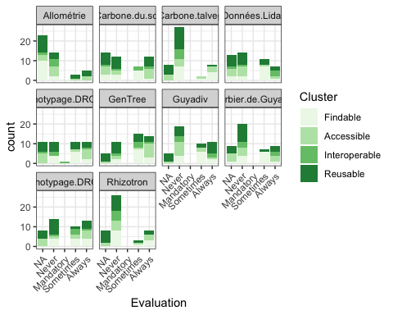

data_narrow %>%  
 filter(Dataset == "Allométrie") %>%  
 ggplot(aes(x = Evaluation, fill = Cluster)) +   
 geom_bar(position = position_stack(reverse = TRUE)) +  
 facet_wrap(~ Dataset, ncol = 4) +  
 scale_fill_manual(values = brewer.pal(4, "Greens")) +  
 theme_bw() +  
 theme(axis.text.x = element_text(angle = 45, vjust = 1, hjust=1)) +  
 theme(legend.position = "none")

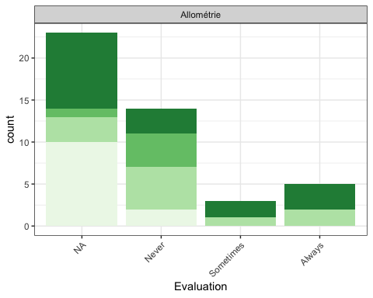

data_narrow %>%  
 filter(Dataset == "Carbone.du.sol") %>%  
 ggplot(aes(x = Evaluation, fill = Cluster)) +   
 geom_bar(position = position_stack(reverse = TRUE)) +  
 facet_wrap(~ Dataset, ncol = 4) +  
 scale_fill_manual(values = brewer.pal(4, "Greens")) +  
 theme_bw() +  
 theme(axis.text.x = element_text(angle = 45, vjust = 1, hjust=1)) +  
 theme(legend.position = "none")

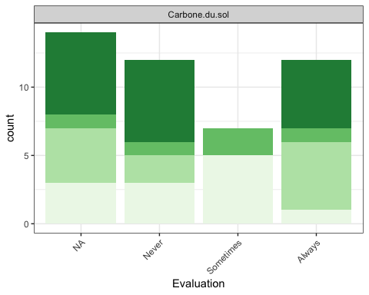

data_narrow %>%  
 filter(Dataset == "Carbone.talveg") %>%  
 ggplot(aes(x = Evaluation, fill = Cluster)) +   
 geom_bar(position = position_stack(reverse = TRUE)) +  
 facet_wrap(~ Dataset, ncol = 4) +  
 scale_fill_manual(values = brewer.pal(4, "Greens")) +  
 theme_bw() +  
 theme(axis.text.x = element_text(angle = 45, vjust = 1, hjust=1)) +  
 theme(legend.position = "none")

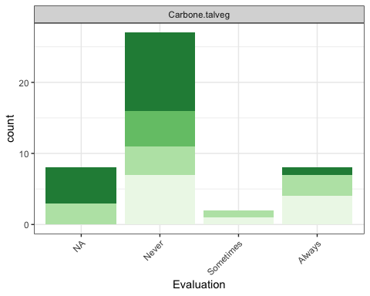

data_narrow %>%  
 filter(Dataset == "GenTree") %>%  
 ggplot(aes(x = Evaluation, fill = Cluster)) +   
 geom_bar(position = position_stack(reverse = TRUE)) +  
 facet_wrap(~ Dataset, ncol = 4) +  
 scale_fill_manual(values = brewer.pal(4, "Greens")) +  
 theme_bw() +  
 theme(axis.text.x = element_text(angle = 45, vjust = 1, hjust=1)) +  
 theme(legend.position = "none")

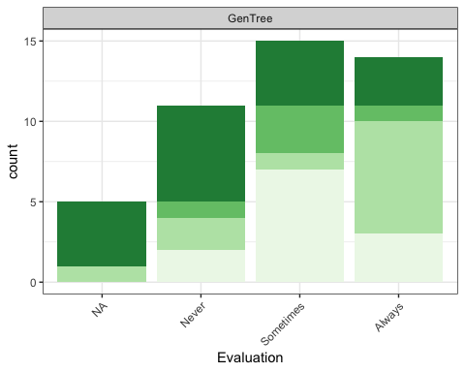

data_narrow %>%  
 filter(Dataset == "Phénotypage.DROPS") %>%  
 ggplot(aes(x = Evaluation, fill = Cluster)) +   
 geom_bar(position = position_stack(reverse = TRUE)) +  
 facet_wrap(~ Dataset, ncol = 4) +  
 scale_fill_manual(values = brewer.pal(4, "Greens")) +  
 theme_bw() +  
 theme(axis.text.x = element_text(angle = 45, vjust = 1, hjust=1)) +  
 theme(legend.position = "none")

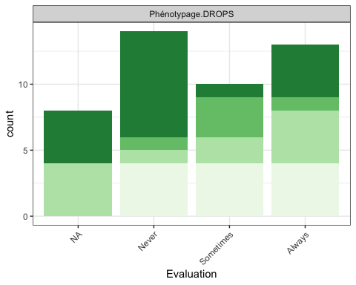

data_narrow %>%  
 filter(Dataset == "Données.Lidar") %>%  
 ggplot(aes(x = Evaluation, fill = Cluster)) +   
 geom_bar(position = position_stack(reverse = TRUE)) +  
 facet_wrap(~ Dataset, ncol = 4) +  
 scale_fill_manual(values = brewer.pal(4, "Greens")) +  
 theme_bw() +  
 theme(axis.text.x = element_text(angle = 45, vjust = 1, hjust=1)) +  
 theme(legend.position = "none")

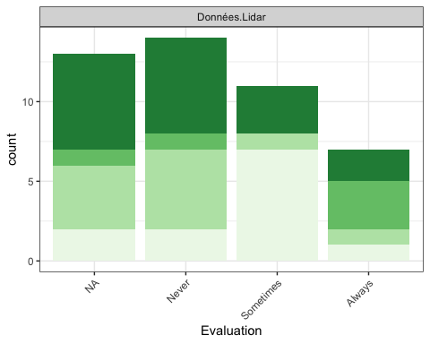

data_narrow %>%  
 filter(Dataset == "Herbier.de.Guyane") %>%  
 ggplot(aes(x = Evaluation, fill = Cluster)) +   
 geom_bar(position = position_stack(reverse = TRUE)) +  
 facet_wrap(~ Dataset, ncol = 4) +  
 scale_fill_manual(values = brewer.pal(4, "Greens")) +  
 theme_bw() +  
 theme(axis.text.x = element_text(angle = 45, vjust = 1, hjust=1)) +  
 theme(legend.position = "none")

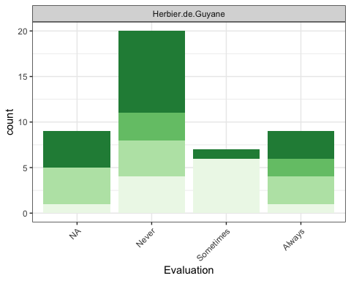

data_narrow %>%  
 filter(Dataset == "Rhizotron") %>%  
 ggplot(aes(x = Evaluation, fill = Cluster)) +   
 geom_bar(position = position_stack(reverse = TRUE)) +  
 facet_wrap(~ Dataset, ncol = 4) +  
 scale_fill_manual(values = brewer.pal(4, "Greens")) +  
 theme_bw() +  
 theme(axis.text.x = element_text(angle = 45, vjust = 1, hjust=1)) +  
 theme(legend.position = "none")

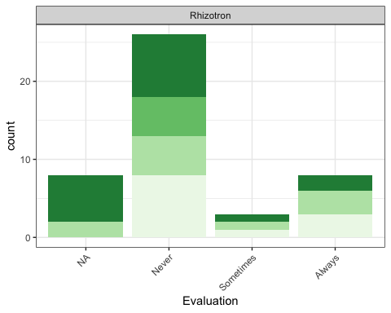

data_narrow %>%  
 filter(Dataset == "Guyadiv") %>%  
 ggplot(aes(x = Evaluation, fill = Cluster)) +   
 geom_bar(position = position_stack(reverse = TRUE)) +  
 facet_wrap(~ Dataset, ncol = 4) +  
 scale_fill_manual(values = brewer.pal(4, "Greens")) +  
 theme_bw() +  
 theme(axis.text.x = element_text(angle = 45, vjust = 1, hjust=1)) +  
 theme(legend.position = "none")

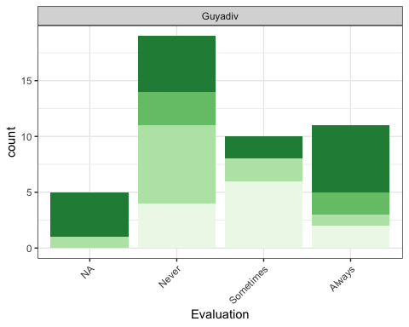

data_narrow %>%  
 filter(Dataset == "Génotypage.DROPS") %>%  
 ggplot(aes(x = Evaluation, fill = Cluster)) +   
 geom_bar(position = position_stack(reverse = TRUE)) +  
 facet_wrap(~ Dataset, ncol = 4) +  
 scale_fill_manual(values = brewer.pal(4, "Greens")) +  
 theme_bw() +  
 theme(axis.text.x = element_text(angle = 45, vjust = 1, hjust=1)) +  
 theme(legend.position = "none")

