- Understand the problem by talking to stakeholders
- Gather and document requirements clearly
- Analyze processes (AS-IS and TO-BE)
- Create diagrams and wireframes to explain ideas
- Coordinate between business and tech teams
- Write user stories / BRD / FRD
- Support development and testing
- Ensure the final solution meets business needs

What is Business Analysis?
Business analysis means understanding how a business works, finding problems or opportunities, and helping teams create the right solutions. It’s basically about connecting business needs with the right actions or systems to get better results.
Who is Business Analyst?
A Business Analyst is a person who understands business needs, finds problems or opportunities, and helps create the right solutions by connecting business teams and technical teams.
He is the face of the Technical team to the Client and all Client Communications will happen through a Business Analyst.
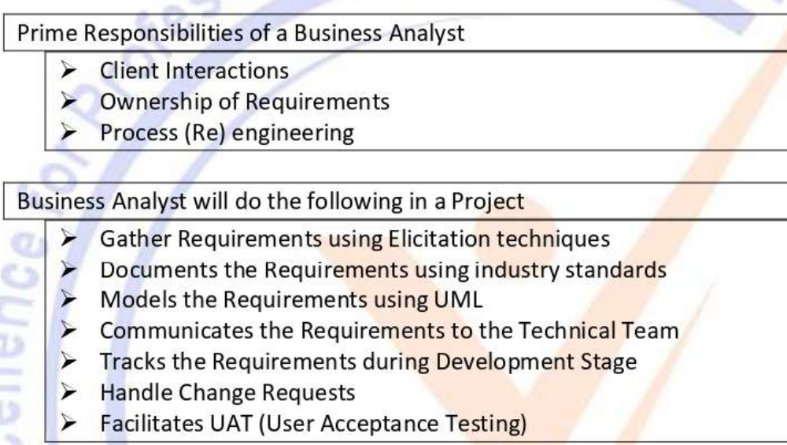

In Business Analysis, a requirement is a need or condition that must be fulfilled to solve a business problem or achieve a goal. It describes what the business wants and how the system should perform.
Types of Requirements:
- Business Requirements – High-level goals or objectives of the organization.
- Functional Requirements – Describe what the system should do (features or functions).
- Non-Functional Requirements – Define system qualities like performance, security, or usability.
- Stakeholder Requirements – Show what each stakeholder (like customers, managers, or users) expects from the project.
- Transition Requirements – Explain what is needed to move from the current state to the new system (e.g., data migration, user training).
The bond between requirements and a Business Analyst (BA) is very strong because requirements are the core of a BA’s job. A BA’s main role is to understand, gather, analyze, document, and manage these requirements to make sure the final product meets business needs.
In simple terms, requirements are what the business wants, and the BA is the person who makes sure those wants are clearly understood and delivered.
Without clear requirements, a project can easily fail — and without a BA, those requirements may not be properly understood or managed.

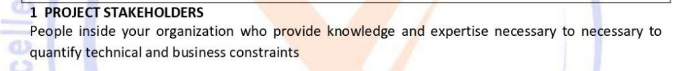
Like- BA, PO, testing specialist, system architect, dev team,
2. Business Stakeholder- is someone from the business side who is directly impacted by the project’s outcome. Who define business goals, share requirements, and ensure the project adds value to the organization.
Like- Project manager, Business owner, operation team, Business sponsor.
3. 3rd party stakeholder-
Like- Auditors, Focus group, Security specialist, safety specialist.
Negative Stakeholders- people or org. who do not want your project to succeed.
Like- competitor, Hacker, Political party, Public opinion.

Business Process Modeling (BPM) is the method of visually representing how a business process works from start to finish. It helps identify steps, roles, decisions, and areas for improvement so that the process becomes more efficient and easier to understand.
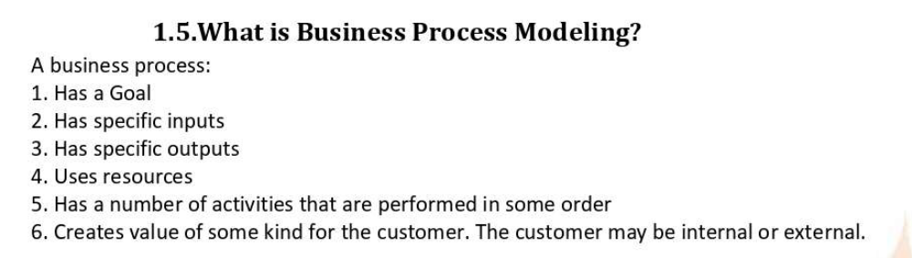

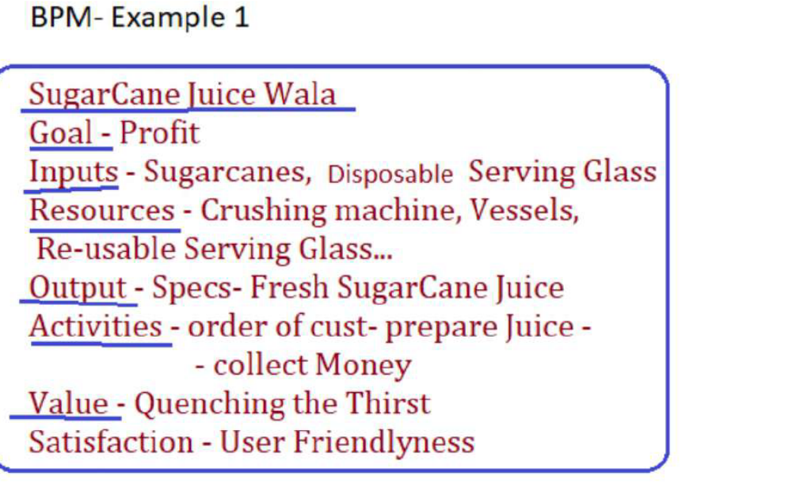

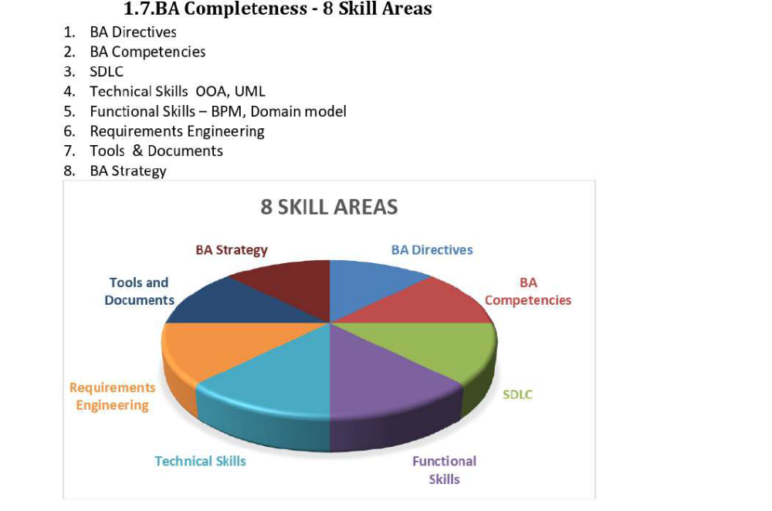

4. SDLC
- Is a process use in S/W development
- It has methodologies (set of guidelines)
- To develop or design high quality s/w which can meet both the client & real-world requirement.
- It has 7 phases like- Planning/Analysis/ Designing/ Implementation/ Testing/ Deployment/ Maintenance.
4.1 Sequential- Waterfall
- This is the most common and classic of life cycle models
- Also known as a linear-sequential life cycle model
- Very easy and simple to understand.
- Introduced by Winston Royce in 1970
- Next phase is started only when previous one has done.
- After every phase, review takes place to check whether project is on right phase or not.

Stages/Phases: - seven
Req. gathering- Req. Analysis- Design- Development/coding- Testing – Deployment, Implementation- Maintenance.

4.2 Iterative- RUP
- The Iterative Model (RUP) is an SDLC approach where the project is developed in small parts called iterations.
- Each iteration goes through all phases — planning, designing, coding, and testing — to build a working version of the software.
- After each cycle, feedback is taken, and improvements are made in the next one.
- It has four main phases — Inception (planning), Elaboration (designing and identifying risks), Construction (development and testing), and Transition (deployment and support).
- This model helps fix issues early, allows changes easily, and delivers a usable product faster. It’s useful for large or evolving projects where requirements can change over time.
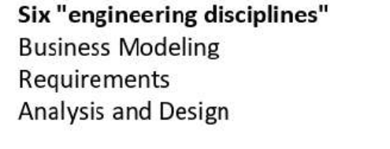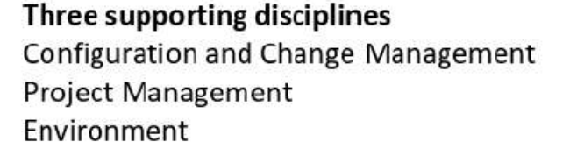
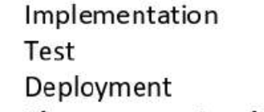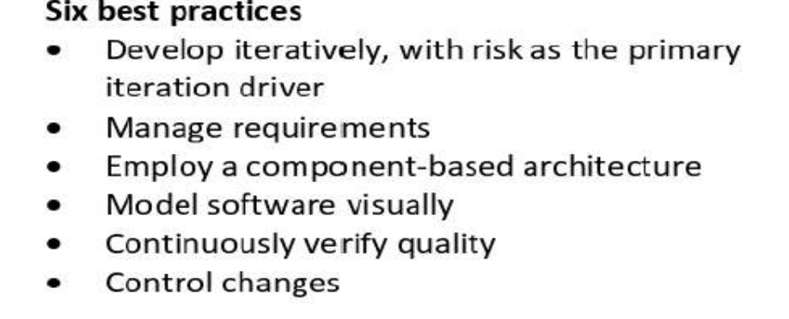
- It is a Risk-driven Model.
- Focused on managing risk through multiple iteration
- The spiral model has 4 phases- Planning- Risk analysis- Engineering- Evaluation
- It involves continuous refinement of a project through iterative cycle of these 4 phases.
- Planning- req are gathered at this phase
- Risk analysis- process is done to identify risk and alternate solutions or prototype is produced at the end of risk analysis phase
- Engineering- software is produced and testing at the end of this phase.
- Evaluation- allows client to evaluate the output of a project before the date so that project can go to the next spiral

Advantages
High amount of risk analysis at every phase
Good for large, mission critical projects
Software is produced early in the s/w lifecycle

Cons
Mgmt. is more complex
Not suitable for small & low risk project
Requires expertise in risk analysis
Can be costly & time consuming due to multiple cycle.

4.4 Agile Model

- Agile is a lightweight and fast development approach used when quick delivery is needed.
- It has less documentation, as the code itself acts as documentation
- It focuses on customer satisfaction through quick updates and changes.
- Agile works best with experienced developers, but it may not support large or highly scalable projects.
Four main values

- Agile focuses on people and teamwork more than tools,
- working software instead of heavy documents,
- customer involvement instead of strict contracts, and
- adapting to change rather than just following a fixed plan.

12 Agile Principles 👇
- Keep customers happy with early and regular delivery of useful software.
- Accept changes anytime to give customers a better product.
- Deliver working software frequently in short cycles.
- Business and technical teams should work together daily.
- Support and trust motivated team members.
- Communicate face-to-face for better understanding.
- Working software shows real progress.
- Maintain a steady and balanced work pace.
- Focus on good design and technical quality.
- Keep things simple and avoid unnecessary work.
- Let teams organize their own work and decisions.
- Review and improve regularly to work smarter next time.

Scrum: - Scrum is an agile framework and is a way of managing projects using Agile principles.
It breaks the work into short cycles called sprints (usually 2–3 weeks), where the team plans, builds, tests, and delivers small, usable parts of the project.
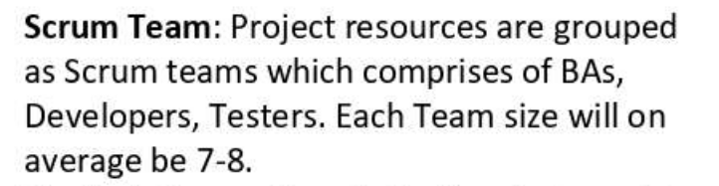
Product Owner-
- decide what to be in the product
- responsible how the product has to be
- regularly interact with the customer and BA
- this role can be played by BA and any person who worked for end user
Scrum Master-
- monitor the performance of the team within the sprint
- team will raise all their issues to him and he will give answer to them
- this can also played by BA or any person
Here’s a simple explanation 👇

1. Product Burndown Chart
A Product Burndown Chart shows the overall progress of the entire project or product backlog.
It tracks how much work (user stories or features) remains to be completed for the whole product across multiple sprints.
✅ Purpose: To see if the project is on track to finish by the planned release date.
📊 Used by: Product Owners and stakeholders for long-term progress tracking.
Example:
If a project has 100 story points and after 4 sprints, 60 are done → the chart shows 40 remaining.

2. Sprint Burndown Chart
A Sprint Burndown Chart shows the daily progress within a single sprint.
It tracks how much work (tasks or story points) is left for the current sprint day by day.
✅ Purpose: To monitor team progress during the sprint and ensure sprint goals are achievable.
📊 Used by: Scrum Master and team for short-term tracking.
Example:
In a 2-week sprint with 50 story points — if 10 points are completed each day, the chart will show a steady decline to zero by the end of the sprint.

- an Epic is a big user story or a large feature in Agile that can’t be completed in a single sprint.
- It’s like a main goal or theme that’s broken down into smaller user stories for easier development and tracking.

What is Sprint: -
- A sprint is a short, fixed time box (usually 2–3 weeks) where the team working to complete, a set of tasks or user stories.
At the end of the sprint, the team shows a working piece of the product (like a new app feature) for review and feedback.
- It’s like a mini project within the overall project — focused, time-boxed, and goal-oriented.

Meetings
- Sprint Planning – At the start of each sprint, the team decides what to work on and creates the sprint backlog.
- Daily Scrum – A 15-minute daily meeting where each member shares yesterday’s work, today’s plan, and any blockers.
- Sprint Review – At the end of the sprint, the team shows finished work to stakeholders and collects feedback.
- Sprint Retrospective – After the review, the team discusses what went well, what didn’t, and how to improve next sprint.
- Product Backlog Refinement – Ongoing session to review, update, and prioritize backlog items for upcoming sprints.
Product Backlog- To do list for the whole project.
- A master list of everything that needs to be for the product.
- Includes all features, changes, fixes, and ideas.
- Created and prioritizes by the Product Owner.
- Keeps evolving throughout the project.

Sprint Backlog- To do list for the current sprint.
- A smaller list taken from the Product Backlog.
- Contains only the tasks selected for the current sprint.
- Planned and owned by the development team.
- Helps track what to finish in that sprint (usually 1-4 weeks).

Acceptance criteria: - are the key conditions that must be fulfilled for a user story to be marked done and to make sure the feature works as expected.
Tasks: - Tasks are small, detailed steps needed to finish a user story. They include actions like designing, coding, configuring, or testing, helping the team build the feature and track progress.
Ex- Develop backend API for file upload and encryption.

Priority: It shows how important or urgent a user story is for the project. It tells the team which work needs to be done first and is usually marked as High, Medium, or Low based on its impact.
User Stories: - User stories are short, simple descriptions of a feature or requirement written from the end user’s perspective
Complexity Points/ Story Points
An estimation of the effort or difficulty of implementing the user story. Complexity points are often used in Agile methodologies for capacity planning and sprint. It is given by the dev. team

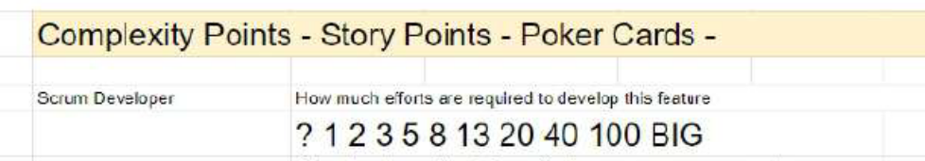

Business Value- means the benefit or importance a feature, task, or project brings to the business.
It helps decide what work should be done first based on how much it helps the company or customers.
✅ Example:
- A feature that increases customer satisfaction or sales has high business value.
- A feature that doesn’t impact goals much has low business value.
👉 In short:
Business Value = How useful or valuable something is for the business or customers.
It given based on priority like – if priority is low then BV – 10, 20, 50
Medium, BV- 100
High, BV- 200, 500
BV is given by the clients.

User Story: - User stories are short, simple descriptions of a feature or requirement written from the end user’s perspective.
As a (type of user),
I want (an action or feature)
So that (benefit or value)
For example:
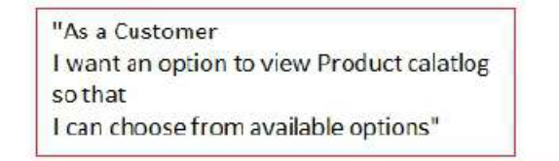
Role of Product Owner-
- Responsible for product vision/ Req. questions/ considers stakeholders interest
- Decide whether to accept/ reject product increment
- Continues / discontinues the development
Role of Scrum Master-
- Guides the team/ remove obstacles
- Collecting real data to improve future predictions.
- Not having any mgmt. authority over team.
Scrum development Team-
- Self organized cross functional team
- Can negotiates commitments with PO
- Work on how to reach on commitments
- Complete 1 sprint at a time
Role of a BA in Agile Scrum-
- He does the req. planning
- Conducts various req. gathering session and analyse them
- Finally req.- listed as feature list
- This feature list is drafted by BA and discussed with PO
- Now BA from this feature list- identify EPIC and breaks them as themes and then to user stories
- Requirement Engineering
Elicitation technique
1) Brainstorming (B): A group creativity technique where stakeholders come together to generate a wide range of ideas and solutions related to the project.

2) Document Analysis (D): Reviewing existing documentation, such as business plans, project charters, and previous project reports, to gather relevant information and insights.

3) Reverse engineering - means analyzing an existing system or product to understand how it works, especially when no proper documentation is available. Instead of starting from scratch, the Business Analyst studies the current system’s screens, reports, workflows, and data to identify its features, business rules, and user requirements.
It helps when a company wants to upgrade, replace, or improve an old system but doesn’t fully know what’s inside it.

Types- black box : - 1. Black Box Reverse Engineering:
- In this method, you don’t see the internal code or logic of the system.
- You just observe how the system behaves — by using the interface, testing inputs and outputs, and checking reports or screens.

2. White Box Reverse Engineering:
- Here, you analyze the internal logic, structure, and code of the system.
- It helps understand how the system is built and why it behaves in a certain way.

4) Focus Groups (F): Small groups of stakeholders (ex. farmers, manufacturers) share their needs and give detailed feedback on the project. Has 6-12 attendees.

Homogeneous Focus Group:
- All participants have similar backgrounds or roles.
- It helps get deep insights from people who share the same type of experience.

Heterogeneous Focus Group:
- Participants come from different backgrounds or departments.
- It helps collect diverse opinions and understand the needs of various users.

5) Observations (O): Involves visiting the user's environment to understand how they perform tasks and the challenges they face (ex procuring seeds, fertilizers, and pesticides).

Passive/Invisible Observation:
- The BA just watches how users do their work without interrupting or asking questions.

Active/VisibleObservation:
- The BA interacts with the user, asks questions, and sometimes participates in the task to understand it better.
4. Observation – Watch how users actually work to find hidden pain points.
- •

6) Workshops (W): Interactive sessions with stakeholders (e.g., APT IT team, farmers, manufacturers) to define detailed workflows and requirements.

7) Joint Application Development (JAD) (J): A collaborative approach where stakeholders and developers work together in workshops to define requirements and design solutions.

8) Interviews (I): Conducting one-on-one or small group interviews with stakeholders to gather detailed information about their needs, preferences, and pain points.

9)Prototyping (P): Creating a early and simplified version of the application often referred to as a Minimum Viable Product (MVP) that stakeholders can interact with.This allows for gathering feedback from users, such as farmers and manufacturers, to refine requirements and improve the final product.
5. Prototyping – Build a sample to see what users like or need.
•

10) Questionnaires/Surveys (Q): Distributing structured forms to gather quantitative and qualitative data from a larger group of stakeholders (farmers).

11) Use Cases (U): It describe how users (farmers, manufacturers) will interact with the system. It helps to define functional requirement.

Sort Requirement- Sorting requirements means organizing and prioritizing the collected requirements to make sure the most important ones are addressed first.
Way to Sort the Requirements:
1) Categorize – Group into types: functional, non-functional, etc.
2) Prioritize – Mark as high, medium, or low priority.
3) Group Similar – Merge related or duplicate requirements.
4) Use Tools – Apply methods like MoSCoW or RTM.
Prioritise Requirement- Prioritizing requirements means deciding which features or tasks are the most important and should be done first.
3 main actors- customer/developer/ business owner

Prioritise Techniques-
1. $100 Test:
In this technique, each stakeholder is given $100 (imaginary money) to spend on the requirements they think are most important. They can divide the money among requirements however they like. The ones that get the most money are the top priorities.
2. Top 10 Requirements:
Here, stakeholders or the team select and rank the top 10 most important requirements from the list. This helps focus only on the most valuable features first.
3. Numerical Assignment (Ranking Method):
Each requirement is given a numerical value or score (like 1, 2, 3) based on its importance or priority. The lower number (1) usually means highest priority, and higher numbers mean lower priority.
👉 In short:
- $100 Test = distribute budget to decide importance
- Top 10 = pick and rank the 10 most important
- Numerical Assignment = assign numbers or scores to rank priorities
4. Moscow Technique:
The Moscow technique is a simple and popular method used by Business Analysts to prioritize requirements based on their importance. The name stands for:
- M – Must Have: Essential requirements that are critical for the system to work.
- S – Should Have: Important but not critical; can be delivered in the next phase if needed.
- C – Could Have: Nice-to-have features that add value but are not necessary.
- W – Won’t Have (for now): Low-priority requirements that can be postponed or dropped.
Validating Requirement- :
1. FURPS:
Functionality, Usability, Reliability, Performance, Supportability – checks how well the system works and performs.
2. CUCV:
Clarity, Understandable, Consistent, Verifiable – ensures requirements are clear, easy to read, not conflicting, and testable.
3. CAE:
Complete, Accurate, Executable – confirms that requirements have full details, are correct, and can be implemented.
4. APVU:
Authorized, Prioritized, Verifiable, Unique – makes sure requirements are approved, ranked by importance, testable, and not repeated.
5. SMART:
Specific, Measurable, Achievable, Relevant, Time-bound – ensures each requirement is clear, realistic, and time-based.

Validation vs Verification: -
- Validation- if the solution is right for the product.
- Verification- if the solution delivered right product.

RACI MATRIX- is a tool used in projects to define roles and responsibilities clearly. it helps avoid confusion by showing who does what in a project.
How to do stakeholder analysis RACI:
Responsible: The individuals performing the task.
Accountable: The individual ultimately answerable for the task.
Consulted: Stakeholders whose opinions are sought.
Informed: Stakeholders kept up to date on progress.
3-Tier Architecture is a software design that divides an application into three layers:
- Presentation Layer – the user interface (what users see, like a website or app).
- Application Layer – the logic or rules that process data between user and database.
- Data Layer – where all the information is stored (like a database).
In short, it separates work into layers to make the system easier to manage, secure, and update.

- BA Strategies
Enterprise Analysis- Describe how BA identify business needs, define solution scope, that can easily implemented by a business, describe what are the problem and their solution, analyse business case document, do feasibility study.
- SWOT Analyses- is a technique used to evaluate a business or project’s Strengths, Weaknesses, Opportunities, and Threats.
- Strengths & Weaknesses are internal factors (like resources, skills, or limitations).
- Opportunities & Threats are external factors (like market trends or competitors).
It helps analysts understand the current situation and make better strategic decisions.
- Strengths- experienced personnel, effective processes, IT systems, customer relationship
- Weakness- gaps in capabilities, lack of competitive strengths, lack of funds, outdated technology
- Opportunities- growing online market, new customer segments,
- Threats- strong competition, changing government regulation, economic downturn.
- GAP Analyses- is a technique used to identify the difference between the current state (where the business is now) and the desired future state (where it wants to be).
It helps determine what “gaps” exist in processes, systems, or performance and what actions are needed to bridge them.
GAP analysis is done by BA and PM.
- A Feasibility Study- is an assessment done to check whether a project or solution is practical, achievable, and worth implementing.
It helps decide if the project should move forward by analyzing key factors like:
✅ Types of Feasibility:
- Technical Feasibility – Can we build it with available technology and skills?
- Economic Feasibility – Is it cost-effective and profitable?
- Operational Feasibility – Will it work well in day-to-day operations?
- Legal Feasibility – Does it follow laws and regulations?
- Schedule Feasibility – Can it be completed on time?
- Root Cause Analysis (RCA)- is a technique used to find the main reason behind a problem, instead of just fixing its symptoms.
It helps identify why an issue happened so that it can be permanently solved.
✅ Common methods:
- 5 Whys Technique: Keep asking “Why?” until you reach the real cause.
- Fishbone (Ishikawa) Diagram: Shows possible causes under categories like People, Process, machines, material, environment etc.

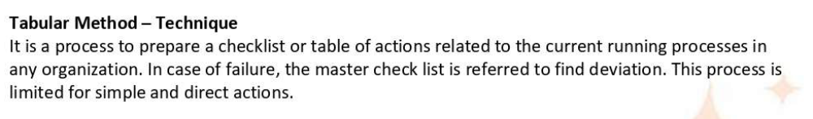

Decision Analysis- a technique of making decision during the uncertain, complex and difficult situations to root out the dilemma avoiding unknown factors known as decision analysis.
Factors involved- Financial, Non- financial
Financial- current situation of the org. in the market space, overall profit margin in the previous Q, and Y.
Non- financial- the incomplete info. About the process, the availability of diff. options affecting the current process.

