<https://www.microsoft.com/en-us/sql-server/sql-server-downloads>

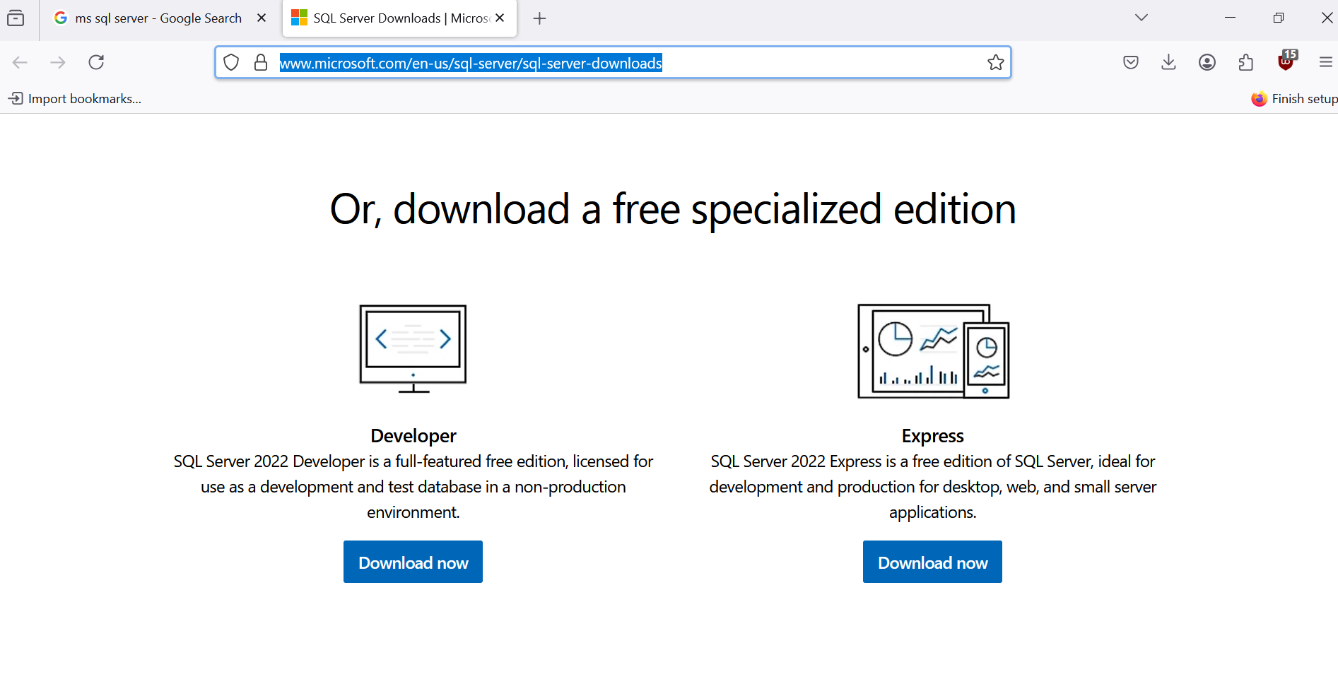

Server=localhost\SQLEXPRESS;Database=master;Trusted_Connection=True;

