<https://www.oracle.com/database/technologies/oracle-database-software-downloads.html#db_free>

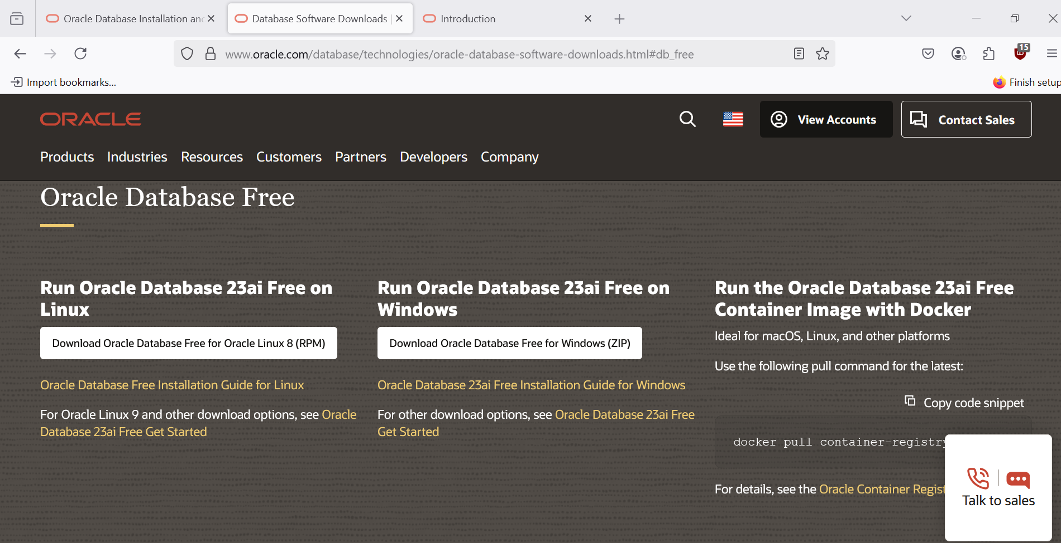

Sys,system,pbdadmin -users

