Works-magnet: Accelerating Metadata Curation for Open Science

Eric Jeangirard1

June 2025

The transition to Open Science necessitates robust and reliable metadata. While national initiatives, such as the French Open Science Monitor, aim to track this evolution using open data, reliance on proprietary databases persists in many places. Open platforms like OpenAlex still require significant human intervention for data accuracy. This paper introduces Works-magnet, a project by the French Ministry of Higher Education and Research (MESR) Data Science & Engineering Team. Works-magnet is designed to accelerate the curation of bibliographic and research data metadata, particularly affiliations, by making automated AI calculations visible and correctable. It addresses challenges related to metadata heterogeneity, complex processing chains, and the need for human curation in a diverse research landscape. The paper details Works-magnet’s concepts, and the observed limitations, while outlining future directions for enhancing open metadata quality and reusability. The works-magnet app is open source on github https://github.com/dataesr/works-magnet

1 French Ministry of Higher Education and Research, Paris, France

**Keywords**: open science, metadata curation, affiliation matching, scholarly communication

# 1. Introduction

Open Science has gained considerable momentum globally, emphasizing the need for transparent, accessible, and reusable research outputs and data. In France, the Ministry of Higher Education and Research (MESR) launched the National Plan for Open Science in 2018, establishing a suite of quantitative monitoring tools. Since 2019, these tools have also been made available to institutions for local monitoring. However, a significant challenge remains: most institutions still depend on proprietary databases for listing their publications and datasets. This dependence hinders the comprehensive and open monitoring of scientific activity.

Beyond merely tracking Open Science, there is a critical and growing need for free, high-quality information on research. Major platforms, such as Web of Science, which are widely used for generating metrics and evaluating researchers, are proprietary. While open bibliographic databases like OpenAlex offer an alternative, they are not immune to inaccuracies. For instance, in the French context in a research entity can up to five or more supervisors, a substantial number of articles are incorrectly assigned to their institutions within OpenAlex. This highlights that, just like proprietary data, open data sources necessitate human curation by experts to improve metadata quality, especially for affiliations.

In response to these challenges, the MESR Data Science & Engineering Team developed Works-magnet (works-magnet.esr.gouv.fr), launched in 2024. Works-magnet is a crucial initiative aimed at accelerating metadata curation to measure the evolution of Open Science in France using reliable, open, and controlled data. It serves as a tool to aid in spotting, curating affiliations in OpenAlex. More broadly preaking, the Works-magnet can help curating metadata produced by AI and machine learning algorithms, giving a tool to put humans back in the loop. Works-magnet can also be used to curate dataset and software mentions for example, or even grants and financial support metadata.

# 2. Challenges in Open Bibliographic Data Curation

The landscape of research metadata is vast and complex, encompassing both “classical” metadata and emerging new types. Classical metadata includes author names (with disambiguation challenges), affiliations, titles, abstracts, publication types, thematic classifications, reference lists, and funding information. Newer metadata types extend to include information on Article Processing Charges (APCs), utilized research infrastructure, financial support beyond funded projects, and the reuse or sharing of datasets, software, and clinical trials.

The collection and processing of such diverse metadata are further complicated by the variety of sources and techniques involved. Data can originate from publishers, archives, authors, funders, and aggregators such as scanR and OpenAlex. The publication processing chain itself is intricate, involving multiple steps: harvesting from various sources, deduplication, identifying authors and their affiliations, tracking citations, and classifying scientific themes.

A significant hurdle lies in the accuracy of automatically generated metadata, particularly affiliations. While various third-party tools, many employing machine learning and artificial intelligence, exist to match organization names to Research Organization Registry (ROR) IDs, their accuracy rates, even ranging from 85% to 95% before human intervention, are not perfect. These tools, including OpenAlex Institution Parsing, S2AFF, RORRetriever, EMBL-EBI ROR Predictor, dataESR affiliation matcher (L’Hôte and Jeangirard 2021), AffilGood matcher (Duran-Silva et al. 2024), and various ROR Predictors developed by Adam Buttrick. NonThis necessitates a “human in the loop” approach.

Despite technical advancements, human curation remains essential, even for seemingly “simple” metadata like affiliations. This is particularly true in France, where the administrative landscape with many supervisors, university mergers, and new types of public institutions make the affiliation landscape difficult to track. Beyond simple alignment, other frictions arise, such as incomplete or erroneous national or international reference systems, and the inconsistent availability of raw metadata (signatures) from different sources like publisher data, web scraping, PDF parsing (e.g., Grobid), and open archive metadata. Furthermore, there are challenges in managing links with software, including implicit mentions and aligning software with SWHIDs via URLs , and difficulties with research datasets, characterized by Datacite indexing issues (where one DOI does not necessarily equal one dataset) and high heterogeneity

# 3. Works-magnet: A Solution for Open Metadata Curation

Works-magnet represents a strategic shift from proprietary to open environments for research data curation. In a proprietary setting, access is restricted to customers, discussions are private, and corrected data often becomes proprietary, reinforcing dependence on the original tools. In contrast, Works-magnet operates within an open environment, accessible to any user, with transparent processes for requesting corrections. The corrected data within this open framework becomes open and reusable by anyone, leveraging the workforce of public employees to enhance the quality of open data. This paradigm promotes an open productivity tool to facilitate curation.

One of the fundamental shifts brought about by Works-magnet lies in its paradigm change, moving from a proprietary data curation environment to an open model. In a proprietary setting, access to tools and data is typically limited to paying customers, discussions are private, and metadata corrections, while improving quality, remain the property of the platform, thus reinforcing user dependence. In contrast, Works-magnet embodies a radically open approach. The system is accessible to everyone, correction requests are managed transparently via public platforms like GitHub, and crucially, the corrected data becomes open and reusable resources for anyone. This model leverages the contribution of the public sector workforce to enrich the quality of open data, transforming curation into a collaborative and transparent process that serves the entire scientific community and beyond.

|  |  |
| --- | --- |
| **Proprietary environment** | **Open environment** |
| reserved for customers | open to any user |
| private discussions and data exchange | transparency in requesting corrections |
| Excel? Database extracts? | (open) productivity tool to facilitate curation |
| Corrected data becomes proprietary | Corrected data is open and can be reused by anyone |
| reinforces dependence on proprietary tools | workforce of public employees is used to improve open data quality |

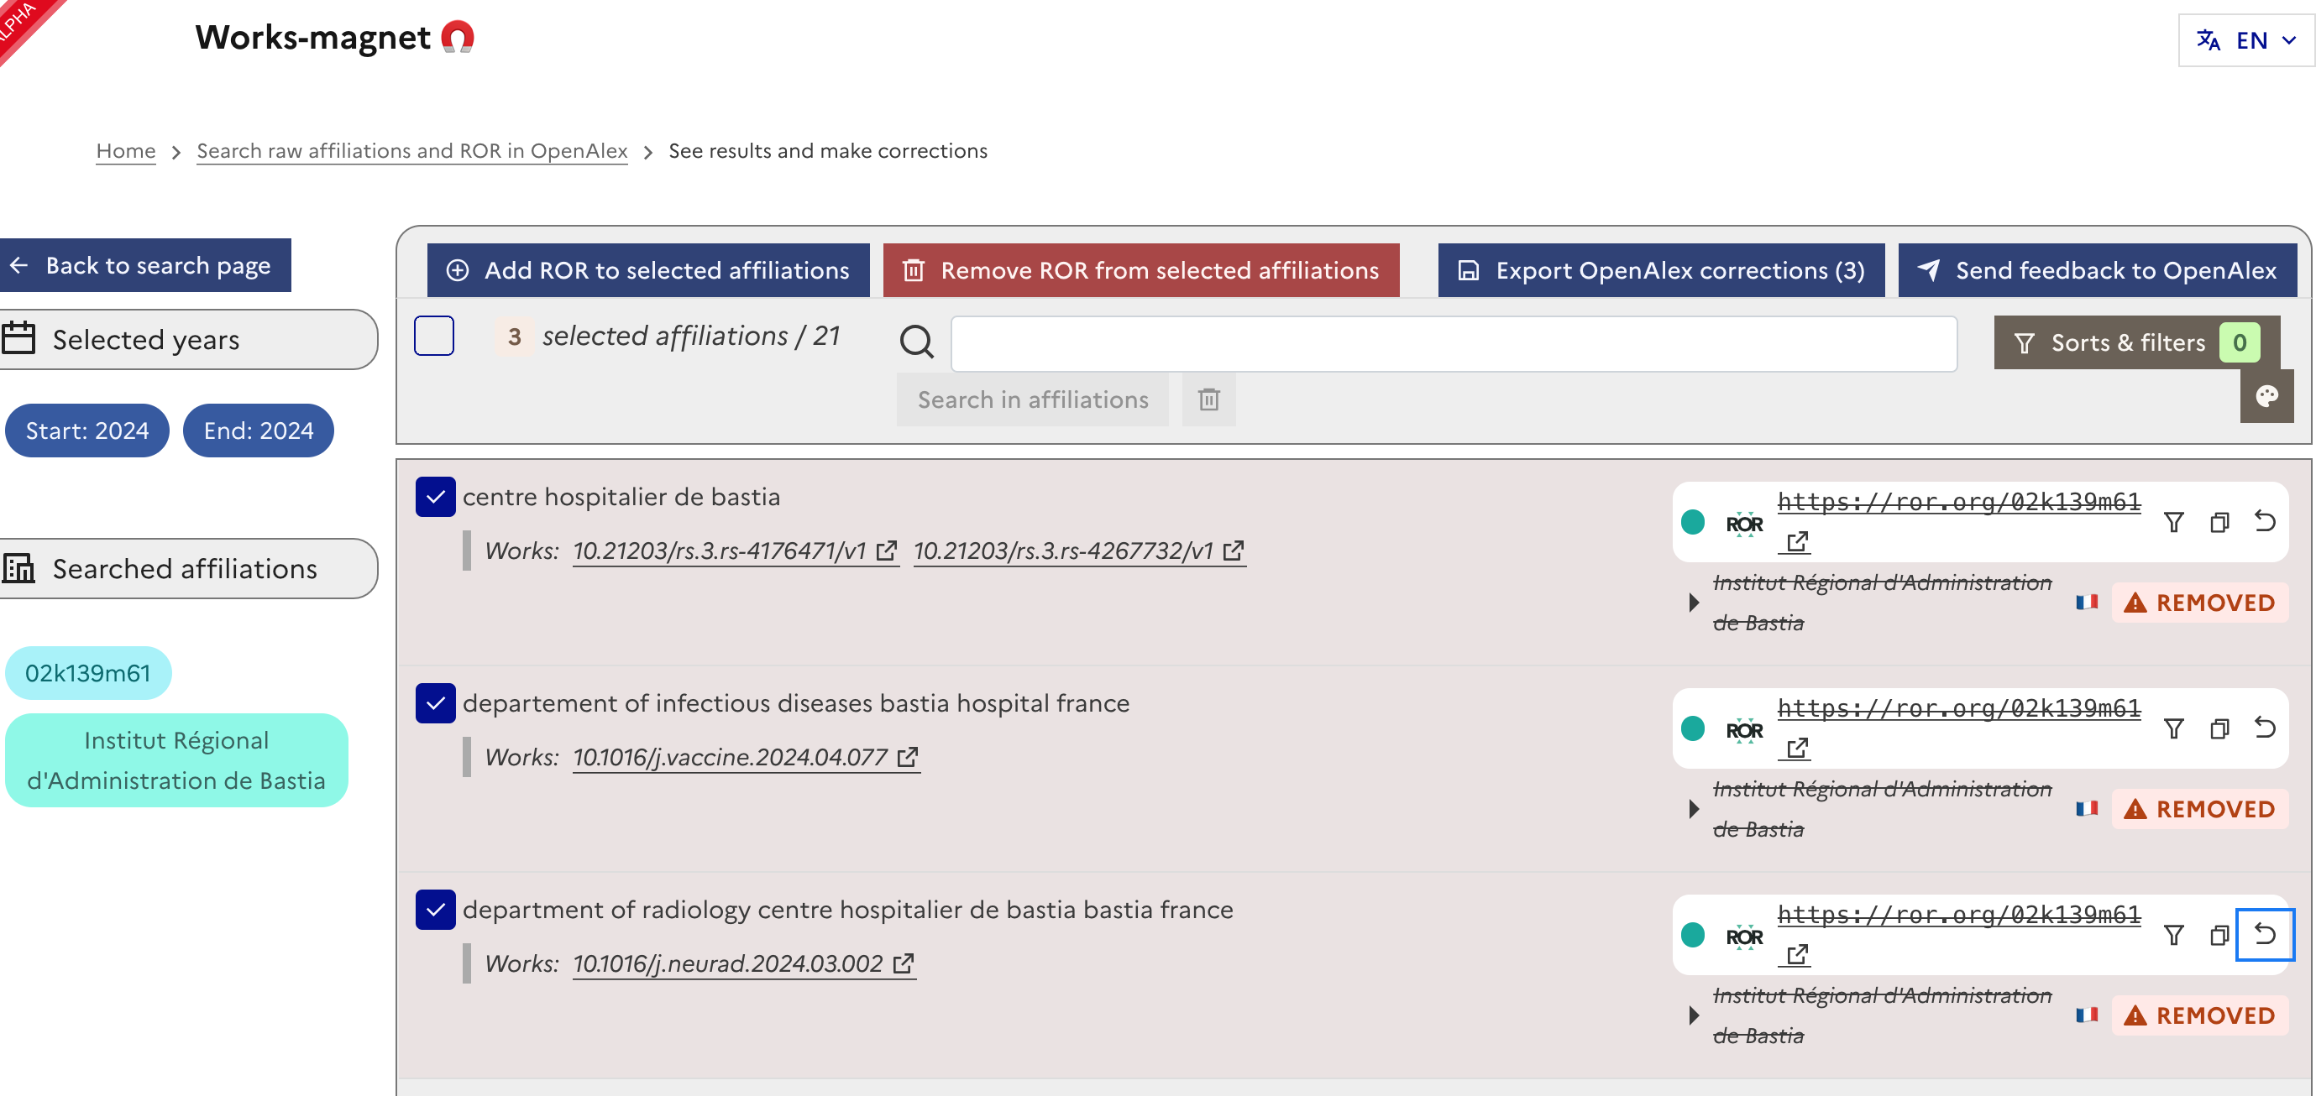

Works-magnet screenshot

# 4. Code and data availibility

The works-magnet app itself is open source on GitHub https://github.com/dataesr/works-magnet

The curated data produced is available both on GitHub via issues https://github.com/dataesr/openalex-affiliations/issues and with open dataset https://data.enseignementsup-recherche.gouv.fr/explore/dataset/openalex-affiliations-corrections/table/

# 5. Monitoring and Limitations

The efficacy and ongoing development of Works-magnet are supported by robust monitoring of correction requests and transparent reporting. Correction requests are systematically tracked, primarily through platforms like GitHub issues. As of recently, 71,283 corrections had been requested, with a significant proportion already closed. Data on these corrections, including their status (open or closed) and the domain of the top contributors, is publicly available. This transparency allows for a clear overview of the ongoing curation efforts and helps identify areas requiring more attention. Specific dashboards are also available to track correction requests for individual establishments.

Despite its innovative approach, Works-magnet faces several limitations. Technical challenges include reliance on the GitHub API, and delays in verification by OpenAlex, which can accumulate a backlog of corrections. The completeness and maintenance of the ROR registry itself also pose a challenge, although many national projects and their synchronization with ROR are attempting to address this. A persistent issue is the inconsistent availability of raw signatures (affiliation strings as they appear in publications), necessitating diverse strategies like web scraping, PDF parsing (e.g., Grobid), and extracting metadata from open archives.

Resource constraints are a significant hurdle for Works-magnet. The project operates with virtually no financial sponsorship and minimal human resources, with less than 0.25 Full-Time Equivalent (FTE) allocated per year. This limited capacity affects the pace of development and the ability to address all identified issues promptly.

Furthermore, specific difficulties are encountered when linking research outputs with software and datasets. For software, challenges include the presence of implicit mentions within texts and the complexities of aligning software with Software Heritage Identifiers (SWHIDs) via URLs. For research datasets, the primary difficulties are related to Datacite indexing, where one DOI does not always correspond to a single dataset, and the inherent high heterogeneity of research datasets themselves.

# 6. Future Directions

The future development of Works-magnet and the broader open metadata ecosystem holds several promising directions. A key objective is to ensure that the results of metadata curation are not only open but also interoperable, facilitating their reuse in diverse contexts beyond the initial scope of Works-magnet. This would maximize the value of the curated data for the entire research community.

Furthermore, the continuously growing and refined dataset resulting from Works-magnet’s curation efforts has the potential to serve as a valuable training base for new artificial intelligence models. This could lead to the development of more accurate and efficient automated curation tools in the future, potentially reducing the reliance on extensive human intervention for certain tasks (Jeangirard 2022).

Finally, there is an ongoing discussion about centralizing the results of various curation initiatives to simplify their dissemination. Such a centralized approach could create a single, authoritative source for high-quality, openly curated research metadata, further advancing the goals of Open Science by making reliable data readily available to all stakeholders. These future directions underscore the commitment to building a sustainable and comprehensive open metadata infrastructure.

# References

Duran-Silva, Nicolau, Pablo Accuosto, Piotr Przybyła, and Horacio Saggion. 2024. “AffilGood: Building Reliable Institution Name Disambiguation Tools to Improve Scientific Literature Analysis.” In *Proceedings of the Fourth Workshop on Scholarly Document Processing (Sdp 2024)*, edited by Tirthankar Ghosal, Amanpreet Singh, Anita Waard, Philipp Mayr, Aakanksha Naik, Orion Weller, Yoonjoo Lee, Shannon Shen, and Yanxia Qin, 135–44. Bangkok, Thailand: Association for Computational Linguistics. <https://aclanthology.org/2024.sdp-1.13/>.

Jeangirard, Éric. 2022. “L’utilisation de l’apprentissage automatique dans le Baromètre de la science ouverte : une façon de réconcilier bibliométrie et science ouverte ?” *Arabesques*, no. 107 (September): 10–11. <https://doi.org/10.35562/arabesques.3084>.

L’Hôte, Anne, and Eric Jeangirard. 2021. “Using Elasticsearch for Entity Recognition in Affiliation Disambiguation.” *arXiv:2110.01958 [Cs]*, October. <http://arxiv.org/abs/2110.01958>.